

**ChildFund International**

**Ethiopia Country Office**

West Arsi Zone Violent Conflict Situation Report **Humanitarian Situation Report [#1 ]**

**[**Oromia **-Ethiopia]**

**[Date Prepared: August 4, 2020]**

**[Point of Contact – Lilly Omondi- Country Director email address:** [**lomondi@childfund.org**](mailto:lomondi@childfund.org)**/**

**Tel: +251 911 250738]**

**[Date Range Covered by Report- August -October 31, 2020]**

**Part 1: The Overall Situation**

Following the assassination of an outspoken Ethiopian singer and activist- Hacalu Hundesa on June 29, a wide spread protests broke out in the capital city Addis Ababa and in Oromia region, created heightening ethnic tensions in the country. According to the Federal and regional Police Commissions and zonal disaster risk management offices (DRMOs), in July 2020 the protests have turned into valance, killing close to 200 people, injured more, damaged significant amount of personal properties and government facilities and displacing thousands of families. Police and military forces are deployed in key locations to try to control the situation. Internet was shut down for more than three weeks. The number of IDPs have also exceeded 10,000 according to the reports obtained from OCHA. Official Government sources have also confirmed that more than 5000 people have been arrested in connection with this violence..

The occurrence of the violence and conflict were sudden and causes and targets were unpredicted. Most of the areas have never been experienced such violence and conflict. So, the local community and local administration were experience the biggest challenge to control the violence and put things in an appropriate order.

ChildFund Ethiopia and its local partner -Siraro Chil;d and Family development association have been monitoring the situation and now planning to respond to the situation as much as they can.

To this end, two ChildFund Team comprising Partnership Portfolio and Emergency Program specialists held a field assessment to West Arsi Zone Shahsmente Town between July 27& 28, 2020 with its local Partner’s team. The purpose of the mission was to assess the humanitarian situation in West Arsi zone including Shashemene town where our Program operational areas founds and Siraro District in relation to the violent conflicts and assess the level of damage with in the community as well as Siraro Child and Family Development Association’s Office and its assets and come up with proposal/recommendations.

**Part 2: The Situation in Areas Where ChildFund Works**

1. **Situation Analysis**

West Arsi Zone is one of the highly affected zones within Oromia region by the violence that was erupted as of July 1, 2020.

The Project office and properties of Siraro Child and Family Development Association (SCFDA)- ChildFund’s Partner Organization -whose properties are all supported by ChildFund were one of the affected areas during this conflict.

The report has thus been organized in two sections: section one deals about the level of damage of SCFDA’s properties, the current state of operation of the LP and proposed interventions and section two deals with the overall situation and humanitarian need for the affected communities in the area

* 1. **Siraro CFDA Office Properties Damage**

Siraro Child and Family Development Association is one of ChildFund Ethiopia’s local implementing partner operating in Siraro district of Wst Arsi zone. The fact that the district has no internet and other facilities, the LP has been working from its Shashemen liaison office while the project site office is serving for the community development facilitators.

The Shashemen Office and its assets was one of the infrastructures damaged by protesters as the office was attached to Haile resort (the office is located on the Haile building and the vehicles were parked in the Hotel compound. The following properties are confirmed of damaged by the violence.

1. 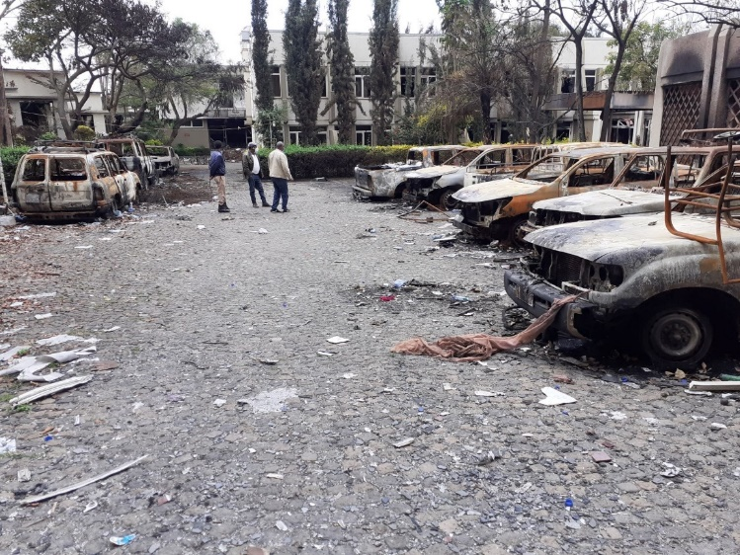**Toyota Double Cabine Pickup plate No 35- 111 AO** whose value is Birr 945,000.00. Other ten vehicles who were parked in the compound were also found to be burned out along this vehicle while six of them are other NGO vehicles.

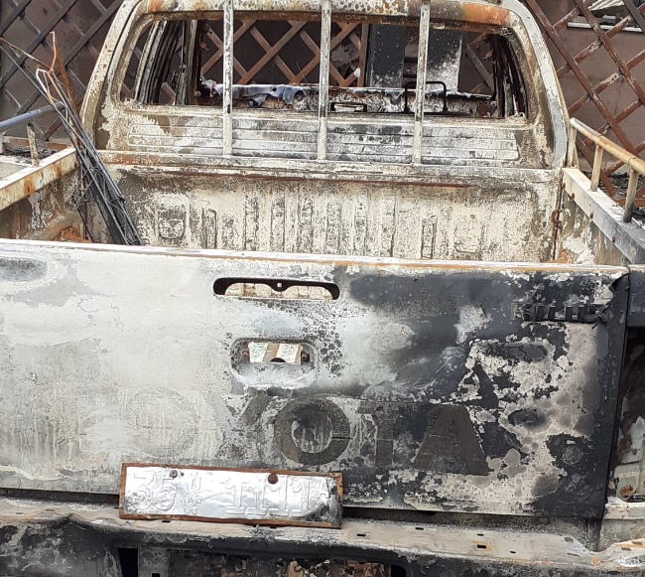 **Figure 2 Other vehicles damaged with fire in the building where SCFDA is located**

**Figure 1 SCFDA's Vehicle damaged with fire**

1. **Office furniture, IT infrastructure, Office equipment and machines and document**s whose lists are mentioned below have also been totally burned out.

|  |  |  |  |
| --- | --- | --- | --- |
| S/N | Item description | Quantity | Value in Birr |
| 1 | Photocopy machine | 2 | 100,000.00 |
| 2 | Printer | 2 | 30,000.00 |
| 3 | Scanner | 1 | 15,000.00 |
| 4 | Laptop | 7 | 175,000.00 |
| 5 | LCD projector | 1 | 25,000.00 |
| 6 | WIFI Router | 2 | 20,000.00 |
| 7 | Desktop computer | 1 | 42,000.00 |
| 8 | Video camera | 1 | 12,000.00 |
| 9 | Stapler -Big | 1 | 1,500.00 |
| 10 | Stapler -Small | 1 | 200.00 |
| 11 | Scissor | 1 | 200.00 |
| 12 | Chairs | 12 | 14,400.00 |
| 13 | Swivel chair | 1 | 10,000.00 |
| 14 | Table | 2 | 10,000.00 |
| 15 | Table (Oval) | 1 | 35,000.00 |
| 16 | Shelf | 1 | 15,000.00 |
| 17 | Bid Box | 1 | 1,500.00 |
| 18 | UPS | 1 | 10,000.00 |
| 20 | Finance and other working documents | 1 |  |

**Sample pictures of damaged infrastructure and furniture**

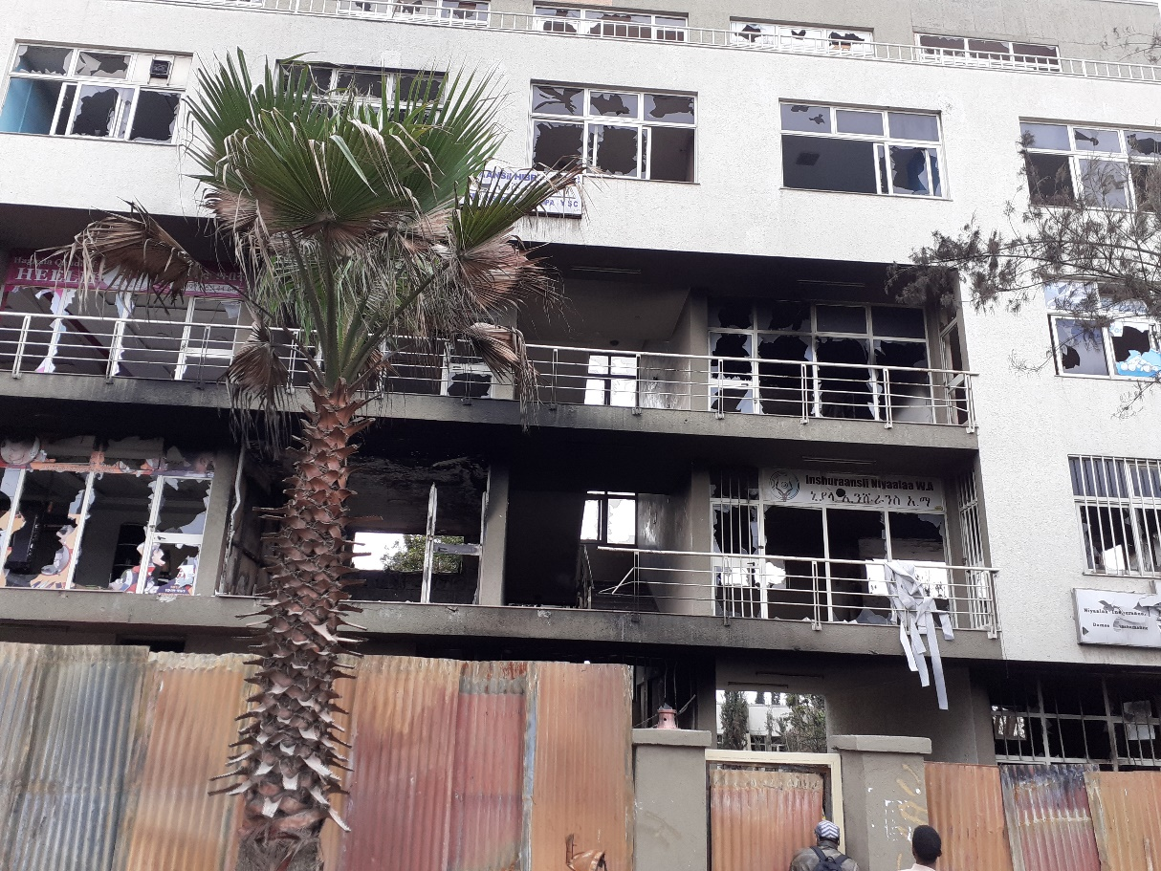

Figure 3 Front View of the office building burned and damaged by the violence

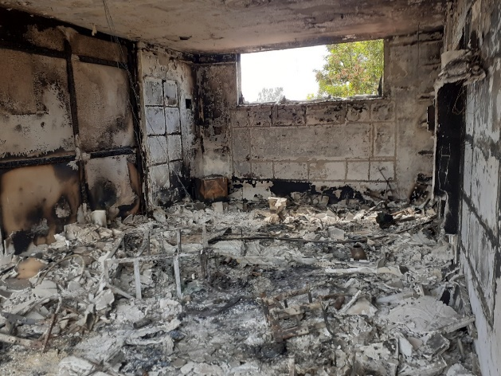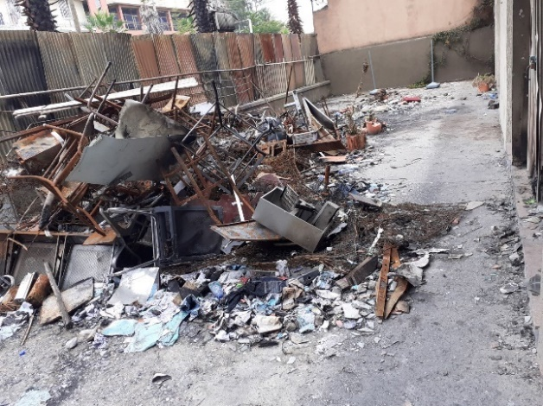

Figure 4. SCFDA Office equipment, supplies and documents turned into Ash with fire

Generally, SCFDA and its staff are currently found in a desperate and depressed situation. The LP has to acquire office on rental basis and restore its properties immediately. To do this they need an urgent support.

* 1. **Humanitarian Situation Overview in West Arsi Zone in General**

As indicate in the background section of this report, the West Arsi Zone- where one of ChildFund Ethiopia’s operational area located is one of the highly affected zones by the violence that was erupted as of July 1, 2020. According to the Commission of the Disaster Risk Management of west Arsi Zone, about nine districts including the city Shahsmene, have been affected by the violence out of the thirteen districts found in the zone.

People have been killed and injured (full data not obtained), damaged significant personal properties and government facilities and displaced thousands of families. Business centers have been burned along their properties. Youths and women entreprenerds

For example, in the City of Shashemen alone, 35 resident houses have totally been damaged and 195 houses were partially damaged. In addition to Residences, different business such as Hotels and restaurants, Business centers, boutiques, ICT centers, men and women hair dressing centers etc. have been burnt along with their properties.

Table 2 below presents an overview of initial data collected by the team from the zonal Administration and disaster risk management commission on the number of displaced people and households. Please note that the data is not complete and will be updated further upon additional needs assessment.

|  |  |  |  |  |  |  |  |  |
| --- | --- | --- | --- | --- | --- | --- | --- | --- |
| S/No | Name of Districts | Households | | | Family members | | | Total |
|  |  | M | F | T | M | F | T | G/total |
|  | G/Asasa | 31 | 4 | **35** | 162 | 118 | **280** | **315** |
|  | Kore | 112 | 24 | **136** | 1228 | 1284 | **2,512** | **2684** |
|  | Adaba | 71 | 5 | **76** | 217 | 209 | **426** | **502** |
|  | Kokossa | 13 | 4 | **17** | 37 | 19 | **56** | **73** |
|  | Shalla | 15 | 5 | **20** | 28 | 28 | **56** | **76** |
|  | N/Arsi | 2 | 0 | **2** | 4 | 3 | **7** | **9** |
|  | Kofele | 62 | 8 | **70** | 111 | 72 | **183** | **253** |
|  | Shashemene Zuriaya | 61 | 11 | **72** | 163 | 242 | **405** | **477** |
|  | Shashemene Town | Unknown | Unknown | **287** | Unknown | Unknown | **1,202** | **1,489** |
|  | **Total** |  |  | **715** |  |  | **5127** | **5878** |

**Source: West Arsi Zone, DRM office, Shashemene, 28 July 2020**

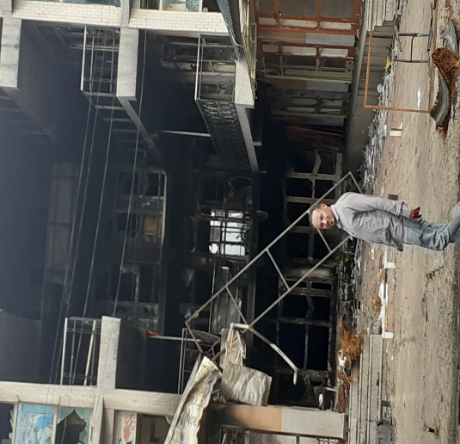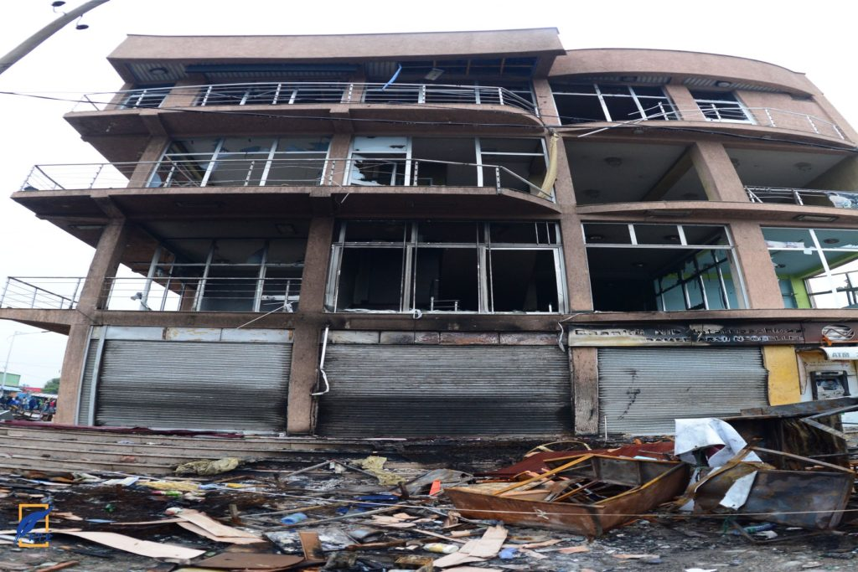

Figure 5 These are two the many business centers damaged in the city of Shashemene which used to host more than 100 small enterprise/business through rental basis...

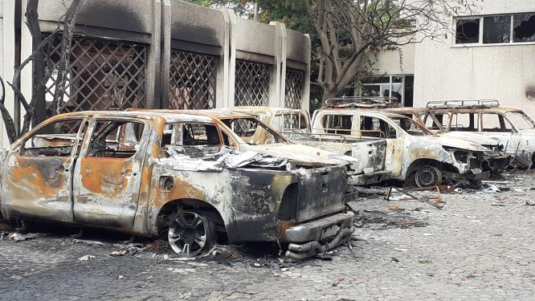

Figure 6 Vehicles burned in the compound of Haile resort- Partly (SCFDA’s vehicle 3rd from left to right)

* 1. **The situation in Siraro District**

Siraro district is characterized with experiencing cyclical drought and flood disasters that affect the food security situation of the households particularly, the poor. The area experienced poor rain fall, cyclical flood hazards during any rainy seasons.

Figure IDPs in Siraro District

The district is also known to have hosting long-term Sidama-Oromo & Oromo- Halaba ethnic conflicts.

According to the Inter-agency field assessment made on May 2020, the district has already 20,774 IDPs displaced from five Villages. These IDPs have been facing Food and NFI, Shelter, issues related with Child Protection, WaSH etc, according to OCHA report published in June 2020.

This district still did not escape from the violence erupted in July 2020. Four causalities were reported (two Civilian and two from security forces) due to the conflict between security forces and the protesters. One vehicle whose property was Siraro District Agriculture office was also burnt. More than 120 suspected people were reported to be detained including Siraro woreda administrator and head of finance and economic cooperation. More people have also flee to the neighboring communities.

Unlike, the SCFDA office in Shashemene Town, the project site office found in Alemtena-Sirbo was saved from being damaged by the beneficiary communities.

1. **Needs Analysis**

Protests and violence have now been seized and that normal activities have resumed. The government has deployed Police and military forces. Hundreds of People suspected of leading the violence are arrested by law enforcement bodies. Nevertheless, public tensions and the trauma remained critical specifically among those of Non-Oromos and Christians. Internet and communication are still not well restored. Displaced population did not go back to their communities and are found in a big trauma and anxiety.

ChildFund currently relies on data from the initial rapid assessment conducted by the local government and shared to Siraro Child and Family Development Association on 10 July 2020 with a written request for support, supplemented by information collected through discussion with concerned Zonal and Shahesmen City administration offices and interview made with few survivors.

Immediate needs identified by the team are:

* + **Shelter / NFI**: IDPs are living in neighborhood, with in the Churches and overcrowded kebeles’ office these are IDPs in Siraro Seven families lived in one room; few rooms were shared with livestock. Their living condition is appalling, with no available basic shelters and NFIs; they do not have blankets, mattresses, clothes nor items for cooking, washing, drinking and collecting and storing water. 725 households or 5,127people in the affected towns and 7000 families in Siraro need urgent emergency support.
  + **Food** items such as maize, wheat flour, pasta, macaroni, rice, sugar, edible oil and skimmed milk for urban IDPs. Supplementary food support for displaced pregnant and lactating women and children under
  + Psychosocial support services to affected population
  + Clothes and Toys for children
  + Sanitary materials such as sanitary pad and soap especially for women and girls
  + Shelter through provision of cash or construction items such as corrugated iron sheet, nails, woods, etc.
  + Cash provision as an alternative to cover other multifaceted needs of the survivors
  + Water treatment chemicals and water collecting materials are remained critical specifically in Siraro IDP areas.
  + The issue of Covid-19 is also one critical area where partners need to give equal attention.

Despite the government’s and organized taskforces effort to mobilize resources to support the IDPs, there is still a big humanitarian gap as indicated by the Zonal DRM commission.

ChildFund and its local partner, Siraro CFDA, can implement some of these humanitarian needs, if not all, based on available resource and capacity at least for three months. Taking our visual observation in Negele Arsi and Shashemene town alone, we assumed this government report seems under reported. Hence, we can say these number will increase by half in due course. We, therefore, recommend considering at least 50% of these targets which presumably 25% of the total needy persons on the ground.

In other words, we recommend focusing on four districts, Shashemene town, Shashemene zuria district, Shalla and Siraro woredas including existing IDPs also.

**Proposed Response Interventions and Budgets Requirements**

**Table 3: Detail budget**

|  |  |  |  |  |  |  |  |  |
| --- | --- | --- | --- | --- | --- | --- | --- | --- |
| **S/N** | **Major activities** | **UOM** | **Qnt** | **U/Cost (Birr)** | **Total cost (Birr)** | **Timeline** | | |
| August | September | October |
| **1** | **Office Re-establishment** |  |  |  |  |  |  |  |
| **1** | Office rent and maintenance | month | 3 | 11680 | 35040 | 11680 | 11680 | 11680 |
|  | **Subtotal** |  |  | **11680** | **35040** | **11680** | **11680** | **11680** |
| **2** | **Furniture** |  |  |  |  |  |  |  |
| 2.1 | Chairs | PCS | 12 | 1,200.00 | 14,400.00 | 14,400.00 |  |  |
| 2.2 | Swivel chair | PCS | 1 | 10,000.00 | 10,000.00 | 10,000.00 |  |  |
| 2.3 | Table | PCS | 2 | 5,000.00 | 10,000.00 | 10,000.00 |  |  |
| 2.4 | Table(Oval) | PCS | 1 | 35,000 | 35,000.00 | 35,000.00 |  |  |
| 2.5 | Shelf | PCS | 1 | 15000 | 15,000.00 | 15,000.00 |  |  |
| 2.6 | Bid Box | PCS | 1 | 1500 | 1,500.00 | 1,500.00 |  |  |
|  | **Subtotal** |  |  |  | **85,900.00** | **85,900.00** |  |  |
| **3** | **Equipment** |  |  |  |  |  |  |  |
| 3.1 | Photocopy machine | PCS | 2 | 50,000.00 | 100,000.00 | 100,000.00 |  |  |
| 3.2 | Printer | PCS | 2 | 15,000.00 | 30,000.00 | 30,000.00 |  |  |
| 3.3 | Scanner | PCS | 1 | 15,000.00 | 15,000.00 | 15,000.00 |  |  |
| 3.4 | Laptop | PCS | 7 | 15,000.00 | 105,000.00 | 105,000.00 |  |  |
| 3.5 | LCD projector | PCS | 1 | 25,000.00 | 25,000.00 | 25,000.00 |  |  |
| 3.6 | WIFI Rauter | PCS | 2 | 10,000.00 | 20,000.00 | 20,000.00 |  |  |
| 3.7 | Desktop computer | PCS | 1 | 42,000.00 | 42,000.00 | 42,000.00 |  |  |
| 3.8 | Video camera | PCS | 1 | 12,000.00 | 12,000.00 | 12,000.00 |  |  |
| 3.9 | Stapler -Big | PCS | 1 | 1,000.00 | 1,000.00 | 1,000.00 |  |  |
| 4 | Stapler -Small | PCS | 1 | 200.00 | 200.00 | 200.00 |  |  |
| 4.1 | Scissor | PCS | 1 | 200.00 | 200.00 | 200.00 |  |  |
|  | **Subtotal** |  |  |  | **350,400.00** | **350,400.00** |  |  |
| **4** | **Food** |  |  |  |  |  |  |  |
| 4.1 | Provide Maize grain for 1000 households for three months | Quintal | 2250 | 1,350.00 | 3,037,500.00 | 1,012,500.00 | 1,012,500.00 | 1,012,500.00 |
| 4.2 | Wheat flour(15kg/person) for 3 months | kg | 225,000 | 35.00 | 7,875,000.00 | 2,625,000.00 | 2,625,000.00 | 2,625,000.00 |
| 4.3 | Provide edible oil (lit/household) for a month | lit | 15,000 | 100.00 | 1,500,000.00 | 500,000.00 | 500,000.00 | 500,000.00 |
| 4.4 | Skimmed milk 400gm for 1750 U5 and PLM | PCS | 5,250 | 500.00 | 2,625,000.00 | 875,000.00 | 875,000.00 | 875,000.00 |
| 4.5 | Rice for 1000 hh | kg | 15,000 | 35.00 | 525,000.00 | 175,000.00 | 175,000.00 | 175,000.00 |
| 4.6 | Macaroni for 1000 hh | kg | 15,000 | 35.00 | 525,000.00 | 175,000.00 | 175,000.00 | 175,000.00 |
| 4.7 | Pasta (50gm) for 1000 hh@10pcs/hh | PCS | 50,000 | 25.00 | 1,250,000.00 | 416,666.67 | 416,666.67 | 416,666.67 |
|  | **subtotal** |  |  |  | **17,337,500.00** | **5,779,166.67** | **5,779,166.67** | **5,779,166.67** |
| **5** | **Non-Food Items** |  |  |  |  |  |  |  |
| 5.1 | Sleeping mats(180mm*270mm); 2 mats/household | Pcs | 2000 | 700.00 | 1,400,000.00 | 466,666.67 | 466,666.67 | 466,666.67 |
| 5.2 | Mattress (180*120m) | Pcs | 1000 | 2,500.00 | 2,500,000.00 | 833,333.33 | 833,333.33 | 833,333.33 |
| 5.3 | Blanket(2 per household) for 1000 households | Pcs | 1000 | 1,100.00 | 1,100,000.00 | 366,666.67 | 366,666.67 | 366,666.67 |
| 5.4 | Bed sheet 2 pcs/hh | Pcs | 1000 | 1,200.00 | 1,200,000.00 | 400,000.00 | 400,000.00 | 400,000.00 |
| 5.5 | Household utensils (metal ware, cups, dish plates, spouns, plastic container) for 1000 households | lump sum | lump sum | 2,500.00 | 2,500,000.00 | 833,333.33 | 833,333.33 | 833,333.33 |
| 5.6 | Corrugated Iron Sheet for 300hhs | Pcs | 9000 | 210.00 | 1,890,000.00 | 630,000.00 | 630,000.00 | 630,000.00 |
| 5.7 | Nails(different size) for 300 hhs | kg | 60 | 9,000.00 | 540,000.00 | 180,000.00 | 180,000.00 | 180,000.00 |
| 5.8 | Sanitary pad for 750 women/girls | PCS | 750 | 45.00 | 33,750.00 | 11,250.00 | 11,250.00 | 11,250.00 |
| 5.9 | Toys for children for 1000 children | PCS | 1000 | 150.00 | 150,000.00 | 50,000.00 | 50,000.00 | 50,000.00 |
|  | **subtotal** |  |  |  | **11,313,750.00** | **3,771,250.00** | **3,771,250.00** | **3,771,250.00** |
|  | **Grand total(ETB)** |  |  |  | **29,122,590.00** | **9,998,396.67** | **9,562,096.67** | **9,562,096.67** |
|  | **Total Budget in USD** |  |  |  | **828,593.91** | **284,473.69** | **272,060.11** | **272,060.11** |

Table 1. Enrolled and Sponsored Children in the Operational Districts

|  |  |
| --- | --- |
| Children 0-5 years | 394 |
| Children 6-14 years | 1,189 |
| Adolescents and youth | 693 |
| Adult caregivers | 2,218 |

Table 2: Data of rural population in Siraro district

|  |  |  |  |  |
| --- | --- | --- | --- | --- |
|  | Total rural population | | |  |
|  | Male | Female | Total |  |
|  | 107,800 | 112,200 | 220,000 |  |

Table 3: Data of total population in the five operational kebeles

|  |  |  |  |  |
| --- | --- | --- | --- | --- |
|  | Enrolled Children in the Target Area | | |  |
|  | Male | Female | Total |  |
|  | 21,070 | 21,930 | 43,000 |  |

SECTIONS BELOW ARE FOR INTERNAL USE ONLY

1. Partnership and coordination

ChildFund and its local partner, Siraro CFDA, are closely working with the local government to strengthen its emergency and recovery activities. Thus, collaboration and coordination among different actors, NGOs, GOs and community is very important. Thus, this project will revitalize such coordination efforts in the way that enhances efficiency and effectiveness of the emergency response activities.

1. Program

Education

Child Protection √

Health √

Food √

WASH √

1. Staffing

Major HR issues: No major HR issues; existing staff can manage the project in coordination with government experts

Visits: None

Departures: None

Arrivals: None

Staff on the Ground :

1. **Yilma Tibeso, Executive Director, SCFDA; sirarocfda@**[**@gmail.com**](mailto:fentalecfco@gmail.com) **/0916831345**
2. **Person 2**
3. **Person 3**
4. **Person 4**

Key contact: Lilly Omondi; email address: [lomondi@childfund.org](mailto:lomondi@childfund.org)

Tel: +251 911 250738

1. Donors

Proposals and concept note submitted:

|  |  |  |
| --- | --- | --- |
| Donor | Program | Amount |
|  |  |  |
|  |  |  |
|  |  |  |

Confirmed funding:

|  |  |  |
| --- | --- | --- |
| Donor | Program | Amount (USD) |
|  |  |  |
|  |  |  |
|  |  |  |
|  |  |  |

1. Finance
2. Media/Communications

Information and media contact:

Information and media contact:

Spokespeople – languages spoken:

| Resources | What’s available | URL |
| --- | --- | --- |
| Photos |  |  |
| Case studies |  |  |
| Press releases |  |  |
| Blogs |  |  |
| Press coverage |  |  |
| Videos |  |  |

1. Additional information
2. Next steps

Further need assessment will be taken place