ChildFund International
Humanitarian Situation Report Template

Humanitarian Situation Report [#3]
[Typhoon Vamco] – [Philippines]
[November 17, 2020]
[Point of Contact – Federico Diaz-Albertini, Country Director]

Part 1: The Overall Situation

Typhoon Vamco (Ulyssess) made 1st landfall at 11PM tonight in Polilio Islands, northern part of Quezon province and made its 2nd landfall around 1:00AM in the morning in the municipality of infanta, northern part of Quezon province. Afterwards it traversed the whole of Central Luzon region and affected the whole of Metro Manila. Vamco was suppose to weaken after it hit but it almost maintained it strength of even after it hit the Sierra Madre mountain range.

Vamco with its diameter of 1,000km radius, an eye of 84km wide and rainband brought a lot of rain and inundated most of Central Luzon and Metro Manila. It flooded Metro Manila more than the last time in 2009 affecting the cities of Marikina, Pasig, and town of the province of Rizal. With the diameter of Vamco it affected the areas affected already by Goni in Bicol region.

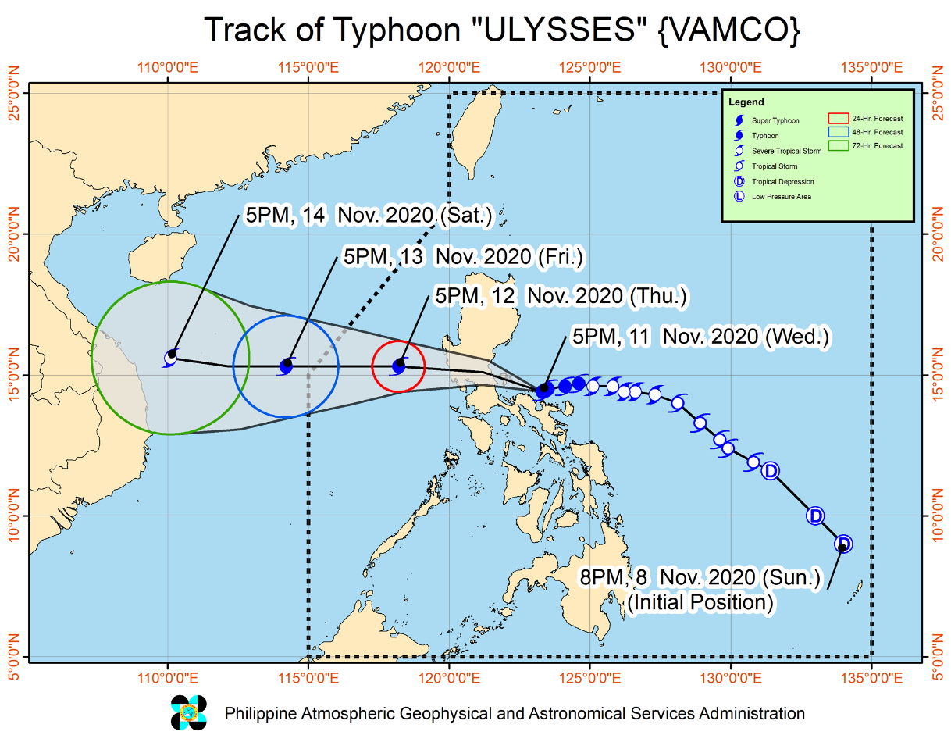

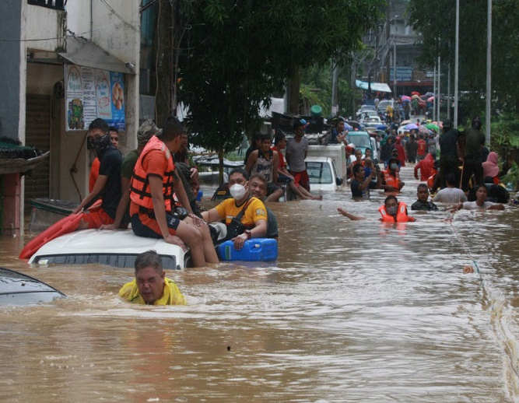
In the National Capital Region (NCR) Tens of thousands of homes in low-lying suburbs were submerged in roof-level floods, trapping residents in their rooftops while awaiting rescue. In Marikina City, the mayor reported that 40,000 houses were either partially or fully submerged, and that all 47 evacuations centers in the city are full, with some evacuees seeking temporary shelter in nearby homes. The police reported at least 13 dead, 20 injured and 15 missing. The rains also caused high turbidity of the water in Ipo Dam in Bulacan, leading to service interruptions as the concessionaire reduced the production in its water treatment plants. Nearly two million households were also without electricity as high winds toppled power lines.
Figure 1.Marikina City, NCR

In Region II (Cagayan Valley), floods and landslides wreaked havoc in the northern provinces of Cagayan and Isabela on 13 November due to the rains brought by Vamco (Ulysses) and previous tropical cyclones and depressions. Local authorities called it the worst in the region in four decades.
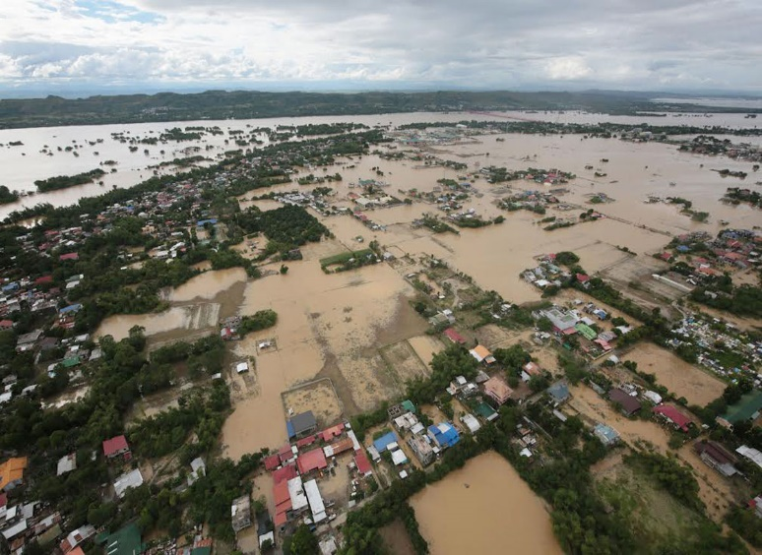
The already swollen Cagayan River in northern Luzon quickly rose and inundated low-lying communities when authorities released water from Magat Dam, one of the largest in the country, to prevent the dam from reaching its critical spilling level. About 3,700 rescue personnel from government and private groups were deployed over the weekend and rescued at least 83,600 people from up to 15-foot deep floods. Rescue operations are still ongoing as the waters are slow to recede, with at least 50 villages remaining isolated.
Figure 2. Cagayan Valley Region

According to the National Disaster Risk Reduction and Management Council, as of November 15, more than 2,074,301 in Regions I, II, III, IVA, IVB, V and NCR were affected in 5,186 barangays (villages). Of these, approximately 306,497 people are currently being served inside and outside evacuation centers, while the rest are seeking refuge with relatives or friends. Region II, IVA, and NCR are hosts to the most people displaced, followed by Region V, III and IVB. There are already 67 deaths, 21 injures and 13 missing persons recorded from region II, IVA, V and Cordillera Administrative Region (CAR).

An estimated USD44, 530,717.35 worth of damage to agriculture was incurred in Regions I,II,III, IVA, V, CAR and NCR. For infrastructure an estimated USD10,059,473.98 worth of damage was incurred and 34,178 houses were damaged (4,059 totally/30,119 partially) in Regions I, III, IVA, V and NCR. There are still several number of affected areas that has still has flood waters and still cannot be fully assessed so these numbers are still expected to rise in the several days.

A total of USD683,027.56 worth of assistance was provided to the affected families; of which, USD534,516.98 from Department of Social Welfare and Development (DSWD) and USD148,469.93 from LGUs.

The DSWD Central Office (CO), Field Offices (FOs), and National Resource Operations Center (NROC) have stockpiles and standby funds amounting to USD21, 488,340.54
Currently no state of calamity declaration yet made from the national government. Respective affected local government units have declared state of calamity.

Part 2: The Situation in Areas Where ChildFund Works
Local partner REINA Federation based in Northern part of Quezon province in Infanta has been totally affected by Vamco as it made 2nd landfall in the municipality of Infanta and cross their other areas in the municipality of Real and Nakar. Also, Gems Heart foundation were directly impacted by the flooding caused by Vamco in metro manila in their areas in Pasay and Manila City.
Vamco indirectly impacts local partner FACE Inc. based in Bicol due to the heavy rains it brought and has further affected communities that were devastated by Goni already just a week ago.
REINA Federation has a 3,064 enrolled families in the area and has identified those families in high-risk area (around 300 families) and have them participated in the preemptive actions of the local government. In Gems Heart area it 976 enrolled families that are most likely to be affected by the flooding brought about by Vamco.
As of this writing, REINA and Gems Heart are waiting for floodwaters to subside before they could conduct assessment in their areas.
Based on initial reports from the field most of the families staying in the evacuation centers are not comfortable staying at the EC’s since the Covid 19 cases in the area have been increasing the past several weeks. This situation added stress and pressure in the establishment of evacuation centers.
As of November 14, the local partner Gems Heart program areas in Metro Manila reported that only minimal impact is recorded and in their covered communities and does not require any response intervention. All 976 enrolled Children have been accounted.
As for REINA program areas in Northern part of Quezon province, the three municipalities covered by REINA, Vamco has affected Infanta, Real and Gen. Nakar as most of the communities experienced flooding and damage to houses and livelihood.
There 4,940 individuals affected in the areas of Real (3,544), Infanta (757) and Nakar(639).Intial result of damage assessment report shows 764 houses are totally damaged (Real-90, Infanta-630, Nakar-33) and 6,371 houses are partially damaged (Real-500, 5,610, Nakar-237). Intial report also shows cost of damage to livestock and agriculture is at USD86,831.93.

Initial distribution of relief like food packs to affected families came from the prepositioned items from the LGU’s of Real, Infanta and Nakar and donation from local businesses in the area, private groups and from the Philippine Red Cross. The relief assistance from the national government particularly from the Department of Social Welfare and Development (DSWD) has not yet arrived as it is awaiting consolidated data of affected population from the three municipalities of the area.

For the programmatic areas of REINA in the three municipalities it has 3,064 enrolled families and all are among the affected families. The member families were able to receive initial relief assistance from the LGU.

Also, as a cluster the program areas of REINA has a total of 233 active cases of Covid 19 (Real-75, Infanta-128, Gen. Nakar- 30)

Part 3: ChildFund’s Response

The CO has a standby staff that can be deployed immediately if needed. Depending on the severity of the impact REINA can implement its own response if the impact is just small scale but will definitely need support of the CO if the impact is at large scale.

Currently REINA and Gems Heart is waiting for floodwaters to subside to conduct rapid assessment. In particularly REINA is looking major impact in there are brought about by the flooding caused by Vamco. REINA federation initially is looking at providing support on relief intervention in their areas related to food distribution and MHPSS. Depending on the result of the assessment both REINA and Gems will definitely conduct MHPSS interventions in their respective areas.

It has been initially reported that most of the schools and families who lost their homes lost also their modules for their remote learning education following the Covid 19 quarantine protocols.

ChildFund has participated earlier on coordination meetings facilitated by the Philippine I-NGO network (PINGON) for Vamco and on-going operations for Goni. ChildFund also is actively participating with the National Child Protection Working Group (NCPWG).

Based on the discussion with local partner REINA, though they are highly impacted by Vamco, it is not as worst as they expected and with that they suggested that the situation can be managed by their team as and remote guidance from the CO can suffice for now. In addition, the respective local government units (LGU) in the area are still on top of the situation especially on providing relief assistance specially food distribution to affected communities.

This recommendation from the partner relates to the increasing number of Covid 19 cases in the three municipalities as the respective LGU’s there are implementing strict quarantine guidelines, which further restrict movements of people and groups.

Based on the initial rapid assessment result conducted by REINA the immediate common needs identified by the three municipal governments are housing repair kits, cash related assistance and livelihood repair assistance. The municipal social welfare office mentioned also to that psychosocial intervention such as psychological first aid (PFA) session is needed by the families affected specially to those who totally lost their homes.

As a response, ChildFund Philippines in support with its local partner will immediately implement in Real, Infanta and Gen. Nakar, Quezon province multi purpose Cash Assistance to support the immediate repair of homes and repair of livelihood assets and provide psychosocial sessions to families whose houses are totally damaged.

The CO also has finalized their response plan which will cover continued learning support by replacing module/learning materials of students damaged by the typhoon and support to livelihood recovery intervention.

Below Sections for Internal Use Only
Staffing and Security
CO staff are on standby for deployment if needed. The CO will also coordinate with the government’s National Task Force on Covid 19 to comply with the protocols and requirement for Humanitarian actor’s implementing response in times of Covid before deployment.
Flights at the capital Manila’s Ninoy Aquino International Airport (MNL) have resumed operations after multiple international and domestic flights were cancelled on 11-12 November. Clark International Airport (CRK, Pampanga province, Central Luzon) has also reopened. The Civil Aviation Authority of the Philippines stated that airports in southern Luzon and Bicol did not sustain major damage during the storm. However, mild flooding and temporary power outages were reported at Plaridel Airport (RPUX, Bulacan province, Central Luzon). These airports are currently operational.
Previously suspended metro rail transit and light rail transit lines serving Metro Manila resumed operations on 13 November. Road disruption persists in parts of the North Luzon Expressway (NLEX), which connects Metro Manila to northern Luzon, as well on various roads in CAR.
Power outages have affected more than 3m people across Luzon, particularly in Metro Manila and Calabarzon. Telecommunications has also been disrupted, especially in Albay, Camarines Sur and Masbate provinces (all Bicol) and Pampanga (Central Luzon). Water outages have been reported in Camarines Sur and Catanduanes (both Bicol) as well. The authorities are gradually restoring essential services in affected areas. However, landslides and flooding may prompt further road closures and communications outages, especially in more remote or mountainous locations.
Government offices and public schools are closed on 13 November in Metro Manila, Bicol, CAR, Cagayan Valley, Central Luzon, Calabarzon, Ilocos and Mimaropa, among other regions. The extension of such closures is possible and may be announced in the coming hours.

- Sponsorship and Grants

Vamco will definitely impact sponsorship activities if it makes major impact in program areas of REINA. 3,064 enrolled children will possible be affected. REINA will immediately conduct headcount after the impact and will submit its report within 48 hours.

All 3,064 enrolled families have been accounted and 84 of were among the families who stayed evacuation center during the onslaught of the typhoon but has returned already to their respective homes. An estimated 80 enrolled families are among the families whose houses are totally damaged.

There are no current grant project in the areas.

- Donors

No donors as of the moment but the CO is estimating around USD 700,000 to support relief intervention related to food distribution and MHPSS intervention, Replacement of Educational materials and Support to modular learning and Livelihood recovery intervention for the areas particularly in REINA Federation in northern part of Quezon province and Gems Heart in Metro Manila.

- Budget

Initially a portion of local partner subsidy will be utilized both for REINA and Gems Heart in the response if needed.

REINA is finalizing their subsidy realignment request for their planned response to this disaster.

- Media/Communications

The communication specialist supported the development of local partner’s fund raising materials and which was picked up by CNN Philippines and was posted on their page.

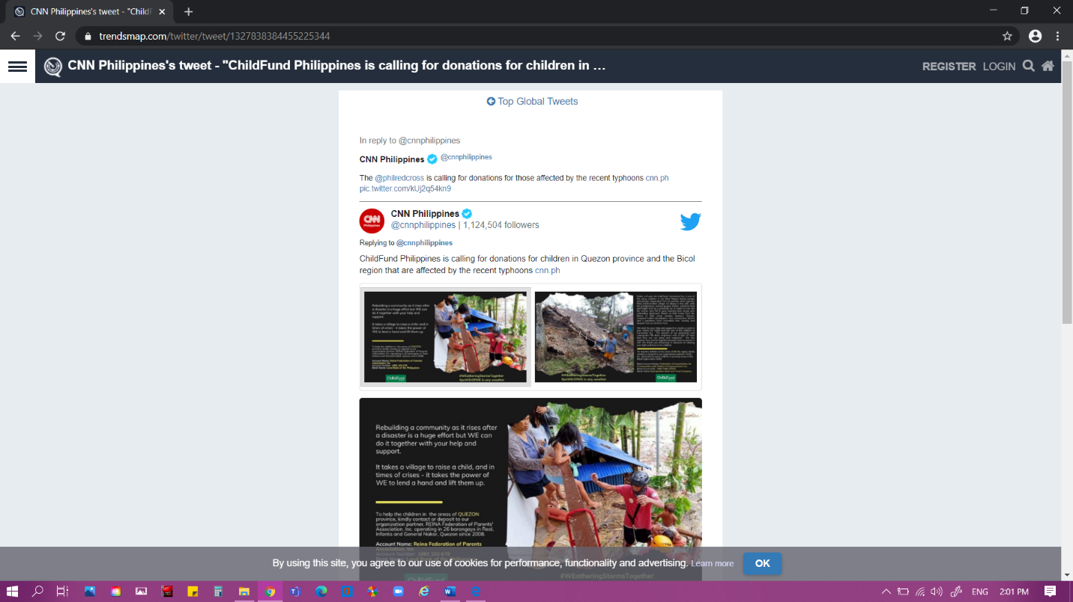

- Support needed or requested from IO, GSS or Global Teams – whether onsite or remote.

Current situation can be manage by CO management.

https://reliefweb.int/sites/reliefweb.int/files/resources/20201112%20Flash%20Update%20no.4%20on%20Typhoon%20Goni.Vamco_final_0.pdf
https://reliefweb.int/sites/reliefweb.int/files/resources/OCHA-PHL-TyphoonVamco-Snapshot-201116.pdf
https://ndrrmc.gov.ph/attachments/article/4138/SitRep_no_6_re_TY_Ulysses_as_of_16NOV2020.pdf
https://ndrrmc.gov.ph/attachments/article/4138/SitRep_no_6_re_TY_Ulysses_as_of_16NOV2020.pdf
https://reliefweb.int/sites/reliefweb.int/files/resources/DSWD-DROMIC-Report-9-on-Typhoon-ULYSSES-as-of-15-November-2020-6AM.pdf

