ChildFund International
Humanitarian Situation Report Template

Humanitarian Situation Report [#2]
[Typhoon Vamco] – [Philippines]
[November 12, 2020]
[Point of Contact – Federico Diaz-Albertini, Country Director]

Part 1: The Overall Situation

Typhoon Vamco (Ulyssess) made 1st landfall at 11PM tonight in Polilio Islands, northern part of Quezon province and made its 2nd landfall around 1:00AM in the morning in the municipality of infanta, northern part of Quezon province. Afterwards it traversed the whole of Central Luzon region and affected the whole of Metro Manila. Vamco was suppose to weaken after it hit but it almost maintained it strength of even after it hit the Sierra Madre mountain range.

Vamco with its diameter of 1,000km radius, an eye of 84km wide and rainband brought a lot of rain and inundated most of Central Luzon and Metro Manila. It flooded Metro Manila more than the last time in 2009 affecting the cities of Marikina, Pasig, and town of the province of Rizal. With the diameter of Vamco it affected the areas affected already by Goni in Bicol region.

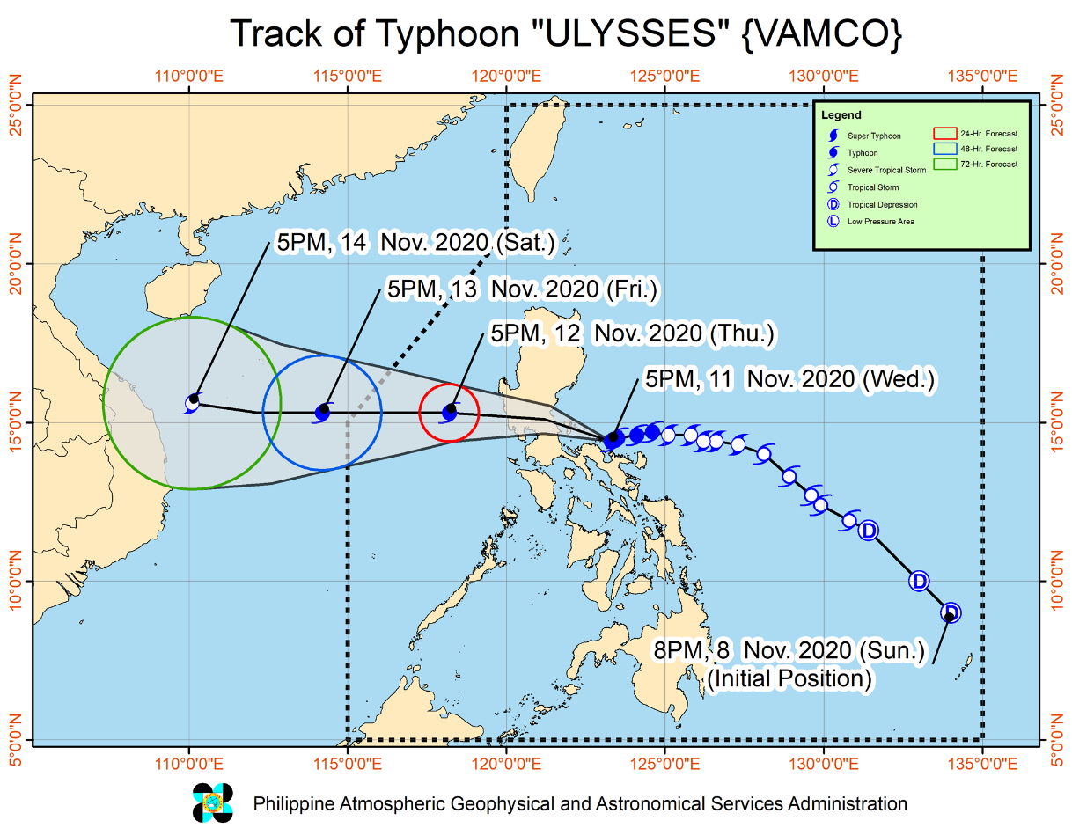

6,676 families or 25, 031 individuals in 273 barangays (villages) in five regions, (National Capital Region, Region IVA, IVB, Central Luzon region and the Cordillera Administrative Region) were affected by Vamco of which 3,769/14,417 persons are being served in inside 245 evacuation centers while 392 families/ 1,464 persons are beng served outside evacuation centers.

4 deaths have been recorded so far and 4 persons missing reported as well. 76 road sections and 30 road bridges have been affected by flooding, mudflow, landslide, swollen river, and soil/rock collapse. 1,632 passengers were stranded in the regions of IVA, V, and VIII.

Part 2: The Situation in Areas Where ChildFund Works

Local partner REINA Federation based in Northern part of Quezon province in Infanta has been totally affected by Vamco as it made 2nd landfall in the municipality of Infanta and cross their other areas in the municipality of Real and Nakar. Also, Gems Heart foundation were directly impacted by the flooding caused by Vamco in metro manila in their areas in Pasay and Manila City.
Vamco indirectly impacts local partner FACE Inc. based in Bicol due to the heavy rains it brought and has further affected communities that were devastated by Goni already just a week ago.
REINA Federation has a 3,064 enrolled families in the area and has identified those families in high-risk area (around 300 families) and have them participated in the preemptive actions of the local government. In Gems Heart area it 976 enrolled families that are most likely to be affected by the flooding brought about by Vamco.
As of this writing, REINA and Gems Heart are waiting for floodwaters to subside before they could conduct assessment in their areas.
Based on initial reports from the field most of the families staying in the evacuation centers are not comfortable staying at the EC’s since the Covid 19 cases in the area have been increasing the past several weeks. This situation added stress and pressure in the establishment of evacuation centers.
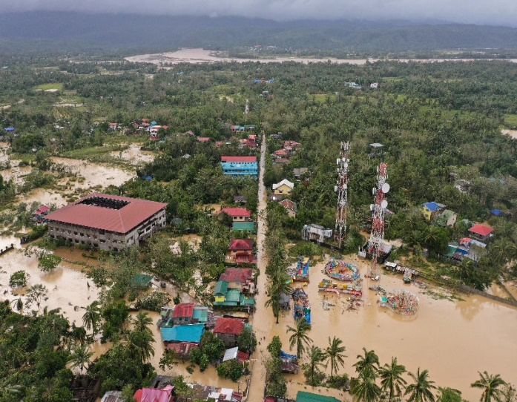
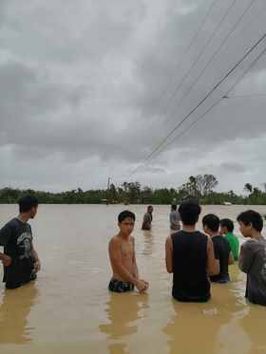

Part 3: ChildFund’s Response

The CO has a standby staff that can be deployed immediately if needed. Depending on the severity of the impact REINA can implement its own response if the impact is just small scale but will definitely need support of the CO if the impact is at large scale.

Currently REINA and Gems Heart is waiting for floodwaters to subside to conduct rapid assessment. In particularly REINA is looking major impact in there are brought about by the flooding caused by Vamco. REINA federation initially is looking at providing support on relief intervention in their areas related to food distribution and MHPSS. Depending on the result of the assessment both REINA and Gems will definitely conduct MHPSS interventions in their respective areas.

It has been initially reported that most of the schools and families who lost their homes lost also their modules for their remote learning eduation following the Covid 19 quarantine protocols.

ChildFund has participated earlier on coordination meetings facilitated by the Philippine I-NGO network (PINGON) for Vamco and on-going operations for Goni. ChildFund also is actively participating with the National Child Protection Working Group (NCPWG).

The CO CERT will convene and organize possible early deployment of an emergency response team to the area of REINA in Queon province.

Below Sections for Internal Use Only
Staffing and Security
CO staff are on standby for deployment if needed. The CO will also coordinate with the government’s National Task Force on Covid 19 to comply with the protocols and requirement for Humanitarian actor’s implementing response in times of Covid before deployment.

- Sponsorship and Grants

Vamco will definitely impact sponsorship activities if it makes major impact in program areas of REINA. 3,064 enrolled children will possible be affected. REINA will immediately conduct headcount after the impact and will submit its report within 48 hours.

There are no current grant project in the areas.

- Donors

No donors as of the moment but the CO is estimating around USD 700,000 to support relief intervention related to food distribution and MHPSS intervention, Replacement of Educational materials and Support to modular learning and Livelihood recovery intervention for the areas particularly in REINA Federation in northern part of Quezon province and Gems Heart in Metro Manila.

- Budget

Initially a portion of local partner subsidy will be utilized both for REINA and Gems Heart in the response if needed.

- Media/Communications
N/A as of the moment

- Support needed or requested from IO, GSS or Global Teams – whether onsite or remote.

Current situation can be manage by CO management.

