ChildFund International
Humanitarian Situation Report Template

Humanitarian Situation Report [#1]
[Typhoon Vamco] – [Philippines]
[November 11, 2020]
[Point of Contact – Federico Diaz-Albertini, Country Director]

Part 1: The Overall Situation

Typhoon Vamco (Ulyssess) is expected to make its 1st landfall at 11PM tonight in Polilio Islands, northern part of Quezon province and will make its 2nd landfall around 1:00AM in the morning in the municipality of infanta, northern part of Quezon province. Afterwards it will traverse the whole of Central Luzon region and will affect the northern part of Metro Manila. Currently it has sustained winds of 140kph and with gustiness of up to 195kph and a speed of 15kph westward.

Vamco will weaken after it makes landfall and hits the Sierra Madre mountain range. Vamco has a diameter of 1,000km radius and an eye of 84km wide. With that it has a wider coverage in terms of its effect particularly the rain it brings.

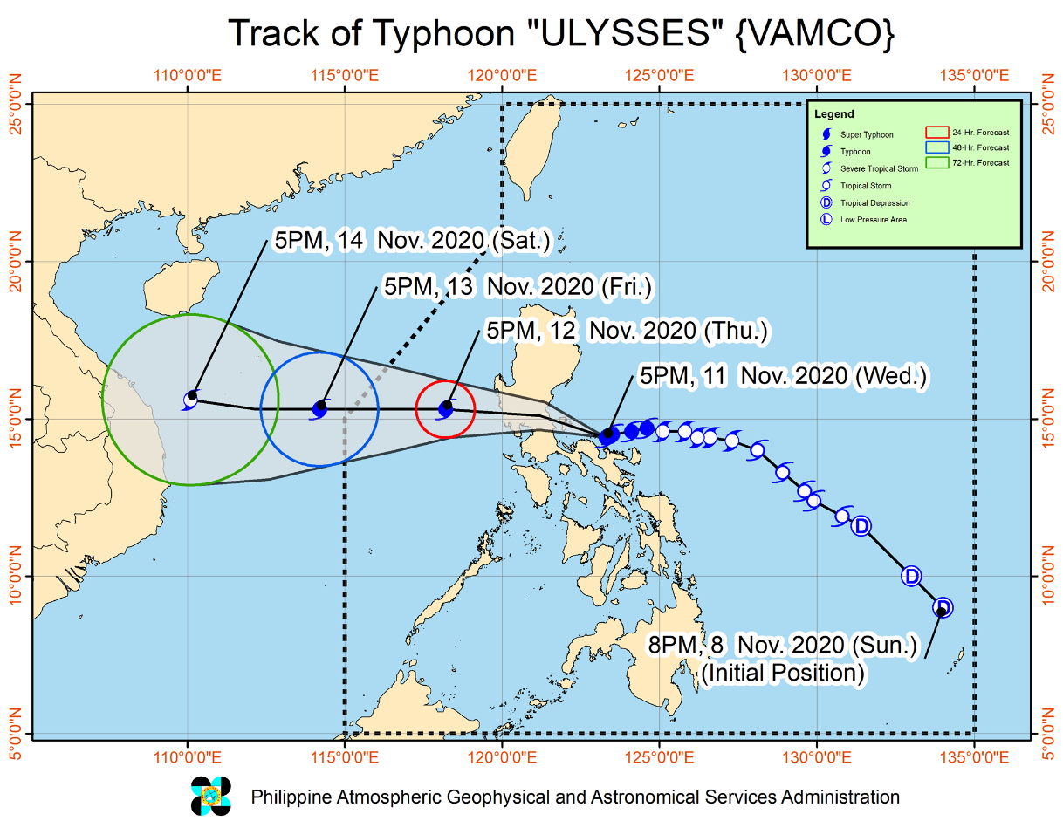

The national government has ordered local government units since yesterday the preemptive evacuation of communities that are in high-risk areas.

The authorities have evacuated residents in Albay, Camarines Norte, Camarines Sur and Catanduanes provinces (all Bicol) ahead of the storm. Bicol and Quezon have been placed on red alert, putting emergency response personnel on standby for deployment. All sea travel has been banned in Bicol.
Landslides and flooding are liable to cause temporary road closures and to disrupt communications, especially in more remote regions.

The National Disaster Risk Reduction and Management UMW Operations Center maintains its RED Alert Status as the Philippines is continuing its emergency response due to Super Typhoon GONI.

Part 2: The Situation in Areas Where ChildFund Works

Program on the direct of the typhoon is the local partner REINA Federation based in Northern part of Quezon province in Infanta. REINA Federation has activated their emergency response team in coordination with their respective partner local disaster risk reduction offices. The loca government units have conducted preemptive evacuation since yesterday to their high-risk communities and are prepositioning relief items already.
Vamco indirectly impacts local partner FACE Inc. based in Bicol due to the heavy rains it brought and has further affected communities that were devastated by Goni already just a week ago.
REINA Federation has a 3,064 enrolled families in the area and has identified those families in high-risk area (around 300 families) and have them participated in the preemptive actions of the local government.
Part 3: ChildFund’s Response

The CO has a standby staff that can be deployed immediately if needed. Depending on the severity of the impact REINA can implement its own response if the impact is just small scale but will definitely need support of the CO if the impact is at large scale.

If needed, partner REINA can implement MHPSS related intervention on affected communities as immediate and initial interventions using their subsidy funds.

ChildFund has participated earlier on coordination meetings facilitated by the Philippine I-NGO network (PINGON) for Vamco and on-going operations for Goni. ChildFund also is actively participating with the National Child Protection Working Group (NCPWG).

After the impact, the CO will immediately try to contact and coordinate on the situation of REINA and immediately plan rapid assessment actions with them.

Below Sections for Internal Use Only
Staffing and Security
CO staff are on standby for deployment if needed. The CO will also coordinate with the government’s National Task Force on Covid 19 to comply with the protocols and requirement for Humanitarian actor’s implementing response in times of Covid before deployment.

- Sponsorship and Grants

Vamco will definitely impact sponsorship activities if it makes major impact in program areas of REINA. 3,064 enrolled children will possible be affected. REINA will immediately conduct headcount after the impact and will submit its report within 48 hours.

- Donors

No donors as of the moment

- Budget

Initially a portion of local partner subsidy will be utilized in the response if needed.

- Media/Communications
N/A as of the moment

- Support needed or requested from IO, GSS or Global Teams – whether onsite or remote.

Current situation can be manage by CO management.

