**ChildFund International**

**Humanitarian Situation Report**

**Humanitarian Situation Report # 1**

**ETA Tropical Strom – Guatemala**

**November 5th, 2020**

**Point of Contact – Jairo Hernandez, jhernandez@childfund.org**

**11/04/2020 – 11/05/2020**

Part 1: The Overall Situation

Sources of Information:

CONRED, National Council for Risk and Disaster Reduction, Municipal Councils, COCODES Community Councils for Local Development.

* Name, time and date of emergency

Tropical Storm ETA, 09:00 hrs Local Time, 11/05/2020

* States/regions/areas of impact

Government Decree, by state of public calamity for: the departments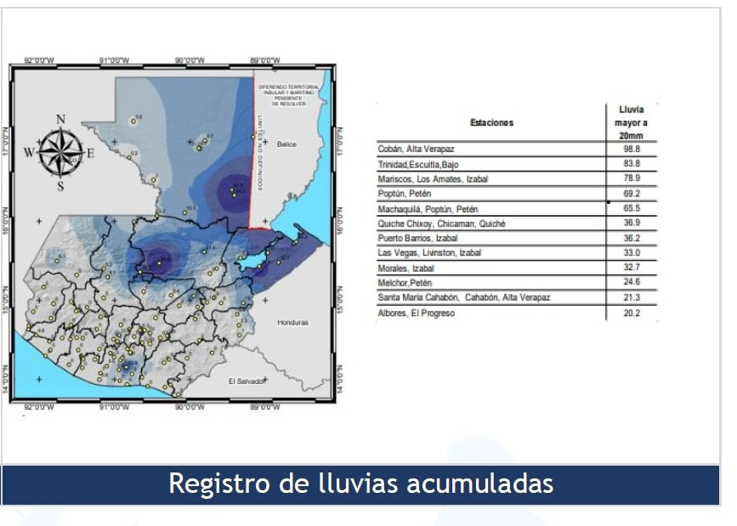

-Petén

-Quiché

-Alta Verapaz

-Izabal

-Chiquimula

-Zacpa

-Jutiapa

-El Progreso

-Santa Rosa

What infrastructure/systems have been affected

Of the areas where we develop the programs, two municipalities in the department of Alta Verapaz are strongly affected, the roads and highways are flooded, and the cultivators of the families are seriously affected, but in general the Country is affected according to the CONRED report:

**Detail of Infrastructure affectation by department**

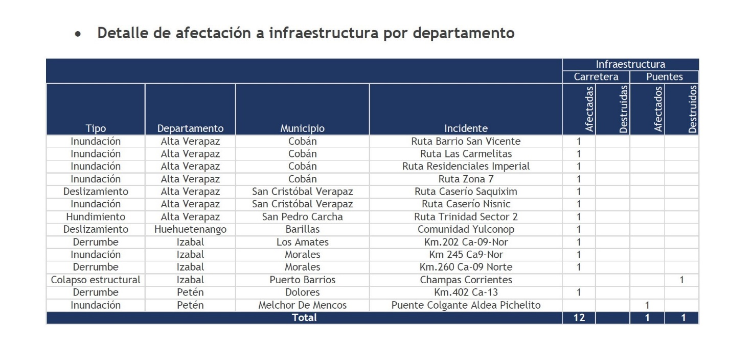

* Any relevant background information about areas affected

The rains intensify more, and it is possible that other areas show damage during the following hours

* Total number of people impacted, with breakdown of adults vs. children and by gender



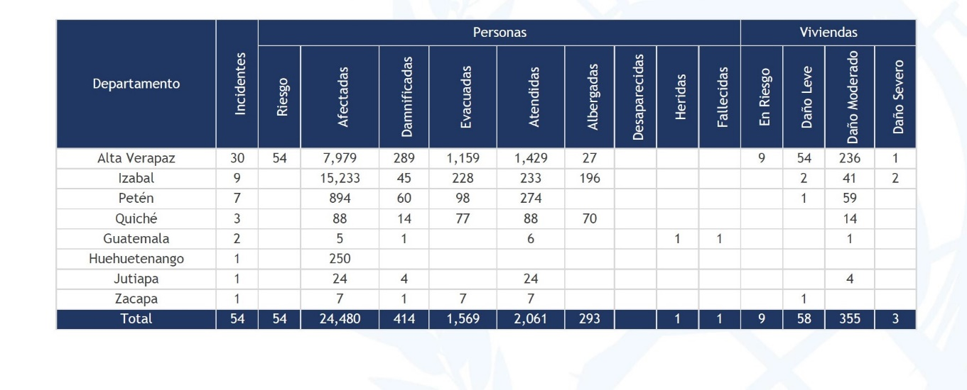

* Number of people injured/dead/missing/etc. (cite sources)

Until this report there is only one deceased person

* For conflict/displacement situations, basic information on the parties to the conflict and their positions, developments in negotiations, etc.

GOH h

|  |  |  |  |
| --- | --- | --- | --- |
| Department | Municipality | Hostel | Sheltered |

as 413 active shelters country wide

|  |  |  |  |
| --- | --- | --- | --- |
|  |  |  |  |

|  |  |  |  |
| --- | --- | --- | --- |
|  |  |  |  |

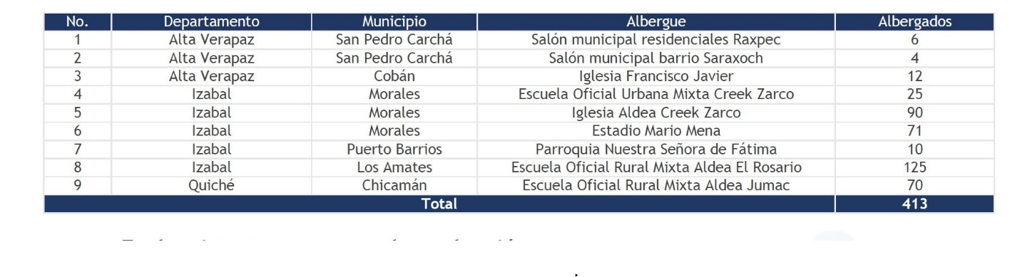

* Host government posture, have they declared a state of emergency and/or requested outside assistance?
* They have already released funds at the time of the emergency declaration and are requesting humanitarian aid from friendly countries, the government indicated. CONRED report annex

Part 2: The Situation in Areas Where ChildFund Works

* Do we have current local partners/programs in the affected area?

Currently there are reports of damage in two municipalities of Alta Verapaz, where we have programs, especially in the Municipality of La Tinta and Panzos, assistance is already being given in moving shelters and assisting them with food so far from 32 families registered in the models programmatic

.

* How many children and families are affected?

Cannot assess that information at this moment.

* What issues are children in these areas facing? (food shortages, safety concerns, homes or schools destroyed, etc.)

Food shortages, security problems, destroyed houses

Risk of illness, cold, fever, lack of medication, lack of adequate nutrition

* Child protection risks caused or exacerbated by crisis situation.

Due to the continuation of the rains, the risk of the situation of children increases, especially their health

Part 3: ChildFund’s Response

To date, the Local partner is coordinated with the authorities to follow up, to house families and provide immediate food and in the next few days will specify the actions

Below Sections for Internal Use Only

* Staffing and Security
  + Which staff are on the ground? Please include names, functions, contact information and arrival/departure dates for both IO and CO staff on the ground.

The Office Staff due to the context of Covid and the mobilization situation is not in the field, we are monitoring remotely, but the members' staff if they are in the field as necessary, especially the technician who attends this area

* + Who is or will be leading/managing the response? (if applicable)

The country's SMT Team.

* + Any gaps in staffing/need for deployment from other COs or Global Teams?

Not as this moment.

* + Confirm the safety of staff and their families in the affected area.

No Staff in danger have been reported, and the emergency communication network is applied

* + Safety and security risks/mitigation plans

No traveling until event ends. Keep ready an Emergency Kit, sufficient water reservoir, medical kit, family communication plan, communication devices with extra batteries, lightning devices, monitor official radial /TV news, identify high areas and local shelters

* + Recommendations around any upcoming travel planned for staff or donors.

Donors nor Staff should travel while the event lasts.

* + Are there any other major HR issues?
* Sponsorship and Grants
  + Will this impact sponsorship activities like correspondence and DFCs?
  + Total number of sponsored children in the affected area, by project number.
  + Confirm status of sponsored children in the area, are all accounted for?
  + List any active grants in the affected area – name of grant, donor, and primary implementer
  + Will grant execution be impacted by the emergency situation?
* Donors
  + Provide information about potential sources of funding (including grant donors, subsidy, Emergency Action Fund, Alliance members, GIK, etc.) for these emergency response efforts using the chart below.

**As soon as there is information on the affected people and the needs, proposals will be made**

|  |  |  |  |  |
| --- | --- | --- | --- | --- |
| **Donor** | **Program** | **Amount (USD)** | **Requested? (Y/N)** | **Confirmed? (Y/N)** |
|  |  |  |  |  |
|  |  |  |  |  |
|  |  |  |  |  |

* Budget
  + Outline how we will use this funding with a rough topline budget.
* Media/Communications
  + List of media who will be or have been contacted with press releases
  + List of emergency spokespeople, including name, location, contact information, and languages spoken
  + Plans for collecting photos/videos/stories, i.e. should an outside photographer be hired?
  + Key points for messaging and visibility, particularly any host government sensibilities that must be considered.
* Support needed or requested from IO, GSS or Global Teams – whether onsite or remote.