ChildFund International
Humanitarian Situation Report

Humanitarian Situation Report # 3
ETA Tropical Strom/ IOTA Hurricane – Guatemala
November 17th, 2020
Point of Contact – Jairo Hernandez, jairoh@childfund.org
11/04/2020 – 11/17/2020

Part 1: The Overall Situation
Sources of Information:CONRED, National Council for Risk and Disaster Reduction, Municipal Councils, COCODES Community Councils for Local Development.
Local partner: ADP, RENACIMIENTO
- Name, time and date of emergency
Tropical Storm ETA, 09:00 hrs Local Time, 11/05/2020/ Hurricane IOTA
- States/regions/areas of impact
Government Decree, by state of public calamity for 10 departments
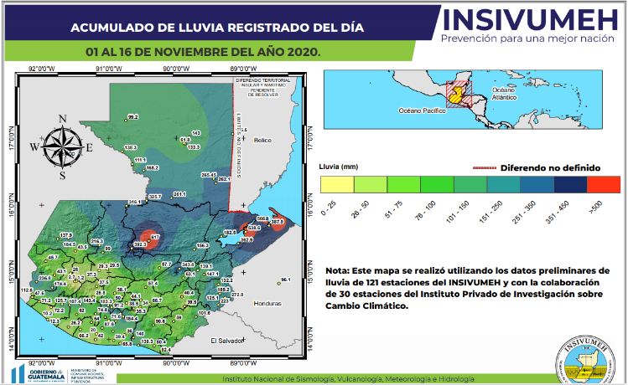
-Petén
-Quiché
-Huehuetenango
-Alta Verapaz
-Izabal
-Chiquimula
-Zacapa
-Jutiapa
-El Progreso
-Santa Rosa

Source: INSIVUMEH. Accumulative rains from November 01 to 16. November 16 2020, https://insivumeh.gob.gt/

What infrastructure/systems have been affected

Detail of infrastructure affected by department. Update: November 10, 2020: TROPICAL DEPRESSION REPORT DERIVED FROM HURRICANE ETA Prepared: Thursday, November 12, 2020 | 14:00 horas. CONRED.
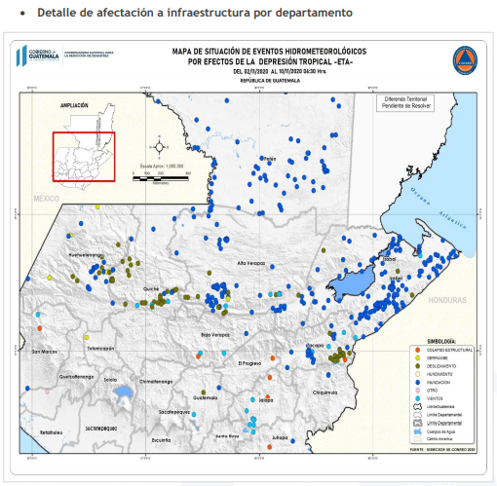
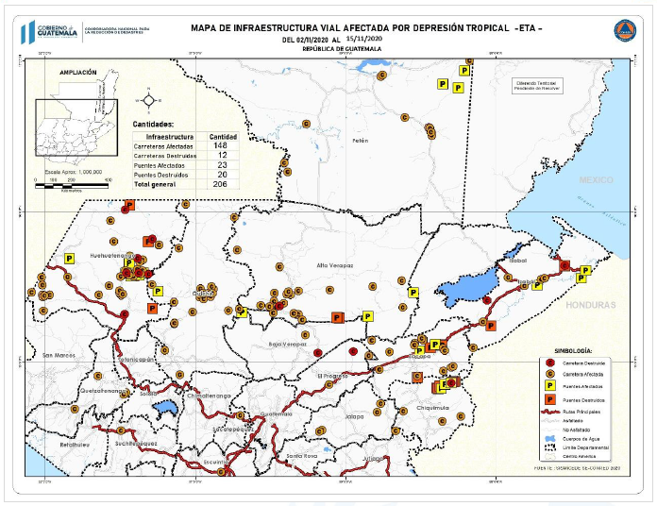
https://conred.gob.gt/category/emergencia/emergencia-eta/

Detail of infrastructure affected by department.
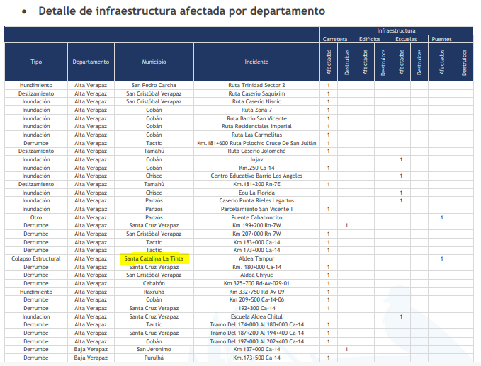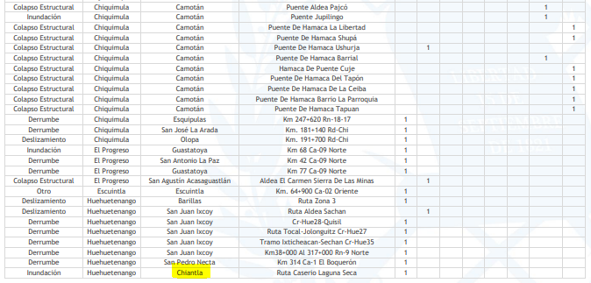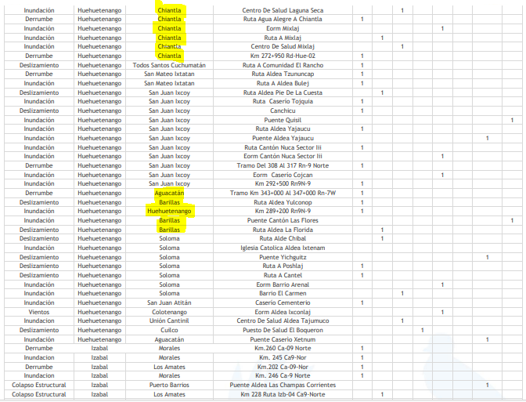
Source: CONRED. November 10, 2020.
Affected infrastructure
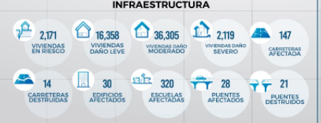
Update: November 16, 2020. 8:00 . Source: CONRED. https://conred.gob.gt/category/emergencia/emergencia-eta/
- 2,171 houses at risk
- 16,358 houses with low damage
- 36,305 houses with moderate damage
- 2,119 houses with severe damage
- 147 roads affected
- 14 roads destroyed
- 30 buildings affected
- 320 schools affected
- 28 bridges affected
- 21 bridges destroyed

- Any relevant background information about areas affected
The rains intensify more, and it is possible that other areas show damage during the following hours
Alta Verapaz is one of the two most affected departments with deaths and reports of many losses in crops and homes. Due to access issues, comprehensive damage assessments have not yet been carried out. (source: Plan International, Sitrep November 11)

According to the National Institute of Seismology, Volcanology, Meteorology and Hydrology of Guatemala - INSIVUMEH-. the IOTA hurricane has weakened to a category 1 hurricane. Over the course of the day it will weaken and degrade to a tropical storm ... For the next two days the rains will become widespread throughout the national territory, with temporary conditions persisting ... The largest accumulated rainfall is forecast towards the south of Petén, Alta Verapaz, Franja Transversal del Norte, Izabal, Huehuetenango, Quiché, Baja Verapaz, Chiquimula, Zacapa, Jutiapa, Santa Rosa, Escuintla and Guatemala "Tuesday, November 17, 2020, 6 : 00 Guatemala time. https://insivumeh.gob.gt/
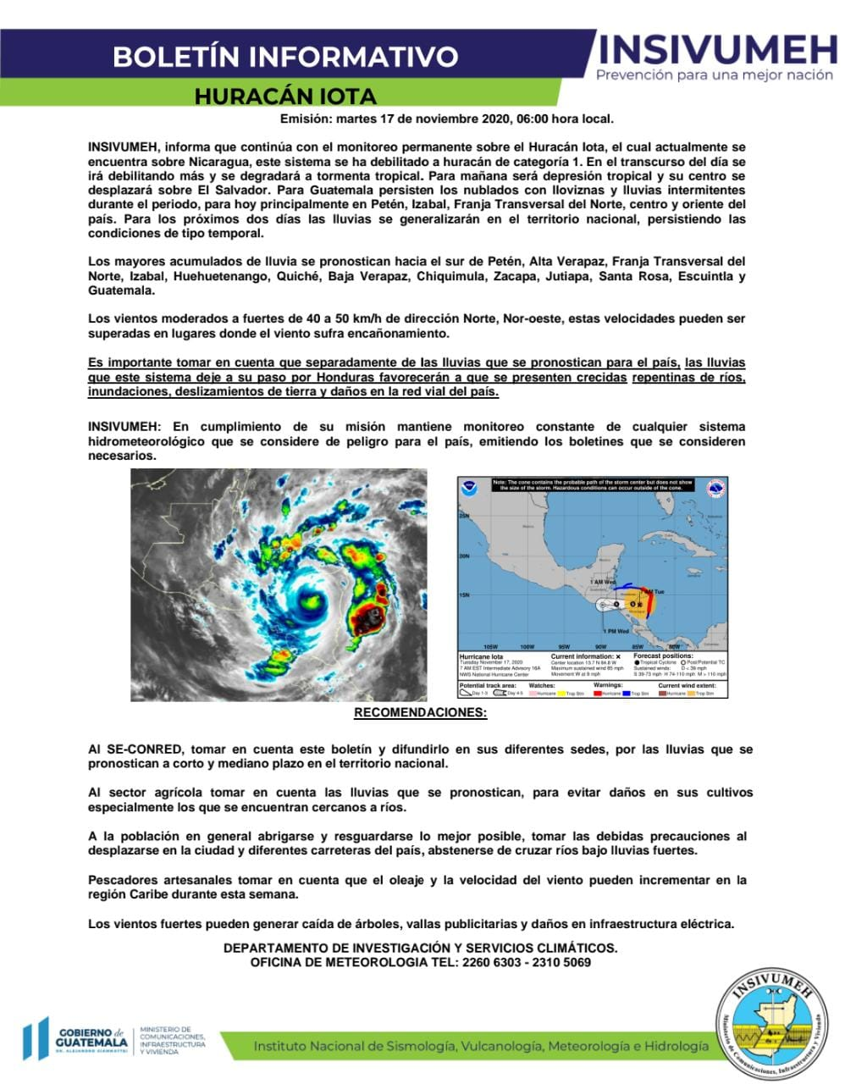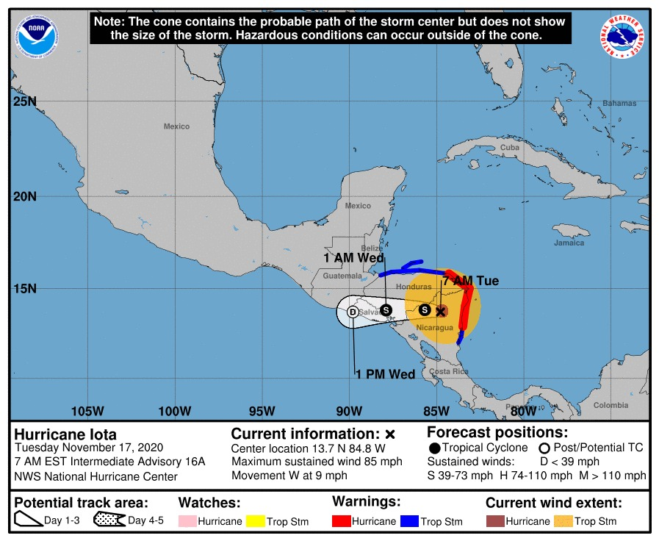
According to CONRED and a report on the "list of municipalities threatened by floods due to the IOTA hydrometeorological phenomenon in the Republic of Guatemala" the following departments and municipalities are under medium and high threat. Only the departments where we have programmatic and project intervention are displayed.
Department, municipality, level of treat:
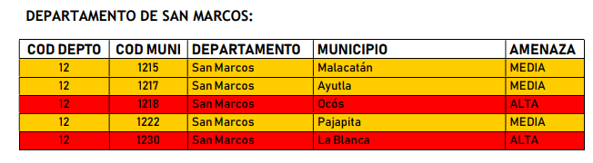
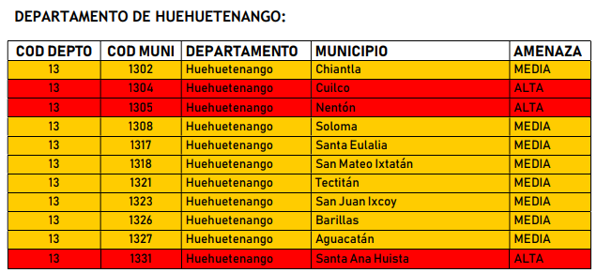
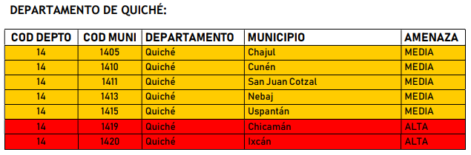
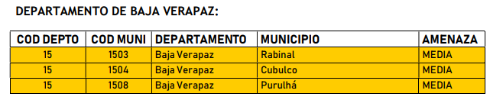
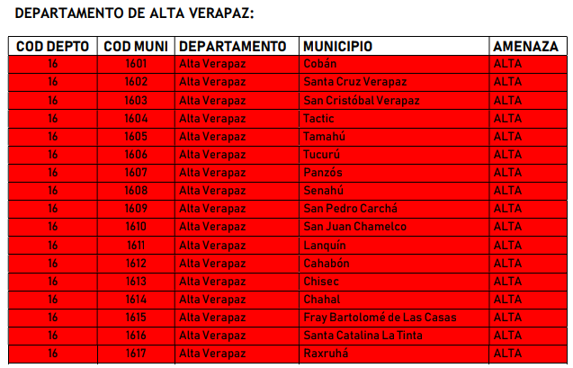
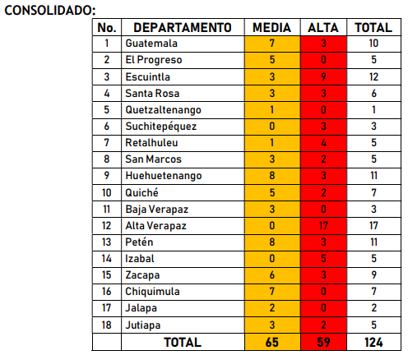

- Total number of people impacted, with breakdown of adults vs. children and by gender

Consolidated number of incidents due to the tropical phenomenon ETA
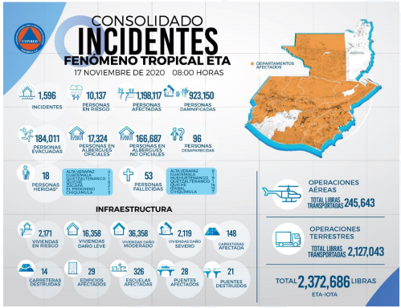

- 1.596 incidents reported
- 10,137 people at risk
- 1,198,117 people affected
- 923,150 people damnified.
- 184,011 people evacuated
- 17,324 people in official shelters
- 166,687 people in non-official shelters
- 96 dissapeared
- 53 deceased
Updated: november 17. 8:00 hours. Source CONRED. https://conred.gob.gt/emergencia/ file:///C:/Users/jairoh/OneDrive%20-%20ChildFund%20International/Desktop/FY2021/RRD/ETA/SITREPS%20CONRED/DRE_20201117_01_Informe%20Ejecutivo_Hurac%C3%A1n%20y%20TT%20ETA.pdf

- Number of people injured/dead/missing/etc. (cite sources)
National level, updated by CONRED, November 17
Injured: 15
Dead:53
Missing: 96
Detail of effects by department.
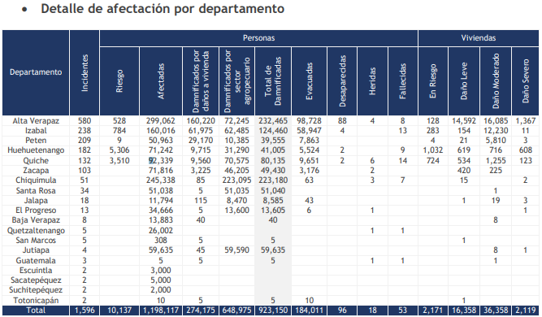
Source: CONRED. Updated: November 17 2020, 8:00 horas https://conred.gob.gt/category/emergencia/emergencia-eta/
file:///C:/Users/jairoh/OneDrive%20-%20ChildFund%20International/Desktop/FY2021/RRD/ETA/SITREPS%20CONRED/DRE_20201117_01_Informe%20Ejecutivo_Hurac%C3%A1n%20y%20TT%20ETA.pdf

- For conflict/displacement situations, basic information on the parties to the conflict and their positions, developments in negotiations, etc.

Una cantidad considerable de población se ha visto afectada y han tenido que abandonar sus hogares

Shelter situation. Updated November 17 2020, 8:00. https://conred.gob.gt/category/emergencia/emergencia-eta/
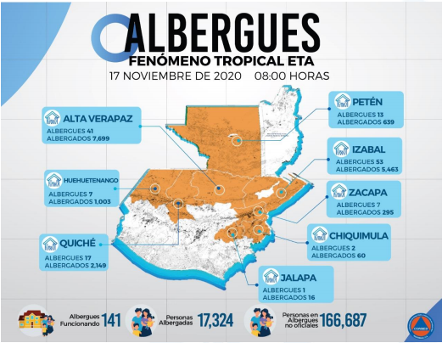
141 active shelters
17,324 persons in official shelters
166,687 persons in non-official shelters
As unofficial shelters it refers to shelters implemented in an improvised way by the own communities.
“At the time of the urgent humanitarian needs assessment in the 52 authorized shelters, official and unofficial, in the municipalities of Cobán, San Pedro Carchá, San Juan Chamelco and Panzós, in the department of Alta Verapaz, the population reported in the shelters in total it was 4,954 people, making a total of 884 families, each family having an average of 5.6 members. With 44% of shelters officially listed by the departmental COE Emergency Operations Center, while 56% correspond to shelters enabled by the same population in support of the affected population.
The municipality of Panzós is where it is concentrated the largest number of people housed, with a total of 2,139 people
Within the sheltered population managed to identify the need to establish protection actions for children find in the places of accommodation, the most of them do not have spaces friendly nor with protection measures for infants, there are no areas equipped for games, so the level of stress and lack of recreation and occupation are evident.
It was determined that the shelters evaluated are spending the night a total of 31 pregnant women, of whom it was not possible to determine that they continue with their control native; for them the overcrowding in the shelters and the lack of conditions to stay overnight can contribute to generating complications in the pregnancy”
(Source: Mercy corps, CENACIDE. November 14, 2020. EMERGENCY HUMANITARIAN NEEDS ASSESSMENT IN ACCESSIBLE, OFFICIAL AND UNOFFICIAL SHELTERS, DUE TO THE IMPACT OF TROPICAL DEPRESSION ETA IN THE DEPARTMENT OF ALTA VERAPAZ, GUATEMALA) file:///C:/Users/jairoh/OneDrive%20-%20ChildFund%20International/Desktop/FY2021/RRD/ETA/EVALUACION%20DE%20NECESIDADES%20MC%20Y%20CENACYDE.PDF
All these conditions can easily be generalized to the situation of shelters throughout the country and can even be aggravated in places where a full assessment has not been possible due to lack of access.

- Host government posture, have they declared a state of emergency and/or requested outside assistance?

- They have already released funds at the time of the emergency declaration and are requesting humanitarian aid from international community. The official governmental call for aid is annexed.
- https://conred.gob.gt/documentos/base_legal/DCS_20201106_Estado_De_Calamidad_DT_ETA.pdf
- https://conred.gob.gt/guatemala-realiza-llamamiento-internacional-por-eta/

Part 2: The Situation in Areas Where ChildFund Works
- Do we have current local partners/programs in the affected area?
Damages have been reported in two areas: Q’eqchi-Achi’ (Alta Verapaz, 3 municipalities: Panzos, La Tinta y Santa Cruz) area and Western Highland areas (Huehuetenango, 2 municipalities Cuilco y Aguacatán). 2 local partners ADP and Tierra Nueva are involved in the response to some of the communities.
Santa Cruz, Alta Verapaz is outside the intervention area but, due to the impact and response capacity of the authorities, this has been defined as an area of action for humanitarian aid.

- How many children and families are affected?
As assessments are getting more in-depth, more families in need are being identified. Initially, this is a table with data on families that need support and could be helped by ChildFund, both in areas where there is programmatic or project intervention and in others where there is not, but the impact of the rains was very strong and It requires joining efforts with other organizations and government authorities to bring humanitarian aid:
department | Municipality | communities | CF presence | LP | Families | Adults | children | Female children | Male children
Alta Verapaz | Panzós | Xucup Panla and Chivich | Yes | ADP | 45 | 86 | 188 | 96 | 92
Alta Verapaz | La Tinta | La Tinta | Yes | ADP | 32 | 61 | 134 | 68 | 66
Alta Verapaz | Panzós | Sepur Zarco | NO | ADP | 151 | 289 | 631 | 322 | 309
Alta Verapaz | Santa Cruz Verapaz | Chitul, Chixajau, Acamal, Pambach | NO | ADP | 124 | 65 | 519 | 265 | 254
Huehuetenango | Aguacatán | Xenaxicul | Yes | Tierra Nueva | 153 | 292 | 640 | 327 | 314
Huehuetenango | Cuilco | Boqueroncito Alto, Aldea Agua Dulce. Caserío Flor del Café, Santa Rosa, Los Rosales | yes | Hermana Tierra-CONFIO | 126 | 240 | 527 | 269 | 258
Totals |  |  |  |  | 631 | 1032 | 2639 | 1347 | 1294

- What issues are children in these areas facing? (food shortages, safety concerns, homes or schools destroyed, etc.)

Food shortages, security problems, destroyed houses
Risk of illness, cold, fever, lack of medication, lack of adequate nutrition
Lack of clothes, beds and sheets.
Food security assistance for economic recovery.

Communities with ChildFund presence

- Q’eqchi’-Achí area (Panzos, La Tinta y Santa Cruz, Alta Verapaz)

One of the most affected areas is the communities in the Polochic basin in Alta Verapaz (North-east). Following up on the situation of the communities caused by the hurricane and then tropical depression ETA, although it is true the rains continued at night on Thursday 05 to dawn on Friday 06, stopping raining in the morning, even reporting sunny periods of time, as previously reported. The affected communities are:

1. Xucup-Panlá, Panzós
2. Chivich, Panzós
3. Cantihá, La Tinta

It is worth mentioning that most of the evacuated people are no longer in the shelters, that is to say that some have returned to their homes to clean them and others to repair them. There is no adequate information in the places where they were housed, because given the emergency, they surely gave more emphasis to meeting the basic needs of the families at that time.

The sum of the families that inhabit the three communities amounts to 705, those directly affected including community (registered and non-registered / community) amounts to:

Community | Number of families
1. Xucup-Panlá, Panzós | 30
2. Chivich, Panzós | 15
3. Cantihá, La Tinta | 32
Total | 77 families

Most of the inhabitants of the Caserio Kantiha, are dedicated to agricultural activity with which they generate income through commercial activities of products such as corn, beans, achiote, sweet potato, chili, marzipan, plantain, bananas. It is worth mentioning that the harvests are temporary and some are grown annually. One of the needs is also the lack of job opportunities and that does not favor the community since they do not have economic resources to cover the needs of the family.

Due to material losses and their crops, families do not have a source of income or a means to support their families, so they need cash to start farming activities again and to generate their own income.

Most of the inhabitants of the Caserio Kantiha, are dedicated to agricultural activity with which they generate income through commercial activities of products such as corn, beans, achiote, sweet potato, chili, marzipan, plantain, bananas. Other people in the community are also dedicated to raising animals (chicken and pigs) and a small number of people are dedicated to micro-businesses, an activity for which they do not acquire remuneration, other than from their own earnings that they can obtain or reach to meet their needs, unfortunately during the passage of tropical storm ETA all the crops of the inhabitants were totally destroyed because the entire community was flooded. Its topography indicates that it is a flat space, its geographical coordinates are the following N 1517963 W 89 49 810 32 the altitude of the municipality oscillates between 100 meters above sea level,

The southern part of the Xucup community is the part where agriculture is concentrated due to the fertile soil and flat area, in it the following crops are produced: corn, beans, blackberries, Yuca, tomato, coriander, squash, rice, chili and papaya. The crops produced by the families take advantage of it by going to sell them in the local market in order to obtain income and thereby meet their needs. Faced with this storm, the floods damaged the families' crops in their entirety. Local partner estimate the following extensions.
Chile = 27.27 Hectares
Corn = 83.95 Hectares
Beans = 4.54 Hectares
Bananas = 45.45 Hectares
Tomato = 6.81 Hectares
Yucca = 2.27 Hectares
Rice = 2.72 Hectares
Papaya = 2.21 Hectares
estimating a loss that ranges between 50 and 100 thousand quetzales.

Of 155 families in the community, they lost an average of 775 “tareas” (measure unit) of milpas, equivalent to 32 hectares, the crop was destined for the consumption of the families, these data indicate that soon the families will enter into a food crisis, even putting their lives at risk of infants, children and adolescents, to an excessive malnutrition that the Ministry of Health will not have the technical capacity in care.
The families affected by the floods in the Xucup community lack food such as basic grains, beans and corn, as well as children who need basic food (priority 1), cleaning supplies while the state of calamity lasts. an approximate of 10 units per essential item. Within the community there is a shortage of piped water due to the damage caused to the pipes.
Despite the damage to crops, human needs go back to better housing, improved roofs and drainage
According to the residents in Santa Cruz Verapaz, the school in the Chitul village is completely flooded and several neighboring houses. (El Periodico. Published 04-11-20).
According to the LP ADP and their contacts in 2 municipalities: 180 families identified in need from several communities of Santa Cruz, and 151 families from the community of Sepur Zarco on the Panzós municipality. The main necessities identified are: Mattresses, ponchos, mosquito nets and kitchen utensils.
- Western Highlands – Tierra Nueva:
The most affected areas are the upper part of Chiantla, the inter-American highway to La Democracia and the community of Xenaxicul in the municipality of Aguacatán. Fortunately, human losses are not reported in the communities.

When monitoring, the most affected area has been the community of Xenaxicul de Aguacatán, therefore, due to the fact that the municipal authorities have not provided support or accompaniment to this community, the authorities limit themselves to providing information. Faced with this situation, they proceeded to the phone calls to each of our families to make a diagnosis about it, 153 families were determined as directly affected and will be attended by the local partner with humanitarian aid.

These families have totally lost the crops, which would serve them to supply themselves with food and generate income, this affectation infers in the null or limited access to food from the municipal seat for the community, harming their families.

- Western Highlands – CONFIO Project
On November 5, it causes severe damage to communities in the municipality of Cuilco, Huehuetenango, which are detailed in the following table:
community | # affected families | # affected persons | # sheltered families | Required support
Boqueroncito Alto | 40 families | 5 members per family 200 persons. | 40 families | Food baskets  First aid medicines  Other medicines
Aldea Agua Dulce. | 30 families | 150 persons | 30 families | Toilet paper  First Aid kit
Caserío Flor del Café , aldea Agua Dulce | 10 families | 60 persons. | 10 families | First Aid kit.  Medicines.
Santa Rosa | 40 families | 200 | 40 families | First Aid kit.
Los Rosales | 6 families | 30 Persons | 6 families | First Aid kit.
Aldea Oaxaqueño. |  |  |  | Food basquets

- Child protection risks caused or exacerbated by crisis situation.
Due to the continuation of the rains, the risk of the situation of children increases, especially their health.
In shelters no COVID protocols were implemented during the first response.
Lack of food.

Part 3: ChildFund’s Response

To date, the Local partner is coordinated with the authorities to follow up, to house families and provide immediate food and in the next few days will specify the actions.
The local partners made a quick diagnosis of the damages in the affected communities, maintaining direct contact with local authorities and local volunteers.
Q’eqchi-achi’ area:
Local partner ADP has delivered food baskets to 43 enrolled families as an early response.
An additional aid was delivered in kind on November 12 to 75 families (including those 43 who received aid in the early response) through the coordination with the marketing specialist and a local NGO “13 aguas”.
ADP has identified the necessity of 257 more families in geographic areas where we don’t have programmatic intervention. But because of the heavy impact of the rains require assistance with mattresses, sheets and mosquito nets.
-
Communities and families to be supported in Panzos, A.V.

No. | community | category | Distance from municipality | Road | Affected families to receive assitance
1 | Se Pur Zarco | Aldea | 40 Km | Dirt road | 151
Sub total affected families |  |  |  |  | 151
Communities and families to be supported in Santa Cruz Verapaz , A.V.
No. | community | category | Distance from municipality | Road | Affected families to receive assitance
1 | Chitul | Aldea | 4.5 km | Dirt road | 36
2 | Chixajau | Aldea | 3.5 Km | Dirt road | 12
3 | Acamal | Aldea | 2.5 Km | Dirt road | 59
4 | Pambach | Aldea | 15 Km | Dirt road | 17
Sub total affected families |  |  |  |  | 124
Total of affected families to be aided |  |  |  |  | 275

These families will be helped with additional funds from CO executed by ADP LP.

Western Highlands

With the diagnosis made and the information obtained from the community, Tierra Nueva delivered assistance to 153 families of the community of Xenaxicul de Aguacatán, Huehuetenango. They delivered bags of food for the equivalent of 38 US$ to each family (a total of $6,040) and will make an assessment on the field to determine the structural damage of some houses through a physical evaluation with an observation technique, filling out a verification form of the damage to the houses and subsequently submitting a real proposal to see the possibility of providing home repair care to these families.

It is worth mentioning that direct access to this community, so far is nil, to reach it and transfer food it will be necessary to enter through the municipality of Sacapulas, Quiché, otherwise you would have to be transshipped through the risk on the road (bridges) and the overflowing of rivers that are part of the traffic.

Below Sections for Internal Use Only
- Staffing and Security
  - Which staff are on the ground? Please include names, functions, contact information and arrival/departure dates for both IO and CO staff on the ground.
The Office Staff due to the context of Covid and the mobilization situation is not in the field, we are monitoring remotely, but the members' staff if they are in the field as necessary, especially the technician who attends this area.

  - Who is or will be leading/managing the response? (if applicable)
The country's SMT Team.

  - Any gaps in staffing/need for deployment from other COs or Global Teams?
Not as this moment.
  - Confirm the safety of staff and their families in the affected area.
No Staff in danger have been reported, and the emergency communication network is applied
  - Safety and security risks/mitigation plans
No traveling until event ends. Keep ready an Emergency Kit, sufficient water reservoir, medical kit, family communication plan, communication devices with extra batteries, lightning devices, monitor official radial /TV news, identify high areas and local shelters
  - Recommendations around any upcoming travel planned for staff or donors.
Donors nor Staff should travel while the event lasts.
  - Are there any other major HR issues?

- Sponsorship and Grants
  - Will this impact sponsorship activities like correspondence and DFCs?
- The delivery times of correspondence will be affected by damage to the communication channels.
  - Total number of sponsored children in the affected area, by project number.
- ADP: 43 families
- Tierra Nueva: 95 families

  - Confirm status of sponsored children in the area, are all accounted for?
- Yes.
  - List any active grants in the affected area – name of grant, donor, and primary implementer
- CONFIO: Cuilco, Huehuetenango. Hermana Tierra.
- Juega conmigo: Alta Verapaz. ADP

  - Will grant execution be impacted by the emergency situation?
- Yes. Activities will be delayed since families will attend the recovery of livelihood conditions.

- Donors
  - Provide information about potential sources of funding (including grant donors, subsidy, Emergency Action Fund, Alliance members, GIK, etc.) for these emergency response efforts using the chart below.

As soon as there is information on the affected people and the needs, proposals will be made

Donor | Program | Amount (USD) | Requested? (Y/N) | Confirmed? (Y/N)

- Budget
  - Outline how we will use this funding with a rough topline budget.

Secured funds

Funding Source | amount | Local partner | Geographic location | actions to take
Subsidy funds | Q 12,900 | ADP | Panzós y la Tinta, Alta Verapaz | Delivery of food bags for 43 registered families (delivered)
Asociación 13 aguas | US $ 2850 | ADP | Panzós y La Tinta, Alta Verapaz | Delivery of bags of food for 75 families (delivered)
Subsidy funds | US $ 6,000 | ADP | Panzós y la Tinta, Alta Verapaz | support for food security for 77 families from Polochic for 2 months (January and February)
Subsidy funds | US $ 25,000 | ADP | Santa Cruz and Panzós, Alta Verapaz | support to families from Santa Cruz and Panzós: 124 families identified in Santa Cruz and 151 families from Sepur Zarco, Panzós identified as needs: mats, sheets, mosquito nets.
Subsidy funds | US $ 1,634 | ADP | Panzós y La Tinta, Alta Verapaz | support to 43 families for food security for 1 month (December)
Subsidy funds | US $ 6,040 | Tierra Nueva | Aguacatán Huehuetenango | support to 153 families with food bags for 1 month (will be delivered on November)

Identified needs:
LP | Geographic location | Need description
Tierra Nueva | Aguacatán Huehuetenango | support to 15 families registered for the reconstruction of houses: sheets, notepads, cement, gravel, labor.
Tierra Nueva | Aguacatán Huehuetenango | support to 153 families for food security for 2 months and rehabilitation of livelihoods
ADP | Panzós y La Tinta, Alta Verapaz | support to 77 families for food security for 2 months and rehabilitation of livelihoods
ADP | Panzos (Sepur Zarco community) and Santa Cruz Verapaz, Alta Verapaz | Support for 275 families outside of our areas with programmatic intervention for food security for 2 months.
Hermana Tierra | Cuilco, Huehuetenango | Support to 126 families with cash transfers for food security x 2 months and rehabilitation of livelihoods
CO | 5 municipalities: Santa Cruz, Panzós, La Tinta de Alta Verapaz y Aguacatán y Cuilco de Huehuetenango. | hiring 5 psychologists and 1 coordinator for 3 months
CO | 5 municipalities: Santa Cruz, Panzós, La Tinta de Alta Verapaz y Aguacatán y Cuilco de Huehuetenango. | communication products: flyers, videos and audios.
CO | 5 municipalities: Santa Cruz, Panzós, La Tinta de Alta Verapaz y Aguacatán y Cuilco de Huehuetenango. | kits for psychosocial care
 | 5 municipalities: Santa Cruz, Panzós, La Tinta de Alta Verapaz y Aguacatán y Cuilco de Huehuetenango | Monitoring and reporting, ground transportation logistics

ubicación | Food security kit | Hygiene kit | Seed kit | House rehabilitation | Beds, sheets and mosquito nets | psychosocial care
Panzós y La Tinta, Alta Verapaz (areas con intervención programática) | 77 | 77 | 77 | 0 | 77 | 77
Panzós, comunidad de Sepur Zarco (areas sin intervención programática) | 151 | 151 | 151 | 0 | 0 | 151
Aguacatán, Huehuetenango | 153 | 153 | 153 | 15 | 153 | 153
Cuilco, Huehuetenango | 126 | 126 | 126 | 0 | 126 | 126
Santa Cruz, Alta Verapaz | 124 | 124 | 124 | 0 |  | 124
Total entregas | 631 | 631 | 631 | 15 | 356
Costo por familia en $ | 63.41 | 63 | 30 | 645 | 60
Total dólares | 40,012 | 39,753 | 18,930 | 9,675 | 21,360 | 88,171

Total funds needed: $ 217,901 for 631 families.
- Media/Communications
  - List of media who will be or have been contacted with press releases
  - List of emergency spokespeople, including name, location, contact information, and languages spoken
  - Plans for collecting photos/videos/stories, i.e. should an outside photographer be hired?
  - Key points for messaging and visibility, particularly any host government sensibilities that must be considered.

- Support needed or requested from IO, GSS or Global Teams – whether onsite or remote.
Sitreps translations and effective identification of funding sources

