**ChildFund International**

**Humanitarian Situation Report**

**Humanitarian Situation Report # 3**

**ETA – IOTA Tropical Strom – Honduras**

**November 18th, 2020**

**Point of Contact**

**Jorge Bejarano, +504-9977-5106 jbejarano@childfund.org**

**Daysi Kocchiu, +504-3363 1748** [**dkocchiu@childfund.org**](mailto:dkocchiu@childfund.org)

**11/13/2020 – 11/18/2020**

**Part 1: The Overall Situation**

* **Sources of Information:**
  + United Nations, Honduras: Situation Report No. 2 to November 8, 2020.
  + SITREP 1 and 2 of Local Partners ADASBA and CASM, with information gathered in the field by staff, community leaders and shelter spokespersons as of November 10, 2020.
  + Honduran Red Cross, Honduras Security Forum
* **Name, time and date of emergency**

Tropical Storm ETA, 16:00 hrs Local Time, 11/12/2020

Hurricane IOTA, 12:00 hrs Local Time, 11/18/2020

* **States/regions/areas of impact**
* The Government of Honduras declared the emergency by ETA on November 2, 2020 through Executive Decree Number PCM-109-2020 published in the La Gaceta newspaper.
* The Departments of Cortés, Yoro, Santa Bárbara, Atlántida, El Paraíso and Colón are the most affected regions.
* IOTA was formed on November 13th 2020. It was located 960 km East from Cabo de Gracias a Dios and had 55 km/h sustained winds and a deployment speed of 11 km/h headed slowly to the South-West of Honduras. It gained strength and reached the Category 5 in the Saffir –Simpson scale.
* It entered Nicaragua territory on Monday November 16th and follow through Honduras territory Tuesday November 17th afternoon. The first Department to be impacted directly by IOTA´s winds and rainfall was Gracias A Dios.
* The hurricane entered as a Category 1 hurricane with winds around 120-150 km/h and lots of heavy rainfall. In the Mosquitian coasts tides between 8-12 feet were expected.
* At first, IOTA was supposed to drive through Nicaragua, Honduras and Guatemala. 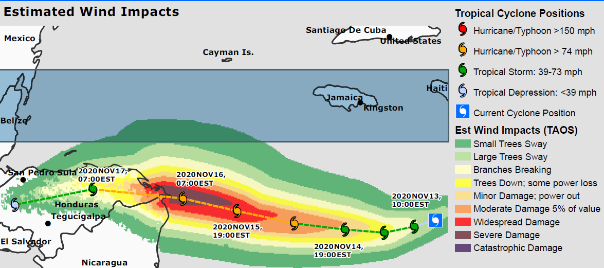
* Later, it changed its course to Nicaragua, Honduras and would disseminate in El Salvador. However, the wind bands loaded with rainfall will always affect all mentioned territories.

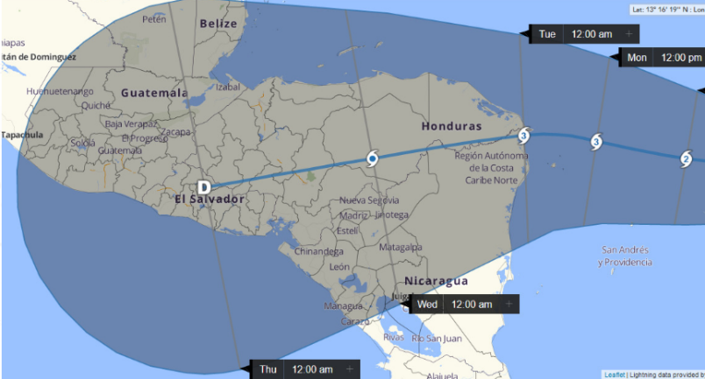

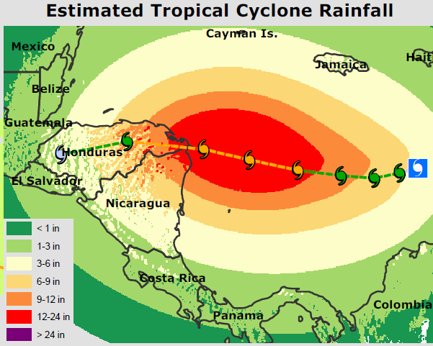

* Considering the severe damages IOTA would leave, COPECO issued a mandatory evacuation for all the areas that were previously affected by Tropical Storm ETA and extended to nearby vicinities. The flooding damages expected from IOTA were considerably superior to those ETA storm left.
* Inner areas of the following departments that were issued the mandatory evacuation were Gracias a Dios, Atlántida, Colón, Cortés, Yoro, Francisco Morazán, Olancho, Choluteca, El Paraíso, Valle.
* Incredibly as it seems, in both natural phenomena, the GOH didn´t mentioned Santa Bárbara. This department did suffer of vast damages in all areas. Be those areas, crops plantations, housing, road and bridges infrastructure, communications, rivers basins over flooded, etc.
* Other areas obliged to evacuate were;

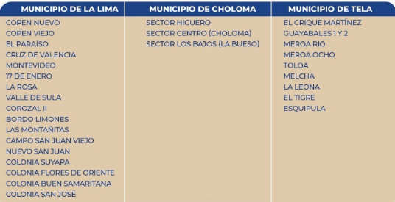

* To aid in the collection of incoming water flow, the Francisco Morazán Dam initiated a three-day program of water discharge.

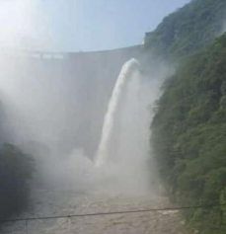

* **What infrastructure/systems have been affected**
* As of November 11, more than 722 isolated communities with some 102,424 isolated people, 21 bridges destroyed and 32 damaged, in addition to around 124 damage to road infrastructure throughout the national territory. More than 230,000 acres of damaged or affected crops are reported.
* There is no official information (COPECO) on the situation in the municipalities of El Progreso, Choloma and Puerto, nor the Department of Santa Bárbara. Regarding Santa Bárbara, CASM and ADASBA report significant damage to the accesses to the communities in which ChildFund develops the program models: collapse of bridges, main and secondary roads.
* Fall of the Gualala bridge leaving the municipalities of Atima, San Vicente and Nuevo Celilac incommunicado.
* Fall of the Jicatuyo bridge that gave access from Nuevo Celilac to the municipality of San José de Colinas, these communities were left without access to Santa Bárbara or San José de Colinas.
* Bridge over the Ulua river, isolated in the Trinidad sector.
* Puente Aguagua leaving the communities of San Vicente, San Nicolás, Arada, Níspero, Nuevo Celilac, Macholoa, Tierra Blanca, El Tontolo, San Jerónimo, Santa Cruz, El Pinal, Santa Rita, Obrajes, El Jololo isolated.
* Communities of ILama in the village of San José de Oriente are and communities of Gualala Arenales, Guacamaya, Lomas del Águila, Platanares cut off due to bridge collapse.
* Communities of La Cuesta, Los Bancos, La Zona, Los Cerritos, La Zona and Barrio La Libertad cut off due to the overflow of the Cececapa river, blocking access with water and sediment of wood, earth and stone.
* Tencoa community cut off due to the flooding of the Ulúa river, directly affecting 10 families in the lower part of the village.
* Communities of Las Crucitas, El Zapote, Las Palmas, Santa Ana, El Edén, La Vueltaza incommunicado due to a collapse in the road at the entrance to the Las Crucitas communities.
* Communities of Azacualpa, Canculunco, Santa Ana, Agua Caliente, Mojarras, Plan de Encima, El Tablon cut off due to the overflow of the El Vado stream.
* The span of time between both phenomenon’s was around 7 days, so, the damaged infrastructure left by Tropical Depression ETA is the same damaged by IOTA but worst. Meaning worst, the housings that in a way resisted ETA impact, were easily destroyed by IOTA´s impact, breaches on interrupted roads by ETA were widen by IOTA and so forth.
* Damaged Infrastructure as of Nov 18/2020.
  + Tencoa Bridge, connection between Tencoa and Gualala communities in Santa Bárbara.
  + Road sector destroyed b/w Trojes and Danli municipalities in El Paraíso.
  + Road sector destroyed b/w Olanchito and Sabá Municipalities in Yoro.
  + Road half sector destroyed b/w La Esperanza and MArcala in Intibucá.
  + Road half sector destroyed b/w San Francisco de La Paz and Gualaco, in Olancho.
  + Landslide in CA-5 Road in EL Balín, Pimienta Cortés.
  + River overflow in CA-13 road b/w El Progreso and Santa Rita in Yoro.
  + Road Flooding b/w El Progreso and SPS, East Boulevard, Cortés.
* **Any relevant background information about areas affected**

Damaged drinking water systems in most affected communities. Likely food shortages due to access problems in many communities. More than 35,000 people in Santa Barbara without access to clean water and electricity intermittently.

* **Total number of people impacted, with breakdown of adults vs. children and by gender. Number of people injured/dead/missing/etc. (cite sources)**

As of November 11 (COPECO, update N ° 32, 4 am.) At the national level, 2,712,772 people affected, 58 deaths, 58,054 people rescued, 432 active shelters, 8,968 families sheltered, 43,899 people sheltered, 17,281 homes affected, 645 homes damaged, 52 homes destroyed, 7 educational centers, damaged by the effects of Tropical Storm Eta.

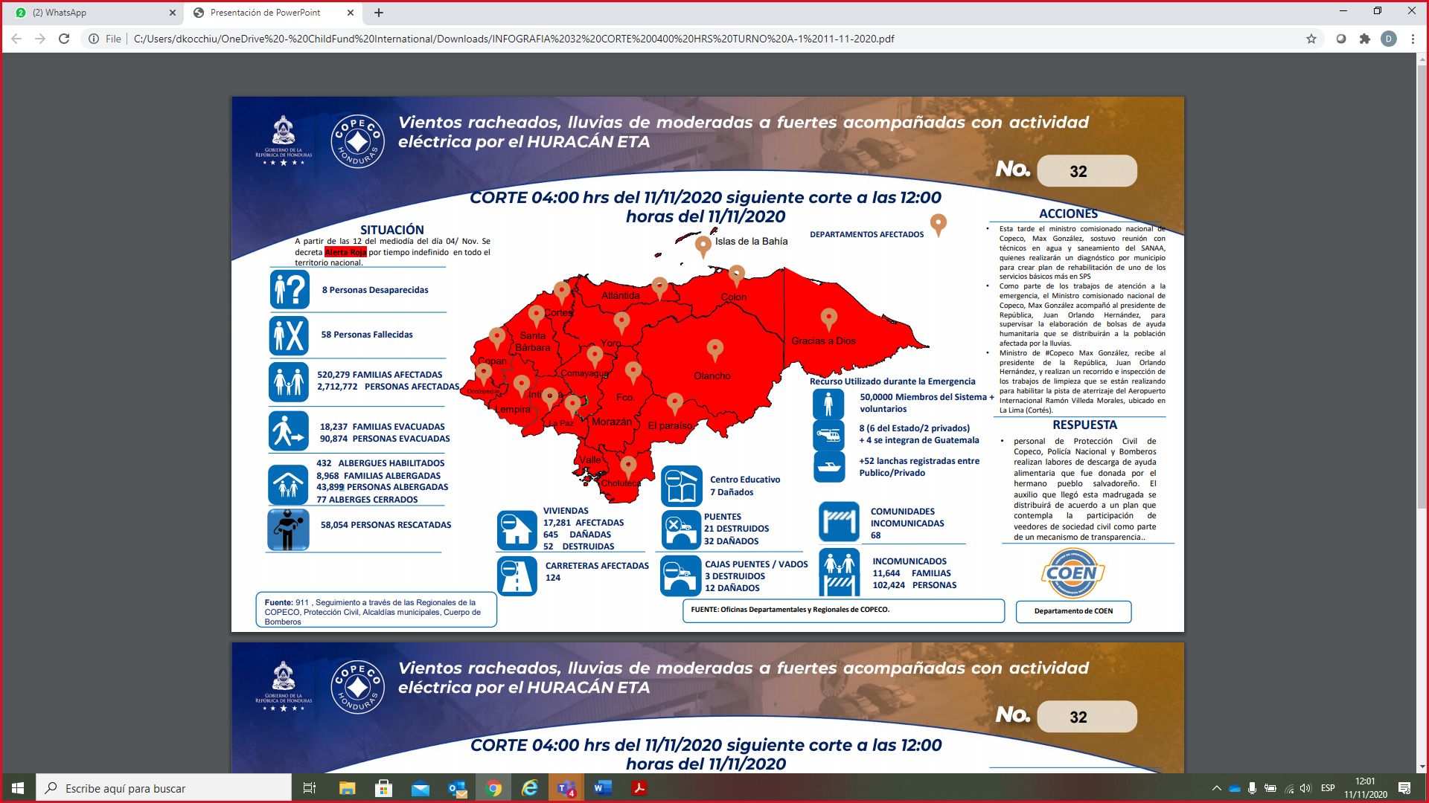

From Nov 15 to Nov 18 at 0700 hrs., COPECO issued the following report:

* 0 missing persons.

* 0 deceased persons (though, 5 deceases are to be determined).

* 3,587 Evacuated Families representing 10,326 individuals.

* 750 active shelters.

* 14,472 sheltered families representing 71,228 individuals

* 142 closed shelters.

* 54 landslides.

* 7,556 affected houses, 57 damaged and 3 totals lost.

* 39 road sectors affected.

* 79 rivers, river basin overflowed.

* 4 damaged Bridge (officially).

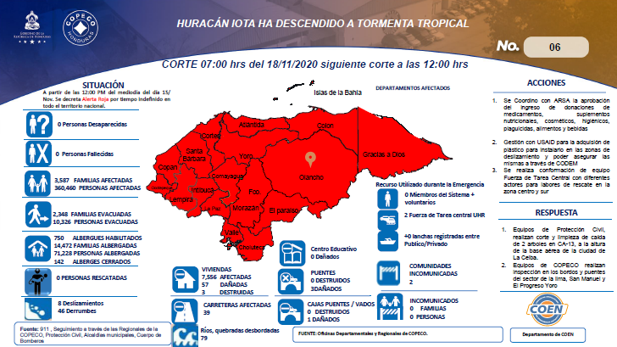

* **Host government posture, have they declared a state of emergency and/or requested outside assistance?**
* The Government of Honduras declared the emergency by ETA on November 2, 2020 through Executive Decree Number PCM-109-2020 published in the La Gaceta newspaper.
* The Central Government and humanitarian aid from civil society organizations (NGOs, United Nations, private companies, among others) are prioritizing support to the cities most affected on the north coast of the country, the area most affected by the tropical storm ETA. Humanitarian support initiatives are developed mainly from community-based organizations and civil society.
* As of November 11, preliminary information indicates that the Ministry of Health will allocate 100,000 rapid tests for the shelters, the BCCIC has offered 250 million dollars for reconstruction in Honduras, the WFP will send 1,500 tons of food for those affected.
* GOH through the Finance Secretariat has transferred funds to all 298 municipalities and has authorized that these funds can be used to attend and mitigate IOTA damages.
* GOH, President JOH presented to the G-16member the severe damages left by ETA and IOTA and requested Humanitarian and Reconstruction assistance for Honduras. Apparently, G-16 members agreed to work with GOH as fast as possible. Some countries have already started to initiate their donation´s processes.

**Part 2: The Situation in Areas Where ChildFund Works**

* **Do we have current local partners/programs in the affected area?**
* Yes, we have operations in the Department of Santa Bárbara through local partners ADASBA and CASM, with a presence in 15 affected municipalities.
* Through the CONFIO Project we have interventions in the municipalities of Puerto Cortés and Choloma, Department of Cortés and El Progreso in the Department of Yoro.
* **How many children and families are affected?**
* In Santa Bárbara, the local partner ADASBA reports as of November 9, 1,160 people evacuated and sheltered, 21 injured, 2 missing and 5 deceased in 12 municipalities of Santa Bárbara (Gualala, Ilama, Zacapa, El Níspero, Concepción Sur, San Vicente Centenario , San Nicolás, Ceguaca, Arada, Nuevo Celilac and San José de Colinas).
* As of November 12, the local partner CASM reports 187 people evacuated and sheltered in 4 municipalities: San José de Colinas, Atima, Nuevo Celilac and Naranjito.
* At the departmental level, a total of 1,474 people evacuated and sheltered are reported in 15 municipalities of the Department of Santa Bárbara.
* In 12 municipalities of Santa Bárbara, according to the available information provided by the partners ADASBA (November 9, 2020) and CASM (November 11, 2020), the most affected population is made up of 354 families with 1,347 members among boys, girls, adolescents , young people and adults who were severely affected in their family homes, for which, they have been forced to relocate to shelters and homes of their relatives.





In the municipalities of Choloma, Puerto Cortés and El Progreso, families were significantly affected. The intense rains have impacted 29 young participants in the CONFIO Project and their families, including entrepreneurs, who have lost their crops or have suffered significant damage to their business infrastructures. One of the entrepreneurs, specifically, Jose Rubí from Aqua tile, producer of papaya, tilapia, and banana suffered losses and damages due to the passage of ETA. Some communities have been cut off due to damage to telecommunication networks and the collapse of bridges. Some of the participants are now affected, 158 are reported and have left their communities, waiting to settle in a shelter. 165 are housed together with their families, they receive care in family homes, churches, schools, community centers, and other spaces converted into shelters, where there are people of all ages.

|  |  |  |  |  |
| --- | --- | --- | --- | --- |
| **Municipio** | **Cantidad de comunidades por municipio** | **Cantidad de jóvenes afectados por municipio** | | |
| **F** | **M** | **T** |
| Choloma | 6 | 12 | 2 | 14 |
| Puerto Cortés | 6 | 4 | 4 | 8 |
| El Progreso | 6 | 4 | 3 | 7 |
| **Total** | | **20** | **9** | **29** |

It should be noted that this information is preliminary, the Project team is conducting an information survey of young people and their families affected by the storm. To do this, it is contacting young people through an online instrument. However, due to communication difficulties, at the close of SITREP 2, there was initial information on 29 young people and their families, that is, 185 people. In the following days, other young people will continue to be contacted, for which it is coordinating with the Choloma Chamber of Commerce and Industries for the dissemination of this consultation.

* As of November 17, according to the available information provided by the partners ADASBA (November 17, 2020) , the most affected population is made up of 667 families with 2,252 members among boys, girls, adolescents , young people and adults who were severely affected in their family homes, for which, they have been forced to relocate to shelters and homes of their relatives (approximately 20 shelters).



At the close of the SITREP it was not possible to have updated information from the CASM local partner and the CONFIO Project due to the limited access or communication with the communities, because of the electric energy cut or the affected roads as a result of the storm IOTA.

* **What issues are children in these areas facing? (food shortages, safety concerns, homes or schools destroyed, etc.). Child protection risks caused or exacerbated by crisis situation.**

Risk of sicknesses, cold, fevers, lack of medication, lack of adequate nourishment, being in shelters exposes child´s safety. Increase in the probability of contagion of COVID 19 in shelters, which according to sources from the Honduran Red Cross has risen by 13% positivity in shelters in Santa Bárbara.

**Part 3: ChildFund’s Response**

On November 10, the Honduras Office began the first stage of the ETA Emergency Response with the prioritization of humanitarian support to families who are in shelters in the most affected municipalities in the Department of Santa Bárbara by delivering to each family (depending on the number of people in it) of: a non-perishable food kit, a toilet kit, a personal biosecurity kit, a daily life support kit and an information pack on child protection and safety measures. biosecurity (RecreArte: Notebook to paint on COVID 19 hygiene prevention, 3 printed infographics on Roadmap Community Protection Mechanisms, Alarm Signs to identify sexual abuse, Physical and emotional abuse).

For each shelter, provision has been made for the supply of a biosafety supply package, a game kit and educational material for children and adults; and with the leader or person in charge of the shelter there will be a socialization on the management of shelters for which the friendly document shared by UNICEF Honduras “Practical Guide for the Planning, Assembly and Coordination of Temporary Shelters” of the government of El Salvador will be used with support UNICEF, IOM and Save The Children technician). On November 9, the Country Office authorized the ADASBA partner to redirect the COVID 19 Response funds corresponding to the months of November and December 2020 (Lempiras 342,729.47 / US $ 14,006); and on November 12, the CASM partner approved the reorientation of the same funds in the amount of L. 229,444.00 / US $ 9,376). On November 11, the Country Office authorized additional subsidy funds to the budget of the approved FY21 POA of the local partners ADASBA and CASM, consisting of $ 27,000, which will be distributed 70% for the ADASBA area and 30% for the by CASM.

On November 16 and 17, prior to the entry of the storm into the country, daily meetings have been held with the three local partners, monitoring the situation and supporting the three local partners with reliable information and guidance (with the technical assistance of the regional DORM Jorge Bejarano).

**Below Sections for Internal Use Only**

* **Staffing and Security**
  + **Which staff are on the ground? Please include names, functions, contact information and arrival/departure dates for both IO and CO staff on the ground.**

CONFIO Project personnel are based in the area affected by the ETA Storm, two of them being directly affected.

* + **Who is or will be leading/managing the response? (if applicable)**

CF-HN Senior Management Team, Multi Country Team assistance.

* + **Any gaps in staffing/need for deployment from other COs or Global Teams?**

Not as this moment.

* + **Confirm the safety of staff and their families in the affected area.**

Colleagues Yohana and Elena Elvira Flores from the CONFIO Project suffered material damage to their family homes.

* + **Safety and security risks/mitigation plans**

No traveling until event ends. For LP staff (ADASBA and CASM), keep ready an Emergency Kit, sufficient water reservoir, medical kit, family communication plan, communication devices with extra batteries, lightning devices, monitor official radial /TV news, identify high areas and local shelters, biosecurity equipment.

* + **Recommendations around any upcoming travel planned for staff or donors.**

The trips are suspended and are only authorized if there are emergency funds and under the authorization of the Director, following the established safety protocols (road conditions, accessibility of the destination, expertise of the driver for handling a 4WD vehicle on complex terrain).

* + **Are there any other major HR issues?**
* **Sponsorship and Grants**
  + **Will this impact sponsorship activities like correspondence and DFCs?**

We do expect to have a negative impact on the delivery of correspondence and gathering replies from sponsored children, as well as coordinating the delivery of DFCs as the access to some communities has been affected.

The delivery of Sponsor Letters was temporarily suspended for Local Partners ADASBA and CASM. DFCs for November are being processed and will be forwarded to the Local Partners.

* + **Total number of sponsored children in the affected area, by project number.**

|  |  |  |  |
| --- | --- | --- | --- |
| Local Partner | # of sponsored and enrolled children | | Number of children affected by the tropical storm |
| Sponsored | Enrolled |
| CASM | 3749 | 4907 | **Verification in process** |
| ADASBA | 5512 | 6889 | **Verification on process** |

|  |  |  |  |  |
| --- | --- | --- | --- | --- |
| **Local Partner** | **# of sponsored and enrolled children** | | **# of children verified so far** | **Number of children affected by the tropical storm** |
| **Sponsored** | **Enrolled** |
| CASM | 3749 | 4907 | Verification in process | None reported yet |
| ADASBA | 5512 | 6889 | 1040 | 56 |

* + **Confirm status of sponsored children in the area, are all accounted for?**

We recently started to implement a tool to do a headcount of children in the affected areas. LPs have just started to gather this information and we will report as soon as it is readily available to us.

Local Partners have started to check the situation of the enrolled children in the area, prioritizing the communities that have reported damages due to the tropical storms ETA and IOTA.

So far 1040 children have been verified and so far 56 were reported affected by the tropical storm. Those affected are in public shelters, with relatives or at their neighbors since their home has suffered damages.

* + **List any active grants in the affected area – name of grant, donor, and primary implementer**

|  |  |  |  |  |
| --- | --- | --- | --- | --- |
| **Grant Job Code** | **Grant Name** | **Donor** | **Status of Implementation (Normal/Reduced/Suspended)** | **Any specific guidance received from donor? (Yes/No)** |
| 3-0380D | Strengthening the Methodology for the progressive eradication | UNICEF | Normal- Field Activities ended in October | No |
| 25-064D | Safe Water for Children in Honduras | P&G | Normal | Yes redirect 1 pallet of sachets for the emergency |
| 12-0354D | CONFIO | Global Affairs Canada | Reduced | Pendant |

* + **Will grant execution be impacted by the emergency situation?**

Within the framework of the execution of the fourth phase (November 2020 - October 2021) of the Project “Clean Water for the children of Honduras” executed by ChildFund in Honduras and financed by P&G, the delivery by P&G Panama of 4 pallets for the activities planned in the Project. As soon as they are in our wineries, the planned activities will resume, in particular the delivery of the sachets to the participating families. Additionally, P&G will send a pallet whose delivery will be part of the Response to the Tropical Storm ETA Emergency (access to potable water) to families affected by the Tropical Storm ETA in the Santa Bárbara area. For this, it will be coordinated with local partners and the Health Region of said department.

The work to repair damage to the electrical energy infrastructure, connectivity and cellular communication, the limitation of access and public transport in the communities of the municipalities of Choloma, El Progreso and Puerto Cortés, as well as the interruption of commercial activities in El Progreso and San Pedro Sula will affect the programming of virtual training activities in component 1200 given the difficulty of contacting the young participants, especially those most affected. Also the purchasing processes (components 1100 and 1200) will be impacted.

* **Donors**
  + **Provide information about potential sources of funding (including grant donors, subsidy, Emergency Action Fund, Alliance members, GIK, etc.) for these emergency response efforts using the chart below.**

|  |  |  |  |  |
| --- | --- | --- | --- | --- |
| **Donor** | **Program** | **Amount (USD)** | **Requested?**  **(Y/N)** | **Confirmed? (Y/N)** |
| P&G | GIK | $7,946 | **Y** | **Y** |
| SEDIS GOH (Criando con Amor) | GIK | $6,000 | **Y** | **Y** |
| Lutheran World Relief | GIK | $89,200 | **Y** | **Y** |
| ChildFund International | Subsidy Funds | $50,382  ($27,000 new subsidy funds, $23,382 COVID 19 funds) | **Y** | **Y** |
| Local Corporate Donors- FUNDAHRSE (cash or in Kind) | GIK | $1,000 | **Y** | **N** |
| Local Funding | GIK | $1,000 | **N** | **N** |
| Heart to Heart | GIK | $2,862 | Y | Y |
| CERF Funding in Health and Protection-UNICEF | Grant | $251,343 | Y | N |
| IO | EAF | $10,000 | Y | Y |

* **Budget**
  + **Outline how we will use this funding with a rough topline budget.**
  + Subsidy funds are planned to be expensed in either emergency/sanitation kits and/or food to sponsored 32 shelters in need. Proposed actions have already defined (Description in Part 3).
  + The 15th of October we signed an agreement for the IV phase for the project “Clean Water for Honduras” with emphasis in Covid-19 prevention, this phase will have components such as multiple aspects geared towards COVID-19 prevention (clean water, hand washing stations for schools and health clinics, biosecurity kits for volunteers, Covid-19 prevention campaign, additional sachets with other nonprofit organizations, etc.) One of this pallet of sachets will direct to the Emergency of Hurricane ETA. Two pallets of sachets will direct to the Emergency of Hurricane ETA and IOTA .
  + During the emergency of hurricane ETA, in humanitarian response, the Criando con Amor Project will support shelters in Tegucigalpa and the north coast with the delivery of: 135 hygiene kits for children under six years of age, 20 diaper bags, 495 milk cans, 195 disposable diapers at a cost of $6,000.00.
  + The 09th of November we received confirmation from Lutheran World Relief to support families affected by the hurricane ETA with 13,200 cloth face masks and and 4,000 baby care kits the container is still on process of delivery.
  + The 12th of November we sent a solicitation to heart to heart foundation through the Manager, GIK and Logistics to support 20 Shelters with Hygiene kits.
  + In order to continue to guarantee protection and well-being to the 354 families belonging to the shelters and/or community houses in the shelters in one of the most affected municipalities in the department of Santa Bárbara: Ilama, San Nicolás, Santa Bárbara, Nuevo Celilac, Arada, El Níspero, Gualala, Ceguaca, Zacapa, Atima and Naranjito. It is necessary to continue to provide this support in subsistence as well as cleaning and protective equipment for an early recovery upon return to their homes. For this reason, on November 12 we send a summary of ChildFund´s Humanitarian Response for UNICEF for their flash appeal of the CERF Funding.
  + To support young people participating in the CONFIO Project and their families, who are in shelters or in family homes, as a first response to subsistence needs, an estimated CAD 406.35/ US $ 283 per month for each family is required, which would be supported for a month with a basic basket, a hygiene kit, medicine cabinet with basic medicines, daily life kit and biosafety and protection kit support. **The estimate for 29 young people and their families, for two months is CAD 23,568.47/ US$16,414.**
* **Media/Communications**
  + **List of media who will be or have been contacted with press releases?**

TVMÁS, PATEPLUMA TV, SB VISION, PARADISE TV Y TELEPROGRESO

* + **List of emergency spokespeople, including name, location, contact information, and** **languages spoken?**

*Socios Locales:*

Alex Darío Rivera, Santa Bárbara, [adasbalex@gmail.com](mailto:adasbalex@gmail.com), español

Wendy Aguilar, Santa Bárbara, [waguilarcasm@gmail.com](mailto:waguilarcasm@gmail.com), español, inglés

*Oficina de País:*

Waleska Zelaya, Tegucigalpa, [zzelaya@childfund.org](mailto:zzelaya@childfund.org), español, inglés

* + **Plans for collecting photos/videos/stories, i.e. should an outside photographer be hired?**

Field technicians from the local partners are currently taking the photographs, sometimes people from the communities as there are places that cannot be reached. The hiring of a photographer has not yet been planned

* + **Key points for messaging and visibility, particularly any host government sensibilities that must be considered?**

On the part of the Government, very few messages and they are in relation to the state of the climate, danger zones for traffic and recommendations to take precautionary measures.

* **Support needed or requested from IO, GSS or Global Teams – whether onsite or remote.**

The Multi Country Team (MCT) supports through the Disaster Specialist (SSDORM) / MCT in monitoring the event, in obtaining the best information available for the corresponding decision-making by the Country Directorate. The Country Director through the Business Development Specialist is analyzing the possibility of establishing a field visit together with the World Relief Regional Officer and the MCT Disaster Specialist to shelters in Santa Bárbara with the purpose of evaluating the collect the reality of those affected in the area and identify the best strategies to respond with support for the affected people.