ChildFund International
Humanitarian Situation Report Template

Humanitarian Situation Report [4]
[Super Typhoon Goni (Rolly)] – [Philippines]
[December 4, 2020]
[Point of Contact – Federico Diaz-Albertini, Country Director]

Part 1: The Overall Situation
On November 1, at 4:50AM Super Typhoon Goni (Rolly) made landfall in the town of Bato, Cantanduanes province in the Bicol region. Goni at its strongest was at 225kph of maximum sustained winds and up to 280kph gustiness, was the strongest tropical cyclone to hit the whole world this year, and was second strongest for the Philippines since Haiyan in 2013. Goni made three landfall as it traversed the Bicol region-Southern Luzon-Metro Manila area.
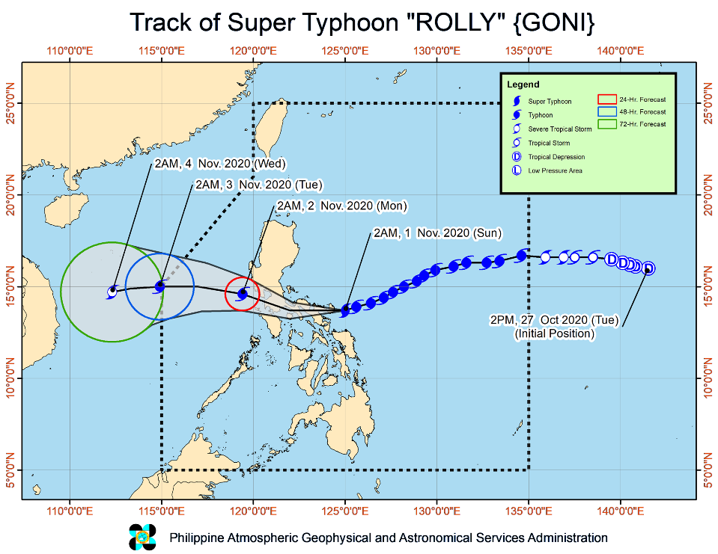

Latest information on the impact of Typhoon Rolly (Goni) points to 41,200 houses destroyed while 141,100 sustained minor to significant damages. In addition, 67 health facilities and thousands of schools have structural damages. Government estimates that damages to infrastructure amount to over $260 million. The Department of Agriculture reported that the successive typhoons resulted in $156 million losses in rice, corn, high valuecrops, fisheries, livestock, and in equipment and facilities. In Catanduanes, the governor stated that the province stands to lose $3 million in monthly income from its main commodity, abaca fibers, due to damages in farms. Other industries such as capture fishing and rice and coconut farming were also severely affected, thus people lost both their main and alternative sources of livelihood.

While the affected areas continue to reel from the consequences of Typhoon Goni and three preceding cyclones in October, another strong typhoon has further hampered response efforts and caused further destruction. Typhoon Vamco/Ulysses lashed the main island of Luzon on 11-12 November, whipping destructive winds and dumping torrential rainfall over a wide area, triggering extensive flooding in several areas, including Metro Manila, and which has led to further displacement and increased the hardship of vulnerable people. Heavy rains affected the Bicol provinces where flooding incidents were reported in 37 municipalities. Catanduanes, which was the worst-hit province by Typhoon Goni, experienced flash floods and landslides. The provincial governor lamented that response efforts are back to zero as house repairs and temporary shelters were again destroyed.

Joint government-HCT rapid needs assessments were undertaken between 3-9 November in the two hardest-hit provinces of Catanduanes and Albay. Teams identified priority needs in the sectors of WASH, emergency shelter, food assistance, livelihoods, and protection. The affected people also expressed their intention to return at the soonest and requested support on shelter materials to rebuild their homes. The local authorities requested additional food packs and medicines as supplies are reportedly running low. Concerns on the influx of people from outside were raised as it may put residents – who are tired and hungry – at risk to infectious diseases. While there has been no reported gender-based violence cases, protection partners have highlighted the urgent need to separate sleeping arrangements in evacuation centers, as different families are sleeping together, and this heightens the risk of abuses.

A total of USD 6,167,272 standby funds available in the Department of Social Welfare and Development (DSWD) Central Office (CO) and Field Offices (FO). Of the said amount, USD 5,374,853 is the available Quick Response Fund (QRF) in the CO.

252,114 family food packs (FFPs) amounting to USD 2,291,846 and available food and non-food items (NFIs) amounting to USD 9,503,264

Local authorities pre-emptively evacuated at least 196,000 people in the affected areas adding to the current displacement caused by Typhoon Goni. Local authorities in typhoon-battered Catanduanes also ordered the mandatory evacuation of coastal communities. In a televised address, the President assured that government is on top of response efforts for Typhoon Vamco, directing local governments and response agencies to prioritize the well-being and safety of the affected. Some 363 search and rescue teams comprising of up to eight members – from the military, police, coast guard, FLASH UPDATE No.4 Philippines: Super Typhoon Goni (Rolly) and Typhoon Vamco (Ulysses) As of 12 November 2020, 11 p.m. local time OCHA Flash Update | 2 United Nations Office for the Coordination of Humanitarian Affairs www.unocha.org Philippine Red Cross and private groups – were deployed to support rescue operations in Metro Manila, Cavite and Rizal provinces.

Meanwhile, for the Typhoon Goni response, which is scaling up, the NDRRMC continues to extend relief packages to the affected communities with the total value of assistance now at $2 million. DSWD provided over 58,000 family food packs, 1,000 hygiene kits, 2,000 kitchen kits, and 100,000 face masks to the Bicol Region. The Department of Budget and Management also assured the replenishment of DSWD’s quick response funds for the continuous provision of assistance to the affected. Beneficiaries of the conditional cash transfer program will also receive full grants for several months and will be excused from complying with the conditionalities for the time being. The agriculture department disclosed that $12.2 million will be provided to 32,000 affected farmers in the Bicol Region whose crops were damaged. The assistance will be provided through the crop insurance corporation as an indemnification fund, with insured farmers and fisherfolk set to receive claims between $200 to $300 for their damaged crops, farm equipment, and fishing boats and gears.

The Government of the Philippines, through its Department of Foreign Affairs, issued a letter inviting the UN Resident and Humanitarian Coordinator to engage in the identification of technical and material assistance that can be mobilized to complement government efforts in responding to the needs of people affected by Typhoon Rolly. On 08 November, the RC/HC led a multilateral mission of aid agencies to Albay province where they witnessed firsthand the damage wrought by the typhoon. The mission spoke with local officials, frontline responders and affected people, and surveyed the impact of the typhoon on a coastal village.

The HCT launched on 9 November a Humanitarian Needs and Priorities Plan to respond to the needs of 260,000 of the most vulnerable people in affected provinces. The Plan calls for US$45.5 million to deliver and implement humanitarian activities to typhoon-affected people living with poverty prior to the disaster and now requiring urgent humanitarian assistance in 16 prioritized municipalities in Catanduanes and Albay provinces in support of the Government response. The plan has been developed based on preliminary assessment findings and early estimates of people in need to enable humanitarian partners to kick-start immediate life-saving and protection activities. About $14 million have been committed or contributed to the typhoon response as of 11 November.

Canada, South Korea, Singapore, UK and USA have donated $2.7 million to the Philippine Red Cross through national societies and IFRC to address basic needs, shelter, livelihood, WASH and protection. UAE has allocated AED35 million ($9.5 million) to the Emirati Red Cross for shelter and other aid. Consultations are underway for EU’s allocation of EUR1.3 million ($1.5 million). The Australian government release pre-positioned stockpiles to UNFPA and World Vision to jointly support mothers and women with disabilities. At least 1,400 maternity and dignity kits will be distributed to pregnant and lactating women and women with disabilities. Some 500 solar radios and water containers will also be provided.

As of Novemver 15 546,155 families or 2,127,408 persons were affected in 5,432 barangays in Regions National Capital Region (NCR), II, III, IVA, IVB, V, VIII, and Cordillera Administrative Region (CAR). Of the total affected, there are e 8,981 families or 36,499 persons currently taking temporary shelter in 464 evacuation centers in Regions NCR, III, IVA, and V and 11,671 families or 48,300 persons currently staying with their relatives and/or friends in Regions V and CAR

There are 182,941 damaged houses; of which, 41,302 are totally damaged and 141,713 are partially damaged.

There are 25 dead and 399 injured and 6 missing person that have been recorded already due to the impact Goni. Most of the death are from Southern Luzon and Bicol region. Meanwhile, 178 Covid 19 patients and 417 medical/support staff in 11 mega and local quarantine/testing facilities were evacuated.
Currently no state of calamity declaration yet made from the national government. Respective affected local government units have declared state of calamity.

The Situation in Areas Where ChildFund Works

With Goni’s very unpredictable movement, it initially put three local partners’ program areas in the path of the typhoon. However, at the last several hours prior to land fall Goni lowered a few degrees and made landfall instead in Catanduanes province early November 1. It directly affected one program area of FACE Inc. as Goni traversed in Pili, Camarines Sur, Bicol region. Another partner was supposedly in the direct path but with the change of direction of the Typhoon, it did not directly affect the program areas of REINA in the northern part of Quezon province. Also in the path of Goni was local partner GEMS Heart based in Metro Manila (Pasay, Manila and T. Marteres, Cavite). Based on initial reports, no impact was observed in Gems Heart program areas as Goni severely weakened already when it passed their communities. Local partners will conduct head counting and rapid assessments in coordination with their partner local governments to validate initial reports received and identify immediate needs of affected families. In terms of number of enrolled families, FACE Inc. in Bicol has 2,414 enrolled families while REINA has 3,064 enrolled families and Gems Heart with 976 enrolled families.

As of November 3, all enrolled families from local partner REINA and Gems Heart are accounted and majority of them were not affected by the super typhoon. Except in REINA there were 8 families in one village that have their houses partially damaged by the winds but are already addressed by the local government units.

As of November 6, 100% of the 2,414 enrolled families of FACE are accounted already. Of the enrolled families in Pili, 55 enrolled families are among the families that their houses were totally damaged.

As of December 2, based on our coordination with the Municipal Social Welfare Office (MSWD) and Disaster Risk Reduction and Management Office (DRRMO) of Pili. The gaps on the needs of the affected communities remain on shelter related assistance particularly for partially damaged houses and immediate cash assistance related to livelihood recovery.

The MSWDO also expressed the need for a psychosocial or PFA session support to their responders and service providers as they are feeling overwhelmed by the major tasks that remain ahead for them. The MSWDO seek the assistance of local partner FACE if they could provide PFA and Psychosocial Sessions with their responders and service providers. To which FACE agreed and are scheduling the session on the 2nd week of December.

The distance learning or the modular learning of the Department of Education (DepEd) in the area of Pili will resume classes on the 1st week of December.

ChildFund’s Response

As of November 2, UN-OCHA in coordination with the provincial government of Albay, organize a joint rapid assessment for organizations based in Albay province only. Our local partner FACE was not able to participate in the joint rapid assessment, as they do not have presence in the province of Albay. Instead, our partner focus their initial assessment in their program area in Pili, Camarines Sur and will afterwards will coordinate with the provincial government of Camarines Sur for rapid assessment results in other affected areas of the province.

The CO will support local partner FACE immediate response intervention in their program area in Pili, Camarines Sur using a percentage of their subsidy funds. FACE is looking at providing Cash-For-Work and Psychosocial interventions related to shelter, as there are 1,226 houses reported as totally damaged. Many of the families affected are not staying in evacuation centers anymore in Pili as affected families went back already to their respective homes as they are very concerned of the security of their family belongings despite their houses are totally damaged.

In the meantime, the CO will only focus in providing support in the program area of local partner FACE in Pili, Camarines Sur as available funds as of the moment are only from partners subsidy. The CO and local partner FACE can expand into other highly affected areas once there are funds available.

Last November 9-11, local partner FACE started implementing psychosocial interventions. The emergency response team of FACE already established 5 sites in thier covered barangays in Pili Camarines Sur, reaching around 100 children ages 4-19. They were provided with psychosocial first aid (PFA) sessions. Participants were able to enjoy mingling with each other and were able to share their experience and feeling during typhoon. Another 10 site targeted to be establish in the week of November 16-20. FACE is targeting 300 children and parents in 10 barangays.

FACE was able to collaborate with Shelterbox to which it committed to provide immediate shelter kits to all totally damaged houses in Pili, Camarines Sur. This will complement their CFW support to their planned immediate shelter repair intervention.

The program team has finalized the CO’s overall response proposal for this emergency last Nov 7. The comprehensive response plan developed will cover from immediate or relief stage up to recovery stage and will be implemented in four Phases, which are;

Phase 1: Immediate Shelter intervention through Cash-For-Work and Psychosocial sessions
Phase 2: Replacement of Learning Materials and Support to Engagement of Learning Support Aides
Phase 3: Support to Livelihood Recovery
Phase 4: Strengthening the Capacity of Local Government in implementing Child Protection in Emergency (CPiE)

This response plan if ever receives full funding support will be implement within a six month period.

FACE has completed their Psychosocial and Psychological First Aid session last November 20 and reached 376 children and youth in 10 covered barangays (villages). In the psychosocial sessions provided the children and youth were able to distress and shared the feelings of fear and worries they felt during

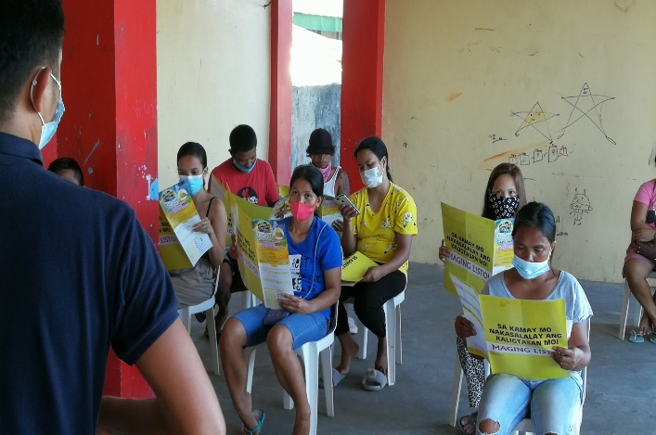
the typhoon. At least around 20 participants had one-on-one PFA session with the facilitators. FACE is developing a PFA documentation report and will be shared to the Municipal Social Welfare and Development Office for their reference and for possible follow-up intervention from their office.
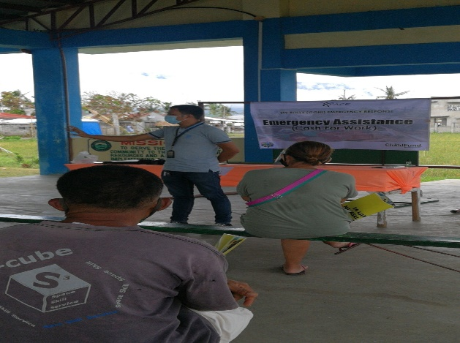

The CO sent a four-person team in Pili to provide support to its local partner FACE in their implementation of their response and arrived last November 29. The team was led by the DRM specialist who provided overall leadership, Communication specialist who collected photos and interviewed program participants and captured compelling stories on the ground, Program Portfolio officer which is the MHPSS expert who conducted review on the PFA sessions implemented by the partners and facilitated a PFA session with the staff of FACE. The 4th member of the team was the driver.
The teamFACE has started their Cash-For-Work (CFW) orientation last November 30 in their covered barangays and will start implementing the CFW activities. The CFW orientation include session on Covid 19 key messages, family preparedness planning session and brief psychosocial session. The session also includes orientation of participants on how they can provide feedbacks and complaints towards the intervention that we are implementing.

Prior to the CFW orientation activities, FACE was able to distribute 596 shelter kits in their covered barangays in Pili. This was a result of our collaboration with Shelter-Box who provided the Shelter kits through their partner Humanities and Inclusion. Shelter-box also provided shelter kits to all other barangays in Pili to all affected families with totally damaged houses. Shelter-box provided 5,117 shelter kits for the Municipality of Pili.

As of December 4, local partner FACE has coordinated with the division office of DepEd in Camarines Sur and in the district offices of DepEd in Pili to finalize the target schools and students for the replacement of learning materials and deployment of Learning Support Aides (LSA) intervention. The LSA’s will support the students in their distance and modular classes while their parents are busy in looking for other source of livelihood to support daily needs.

Below Sections for Internal Use Only
- Staffing and Security

With the strict implementation of Covid 19 pandemic quarantine protocols by the government, currently the Country Office has not deployed any teams yet on the ground. If ever the partner on the ground requires the physical presence of CO staff on the ground, the CO need to comply with all travel pass and registration requirements from the governments inter agency task force on Covid 19 in order to reach the program areas including swab testing for staff that will be part of the response team. Local partner will deploy staff on the field to conduct assessment and coordination on the ground.

As government and humanitarian teams respond to the needs, the health department issued an advisory that humanitarian responders do not need to undergo PCR test (swab test). Responders may be deployed under the conditions that they have no symptoms and recent exposure to a COVID-19 case and have been cleared by a medical doctor.

The advisory also added that Upon deployment, responders will be adhere to established Infection Prevention and Control protocols and will be in appropriate Personal Protective Equipment (face mask, Face shield and gloves). Deploying agency/unit will be responsible to the over-all safety and welfare of the responder. Coordination with relevant health authorities in the area of deployment should likewise be observed.

A total of 60 road sections and 7 bridges are affected by flooding, landslide and uprooted trees/fallen utility posts in Regions II, III, IV and V of which, 12 roads and 6 bridges are still not passable while 122 cities/municipalities are still experiencing power interruption.

As of November 29, the CO sent a Four-person team to Pili, Camarines Sur from Infanta, Quezon to provide support the local partner FACE in the implementation of their response. The team was led by the DRM specialist, Communication specialist, Program Portfolio officer which is the MHPSS expert on the team and a driver. Before the team left Metro Manila they first seek a travel from the Police designated by the Covid 19 Inter Agency Task Force and requested acceptance certificate from the local government Covid 19 task force of Pili.

- Sponsorship and Grants

In terms of number of enrolled families, FACE Inc. in Bicol has 2,414 enrolled families while REINA has 3,064 enrolled families and Gems Heart with 976 enrolled families. Most likely sponsorship activities will only affect the program area of FACE in Pili, Camarines Sur. No grant project currently implemented in the areas. 100% or all 2,414 enrolled children of FACE are accounted for.

- Donors

ChildFund Australia has committed AUD30,000.00 or USD21,600.00 and ChildFund International has committed USD10,000.00 for the support of the response plan of the CO.

The Taiwan Fund for Children and Families (TFCF) also committed USD10, 000.00 for this response.

- Budget

For the initial response it will utilize a percentage of the subsidy from local partner FACE.. The subsidy of FACE will be used to implement a portion of the Phase 1 of the response plan amounting to USD13, 000.00.

With the contribution of ChildFund Australia (USD21, 600.00) ChildFund International (USD10, 000) and TFCF (USD10, 000) including local partner subsidy (USD13, 437.5) this gives this emergency response current total budget of USD55, 037.5.

- Media/Communications

The CO’s communication specialist has developed a material already to be sent to IO. Please click on the link to see the communication materials- https://childfundintl-my.sharepoint.com/:w:/g/personal/vlascano_childfund_org/Eex1jHfPcFdGmH4iBXKxWHsBO5zy88MKHkd_PaAJvoPkpw?e=Mqgdc5

The communication specialist supported the development of local partner’s fund raising materials and which was picked up by CNN Philippines and was posted on their page.
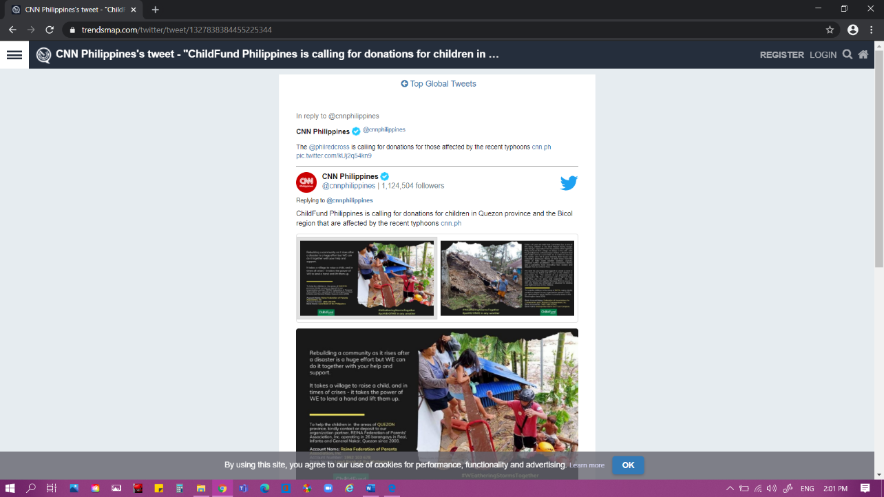

- Support needed or requested from IO, GSS or Global Teams

Current capacity of CO and local partner is enough to support this emergency if ever there is a decision to respond.

https://reliefweb.int/sites/reliefweb.int/files/resources/20201112%20Flash%20Update%20no.4%20on%20Typhoon%20Goni.Vamco_final_0.pdf
http://ndrrmc.gov.ph/attachments/article/4135/Sitrep_no_2_re_STY_Rolly_as_of_01_Nov_2020_8AM.pdf
https://reliefweb.int/sites/reliefweb.int/files/resources/20201102%20Flash%20Update%20no.2%20on%20Typhoon%20Goni.Rolly_final.pdf?utm_source=OCHA+Philippines+SitRep+list&utm_campaign=dec5a5ecc5-
https://reliefweb.int/sites/reliefweb.int/files/resources/DSWD-DROMIC-Report-26-on-Super-Typhoon-Rolly-as-of-15-November-2020-6AM.pdf
http://ndrrmc.gov.ph/attachments/article/4135/SitRep_no_12_re_STY_ROLLY_as_of_11NOV2020.pdf
https://reliefweb.int/sites/reliefweb.int/files/resources/20201102%20Flash%20Update%20no.2%20on%20Typhoon%20Goni.Rolly_final.pdf?utm_source=OCHA+Philippines+SitRep+list&utm_campaign=dec5a5ecc5-EMAIL_CAMPAIGN_2019_03_26_12_31_COPY_01&utm_medium=email&utm_term=0_2172bc068e-dec5a5ecc5-179831857
http://ndrrmc.gov.ph/attachments/article/4135/SitRep_no_12_re_STY_ROLLY_as_of_11NOV2020.pdf

