ChildFund International
Humanitarian Situation Report - 3
Cyclone Amphan – India
Date Prepared: 10th June 2020
Rama Rao Dammala; Specialist - DRM; +91 98183 92578; rdammala@childfund.org
Period Covered: 5th June to 10th June 2020
Updates are highlighted in yellow colour
Part 1: The Overall Situation
- Name, time and date of emergency:
Cyclone Amphan; 2:30 PM; 20th May 2020

- States/regions/areas of impact:
Odisha and West Bengal state of India

- What infrastructure/systems have been affected:
The Disaster has caused severe damage to the Communication, Shelter, WASH, Livelihood, Education, Protection and Food & Nutrition sectors.

- Any relevant background information about areas affected:
The cyclone has impacted 16 districts (4 in Odisha and 7 in West Bengal). The districts of North 24 Parganas, South 24 Parganas, East Medinipur and Kolkata are the worst hit in West Bengal. North and South 24 Parganas are part of Indian side of Sundarban, which is a fragile eco-system particularly vulnerable to climate change impact and has been considered as one of the hotspots of India.

- Total number of people impacted, with breakdown of adults vs. children and by gender:
It has impacted 18.08 million people - 13.60 million in West Bengal and 4.48 million in Odisha as per government of Odisha and Inter Agency Group (IAG) West Bengal. There is no disaggregated data of the impacted population available right now. Will be shared once we get it from the authentic sources.

The Double Whammy of Amphan:
The people of West Bengal especially from the cyclone affected districts are impacted by double disasters, COVID-19 pandemic and cyclone Amphan. West Bengal ranks 8 out of 36 State/UTs infected by the COVID-19. So far, 8,985 COVID-19 positive cases reported in the state of West Bengal with 415 deaths. More than 75% of people from Sundarbans migrate to other parts of the country for livelihoods and they are now returning to their homes both in South 24 Parganas and North 24 Parganas districts of Sundarban. Both the districts are categorized as Red Zones with 542 positive cases in North 24 Parganas district and 157 positive cases in South 24 Parganas. The trend is showing increase in the number of COVID-19 cases in West Bengal after the migrants return to their respective districts (source: study by the quint). In Sundarbans the risk is higher as the quarantine centres were used for cyclone shelter during cyclone Amphan without much social distancing.

- Number of people injured/dead/missing/etc. (cite sources)
88 people (87 in West Bengal and 1 in Odisha) – as per state IAG and Government reports

- For conflict/displacement situations, basic information on the parties to the conflict and their positions, developments in negotiations, etc. – Not Applicable

- Host government posture, have they declared a state of emergency and/or requested outside assistance?
The severity of the cyclone is more in West Bengal and the Chief Minister of West Bengal has appealed for humanitarian help. She said that "I have never witnessed such a fierce cyclone and destruction in my life. I would request Prime Minister Narendra Modi to come and visit Cyclone AMPHAN-affected areas". The Chief Minister also said that Cyclone AMPHAN was "worse than coronavirus". Giving a ballpark figure of $13.30 billion as a cost of the damages, Ms. Banerjee said, "We have to re-build everything. I appeal to the Centre, we want humanitarian help". The Prime Minister of India has made an Ariel Survey of the affected areas in West Bengal and Odisha and announced relief package of $133.21 for West Bengal and $66.60 million for Odisha.
Part 2: The Situation in Areas Where ChildFund Works
- Do we have current local partners/programs in the affected area?
Our current local partners and program areas in Odisha and West Bengal also affected with minimal severity not requiring any assistance. Our program areas were affected by the Extremely Severe Cyclonic Storm AMPHAN; however with less intensity in both Odisha and West Bengal. The storm has uprooted tree and caused some damage to thatched houses not many though. It did not cause any specific impact to our sponsored and enrolled children and families.

Both the LPs (CTD in West Bengal & VARRAT in Odisha) have been working with local administration since 19th May 2020 mainly to disseminate early warning, evacuation of people to shelters and providing cooked food to the people at shelters. Our LPs have also alerted Task Forces (formed and strengthened under DRR program) who are supporting the local communities in the preparedness activities. Following are some snaps of the supported by our children and youth in Odisha.
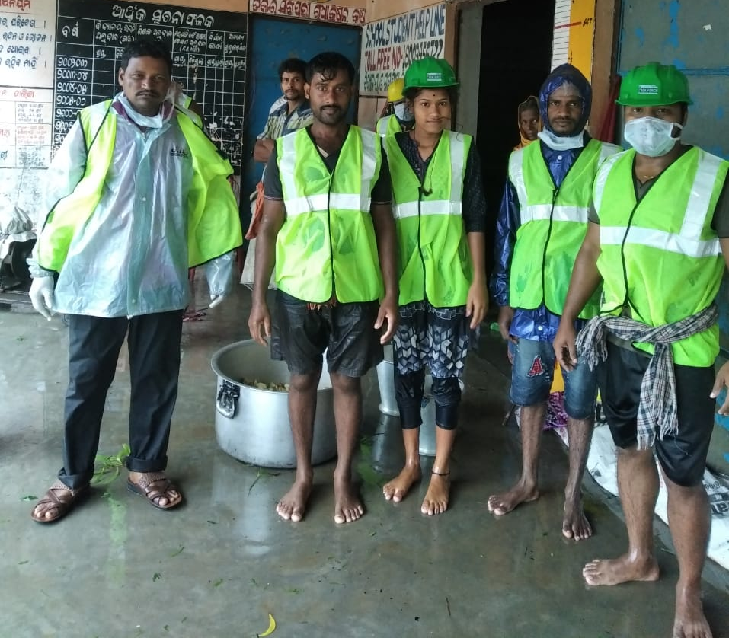
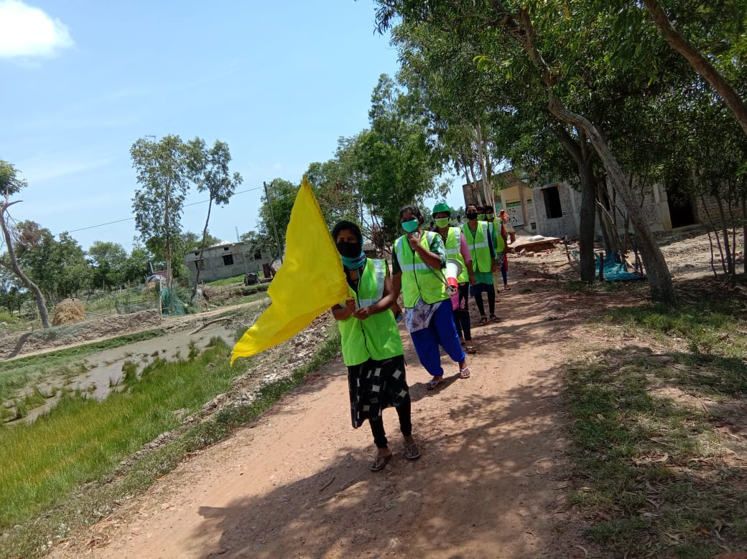

Task Force members disseminating Early Warning Task Force members at evacuation shelter
- How many children and families are affected?
All our sponsorship children and their families are safe. The impact was more on communication disruption, uprooting of trees and some damage to thatched houses.

- What issues are children in these areas facing? (food shortages, safety concerns, homes or schools destroyed, etc.)
There are no significant reporting of the problems affecting children in our program areas.

- Child protection risks caused or exacerbated by crisis situation.
Nothing specific has been reported or observed.

Part 3: ChildFund’s Response
- Planned, desired or ongoing response – inside or outside current operational areas.
ChildFund India has decided to respond in Sundarban, one of the worst affected areas. However, the proposed area is non-program and outside of our current operational areas. Therefore, ChildFund India SMT has reviewed the situation and explored funding opportunities and accordingly and decided to respond. ChildFund India has secured necessary approvals from RO/IO to launch the humanitarian response project in outside current operational areas.

ChildFund India is developing the response plan targeting 100,000 population including 38,000 children to benefit from the response activities both relief and rehabilitation phases. The first draft budget is estimated at $866,000 for a period 6 months. The response plan will be updated with the more information generated through different assessments progressively.

- Who are we partnering or collaborating with to provide our response?
We have already identified a local NGO, Sundarban Social Development Centre (SSDC), which is based in Sundarban’s South 24 Parganas district. The due diligence process has been initiated.

- What kind of response activities or interventions are being provided? What support items are needed (or have been collected/distributed)?
  - Family Kits: Rapid Relief to 10,000 vulnerable households consisting of approx. 50,000 population including 19,000 children. The family kit comprising of Food basket, Hygiene kit and Shelter kit (Mosquito Nets, Tarpaulins, Floor Mats). This kit will support the affected families to recover from the impact of the cyclone and rebuild life with dignity.

  - Water Sanitation and Hygiene (WASH) activities will be launched to mitigate ill health, waterborne and other communicable diseases. Repair and Restoration of water sources such as ponds and tube-wells, open wells are an important relief and early recovery activity. Disinfection of schools and village surrounding along with WASH awareness campaigns will be prioritised in all 100 villages. We plan to establish child friendly hand washing stations at the schools to improve hand washing practices to maintain safe hygiene and prevention COVID-19 infection. We plan to establish 50 handwashing facilities in the affected areas.

  - Education Support: ChildFund proposes to provide Inter Generational Coping and Learning Kit for children to engage in home based activities along with their siblings and parents. Since, the schools and ICDS centres are closed due to COVID-19 pandemic, this intervention supports children’s learning continuity and reduces their stress level through engagement of different activities. We propose to provide 10,000 kits to cover equal number of families. In addition, ChildFund proposes to distribute school kits to 50 schools consisting teaching learning materials that will support school re-opening.

  - Early Recovery activities through Livelihoods support to vulnerable households targeting marginal farmers, landless poor and migrant workers. The livelihoods support will include seeds support, kitchen garden support, bettle leaves restoration, poultry support and other off-farm livelihoods opportunities will be considered. ChildFund aims to support 4,000 vulnerable families.

  - Establishing / Strengthening Community Based Child Protection Mechanisms will be an integral part of the response in the target villages. Through this intervention, ChildFund would assess the existing child protection mechanisms and strengthen them in line with the national flagship program i.e. ICPS. ChildFund will also network and liaison with district/block administration to highlight child protection issues and address them through functional CP mechanisms These activities will prioritised in 100 villages and implemented in close collaboration with various stakeholders at PRI and District/Block level. ChildFund will also conduct orientation sessions / mass awareness on the CP risks for children and how deal with the Psychosocial support.

ChildFund’s cyclone Amphan response targets to address immediate and early recovery needs of the affected children and communities in Sundarbans. However, ChildFund would deliver the emergency relief and rehabilitation activities with due consideration to COVID-19 pandemic. For example, ChildFund and its local implementing partner will ensure all the government safety guidelines on COVID-19 while delivering relief to the affected children and families. On the other hand, the interventions will inbuild activities addressing COVID-19 needs such as messages on COVID-19 prevention and management, hygiene/sanitation kits will have face masks, sanitisers/soaps, promotion of hand washing and social distancing messages, etc.

- How is ChildFund linked with humanitarian coordination structures, i.e. in which clusters or working groups do we participate?
ChildFund India is participating in emergency coordination meetings organised for cyclone Amphan both at national level by Sphere India and Inter Agency Group (IAG) at Odisha and West Bengal. In India we do not have UNOCHA and its cluster coordination structure.

- Next steps
ChildFund India has scheduled first distribution tomorrow i.e. 5th June 2020 in Sundarbans and more distributions will be undertaken based on the resource mobilisation.

- For SitReps submitted after ChildFund response has been initiated, what is the current progress of implementation vs. the established response plan?
We have reached 58 households benefitting 297 population including 100 children. We will furnish more details on the target and reach in subsequent SitRep.

Below Sections for Internal Use Only
- Staffing and Security
  - Which staff are on the ground? Please include names, functions, contact information and arrival/departure dates for both IO and CO staff on the ground.
Due to lockdown and movement restrictions between the states, ChildFund team members could not be travelled to the affected areas from other parts of the country. We have deployed two members from our existing local partner (CTD), which is close to the affected areas in Sundarban. They will undertake the distributions schedule on 5th June 2020 with guidance from Specialist - DRM based at New Delhi office.

ChildFund with support from CTD team members has completed first distribution in Uttar Gopal Nagar Village of Patharpratima Block in South 24 Parganas district in West Bengal. ChildFund provided family kits consisting of Food Basket to meet food requirements of 5 member family for 15 days along with hygiene/sanitation materials to maintain household hygiene and prevention of COVID-19 infection. The distribution took place on 5th June 2020 benefitting 297 people including 100 children from 58 households.

  - Who is or will be leading/managing the response? (if applicable)
The Specialist - DRM with strategic guidance from Program Director and Country Director.

  - Any gaps in staffing/need for deployment from other COs or Global Teams?
Country Office staff are equipped to manage the response through local partners.

  - Confirm the safety of staff and their families in the affected area.
None of our staff located in the affected areas in West Bengal and Odisha. Our LP’s staff in both West Bengal and Odisha were affected without much severity.

  - Safety and security risks/mitigation plans
As of now, our movement is restricted, and we are following government safety and security guidelines. No specific security threat has been observed or reported in the affected areas.

  - Recommendations around any upcoming travel planned for staff or donors
Travels are avoided due to movement restrictions and quarantine enforcements.
  - Are there any other major HR issues?
Nothing specific as of now.

- Sponsorship and Grants
  - Will this impact sponsorship activities like correspondence and DFCs? No

  - Total number of sponsored children in the affected area, by project number.
    - 2849 / VARRAT: Sponsored - 1,152; Enrolled - 1,767
    - 2879 / Centre for Total Development (CTD): Sponsored - 278; Enrolled-280

  - Confirm status of sponsored children in the area, are all accounted for?
As shared earlier, all our sponsored and enrolled children are safe and accounted for.

  - List any active grants in the affected area - name of grant, donor, and primary implementer: No grants are implemented in the affected areas

  - Will grant execution be impacted by the emergency situation? Not Applicable

- Donors
  - Provide information about potential sources of funding (including grant donors, subsidy, Emergency Action Fund, Alliance members, GIK, etc.) for these emergency response efforts using the chart below.

ChildFund India has connected with a large national media company (NDTV) interested in raising funds nationally to support children and families affected by this disaster, through a telethon campaign. This is a unique opportunity to promote ChildFund’s visibility and exposure and enhance local fundraising not just for this emergency response but in the future.

ECHO has issued funding call worth EUR 550,000 to support cyclone Amphan affected communities especially in West Bengal. This was opened to the existing partners of ECHO.

Donor | Program | Amount (USD) | Requested? (Y/N) | Confirmed? (Y/N)

ChildFund partnered with NDTV (national news channel) to run a Telethon on the 7th June 2020 (Sunday). The Telethon featured several celebrities from Bollywood, sports, poets, singers and Chief Minister of West Bengal who appealed for support to the cyclone affected communities. The Telethon titled “All for Bengal” also featured ChildFund’s key staff namely the Country Director (Neelam Makhijani), Regional Director (Roland Angerer) and Program Director (Chandrashekhar Pandey) who emphasized the needs and sufferings of children in Sundarbans and appealed for support to address the gaps.

- Budget: Outline how we will use this funding with a rough topline budget. Furnished above

- Media/Communications
  - List of media who will be or have been contacted with press releases; will be initiated.
  - List of emergency spokespeople, including name, location, contact information, and languages spoken: Ms. Neelam Makhijani, Country Director of ChildFund India
  - Plans for collecting photos/videos/stories, i.e. should an outside photographer be hired? Initiated collection of photographs through LPs.
  - Key points for messaging and visibility, particularly any host government sensibilities that must be considered. Currently ChildFund is adapting and utilizing the existing IEC materials from government and our own repository.

- Support needed or requested from IO, GSS or Global Teams - whether onsite or remote. We requested supported in securing the approvals and has been processed in quick turn around time. Thanks for this faster approval process.
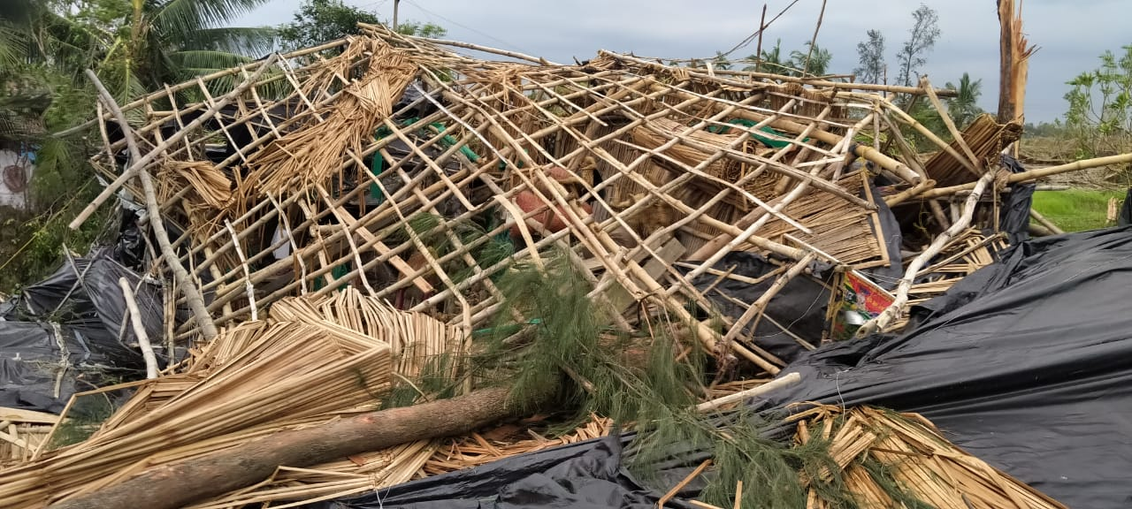
A Thatched house completely collapsed due to heavy wind brought by cyclone
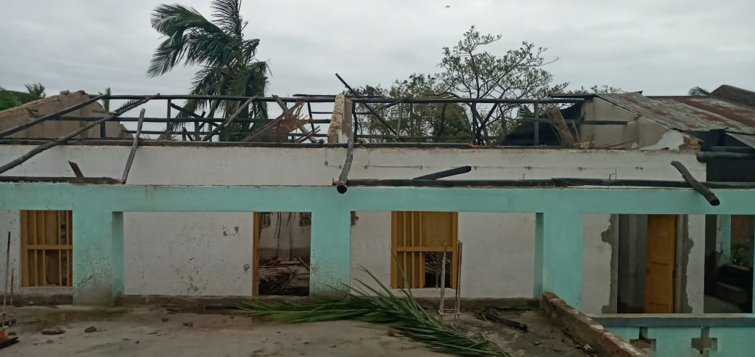
A school building with asbestos top completely blown away by the winds

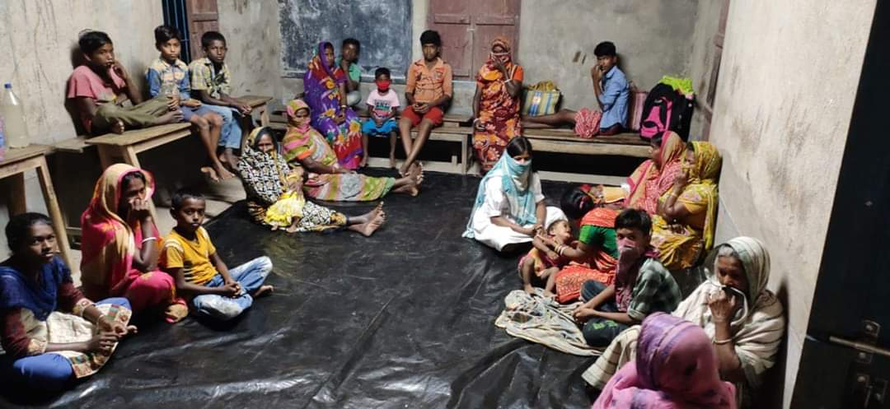
People taking shelter at an evacuation shelter in Sundarban
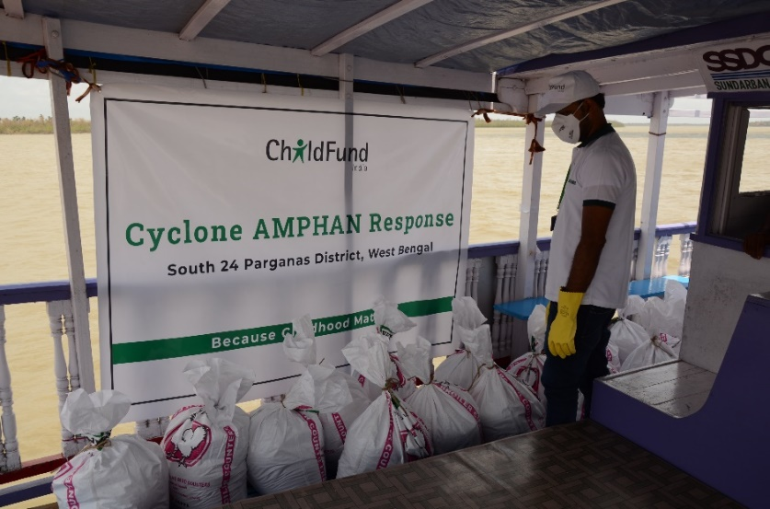
Relief materials transported using motorized boat
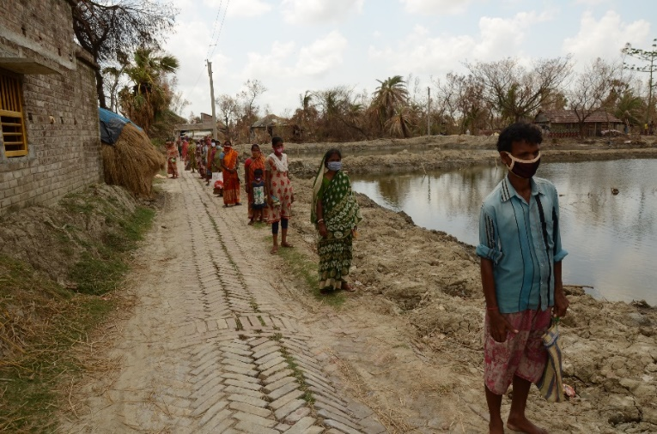
Maintaining social distance at the distribution point
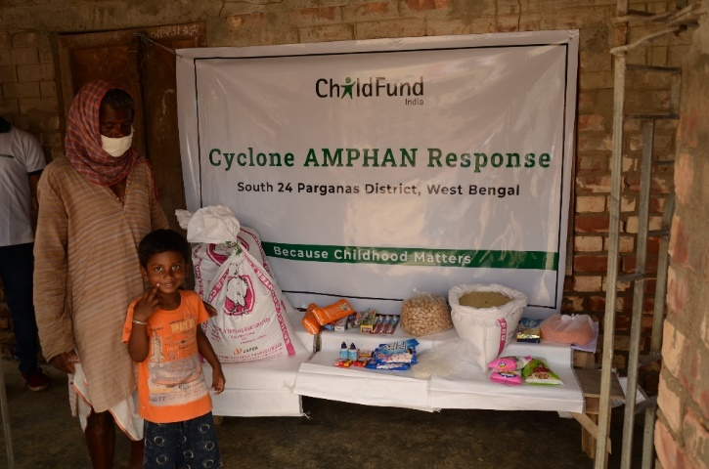
Beneficiary receiving family kit at the distribution point

