ChildFund International
Humanitarian Situation Report Template

Humanitarian Situation Report # 2
[TY Odette (Rai] – [Philippines]
[December 19]
[Date range covered- December 18-19]
[Point of Contact – Anand Vishwakarma, Country Director]

Overall Situation

On December 16, Typhoon ‘Rai” has made its first landfall over Siargao Island, Surigao del Norte in Mindanao region at around 1:30 p.m. TY Rai had a maximum sustained winds of 195 kilometers per hour (kph), gustiness of up to 270 kph, with a speed of 30 kph. TY Rai made 9 landfalls as it moved across the Visayas island provinces. It made its last land fall in municipality of Roxas, Palawan province. As of December 18, Rai decelerates while moving West Northwestward towards the Kalayaan Islands and has exited the Philippines around 2PM.
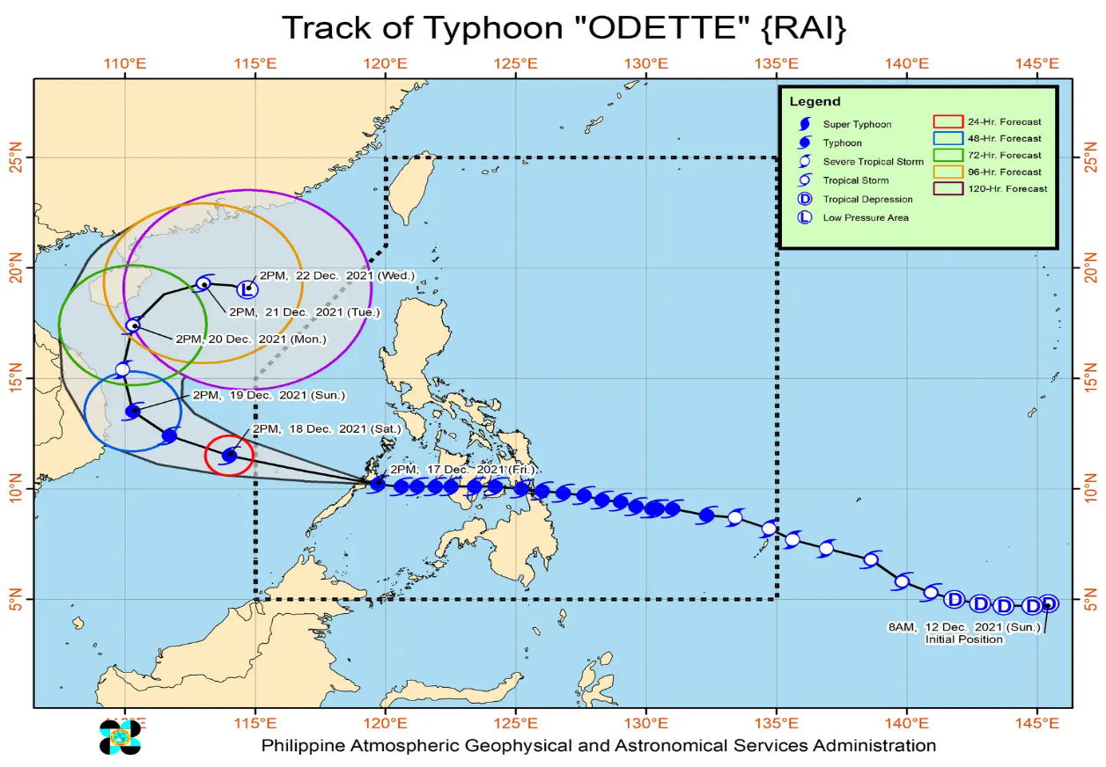

As of December 19, 202,650 families or 780,800 persons (previous report 130,128 families or 477,614 persons) were affected by Typhoon Rai in 2,322 Barangays/villages (previous report 1,417) in seven regions (V, VI, VIII, X, XI, Caraga, and MIMAROPA). 74,680 families or 279,623 persons (previous report 77,494 families or 289,049 persons) sought temporary shelter in 2,060 (previously 1,603) evacuation centers in Regions V, VI, VIII, X, XI, Caraga, and MIMAROPA. There are 82,107 families or 308,605 persons still displaced in the affected regions. 75 persons (previous report 31) have been reported dead and 1 is missing.

As of this time, 12 flights were cancelled and 80 seaports were affected in CALABARZON, MIMAROPA, Region 5, Region 6, Region 7, CARAGA. 5,564 passengers, 2338 Rolling Cargoes, 11 Vessels, and 2 MCBAs were reported stranded. 75 cities/ municipalities experienced power outage/interruption in Region 6, Region 7, Region 8, Region 11 and 3 cities/ municipalities experienced interruption in telecommunications in Region 7, Region 8.

22 roads are still not passable. initial reports shows that 3,783 are reported damaged. No reports yet on damages to infrastructure and agriculture as rapid assessments are still on-going. 306 cities/municipalities had class suspension while 287 cities/municipalities had work suspension.

USD71,486 worth of assistance was provided by the Local Government Units (LGUs) to the affected families. A total of USD 1,570,600 standby funds available in the Department of Social Welfare and Development (DSWD) Central Office (CO) and Field Offices (FO). Of the said amount, USD 202,600 is the available Quick Response Fund (QRF) in the CO.

103,340 Family Food Packs (FFPs) available in Disaster Response Centers; of which, 101,042 FFPs are at the National Resource Operations Center (NROC), Pasay City and 7,298 FFPs are at the Visayas Disaster Response Center (VDRC),Cebu City. 116,417 FFPs available at DSWD-FO V, VI, VIII, X, XI, and Caraga. 190,425 FFPs in other DSWD-FOs which may support the relief needs of the displaced families due to Typhoon “Odette” through inter-FO augmentation.

On December 17 the CO participated with the virtual humanitarian coordination meeting facilitated by UN-OCHA and discussed rapid assessment plans of respective organizations.

Currently, no state of calamity declaration has been made from either the local government units affected or the national government.

At least three provinces -- Cebu, Bohol, and Negros Occidental – and the whole of Cebu City have been placed under state of calamity.

The Situation in Areas Where ChildFund Works

Two program areas were along the path of the typhoon last December 16 and 17 covered by two local partners -- KKKK in Cagayan De Oro city, Misamis Oriental province and CHILD Initiative (Roxas city, Capiz province, San Joaquin, Iloilo province, Bacolod City, Negros Occidental province). As of December 18, KKKK in Cagayan De Oro city reported that TY Rai had no major impact on their covered communities. All 989 enrolled children where accounted. In Roxas City (with 762 enrolled children), CHILD Initiative reported no major impact in their communities and all enrolled children have been accounted for. Several families were reported to have participated in pre-emptive evacuation but all of them have returned to their respective homes.
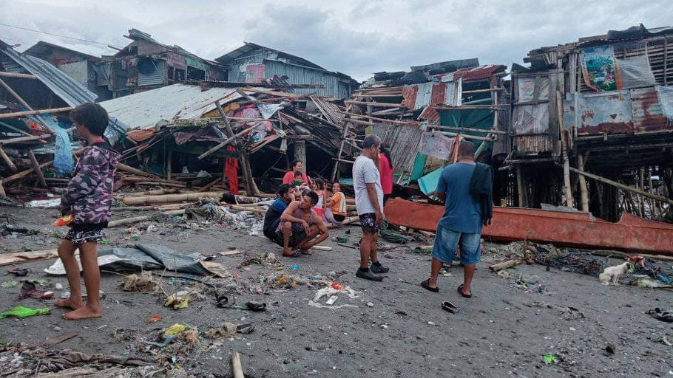

However, CHILD Initiative reported that their areas in Bacolod City (565 enrolled children) and San Joaquin(790 enrolled children) municipality were the ones that were impacted the most as they were almost in the direct path of the typhoon. 1,220 families or 4,986 individuals in Bacolod city overall were displaced either in evacuation centers or at homes of relatives and friends currently while in San Joaquin 786 families or 2,905 individuals overall were displaced either in evacuation centers or at homes of relatives and friends.

In San Joaquin area, 262 houses were totally damaged and 1,343 houses are partially damaged. 466 families or 1,725 individual are still displaced.

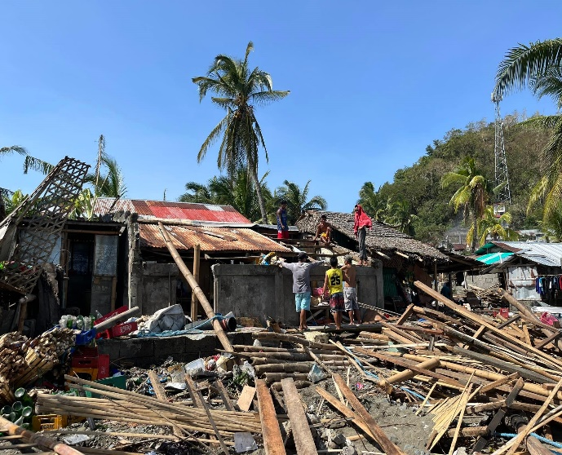
Based on initial report from local partner staff, most of the communities affected greatly by the typhoon were informal settlers in coastal communities.

Overall immediate needs identified initially are 1) shelter related assistance since most of the families’ houses affected are made of light materials. 2) FI and NFI was also identified as immediate need but it will be augmented by the social welfare department. 3) MHPSS interventions has also been identified as one of the immediate needs.

ChildFund’s Response

ChildFund Philippines will begin it response focusing on the program areas of CHILD Initiative in Bacolod City and San Joaquin municipality. We will continue to assess the situation in most affected communities and availability of funds based on which the response will be further expanded.

We will implement immediate relief intervention on December 20 in San Joaquin setting up their MHPSS interventions and possible cash interventions to families whose houses are totally damaged.

As per current estimates we need US$ 230,000 to cover immediate relief intervention, support education in emergency intervention and livelihood recovery. A more detailed plan and budget will be prepared in coming days.

Given the scale of the disaster, the Country Office is considering to also respond in non-program areas particularly in Northern Mindanao which is among the hardest hit areas by typhoon Rai. Our proposed priority provinces and municipalities are still to be determined and will be included in the next report. The CERT will develop a separate response plan for this ASAP and will share to the Alliance for support.

Below Sections for Internal Use Only
- Staffing and Security

Currently the Country Office has staff are on standby ready to deploy if needed for response. Deployments will also consider existing COVID-19 protocols. Local partner staff is deployed already on the field to conduct assessment and coordination on the ground.

- Sponsorship and Grants

For the directly affected local partner CHILD Initiative they have 2,117 enrolled children in there covered areas (San Joaquin- 790, Bacolod-565, Roxas- 762). The enrolled children in Roxas city are all accounted already while in Bacolod and San Joaquin head counting is still on-going and sponsorship activities might be affected in these areas.

There two on-going grant projects in the areas CHILD Initiative; COVID Response project from ChildFund Korea in San Joaquin and Project ACHIEVE from ChildFund Australia in Bacolod City.

- Donors

No Donors yet

- Budget

If the CO needs to respond, our local partner will initially realign a portion of their subsidy for this emergency and we are also planning to request from ChildFund Korea to realign the projected savings from the COVID Response project for emergency response use. Depending on the size of planned response we may seek funds from other sources as well.

CHILD Initiative will realign part of its funds to start up its response. The realigned funds will become part of the overall budget for the whole response plan.

- Media/Communications

Currently local partner are collecting photos and potential stories on the ground.

- Support needed or requested from IO, GSS or Global Teams

Current capacity of CO and local partner is enough to support this emergency if ever there is a decision to respond.

https://dromic.dswd.gov.ph/tropical-depression-odette-13-dec-2021/
https://monitoring-dashboard.ndrrmc.gov.ph/page/situation/situational-report-for-tc-odette-2021

