ChildFund International
Humanitarian Situation Report Template

Humanitarian Situation Report [1]
[Super Typhoon Goni (Rolly)] – [Philippines]
[November 3, 2020]
[Point of Contact – Federico Diaz-Albertini, Country Director]

Part 1: The Overall Situation
On November 1, at 4:50AM Super Typhoon Goni (Rolly) made landfall in the town of Bato, Cantanduanes province in the Bicol region. Goni at its strongest was at 225kph of maximum sustained winds and up to 280kph gustiness, was the strongest tropical cyclone to hit the whole world this year, and was second strongest for the Philippines since Haiyan in 2013. Goni made three landfall as it traversed the Bicol region-Southern Luzon-Metro Manila area.
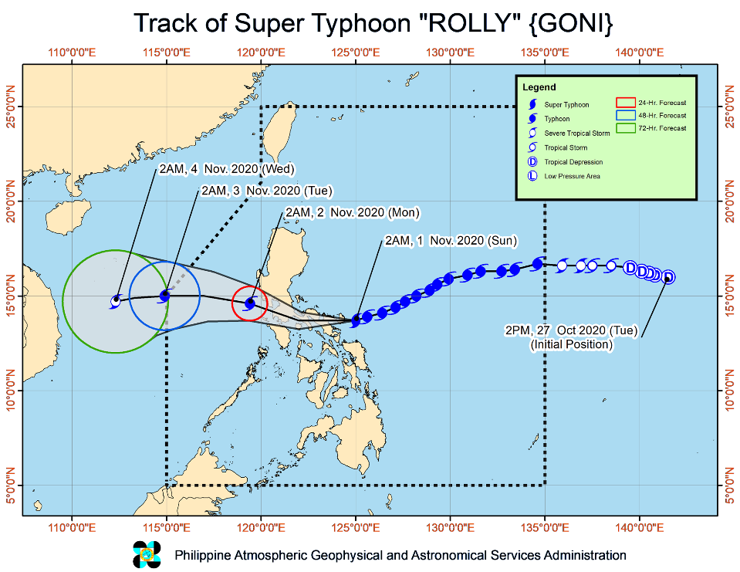

As of November 1, 9:00PM, Goni has exited land mass and will exit Philippine Area of Responsibility by tomorrow morning, November 2. Goni has highly impacted the provinces of Catanduanes, Albay and Camarines Sur in the Bicol region, Southern Quezon, Batangas, Laguna and Cavite provinces in Southern Luzon region. Goni passed the southern part of Metro Manila but further weakened already as it passed early evening.

Based from initial reports, due to the torrential rains early in the morning, Lahar overflowed from Mt. Mayon slope in Albay resulting to flooding the communities below adjacent to the rivers and creeks surrounding Volcano. Goni resulted also to storm surges, 2 meters high in coastal communities of southern part of Quezon province and the torrential rains cause Laguna lake to overflow affecting the surrounding municipalities.
The Province of Albay in Bicol region is one the most affected with massive volcanic mudflow from Mayon Volcano has been reported in the town of Guinobatan, Albay, burying at least 147 houses. Flooding has been reported as reaching the roof levels. In Camarines provinces, many houses have been destroyed especially in the coastal communities. In the province of Quezon, storm surge occurred in the town of Tagkawayan. In the province of Aurora, residents of towns of Dinggalan and Dipaculao are evacuated from landslides coming from the mountain range, Sierra Madre, and storm surge coming from the Pacific Ocean. Catanduanes, the Ground Zero, could have 80% to 90% damage on shelter especially in towns of Bato, Virac and San Andres. The lahar flashflood in Albay from Mayon Volcano is massive. 16 dead (10 from Albay and 6 from Catanduanes) are reported by media so far and unknown number of people are missing. Communication network and power outage in most of Bicol areas hinders flow of information. The situation in many areas remain unknown. (ECHO, 2 Nov 2020)

The Department of Agriculture reports that 16,900 hectares of land are damaged, affecting 18,000 farmers. Initial estimates place production losses at 66,600 metric tons of rice, corn and high-value crops, amounting to US$24 million in value.

A total of USD 6,167,272 standby funds available in the Department of Social Welfare and Development (DSWD) Central Office (CO) and Field Offices (FO). Of the said amount, USD 5,374,853 is the available Quick Response Fund (QRF) in the CO.

252,114 family food packs (FFPs) amounting to USD 2,291,846 and available food and non-food items (NFIs) amounting to USD 9,503,264
Prior to landfall, 96,543 families or 346,993 individuals preemptively evacuated in Region 3 (Central Luzon), Region 4A-B (Southern Luzon), Region 5 (Bicol Region) Region 6 (Western Visasyas) Region 7 (Central Visayas and National Capital Region (Metro Manila).

As of November 3 there are 402,458 families or 1,612,893 individuals affected by Goni. Of the total affected, there are 87,295 families or 333,868 individuals still being served in 4,346 evacuation centers and 19,347 families or 74,605 individuals served outside evacuation centers

There are 17 dead and 2 injured that have been recorded already due to the impact Goni. Most of the death are from Southern Luzon and Bicol region.
Currently no state of calamity declaration yet made from the national government. Most likely the declaration would be coming from the concerned local governments only.

The Situation in Areas Where ChildFund Works

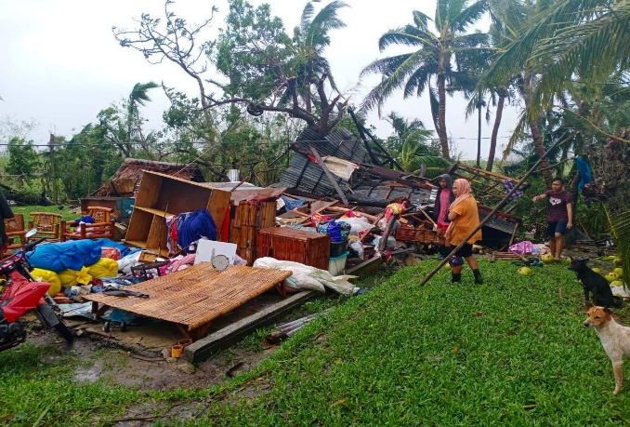
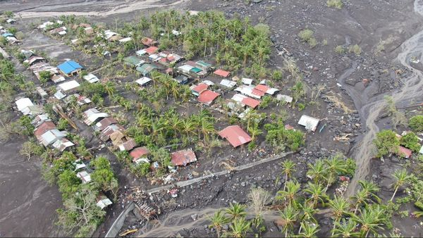
With Goni’s very unpredictable movement, it initially put three local partners’ program areas in the path of the typhoon. However, at the last several hours prior to land fall Goni lowered a few degrees and made landfall instead in Catanduanes province early November 1. It directly affected one program area of FACE Inc. as Goni traversed in Pili, Camarines Sur, Bicol region. Another partner was supposedly in the direct path but with the change of direction of the Typhoon, it did not directly affect the program areas of REINA in the northern part of Quezon province. Also in the path of Goni was local partner GEMS Heart based in Metro Manila (Pasay, Manila and T. Marteres, Cavite). Based on initial reports, no impact was observed in Gems Heart program areas as Goni severely weakened already when it passed their communities. Local partners will conduct head counting and rapid assessments in coordination with their partner local governments to validate initial reports received and identify immediate needs of affected families. In terms of number of enrolled families, FACE Inc. in Bicol has 2,414 enrolled families while REINA has 3,064 enrolled families and Gems Heart with 976 enrolled families.
Figure 2. Lahar covered community in Daraga, Albay
Figure 1. totally damaged house of FACE Community Volunteer in Pili town

As of November 3, all enrolled families from local partner REINA and Gems Heart are accounted and majority of them were not affected by the super typhoon. Except in REINA there were 8 families in one village that have their houses partially damaged by the winds but are already addressed by the local government units.

In FACE, 97% or 2,343 of the 2,414 enrolled families are accounted already. Of the enrolled families in Pili, 45 enrolled families are among the families that their houses were totally damaged.

ChildFund’s Response

At this time, the Country Office is awaiting assessment report from affected local partners particularly FACE Inc in Bicol region and will base its decision as to kind of response intervention it will propose for support. The emergency fund mechanism from the subsidy from the local partner can be used immediately already for initial response activities and interventions.

The Country Office is looking also at collaborating with alliance partner EDUCO in the Bicol region as they have program areas neighboring to our partner’s program areas in Camarines Sur province.

The Country Office also participated earlier in the Philippine INGO network coordination meeting to map all member organizations planned and existing intervention in the affected areas.

Based on initial reports received from social media and news outfits feeds, displaced and affected family’s needs are on shelter, immediate relief interventions.

We will get more information as to the extent of needs to be addressed, as soon our partners will complete the coordinated assessments from the field.

As of November 2, UN-OCHA in coordination with the provincial government of Albay, organize a joint rapid assessment for organizations based in Albay province only. Our local partner FACE was not able to participate in the joint rapid assessment, as they do not have presence in the province of Albay. Instead, our partner focus their initial assessment in their program area in Pili, Camarines Sur and will afterwards will coordinate with the provincial government of Camarines Sur for rapid assessment results in other affected areas of the province.

The CO will support local partner FACE immediate response intervention in their program area in Pili, Camarines Sur using a percentage of their subsidy funds. FACE is looking at providing Cash-For-Work and Psychosocial interventions related to shelter, as there are 1,226 houses reported as totally damaged. Many of the families affected are not staying in evacuation centers anymore in Pili as affected families went back already to their respective homes as they are very concerned of the security of their family belongings despite their houses are totally damaged.

In the meantime, the CO will only focus in providing support in the program area of local partner FACE in Pili, Camarines Sur as available funds as of the moment are only from partners subsidy. The CO and local partner FACE can expand into other highly affected areas once there are funds available.

The program team is currently finalizing the CO’s overall response proposal for this emergency.

Below Sections for Internal Use Only
- Staffing and Security

With the strict implementation of Covid 19 pandemic quarantine protocols by the government, currently the Country Office has not deployed any teams yet on the ground. If ever the partner on the ground requires the physical presence of CO staff on the ground, the CO need to comply with all travel pass and registration requirements from the governments inter agency task force on Covid 19 in order to reach the program areas including swab testing for staff that will be part of the response team. Local partner will deploy staff on the field to conduct assessment and coordination on the ground.

As government and humanitarian teams respond to the needs, the health department issued an advisory that humanitarian responders do not need to undergo PCR test (swab test). Responders may be deployed under the conditions that they have no symptoms and recent exposure to a COVID-19 case and have been cleared by a medical doctor.

The advisory also added that Upon deployment, responders will be adhere to established Infection Prevention and Control protocols and will be in appropriate Personal Protective Equipment (face mask, Face shield and gloves). Deploying agency/unit will be responsible to the over-all safety and welfare of the responder. Coordination with relevant health authorities in the area of deployment should likewise be observed.

A total of 50 road sections and 5 bridges are affected by flooding, landslide and uprooted trees/fallen utility posts in Regions II, III, IV and V of which, 37 roads and 4 bridges are still not passable while 165 cities/municipalities are still experiencing power interruption.

- Sponsorship and Grants

In terms of number of enrolled families, FACE Inc. in Bicol has 2,414 enrolled families while REINA has 3,064 enrolled families and Gems Heart with 976 enrolled families. Most likely sponsorship activities will only affect the program area of FACE in Pili, Camarines Sur. No grant project currently implemented in the areas.

- Donors

No Donors yet

- Budget

For the initial response it will utilize a percentage of the subsidy from local partner FACE.

- Media/Communications

Currently local partner are collecting photos and potential stories on the ground.

- Support needed or requested from IO, GSS or Global Teams

Current capacity of CO and local partner is enough to support this emergency if ever there is a decision to respond.

https://reliefweb.int/disaster/tc-2020-000214-phl?utm_source=OCHA+Philippines+SitRep+list&utm_campaign=dec5a5ecc5-EMAIL_CAMPAIGN_2019_03_26_12_31_COPY_01&utm_medium=email&utm_term=0_2172bc068e-dec5a5ecc5-179831857
http://ndrrmc.gov.ph/attachments/article/4135/Sitrep_no_2_re_STY_Rolly_as_of_01_Nov_2020_8AM.pdf
http://ndrrmc.gov.ph/attachments/article/4135/Sitrep_no_2_re_STY_Rolly_as_of_01_Nov_2020_8AM.pdf
http://ndrrmc.gov.ph/attachments/article/4135/Sitrep_no_4_re_STY_Rolly_as_of_03NOV2020.pdf
https://reliefweb.int/sites/reliefweb.int/files/resources/20201102%20Flash%20Update%20no.2%20on%20Typhoon%20Goni.Rolly_final.pdf?utm_source=OCHA+Philippines+SitRep+list&utm_campaign=dec5a5ecc5-EMAIL_CAMPAIGN_2019_03_26_12_31_COPY_01&utm_medium=email&utm_term=0_2172bc068e-dec5a5ecc5-179831857
http://ndrrmc.gov.ph/attachments/article/4135/Sitrep_no_4_re_STY_Rolly_as_of_03NOV2020.pdf

