ChildFund International
Humanitarian Situation Report Template

Humanitarian Situation Report [#2]
[Jakarta Flood] – [Indonesia]
[20 Feb 2021 afternoon]
[Point of Contact – Hanneke Oudkerk, Country Director]
[20 Feb 2021]

Part 1: The Overall Situation
The result of continuous rain in the past few days and heavy rain early morning Saturday 20 Feb 2021, floods inundated parts of Jakarta forcing thousands to leave their homes. The interim head of Jakarta's Regional Disaster Mitigation Agency (BPBD), said 379 families or a total of 1,380 people had to leave their homes as floodwaters reached between 0.4 to 1.8 meters deep, mostly in the South and East Jakarta.
"Several areas that are still affected [by the flood] due to the high rainfall and overflows of Ciliwung River, Krukut River and Pesanggrahan River in South Jakarta, as well as the overflow of PHB Sulaiman, Sunter River, Cipinang River in East Jakarta,".
There were 193 neighborhood units (RT) — the lowest administrative unit in Indonesia that comprises up to 50 households — affected by the flood. That was about 0.6 percent of Jakarta's 30,470 RTs.
Weather data from the Meteorology, Climatology and Geophysics Agency (BMKG) showed moderate to heavy rain fell across the greater Jakarta area at 01.30 a.m. on Saturday, the latest in a series of pouring rains in the past week.
The extreme weather would continue on Saturday, BMKG warned with potential for rain accompanied by lightning and strong winds in the South, West Jakarta, and East Jakarta areas were expected during the day and night, the agency said on its website on Saturday.
Several sections in Jakarta toll roads were inundated and inaccessible, these include Jakarta-Cikampek Toll Road, Jakarta-Tangerang Toll Road, Jagorawi toll roads, and Jakarta Inner Toll Road.
State utility firm Perusahaan Listrik Negara (PLN) said it had cut the power to more than 60.000 homes in the greater Jakarta area to eliminate electrocution risk.
During writing this sitrep #2, 9PM 20 Feb 2021, heavy rain pouring Jakarta and media reportedsome area inundated again after some times in afternoon water begin receding.

Part 2: The Situation in Areas Where ChildFund Works

In the 3 areas where ChildFund’s partners present their program, most of the water inundated at in the areas of South Jakarta while West Jakarta where the other partner located the water receding in the afternoon.
Below the number of sponsor and enrolled children in the affected area
Partner Organization (Use Salesforce identifying code/name.) | # of Enrolled and Sponsored Children
 | Sponsored | Enrolled | Area
Yayasan Dharma Kasih | 786 | 899 | West Jakarta
Panti Nugraha | 789 | 1,125 | South Jakarta
Perkumpulan Marga Sejahtera | 329 | 426 | South Jakarta

The flood happens during the weekend and no learning program at the school as all children did home learning during the pandemic covid19.

Part 3: ChildFund’s Response

Through partner (Marga Sejahtera) in South Jakarta the team hand over materials to cook for food to community who organize the public kitchen.
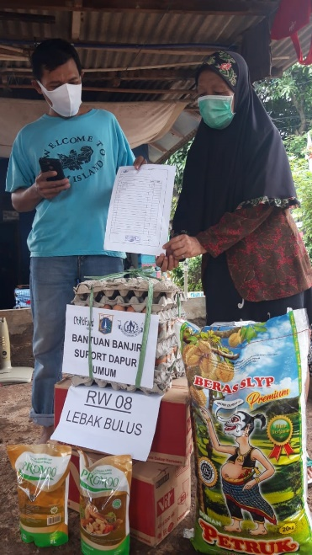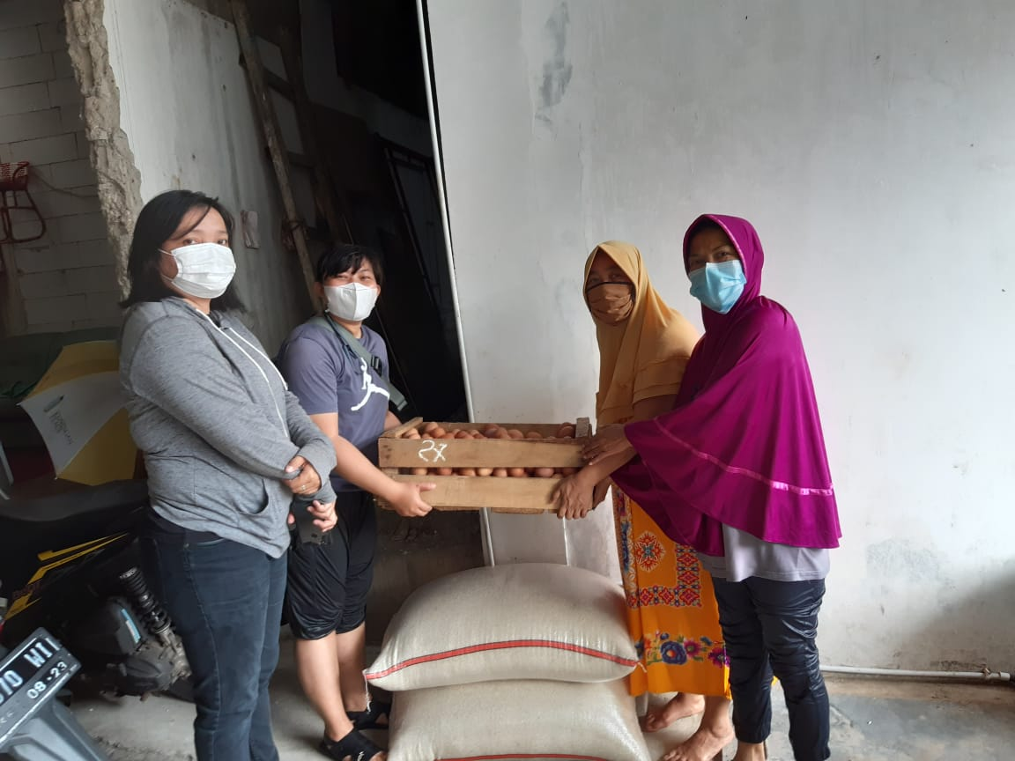
Handover materials for public kitchen by Partner staff Marga Sejahtera to community who set public kitchen.

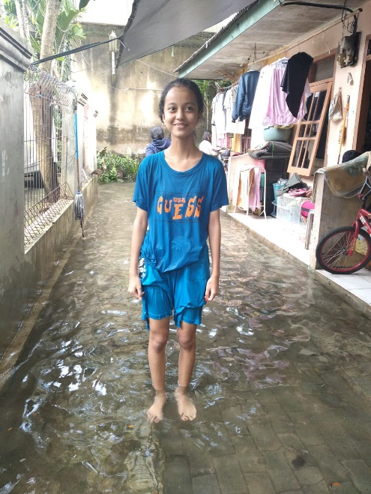
Dela Ramadayanti 14 years old from Cilandak Barat South Jakarta where Panti Nugraha as ChildFund’s partner has a program. She is one of the sponsor children who said the flood begins at 2am when she slept. This is the first flood she experiences since 2021 although in previous years her house experiences flooded when the heavy rain happen. The flood happens due to heavy rain and the overflowing of water from the river in her village. Dela temporarily evacuated to other family house whose house did not inundate. All family member is fine although she does not know when can return home as rain continues to pour Jakarta. Even though she evacuated with family to other house, Dela applied the covid19 protocol by keep distance from others.

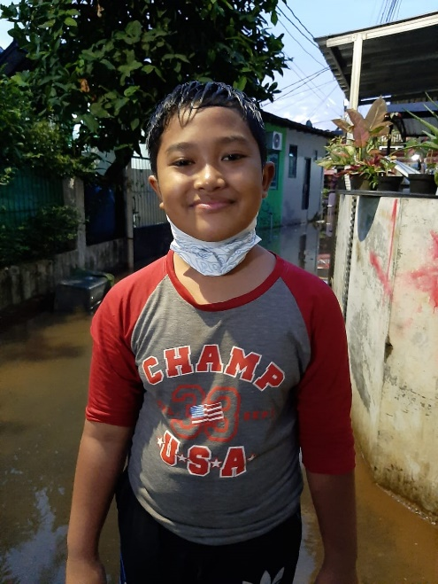
His name is Adam Nuranas 10 years old a sponsor children from Jati Padang South Jakarta in the area where Marga Sejahtera has a program. “This is the worse flood that I experience this year,” Adam said. The flood happens because of the collapse river bank of Cisarua river. My sibling and family felt sad and trauma because the water remains inundated as high as the thigh. “During the evacuation, I and my family applied covid protocol”, Adam said.

Below Sections for Internal Use Only
- Staffing and Security
  - In the morning, headcount begin and identified the house of 1 staff flooded but they are OK
  - Flood alert circulated to all staff member

- Sponsorship and Grants
  - Floods happen for 2 days and may disrupt program activities if the flood situation getting worse due to continuing rain at Greater Jakarta. At this moment,

- Donors
  - Provide information about potential sources of funding (including grant donors, subsidy, Emergency Action Fund, Alliance members, GIK, etc.) for these emergency response efforts using the chart below.
Donor | Program | Amount (USD) | Requested? (Y/N) | Confirmed? (Y/N)

- Budget
  - Outline how we will use this funding with a rough topline budget.

- Media/Communications
  - List of media who will be or have been contacted with press releases: Hanneke Oudkerk, Country Director
  - List of emergency CO spokespeople, including name, location, contact information, and languages spoken: Hanneke Oudkerk, Country Director in Jakarta
  - Plans for collecting photos/videos/stories, e.g., should an outside photographer be hired? No need
  - Key points for messaging and visibility, particularly any host-government sensibilities that must be considered. N/A
  - ChildFund Indonesia continue posted theme Covid19 on Social Media

- Support needed or requested from IO, GSS or Global Teams – whether onsite or remote.

