**ChildFund International**

**Humanitarian Situation Report 2**

**INDIA CYCLONE “NIVAR”**

**Rama Rao Dammala; Specialist – DRM; +91 98183 92578;** [**rdammala@childfund.org**](mailto:rdammala@childfund.org)

**Date Prepared: 3rd December 2020 (1700 HRS)**

**Updates highlighted in yellow colour**

Part 1: The Overall Situation

The Very Severe Cyclone **NIVAR** made landfall at around 2:30 am on the 26th November 2020 with winds of up to 130 km per hour, according to the India Meteorological Department (IMD). **Three** people were killed in Tamil Nadu as cyclone made landfall overnight near coastal town of Marakkanam – Tamilnadu, 30 km north of Puducherry. Hours after the landfall, the tropical storm has weakened from a "very severe cyclonic storm" to a "severe cyclonic storm". More than **200,000 people** were evacuated to safety in the two coastal states that had been bracing for the cyclone. While the damage assessment is on, the state governments said they were working on "war-footing" amid heavy rainfall and flooding in many parts. Image: cyclone path (Source: IMD).

The tropical storm, which originated in Bay of Bengal, forced authorities in the southern states to declare a public holiday till Thursday, close the Chennai airport and metro services. Metro and bus services in Chennai were resumed in the afternoon. The cyclone uprooted trees and brought with it torrential rain of up to 30 centimeters in a few hours in some parts. Rescue workers were using heavy machinery to remove hundreds of uprooted trees and its branches. Heavy rains from the storm caused flooding in some streets of the city of Chennai, Tamil Nadu's capital city which is home to many large automobile manufacturers. Around 1,200 National Disaster Response Force personnel were stationed in Tamil Nadu, Puducherry and neighbouring Andhra Pradesh as well, NDRF chief SN Pradhan said. Twelve teams are in Tamil Nadu (six in Cuddalore district and two in Chennai), seven in Andhra Pradesh and three in Puducherry. An additional 20 teams were on standby in Odisha's Cuttack, Vijaywada in Andhra Pradesh and Thrissur in Kerala.

Barely a week after Cyclone Nivar left a trail of devastations in the state of Tamilnadu, Puducherry and Andhra Pradesh, another Cyclone ‘Burevi’ is will hit Tamil Nadu on December 4, the second time in a week, the Cyclone Warning Division of the India Meteorological Department (IMD). The Cyclonic Storm with wind speed of 70-80 gusting to 90 kmph will cross south Tamilnadu coast between Pamban and Kanniyakumari during 3rd December night and 4th December early morning as a Cyclonic Storm with wind speed of 70-80 gusting to 90 kmph. Thus its impact on south Tamilnadu coastal districts is very likely to commence from 3rd December forenoon initially over Ramanathapuram district and gradually towards Kanniyakumari district. (Source: IMD)

Part 2: The Situation in Areas Where ChildFund Works

**ChildFund Project Location: PMSSS – Puducherry**

PMSSS – CDP supported by ChildFund India is working in 14 villages of Ariyankuppam and Nettapakkam Communities. During the NIVAR cyclone there was continuous heavy rain resulted in inundation in most of the service areas which paralyzed the normal life of people. Trees are uprooted and most of areas blocking the vehicle movement. The following is brief summary of the impact on the enrolled families:

* + 83 Enrolled children and their families - in total 415 persons were affected
  + 430 families from community and in total 2150 persons were affected
  + Out of 83, the roof of 16 enrolled children houses were damaged (made up of thatched leaf/natural grass)

Basic issues faced by the children and family are:

* + Drinking water
  + Food
  + Homes
  + Education materials
  + The children residing at huts took refuge in their relatives/neighbours houses may face child protection issues.

Youth club members at service areas volunteer themselves in removing fallen trees which obstruct the access as well as inundated area is being cleared by the local authorities. The youth and local teams are coordinating with government to access emergency relief support. In addition, once we get access to the affected areas, we will come up with needs/gaps and accordingly propose for the potential response activities.

**ChildFund Project Location 2: RASS - Chennai**

Our interventions areas are in flood prone zone in Chennai and Thiruvallur districts of Tamilnadu.

Moondru Nagar, New Anna Nagar and Periyar Nagar are our intervention areas in Thiruvallur district are located in the river belt of Ambattur river are now fully covered with water, most of the roads and houses are filled with rainwater in some places stagnant water is mixed with the clogged drainage water, there is no power in the Chennai and Thiruvallur district due to the rainfall. All our enrolled children are accounted for and safe. Some houses of enrolled children have been affected and water has entered into the houses. Below are some images of the area.

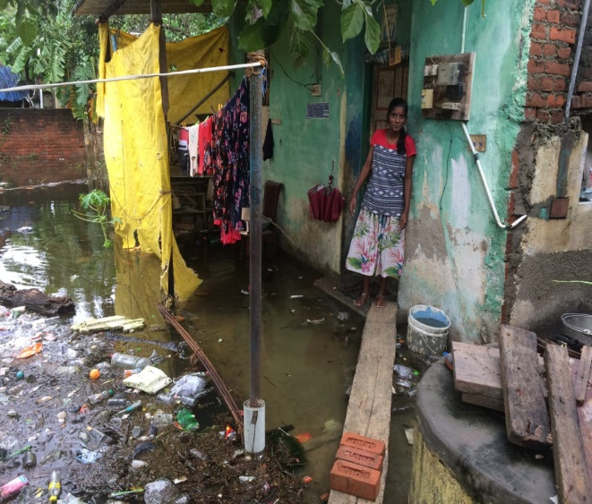 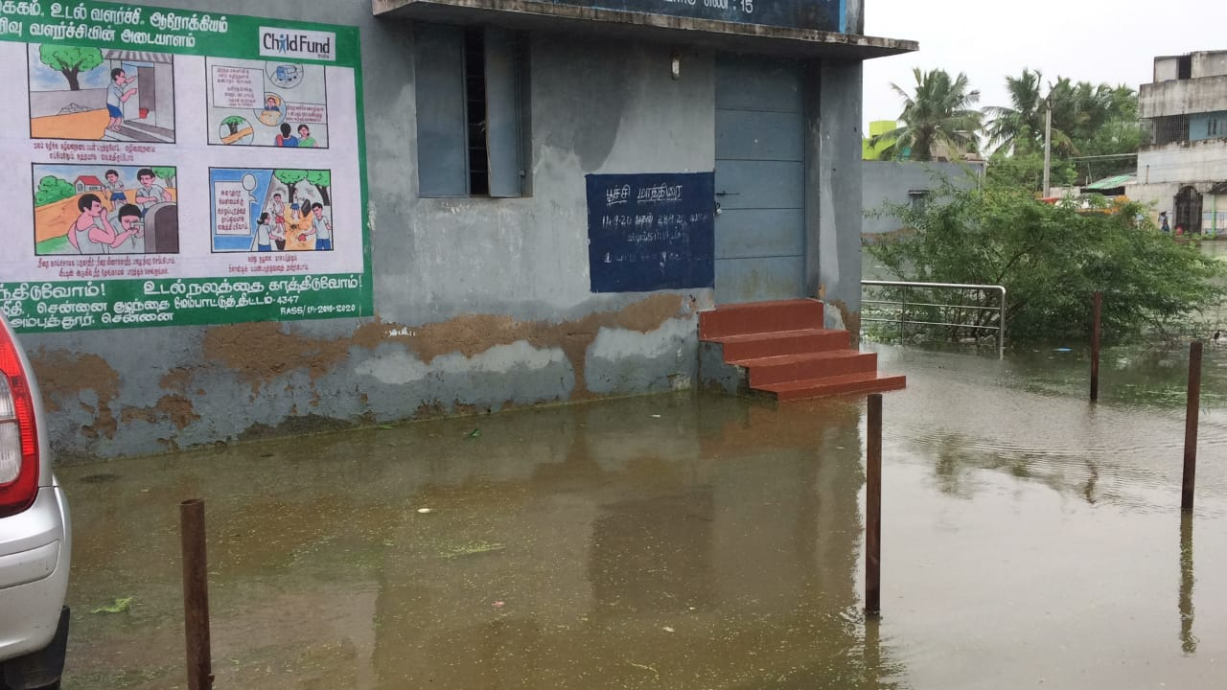

Our enrolled child’s house with water logging Child Resource Centre surrounded by water

Our teams will visit the affected areas tomorrow as people from the evacuation centres have started returning to their homes after the government has issued de-warning. The teams will quickly assess the situation and identify the gaps for any potential response activities.

**ChildFund Location 3: BEDROC – Nagapattanam, Tamilandu:**

Initially it was in the cyclone path but later the path changed and did not impact Nagapattinam location. All the children and communities are safe.

**ChildFund Location 4: RASS - Chittoor district of Andhra Pradesh:**

Once the cyclone NIVAR made landfall at Tamilnadu coast, the heavy rainfall with gusting winds continued towards north of Tamilnadu and south of Andhra Pradesh where one of our project location was affected by the cyclone. The local partner (RASS) has reported the impact of the cyclone and accordingly submitted a quick assessment report with recommendations for support.

Part 3: ChildFund’s Response

* Planned, desired or ongoing response – inside or outside current operational areas.

ChildFund / LPs present in three locations namely Puducherry, Chennai and Chittoor (Andhra Pradesh) have undertaken quick assessment of our program areas affected by the cyclone. The team from Chennai has confirmed that the impact of the cyclone is minimal and normalcy has returned thus not necessitating any response. The teams did assessment in Puducherry and Andhra Pradesh recommended for localized response activities. The response activities mainly target to support 107 families with food assistance and temporary shelter materials (tarpaulins and rope) both in Andhra Pradesh and Puducherry.

* Who are we partnering or collaborating with to provide our response?

The response will be implemented with the existing local partner and/or ChildFund teams present at the project locations.

* What kind of response activities or interventions are being provided? What support items are needed (or have been collected/distributed)?
  + Food kits (dry ration) – 107 families (Puducherry – 84 + AP-23)
  + Tarpaulin with rope – 107 families (Puducherry – 84 + AP-23)
* How is ChildFund linked with humanitarian coordination structures, i.e. in which clusters or working groups do we participate?

ChildFund India has been participating in Inter Agency Coordination meetings organised by Sphere India at national level since 25th November 2020. ChildFund is also participating in the join rapid needs assessment planned to be completed within 96 hours in severely affected districts of Tamilnadu and Puducherry.

* Next steps -
  + Teams will visit the affected areas for quick assessment to understand immediate needs as well as government support. The visits will also help us understand the gaps, if any, to be supported by ChildFund. Completed
  + ChildFund staff/volunteers will participate in the join rapid needs assessment coordinated by Sphere. The team members will undertake the survey in our locations using Kobo collect. Completed
  + Relief activities are being implemented after securing the approvals at each of these locations to support the identified families.
* For SitReps submitted after ChildFund response has been initiated, what is the current progress of implementation vs. the established response plan?
  + To support the needs of the affected children and families in our program locations of Puducherry and AP, we have prepared location wise brief proposals with budget and secured internal approvals to start the relief activities.

Below Sections for Internal Use Only

* Staffing and Security
  + Which staff are on the ground? Please include names, functions, contact information and arrival/departure dates for both IO and CO staff on the ground.
    - K. Ananth, Specialist - Livelihoods visited Puducherry as per his schedule and also undertaken the rapid assessment and submitted quick assessment report. Following are few photos from the assessment:

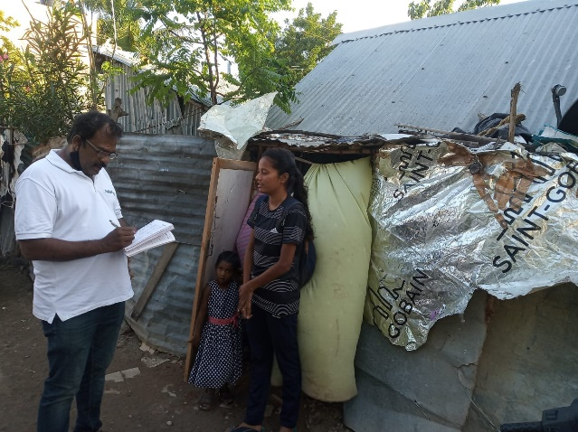 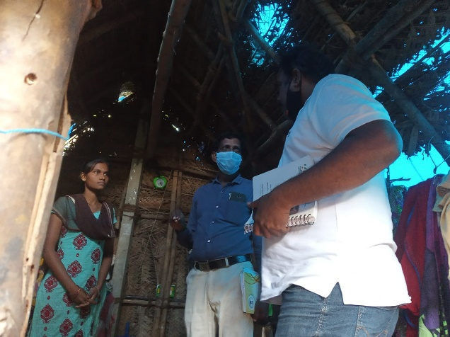

* + - In Chennai and AP, LP staff visited the affected areas and submitted updates and proposal for support.
  + Who is or will be leading/managing the response? (if applicable)
    - Rama Rao Dammala, Specialist – DRM with support from field teams and Senior Manager – Program & Partnership for the affected states.
  + Any gaps in staffing/need for deployment from other COs or Global Teams? NO
  + Confirm the safety of staff and their families in the affected area.
    - The affected area is safe and has not reported any safety related incidences till now.
  + Safety and security risks/mitigation plans. Not applicable at this point in time.
  + Recommendations around any upcoming travel planned for staff or donors No travels planned for this response activities as it is a localized response managed by the project team and LP
  + Are there any other major HR issues? NO
* Sponsorship and Grants -
  + Will this impact sponsorship activities like correspondence and DFCs?

The cyclone will some impact on the sponsorship activities for temporary period as the normal life has been disrupted. SR activities have been resumed at all the locations.

* + Total number of sponsored children in the affected area, by project number.
    - 4347 / Chennai CDP: Enrolled-281; Sponsored-275
    - 4125 / Nagapattinam CDP: Enrolled-1370; Sponsored-709
    - 9422 / Puducherry CDP: Enrolled-182; Sponsored-176
    - 3895 / BALAJI BALA VIKAS: Enrolled-1157; Sponsored-934
  + Confirm status of sponsored children in the area, are all accounted for?

All are accounted for and there is no reporting of any major injury or impact on the sponsored families.

* + List any active grants in the affected area – name of grant, donor, and primary implementer

We have one active grant in Chennai, we are assessing the impact and will share information accordingly.

* + Will grant execution be impacted by the emergency situation?

There is no specific impact on the active grants in Chennai and they have been continued.

* Donors -
  + Provide information about potential sources of funding (including grant donors, subsidy, Emergency Action Fund, Alliance members, GIK, etc.) for these emergency response efforts using the chart below.

|  |  |  |  |  |
| --- | --- | --- | --- | --- |
| **Donor** | **Program** | **Amount (USD)** | **Requested? (Y/N)** | **Confirmed? (Y/N)** |
| No specific donor interest was generated for this cyclone within the country. We are deploying internal subsidy resources to support our sponsored children as well as other severely affected families in the same location. | | | | |

* Budget – Not applicable
  + Outline how we will use this funding with a rough topline budget.
* Media/Communications – Not applicable
  + List of media who will be or have been contacted with press releases
  + List of emergency spokespeople, including name, location, contact information, and languages spoken
  + Plans for collecting photos/videos/stories, i.e. should an outside photographer be hired?
  + Key points for messaging and visibility, particularly any host government sensibilities that must be considered.
* Support needed or requested from IO, GSS or Global Teams – whether onsite or remote.