ChildFund International
Humanitarian Situation Report Template

Humanitarian Situation Report # 1
[TY Ambo(VongFong] – [Philippines]
[May 14, 2020]

Overall Situation

Typhoon Ambo (Vongfong) made landfall in San Policarpo, Eastern Samar, at 12:15 pm on Thursday, May 14, the first to hit the country in 2020 and in the midst of the coronavirus outbreak.
In a bulletin released past 2 pm on Thursday, the Philippine Atmospheric, Geophysical, and Astronomical Services Administration (PAGASA) said Ambo is already in the vicinity of Oras, Eastern Samar.

Typhoon VONGFONG (AMBO) continues to track westward across Samar Island and has weakened slightly, with its EYE no longer present. Its eyewall and rainbands continues to lash the island with typhoon-force winds and heavy to intense rainfall.

TY VONGFONG (AMBO) is forecast to weaken further as it turns northwestward across Western Sorsogon early tomorrow with an increased forward speed of 17 km/hr cutting across the western coastal areas of Albay and Camarines Sur through tomorrow morning. At 2 PM tomorrow afternoon, the typhoon will be just along Western Camarines Norte or between the towns of Capalonga and Santa Elena.

The Western Trough of TY VONGFONG (AMBO) will continue to bring scattered to occasional rain showers and thunderstorms across parts of Mindanao, Rest of the Visayas, Bicol Region, and Southern Tagalog Provinces including Mindoro tonight & tomorrow.
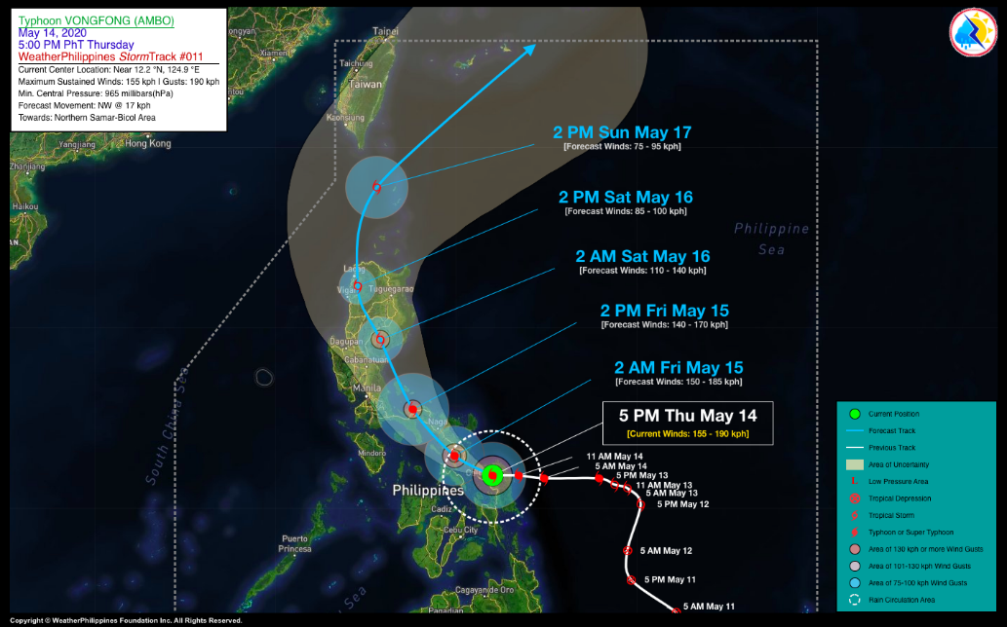

As of 5:00 PM PhT today, May 14…0900 GMT. The cloud-filled eye was located over the foothills of Mount Yaua, Samar (near 12.2°N 124.9°E), about 36 km east-northeast of Calbayog City, Samar or 39 km southeast of Catarman, Northern Samar. Maximum Sustained Winds (10-min avg) is at 155 kph near the center with gustiness or around 190 kph. West @ 14 kph, towards Northern Samar-Bicol Area.

Based on various weather forecasting model it is most likely to make another landfall Matnog, Sorsogon province around 10:00PM-11:00PM, May 14.

A total of USD 4,802,504.33 standby funds available in the Department of Social Welfare and Development (DSWD) Central Office (CO) and Field Offices (FO).

412,238 family food packs (FFPs) amounting to USD 3,520,970 and available food and non-food items (NFIs) amounting to USD12, 000,575.

Currently no state of calamity declaration yet made from the national government. In this emergency most likely the declaration would be coming from the concerned local governments only.

The Situation in Areas Where ChildFund Works

As of early evening of May 14, one local partner is on the direct path of the typhoon. The program areas of FACE Inc in Matnog, Bulan and Irosin Sorsogon province will be directly impacted by the typhoon if it maintains its path. FACE Inc areas was also affected by TS Kammuri last December 2, 2019.

Other areas that has a probability to be affected by TS VangFong is the program area in Northern Quezon province if the typhoon maintains it strength by May 17, Saturday.

Local partners staff are on alert already and monitoring situations in their areas remotely as they are still under community quarantine restrictions with the Covid 19 pandemic emergency.

ChildFund’s Response

Currently, the Country Office is awaiting assessment report on the afternoon of May 15, 2020 after Vangfong is expected to leave the vicinity of Bicol region. If ever the typhoon leaves a major impact in the program areas of FACE Inc, the Country Office will implement a Cash Programming related intervention given that all areas that will be affected by this typhoon is still under relief phase due to the Covid 19 emergency.

Below Sections for Internal Use Only
- Staffing and Security

Regardless of magnitude of impact of this typhoon, no staff will be deployed from the CO as travel restrictions is still in effect given the Covid 19 emergency.
- Sponsorship and Grants

For FACE Inc, they have 2,449 enrolled children in there covered areas. Around 300 enrolled families participated in the preemptive evacuation conducted by the local government as these families live in communities that high risk to flooding and storm surges. Head counting will be as soon as the storm will pass.

- Donors

No Donors yet

- Budget

If ever there will be a decision to respond most likely It will only utilize the remaining subsidy of the partner and the CO will propose to IO for additional funds for Cash Programming in support to the partners possible relief efforts.

- Media/Communications

No media materials yet as of the moment

- Support needed or requested from IO, GSS or Global Teams

Current capacity of CO and local partner is enough to support this emergency if ever there is a decision to respond.

