Ethiopia Country Office
Siraro Food Insecurity and Malnutrition Situation Report [#1 ]

[Date Prepared: March 10, 2021]
[Point of Contact – Lilly Omondi- Country Director email address: lomondi@childfund.org/
Tel: +251 911 250738]

[Date Range Covered by Report- December 1,2020 -February 28, 2021]

Part 1: The Overall Situation
Siraro Woreda/District is located in West Arsi Zone of Oromia regional state having 28 rural and 4 urban kebeles hosting a total population of 207,541(105,846F). The district is also known to have no irrigation with very low water supply coverage (21%) as a region. This woreda is frequently affected by natural hazards such as drought, floods, hailstorms, pest infestations and crop diseases. Each year these hazards (though the magnitude varies from time to time) have been reducing crop production potential, threaten livestock, and undermine livelihoods. To date trends have shown that moderate to severe droughts, occurs every two to five years. According to the Siraro Woreda Disaster Risk Management Office’s assessment made two months ago, more than 63,000 of the woreda population have been facing critical food shortage. The report has also showing that the woreda has experiencing severe drought and malnutrition problem almost in 21 kebeles/villages.
Cognizant of this situation ChildFund’s Local partner Siraro Child and Family Development Association requested ChildFund Ethiopia for the joint assessment of the situation. Accordingly, a joint rapid assessment has been conducted between February 25-28, 2021 to understand the overall food security and malnutrition situation in the woreda in general and in our operational area in particular.
The LP and CO has also started to respond to the situation with its existing resource and capacity. However, as the problem is too severe, the CO is preparing a concept note to raise additional resource.
This situation report is thus prepared to inform our International Office of the situation and the next actions to be taken place.

Part 2: The Situation in Areas Where ChildFund Works
- Situation Analysis
In Siraro Woreda ChildFund and its local partner operates within five kebeles through its sponsorship program. A total of 2, 523(1,176 Girls) enrolled children and their families have directly been supported with the sponsorship program while more than 47,000 people of the five kebels are also benefiting from the ongoing programs being implemented in the area.

Table 1. Number of Enrolled Children
Age category | Boys | Girls | Total
Children 0-5 years | 346 | 325 | 671
Children 6-14 years | 659 | 540 | 1,199
Adolescents and youth | 342 | 311 | 653
Total Children | 1,347 | 1,176 | 2,523
The five kebeles where ChildFund Works also experience similar problem with that of the majority of the kebeles reported to have food shortage in the district/woredas. The current reality at the ground is even much severe than the report issued by the DRM office. According to the residences of the area this year’s problem is the first severe case ever in the last nine years. The result of the discussion held with students, community members and kebele officials as well as physical observation of some houses revealed that, most of the communities have no food stock in their home. Increased cases of malnutrition continue to be reported during the month in many Kebeles. Poor crop performance of the last meher season (45% of crop loss) coupled with the prevailing low saving culture and other structural problems are the main reasons for the current food shortage.
Excessive rainfall during the initial months of the meher season; Early off set of rainfall during the cultivation of Teff and haricot bean; Crop diseases (mainly on Maize); flood in some parts of the woreda; Rainstorm and in adequate and low quality of input supply are reported to have been contributing for the crop loss in the last meher season
There is also a big fear that the current food insecurity will sustain for the coming year as the Belg production (which covers almost 60-70% of the local production) is almost failed. The belg rain should have started by mid-December and by know crops should have grown on the field. However, until the time of this assessment, no farmer’s field was cultivated.
Several Indicators of food stress have been exhibited in the communities:
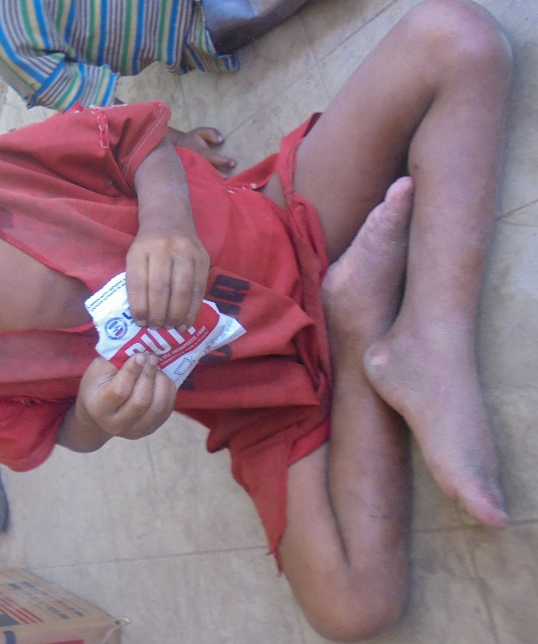
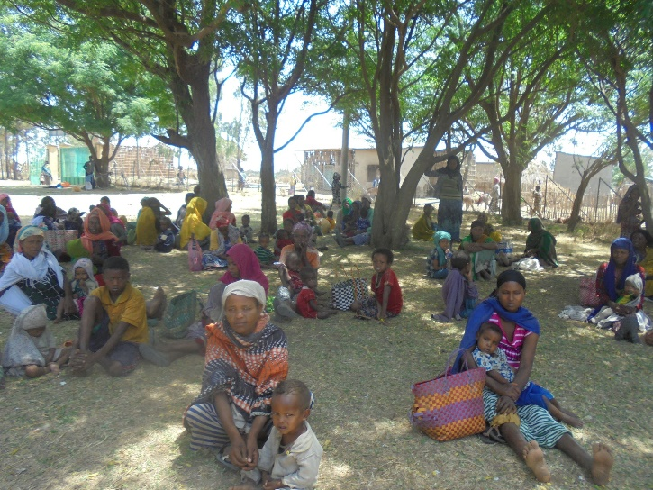
Severe and increasing trend of Malnutrition: Malnutrition among under five children and pregnant and lactating mothers increases from month to month. According to the data obtained from Woreda Health office and GOAL’s CMAM project office, OTP and Stabilization center (SC) admitted children by months were 925, 1178 and 1500, in the months of December, January and February respectively. Out of the 1178 children admitted in the month of January, 204 children were admitted by the sign of Edema/ Kwashiorkor which is the severe form of malnutrition attributed to essential food shortage. We have also observed that three Siblings of our enrolled families from one Kebele- Boye Awrkasa have been admitted in Ropi-01 SC due to sever Acute malnutrition cases. It was also noted that elder children above 5 years old and adults have also been showing EDEMA cases which is very unusual according to the health professionals working in the area.
Figure 1 Sample Children with EDEMA case attending OTP at Almtena Sirbo HC, Siraro
Table 2. Data of under five year children and Mothers (Lactating & Pregnant) for Malnutrition Status detection in Five Operational Kebeles
 | Kebele | Children under 5 year |  |  |  | Mothers
 |  | SAM |  | Total | MAM | Pregnant |  |  | Lactating
 |  | OTP | SC |  |  | SAM | MAM | Total | SAM | MAM | Total
1 | Ropi Town | 11 |  | 11 | 74 |  | 89 | 89 |  | 72 | 72
2 | Ropi Sinta | 76 | 0 | 76 | 234 |  | 206 | 206 |  | 62 | 62
3 | Damine Leman | 75 | 0 | 75 | 483 |  | 112 | 112 |  | 198 | 198
4 | Boye Awarkasa | 100 | 7 | 107 | 408 |  | 130 | 130 |  | 272 | 272
5 | Alemtena Sirbo | 84 | 3 | 87 | 178 |  | 89 | 89 | 2 | 98 | 100
 | Total | 346 | 10 | 356 | 1377 | 0 | 626 | 626 | 2 | 702 | 704
Source: Siraro Woreda Health Office Report of February 2021
Increased School dropout: the majority of the students have dropped their education due to Covid-19 case and the prevailing food shortage.
The below table shows sample data obtained from Awarkasa Primary school
Grade level | Last year (before Covid-19) | Enrolled in this academic year | Current number
Grade 2 | 400 children | 135 | 45
Grade -3 | 110 | 31 | 12
Grade 4 |  | 44 | 14

Labor migration to the nearby districts such as Dugda, ziway and other places where agricultural labor is highly demanded. As discussed in the above section, many students who dropped their education have left the areas for searching daily wage. The study team were able to talk to enrolled children in the school whether their brothers or sisters have left the area due to the same problem. Accordingly, three out of eight children told to the team members that at least one member of their family have left the area. Mekida Dewoyo- (Female, Case # 1448) told to the team that three of her brothers have left the area. Mircha Shamber(Male- Case#1441 ) and Gutema Beriso ( Male- case# 2120) have also explained to the team that one brother of each have been employed as agricultural daily laborer outside of their woreda with a yearly wage rate of 2,000-3,000 Birr. It was also noted that this in-country migration is facilitated by local brokers or by family members.

Increased forced and Early marriage:
It has also been witnessed that forced and early marriage of children has been increased as a coping strategy. The assessment team have talked with four Girls who experienced the same problem but escaped with the support of school communities and others. The LP has been supporting these girls to pursue their education.

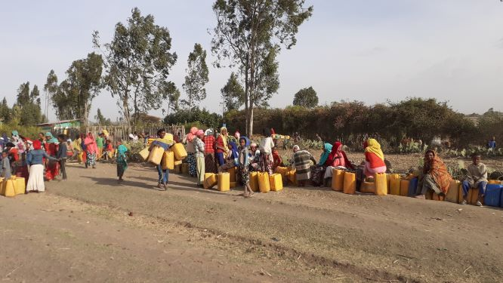
Severe water shortage: Significant people in the woreda has critical water shortage i.e almost 18 kebekles having 162,020 peoples are suffering from water shortage. The share of the cost of water is almost 60 % of the household’s expenditure that is attributed to high cost of water i.e a 15 litter jerrican costs 15 Birr in the urban areas. The problem is mainly pronounced outside of the operational area. Although the Zonal DRM office requested for Water trucking(six in number), so far, no response was obtained from the regional government nor from the Federal DRM.
Figure 2 Boys and girls coming from different kebeles waiting for water for several hours

The price of animals has generally been decreasing with an average of 33% between the month of October and February and on the other hand the prices of maize (the main staple food in the area) has been increased by 40% during the same period,
Shortage of animal pasture since farmers are selling their feed reserve (crop by-products) for purchasing food items. have also been additional challenges facing the communities right now.
Other negative coping strategies such as farmland lease, sale of animals and reserve animals’ feed (crop by product); firewood collection and sale for purchase of food items is also being widely practiced.
Increasing trend of rural-urban influx for Begging, Shift of diet from the normal staple food to some type of Tubers/root crops such as locally called “Boina’ and sometimes escape their mealtime and Sharing supplementary food among the families (those who are receiving SF for their children or Pregnant and lactating mothers are also some worst forms of coping strategies being pursued by the communities.
- Current Response and Gap Analysis
To cope with the rapidly deteriorating nutritional situation, new SCs and OTPs have been established in the district in the existing health centers and Health posts respectively. Between the months of October and February 4,559 children have been admitted to OTP and SC while the number of admissions is increasing from time to time. GOAL Siraro CMAM Project office have been supporting the program through the supports from UNOCHA. However, as the supports from UNOCHA has been interrupted due to the shift of focus to the North Ethiopia crises, Goal has interrupted its program as of February 28, 2021.
Moderately malnourished children, pregnant and Lactating mothers have been receiving supplementary food with the support obtained from WFP. However, it has been noted that this food support has been shared in the home with the rest of family members. Moreover, as the number of cases is increasing from time to time, the support does not match with the actual need.
The relief food ration that has been distributed to the 21,800 relief Beneficiary and the 20,774 IDP found in the district has been discontinued since the last two months. Although, the Zonal DRM office has requested the regional DRM bureau for the immediate relief support for 63,861 people, no support was delivered since the last two months again due to the shift of attention to the North.
Siraro Child and Family development Association has also made some effort to support families with critical food shortage, the coverage is also still insignificant compared to the scope of the problem.
Overall, the current support being in place is too small and inconsistent compared to the problem at the ground which call for immediate action before the problem escalates to the level claiming life of the children.

- Proposed Response Interventions
The following actions are proposed to address the current problem of food insecurity and malnutrition in the short term and bring sustained changes in the long term:
- The need to start general food ration at least with in our operational areas until the next harvest season
- Provision of Seed emergency and other seeds of early maturing and drought resistance varieties and agricultural inputs is important to reduce the risk of future food shortage,
- There is a need to start School feeding program at least within primary and junior secondary schools found in our operational kebeles until the coming harvesting time. Except in one school all schools have Water supply and cooking equipment. What is needed is only food supplies. This has a multiplier effect: children can eat at least once in a day and relief from hunger/starvation, attract children to school, reduces child labor and protect early marriage of girls, improve children’s educational performance.
- Once children get back to school, there is a need to initiate a special tutorial and other education support program such as scholastic materials for needy children, Dignity Kits for Girls etc. are important
- The need to focus on women and girls on any emergency support services. It has been noticed that men could not bring home any emergency assistance rather sale to the market.
- Further promoting disaster risk management strategies among the communities
- The need to start water trucking services (in one school with in operational area and )outside of the operational area
- Maintain non-functional water schemes to curb the water shortage

SECTIONS BELOW ARE FOR INTERNAL USE ONLY

- Security & logistics

No Security issue is observed

- Partnership and coordination

ChildFund and its local partner, SCFDA, are closely monitoring the situation with the local government. In addition to to-date response, joint relief response and recovery plans are under development in the area.

- Program

Food Security √

Nutrition √

Child Protection √

Health √

WASH √

- Staffing

Major HR issues: None

Visits: None

Departures:

Arrivals:

Staff on the Ground:
- Livelihood program and Emergency program specialists and other staff at the CO
- The LP staff such as the Manager, ECD officer and others community development facilitations

Key contact: Lilly Omondi; email address: lomondi@childfund.org ;
Tel: +251 911 250738

- Donors
None

Proposals and concept note submitted:
Donor | Program | Amount

Confirmed funding:
Donor | Program | Amount (USD)

- Finance

- Media/Communications

Information and media contact:

Information and media contact:

Spokespeople – languages spoken:

Resources | What’s available | URL
Photos
Case studies
Press releases
Blogs
Press coverage
Videos

- Additional information

The detail assessment report is available and can be submitted if required.

- Next steps

Next step is to undertake detail assessment, start immediate support with available resource, develop concept notes and search for additional resource.

