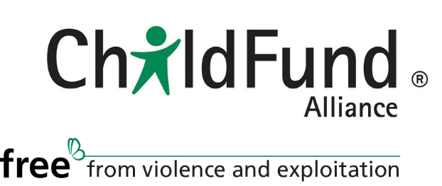

Recap of Process to update the ChildFund Alliance Member’s Agreement.
Prepared by Laurence (Larry) Parker, Attorney, Williams Mullen

In mid-September of 2020, ChildFund Alliance’s secretariat engaged Williams Mullen to prepare an updated Member’s Agreement for ChildFund Alliance. Larry Parker of Williams Mullen met with Simon Whyte and Meg Gardinier via Zoom on September 24, 2020 to discuss Simon’s desired approach to the new Member Agreement.

While in the past, the member agreement was an intellectual property license focused on the Alliance sharing its trademarks and logos with members, Simon wanted the new Member Agreement to become an over-arching governance document, with the intellectual property license to be a subsidiary document. At the Secretariat’s request, Williams Mullen reviewed the constitution, bylaws and existing member agreement to prepare to draft the new Member Agreement.

Williams Mullen shared the first draft of a Member Agreement with the Alliance in October 2020. After incorporating a few rounds of comments from the Secretariat in the fall of 2020 and early 2021, the secretariat shared a draft with members in February 2021. By the summer of 2021, most members and ChildFund International had reviewed the agreement. ChildFund International and several members, including ChildFund Australia, New Zealand, Barnfonden, and WeWorld provided written comments. The Secretariat worked with Williams Mullen to further revise the Member Agreement based on these comments and held calls with ChildFund International and Child Fund Australia to discuss some of their comments in detail. The Secretariat is now circulating the current, hopefully final version of the Member Agreement, to members for the Board of Directors meeting on 30 November 2021.

46497778

