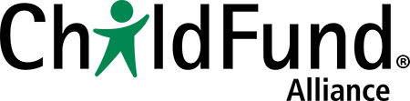

Showcasing learnings across countries and influencing practice across the Alliance
ChildFund Alliance will use several vehicles to showcase learnings from the Child-friendly accountability initiative across countries and influence practice across the Alliance.
- Regular check-in teleconferences for all participating country offices and members of the Child-friendly Accountability Task Force give facilitators, project managers, Secretariat staff and Alliance member program directors the opportunity to share learnings, and discuss achievements and challenges.
- The web-based platform will allow facilitators and project managers to share key documents to inform their peers of activities, outputs and outcomes.
- The members-only section of the Alliance website contains all materials relating to the initiative, and is available to all staff of Alliance members and country offices around the world.
- ChildFund Alliance will produce a semi-annual e-learning newsletter for ChildFund staff and staff of other child-focused agencies that are interested in implementing Child-friendly accountability.
- The project assessments and impact evaluations will be shared with all staff, and made publicly available on the ChildFund Alliance website.
- The monthly ChildFund Alliance advocacy update, which is widely distributed among staff worldwide, will report on major achievements of the Child-friendly accountability initiative.

