ChildFund International Humanitarian Situation Report
Humanitarian Situation Report [01]
[Conflict Emergency Response in Isiolo County– Kenya]
[January 2021]
[Issa Kipera, Program and Sponsorship Director, IKipera@childfund.org]
[January 2021]
- The Overall Situation
Isiolo County is categorized as arid and semi-arid lands (ASALs) and experiences semi-arid climatic conditions with minimal rainfall and extreme temperatures. The County has been experiencing ethnic clashes in the recent years especially after the emergence of county governance in Kenya. The patterns of conflicts in the County are complex with different pastoralist communities locked in protracted inter-communal conflicts. The dynamics of inter-communal conflicts particularly among the various ethnic groups; the Samburu, Meru and Turkana are predominantly triggered by a combination of political, social, economic, cultural, and environmental factors.

Natural resources scarcity continued to trigger conflicts between local people in Isiolo County with the recent killings of people and theft of livestock between the Turkana and Samburu Communities living along the shores of Ewaso Nyiro. With the looming dry season, the second wave of desert locust infestation and Covid-19 pandemic the situation is becoming worse and will lead to increased suffering of the people.
Currently in Isiolo county where the Nawiri Children’s Development Program (NCDP) operates, families and children are experiencing a wave of violent conflicts, mainly between the Turkana and Samburu communities. Reports indicate that the fresh conflict that took place in mid-January 2021 between the two communities have left 102 households displaced with a total of 179 enrolled children affected. These children are school going and thus their safety and access to schools has been disrupted. The situation remains fragile and under threat, and if the situation is not quickly addressed may lead to massive destabilization of the community operations.
- Interventions by other stakeholders (National and County Governments, Kenya Red Cross, etc.)
Isiolo County and national government have initiated community peace forums among the conflicting communities in Isiolo North. In addition, the conservancy rangers are also playing a role in peace building through joint conservation promotion events as an instrument of peace.
- The Situation in Areas Where ChildFund Works and interventions by ChildFund Kenya through the Local Partners i.e. cash transfers, food distribution, farm input vouchers, trainings etc.
Nawiri CDP responded promptly through own resources by distributing foods stuff to 80 caregivers out of the 99 affected by conflict. Nineteen (19) of the affected families were not included in the LPs support because they were included in an ongoing CT-OVC program run by the department of children services which provides social protection through a regular cash transfers to families living with vulnerable children. Each of the families that were supported received 18kgs of beans, 20kgs of maize, 2 litres cooking oil, and 1kg salt. This food is expected to last them for one month, thus safeguarding the nutritional health needs of the children and their caregivers.
However, despite this support and that provided through the government cash transfer program, all the affected 99 households remain highly vulnerable and food insecure as these households have do not have adequate resources to immediate their basic needs. They are in dire need for humanitarian aid to protect the children from hunger and other opportunistic effects due to displacement. Most of these households are still displaced and currently hosted at the Archers post catholic mission due to the fragile situation the area.
Interventions
Activity | No. of Units | Unit Cost  USD | Frequency | Total  USD
Purchase and distribute dry foods to 80 affected households | 80 HH | 45.64 | 1 | 3,651
Total | 80 HH |  |  | 3,651

Challenges
- Politics, socio-cultural orientation, governance, drought, and unstable regional environment undermining sustainable peace.
- Lack of agreed land use and range management plans to prevent sporadic violence on boundary disputes.
- Political alignment differences in the community resulting in power struggle leading to violent conflicts.
- Compromised trust due to suspicion of intent and lack of political good will from the local leaders.
- The existence of multiple hazards in the area; desert locust invasion, floods and conflict at the same time exacerbating the vulnerability of the community.

Below Sections are for Internal Use Only

- Security and Logistics: Heavy presence of security personnel with armored vehicles have been reported around Ngaremara villages on mission to recover the stolen livestock and probably on disarmament exercise following the series of intercommunal attacks between Turkana and Samburu communities which have resulted to the killings and displacement of population from their homesteads. Community members are claiming to have been harassed by security personnel present in the area.
- Partnership and Coordination: ChildFund Kenya and its local partner, Nawiri Child Development Program, that operate in Isiolo county respectively continue to collaborate with both county and national government officials and technical staff, other Non-Governmental Organizations e.g. Kenya Red Cross, in ensuring that peace meetings take place.
- Staffing: Ongoing emergency response efforts are currently supported by existing Country Office and LP staff.

- Donors: To date, ChildFund Kenya has utilized Ksh2,366,310 (USD23,663) towards the community conflict emergency response interventions in Marsabit County where USD 6540 is from ChildFund Kenya Subsidy Discretional Funds and USD 10,000 from the ChildFund International Emergency Fund and another USD 6800 for the Baragoi conflict in Samburu County from ChildFund Kenya Subsidy Discretional funds.

Sponsorship and Grants
Sponsorship Area | Sponsored Children
Isiolo | 887 (Female = 462 & Male = 425)

County | Active Grant | Donor | Primary Implementer
Isiolo | none | N/A | N/A

Isiolo Community Conflict Funding
Donor | Amount USD | Program | Status
LP Subsidy Funding | 3,600 | Emergence Response | Ongoing

- Media/Communications
- NDMA County Drought Coordinators
- Cabinet Secretary, Internal Security
- Office of the President through County Commissioners and area chiefs

- Plans for collecting photos/videos/stories, i.e. should an outside photographer be hired?
Normally when implementing such emergency grants, the officers in the field are provided with HD cameras for collecting quality photos and videos and providing success stories from beneficiaries who have benefitted and become resilient out of the intervention. The donor at times can arrange for the outside media services to collect videos and stories in the form of documentary meant for visibility and fund raising.

- Key points for messaging and visibility, particularly any host government sensibilities that must be considered.

Being guided by humanitarian principles and measures, the information for visibility either by print or broadcast media must meet the threshold of the standards that govern it either internationally or locally.

Support needed or requested from IO, GSS or Global Teams – whether onsite or remote. The Country Office will need the support to raise more funds for the Marsabit community conflict response to safeguard livelihoods of those affected.

Photos

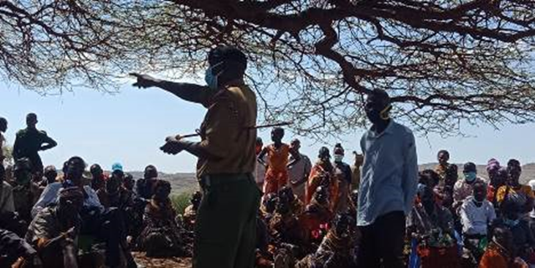
Fig 4: Assistant County Commissioner addressing the participants during peace forum

