COVID 19 (2nd WAVE) RESPONSE PLAN
(Updated on 10th June 2021)

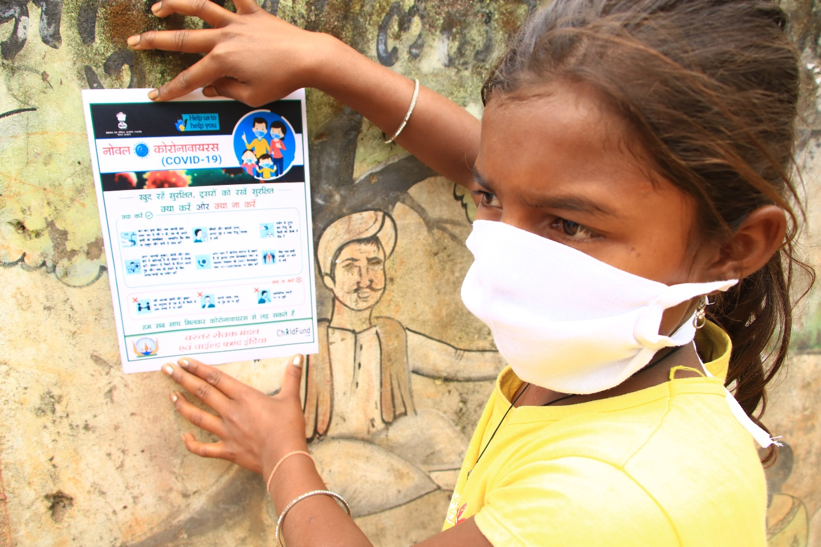

Summary
Time frame for response | 9 months
Target Budget | $ 2.88 million
Target Beneficiaries | Overall Reach is 10 million with direct support to 1 million population
Sectors | Health, Hygiene, Food and Psychosocial Social Support
Locations | 3,000 villages; 15 States
Key contacts: | Neelam Makhijani, Country Director, ChildFund India  nmakhijani@childfund.org; +91 99000 23973  Rama Rao Dammala, Senior Specialist – DRM, ChildFund India  rdammala@childfund.org; +91 9818392578

- Problem Statement and Rationale (as on 10th June 2021):
India’s second covid wave shows declining trend since beginning of June 2021. The country now accounts for some 16.65% of all active COVID19 cases in the word. The second wave of the coronavirus pandemic has a brutal impact on most of the States in India. The new surge has nearly crippled the medical infrastructure, unavailability of hospital beds, unavailability of Oxygen, and medical supplies forced to implement weekly lockdowns and nigh curfew in majority of Indian states. India was recovering from first wave of COVID19 until beginning of March 2021 when the second wave of COVID19 began initially from the states of Maharashtra and Kerala. Experts confirmed that the second wave is mainly triggered by the Indian variant of coronavirus, which has higher rate of infection compared with the first wave of coronavirus. The infections have risen sharply (nearly three times when compared with first wave of COVID19) mainly attributed to COVID inappropriate behaviours, general elections, etc. Below are the key statistics of the COVID19 situation in India and in our operational states.

- India reports 93,828 new cases, 6,139 deaths and 149,022 discharges in the last 24 hours, as per Union Health Ministry. Tamil Nadu records highest daily spike of 17,321 Covid-19 cases, and Maharashtra highest 661 deaths.
- After two months, daily positive cases came to below 100,000 cases per day. The highest ever recorded positive cases was on 7th May 2021 at 4,14,188 per day.
- Till 10th June 2021, total COVID19 cases reported stands at 29,183,121 with 359,676 deaths and 27,655,493 recovered from the infection.
- As on date, total vaccination done 242,726,693 doses out of them, 195,482,945 beneficiaries vaccinated 1st dose and 47,243,748 beneficiaries received 2nd dose.
- From 1st May 2021, Govt of India declared vaccination for all i.e. 18 years and above. However, due to shortage of the vaccine, most of the State Governments stopped the vaccination for 18+ and prioritised to vulnerable groups such as elderly, 45 years and above and people with co-morbidity.
- The Prime Minister announced that the vaccination of 18 years and above will be resumed from 21st June 2021 by addressing the shortage through additional procurements.

Following is COVID19 impact numbers in ChildFund operated states:
Sl. | Name of the ChildFund Operational States / UTs | COVID 19 Cases Confirmed | Cured / Discharged / Migrated | Deaths
1 | Jharkhand | 3,42,481 | 3,32,622 | 5,076
2 | Telangana | 5,96,813 | 5,69,086 | 3,426
3 | Bihar | 7,15,179 | 7,01,234 | 9,429
4 | Madhya Pradesh | 7,86,755 | 7,71,243 | 8,441
5 | Odisha | 8,31,129 | 7,64,673 | 3,123
6 | Rajasthan | 9,48,024 | 9,27,443 | 8,749
7 | Chhattisgarh | 9,83,916 | 9,52,532 | 13,271
8 | Delhi | 14,30,128 | 14,00,913 | 24,704
9 | West Bengal | 14,42,830 | 14,11,573 | 16,555
10 | Uttar Pradesh | 17,00,476 | 16,66,001 | 21,516
11 | Andhra Pradesh | 17,79,773 | 16,64,082 | 11,696
12 | Tamil Nadu | 22,92,025 | 20,59,597 | 28,170
13 | Karnataka | 27,28,248 | 24,80,411 | 32,291
14 | Maharashtra | 58,63,880 | 55,97,304 | 1,01,833
Total - 14 Operational States |  | 22,441,657 | 21,298,714 | 288,280
A recent online survey among 410 Indian Administrative Service (IAS) officials of the Central government has revealed that there is acute shortage of medical infrastructure in India to deal with novel coronavirus disease (COVID-19). At 3.6% of GDP, India’s overall health spending is among the lowest compared with peer and advanced economies. Of this, government spending on health accounts for an abysmal 1%. Unsurprisingly, out-of-pocket health expenditure for households is extraordinarily high in India. About 65% of all health expenditure in India (approx. 2.5% of GDP) is borne privately by households3.

COVID-19 vaccination contributes significantly to the equitable protection and promotion of human well-being among people. India’s equitable access to a vaccine is the only way to mitigate the public health and economic impact of the pandemic and is the current priority. However, this too is in short supply and logistics for vaccinating last mile person is a big concern.

The infection is slowly spreading in the rural areas because of reverse migration from urban cities. There are no quarantine centres established in the rural areas and people (who came from cities) mingle with other rural population pose higher threat of infection. The lockdowns, night curfews and reverse migration is impacting the lives and livelihoods of vulnerable population in both urban and rural areas and thus the need for support to maintain covid appropriate behaviour with food security and hygiene.

Ever since COVID -19 became a pandemic, the children and their families have been experiencing stress and trauma, the prolonged closures of schools have added fuel to this. A lot of studies including our own indicate that children are feeling sad, they are feeling helpless and are experiencing anxiety issues. In a recent assessment on “fears, perception and expectations of children and other key stakeholders on reopening of schools” done by ChildFund India with around 2000 children in 10 states, more than 73% children reported feeling sad and more than 60% reported experiencing negative changes in their behaviour like increased irritability, anxiousness, lack of concentration and so on.

Considering the current challenges posed by COVID19 second wave, ChildFund India decided to launch emergency response and recovery interventions to support the public health infrastructure, vaccination promotion and uptake, medical and protective kits for Frontline workers, food and hygiene along with psychosocial support to children and families affected by COVID19.

- Response Goal:
To relieve sufferings of vulnerable people affected by COVID19 pandemic through medical equipments support, child friendly covid care centres, vaccination of all eligible people and other life-saving support in our target communities.

- Response Outcomes:
- Ensuring availability of basic medical equipments at the Primary & Secondary health care Units in highly vulnerable districts and metropolitan cities of benefitting nearly 10 million people.
- Ensure child-friendly facilities and medical equipment’s at Urban Paediatrics COVID-19 treatment centres.
- People in our target areas get correct information and are not influenced by mis/disinformation, myths, or misconceptions. Provide correct, consistent, and timely information on the new COVID-19 vaccine(s) (availability, safety, and timelines) and vaccination processes.
- Address low-risk perception of the infection amongst people and build an enabling environment to adopt and maintain COVID appropriate behaviours to reduce any risks of infection.
- Improve access, affordability, and accessibility of Covid -19 vaccination and related materials for all vulnerable /exclusion groups.
- Vulnerable people have access to food, hygiene and Psychosocial support to prevent food insecurity and maintain healthy hygiene behaviour.

- Project Reach and Target Beneficiaries:
ChildFund India proposes to reach 10 million population (including 1 million population to benefit with direct services of the response activities) across 3,000 villages in 15 states/UTs through medical supplies, protective kits, vaccination campaign and IEC/BCC on COVID19 CAB. The intervention will also support strengthening of local health care systems through provision of medical supplies. In addition, selective vulnerable people will be supported with food baskets, hygiene kits and psychosocial support.

- Response Activities:
The following key activities will be implemented in the next 9 months as part of our response plans:

- Medical equipments to 75 PHCs/CHCs and Medical/Protective Kits to Frontline Workers
ChildFund proposes to provide medical equipments to the first tier of health system (average of 10 bedded hospitals for Covid-19 patients) and through community health workers. The response project will address shortages through supply of medical equipment’s to (Primary Health Care) PHCs ***and CHCs (Community Heath Centre) for next 45 days. Primary Health centres are selected with < 30 % basic medical equipment shortages reported in the last week of April 2021. District data on shortage of medical equipment at Primary Health Care centres has been taken into consideration while preparing this response plan. The following medical equipment and supplies are most often required as immediate need at PHC and CHC level operating as COVID care centres along with PPE kits for the healthcare workers:

At the PHCs (10 bedded) and CHC (20-30 bedded) & Covid care centres of 30-40 bedded:
Medical equipment | Minimum Requirement
Oxygen Flow Meter | 20
Oxygen Concentrator (Dual flow – 10 litre). | 2
Oxygen Concentrator mask | 50
Non rebreathe mask | 50
Bipap Machine | 8
High Flow Nasal Mask / Simple Oxygen Masks | 50
Glucometer | 2
Pulse Oxy meter | 10

Medical Essential kit for 5,000 Frontline Healthcare workers
The response will provide following safety kits to frontline worker in all the target blocks across 15 districts of India. The following activities would be undertaken by the ChildFund existing staff for ensuring sensitization and accessibility of the vaccine.

Items | Numbers
N95 Mask. | 5
Face Shield | 5
Pulse Oxy meters | 1
PPEs for frontline workers | 1 set
Digital thermometers for workers | 1 pc

- 75 Child-friendly facilities at Urban Paediatrics Treatment Centres:
The project will ensure set-up of child friendly COVID-19 care centres. The children wards would be decorated with wall painting, toys and balloons and there would be provision for outdoor activities which include swings and seesaws, among others. Children from the age group of 1 to 14 are to be kept in these wards under paediatric covid care centre. The following are the list of items proposed under this plan:

Sl. No. | Items
1 | Toys and play materials
2 | Child Friendly Wall paintings
3 | Child sitting colourful chairs
4 | Swings and seesaws for outdoors

- Strengthen and support the government initiative to vaccinate one and all:
ChildFund India will collaborate with the government health departments at local level to roll out the vaccination program at large scale. Some of the sub-activities undertaken to achieve this main activity are listed below:
- Pre-launch sensitization events at the district/block level
- Training and orientation of youth, civil society organizations, self-help groups, Panchayats, and other community on COVID19 vaccination and its process
- Conducting Training of Trainers (ToT) on COVID-19 vaccination process including social mobilization, communication planning and implementation for IEC
- Conducting training on social mobilization and IPC for community mobilizers.
- Hiring of vaccinators, tie up with franchise hospitals for vaccine sessions.
- Mobile vaccine delivery for sparsely populated, mobile sessions will be planned at places where routine immunization coverage is weak, and a small number of beneficiaries does not warrant an independent session.
- Medical supplies support to health care systems strengthening.
- Development of communication materials (IEC) -FAQs, leaflets on vaccines and Covid -19
- Develop articles with support from influencers about the safety and efficacy of the COVID-19 vaccine at state and regional media.

- Implementation strategy for vaccination activity:
Phase1:
Strategy A: Networking & collaboration with government and non-government stakeholders for the ‘Vaccination Campaign’.
Suggestive line of actions
- Networking and collaboration with concerned government departments/officials and other like-minded stakeholders
- Develop a joint state/district level Plan of Action for the ‘community-based vaccination campaign’ with clear role and responsibilities of stakeholders to be engaged in. Also agree upon on the span of the vaccination campaign e.g. ‘ Weekly or Fortnight vaccination campaign’ and identifying hotspot districts/areas for the vaccination. This will also help in putting in place a Team of Doctor/professional on standby to handle any adverse event during the span of the campaign.
- Set-up steering committees and the taskforce group at district level to plan, execute and monitor the campaign. The taskforce can have representation of different stakeholder departments for better coordination and convergence at all levels.

Strategy B: Training and knowledge building programs
Suggestive line of actions
- Develop a training module on COVID and Vaccination program and put in place a training program cascading from state to block level
- Conduct state/district ToT for nodal officers from district health department along with officials from WCD and education.
- Block level trainings for officials of health, Education and WCD, to be conducted by trained nodal officers
- Conduct community meetings/sensitization activities by block level officials (trained) with support of ANM/ASHA/AWW.

Phase 2:
Strategy A: Mass awareness on COVID vaccine: educating people in the community about the current wave of COVID, its effects on health and the benefits of the COVID vaccine. Different available media tools can be used to educate masses on the issue.
Suggestive line of action
- Mass media
- Social media
- Local folk media
- IEC/BCC activities

Strategy B: Facilitating easy registration- ChildFund can facilitate for easy registration of eligible community members for the COVID vaccination.
Suggestive line of action
- Set-up a community-based help Desk
- Collect/prepare all required documents for the prospective beneficiaries

Phase 3:
Strategy A: Holding ‘Community-based Mass Vaccination Campaign’ in all target communities.
Suggestive line of actions
- Finalizing vaccination sites
- Ensuring all necessary preparations are in place e.g. required no. of vaccines (logistic of the supply chain), medical professionals, PPE and other health/safety kits/materials, logistic arrangements in case of any person developing side effects on site etc.
- Ambulance service to handle emergency
- Ensuring the Team of Doctor/professional is alerted/put on standby to handle any adverse event during vaccination days of the campaign
- Reporting of the vaccination administered to people to the concerned block/district officials

- Distribution of Food Basket to 15,000 families:
Food security is fragile under normal circumstances and it gets aggravated during the lockdown period especially of vulnerable families dependent on daily wages. The disruption to livelihoods as a result of the lockdown and movement restrictions pre and post lockdown will increase the food insecurity and putting children and their families at risk. ChildFund proposes to provide dry food baskets to vulnerable families within its current operational areas so that the impact of the crisis is minimised and children and families are protected from food insecurity and starvation.

- Distribution of hygiene kits to 25,000 families with BCC messages:
ChildFund proposes to distribute hygiene kits along with hygiene and sanitation messages to the vulnerable families so that they are protected from the deadly disease contamination and transmission. Effective handwashing and hygiene practices along with social distancing and other changes in behaviour are the key to slowing the transmission of the virus and combatting stigmatization. This activity will increase the COVID Appropriate Behaviour (CAB) at individual household level.

- Psychosocial Support:
Last year the focus of Inter Generation Coping and Learning (IGCL) that further got developed into neighbourhood session was on preventive measures as far as psycho-social support is concerned, however, this time, the need is much more intense as it has already been a year into the pandemic and the conditions are more gross. Hence this time we need to take a two-pronged approach:
- Working at the preventive and emotional first aid level - Continue with the SEL support in more intensive formats including focus on art, play and rich family interactions.
- Providing linkage and support with intensive professional care.

Objectives are
- To engage children and their families in activities related to socio – emotional development like the special SEL sessions, art sessions, play activities and so on, so that they feel less stressed and more connected.
- To provide expert psychosocial support to children, parents, and even front-line workers by linking them with the experts.
- To generate awareness in the community about the right measures to be taken for mental wellbeing.

Action points:
- Provision of weekly plan and IEC as well as material for SEL as we were doing with IGCL. We have a whole kit developed now, which was developed in the last phase. It contains, worksheets, especially designed cards games and board games on emotions as well as managing emotions, art material and game books, parental guidance material and so on.
- Identifying and linking with the expert counsellors and counselling agencies, providing counselling support for those who need. We can reach out and find linkages with institutes like NIMHANS and so on who are also providing tele counselling services.
- Organising mass awareness drives on messaging around mental and emotional well being in the times of COVID – This would include wall writing, street plays, loudspeaker vans, screening of animated movies, jingles and other such material.
- Community Lectures and webinars with the expert psychologists/counsellors – Recorded lectures, videos, discussions with the experts can be broadcasted through mobile vans, or loudspeakers or even online.
- Special interaction, activities, and exercises for frontline workers – Since the frontline workers are also on the verge of breaking down now, so experts will be engaged in providing advice and carrying out some mental and emotional wellbeing supportive activities for them.

- Progress made so far in line with Response Plan:
ChildFund has secured $1.2 million to support the following critical activities:
- 78 PHC/CHC/Urban Health Centres with medical equipments
- Establishing 28 Child Friendly Covid Care Centres along with SOP development
- Medical essential and protective kits to 3,000 Frontline Workers
- Vaccination Drives in 4 high risk districts
- Hygiene kits to 6,000 kits
- Food baskets to 1,500 families

ChildFund has started the implementation of response activities since 1st week of May 2021. The distributions mainly focused on addressing immediate needs of the local health system (PHC/CHCs/Covid care centres) to enhance COVID19 management and prevention. Till date, the following medical equipments and supplies were distributed to save precious lives:

Name of medical equipment/item | Quantity distributed
# of PHCs/CHCs/Covid Care Centre Covered | 40
# of Oxygen Flow Meter | 688
# of Oxygen Concentrator (single flow – 5 litre) | 148
# of Oxygen Concentrator mask | 2,685
# of Non rebreathe mask | 2,900
# of Bipap Machine | 270
# of Simple Oxygen Mask | 2,400
# of N-95 Mask (Reusable) | 10,310
# of Face Shield (Reusable) | 310
# of Pulse Oxy meters for frontline workers and PHCs | 375
# of Glucometer | 44
# of PPE kits with thermometer | 237

Handing over of medical equipments in an Urban PHC in Hyderabad
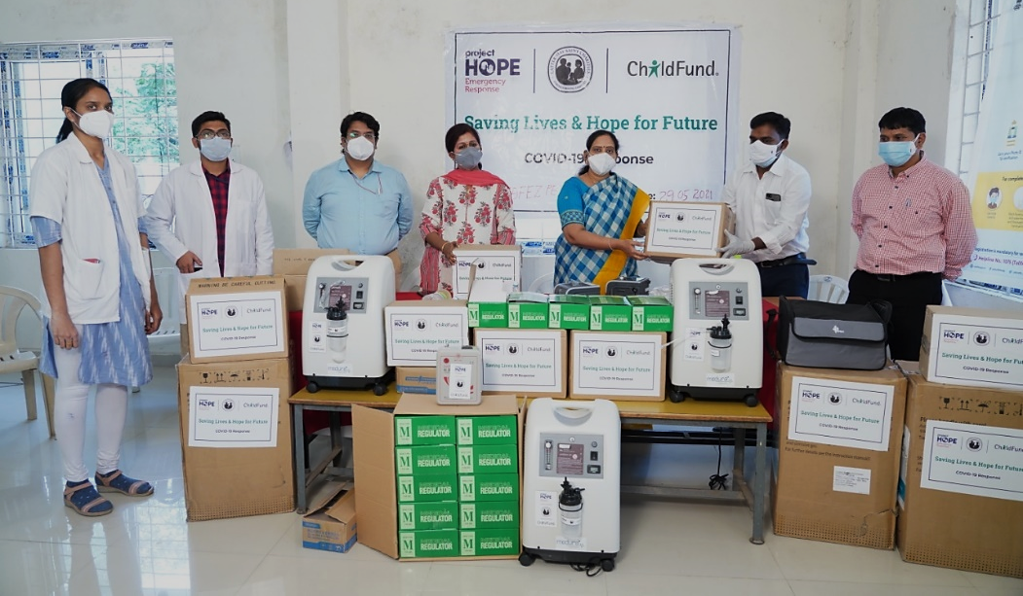

Medical staff is monitoring the oxygen flow in an oxygen concentrator provided at Navi Mumbai
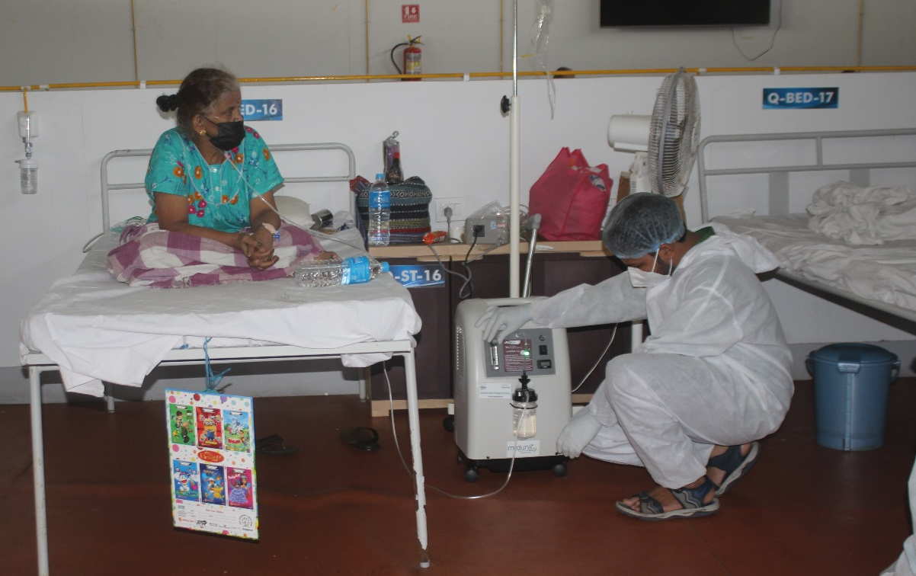

A Medical doctor in Dhar (Madhya Pradesh) checking pulse oxymeter provided to their PHC
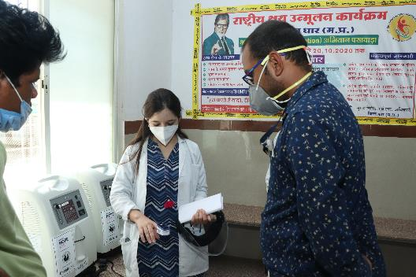

Medical essential and protective kits distributed to ASHA/ANM in Junnar, Maharashtra
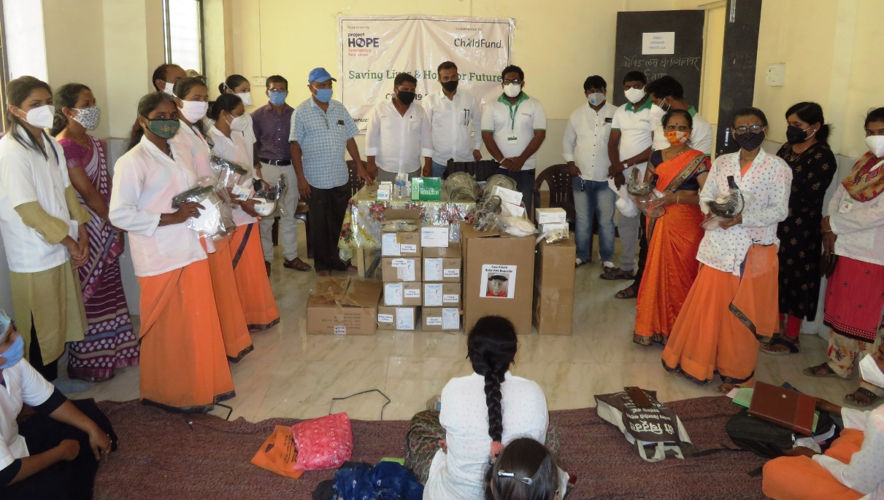

- Financial Considerations and Duration:
The estimated funding for the Response Plan is approx. USD 2.88 Million. Detailed budget break-up can be shared on request. ChildFund has already raised approx. $1.2 million against the target. The resource mobilisation teams (corporate and individual fund raising) have scaled up their efforts to mobilise resources to support our interventions across the program locations including grants project locations.

- Management and Operational Approach:
ChildFund India has both direct implementation and local partners across 15 states and Union Territories and will implement the proposed COVID19 second wave response activities through the network of the said human resources. The project officers at direct implementation locations along with their teams will drive the implementation at local level technical guidance from thematic specialist at National Office. In addition, ChildFund will engage education volunteers, youth collectives, adolescent groups and mothers groups. These human resources are from the same villages / communities who have contextual understanding and ensure smooth implementation of the activities by adhering to risk mitigation actions. Technical oversight is provided by the Senior Specialist – DRM based in Delhi with strategic guidance from the Country Director and other key functional head such as HR, Finance, Admin, Communication and Fund raising.

- Monitoring and Evaluation
We have created a dashboard to capture the COVID19 response related data and information from the field. Since, the response activities are being currently implemented the existing MIS/M&E protocols will be used to monitor and report on the intervention. Online Google Template has been created so that the distribution details are updated as per the progress on regular basis.

- Media, Communications and Fundraising
ChildFund Communications team has been supporting to coordinate with the PR agencies to share our information with larger potential supporters. The website has been updated with information on the response as well as donation page. SitReps are being prepared and shared with IO/RO as per the timelines. Photographs are being collected as part of photo bank for this response.

Corporate and Individual Fundraising channels have been activated and followed up for resource mobilisation to support our efforts for the crisis.

End of Document

