FLOOD SITUATION IN NOTHERN KENYA: SITUATION REPORT 2020

Date: 7th January 2020

Country/Location: Kenya (Turkana, Marsabit, and Samburu counties)

Title of Emergency: Food Crisis Emergency Response

Dates covered by report: 1st November to 30th December 2019

COUNTRY SITUATION HIGHLIGHTS
- Heavy rainfall in many regions of Kenya since the start of the short rains season in early October has led to riverine and flash floods, rock falls and mudslides.
- More than 11000 people have been affected, mainly in the Northern Kenya according to the Kenya Red Cross Society (KRCS). It has also been confirmed that many people living in low lying areas have been displaced as a result of rivers breaking banks.
- At least 8 flood-related deaths have been registered, according to Local media reports quoting the Government, and the death toll and number of people displaced is expected to rise in the days ahead as further information is received and verified from affected areas.
- In Turkana County it is estimated that 1,945 HH have been affected by the floods. A total of 8,220 shoats, 71 camels, and 82 cattle died from floods and nearly 3,900 acres of irrigated land was destroyed. In Samburu county 642HH, 413 goats, 32 cows and 6 camels have been affected by floods and in Marsabit county 456HH affected with over 3000 livestock’s washed by flash floods
- Destruction and damage of key infrastructure -including roads, bridges, schools and health facilities– has been reported in multiple areas.
- The rains -driven by the strong positive Indian Ocean Dipole (IOD)- was expected and continued for weeks with most parts of the country experiencing above average rainfall until late December 2019, according to the Kenyan Meteorological Department.
- The heavy rains and floods followed a prolonged period of drought in Kenya. Two consecutive seasons of poor rainfall and high land surface temperatures in many areas led to poor crop and livestock production and rapid deterioration of rangeland resources, according to the latest Integrated Phase Classification (IPC) report.
- Prior to the floods, a projected high number of people were projected to face IPC Phases 3 (crisis) and 4 (emergency) in October especially in the Northern parts of Kenya. Although the rains brought reprieve in some locations, in others there was risk of damaging crops and killing livestock.
- Higher than usual rainfall was received and continued in the regions throughout November, 2019 and December, 2019 with persistent risks of floods slipping to early January 2020
- Sometimes in late December, the government that swarms of desert locusts started crossing into northern Kenya. Three counties of Wajir, Marsabit and Mandera are affected. The government commenced aerial spraying in three counties to try to head off a locust invasion which has already caused extensive damage to farmland in neighboring Somalia and Ethiopia. ChildFund has operations in Marsabit. The three affected counties are largely semi-arid and are occupied mostly by pastoral communities.

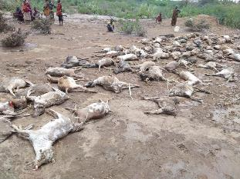

Livestock’s washed away by flash floods in Turkana County

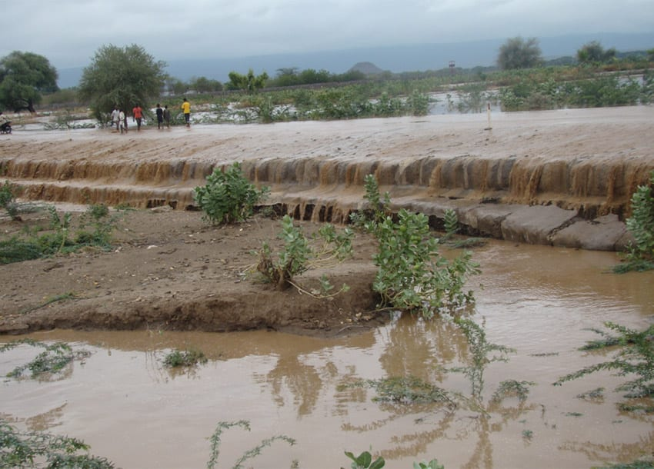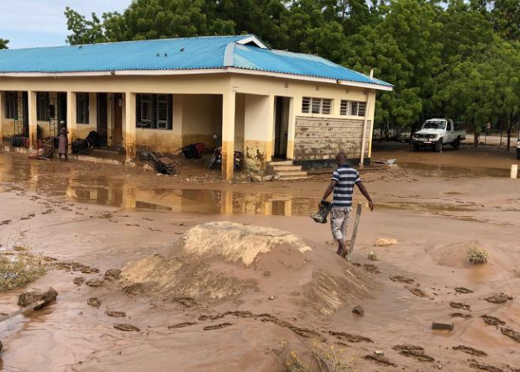

(Right) River Turkwell in Turkan County breaks its banks due to floods. (Left) Poor access to one of the health facilities in Marsabit county due to flooding

CHILDFUND KENYA’S RESPONSE

In a bid to mitigate the effects of the drought, ChildFund Kenya working with its Local Partners (LPs) has been intervening in 7 counties reaching over 17,680 people with life-saving assistance since December 2018. These interventions are in Food Security, Health and Nutrition, and WASH with Child Protection as a cross-cutting sector. However, given the prevailing situation i.e. flooding in some areas and below average rainfall recorded in other parts, there is need to review and scale up these interventions to reach more people as soon as possible. Additional funding is needed so that ChildFund can fully implement an elaborate emergency response. With support from the IO Emergency Management Unit, the Country Office intends to develop a two-year emergency response strategy focusing on immediate interventions, recovery and resilience-building for the affected areas. Below are some of the interventions that were implemented during the reporting period:

- Early Childhood Development (ECD) centers and Pregnant and Lactating Women (PLW) supported with supplementary feeding

ChildFund operating in Marsabit counties, supported 315 pregnant and lactating mothers with food items like maize, beans, oil and rice as an emergency response to drought and flood to increase household food security.

In Turkana County, 25 ECDs were supported with supported with supplementary feeding in Turkana South, Turkana Central & Loima Sub-Counties by Child Fund Kenya. A total of 4,545 Children (Boys-2,304, Girls-2,241).

In Samburu County, ChildFund supported 289 PLWs and procured the following food stuffs for PLWs. Rice- 135 bags of 25 kgs Beans-25 bags of 45 kgs, cooking oil-35 cartons of 5 kgs

- Vulnerable families supported with supplementary feeding

Due to the worsening situation in Turkana County, particularly at the household level, and following an appeal by the County Government, ChildFund supported 138 HH with food and non-food items reaching a total of 828 beneficiaries (Male-405 & Female-423)

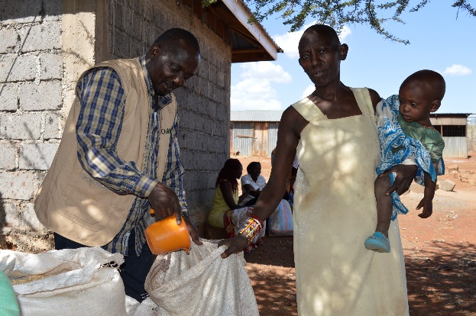
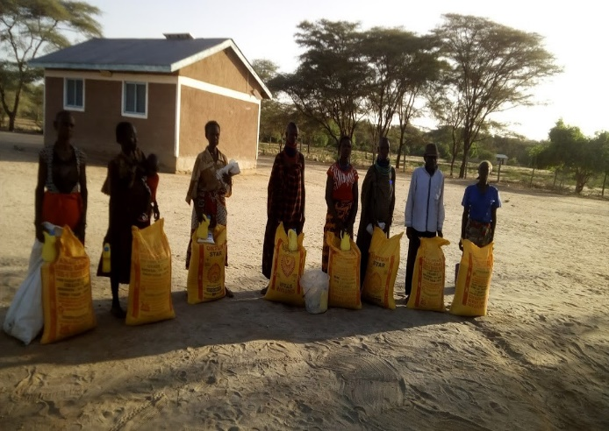

(Right) A group of beneficiaries of food commodities in Turkana County. (Left) Local partner staff distributing food commodities in Marsabit.

- Water, Sanitation and Hygiene (WASH)

In Turkana County, ChildFund Kenya, with support from ChildFund Korea under the ongoing Turkana WASH and Nutrition Project, installed a solar pumping system in one borehole in Katilu community of Turkana south sub-county. Upon completion, this borehole will benefit 1,850 community members.
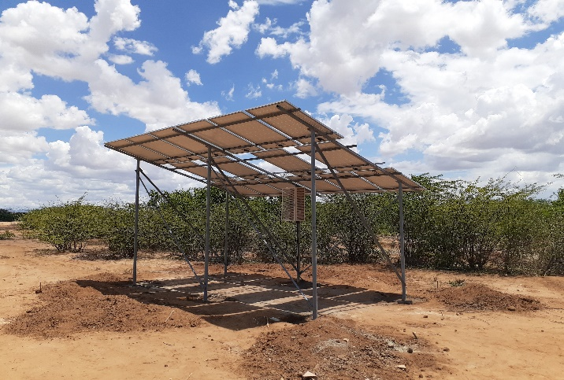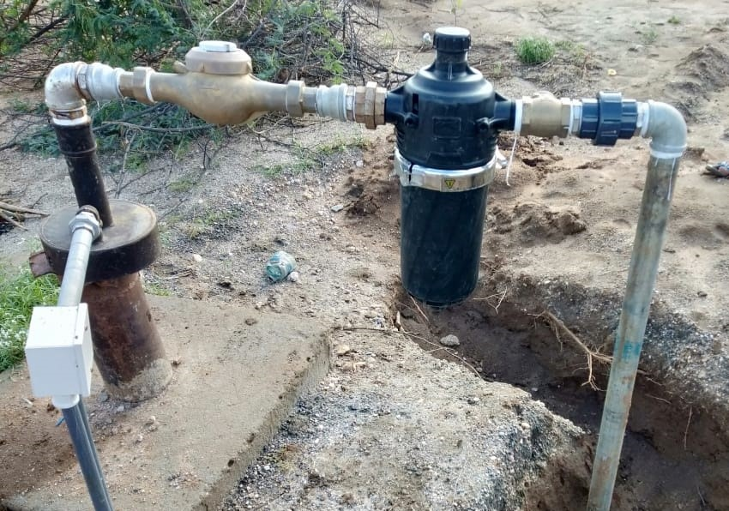
(Right) Crystalline solar modules at Katilu (Left) Katilu filter and borehole and abstraction point.

SECTIONS BELOW ARE FOR INTERNAL USE ONLY

- Security & logistics

The security situation across the country and in the affected counties has generally remained calm. However, the security situation specifically in Turkana South and Turkana East sub-counties remains unpredictable because of the high likelihood of cattle-rustling between Turkana and Pokot herders since both communities have concentrated their livestock on the border area because that is the area that still has some pasture following the prolonged drought. Reports of cattle rustling between the Turkana and Samburu communities were also reported in Saburu North.

- Partnership and coordination

ChildFund and its LPs continue to participate in national and county level emergency response coordination forums. LPs are actively participating in county level steering groups charged with assessment, planning and implementation of interventions. ChildFund also works in collaboration with other international and local Non-Governmental Organizations such as UNICEF and World Food Program.

- Staffing

Ongoing emergency response efforts are currently supported by existing Country Office and LP staff.

- Donors: To date, ChildFund Kenya has utilized USD 227,697 to implement various emergency response interventions using funding from subsidy and ongoing grants as indicated below:

Donor/Source of Funds | Program | Amount (USD)
ChildFund Korea | Disaster Risk Reduction Project in Marsabit County | 49,314
ChildFund Korea | WASH and Nutrition Project in Turkana County | 88,891
UNICEF | Integrated ECD Project in Samburu County | 1,779
Funding Model  re-allocation in Turkana County | Frontiers Children Development Program (Turkana County) | 18,662
Subsidy re-allocation | Nawiri Child Development Program (Marsabit County) | 26,020
Subsidy re-allocation | Samburu Children’s Program (Samburu County) | 13,226
Subsidy re-allocation | Frontiers Children Development Program (Turkana County) | 29,509
Subsidy re-allocation | Central Rift Child Development Program (Baringo County) | 296
Total |  | 227,697

- Media/Communications

Spokesperson: Chege Ngugi, Country Director

Media contact: Maureen Siele, Communications Officer

Languages spoken: English

Resources | What’s available | URL
Websites | Media coverage of the drought and floods situation in Kenya | Drought crisis, food insecurity could worsen in Kenya – IGAD  https://citizentv.co.ke/news/drought-crisis-food-insecurity-could-worsen-in-kenya-igad-241362/  Drought to get worse, state warns  https://www.the-star.co.ke/news/2019-04-10-drought-to-get-worse-state-warns/  Floods to hit Nairobi and four other counties  https://www.the-star.co.ke/news/2019-04-26-floods-to-hit-nairobi-and-four-other-counties/  Transport paralyzed in Turkana as flash floods cut off Kakuma-Lokichogio road  https://citizentv.co.ke/news/hundreds-stranded-as-kakuma-lokichogio-road-cut-off-in-flash-floods-242091/  Woman, child swept away after Nairobi floods wreak havoc  https://citizentv.co.ke/news/woman-child-swept-away-after-nairobi-floods-wreak-havoc-242249/  Several families displaced as floods wreak havoc  https://www.standardmedia.co.ke/article/2001323348/several-families-displaced-as-floods-wreak-havoc-in-bondo

