

**Fentale District Flood Hazard Situation Report [Oromia -Ethiopia]**

**Humanitarian Situation Report**

**[Date Prepared: September 4, 2020]**

**[Point of Contact – Lilly Omondi- Country Director email address:** [**lomondi@childfund.org**](mailto:lomondi@childfund.org)**/**

**Tel: +251 911 250738]**

Introduction

Between September 3&4, 2020, ChildFund Ethiopia Team comprising Emergency Program and Partnership Portfolio specialists held a field mission to the flood affected areas in Fentale district, East Shoa zone of Oromia region. The purpose of the mission was to assess the humanitarian situation in the district attributed to the flood occurred in the area as of September 2, 2020.

This brief report is thus prepared to inform the CO SMT and EMU at IO while the detail assessment on the situation and need will be communicated further.

Country/Location: Fentale district, East Shoa Zone of Oromia Region, Ethiopia

Title of emergency: Rapid Relief Response to Fentale Flood Disaster Affected Communities

Dates covered by report: September 6, 2020 – November 2020

Situation Report No.: One

**Part 1: The Overall Situation** (for EXTERNAL use)

Ethiopia is prone to recurrent floods every year during the major rainy season, particularly between June and September, which threatens the lives and livelihoods of thousands of people. According to the estimates released by the National Flood Task Force, 2,066,683 people are estimated to be affected by river and flash floods during the 2020 kiremt season.

This situation has already been witnessed in many places of the country. Since Mid-April the flooding occurred in Somali, Afar, Southern Nations, Nationalities, and Peoples Region (SNNP), Dire Dawa, Oromia, Gambella, and Harari regions in Ethiopia and had affected hundreds of thousands of people and their assets. According to the National Disaster Risk Management Commission (NDRMC), at least 151,828 people were affected by recent floods in the country (July and August). As of end of August and the first few days of September 2020 alone more than 120,000 people in Ethiopia's Afar and Oromia regional states have been affected by floods as the Awash River flows out of its riverbank due to heavy rains and displaced more than 92,000 of them.

The flood has resulted in sever humanitarian and economic damages in the country.

The National Meteorological Services forecasts a continuation of normal to above normal rainfall in many parts of Ethiopia. Should this forecast come prove accurate, more people within the Awash River basin are still likely to be affected by the flooding.

**Part 2: The Situation in Areas Where ChildFund Works**

1. **Situation Analysis**

Fentale district and Metehara town where ChildFund and its local implementing partner operates are one of the areas where highly affected by the flood occurred as of end of August and the first week of September. The massive flooding in Fentale was mainly caused by the overflow of Awash River but was exacerbated by Beseka Lake, which has also seen high volume of rainwater beyond its capacity

According to the information obtained from Metehara town administration and Fentale District Disaster Risk Management commission a total of 30,494 (14,860.00F) people have been displaced from 8 kebeles (1 urban and 7 rural).

The details are illustrated in the below table.

Table 1 Number of people displaced by Kebele by gender

|  |  |  |  |  |  |  |  |
| --- | --- | --- | --- | --- | --- | --- | --- |
| S/ No | Kebele Name | People affected | | | | | |
| Households by Gender | | | Families by Gender | | |
| F | M | Total | F | M | Total |
|  | Haro Adi kebele  (Urban) |  |  | 5,812 | 7,101.00 | 7,085.00 | 14,186 |
|  | Gola | 408 | 205 | 613 | 2124 | 2006 | 4130 |
|  | Gare Fufate | 437 | 193 | 630 | 1579 | 1571 | 3150 |
|  | S/Weba | 334 | 146 | 480 | 1653 | 1227 | 2880 |
|  | Gelacha | 560 | 208 | 768 | 1458 | 3150 | 4608 |
|  | F/Ledid | 99 | 21 | 120 | 352 | 249 | 601 |
|  | Alge | 139 | 3 | 142 | 466 | 218 | 684 |
|  | Gare Dima | 44 | 7 | 51 | 127 | 128 | 255 |
| **Total** |  |  |  | **8,616** | **14,860.00** | **15,634.00** | **30,494.00** |

Note: The details of affected populations by age group will further be assessed.

Out of those displaced communities ChildFund enrolled children and their families constitute 44%(13,530).

The below table illustrated the details of the categories by Kebele.

Table 2 Number of Enrolled and Sponsored Children affected by flood in the area

|  |  |  |  |  |  |  |  |  |  |  |  |  |  |
| --- | --- | --- | --- | --- | --- | --- | --- | --- | --- | --- | --- | --- | --- |
|  | Haro Adi | | | | | | | | | | | | |
| Category | Sex | | | | 0-5 | 6-14 | | 15-24 | | | Total | | |
| Enrolled children | Male | | | | 35 | 337 | | 330 | | | 702 | | |
| Female | | | | 42 | 317 | | 338 | | | 697 | | |
| Total | | | | 77 | 654 | | 668 | | | 1399 | | |
| Siblings | Male | | | |  |  | |  | | | 2808 | | |
|  | Female | | | |  |  | |  | | | 2788 | | |
|  | Total | | | |  |  | |  | | | 5596 | | |
| Adults/Caregivers | Male | | | |  |  | |  | | | 662 | | |
| Female | | | |  |  | |  | | | 737 | | |
| Total | | | |  |  | |  | | | 1399 | | |
| Grand Total |  | | | |  |  | |  | | | 8394 | | |
|  | Gola | | | | | | | | | | | | |
| Category | Sex | | | 0-5 | | 6-14 | | | 15-24 | | Total | | |
| Enrolled children | Male | | | 15 | | 80 | | | 72 | | 167 | | |
| Female | | | 5 | | 63 | | | 48 | | 116 | | |
| Total | | | 20 | | 143 | | | 120 | | 283 | | |
| Siblings |  | | |  | |  | | |  | | 668 | | |
|  |  | | |  | |  | | |  | | 464 | | |
|  |  | | |  | |  | | |  | | 1132 | | |
| Adults/Caregivers |  | | |  | |  | | |  | | 172 | | |
|  | | |  | |  | | |  | | 111 | | |
|  | | |  | |  | | |  | | 283 | | |
| Grand Total |  | | |  | |  | | |  | | 1698 | | |
|  | Gelcha | | | | | | | | | | | | |
| Category | Sex | | 0-5 | | | | 6-14 | | | 15-24 | | Total | |
| Enrolled children | Male | | 18 | | | | 97 | | | 43 | | 158 | |
| Female | | 12 | | | | 86 | | | 56 | | 154 | |
| Total | | 30 | | | | 183 | | | 99 | | 312 | |
| Siblings |  | |  | | | |  | | |  | | 632 | |
|  |  | |  | | | |  | | |  | | 616 | |
|  |  | |  | | | |  | | |  | | 1248 | |
| Adults/Caregivers |  | |  | | | |  | | |  | | 154 | |
|  | |  | | | |  | | |  | | 158 | |
|  | |  | | | |  | | |  | | 312 | |
| Grand Total |  | |  | | | |  | | |  | | 1872 | |
|  | Alge | | | | | | | | | | | |  | |
| Category | Sex | 0-5 | | | | | 6-14 | | | 15-24 | | Total | Grand Total | |
| Enrolled children | Male | 2 | | | | | 64 | | | 52 | | 118 | 1,145.00 | |
| Female | 1 | | | | | 70 | | | 72 | | 143 | 1,110.00 | |
| Total | 3 | | | | | 134 | | | 124 | | 261 | 2,255.00 | |
| Siblings |  |  | | | | |  | | |  | | 472 | 4,580.00 | |
|  |  |  | | | | |  | | |  | | 572 | 4,440.00 | |
|  |  |  | | | | |  | | |  | | 1044 | 9,020.00 | |
| Adults/Caregivers |  |  | | | | |  | | |  | | 117 | 1,105.00 | |
|  |  | | | | |  | | |  | | 144 | 1,150.00 | |
|  |  | | | | |  | | |  | | 261 | 2,255.00 | |
| Grand Total |  |  | | | | |  | | |  | | 1566 | 13,530.00 | |

**Source**: FGO

Although no human fatality is reported with flood hazard as a result of the concerted effort of the government and other stakeholders to evacuate the people, severe damages of residential houses, agricultural produces and animals have been reported by the flood. Institutions such as schools (1), Private and Public Banks (2), government offices (3), many private commercial centers are also reported to have been damaged by the flood.

Residents did not take any of their assets with them while escaping from the flood.

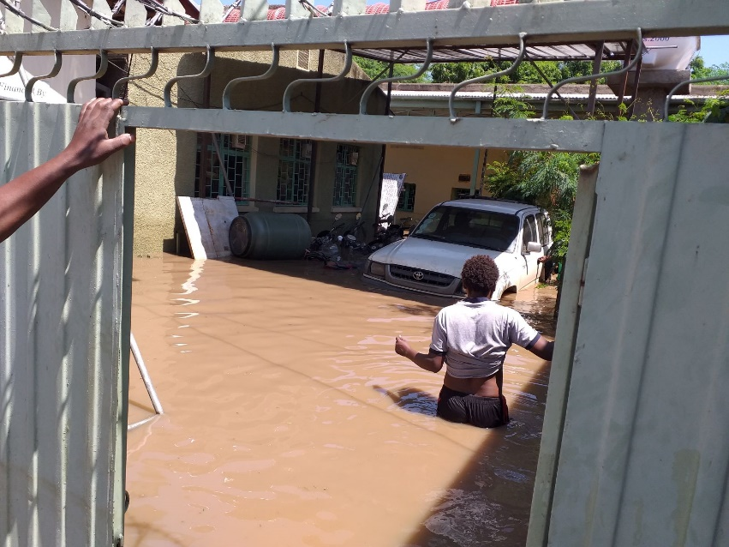Future Generation’s Organization (FGO)- ChildFund’s Implementing Partner Organization has also been affected by the flash flood. The vehicle and all office assets and documents are all swamped by the water. However, the Laptops have been saved since LP the staff have taken them to their Home due to the temporary closure of the office two weeks before in relation with Covid-19 positive report on one of the LP staff. Their store located in other place have also been saved somehow though inundated with the water.

**Figure 1 The Partner's Office In Haro Adi Kebele**

In order to preposition itself for the quick response, the LP has rented a new office close to the IDP centers but looking for Vehicle and some office furniture, equipment and machines which will help them resume their operation shortly..

**Safe water supply** is one of the critical problems for the IDPs as the urban water supply system was totally distrusted due to the same flooding issues. Although Water trucking has been started, the shortage of trucks and distance of water point (water is feteched from either Welnchiti or Adama town) became a big constraint right now.

There is also a big concern over the risk of infection with the **Corona Virus**/Covid-19/. People are very congested in the relocation center and while transporting from their home to the center. No personal protective equipment and Supplies are given to the IDPs right now.

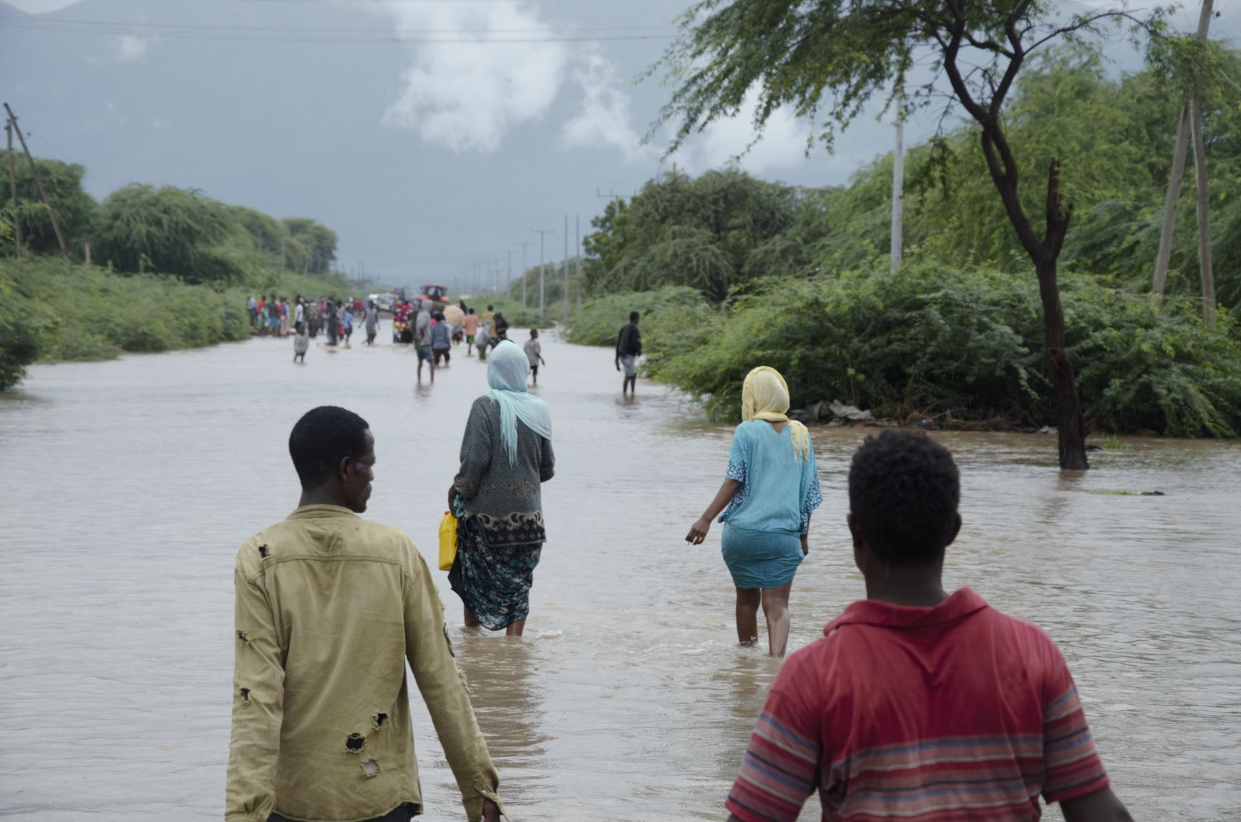

Figure 2 Haro Adi Kebele Inundated with the flood coming out from Awash River

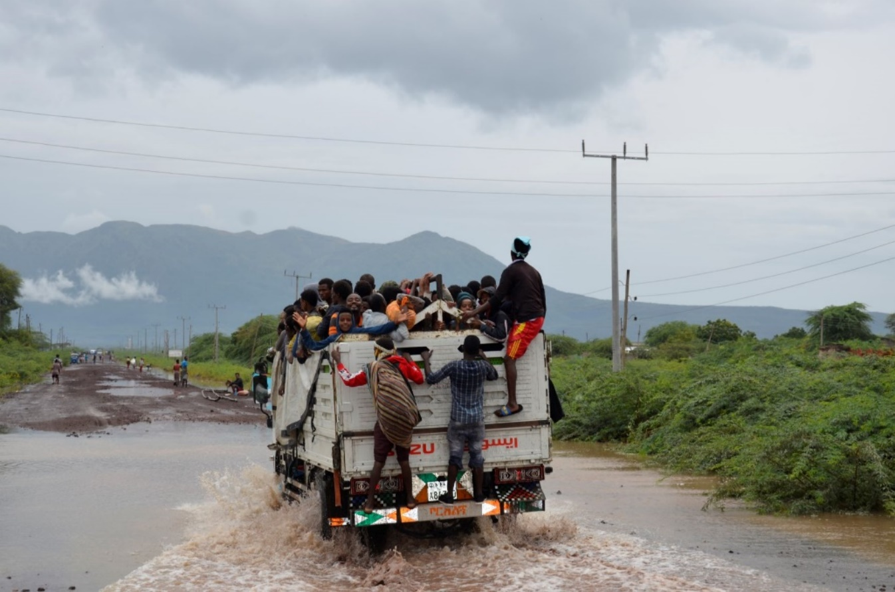

Figure 3 Isuzus rescuing people from the flood

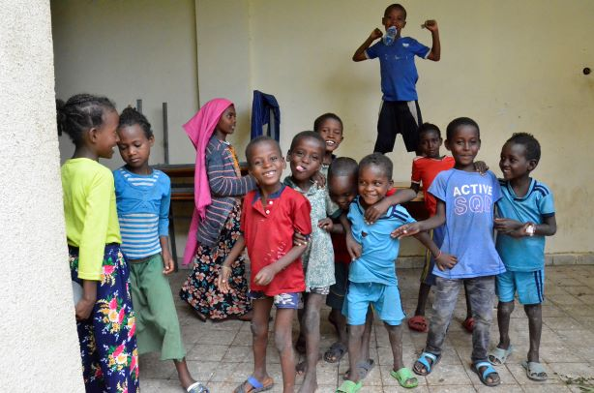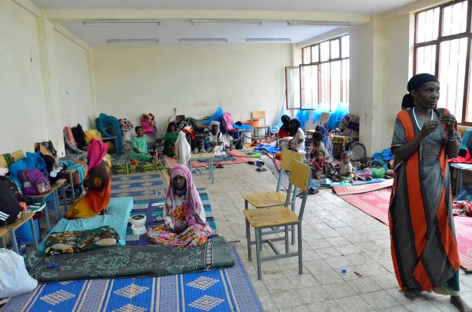

Figure 4 Children and mothers relocated to Metehara school( those assigned in one room-parly)

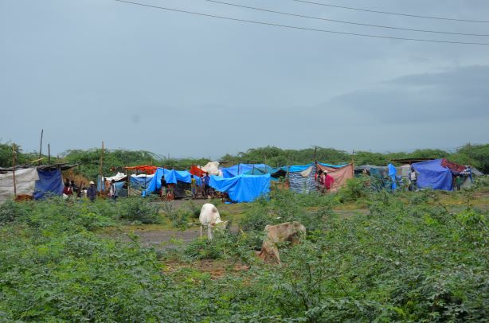

Figure displaced people relocated in the open field to escape the flood

1. **Needs Analysis**

As of September 4, 2020, the National Disaster Risk Management Commission (NDRMC) has provided 100 Quantal of Rice and other NFIs such as plastic sheet. The urban communities are also mobilizing food support from the urban dwellers. Despite the government’s and taskforces effort to mobilize resources to support the IDPs, there is still a critical humanitarian gap as indicated by the Zonal, Woreda and Metehara city administrations DRM commission which need to be addressed immediately.

Some of the immediate needs include but not limited to:

* + **Food Relief** items such as maize, wheat flour, pasta, macaroni, rice, sugar, edible oil and skimmed milk for under five children. Supplementary food support for displaced pregnant and lactating women and children under five.
  + **Emergency Wash interventions:** Water trucking, provision of Water treatment chemicals and water collecting materials, Sanitary materials such as sanitary pad and soap especially for women and girls, Hygiene promotion
  + **Covid-19 Response Interventions such as** provision of Reusable masks, community education/awarenessraising activities,
  + **Child Protection**: creation of child friendly spaces with in the IDP centers and equipping with the necessary materials such as Clothes and Toys for children, community education etc.
  + **Shelter / NFI**: IDPs in the rural a kebeles are living on open field without adequate shelter. Hence in the short term there is a need to provide them with tents or Plastic sheets. In both cases i.e urban and rural IDP sites, their living condition is appalling, with no available NFIs; they do not have blankets, mattresses, clothes nor items for cooking, washing, drinking and collecting and storing water.
  + In the medium and long term there is a need to rehabilitate their houses as many destitute families have already lost their houses by the flood.
  + **Psychosocial support** services to affected population

ChildFund and its local partner, FGO, can implement some of these humanitarian needs, if not all, based on available resource and capacity at least for three months.

**Proposed Response Interventions and Budgets Requirements**

**Table 3: Detail budget**



SECTIONS BELOW ARE FOR INTERNAL USE ONLY

1. Partnership and coordination

ChildFund and its local partner, Future Generation’s Organization(FGO), are closely working with the local government to strengthen its emergency and recovery activities. Thus, collaboration and coordination among different actors, NGOs, GOs and community is very important. Thus, this project will revitalize such coordination efforts in the way that enhances efficiency and effectiveness of the emergency response activities.

1. Program

Education

Child Protection √

Health √

Food √

WASH √

1. Staffing

Major HR issues: No major HR issues; existing CO and LP staff can manage the project in coordination with government experts

Visits: None

Departures: None

Arrivals: None

Staff on the Ground :

1. **Samuel Terfa, Executive Director, FGO; 0911899397**
2. **Person 2**
3. **Person 3**
4. **Person 4**

Key contact: Lilly Omondi; email address: [lomondi@childfund.org](mailto:lomondi@childfund.org)

Tel: +251 911 250738

1. Donors

Proposals and concept note submitted:

|  |  |  |
| --- | --- | --- |
| Donor | Program | Amount |
|  |  |  |
|  |  |  |
|  |  |  |

Confirmed funding:

|  |  |  |
| --- | --- | --- |
| Donor | Program | Amount (USD) |
|  |  |  |
|  |  |  |
|  |  |  |
|  |  |  |

1. Finance
2. Media/Communications

Information and media contact:

Information and media contact:

Spokespeople – languages spoken:

| Resources | What’s available | URL |
| --- | --- | --- |
| Photos |  |  |
| Case studies |  |  |
| Press releases |  |  |
| Blogs |  |  |
| Press coverage |  |  |
| Videos |  |  |

1. Additional information
2. Next steps

Detail Need assessment, relief response and monitoring of the situation and Update the sitrep