Supporting children and women in drought affected areas in Kenya

In March 2017, ChildFund Kenya issued an emergency appeal requesting $2,360,000 to reach 44,562 people in 5 counties with life-saving assistance. ChildFund Kenya received $1,409,500 to implement various interventions in Food Security, Health and Nutrition, and WASH with Child Protection as a cross-cutting sector. To date, the local partners’ re-directed subsidy is $103,256. Below are stories from some of the beneficiaries. A link to more photos and videos showing these interventions is here https://photos.app.goo.gl/5ayo0ANTHgd6tM8B2

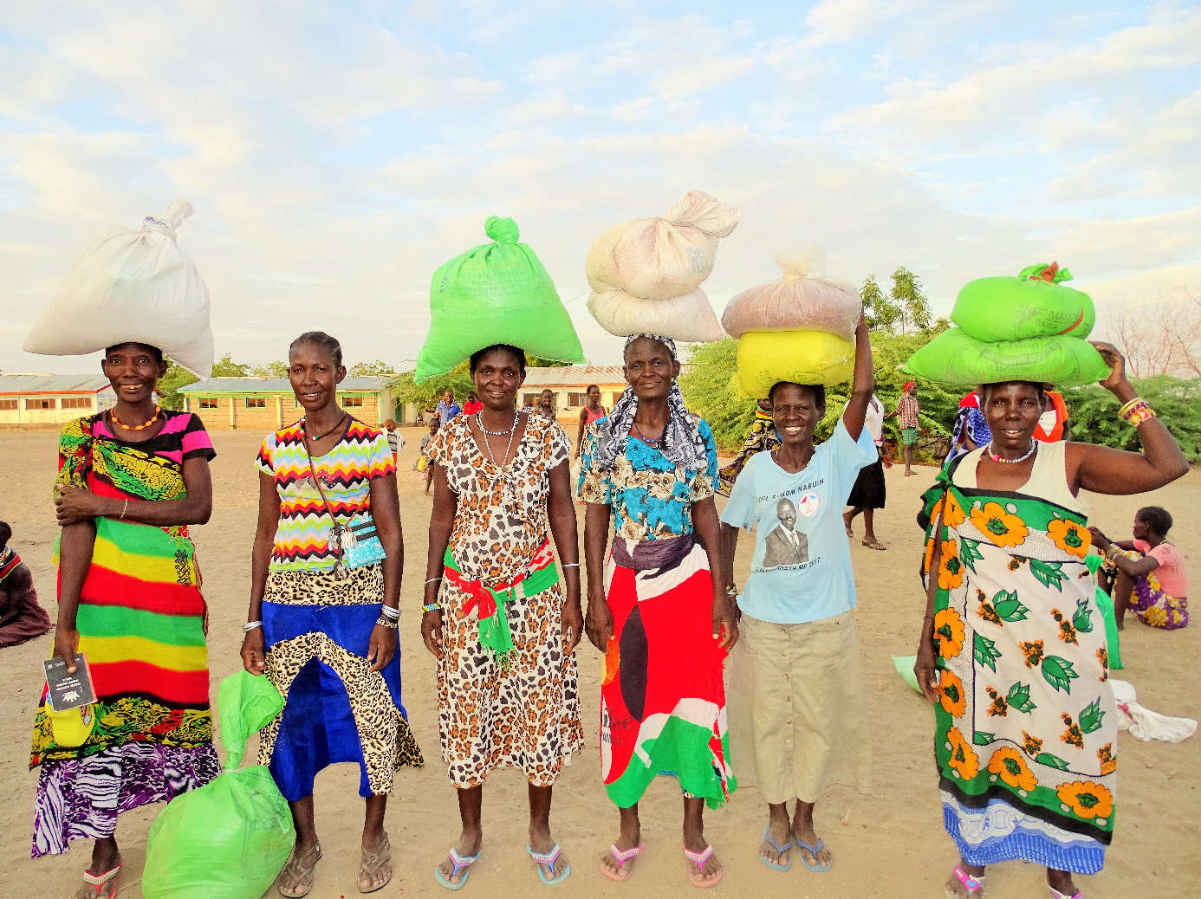 Pregnant and lactating women smiling after receiving food rations in Turkana County.

Nakurka’s story
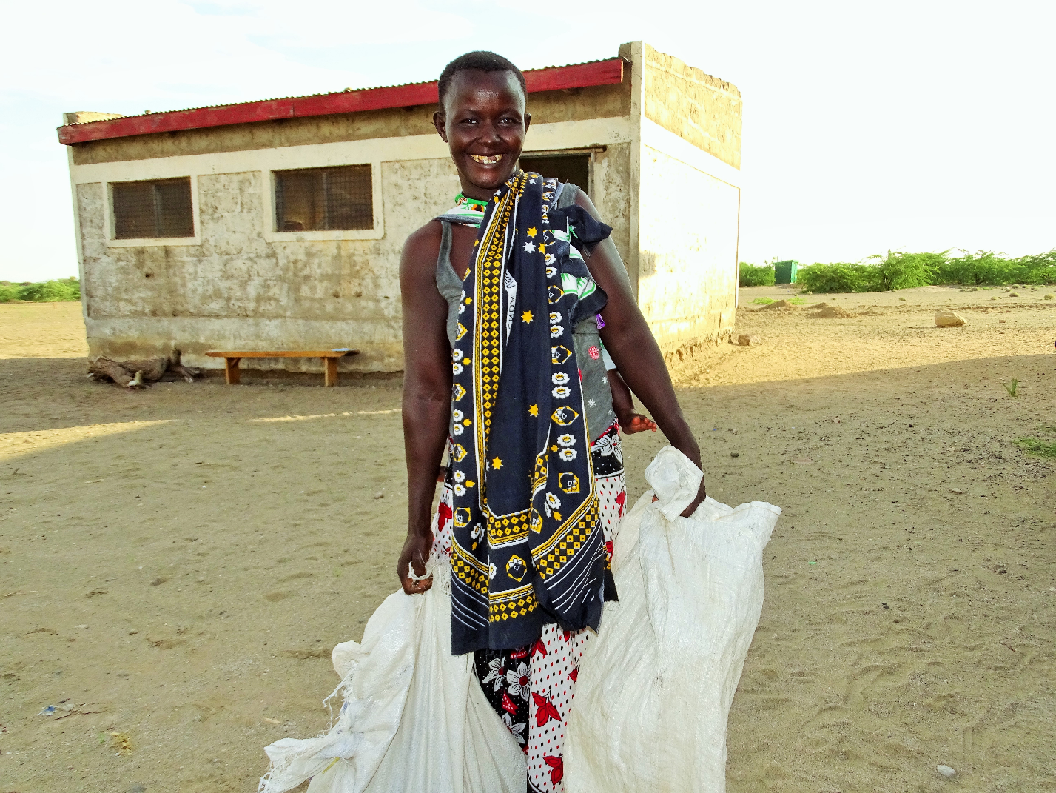
Nakurka, carrying her last born, 6-month-old Achichi on her back, as she waits to receive food from ChildFund

Meet 36-year-old Nakurka. Nakurka is a widow and a mother of 8. Her husband was killed by Ethiopian militia when he and other men were grazing their goats along the Turkana - Ethiopia border in February 2017, just when the drought had started. Her eldest child is 16 while her youngest is 6 months. She lost one child, aged 7, due to the drought.

How has this drought affected your life?
This drought has been the worst experience in my life. It started slowly last year around November, the place was very dry and we thought things would get better over time. But the worst was yet to come. By the beginning of this year, with no signs of rain, we knew that things were really bad. We had about 20 goats. My husband and his friends decided to go out in search of pasture and water for the animals and they ventured north towards the Ethiopian border. Little did I know that was the last time I would see him. After about three weeks, I was informed that he was killed. One month later, my 7-year-old son died. It was because of hunger. He was very weak and had become malnourished and sickly.

How has ChildFund supported you during this period?
During this period, ChildFund gave us 24 kilograms of rice, 16 kilograms of beans and a litre of cooking oil. This has been very helpful to me and my family. Thanks to ChildFund, we have had something to eat otherwise all of us would have died from starvation. Before we received these rations, we used to boil wild poisonous fruits (locally known as sorich) that we would eat at night before going to bed. You know if you don’t eat something before you sleep, then it becomes impossible to sleep. If you don’t boil them well for over 12 hours, you can die. My children’s health is improving gradually and I am also able to breastfeed my youngest. My breasts had dried up because I wasn’t eating anything.

What do you want to say to the people who are giving you this food?
Thank you very much. You are amazing people. It truly touches me to imagine that someone somewhere who I have never met cares about me, my family and our community. I pray that you don’t stop and that we shall never lack food or water.
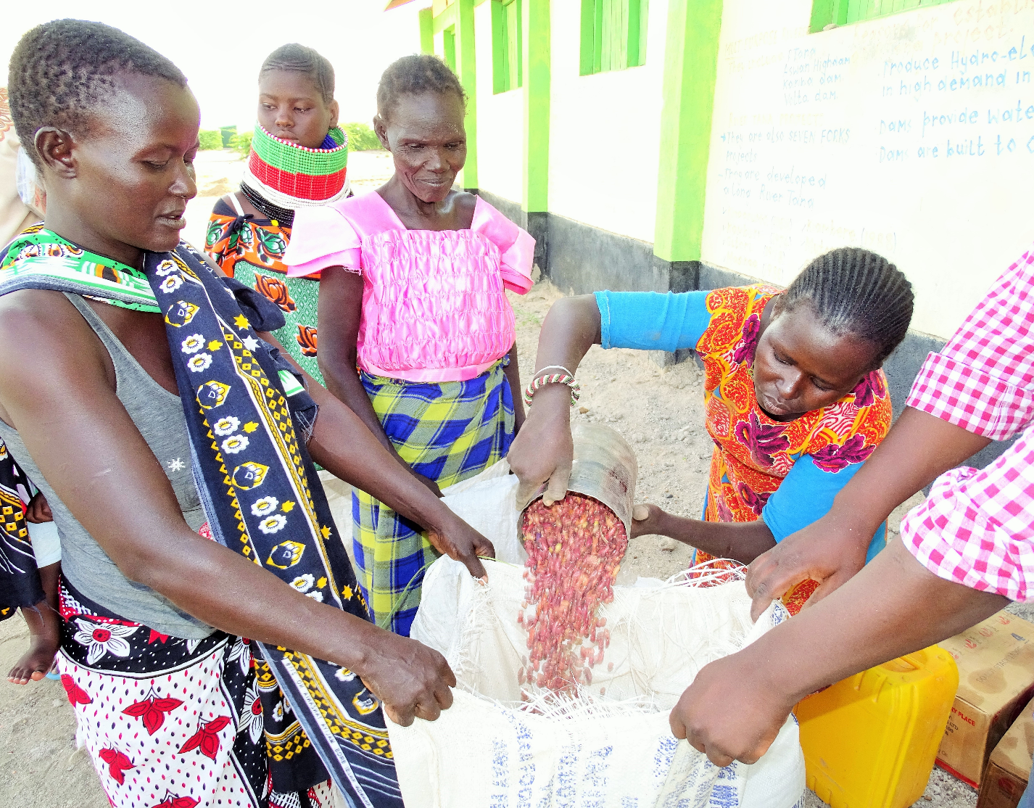
Nakurka, carrying her last born, 6-month-old Achichi, on her back, receiving beans from ChildFund

Ayien’s Story
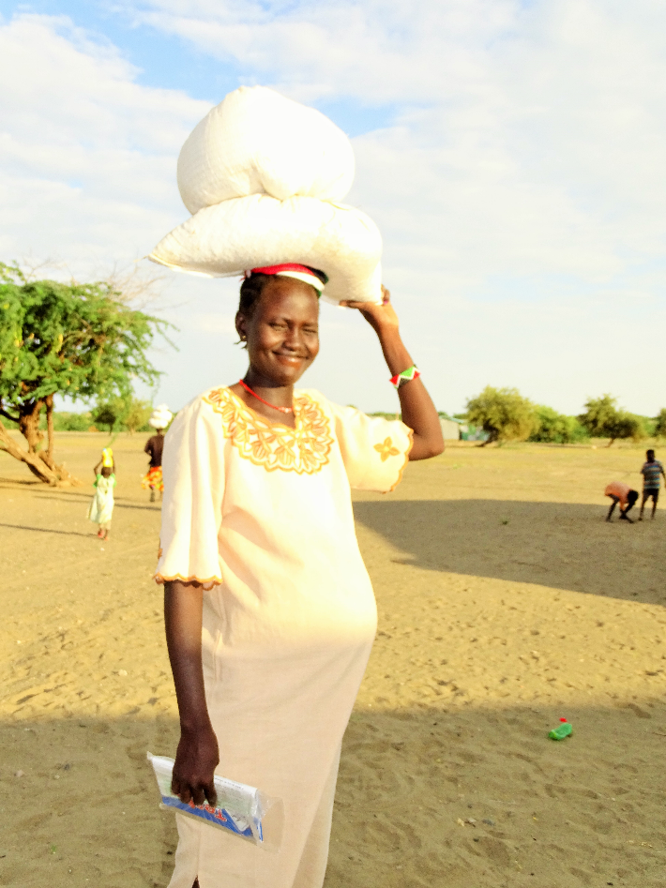
Ayien, 32, smiling after receiving her rations from ChildFund

This is Ayien, 32, from Nachukui village in Turkana North Sub County. She is married and is a mother of 7, with her eighths on the way. She is 8 months pregnant. Her husband is employed in nearby Kalokol town as a motorcycle driver. The money he gets is not enough to provide for his family since the motor cycle is not his and he has to pay rent to the owner.

How has this drought affected your life?
Life has been very difficult. We do not have enough to eat. Our children sleep hungry. It is extremely painful for me as a parent to watch my children suffer and not be able to do anything about it. All my goats died during the drought. We are helpless. This land has been so barren we keep asking God why He put us here and why we have to go through this. We wake up at sunrise to prepare wild fruit (sorich), which we boil the whole day and keep discarding the boiled soup, so that we can remove the poison. If you do not prepare the sorich well, it can turn out to be your last meal. Yet this is what we have depended on to stay alive.
How has ChildFund supported you during this period?
Were it not for ChildFund and the other organizations that have helped us, I would not be here today. ChildFund recently gave me 24 kilograms of rice, 16 kilograms of beans and a litre of cooking oil. This is the only food we have. Before that, we were starving just like everyone else in this village. Being pregnant at this time makes everything worse. I often feel hungry but there is nothing to eat. I used to worry that my child might be born underweight and unhealthy. But now because of the food we are receiving, I am starting to regain weight and I feel stronger.

What do you want to say to the people who are giving you this food?
Thank you so much. This intervention is a life-changing experience. You are giving us hope that we will live to see another day, another month and another year. Now I know that my child will be born healthy. God bless you. I also wish they could drill a borehole nearby with fresh water so that we can stop drinking the lake water. It is too salty.

Dorcas’ Story
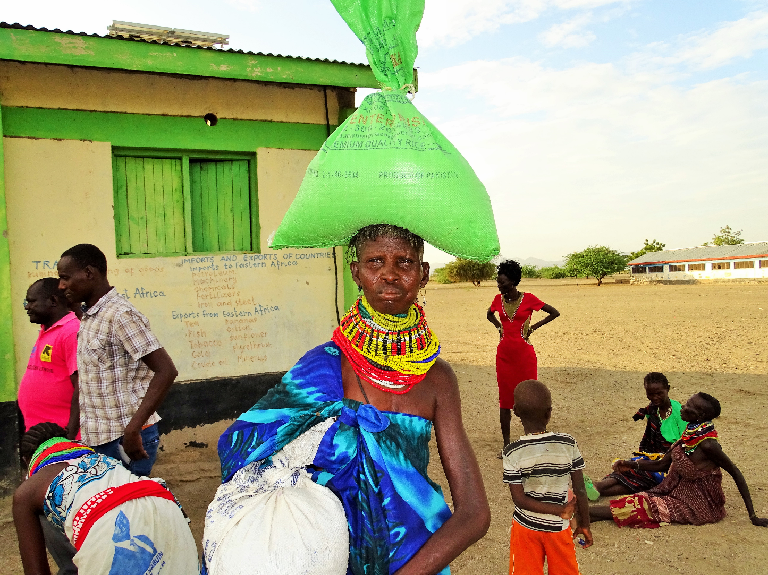

This is Dorcas, 37, from Nachukui village in Turkana North Sub County. She is married and is a mother of 6 children. Her eldest is 20 years while her youngest is 11 months. Her husband is a fisherman in Lake Turkana.

How has this drought affected your life?
Things have been very tough for us and our families. Life has become impossible. Everyone in the community has been affected. We have not had enough food to eat, our children have become weak and malnourished, even some of us adults have also become malnourished. We have become accustomed to sleeping hungry and eating wild fruits. I had over 100 goats and lost 90 of them to the drought. Now, I live like a beggar, like a dog, because I am very poor.

How has ChildFund supported you during this period?
I am so happy about the work that ChildFund is doing. Because of them, now we have food to eat. In fact, today I have not eaten anything since morning. Were it not for this food that we have received today, we would sleep hungry tonight, but now I am happy that my children and I have something to eat. I am going to use these 24 kilograms of rice, 16 kilograms of beans and cooking oil well so that this food keeps us going for as long as possible.

What do you have to say to the people who are giving this food to you?
Thank you so much. Keep supporting us and empowering us so that we do not have to depend on you and other donors whenever we have a drought.

Maani’s Story
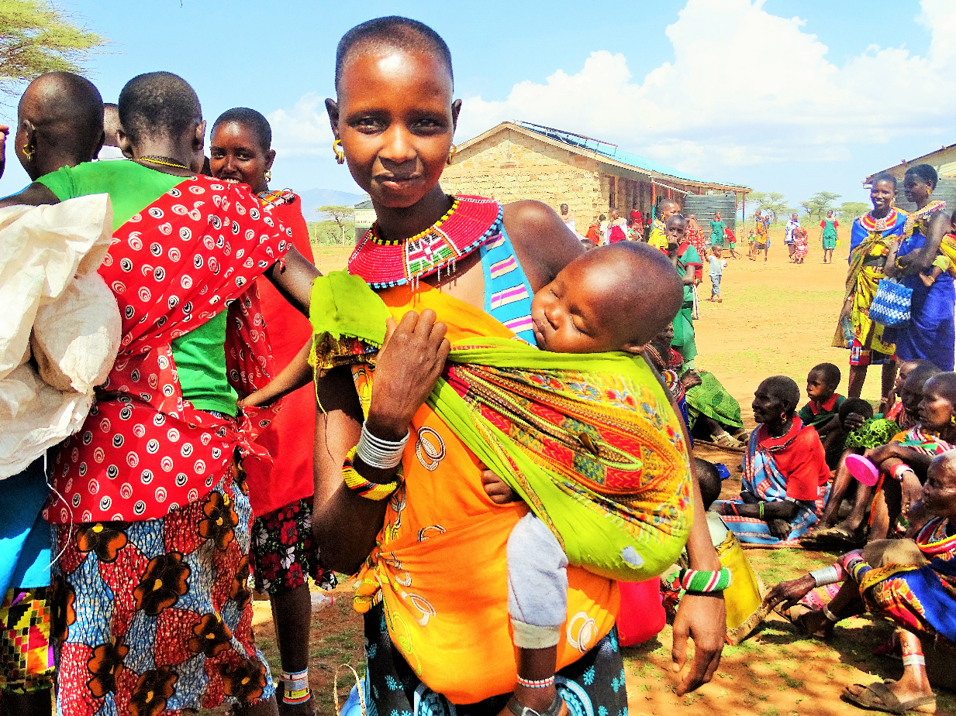
Maani, 18, with her baby, queuing for food at Bendera Primary School in Samburu County

Meet Maani Leshore, 18. Maani is married and a mother of one. She has been married for four years and has an 18-month old daughter. She dropped out of school in class 4 after being circumcised, and was married off four years later. Maani is among 660 Pregnant and Lactating Women who have been receiving maize, rice, beans and cooking oil from ChildFund.

How has this drought affected your life?
Life has been difficult. Children sleep hungry. Animals have died. We don’t have food or water for us and for our animals. People have died from this drought as we fight with the Turkana community over the little remaining water and pasture for our animals. Things are terrible. I remember when growing up, we could predict when the rains would come. We had enough to eat. We used to eat meat and drink milk. We had so many animals such that we could sell others not because we were hungry but because we had enough. But today, it is the complete opposite.

How has ChildFund supported you during this period?
ChildFund has done so much for us. Since last year when we were hard-struck by drought, ChildFund has been helping us take away some of the burden by providing foodstuff such as maize, beans and cooking oil as well as enabling access to clean drinking water although it runs out quickly due to high demand. This food has gone a long way in ensuring that my child is healthy. So far I have received 15 kilos of maize, 5 kilos of rice, 5 kilos of beans and 2 litres of cooking oil.

What do you have to say to the people who are giving this food to you?
I have never been happier in my life. Thank you so much. You have given us life and hope. I don’t know how to thank you.

Itoot’s Story
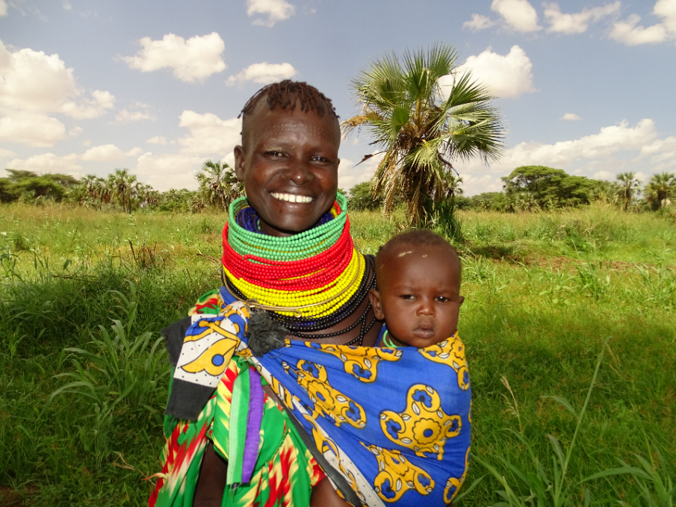
Itoot, 25 is married and is a mother of 3. Her children are aged 7 years, 4 years and 8 months (Ekal, pictured). She lives in Nadapal village in Turkana County. Her husband is jobless. He used to be a herder but his entire herd perished during the drought. He had 18 goats and 2 camels.

How has this drought affected your life?
We have truly suffered. When the drought started, our animas started dying one by one. Eventually all of them perished due to lack of water and pasture. We slaughtered the weak ones that were left because we knew that they would die and at the same time, we had nothing to eat. Getting water was difficult. I would walk for over 15 kilometres in search of water. We spent our days looking for water and boiling poisonous wild fruit (sorich) to eat. We kept thinking that the rains would come until we lost hope. My children had become weak. We would only eat once per day or have nothing at all. The older people suffered the most because we have to feed our children first whenever we get something.

How has ChildFund supported you during this period?
ChildFund has supported us in so many ways. My two older children are healthy because of the unimix porridge they receive at Kooliyoro ECD every day. I receive the fortified Corn Soya Blend at the health centre every month which I use to make porridge that keeps me going. As you can see, I am very healthy. Even Ekal here (pointing at her 8 month old son strapped on her side) is very healthy because I have milk to breast feed him and I am strong. I am also part of the farmers’ group under the Food For Assets (FFA) Project. Through FFA, we planted maize and sorghum last season. We harvested over 30 bags of maize that was shared out among the members. This is the food that we have been eating. We also have a kitchen garden where we plant vegetables. Unfortunately, this season, there was an invasion by army worms that attacked all our maize. We are not expecting much maize this harvest. We hope we can get seeds that are resistant to these pests so that we can plant again.

What do you have to say to the people who are giving you this food?
Thank you very much.

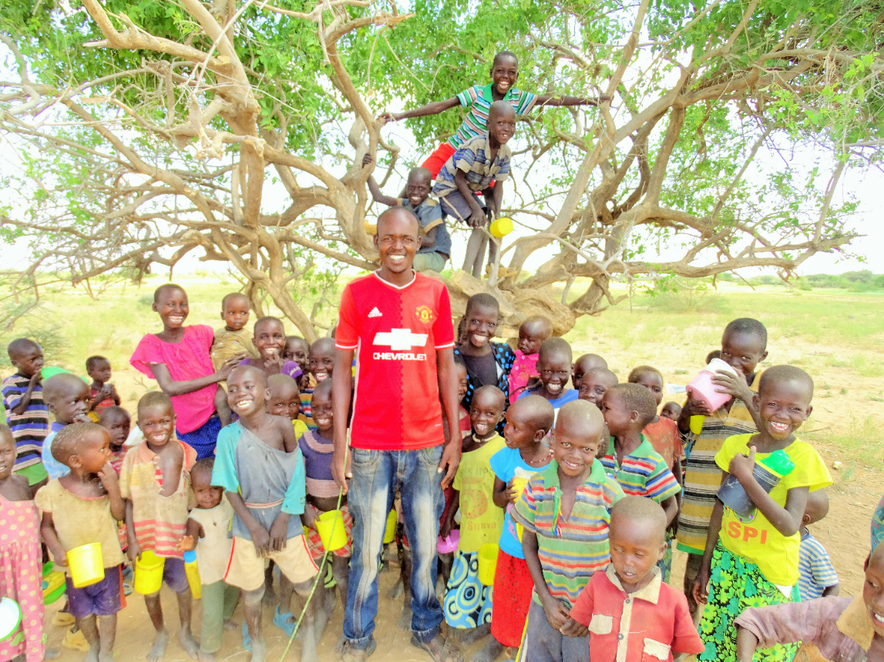
Thomas Eyanai, 22, and pupils at Kooliyoro ECD center in Turkana County. This tree is their classroom. Thomas is the only teacher. The children are carrying tins that they use as cups to drink porridge every day at 10 am. Although schools are closed, the children still show up every day to drink the porridge.

How has this drought affected children in Kooliyoro ECD?
This drought severely affected the well-being of these children in terms of their health, education and protection. Before they started getting the porridge, most of them were malnourished, their concentration was low because they were hungry. It is very hard to teach a hungry child. Others dropped out of school. A lot of them were neglected as their mothers went out in search of water, sometimes trekking for over 15 kilometers, and the fathers went out in search of water and pasture for animals. Most of the time, these young ones were left alone or under the care of the elderly who also need help.

How has ChildFund supported you during this period?
ChildFund has been of great help in averting this crisis. We started receiving this unimix porridge in July and it has done wonders for these children. They are very happy. Those who had dropped out of school came back because they knew that they would get something to eat in school. I now have over 128 children enrolled here, before, we had less than 80. The children are healthier, although we are urging parents to go out and look for other food to supplement the porridge. They cannot depend on the porridge only.

What do you have to say to the people who have supported Kooliyoro ECD with unimix?
Thank you so much. We are extremely grateful. If we did not have this porridge, then this center would probably have closed down completely by now. These children would have been severely malnourished but thanks to you, their health has improved and they are also back in school. Without education, they cannot get out of this vicious cycle.

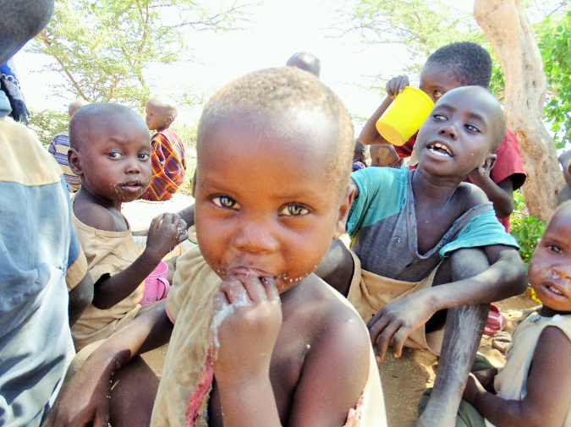
“This porridge is very sweet. I come here every day early in the morning so that I don’t miss.” Etabo, 3 years
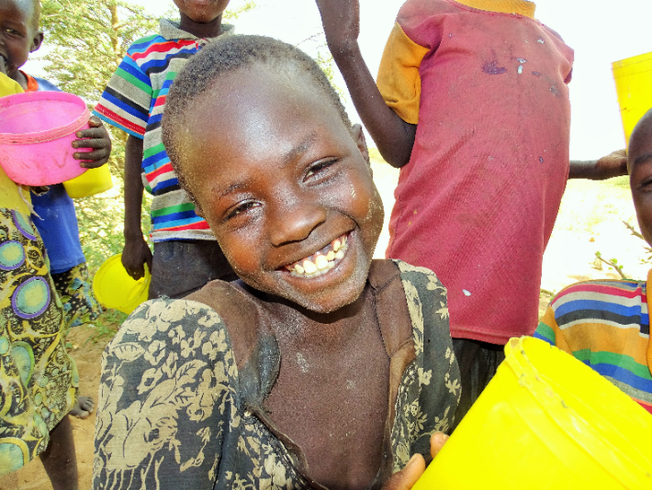
“I love this porridge. It is very sweet and heavy. I am very happy.” Akai, 6 years
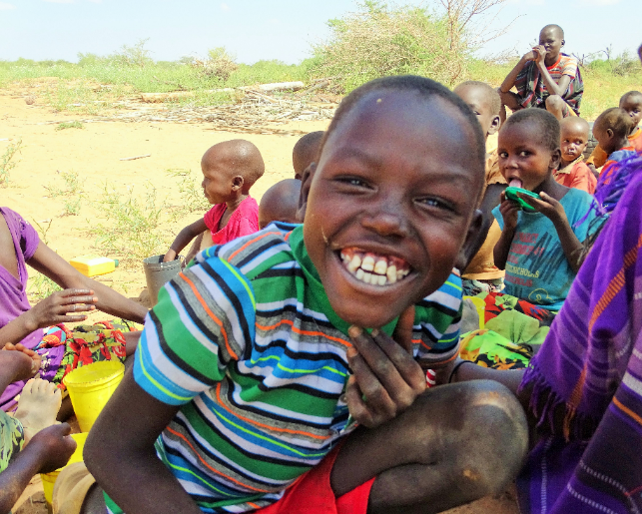
“I am not in this school, but I bring my small brother here every day and I also get whatever remains after the small children have been served.” Lopeyok, 6 years

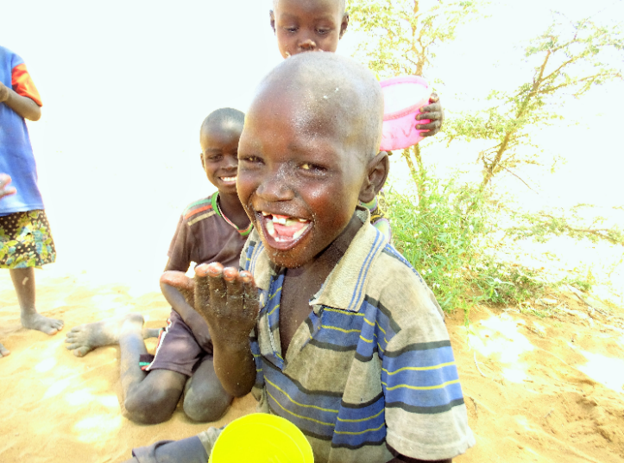
“This porridge is the best. It is better than the food we eat at home.” Ipati, 4 years

Epetet’s Story
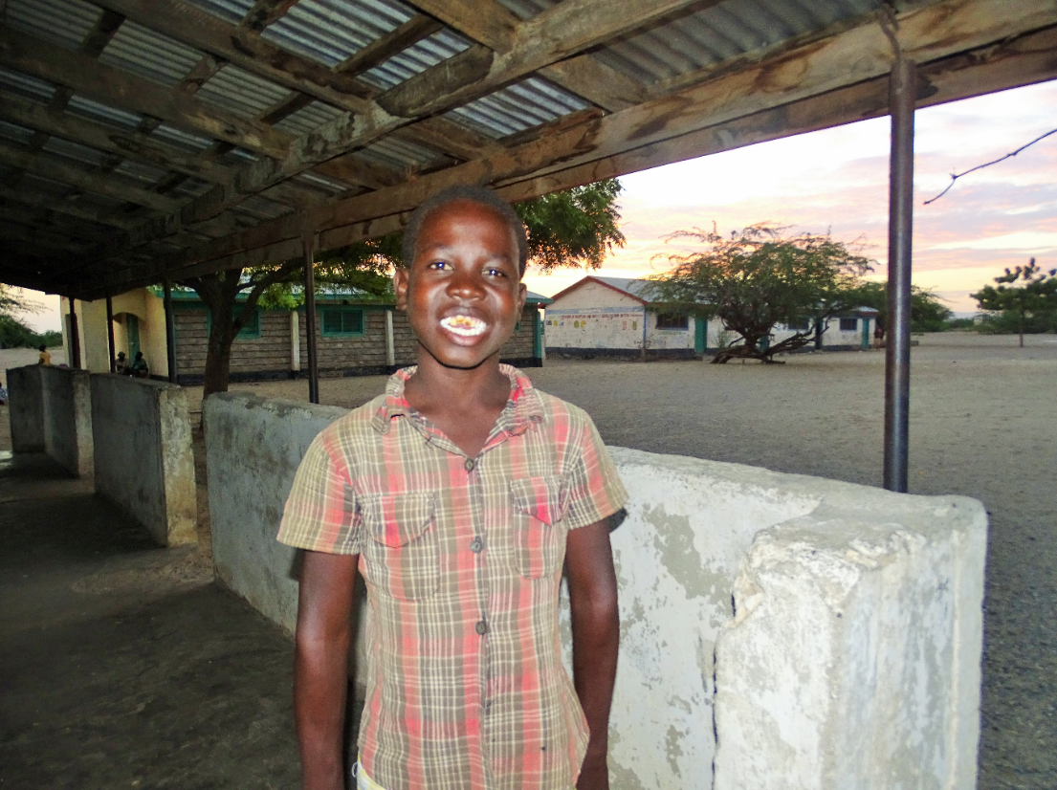
Eoko Epetet is a class 4 student in Nachukui Primary School. He is the third born in a family of 6 boys and lives with his father. Their mother deserted them when he was still young. Asked how old he is he says he doesn’t know and that no one has ever told him his age. Eoko is one of the children who has been supported by ChildFund to go back to school as part of its child protection interventions. ChildFund trained community based resource persons who are supporting the Department of Children’s Services to identify children experiencing various protection issues and working together with the government to facilitate appropriate referrals.

How has this drought affected your life?
The drought was very bad. I was forced to drop out of school to take care of our goats as we searched for pasture and water. My older brothers had already dropped out of school and they work in Lake Turkana as fishermen so they could not take care of the goats. I really wanted to stay in school and learn but my father insisted that we could not just sit and watch as our 32 goats died. I was away from home for over 3 months taking care of animals with other villagers who also had their herds. We kept walking for days and days.

How has ChildFund supported you during this period?
My younger brother told me that some people came to our home and asked to speak to my father. The wanted to know where I was and why I was not in school. My father told them that I had dropped out to take care of the goats. There was a long discussion and my father was asked to come and look for me and take me back to school immediately. I think two days later, he located us in the bush and we went back home and I was immediately taken back to school.

What do you have to say to the people who brought you to school?
I am so happy. I am so grateful because they made my father understand that I have rights and that there is more to life than just herding goats. Now I have a brighter future. I want to be a doctor when I grow up. My favorite subject is Mathematics because it reminds me of when I was counting goats in the bush.

Violet’s story
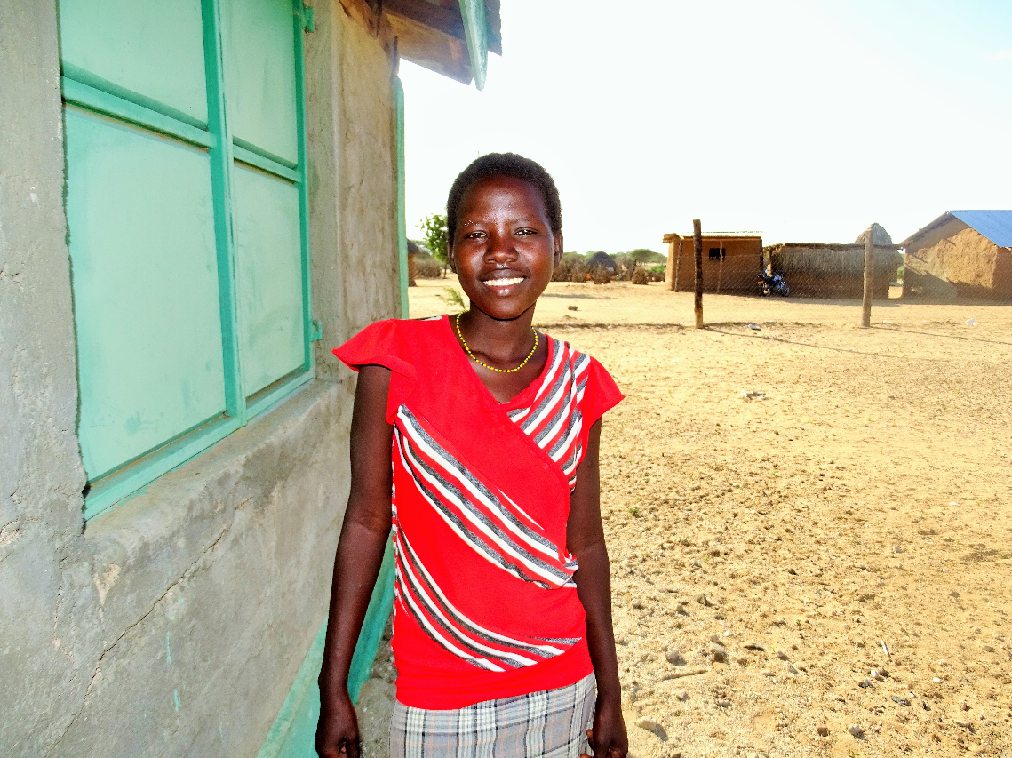
This is Violet Nyanga, 17, an orphan. Violet was forced by her older brothers to drop out of school and get married so that her family would receive a dowry that would cushion them from the impact of the drought having lost all their livestock. Community based child protection persons, supported by ChildFund, rescued her from the marriage and she will be going back to school in January 2018, once schools reopen.

How has this drought affected your life?
As a result of this drought, I was forced to get married so that my family could get some income in the form of a dowry.

How has ChildFund supported you during this period?
ChildFund supported me through Mary Ekuam, the chairlady of the child protection committee in this village, who has made sure that I will go back to school next year. She and other members came and talked to me about the importance of school and convinced me to go back. I dropped out of class 7 and I hope to complete my primary school education and proceed to secondary school.

What do you have to say to the people who brought you to school?
I would like to thank Mary, and her group for helping me and for advocating for children’s rights. I had given up on making it in life and being a nurse.

