ChildFund International Humanitarian Situation Report
Humanitarian Situation Report [01]
[Drought Emergency Response – Kenya]
[March 2021]
[Issa Kipera, Program and Sponsorship Director, IKipera@childfund.org]
[March 2021]
Part 1: The Overall Situation:
According to the Short Rains Assessment (SRA) of February 2021, the number of people facing acute food insecurity is estimated at 1.4 million an increase from 739,000 reported during 2020 long rains assessment (LRA) and this calls for urgent need for food assistance. Out of 1.4 million, it is estimated that 238,000 people are in emergency phase (IPC phase 4) spread across eight counties (Mandera, Wajir, Garissa, Tana river, Marsabit, Samburu, Turkana and Isiolo) with the rest in Crisis phase (IPC phase 3). The increase in numbers is attributed to below normal performance of the short rains thus impacting negatively on already fragile food security situation in the ASALs. Moreover, the situation is expected to further deteriorate during the forecast below-average 2021 March – May long rains season with an estimated 2 million people likely to experience acute food insecurity.

A recent assessment conducted by members of the ASAL Humanitarian Network in the Month of March, supported by ACTED, Oxfam and Concern Worldwide highlighted that approximately 412,066 children between 6 and 59 months old and 98,759 pregnant and lactating women were malnourished and in need of treatment. Additionally, 814 water trucking sites were reported across Turkana, Wajir, Mandera, Marsabit, Garissa, Samburu, Isiolo and Tana River. This is an indicator for the government and development partners to allocate resources for preparedness, response, and resilience building, to address these crises that have a devastating impact on the vulnerability of pastoralist and agro-pastoralist communities across the ASAL counties of Kenya.

Situation in Baringo County: As per the NDMA monthly drought bulletin, the county is at normal phase with worsening trend. However, the county it is at alert phase in the pastoral livelihood zones. Most areas received below normal rains with the vegetation greenness as depicted by the Vegetation Condition Index (VCI) being at above normal but with a declining trend as water levels in most water sources being below normal at 30-40% capacity.

The pasture conditions are poor mostly in pastoral and agropastoral areas. The most affected sub counties are Baringo South and Tiaty. The current pastures are expected to last for less than one month in pastoral, agropastoral and irrigated livelihood zones given the prevailing conditions. Distances to water sources for households are below normal seasonal ranges and on an increasing trend due to reduction of water in the open water sources with the bulk of the households having acceptable food consumption score.

Situation in Isiolo County: According to the monthly drought bulletin, in Isiolo county all the livelihood zones are at the alert phase with the worsening trend. The month was characterized by hot sunny weather with Isiolo central and Kinna experiencing off-season showers. The vegetation condition in a greater proportion of the county remained in moderate while a great proportion of accessible forage ranged from fair to poor, due to poor to no regeneration in pastoral livelihood zones. Shortage of livestock feed is therefore looming. Although water availability is still fair, the situation is projected to worsen due to low recharge levels.

Situation on Marsabit County: In Marsabit County all the livelihood zones are in alarm phase except for the Agro-pastoral zone that is at the alert phase. In March, most parts of the county generally remained dry with exception of localized parts of North Horr, Laisamis and Moyale Sub-Counties which received off-season rains. The 3-months Vegetation Condition Index for February was 22.8 across the county thus showing considerable deterioration when compared to the previous months VCI of 28.15. Overall, the vegetation condition has remained in the moderate vegetation deficit band.

Situation in Samburu County: According to the monthly drought bulletin, the county is at alert phase with the worsening trend. The county experienced sunny and dry weather conditions prevailed with few places receiving erratic and depressed rainfall not lasting for 30 minutes. Vegetation cover and surface water resources remained on downward trends while open surface water sources in pastoral areas have dried up with few holding around 10 percent of their capacity. The situation is however slightly better in the Agro pastoral livelihood zones, where open sources are holding about 40 percent capacity. The satellite drive data indicates that on average the vegetation condition index slid to moderate vegetation deficit for the county. Several parts of Samburu East have been degraded and heavily affected by alien plants especially Acacia Reficiens (Lchurai).

Situation in Turkana County: According to the monthly drought bulletin, the county is at alarm phase with the worsening trend. Dry and hot weather conditions dominated across all parts of the County during the period under review with the daytime temperature ranging between 36-38 degrees. Consequently, total rainfall for the 6-month period (September 2020 - February 2021) represents only 48 percent of the rainfall normally recorded for that span of time. The condition of vegetation deteriorated significantly. The fisheries and pastoral livelihood zones remained the most affected. The water situation was equally dire across several areas with over 90 percent of water pans having dried up and the depth of traditional river wells increasing substantially.

Interventions by other stake holders (National and County Governments, CSOs etc)

Baringo County: Kenya Red Cross carried out the rehabilitation of boreholes in Kolowa, Tangulbei and Chemirimion. Self Help Africa supported the lining of Sandai Irrigation scheme, and the rehabilitation and expansion of Kiboi irrigation scheme. The County government’s Livestock Department facilitated the capacity strengthening to youth groups and communities on pasture, bee keeping and provided pasture seeds and beehives. Department of Water supported water tracking, rehabilitation, drilling and equipping of boreholes. The NDMA also coordinated the review of contingency plans and response plans.

Turkana County: National Drought Management Authority (NDMA) provided Cash transfer to 39,918 vulnerable households through the Hunger Safety Net Programme (HSNP) in all the seven sub-counties. The Ministry of Health (MoH), UNICEF, Save the Children International (SCI), World Vision International (WVI), International Rescue Committee (IRC), Kenya Red Cross Society (KRCS) and Afya Timiza were engaged in the Management of Acute Malnutrition in all the seven sub-counties.
Marsabit County: USAID/WFP through SND distributed food rations to 38,310 beneficiaries across the County under the Sustainable Food System Programme which comprised of 458Mts of cereal, 101Mts of pulses and 34Mts of vegetable oil. VSF Germany provided unconditional cash transfers of KES 3,000 per month to 200 vulnerable (Illeret -95 HH and Loiyangalani- 105 HH) households for a period of 2 months. Concern Worldwide provided grants for 12 ward Disaster Risk Reduction plans. CRS supported formation and orientation of multisectoral platform for food security and nutrition, participatory institutional capacity assessment for county government and partners (PICA) to identify gaps for strengthening, participatory epidemiology study to define seasonality of calendar /months in North Horr and Loiyangalani.
Samburu County: County Department of Veterinary carried out livestock vaccination against PPR and Newcastle. The County Government and its partners also did water trucking, repair and servicing of the nonfunctional boreholes in the county. The NDMA carried out drought monthly early warnings and bulletin for general community sensitization and preparedness.

Part 2: ChildFund Kenya’s Response in Baringo, Marsabit, Samburu and Turkana Counties
Baringo County: During this period, ChildFund Local Partner (Central Rift Community Development Program) participated in the stakeholders meeting organized County Disaster Response Unit to develop county drought emergency plan.
Turkana County: Child Fund through its Local Partner (Frontiers CDO) participates in Stakeholder’s forums where Drought/Disaster planning and coordination is done. Through DRR Program, Child Fund intends to support 250 vulnerable households with cash transfers.
Samburu County: The LP did not carry out any response in the month of March, expect for closely working with the NDMA in drought response planning through the County Steering Group (CSG) responsible for emergency coordination.
Marsabit County: During the month, ChildFund’s LP, Nawiri Child Development Programme supported 120 households in Karare ward with 6,525 kgs of rice, 1,250 kgs of beans, and 20 cartons (240 liters) of fortified oil.
Needs and Sectoral Gaps in the Area:
- Water Sector – Rehabilitation of the malfunctional/broken-down facilities e.g. boreholes in counties, provision of fuel subsidy to the strategic boreholes, stock piling of fast-moving spare parts in areas that are currently experiencing acute water shortage across the Counties.
- Cash transfer programs – unconditional cash transfer to cushion target worst hit households from drought, this is to enable them access nutritious food for their families and children.
- Support livestock disease surveillance, mass treatment for parasites and clinical cases across the drought affected pastoral counties, while promoting livestock commercial off-take.
- Provision of livestock feeds/supplements including hay and water for animals and in the most affected locations in the counties.
- Sensitize caregivers on disease and malnutrition identification in children under five years of age to enhance surveillance during the prevailing drought period.
Type of Intervention | Estimated Amount (USD)
Rehabilitation of water facilities, provision of fuel subsidy to the strategic boreholes, stock piling of fast-moving spare parts to assist communities to access | 20,000
Support 600 families with cash transfer to access food and other necessities for three months | 45,000
Support pastoral communities through livestock disease surveillance, mass treatment and vaccination program | 10,000
Provision of livestock feeds/supplements including hay to most affected households in the counties | 15,000
Sensitize caregivers on disease and malnutrition identification in children under five years of age | 5,000
Total | 95,000

Below Sections for Internal Use Only
Sponsorship and Grants

Sponsorship Area | Sponsored Children
Samburu | 4,163
Marsabit | 2,435
Baringo | 2,084
Isiolo | 630
Turkana | 1,168

- Security and Logistic
The security situation across the county has generally remained calm however, in such areas and in the face of disasters, it remains unpredictable. For example, in Marsabit, Isiolo and Samburu, cases of community conflicts seem to be escalating.
- Partnership and coordination
ChildFund and its LPs continue to participate in national and county level emergency response coordination forums. LPs are actively participating in county level steering groups charged with assessment, planning and implementation of interventions. ChildFund also works in collaboration with other international and local Non-Governmental Organizations and UN agencies such as UNICEF FAO and World Food Program. In addition, ChildFund is an active player in the Kenya Humanitarian Partnership Team (KHPT) meetings.
- Staffing
Ongoing emergency response for other emergencies in area is currently supported by existing Country Office and LP staff.
- Donors:
Since the onset of the drought situation in the various counties no major funded response project has been undertaken with the intention to fundraise especially for the counties in the alert and the alarm phase of the drought where ChildFund work including Turkana, Marsabit, Isiolo and Baringo.
Donor/Source of Funds | Program | Amount (USD) | Status
LP Subsidy | Drought Response in Marsabit (food distribution) | 2,807 | Distribution on going
ChildFund Germany (Grant) | Emergency Response Turkana (Cash transfer) | 18,981 | Ongoing
Total |  | 21,788
- Media/Communications
Spokesperson: Chege Ngugi, Country Director
Media contact: Awino Nyamolo, Communications Specialist
Languages spoken - English
- Plans for collecting photos/videos/stories, i.e. should an outside photographer be hired?
Normally when implementing such emergency grants, the officers in the field are provided with HD cameras for collecting quality photos and videos and providing success stories from beneficiaries who have benefitted and become resilient out of the intervention. The donor at times can arrange for the outside media services to collect videos and stories in the form of documentary meant for visibility and fund raising.

- Key points for messaging and visibility, particularly any host government sensibilities that must be considered.

Being guided by humanitarian principles and measures, the information for visibility either by print or broadcast media must meet the threshold of the standards that govern it either internationally or locally.

Support needed or requested from IO, GSS or Global Teams – whether onsite or remote. The Country Office will need the support to raise more funds for the Isiolo, Marsabit and Samburu community conflict response to safeguard livelihoods of those affected.

Photos
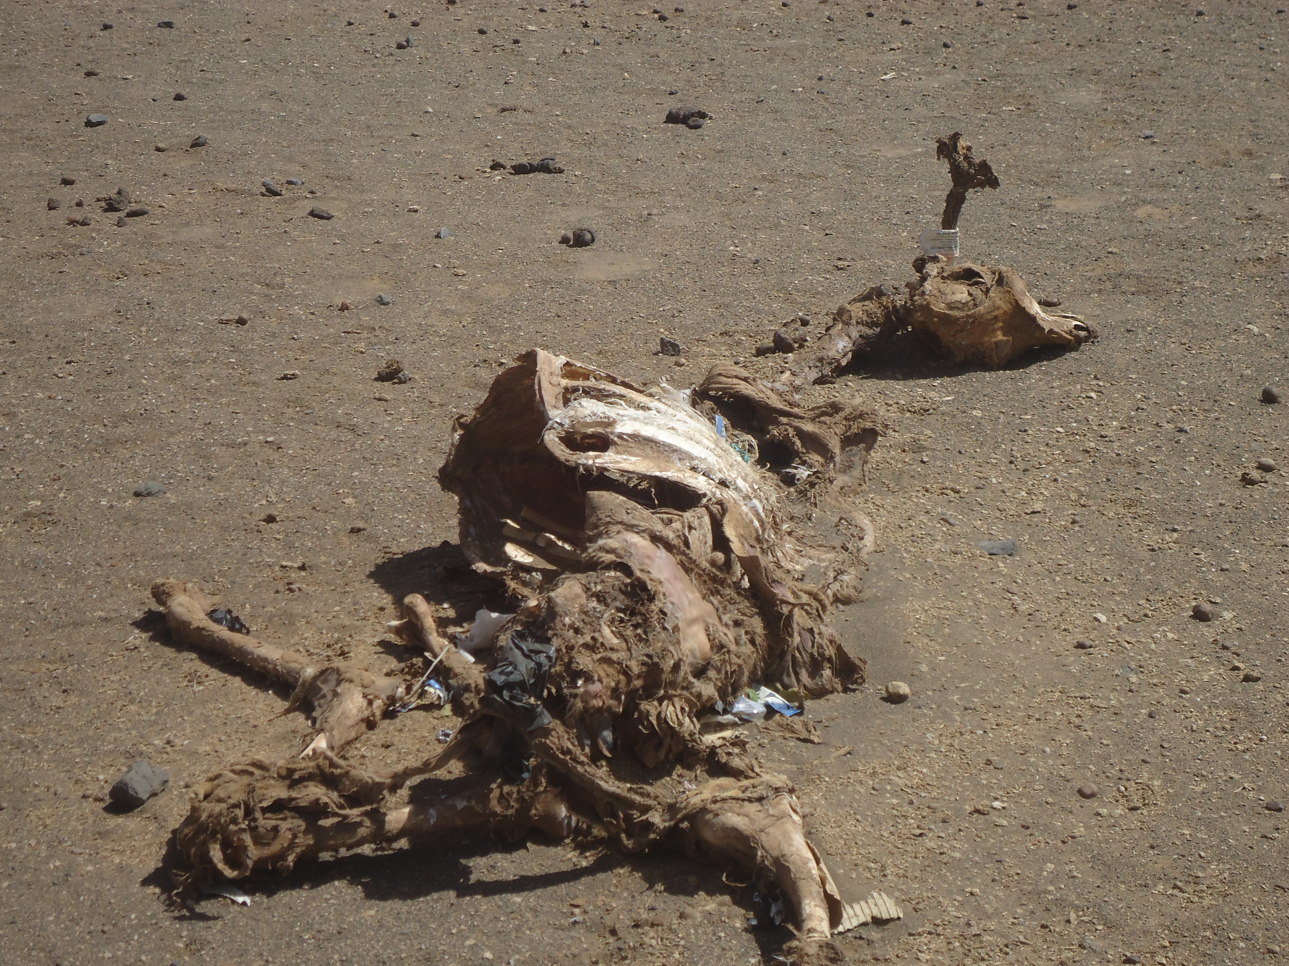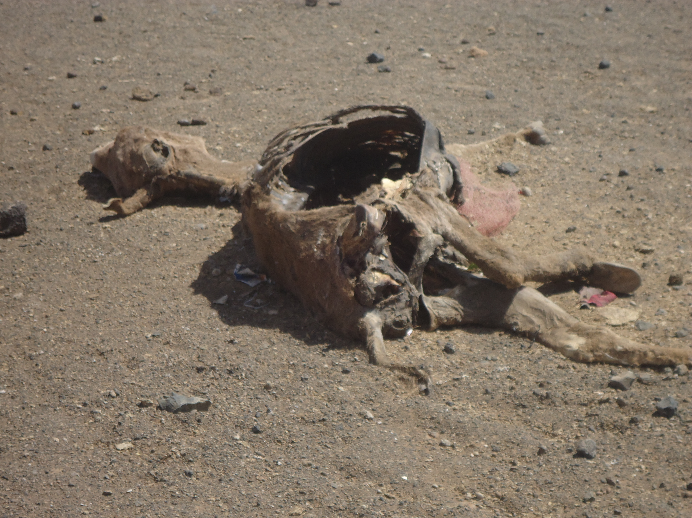
Images of dead livestock due to drought in Marsabit County

