Ethiopia Country Office
Humanitarian Situation Report: Fentale and Siraro area – Oromia Region of Ethiopia [#3 ]

[Date Prepared: March 08, 2022]
[Point of Contact – Lilly Omondi- Country Director email address: lomondi@childfund.org/
Tel: +251 911 250738]

[Date Range Covered by Report- December 1,2021 -February 28, 2022]

- The Overall Situation
Oromia regional state is one of the eleven regional states that constitute the Federal Democratic Republic of Ethiopia. Administratively, the region is divided into 21 zones and 337 districts out of which 46 are urban districts and the remaining 291 are rural districts. Current projected total population of the Region is more than 50 million (50,686,778) which accounts for over 43 percent of the total population of the country.
Drought and conflict are currently two key challenges affecting the population of Oromia. During last Belg 2021, the rain in Eastern, and South zones of the region including the East shoa and West Arsi Zones where ChildFund operates was extremely below normal in amount, erratic in distributions, wide long dry spell and early withdrawal by more than two months. Hence, there was total fail of Belg rain those areas. Similarly, the complete absence of meher rain 2021 (September to November) exacerbates the overall food in security situation in pastoral and agro pastoral areas of the region.
The impacted of this situation was contributed for high crop yield reduction and crop failure as well as poor animal production and productivity were noted in the areas.
Currently, significant number of communities, particularly in eastern, southern eastern and southern parts of the region facing by critical food shortage and lack of water for both livestock and human beings. According to the regional Disaster Risk Management and Displaced Communities Rehabilitations Commission report published in February 2022, overall 81% the expected land did not been planted and unable to produce crop for both Belg and Meher Seasons due to complete(100%) failure of rain for example in Borena and East Bale zones, in Gujii, East Hararge and, West Haragee zones and partial failure in West Arsi East showa and Arsi zones.
According to the Regional Disaster Risk Management and Displaced Community Development Commission report, as at mid-February 2022, about 461,119 animals have been died in eight zones of the region while Borena, East Bale and Guji zones took the lion share in their order of severity.
The report also revealed that a total of 3,605,304 people were affected by the current drought related emergency in more than 125 woredas/districts and warns that unless addressed timely, this figure can also grow to 4.5 million.
Looking at the Nutrition Situation, during the month of December 2021, a total of 15,642 new SAM admissions were reported from all zones of the region with an overall reporting rate of 89.3%. Out of the total new SAM admissions during the month, 54.8% of the cases were reported from five zones, namely Arsi, East Hararge, Jimma, West Arsi and West Hararge zones.
Total Oedema cases in the last five months was 11,317 which is 12.6% of the total cases.
The impact of drought has also equally affected education program through student dropout and school closed due to water stress.
Besides the natural disaster, the region is also experiencing one of the severe cases of displacement due to conflict in the country. Currently about 737,938 people (407,005 M and 330,933 F) are reported to have been displaced mainly due to conflict.
Pre harvest assessment result indicated more than 4.5 million people were in need of food assistance for a period of 6 months. It was also reported that only 47% of the total requirement was mobilized so far.
The council of the regional government in its extraordinary meeting held on March 2, 2022, urged all UN and NGOs operating in the region to collaborate on the resource mobilization and intervene in the response program.
Two of the ChildFund operational areas namely Fentale and Siraro area also included with the 68 districts/woredas identified as Hot spots woreda #1 of the regions in terms of drought.
Cognizant of this situation, ChildFund Ethiopia in collaboration with its Local partners namely Future Generations Organization and Siraro Child and Family Development Association and Future Generations Organization was closely monitoring the situation for the last three months in areas where they are operating. Furthermore, joint rapid assessment has been conducted between February 25-28March 3, 2022, to understand the overall humanitarian situation.
The LPs and CO have also started to respond to the situation through allocating 3.2 million Birr with their existing resource and capacity. However, as the problem is too severe and the current response programs with other partners in our areas of operational area is insignificant, the CO has prepared this situation report to inform the situation to IO and alliance members to ask for additional resources.

- The Situation in Areas Where ChildFund Works
  - Fentale:
Fentale is located in East Shoa Zone of Oromia region. The district is arid and found in the great rift valley system. The people of the district are predominantly pastoralists and rely on animal rearing as their major source of livelihood. Administratively it is divided into 18 rural and three urban kebeles.
In this District ChildFund Operates in 12 Kebles/communities with a sponsorship program as well as projects serving 3,130 enrolled children and 82,366 (Female:37,823 and Male : 44,553) members of the communities.

Table 1 # of Enrolled Children by Life stage and gender
Age category | Girls | Boys | Total
Children 0-5 years | 525 | 519 | 1044
Children 6-14 years | 556 | 609 | 1165
Adolescents and youth | 479 | 442 | 921
Total Children | 1,560 | 1,570 | 3,130
Fentale District including ChildFund’s operational communities are known to have experiencing multitudes of hazards that include climate change induced shocks such as drought and flood, conflicts and in the past the Desert locust. For the last two consecutive seasons inadequate rain was recorded that resulted in decreased crop yield and depletion of animal feed and water for human and animals. The assessment team has witnessed that the cattle are getting weak and unable to move because of lack of feed and water. In some areas, the shortage of water and pasture is forcing the residents to migrate. Some of the respondents also told to the team that animals are dying which is their main source of income.
Besides the ongoing drought, the residents of the district have been suffering from conflicts that last more than three years. The fresh conflict that took place a month ago has also resulted in the new displacement of 8,192 people. Communities including enrolled families displaced from ‘Gelcha’ and other Kebeles due to the conflict that took place a year ago were partially returned to their kebeles while the rest of them are still residing in other communities like ‘Ilalala’ Kebele. Both the communities who returned to their original places as well as IDPs found in other places are found in a very difficult situation. infrastructures such as Water schemes, ECD centers, residential houses etc. were damaged during the conflict. The livelihood of the communities is totally disrupted that has aggravated the food shortage.
The residents of the district who were affected with a flood that took place a year ago were also did not been recovered so far.

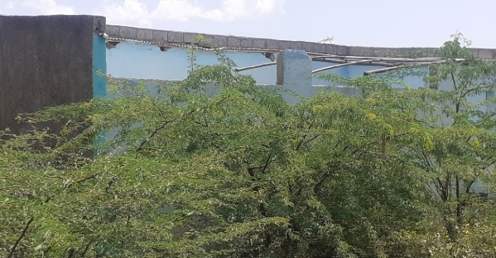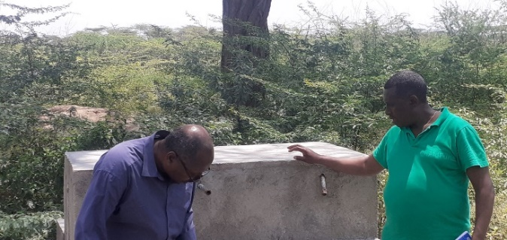
Figure 1 ECD Center and Water points damaged during the Conflict

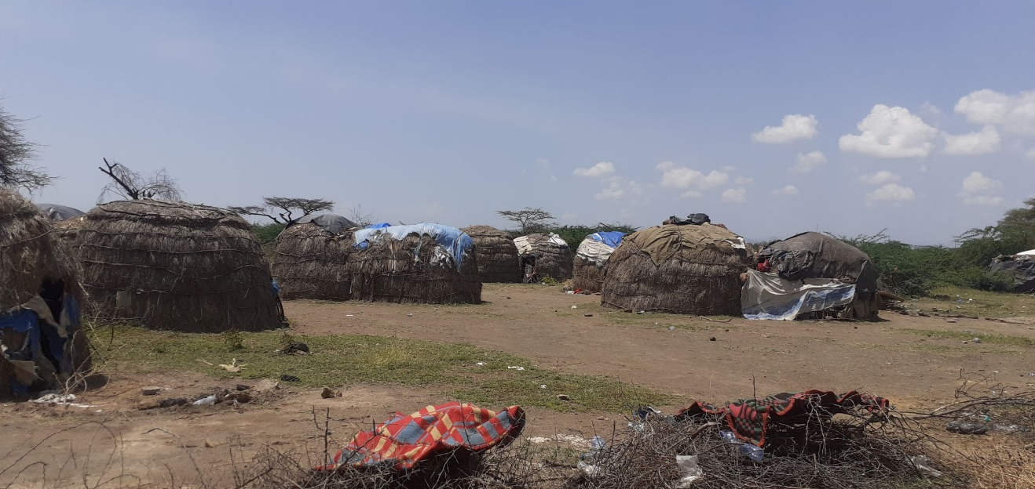

All these hazards have compounded the humanitarian situation of the district.
- According to the assessment made by the government in February 2022, a total of 39,147 people living in 10 kebeles are identified for urgent food and water assistance.
- Due to the escalating displacement of the communities in fear of conflict and search of water and animal feed by the families as well as due to inability of the families to feed their children, students are started to drop out their education. At present 9 primary schools are at risk of closure due to the drought.
- Child protection and general protection issue are expected to rise as children and women spend much of their time in search of water and are sometimes left alone while the male leave the area where they could find water and feed for their animals which will increase the risk of girls being raped or forced marriage or SGBV. Children who quits their education are also subject for child labor and exploitation.

  - Siraro
Siraro District is located in West Arsi Zone of Oromia regional state having 28 rural and 4 urban kebeles hosting a total population of 207,541(105,846F).

In Siraro District ChildFund and its local partner operates within eight kebeles through its sponsorship and grant programs. A total of 2, 523(1,176 Girls) enrolled children and their families have directly been supported with the sponsorship program while more than 67,000 people are also benefiting from the ongoing programs being implemented in the area by ChildFund and the LP.

Table 2 # of enrolled Children (Siraro) by life stage and gender
Age category | Boys | Girls | Total
Children 0-5 years | 346 | 325 | 671
Children 6-14 years | 659 | 540 | 1,199
Adolescents and youth | 342 | 311 | 653
Total Children | 1,347 | 1,176 | 2,523

Food availability status
As per the pre- and post-harvest assessment of 2021 report, crop yield is reduced by 33.7% causing food shortage for 63,217 people in the Siraro district. The major reason for yield loss is shortage of rain (late on set, erratic, low and early secession), and Crop pests. It is approved by the zonal emergency taskforce to provide 63,217 people with emergency food aid for 6 months starting January 2022 but as of February 2022 no food aid is supplied to beneficiaries.
Belg rain was expected to start on 3rd week of January 2022 but there was no rain as of end of February. Absence/shortage/delay of Belg rain affect the availability of water for animals, affect availability of feed for animals, affect the availability of vegetables and finally availability of food that would be available from Belg harvest.
Besides, there are 20, 774 conflict induced IDP dispersed in 6 kebeles in the host communities in Siraro who are not yet returned, and it is approved by the zone emergency taskforce to provide with emergency food aid but not provided yet.

Malnutrition status

- In December 2021 there were 347 under five children new admission at OTP ---new admission at SC 37
- In January 2022 there were 394 under five children new admission at OTP ---new admission at SC 42
- New SC children at the loke Hospital alone was 54 in the month of January 2022.
- Pregnant and lactating women: Up to end of January MAM 7325
- Goal Ethiopia was operating for the months of July 2021 to January 2022 and managed CMAM and left the area making risk of increasing malnutrition further.

Generally, there is increasing trend of malnutrition

WASH status
Siraro district has 32 kebeles (28 rural and 4 urban) and the district water coverage is only 21.7%. 11 kebeles having a total population of 75,891 do not have any water facilities/no water access. 8 water truck is needed but currently only 4 are assigned and operational by government and humanitarian organizations.
Some of the water facilities in the kebeles having borehole water access are not functional and need maintenance.

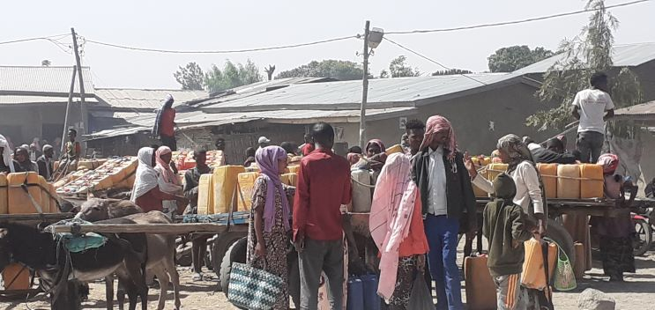
Figure 2 Senbete Shalla Open water market

Education status

There are 65 schools in the district (61 primary schools and 4 high schools) having a total student population of 53,9473(M: 32,940 F: 21,060) and 10 KG having 1200 students. All 10 KGs and 9 primary schools having a total student of 8500 are within ChildFund’s operational kebeles.
School dropouts’ rate is currently 10.6% and is expected to increase more during the coming months.

Protection issues:
The drought disproportionally affects women and children, exacerbating existing protection threats and vulnerabilities and creating new ones. The extended drought in the woreda not only resulting in the drop out of children from school but also exacerbates the already rampant practice of child marriage in the community. Despite efforts in place both by the government and other non-state actors, child and family arranged marriage is still common in Siraro. When Children drop out from school, families will send their boys to different zones to work as farm labor while arrange forced marriage for girls. Families plan child marriage to get dowry from the groom’s family as a source of income to support their livelihoods. When the marriage is scheduled the girl child is provided with money to buy clothes, she eager for and she gives consent for marriage. She also think/believes that her basic need for food, shelter, cloth and other things fulfilled in the future from male families.

Market situation
The major stapple food in the district is maize and its price is very much increasing. Last year in the month of February 2021 the price of maize grain was 1200 birr/quintal and currently the (February 2022) the price is 2400 birr/quintal. Due to water and feed shortage the animal body is becoming emaciated, and their price is becoming lower and lower.
The current price inflation for industrial materials such as Soap, oil, Sugar that rural community use is much affecting the expenditure of the community.

Key Issues
- As drought time increases food shortage, malnutrition and water shortage is projected to increase in the coming months.
- As food shortage increase malnutrition and school absenteeism and dropout increases
- As water shortage increases households’ expenses to buy water increases causing food accessibility difficult
- Financial capacity of the households to buy agricultural inputs become deteriorating.
- If malnutrition is not well managed death of under five children might rise.
- Price inflation of major stapple food items will complicate the affordability of food for vulnerable HHs

- Proposed Response Interventions and Budget Requirement

The key interventions have proposed for the coming three months and budget requirement is indicated as follows:
 |  |  | Exchange rate | 50.5641
S/No | Key Interceptions | Total Proposed Resources | Propose dresources by District |  | Remark
 |  | USD | Fentale | Siraro
1 | Undertake in-depth assessment to better understand the protection risks/concerns in the drought affetced Kebeles faced by the community | 989 | 494 | 494
2 | strengthening of CBCM and committees’ interventions at Woreda and affected kebele levels | 1,978 | 989 | 989
3 | Undertake need-based Child Protection interventions as per the assessment result | 9,888 | 4,944 | 4,944
4 | Provide special school-based supports for needy children such as scholastic materials and Dignity kits(600 children in each District) | 11,866 | 5,933 | 5,933 | only in operational kebeles
5 | Cash Transfer for 1500 Households having children, lactating and pregnant mother to enable them purchase food items for three months (750HH in each district). | 59,983 | 29,992 | 29,992 | 40USD per HH
6 | Provision of School meals in 14 primary schools for 6,278 students(Fentale1,614 students and Siraro 4,664 students) for three months-April to June | 148,991 | 38,304 | 110,687 | Three months
8 | Maintenance/rehabilitation of damaged water schemes that include Rehabilitation water treatment plant and water points, Water line extension and Roto/water container installation and Supplying water chemicals | 29,665 | 29,665 | -
9 | Emergency water provision through water trucking for 60 days (to use the government trucks -only to cover the cost of fuel and other operating cost) for those kebeles who are highly affected by drought | 6,922 | 6,922 | - | Kebeles outside of operational areas where IDPs are located
10 | Provide 25 Kg of wheat flour and 3 liter of edible oil for 250 households having critically malnourished children | 14,585 | 7,293 | 7,293
11 | Support SC centers
11.1 | Provide Wheat/maize flour, oil, and soap for five health institutions managing SC | 2,373 | 1,187 | 1,187
11.2 | Provide Nonfood items (blanket, Mattress etc.) for health facilities managing SC | 3,738 | 1,869 | 1,869
11.3 | Supply of Essential drugs for five health facilities (3 HC and one Hospital) that are managing SC | 5,933 | 2,967 | 2,967
 | Total | 296,912 | 130,558 | 166,354 | -
 | Operating cost | 20,784 | 9,139 | 11,645 | -
 | Grand Total | 317,696 | 139,697 | 177,999 | -

The CO has already assigned about 3.0 million Birr for the two areas to provide immediate response. If situations are getting worsening budget shift will be made place until resources are obtained from alliance or other external sources.

SECTIONS BELOW ARE FOR INTERNAL USE ONLY

- Security & logistics

In Fentale area there some kebeles where easy access is difficult due to security reason. But in the current operational kebeles of both woredas there is no security issue right now.

- Partnership and coordination

ChildFund and its local partner, FGO& SCFDA, are closely monitoring the situation with the local government.

- Program

Food Security √

Nutrition √

Child Protection √

Health √

WASH √

- Staffing

Major HR issues: None

Visits: None

Departures:

Arrivals:

Staff on the Ground:
- Livelihood program and Emergency program specialists and other staff at the CO
- The LPs staff such as the Manager, ECD officer and others community development facilitations

- Donors
None

Proposals and concept note submitted:
Donor | Program | Amount

Confirmed funding:
Donor | Program | Amount (USD)

- Finance

- Media/Communications

- Additional information

- Next steps

Next step is to undertake detail assessment, start immediate support with available resource, develop concept notes and search for additional resource.

