ChildFund International Humanitarian Situation Report

Humanitarian Situation Report [11]
[Desert Locust Invasion Emergency Response in Marsabit, Samburu, Baringo, Turkana, Isiolo and Kitui Counties – Kenya]
[March 2021]
[Issa Kipera, Program and Sponsorship Director, IKipera@childfund.org]
[March 2021]
- The Overall Situation
According to the Food and Agriculture Organization (FAO) Desert Locust monthly Bulletin No. 510 of 3rd April 2021, during the month of March, swarms remained immature due to a lack of rainfall. Most of the swarms were present in Baringo and Nakuru counties and areas between Mt. Kenya and the Rift Valley. To a lesser extent, swarms were found in parts of Samburu and Marsabit counties, North of Kajiado county and areas south of Nairobi county. Although many swarms were reported more than once, their total number and size have steadily declined. Swarms were reported from 12 counties in the first week compared to 3 counties by the end of the month. Control operations also declined as fewer targets were present with only 1,184 ha treated in March, of which 671 ha were by air. It is expected that with subdued rainfall, the swarms will not mature and breed, thus severely limiting the scale and extent of any breeding in March and April. However, in case of April-May rains falling, this will allow any residual swarms to mature and lay eggs in northern areas (Marsabit, Turkana, and Samburu). This may occur during the first half of April, giving rise to small hoppers by early May. Otherwise only a few small immature swarms are likely to persist, and locust infestation thus expected to continue to decline.
Samburu County: The county had reduced locust infestation. However, the threat of DLI to food security and livelihood situation in this region persists. The situation is made worse by the ongoing COVID-19 pandemic, intercommunal conflict, and the worsening drought situation. During the month various villages reported presence of Desert locust invasion including Tuum, Ngilai, Opiroi, Louwa, Raraiti, Tamiyoi, Shabaa, Lkuroto, Angata rongai, Logorate, Amaya and Kasilangwa. The locust has had adverse effects on the vegetation cover and contaminating water points in the affected areas. FAO and Samburu county government are doing surveillance and spraying of the swarms despite difficult terrains in some areas. Field monitors continue to give daily updates and coordinates for the affected grazing fields to inform the control operations.
Marsabit and Isiolo Counties: The counties during the month continued to experience the second wave of desert locust invasion. Due to aggressive control operations, the scale of infestation declined. Larger grazing lands have been destroyed by locust in part of Laisamis in Marsabit and Oldonyiro in Isiolo County. Cases of diarrhea in livestock after ingesting of desert locust droppings were also reported across the areas that were affected.
Turkana County: There were no reported cases of Desert Locust in Turkana county. However, should the county experiences additional rains, the residual swarms could mature and lay in the first half of April, giving rise to small hoppers by early may, this calls for the county and other partners to remain alert for any possible invasion. Currently, the County drought situation is worsening, hence minimal chances of new swarms.
Baringo and Elgeyo Marakwet counties: During the period under review, swarms were reported to be present in Baringo and Nakuru counties and areas lying between Mt. Kenya and the Rift Valley.
Kitui County: A few swarms continue to be present in some parts of the county due to the county’s proximity to Garissa County where the swarms had initially crossed from Somalia. It is expected that with control operation, the swarms will continue to decline.
Interventions by other stake holders (National and County Governments, FAO etc.)
National Government, FAO, other partners
Several actors have been responding to the desert locust invasion in various counties in different ways including surveillances and spraying of the areas invaded by the desert locust, and cash assistance to the affected households. FAO continue to support the county governments in the surveillance and control operation, including both aerial and ground operations coupled with climate proofing activities to ensure resilience of potentially affected communities.

Samburu County: County government of Samburu in partnership with FAO and the Ministry of Agriculture at the national government continued with surveillance and coordination of locust hoppers spraying with the field monitors reporting daily on the coordinates and areas affected by the locust for response.
Marsabit and Isiolo Counties: During the reporting period, FAO carried out control operations in the Counties, through the issuance of six surveillance vehicles, three pickups mounted with sprayers, one helicopter, two spray airplanes and one fixed wing aircraft for surveillance operations along the affected areas.
Turkana County: The National and the County Governments with support from FAO have put in place preparedness plans, with control interventions measures, to manage any new emergence of desert locust in the county.
Baringo and Elgeyo Marakwet counties: With report of the new swarms during the month, the county and national governments-initiated surveillance and preparedness based on the updates from FAO and the National Government Ministry of Agriculture for timely response.
Kitui County: The Kitui County Government continued with both aerial and ground spraying in the last pocket in the Hilly sections in Kitui East. The exercise has been successful, and the few remaining swarms are insignificant and may easily be eradicated.
The Situation in Areas Where ChildFund Works and interventions by ChildFund Kenya through the LPs i.e., cash transfers, food distribution, farm input vouchers, trainings etc.
During the period under review, ChildFund Kenya and Local Partners (LPs) in the affected counties continued to collaborate with other stakeholders at the local level to monitor the situation and gathering the relevant updates for planning.

Samburu County: Samburu children’s Programme (SCP) as a key partner in monitoring the effects of the locust invasion in the county worked with other stakeholders to provide updates of the situation. The LP worked closely with the Department of Special Programs that is mandated to coordinate locust movement monitoring, surveillance, and operations in the county.

Marsabit and Isiolo counties: During the month, Nawiri CDP partnered with the County Steering Group (CSG) in organizing coordination meetings and forums. Additionally, the LP also advised the communities through the Community Managed Disaster Risk Reduction (CMDRR) Committees on the Locust movement pattens and control operations.

Turkana County: The LP, Frontiers Children Development Organisation (FCDO) continued to actively participate in the county stakeholders’ forums including the County Steering Group meetings. Although currently, desert locusts are not present in the County, the LP is still on alert in the event of any invasion.

Baringo and Elgeyo Marakwet: The local partner, Central Rift Community Development Program had no new interventions towards desert locust invasion. However, the partner continued?. to collaborate with the government and other relevant stakeholders to track the desert locust status and effects.

Kitui County: The Kitui County Government mapped out the areas/community that require support on vegetation regeneration through tree planting especially during the long rains. This was shared during the CSG meeting led by the National Drought Management Authority (NDMA) where all the partners were tasked to consider supporting this initiative. ChildFund’s LP, Eastern Child Development Program (ECDP), is thus in the process of seeking resources to support the initiative.

Challenges
- Limited resources to support recovery phase interventions for the communities that had adverse effects of the DLI.
- Insecurity in Samburu North, parts of Marsabit and Isiolo affects response and program implementation and spraying by government and other partners.
- Government diverted focus to the third wave of COVID-19 pandemic has compromised the effort on the response to DLI.
- Difficulty in accessing some areas for control operation due to terrain and vegetation cover hence making the locust to continue spreading.
- Vulnerable and deprived families with children continue to suffer significant damage.
Needs and priority Areas:
- Immediate livelihood and food security support programs to vulnerable Desert Locust affected households are needed to ensure adequate access to food and rebuild household livelihoods.
- Continued Desert Locust surveillance and control operations to identify and rapidly control new swarms and hopper bands to prevent further Desert Locust-related crop and pasture losses.
- Additional assessments to better understand the full extent of Desert Locust impacts across the region.
- Strengthened food security monitoring and early warning systems with an increased focus on anticipatory action, given severe levels of existing food insecurity and the high frequency of a variety of hazards.
Type of Intervention | Estimated Amount (USD)
Support the County govern in Continued Desert Locust surveillance and control operations | 15,000
Support 700 families with cash transfer to access food and other necessities for three months | 65,100
Support 500 pastoral communities through livestock disease surveillance, mass treatment and vaccination program | 25,000
Provision of livestock’ supplements to 450 livestock keepers and Boma Rhodes seeds | 15,000
Conduct community Sensitization to 200 caregivers on DLI movement and early action. | 3,500
Total | 123,600

Below Sections for Internal Use Only
Sponsorship and Grants
Sponsorship Area | Sponsored Children
Samburu | 4,163
Marsabit | 2,435
Kitui | 1,921
Baringo | 2,084
Isiolo | 630
Turkana | 1,254

County | Grant | Donor | Primary Implementer | Status
Samburu | DLI Response | ChildFund Korea | ChildFund Kenya | Completed
Marsabit | Disaster Risk Reduction (DRR) and DLI Response | ChildFund Korea | ChildFund Kenya | Completed
Kitui | None
Baringo | DLI Response | ChildFund Korea | ChildFund Kenya | Completed
Isiolo | None
Turkana | DLI Response | ChildFund Korea | ChildFund Kenya | Completed

DLI Funding
Donor | Amount USD | Status
Barnfonden | 10,000 | Implemented and closed
ChildFund International | 5,000 | Implemented and closed
ChildFund New Zealand | 9,000 | Implemented and closed
ChildFund Korea | 100,000 | Implemented and closed
UNFPA* |  | Implemented and closed
* UNFPA provided dignity kits that were distributed to teenage girls from HHs receiving support from ChildFund.

Media/Communications
- NDMA County Drought Coordinators
- Cabinet Secretary, Ministry of Agriculture and Livestock
- FAO
- WFP
- IGAD
- RDLA

- Plans for collecting photos/videos/stories, i.e., should an outside photographer be hired?
Normally when implementing such emergency grants, the officers in the field are provided with HD cameras for collecting quality photos and videos and providing success stories from beneficiaries who have benefitted and become resilient out of the intervention. The donor at times can arrange for the outside media services to collect videos and stories in the form of documentary meant for visibility and fund raising.

- Key points for messaging and visibility, particularly any host government sensibilities that must be considered.

Being guided by humanitarian principles and measures, the information for visibility either by print or broadcast media must meet the threshold of the standards that govern it either internationally or locally.

Support needed or requested from IO, GSS or Global Teams – whether onsite or remote. The Country Office will need the support to raise funds for the locust invasion response to safeguard livelihoods of those affected.

Photos

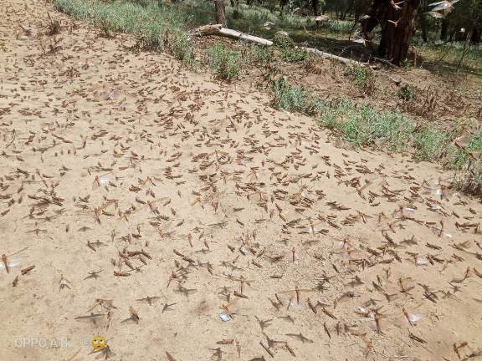
Desert locust invading grazing fields at Raraiti, taken on 8th April, 2021
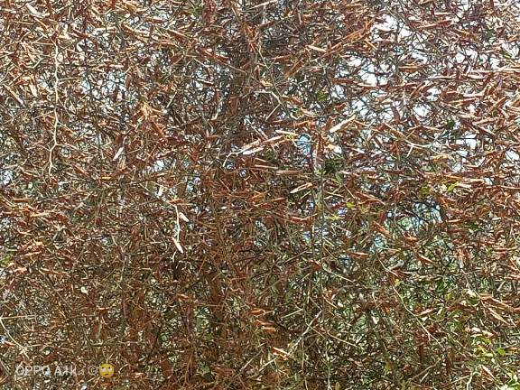
Trees invaded by desert locust at Raraiti, taken on 8th April, 2021

