ChildFund International
Humanitarian Situation Report

Humanitarian Situation Report [02]
[Desert Locust Invasion Emergency Response in Marsabit, Kitui, Samburu and Baringo Counties – Kenya]
[26th March 2020]
[Issa Kipera, Program and Sponsorship Director, IKipera@childfund.org]
[December 2019-March 2020]

Part 1: The Overall Situation

“The threat from the locusts “remains extremely alarming" in the Horn of Africa, where “widespread breeding is in progress and new swarms are starting to form, representing an unprecedented threat to food security and livelihoods at the beginning of the upcoming cropping season,” according to a warning issued this month by the U.N. Food and Agriculture Organization.
The desert locust is considered one of the most dangerous migratory pests in the world. One locust — which can be about two to three inches long — can travel about 93 miles and a small swarm — containing 40 million locusts — can eat the same amount of food that 35,000 people can eat in one day.

Desert Locust invasion has ravaged greatly the Greater Horn of Africa where tens of thousands of hectares of cropland and pasture have been destroyed in Ethiopia, Kenya and Somalia which will greatly negatively impact severe consequences on agriculture-based livelihoods in areas where food security situation is already dwindling. This Desert Locust is considered the most destructive migratory pest in the world due to its nature of being highly mobile and feeds on large quantities of vegetation including crops, pasture and fodder. If tangible measures are not put into place as early as possible, the Greater Horn of Africa will have a devastating and unprecedented threat to food security and livelihoods that could plummet the region into further suffering, displacement and potential conflict for scramble for scanty resources.

The U.N. recently raised its aid appeal relating to locusts to $138 million, up from $76 million, saying the need for more help is urgent. Experts have warned that if the number of locusts is unchecked, they could grow 500 times by June, when drier weather is expected in East Africa.
In Kenya since the end of December 2019, dozens of Desert Locust swarms have arrived from Ethiopia and Somalia on a nearly daily basis. These swarms have spread widely with terrifying speed of migration wreaking havoc to vegetation that had just sprouted and flourished from the short rains experienced in October to December 2019. One swarm in northeast Kenya was estimated to be about 1,490 miles squared with somewhere between 100 to 200 billion locusts in that single swarm, said Mark Lowcock, under-secretary-general for humanitarian affairs and emergency relief coordinator at the United Nations Office for the Coordination of Humanitarian Affairs, during a recent briefing. To date, about 70,000 Hectares of land have already been infested. As the pest spread so fast to many counties in the country especially the pastoralists in the north, more negative impact is reported which will escalate the vulnerability levels as they recently were just recovering from a prolonged drought of 2018-2019. This menace is a huge blow to thriving economies derived from agriculture, pastoralism and agro-pastoralism, which are a buttress to the livelihoods of the affected counties. Now that the calendar is approaching of the long rain season, the breeding of desert locusts will be high and can easily get out of hand if stringent measures are not put into place to curb breeding and the migratory pattern. This translates to more people rendered vulnerable.

In a March update, the U.N Food and Agriculture Organization (FAO) said the locust situation remained “extremely alarming in the horn of Africa” specifically in Kenya, Ethiopia and Somalia where widespread breeding was in progress. New swamps were starting to form “representing an unprecedented threat to food security and livelihoods at the beginning of the upcoming cropping season”, the agency added.

A new generation of hopper bands that hatched in February 2020 in Northern Kenya has matured and ready to fly, signaling a new a headache to the government as it battles locust menace. This is the first ever generation bred in Kenya to fly since invasion was reported. The veracious pests have been laying eggs along their migratory paths which started from Wajir, Mandera, Isiolo and Samburu counties. Government experts say the hopper bands could form swarms close to 100 times larger than the wave that descended in the region from neighbouring countries of Somalia and Ethiopia.

Currently the available statistics show that Desert Locust invasion in Kenya has invaded 26 Counties most of them being Arid and Semi-Arid Lands (ASAL), where cyclic and sporadic drought lead to emergencies resulting to destruction of livelihoods derived from farmland and livestock. Some of the Counties are; Mandera, Garissa, Wajir, Marsabit, Isiolo, Meru, Laikipia, Kitui, Baringo, Samburu, Turkana, Tharaka Nithi, Embu, Muranga, Machakos and Tana River. This invasion is forecasted to reach more counties if the situation is not contained. Of the 26 counties invaded, ChildFund and its local partners have presence in 11 counties, with the hardest hit being Marsabit, Turkana, Baringo, Isiolo, Tharaka Nithi and Kitui.

The locust upsurge is happening in a region with an already high level of food insecurity that requires humanitarian assistance. About 10 million people out of the current 13 million people who are in IPC 3+ (Integrated Phase Classification 3+) are located in areas currently affected by desert locust infestations. Out of this population, 3.1 million Kenyans are affected by this menace.

The Government of Kenya through its line Ministry of Agriculture and Livestock has already been addressing the situation using her own resources. These responses range from scientific to traditional methods, whereby the government undertakes aerial control operations through aircraft spraying and the communities chasing the pest through making noise. Through National Drought Management Authority (NDMA), coordination has been key between the government and non-state actors on putting forth strategies on how to combat the locust spread and its further containment.

The government of Kenya is keen on controlling the desert locust menace and has formed working groups to combat the pest. FAO is leading efforts on complementing the government response measures. FAO is now responding under the four pillars that are informed by previous responses. These pillars are curb the spread of desert locust by assessment, early warning and forecasting and locust control operations; safeguard livelihoods by cash transfer interventions, supplementary livestock feed, farming inputs packages; support early livelihoods recovery and coordination. FAO is continuing soliciting funds for these four pillars alongside World Food Program (WFP), Intergovernmental Authority on Development (IGAD) and OCHA.

FAO began training in the mid-March 2020 where 300 National Youth Service (NYS) trainees were provide training as part of its action plan aimed at boosting the Government of Kenya’s (GoK) ground surveillance on desert locusts. An additional 300 trainees will participate in future capacity buildings exercises at the NYS College, bringing the total number of monitors added to the governments’ teams to 600.

Part 2: The Situation in Areas Where ChildFund Works

ChildFund Kenya and its Local Partners (LPs) are working in 11 out of the 26 affected counties. The programs that ChildFund Kenya and its LPs are implementing in the affected counties include Child Protection, Early Childhood Development (ECD), Education, Health and Nutrition, WASH, Food Security, Household Economic Strengthening and Climate Change Adaptation. So far, preliminary data collected from the LPs in four most affected counties where ChildFund and its LPs work are as shown below:

Category | Female | Male | Total
Children | 4,800 | 3,200 | 8,000
Youth | 192 | 128 | 320
PLWs | 2,000 |  | 2,000
Farmers | 1,344 | 896 | 2,240
Pastoralists | 300 | 200 | 500

Since the invasion of locusts, the crops and vegetation that had started sprouting and flourishing have been destroyed by the pest. As a result of the invasion, so far no harvests have been registered in areas where crop farming was done during the short rains of October to December last year. This therefore translates into food insecurity, shortage of food supply hence high market prices in the affected communities. Due to spraying and its hazardous effects, communities in affected areas have been asked to move out of the areas with their livestock which means families have been displaced therefore prompting children not to go to school and also exacerbating the likelihood of risks to dangers on children and youth. Families are also migrating to areas where impact of locusts is low where they can access pasture and fodder for livestock, and proximity to government emergency services.

Several areas are battling new desert locust invasions despite the ongoing spraying of hatchlings. There are new cases of invasion being reported in new geographical areas mostly the food basket of the country. Farmers have criticized the government for abandoning the war on the destructive insects. The residents called for speedy intervention by both the county and national governments especially aerial and ground spraying

On the other hand, the reporting COVID-19 cases in the country has diverted government, donors and other stakeholders focus and attention on desert locust infestation and the control. Additionally, the fight against locusts has been hit by a shortage of pesticides following the suspension of flights worldwide. Seed growers, including Kenya Seed Company, have halted work amid the coronavirus onslaught. “Due to the (Covid-19) outbreak … we are temporarily closing our doors as instructed by the government to promote self-quarantine,” a notice by the Simlaw Seeds subsidiary of Kenya Seed Company stated at its outlets in Eldoret.

Part 3: ChildFund’s Response
ChildFund Kenya is a member of County Steering Group (CSG) in all the 26 Counties it operates either through the LPs or ChildFund staff. The CSG is coordinated by National Drought Management Authority (NDMA) which is responsible for coordinating both state and non-state actors on their humanitarian responsiveness and especially during the times of emergencies brought about by unforeseen hazards.

In the meantime, apart from the government that is moving with speed to combat the spread and containment of locust, all non-state actors are in the coordination and planning phases where they are soliciting for funds to join government effort in addressing the deadly pest. In the case of ChildFund Kenya, we have already identified the most adversely affected counties, the number of affected households and their needs. We also embarked on fundraising mainly from Alliance Members in order to respond. So far, a total of USD 10,000 has been raised from ChildFund Barnfonden and a proposal for USD 100,000 is in the process of being finalized and submitted to ChildFund Korea. More funds being requested are aimed at implementing emergency response activities that will alleviate suffering of susceptible vulnerable groups including sponsored children. The proposed response activities range from and not limited to; procurement and distribution of supplementary feeding, procurement of food commodities to 8,000 children under 5 years; cash transfer to 2,000 Pregnant and Lactating Women (PLWs) to procure food commodities; procurement and distribution of farm inputs to 2,240 farmers; procurement and distribution of 1,125 tons (75,000) hay; training of 240 farmers on animal husbandry and disease prevention; procurement and distribution of 60 water storage tanks to 60 ECDs; procurement and distribution of 10,000 litres of water to the 60 ECDs; procurement and distribution of 2,000 jerricans of 20 litres each to 2,000 PLWs; procurement and distribution of water treatment reagents (water guards) to 60 ECDs and 2,000 PLWs; train 129 ToTs on Child protection; train 320 youth organized into groups on entrepreneurship skills with focus on management of Volunteer Savings and Loan (VS&L) activities; community awareness and sensitization public meetings; participation at national level forum in addressing the desert locust menace and training of County Government Agriculture, livestock and environmental technical officers on desert locust early warning systems and information. ChildFund Kenya as a routine in its working areas through the government coordination arm is a member of many working groups-referred to as sector groups like WASH, Heath and Sanitation, Education, Food Security and Nutrition and Child Protection cutting across all sector groups. In addition, ChildFund has joined Regional Desert Locust Alliance (RDLA). The Regional Desert Locust Alliance brings together National and International NGOs who are responding to the desert locust crisis in the greater Horn of Africa. The Alliance was formed in February 2020 in response to the increased locust threat to food security and livelihoods in eight countries in the greater Horn of Africa - Djibouti, Eritrea, Ethiopia, Kenya, Somalia, South Sudan, Uganda and the United Republic of Tanzania.

Below Sections for Internal Use Only

Staffing and Security
ChildFund Kenya will be responsible for the implementation of the desert locust invasion emergency response in all the four selected affected counties. In each of the counties, ChildFund Kenya will collaborate with its LPs namely Central Rift Children Program in Baringo, Samburu Children Program in Samburu, Nawiri Child Development in Marsabit and Eastern Community Development Program in Kitui. Other actors which ChildFund Kenya will partner with in the implementation of the project include the respective County Governments departments of agriculture, livestock, environment and social protection, and National Drought Management Authority at county level.

In terms of the day to day implementation and management of the project, a Project Officer will be hired. S/He will be supported by 4 Assistant Project officers, each one to be located in the affected County. ChildFund Kenya Food Security and Livelihood Specialist and the Area Manager will provide backstopping while the Program and Sponsorship Director, the Grant Manager and Finance Manager will provide oversight and support.

The 4 Assistant Project Officers to be deployed to every of the 4 Counties will be people brought up and residing in those counties, therefore the element of mobilization of the communities is answered and responded well. Since these staff are conversant with the geographical landscape and cultural parameters of their areas of origin the security risks are minimal or even none. Through experience, ChildFund Kenya in the past has been implementing other emergencies brought about by drought and none of insecurity threats are documented to have occurred. The only risk that is foreseen is families and children further migration to areas with pasture and fodder which upon multi-sectoral, Multi-agency intervention to this locust scourge, vulnerable people’s needs will be mitigated and therefore there will be minimal or no further migration.

Sponsorship and Grants
Sponsorship Area | Sponsored Children
Samburu | 4,204
Marsabit | 2,435
Kitui | 1,921
Baringo | 2,084

County | Active Grant | Donor | Primary Implementer
Samburu | Integrated Early Childhood Development (IECD) | UNICEF | ChildFund Kenya
Marsabit | Disaster Risk Reduction (DRR) | ChildFund Korea | ChildFund Kenya
Kitui | Subsidy | ChildFund Korea | ChildFund Kenya
Baringo | None

Despite ChildFund Kenya implementing several projects in the affected counties, their impact of the targeted group may be adversely affected by the desert locust infestation. Thus, the desert locust infestation will have the impact of not only increasing the number of vulnerable households, but also increase the levels of vulnerability of those already in the category. Those households expecting to be targeted will increase, thus looking forward to be included in the interventions of the current active grants.
Donors
Donor | Program | Amount (USD) | Requested? (Y/N) | Confirmed? (Y/N)
ChildFund Korea | Emergency Response | 1,615,229 | No | No

Media/Communications

- NDMA County Drought Coordinators
- Cabinet Secretary, Ministry of Agriculture and Livestock
- FAO
- WFP
- IGAD
- RDLA
- Plans for collecting photos/videos/stories, i.e. should an outside photographer be hired?

Normally when implementing such emergency grants, the officers in the field are provided with HD cameras for collecting quality photos and videos and also providing success stories from beneficiaries who have benefitted and become resilient out of the intervention. The donor at times can arrange for the outside media services to collect videos and stories in the form of documentary meant for visibility and fund raising.

- Key points for messaging and visibility, particularly any host government sensibilities that must be considered.
Being guided by humanitarian principles and measures, the information for visibility either by print or broadcast media must meet the threshold of the standards that govern it either internationally or locally.

Support needed or requested from IO, GSS or Global Teams – whether onsite or remote.
The Country Office will need the support to raise funds for the locust invasion response so as to safeguard livelihoods of those affected.

Photos
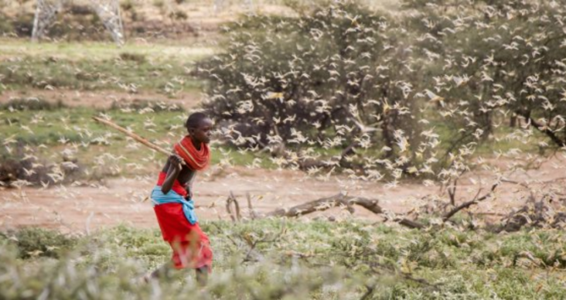
This is the largest locust invasion in Kenya in 25 years. Patrick Ngugi/AP/SIPA

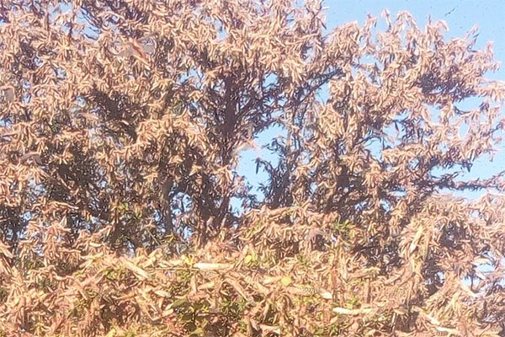
Swarms of desert locusts which have invaded parts of Tseikuru, Kyuso and Mivukoni in Mwingi North, Kitui County -Nation Media Group
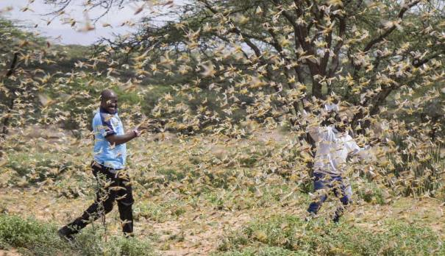
Two men who work for a county disaster team identifying the location of the locusts, are surrounded by a swarm of desert locusts filling the air, near the village of Sissia, in Samburu County in January 16. [AP]
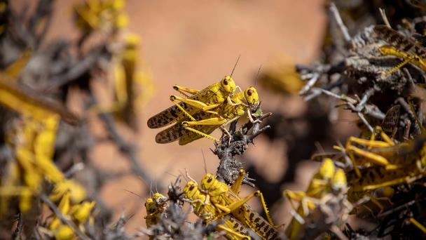
Desert locusts mate on a bush in northeastern Kenya. The desert locust is considered to be the most dangerous of all migratory pest species in the world due to its ability to reproduce rapidly, migrate long distances, and devastate crops. (@FAO/Sven Torfinn / FAO)
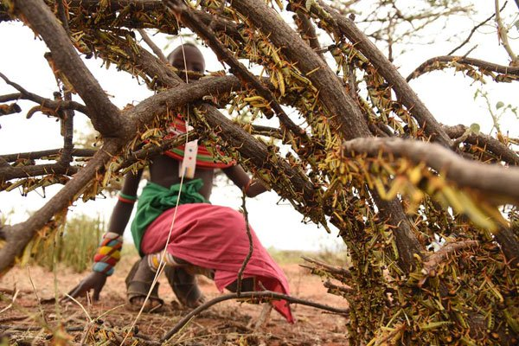Murdane Nai observes a swarm of young locusts at Nguaruny in Samburu East, Samburu County, on March 11,2020. Nation Media Group

Training of 300 National Youth Service (NYS) on ground surveillance on locusts in Kenya on 13th March 2020.
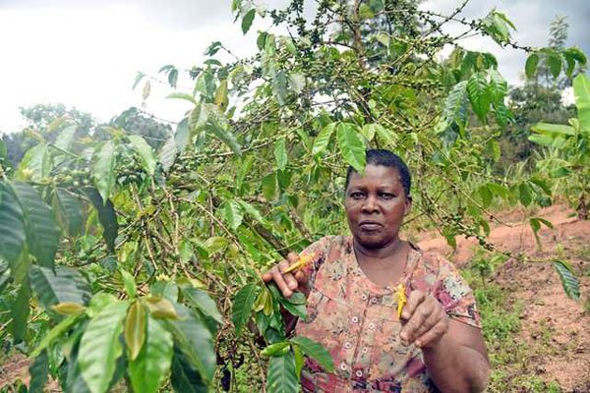
A small-scale farmer displays locust on her coffee plantation- Nation Media Group

http://fews.net/IPC
http://www.fao.org/ag/locusts/en/info/index.html
CSG is a government forum coordinated by NDMA which brings on board all state and non-state actors together during the times of emergencies for purposes of fund raising, mapping hot spots, response and recovering monitoring

