ChildFund International
Humanitarian Situation Report Template

Humanitarian Situation Report [1]
Effects of Senegalese military operation in Casamance: Sounds of gunfire and shells landing in Gambian border villages of Foni
Date: March 17, 2022
[Point of Contact – Mr. Nfamara Dabo, Programs & Sponsorship Director, ndabo@childfund.org ]
Date Range Covered by Report: March 14-17, 2022

Part 1: The Overall Situation

Foni is in the geographical demarcation of the West Coast Region, Gambia. It is flanked by Kombo East, West Coast Region on the west, Lower River Region on the east, the river Gambia on the north and bordered with the Senegalese region of Casamance on the south. Foni is inhabited by different tribes, but the Jola tribe dominates. However, the people have mutual and social relations, as it could be manifested in the way they share social norms, hold common characters, celebrate each other’s social events like naming, marriage, initiation ceremonies, and even in times of funerals, they share the grief. The area is a stronghold of the Alliance for Patriotic Re-orientation and Construction (APRC) as far as Gambian politics is concerned. This is due to the fact the founder of the party and former President, Yahya Jammeh, originates from Foni.
Following the formation of an effective coalition government by the opposition parties during the December 2016 presidential election, the 22 years regime of the APRC ended. Nonetheless, the APRC won all the seats in in the Fonis during the April 2017 National Assembly elections. When the results of the 2016 Presidential Election was announced, the former president, Yaya Jammeh accepted defeat to Adama Barrow, but after a week, he announced his annulment of the election results. Former President Jammeh’s action led the country through months of political standoff that. The ECOWAS economic block intervened by sending in Economic Community of Military Intervention in The Gambia (ECOMIG). The arrival of the ECOMIG forces and negotiation by key ECOWAS leaders persuaded former President Jammeh to step down, and he went on exile to Equatorial Guinea, ending his 22 years rule. In relation to this, most of the people in Fonis, most especially the Jola (the tribe of Jammeh) mourned the departure of their party leader; thus, seemingly making them (the APRC loyalists) reluctant to accept the change. The failure to recognize the fact that governments come and go, and associating politics to tribal and social lines could result to unwanted political tensions, seemed to be the preoccupations of the APRC party militants.
The people of Casamance, southern Senegal shares family ties, cultures, and lot of things in common with the people of Fonis, and The Gambia at large. The relationship is even stronger with the people living along the border villages. The Casamance region is affected by a protracted conflict for independence, that commenced in 1982. The conflict has been characterized by sporadic fighting between MFDC separatist and the Senegalese armed forces, by factional fighting, and by attacks on villages and villagers considered by the MFDC and other factions to oppose their aims for independence.
One of the posts for the ECOMIG forces is Bwiam, Foni, where the Senegalese ECOMIG forces are stationed. The presence of the Senegalese ECOMIG forces in Foni has been dubbed, by many people in the area, as strategy by Senegal and the Gambia government to study the movements of MFDC separatist and map out ways of launching an attack on them. Although no evidence of such has been established, but it is worth noting that the operations of the Senegalese ECOMIG soldiers are on apprehending trucks with wood logs as one of their key functions, especially those trucks suspect of originating from Casamance. This action of confiscating logs and trucks have angered many people in the Fonis, which is cause for alarm.
On the March 13, 2022, around 13:45 pm Foni witnessed mass population movement from the border towards the interior of Foni Kansala, Bintang and Bondali Districts. The movement was a result of a continuous firing between the MFDC Rebels and the Senegalese Soldiers along the border and live bullets fallen in the Gambian border communities. It was later reported that Senegalese military launched operation in Casamance. This incident was preceded by the January 24, 2022, exchange of fire between the MFDC Rebels and the ECOMIG Senegalese Soldiers in the Gambia during a chase of vehicle with wood logs driving from Casamance to the Gambia which claimed the lives of two (2) Senegalese ECOMIG Soldiers and others captured. The January 24 incident led to the fleeing of 163 families with a total population of 1861 persons from Foni Kansala border belt to Foni communities mainly situated on the trans-Gambia Highway as a safe place. The IDPs were hosted by 135 families and 298 families are still struggling with the impact of both the displacement and hosting.
The National Disaster Management Agency (NDMA) is the lead government to coordinate responses to such situations. NDMA together with other institutions including Foni Ding Ding (FDD) Federation conducted a rapid assessment of the January 24 incident, but government did not support the IDPs and their host families. However, WFP through NDMA provided a bag of rice (50kg) to 157 internally displaced households, and ChildFund through Foni Ding Ding Federation provided cash assistance (D133,000) to 33 host enrolled families in addition to offering spaces to accommodate IDPs.
With regards to the most recent incident, all the communities within the border belt of Foni Kansala, Bintang and Bondali Districts have moved yesterday due to fear and panic. The movement was not also limited to Internal displacement alone, but some refugees were also received in Foni Bondali Districts who were reported to come from (Kafunda and Younor) villages in Casamance. As at yesterday evening an estimated population of 2,000 IDPs were registered within Foni Kansala, 700 IDPS in Foni Bintang and 400 received at Bondali districts respectively. On the side of the refugees, an estimated 50 households have already moved in, and they are settled at Kankurang, Burambang, Nyantempo, Bondali Jola, Kafenkeng and Kanwally villages in Bondali (NDMA, March 2022 Rapid assessment brief). The situation poses serious challenges on the host communities in terms of both physical and materials resources to accommodate the pressing needs of the IDPs.
Part 2: The Situation in Areas Where ChildFund Works

The entire area is coverage of ChildFund sponsorship area covered by the Foni Ding Ding (FDD) partner. Our enrolled and sponsored children and their families are directly affected by the conflict. The entire area of Foni is under the jurisdiction of Foni Ding Ding Federation. However, as mentioned earlier FDD with support from ChildFund has supported 33 affected host families using with unconditional cash assistance. Each of the 33 affected families received cash ranging from D2000 ($40) to D4000 ($80) based on the number of Internally Displaced Persons (IDPs) they hosted.
Recently, the government through National Disaster Management Agency (NDMA) setup a task force who are charged with responsibility of conducting rapid assessment as well as convene meetings to inform government subsequent action(s). However, it worth noting continuous gunfire has caused a lot of panic in the area resulting to offices and schools’ closures as precautionary measures. In addition, most of the families are facing multiple vulnerabilities as this is the second time of being displaced within 2 months. Equally the previous host families are hosting them again, sharing their meagre resources with the IDPs and or Refugees, while they continue to suffer the impact of the last two months’ incident. Families whose shelter were damaged due to live bullets will continue to be vulnerable since those houses are not yet fixed. Shockingly, school going children within the Kansala, and Bintang Districts have their schools closed until further notice owing to shells dropping near the schools. This means children will have to miss classes again after some missing the entire month of February 2022. The other cause for concern is the placement of children, youth, women and men in congested homes or houses that poses serious child protection risks, ranging from molestation, rape, harassment amongst other. Health risks may also exist due to overcrowding and limited sanitation facilities/services to meet the growing demands.

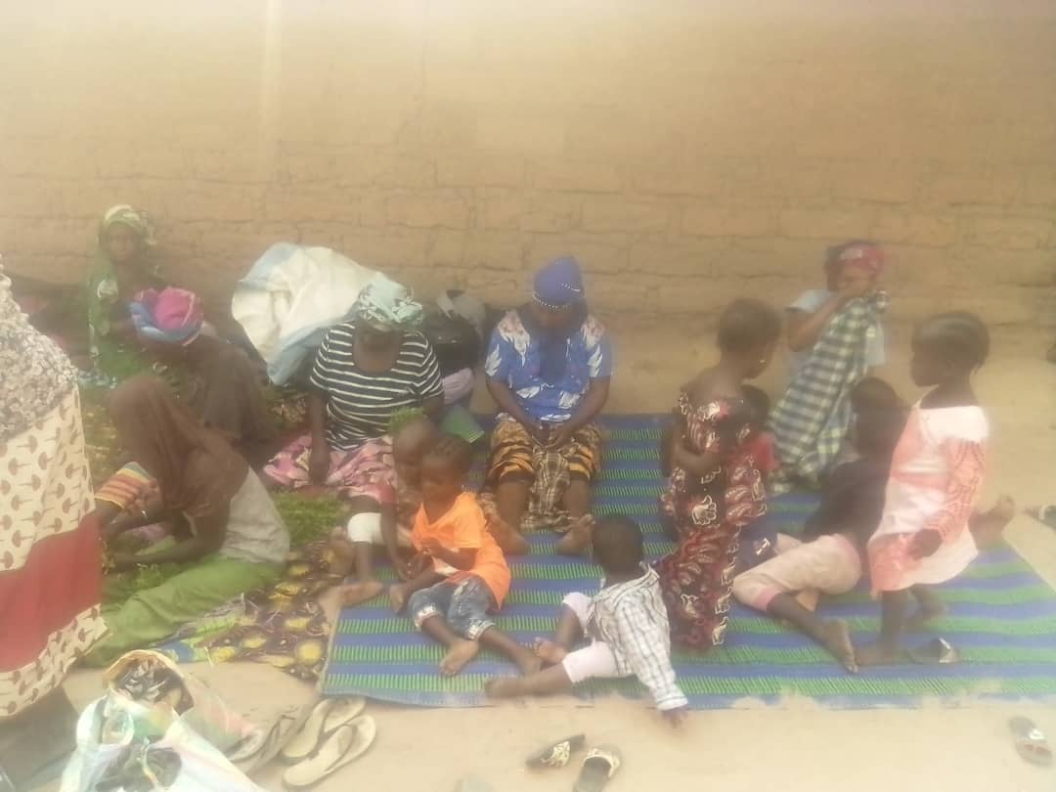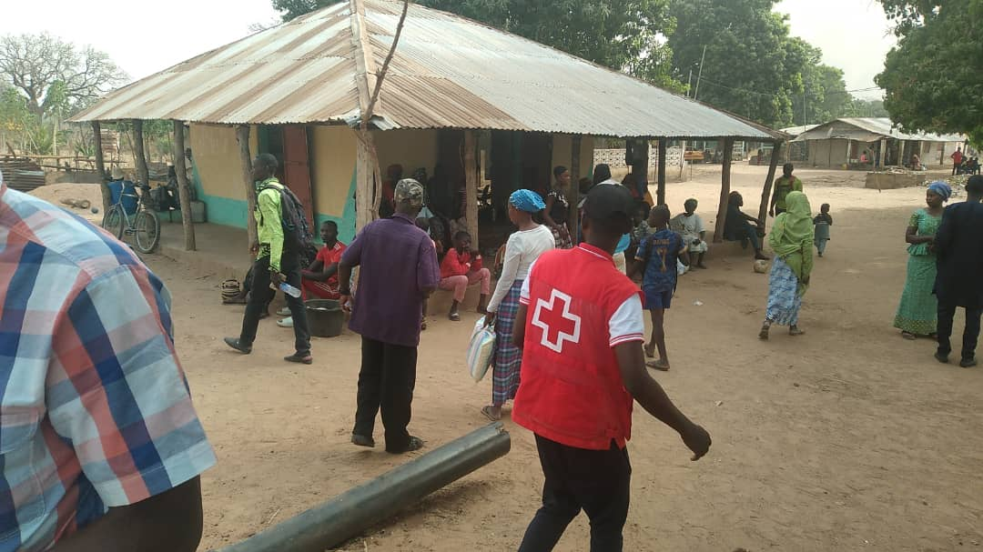A snap shot of IDPs upon arrival
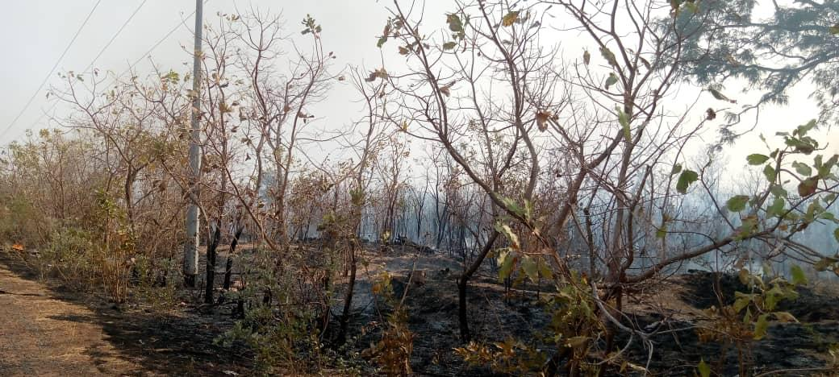Shells landed on this site and burnt the entire area around Kanilai

Part 3: ChildFund’ s Response

Cash Assistance to affected enrolled families
Shortly after the January 24th clashes between MFDC rebels and Senegalese ECOMIG forces, ChildFund through FDD federation supported 33 families with unconditional cash to help families cope with pressure of the IDPs.

Below Sections for Internal Use Only
- Staffing and Security
Security: The Gambia Armed Forces are deployed along the border line to provide security as well as monitor so that there is no launch of attack from the Gambian soil. However, there are no sign of normalcy anytime soon. The presence of Senegalese ECOMIG forces in the Foni area serve as a threat to peace as many fear that MFDC rebels will attack them as revenge if they are overpowered by the Senegalese Army attacking from the interior of Casamance.
Which staff are on the ground? Please include names, functions, contact information and arrival/departure dates for both IO and CO staff on the ground.
Staffing: the emergency response task force assigned by the government to conduct a rapid assessment of the situation and report back accordingly for onward support includes FDD federation staff.
Partnership and Coordination: On behalf of ChildFund the Gambia, the local partner, NDMA, the Gambia Commission for Refugees, the Immigration department and the Gambia Red Cross Society are working closely to ensure that proper data is collected and coordinated response is done from government.
- Sponsorship and Grants
The incident will have a great impact on the sponsorship processes particularly on correspondence from children. The situation has led to temporal closure of offices for staff and families’ safety while work is done from home. This will affect direct contact with children but rather through phone calls or messaging.
Sponsorship data of the area
Community Association | # Enrolled | # Sponsored
Sibanor | 624 | 430
Somita | 339 | 253
Besse | 493 | 347
Bwiam | 339 | 233
Kanilai | 414 | 288
Sangajor | 318 | 187
Bondali | 496 | 368
Bullenghat | 357 | 217
Wassadou | 331 | 239
Mankana | 325 | 193
TOTAL | 4036 | 2755

- Donors
  - Provide information about potential sources of funding (including grant donors, subsidy, Emergency Action Fund, Alliance members, GIK, etc.) for these emergency response efforts using the chart below.
Donor | Program | Amount (USD) | Requested? (Y/N) | Confirmed? (Y/N)
ChildFund | Provision of food items | D352,500 =$7,050 | N
 | Provision of sanitary materials | D75000 = $1,500 | N
 | Provision of beddings | 180,000 =$3,600 | N
 | Conduct periodic counselling and protection sessions | 60,000 =$1,200 | N
Total |  | $13,350.00

- Budget
  - Subsidy
  - Fund raising through ChildFund IO

- Media/Communications

Spokesperson: Ms. Musu Kuta Komma, Country Director

Media contact: Mr. Mustapha Mbye, Communications Specialist

Languages spoken: English, Mandinka, Wolof

- Support needed or requested from IO, GSS or Global Teams – whether onsite or remote.

