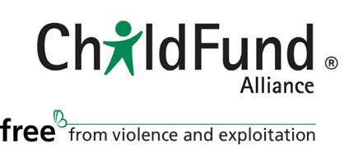

ChildFund Alliance Board of Directors
Michael Rose, Chairman

Michael joined the ChildFund Alliance Board in 2007 and became Chairman in 2011. He is a former Chairman of ChildFund Australia and Chairman of the Institute for Global Development at the University of New South Wales.

Michael serves on the boards of a number of government, arts and not-for-profit organizations and is actively involved in aspects of welfare reform, economic development and education in Australian Indigenous communities.

Lennart Wiklund, Vice Chair

Lennart is the Chairman of Barnfonden (Sweden). His academic studies were in political science, statistics, law and journalism. His professional career has been in journalism, film and newspaper management. He is a past President and CEO of Video Express, the pan-Scandinavian Swedish Film Industry. Lennart has been a member of Group Management of the Bonnier Group (HR and Information/Communication), as well as Chairman of the Media Employers Association, Vice Chairman of Almega, Chairman of the Polar Music Prize, a member of the Board World Press Freedom Fund, WAN, a member of the Board in SF Bio, Swedish Film Industry, and Vice-Chairman of Bonnier Solutions. He also volunteers to help children in need (Min Stora Dag).

Paul Newbigging, Treasurer

Paul is the President and Chair of the Board of Broadcorp, a private real estate investment fund, and the owner/operator of the Murray E. Newbigging Funeral Home in Toronto, Ontario. He is an active member of the funeral services community in Ontario and Canada. As President of both the Funeral Directors for Open Dialogue and the Toronto and District Funeral Directors Association, Paul has been instrumental in shaping changes to funeral services legislation in Ontario. He is a founding member of the Coalition of Funeral Professionals in Canada, and the Chairman of Transition Sciences Inc., a cleantech company offering alternatives to the Canadian funeral industry.

Paul was educated at Meistershaft College, York University and Humber College. Humber College, where Paul is a lecturer in the health sciences program, has honored him with the Alumni of Distinction Award and a nomination for the Premier of Ontario Award for his ongoing support.

In addition to his work with Christian Children’s Fund of Canada and ChildFund Alliance, Paul volunteers with several organizations in his Toronto community.

Imma Barral
Jean-Pierre Barranger
Gerald Doherty
Anne Lynam Goddard
Hiroshi Harashima
Dr. Nancy E. Hill
Barbara Beate Holzbaur
Je Hoon Lee
Natasha Lewis
Seung-Il Shin
Daniel Silva
Simon Whyte

