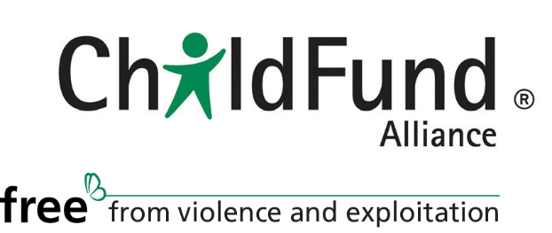

2019 as a Milestone Year toward achieving a world where all children live free from violence and exploitation
Background
In the lead-up to the 2015 adoption of the Sustainable Development Goals (SDGs), ChildFund Alliance promoted the inclusion of target 16.2- End abuse, exploitation, trafficking and all forms of violence against and torture of children and related targets to end violence against children. Now ChildFund is committed to taking action to realize these targets. Within the ChildFund Alliance Strategic Plan 2016-2021, our first strategic priority is to “Advance SDG target 16.2 and related targets through global, regional and national advocacy and engagement.”
In 2019, the United Nations High-Level Political Forum (HLPF) will include an in-depth examination of three SDGs that contain targets relevant to ChildFund’s advocacy priority to end all forms of violence against children: 16, 8 and 4. 2019 also marks the 30th anniversary of the UN Convention on the Rights of the Child (CRC). The 2019 HLPF will be the first since the SDGs were agreed by all Member States that will be held at Head of State level.
Objectives for actions around this milestone year
2019 will be a milestone year as both the 30th anniversary of the UN Convention on the Rights of the Child and the SDG targets related to violence against children offer a unique opportunity for ChildFund to mobilize across the Alliance in support of shared priorities.
Key objectives:
- Call attention to 2019 as a milestone year in the movement to ensure that all children are free from violence and exploitation.
- Raise awareness about the 30th anniversary of the CRC and the work left undone.
- Elevate the voices of children within the national, regional and global SDG review processes.
- Position ChildFund as a strong advocate and champion for 16.2.

Overview of joint actions
Working with children to effect change: Child-friendly Accountability
Building on our strong contributions to the positioning of SDG Target 16.2 within the 2030 Agenda (the SDGs), the child-friendly accountability initiative was developed to support implementation of Target 16.2. The project equips young people with the knowledge and skills to engage governments and other stakeholders, participate in decision-making and planning, and take action to strengthen child protection systems. In July of 2019, when the global community convenes to review SDG 16 in depth, young people should have a voice in this critical UN process.

Awareness-raising: Small Voices, Big Dreams (SVBD)
Launched in 2010, SVBD is a survey of children’s voices that aims to generate awareness of children’s perspectives and experiences. In 2019, the survey will focus on a topic related to ending violence against children with the objective of raising awareness and mobilizing public opinion on the issue of violence against children.

Elevating our key messages through collaboration with other child-focused organizations
In order to amplify the call to governments to enable young people to participate in the decisions that affect them and work to end violence against children, ChildFund will continue to partner with other child-focused organizations. This work is being carried forward through the Joining Forces initiative that brings together ChildFund, Plan International, Save the Children, SOS Children’s Villages, Terre des Hommes and World Vision. In addition, ChildFund works closely with a group of child-focused organizations in New York to advocate within the UN System for children’s participation, children’s rights and accountability in the SDG process.

Supporting ChildFund engagement in official SDG Review Processes
ChildFund members are engaging at the national level in the Voluntary National Reviews, and some of the Regional Forums for Sustainable Development and bringing the key messages from those processes into the HLPF.

Key products and UN processes:

Date | ChildFund product/ UN process / Joint product of child-focused agencies
May 2018 | Child-friendly Accountability Initial Impact Report
July 2018 | High-Level Political Forum
November 2018-  May 2019 | Governments conduct Voluntary National Reviews (review of the SDGs at the national level) with inputs from different stakeholder groups, including CSOs and children.
Spring 2019 | SVBD launch
March-May 2019 | Regional Forums for Sustainable Development (review of SDG progress at the regional level)
April 2019 | Child-focused agencies launch Child Rights Now Flagship Report in the lead-up to the 30th Anniversary of the CRC
May 2019 | Child-friendly Accountability Impact Report
May 2019 | Advocacy document that highlights programmatic work in line with the INSPIRE strategies and recommendations emerging from Child-friendly Accountability
July 2019 | High-Level Political Forum
September 2019 | Head of State and Government session of the HLPF
November 2019 | 30th Anniversary of the CRC

