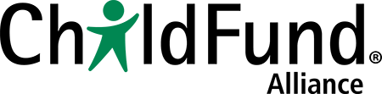

Child-friendly Accountability Toolbox – Module 13, p. 135

Analyzing Child Protection Laws and Policies Chart

 | What do local policies or laws say? |  | What do national policies or laws say? |  | What are the gaps?
 | Policy/law | What it says | Policy/law | What it says
Preventing violence
Seeing violence/ Listening to children
Finding out what happened
Helping children who are experiencing violence
Helping families to help children
Punishing the person who abused the child

