ChildFund International
Humanitarian Situation Report Template

Humanitarian Situation Report 002
EBOLA – Guinea
February 22, 2021
Point of Contact – Sekou Touré SSFP +224 622 35 12 08 stoure@childfund.org
From February 16, 2021 to February 22, 2021

FOR UPDATES, PLEASE HIGHLIGHT UPDATED SECTIONS IN RED

Part 1: The Overall Situation
COUNTRY EMERGENCY BACKGROUND INFORMATION
Guinea Conakry has recorded confirmed cases of Ebola in Gouecke in the NZerekore Prefecture. An official Government declaration of Ebola was published on February 14, 2021 after an Emergency meeting under the leadership of Ministry of Health.
The Nzérékoré Region is a region in the southern part of Guinea. Its capital and largest city is Nzérékoré. It is one of the eight administrative regions of Guinea, bordered by the countries of Sierra Leone, Liberia, and Ivory Coast, and the Guinean regions of Kankan and Faranah.

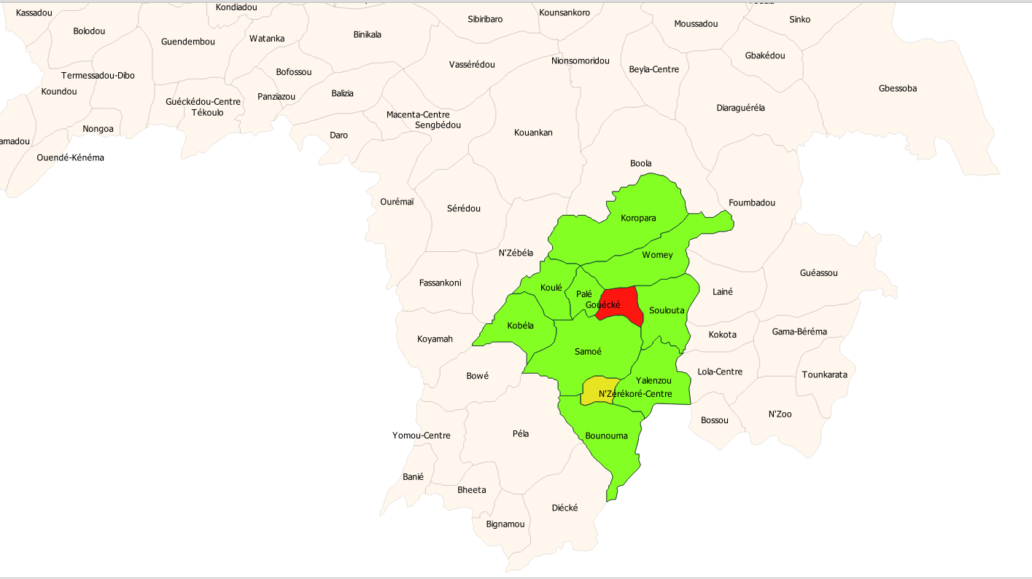
Foyer actif
Foyer en alerte
Foyer calme
Legende
Total Number of EBOLA Cases Reported* | Number of Deaths** | Number of Cases Recuperated | Contact tracing
10 | 5 | 0 | 318
SOURCE: Investigation report from MoH of February 21, 2021
Note:
* Number of confirmed and suspected cases from EVD: 10
- Number of EBOLA Cases confirmed: 4
- Number of EBOLA suspected cases: 6
** Number of deaths from EVD among confirmed and suspected cases: 5
- Number of deaths from hospital reported: 1
- Number of deaths from community reported: 4
Contact tracing: 318 contacts out of 348 are followed up by the mechanism put in place by the ANSS (National Health security Agency) i.e 91.3%. Conakry recorded 39 contact persons who are part of the followed-up targets.
ChildFund-supported areas (Provide only if you have reliable data on this. You can report on a consolidated basis or by program state/region/province/etc. if you have this detail.)
Geographical area (country or state/region/province | Total Number of EBOLA Cases Reported | Number of Deaths | Number of Cases Recuperated
SOURCE: National Ministry of Health or other reliable source

- Any relevant background information about areas affected.
The first case was a nurse from the health center in Gouecke who got sick, was seen by the chief Doctor and referred to Nzerekore. She is believed to have died between 27th and 28th January and was buried on February 1st.
Following the burial of the deceased nurse, eight (8) cases of diarrhoea, vomiting and bleeding were seen in area of Gouecke, 45km from Nzerekore, of whom 3 died. These (8) cases were participants at this funeral. Samples were taken and expedited to labs in Conakry and Gouecke. 4 patients are currently in isolation in Nzerekore since the 11th of February and one in Conakry since February 12th. The lab in Gouecke provided the first confirmed case of Ebola on Feb. 12th.
- Host government posture: Have they declared a state of emergency and/or requested outside assistance? Which nationwide measures has the government taken, e.g., limitation on meetings, internal travel, school closures etc.
- Based on the Regional Health Department’s preliminary investigation report, the Guinea government declared the epidemic on February 14th 2021 but has not as yet declared a state of Emergency
- The affected area (Gouecke) is now isolated,
- An investigation task force composed of the National Health Security Agency (ANSS), WHO, MSF, Red Cross, …has been set up and is now in the affected area for a thorough investigation of suspected contact cases in relation with local authorities.
- Activation of the coordination and cluster of EBOLA response in the country
- Activation of EBOLA treatment center in Gouecke
- MoH in relation with WHO is committed for a prompt acquisition of EBOLA vaccines,
- Implementation of International Health standards and rules in Guinea,
- The government invited the population in the affected area for the strict respect of barriers measures and inform the health centers of any suspected cases.

- What responses has the government put into place to address the health crisis and/or the economic impact?
- Activation of the EBOLA response cluster and coordination in the country
- Activation of EBOLA treatment center in Gouecke,
- The MoH, along with the WHO, is committed to a prompt acquisition of EBOLA vaccines.
- Activation of EVD treatment centers in N’Zerekore and other regions
- Activation of regional alert and response task forces against epidemics (ERARE)
- Arrival of Ebola vaccines planned for N’Zerekore postponed for February 23, 2021
- Community awareness sensitization on EVD in N’Zerekore.

Part 2: The Situation in Areas Where ChildFund Works

Partner Organization (Use Salesforce identifying code/name.) | # of Enrolled and Sponsored Children |  | EBOLA Cases Reported in ChildFund Communities (Y/N/Unknown) Provide number if available. | Number of Enrolled Children Reported with EBOLA (If available.) | Number of enrolled children diseased as result of EBOLA
 | Sponsored | Enrolled
FMK | 2 190 | 4 243 | N | 0 | 0
FDD | 1 842 | 3 766 | N | 0 | 0

Part 3: Guinea Response preparation
The Guinea Country office will update the Country emergency response in relation with Government, WHO and ANSS response guidance and standards, in addition to already existing COVID19 response.
The main areas of focus will be:
- community awareness/sensitization campaign through Community health volunteers, local radios, posters, by our local partners.
- Distribution of hygiene kits and handwashing facilities in the schools, health centers and household public in communities.
- Participation in the national and local clusters and coordination mechanisms
- Distribution of personal protection kits to staff and community volunteers in our program areas.
- Donation of GIK like handwashing facilities, personal protection kits for professional health staff, hygiene kits for health centers in the affected areas
- Preventive measures as per ANSS guidelines:
  - Avoid contact with blood and body fluids (such as urine, saliva, sweat, vomit, breast milk, amniotic fluid, semen, and vaginal fluids) of people who are sick.
  - Avoid contact with semen from a man who has recovered from EVD, until testing shows that the virus is gone from his semen.
  - Avoid contact with items that may have come in contact with an infected person’s blood or body fluids (such as clothes, bedding, needles, and medical equipment).
  - Avoid funeral or burial practices that involve touching the body of someone who died from EVD or suspect EVD.
  - Avoid contact with bats, forest antelopes, and nonhuman primates (such as monkeys and chimpanzees) blood, fluids, or raw meat prepared from these or unknown animals (bushmeat).
Part 4 Media/Communications
  - List of media who will be or have been contacted with press releases. Local radio stations in Dabola, Dalaba, Pita, Mamou and Kindia
  - List of emergency CO spokespeople, including name, location, contact information, and languages spoken.
Country Office:
- Drissa Dabone, Country Manager, Conakry, ddabone@childfund.org, +224 622 35 12 15, French & English
- Sekou Toure, SS Focal Point, Conakry, stoure@childfund.org, +224 622 35 12 08, French & English
- Bangaly Diane, Field Office Coordinator, Mamou, bdiane@childfund.org, +224 628 57 46 87, French

- Support needed or requested from IO, GSS or Global Teams – whether onsite or remote.
- Technical orientation/support and guidance
- NSP Funding to support government and LPs’ efforts.
- Adjustment of existing contingency plan and budget approval

