ChildFund International
Humanitarian Situation Report - 3
INDIA COVID19 - Second Wave
Prepared by: Rama Rao Dammala; rdammala@childfund.org
Date & Time Prepared: 10th June 2021 (1900 HRS)
Updates highlighted in yellow colour

Part 1: The Overall Situation
India’s second covid wave shows declining trend since beginning of June 2021. The country now accounts for some 16.65% of all active COVID19 cases in the word. The second wave of the coronavirus pandemic has a brutal impact on most of the States in India. The new surge has nearly crippled the medical infrastructure, unavailability of hospital beds, unavailability of Oxygen, and medical supplies forced to implement weekly lockdowns and nigh curfew in majority of Indian states. India was recovering from first wave of COVID19 until beginning of March 2021 when the second wave of COVID19 began initially from the states of Maharashtra and Kerala. Experts confirmed that the second wave is mainly triggered by the Indian variant of coronavirus, which has higher rate of infection compared with the first wave of coronavirus. The infections have risen sharply (nearly three times when compared with first wave of COVID19) mainly attributed to COVID inappropriate behaviours, general elections, etc. Below are the key statistics of the COVID19 situation in India and in our operational states.

- India reports 93,828 new cases, 6,139 deaths and 149,022 discharges in the last 24 hours, as per Union Health Ministry. Tamil Nadu records highest daily spike of 17,321 Covid-19 cases, and Maharashtra highest 661 deaths.
- After two months, daily positive cases came to below 100,000 cases per day. The highest ever recorded positive cases was on 7th May 2021 at 4,14,188 per day.
- Till 10th June 2021, total COVID19 cases reported stands at 29,183,121 with 359,676 deaths and 27,655,493 recovered from the infection.
- As on date, total vaccination done 242,726,693 doses out of them, 195,482,945 beneficiaries vaccinated 1st dose and 47,243,748 beneficiaries received 2nd dose.
- From 1st May 2021, Govt of India declared vaccination for all i.e. 18 years and above. However, due to shortage of the vaccine, most of the State Governments stopped the vaccination for 18+ and prioritised to vulnerable groups such as elderly, 45 years and above and people with co-morbidity.
- The Prime Minister announced that the vaccination of 18 years and above will be resumed from 21st June 2021 by addressing the shortage through additional procurements.
- The Prime Minister in his address to the Nation on 7th June’ 21 announced the extension of free ration scheme for 800 million people until Deepavali festival, which is October/November.

Following is COVID19 impact numbers in ChildFund operated states:
Sl. | Name of the ChildFund Operational States / UTs | COVID 19 Cases Confirmed | Cured / Discharged / Migrated | Deaths
1 | Jharkhand | 3,42,481 | 3,32,622 | 5,076
2 | Telangana | 5,96,813 | 5,69,086 | 3,426
3 | Bihar | 7,15,179 | 7,01,234 | 9,429
4 | Madhya Pradesh | 7,86,755 | 7,71,243 | 8,441
5 | Odisha | 8,31,129 | 7,64,673 | 3,123
6 | Rajasthan | 9,48,024 | 9,27,443 | 8,749
7 | Chhattisgarh | 9,83,916 | 9,52,532 | 13,271
8 | Delhi | 14,30,128 | 14,00,913 | 24,704
9 | West Bengal | 14,42,830 | 14,11,573 | 16,555
10 | Uttar Pradesh | 17,00,476 | 16,66,001 | 21,516
11 | Andhra Pradesh | 17,79,773 | 16,64,082 | 11,696
12 | Tamil Nadu | 22,92,025 | 20,59,597 | 28,170
13 | Karnataka | 27,28,248 | 24,80,411 | 32,291
14 | Maharashtra | 58,63,880 | 55,97,304 | 1,01,833
Total - 14 Operational States |  | 22,441,657 | 21,298,714 | 288,280
Part 2: The Situation in Areas Where ChildFund Works
- Delhi: The Covid-19 figures reported by the Delhi government show a significant drop in cases and deaths after the worst outbreak in April and May 2021. To curb the spread, government in Delhi had imposed a stringent lockdown which lasted for almost one-and-a- half months. However, on 5th June Delhi saw 414 new cases and 60 deaths which led to relaxation in the lockdown restrictions. With the positivity rate at 0.53%t, the government is now aiming to revive the economy. Therefore, it has been decided some relaxation in Unlock 2.0 from 7th June. Shops and shopping malls will be allowed to reopen on odd-even basis. They will be allowed to operate from 10 AM to 8 PM. Shops selling essential items and pharmacies have not been included in the ambit of this odd-even arrangement and can open all days of the week. In public sector offices, Group A officials can work from office on all days, but other categories under them can work at only 50%. Those in essential services can work at 100%. Private offices can reopen with 50% capacity from 9 AM to 5 PM but have been urged to work from home as much as possible. Companies have been asked to opt for staggered shifts to minimize crowding.

- Uttar Pradesh (UP) is the most populous state of India and we have sponsorship projects in 6 districts and a grant project supported by EU in 10 districts. As per the latest guidelines from Uttar Pradesh state government all the districts which has less than 600 COVID-19 cases, the lockdown is eased from 7am - 7 pm but weekend lockdown is continuing. No gathering of more than 15 members allowed.

- Odisha: Due to excessive surge in Covid cases during May the government extended the lockdown from 19th May to 31st May and later on extended up to 17th June in the entire state. Since last one week there is gradually declining trends started, Government is planning to declare the relaxation in some of the districts where the positive cases are very less especially in the western & southern districts.

- Chhattisgarh: Due to excess surge, State government declared lockdown from 15th April to 15th May, later on lockdown extended up to 31st May. Due to declining trend in positive cases the state government declared the relaxation from 6 am to 6 pm with limited gatherings. But the weekend shutdown is there.

- Jharkhand: In a bid to break the chain of Covid-19 spread in the state, government extended to 31st May and again the lockdown extended till 10th June. but some relaxation has been given in 15 districts from 6 AM - 2 PM about the opening of shops and moment.

- West Bengal Due to COVID-19 Pandemic situation (in 2nd Wave), State Govt. declared the 1st time lockdown from 15th May to 30th May’2021 and further lockdown extended from 31st May 15th June’21.

- Bihar: The State Govt. has extended the lockdown from 15th May to 9th June and again up to 15th June 2021. Night curfew will continue from 7.00 p.m. to 5.00 a.m. morning except for emergency cases.

- Karnataka: The state is under lockdown since 27th April to 14th June’ 21, People are allowed to move between 6 AM to 10 AM to buy essentials. Now, the government is planning to unlock in 4-5 phases as because there is a decreasing trend in last 4-5 days in positive cases. Government has announced relief packages for affected groups such as laborer etc. We have distributed medical equipments to 15 PHCs under Project HOPE.

- Tamil Nadu: The state is under lockdown till 14th June’ 21. There is a surge in COVID cases in 11 districts, which includes ChildFund intervention districts namely, Nilgiris, Erode, Nagapattinam and Chennai. Field team is in touch with the beneficiaries over phone and is providing guidance to stay safe. Vaccination camps are being held by health department in some of our intervention villages. Livelihood is affected due to continuous lockdown and fishing is currently restricted in coastal are.

- Andhra Pradesh: The government has extended the lockdown till June 20, 2021, due to rise in the cases in the month of May. In June’ 21 the positivity rate and number of new cases have reduced marginally; the relaxation time has been revised as 6am to 2pm. The government has announced a relief of Rupees Ten Lakhs for children who have lost parents due to COVID-19. Field teams participated in GO-NGO Coordination meetings organized by the District Administration. The local partners, direct implementation team and grant projects team are working as per the government protocol on rosters.

- Telangana State: The lockdown in the state which was supposed to end on 10th June 2021 has been extended till June 19, 2021 with more relaxation from 6am to 6pm but establishments, shops etc. to close by 5pm. Vaccination drive for 18+ is initiated but there is not enough stock. The field team is in touch with beneficiaries and is working in office as per roster and providing necessary support. The direct implementation team distributed medical equipment and supplies among 7 PHCs in Hyderabad Municipality under Project Hope. The LWS, Targeted Intervention and E-Saksham grant project team is engaged in project activities considering all COVID guidelines.

- Madhya Pradesh: The Govt. of MP has started for unlocking from Jun 1st,2021 in a phased manner, 2 of our operational districts have been unlocked from 1st June but night curfews were enforced. Govt. offices are allowed to operate with 50% workforce and 50% workforce allowed for Private Sector organizations. The field has distributed medial equipments to 14 PHCs covering three districts namely Jhabua, Alirajpur and Dhar. The medical essential kits and protective kits are planned for distributions.

- Maharashtra: In the State, the situation has improved. The opening up after lockdown has been planned in phases and the districts have been divided into four levels. We have Mumbai under Level 3 and Pune under Level 4. For level 3 there are certain shops and establishments to operate till 4.00 p.m. Offices also can function till 4.00 p.m. with 50% attendance. The field team has distributed medical equipments to 4 PHCs under Project HOPE as well as medical essential and protective kits to frontline workers in both Navi Mumbai and Junnar areas.

- Rajasthan: The government of Rajasthan started its partial unlocking process with several shops allowed to reopen between 6 am and 11 am as per the guidelines issued by the authority. Till June 7, all government offices remain open with 25% staff occupancy from 9.30 am to 4 pm, and private offices from 9.30 am to 2 pm. After June 7, the staff occupancy in offices were increased to 50 % and private offices were allowed to open till 4 pm. Section 144 is continued till June end. Schools/Coaching Institute/Training centers are closed.
Part 3: ChildFund’s Response
- Planned, desired or ongoing response – inside or outside current operational areas.
ChildFund India has revised its response plan targeting to reach 10 million population including direct support to 1 million population across 3,000 villages with a budget of over $2.25 million. The response activities will be implemented in our current program locations spread across 15 states/UTs focusing on the following key areas:
  - Health interventions mainly supporting local health systems (primary health care - PHC) with medical supplies, PPE and medical essential kits to frontline workers. This intervention will strengthen the health infrastructure, which is crippled due to overburdened case load and help saving lives.
  - Vaccination campaigns to sensitize communities on vaccination and increase access to most vulnerable population through mass awareness, supporting local panchayats and health systems for vaccine delivery and capacity building of key stakeholders. Supporting local health system to deliver vaccinations in remote locations especially in rural areas.
  - Hygiene kits to support vulnerable families to maintain Covid Appropriate Behaviour (CAB) and maintain safe and hygiene practices as a preventive measure.
  - Dry Food Baskets to ensure food security of DEV families whose livelihoods have been affected. The food basket support will be mainly targeted in those locations where reverse migration has taken place as a result of COVID19 second wave.
  - Psychosocial support through IGCL intervention will be continued to support children who are currently unable to attend schooling due to its closure. The child protection element will be ensured through these interventions.
- Who are we partnering or collaborating with to provide our response?
We are implementing the current response activities through our existing local implementing partners as well as direct implementation teams across all the states.
- What kind of response activities or interventions are being provided? What support items are needed (or have been collected/distributed)?
Currently we have prioritised the health intervention focusing on medical supplies, child friendly covid care facilities, medical kits and essential kits for frontline workers. The procurement and distributions are in progress.
- How is ChildFund linked with humanitarian coordination structures, i.e. in which clusters or working groups do we participate?
ChildFund India is a member of Sphere India – a coalition of humanitarian agencies in India, which coordinates humanitarian response activities in India in the absence of UNOCHA. We are attending the coordination meetings / other initiatives virtually.

- Next steps
  - Procurement of child friendly covid care centre materials, health equipments, medical essential & PPE kits, hygiene kits, dry food rations, IEC/BCC materials
  - Distribution of the materials at the PHC and community level
  - Development of partnerships with the health departments and coordination
  - Initiation of vaccination campaign both design and implementation

- For SitReps submitted after ChildFund response has been initiated, what is the current progress of implementation vs. the established response plan? Below is the summary of our reach of medical equipments distributions in Madhya Pradesh, Maharashtra, Karnataka and Hyderabad.
Project Hope- Health Care coverage |  | GRAND TOTAL
HOPE PROJECT - HELATH CARE CENTRE | # of District | 8 & 1 Municipality
 | # of Block/Taluk | 45
 | # of Urban/Rural PHCs/Health Care Centres | 40
 | # of Village / Ward covered by all Health Centres | 2,661
 | # of Population covered through all Health Centres | 6,936,889

Project Hope- Medical Equipment |  | GRAND TOTAL
Medical Equipments and Essentials Distributed | # of Oxygen Flow Meter | 688
 | # of Oxygen Concentrator (Dual flow – 10 litre) | 148
 | # of Oxygen Concentrator mask | 2,685
 | # of Non rebreathe mask | 2,900
 | # of Bipap Machine | 270
 | # of Simple Oxygen Mask | 2,400
 | # of N-95 Mask (Reusable) | 10,310
 | # of Face Shield (Reusable) | 310
 | # of Pulse Oxy meters for frontline workers and PHCs | 375
 | # of Glucometer | 44
 | # of PPE kits with thermometer | 237

Handing over of medical equipments in an Urban PHC in Hyderabad
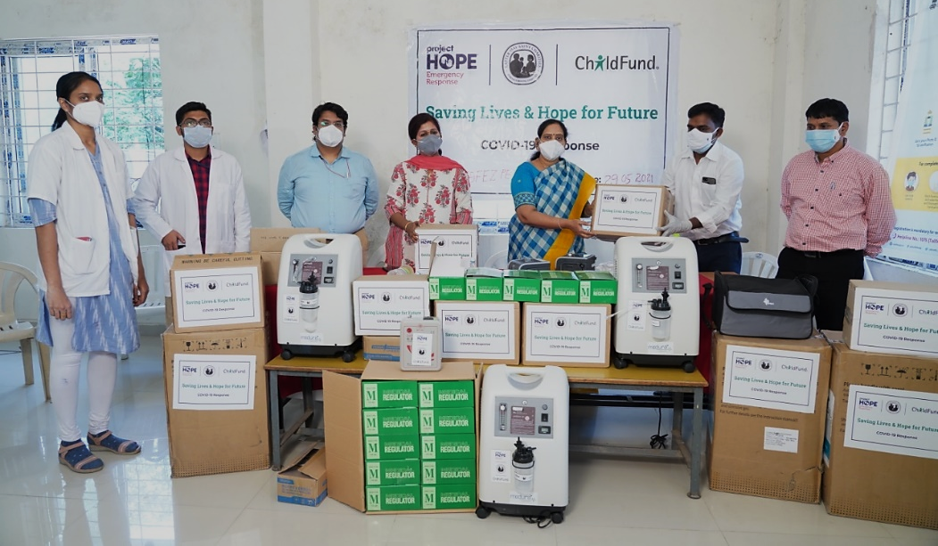

Medical staff is monitoring the oxygen flow in an oxygen concentrator provided at Mumbai
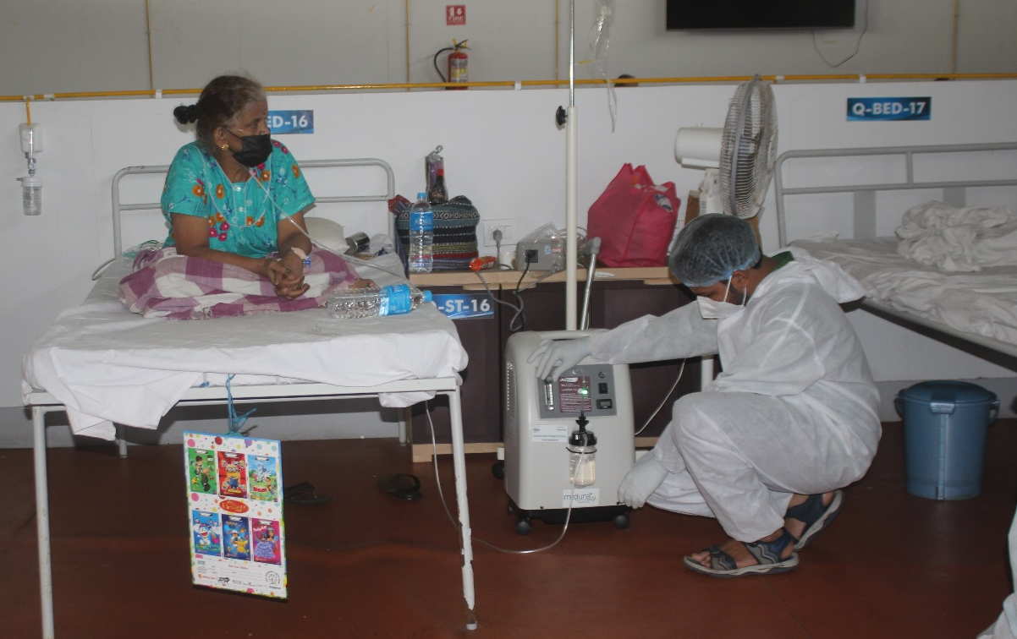

The Medical doctor in Dhar checking pulse oxymeter provided to their PHC
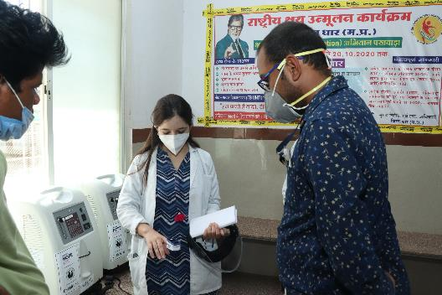

Below Sections for Internal Use Only
- Staffing and Security
  - Which staff are on the ground? Please include names, functions, contact information and arrival/departure dates for both IO and CO staff on the ground.
The field teams of both direct implementation sites and local implementing partners will implement the COVID19 response activities. These teams are based at the field level with direct access to affected communities.

  - Who is or will be leading/managing the response? (if applicable)
The Senior Specialist - DRM is the focal point for this response with the guidance of the Country Director and other SMT members.

  - Any gaps in staffing/need for deployment from other COs or Global Teams?
The CO is adequately resourced to manage the response activities.

  - Confirm the safety of staff and their families in the affected area.
    - Update on payroll staff:
      - From the date COVID19 pandemic started, as on date of this report, 23 staff have diagnosed positive for COVID19 and all the staff have recovered and resumed work.
      - During the reporting period no pay roll staff reported with COVID19 positive.

    - Update on Consultants/Non-staff engagements for DI programs:
The following states have reported cases among field teams who are on consultancy/non-staff category arrangement.
State | No of cases reported | Recovered & Deaths
Delhi – urban project | 0 | 0
Uttar Pradesh | 0 | 0
Maharashtra | 5 | 5
Rajasthan | 2 | 2
West Bengal | 0 | 0
Bihar | 0 | 0
Jharkhand | 1 | 1
Madhya Pradesh | 4 | 3 recovered and 1 passed away
Odisha | 2 | 2
Chhattisgarh | 0 | 0
Karnataka | 0 | 0
Andhra Pradesh | 1 | 1
Link Workers Scheme project – Telangana | 16 | 16
Link Workers Scheme project – Andhra Pradesh | 7 | 7
TOTAL | 38 | 38

- Update on LP staff:
Name of the LP | Grant / LP | Confirmed Cases | Recovered | Under Treatment / Home Isolation
KRWCS | LP | 1 | 1 | 0
NKJE | LP | 6 | 6 | 0
Asha Kendra | LP | 1 | 1 | 0
BEDROC | LP | 3 | 3 | 0
CREED | LP | 3 | 3 | 0
SHECS | LP | 3 | 3 | 0
CECOEDECON | LP | 1 | 1 | 0
PVC | LP | 3 | 3 | 0
CSOs under EU project in Uttar Pradesh | Grant CSOs | 7 | 7 | 0
TOTAL |  | 28 | 28 | 0

  - Safety and security risks/mitigation plans
The safety and security in our program locations is stable and not reported any incident that may have safety risk for our teams at field level. The SMT is finalising Return to Office guidelines with inputs from RO/IO. The offices will be opened gradually as per state directives and Return of Office guidelines.

  - Recommendations around any upcoming travel planned for staff or donors
No work-related travel taking place and it is not recommended till further notice. Currently, majority of the staff are working from home.

  - Are there any other major HR issues?
Nothing specific to report as of now.

- Sponsorship and Grants
  - Will this impact sponsorship activities like correspondence and DFCs?
The sponsorship communications majorly affected for the past one month due to the increase in the COVID19 cases as well as movement restrictions imposed by the local government authorities. DFCs for the month of April and May will be initiated during 2nd & 3rd week of June 2021.

  - Total number of sponsored children in the affected area, by project number.
Partner Organization (Use Salesforce community identifying code/name.) | # of Enrolled and Sponsored Children |  | COVID19 Cases Reported in ChildFund Communities (Y / N / Unknown) Provide number if available. | Number of Enrolled Children Reported with COVID19 (If available.) | Number of enrolled children deceased as result of COVID19
 | Sponsored | Enrolled
1219 / Jaipur Child Development Program | 565 | 566 | Yes (157) | 0 | 0
1222 / Manav Sewa Kendra | 367 | 370 | Yes (81) | 0 | 0
1224 / Pratapgarh Child Development Program | 212 | 214 | Yes (2) | 0 | 0
2880 / Sultanpur Child Development Program | 679 | 1413 | Yes (83) | 0 | 0
2883 / Chitrakoot Child Development Program | 1596 | 1741 | Yes (35) | 0 | 0
4068 / Disha Children's Program | 1894 | 1942 | Yes (64) | 0 | 0
4117 / Kaushambi Child Development Program | 583 | 584 | Yes (0) | 0 | 0
4120 / Gogunda Child Development Program | 1714 | 2107 | Yes (49) | Yes (1) cured | 0
4268 / Jhabua Area II | 1314 | 1553 | Yes (3) | 0 | 0
4269 / Jhabua Area I | 782 | 797 | Yes (21) | 0 | 0
4270 / Udaipur Area I | 388 | 394 | No | 0 | 0
4271 / Udaipur Area II | 354 | 355 | Yes (6) | 0 | 0
4355 / Kotra Child Development Program | 271 | 612 | No | 0 | 0
4338 / Delhi Child Development Project | 553 | 917 | Yes (8) | 1 | 0
2420 / Dindigul Child Development Program | 325 | 327 | Yes (119) | 0 | 0
2424 / Kurnool Child Development Program | 268 | 269 | Yes (272) | 0 | 0
2850 / Anantapur Child Development Program | 1000 | 1729 | Yes (1563) | Yes (1) cured | 0
2852 / Kanyakumari Child Development Program | 347 | 351 | Yes (953) | 0 | 0
2854 / Gangavathy Child Development Program | 248 | 251 | Yes (46) | 0 | 0
2856 / Karwar Rural Women & Children Dev SOC | 693 | 702 | Yes (313) | Yes (1) cured | 0
2857 / N K J Educational and Charitable Society | 195 | 198 | Yes (4347) | Yes (1) cured | 0
3030 / Pune Child Development Program | 740 | 1397 | Yes (1619) | Yes (6) cured | 0
3147 / NILGIRIS ADIVASI WELFARE ASSOC | 202 | 204 | No | 0 | 0
3701 / Mysore Child Development Program | 1040 | 1158 | Yes (12089) | Yes (2) cured | 0
3702 / AMALAS KUTUMBA ABIVRUDDI YOJANE | 224 | 220 | Yes (113) | Yes (1) cured | 0
3704 / ASHA KENDRA | 275 | 275 | Yes (698) | Yes (1) cured | 0
3895 / BALAJI BALA VIKAS | 869 | 1073 | Yes (331) | Yes (7) | 0
4080 / Child Development Project - Kakinada | 671 | 1099 | Yes (798) | Yes (8) | 0
4082 / Salur Child Development Program | 257 | 259 | Yes (71) | Yes (1) cured
4125 / Nagapattinam Child Development Program | 913 | 1299 | Yes (200) | Yes (1) cured | 0
4290 / Raichur Child Development Program | 913 | 987 | Yes (181) | Yes (6) cured | 0
4305 / Mumbai Child Development Project | 945 | 1348 | Yes (5116) | Yes (4) Cured
4306 / Hyderabad Child Development Project | 766 | 871 | Yes (2605) | Yes (4) | 0
4322 / Vijayawada Child Development Project | 802 | 1068 | Yes (5658) | Yes (5) Cured | 0
4347 / Chennai Child Development Program | 244 | 251 | Yes (93) | Yes (1) Cured | 0
9402 / CAPUCHIN KRISHIK SEVA KENDRA | 170 | 170 | Yes (1332) | Yes (1) Cured | 0
0617 / West Singhbhum Child Development Project | 912 | 1200 | Yes (2) | 0 | 0
1213 / PARIVAR VIKAS CHANDRASHEKHARNAGAR | 226 | 227 | Yes (12) | 0 | 0
1217 / Daltonganj Area-1 | 217 | 218 | Yes (3) | 0 | 0
2849 / Kendrapada Child Development Program | 1196 | 1771 | Yes (22) | 0 | 0
2879 / CENTRE FOR TOTAL DEVELOPMENT | 213 | 215 | Yes (45) | 0 | 0
2881 / Bastar Child Development Progarm | 1014 | 1032 | Yes (143) | 0 | 0
3900 / Rayagada Child Development Project | 213 | 214 | Yes (288) | 0 | 0
3993 / Jamui Child Development Program | 351 | 353 | Yes (9) | 0 | 0
4067 / Koraput Child Development Program | 608 | 1231 | Yes (548) | 0 | 0
4115 / Keonjhar Child Development program | 1328 | 1751 | Yes (159) | 0 | 0
4258 / Malkangiri Area Program | 888 | 904 | Yes (285) | 3 (2 cured) | 0
4267 / Daltonganj Child Development Project | 746 | 761 | Yes (88) | 0 | 0
4274 / Kalahandi Child Development Program | 904 | 1454 | Yes (160) | 0 | 0
4275 / Deoghar Child Development Program | 426 | 435 | Yes (5) | 0 | 0
4297 / Giridih Child Development Program | 252 | 254 | Yes (16) | 0 | 0
4298 / Jamtara Child Development Program | 225 | 227 | No | 0 | 0
4299 / Naupada Child Development Program | 390 | 394 | Yes (113) | 0 | 0
4352/ Bhubaneswar Child Development Program | 395 | 966 | Yes (25) | Yes (1) cured | 0
9502 / Balrampur Child Development Project | 320 | 322 | Yes (53) | 0 | 0
55 Locations | 34,203 | 43,000 | Yes (41,002) | 56 (36 Cured) | 0

  - Confirm status of sponsored children in the area, are all accounted for?
Total 41,002 COVID19 positive cases reported from our program communities. 56 enrolled / sponsored children diagnosed as COVID19 Positive, 36 have been cured and rest 20 are under treatment / quarantine. All other enrolled/sponsored children are safe and reached through phone and/or through community animators / mobilisers from the same communities.

  - List any active grants in the affected area – name of grant, donor, and primary implementer – ChildFund India is primary implementer in all the grant projects.

Grant Job Code | Grant Name | Donor
12-0450D | INDS-Enhancing CSOs-LA-Gender Equality-2019-EU. | European Union
 | PENCIL-Technicolor | Technicolor
NSP | ARYAKA | ARYAKA
1008F | Khilta Bachpan | ChildFund Special Project
99-0255 | WHEEL 2019 | HSBC
2-0331 | Link Workers Scheme (LWS) Project | APSACS
2-0343 | Link Workers Scheme (LWS) Project | TSACS
2-0328 | Targeted Intervention Project - Jagitiyal | TSACS
2-0330 | Targeted Intervention Project – Ramagundam | TPSACS
12-0437 | PEACE Protective, Enabling, Accountable and Child Friendly Environment | FORUM SYD
99-0259D | SPLASH 2019- Bangalore | Technicolor
24-087D | IND-PENCIL | HCL Foundation
12-0465D | Child-Friendly & Climate Ready Schools (CCS) | RADIOHJALPEN through ChildFund Sweden
99-0265D | COVID 19 affected- continuity of learning | United Way Mumbai
99-0263D | SNEH - Alirajpur | Acuity Partners
New Project | Promoting Hygiene and Sanitation practices among children of Urban slums | Reckitt Benckiser
25-067D and 25-068D | eSaksham III - Building Better Future for Youth through employment Hub (Hyderabad & Mumbai) | State Street / Give2Asia
99-0269D | Ensuring Sustainable livelihood for COVID 19 impacted families through women entrepreneurship | HSBC

  - Will grant execution be impacted by the emergency situation?
Yes, the pandemic has impacted the pace of the grants implementation.

- Donors
  - Provide information about potential sources of funding (including grant donors, subsidy, Emergency Action Fund, Alliance members, GIK, etc.) for these emergency response efforts using the chart below.
Donor | Program | Amount (USD) | Requested? (Y/N) | Confirmed? (Y/N)
Project HOPE | Medical equipments, PPE and Vaccination campaigns | $800,000 | Y | Y
Project HOPE | Medical equipments and Child friendly covid care facilities in urban slums | $500,000 | Y | N
ChildFund International | Medical equipments, PPE and Vaccination campaigns | $211,000 | Y | Y
ChildFund New Zealand | Hygiene kits & Dry Food Ration | $10,000 | Y | Y
Give India | Hygiene kits & Dry Food Ration | $13,000 | Y | Y
ChildFund Germany | Vaccination campaign | $100,000 | Y | N
ChildFund Korea | To support overall COVID19 response activities | Discussions in progress to agree on the activities and budget
NDTV Telethon | To support overall COVID19 response activities | This National Television Telethon planned on 13th June from 7 PM to 9 PM. The Telethon will raise funds to support our response activities on COVID19.

- Budget
  - Already shared above.

- Media/Communications
  - List of media who will be or have been contacted with press releases
ChildFund has been working with PR agencies to issue press releases/media briefs and engaged in several theme-based interventions.

  - List of emergency spokespeople, including name, location, contact information, and languages spoken
Ms. Neelam Makhijani, Country Director of ChildFund India in Hindi and English.

  - Plans for collecting photos/videos/stories, i.e. should an outside photographer be hired?
Collection of photographs through LPs and direct implementation locations is initiated through creation of folder in one drive. External photographers engaged for this purpose.

  - Key points for messaging and visibility, particularly any host government sensibilities that must be considered.
ChildFund is adapting and utilizing the existing IEC materials from government and our own repository.

- Support needed or requested from IO, GSS or Global Teams – whether onsite or remote. Will be intimated as and when the support is required.

- Communication Update on COVID19 response activities:
- Updated website with 2nd wave response and supported in updating the donation page.
- Explored partnership opportunities for visibility and Fundraising for our COVID Response with the likes of Radio Mirchi, The Better India and NDTV.
- ChildFund has partnered with NDTV to raise funds for our response through a 3 week campaign which includes a 2 hour long live telethon.
- Regular Social Media posts on our COVID response as well as on Child Protection during COVID and post on Myth busting.
- Developed and Circulated Newsletter with COVID response and other updates.
- Created a video on our COVID response.
- Ensured our and donor branding and collected some photos, footages and interviews from our 2nd response beneficiaries.
- A press release on ChildFund and Project HOPE’s response to COVID was disseminated, which received coverage in nearly 100 publications (Print and Digital) were garnered across national and regional publications:

- Print Media also received an overwhelming coverage response.
- Online media coverage:
- https://timesofindia.indiatimes.com/india/childfund-india-reaches-out-with-medical-supplies-and-vaccination-support-in-rural-areas/articleshow/82627974.cms
- https://www.edexlive.com/news/2021/may/14/childfund-india-to-provide-covid-19-aid-including-medical-supplies-and-vaccination-inrural-areas-20681.html
- http://bwwellbeingworld.businessworld.in/article/ChildFund-India-Reaching-10-M-In-Rural-India-With-Medical-Supplies-Vaccination-Support/13-05-2021-389604/
- https://csrbox.org/India_CSR_news_ChildFund-India-reaching-10-million-in-rural-India-with-medical-supplies-and-vaccination-support_1178
- https://indiacsr.in/childfund-india-reaching-10-million-in-rural-india-with-medical-supplies-and-vaccination-support/
- https://indiaeducationdiary.in/childfund-india-reaching-10-million-in-rural-india-with-medical-supplies-and-vaccination-support/

- IANS Flash (Wire):
*Please note that the IANS Flash is a multi-stakeholder story and while ChildFund India is not mentioned in the headline, details of the work being done by ChildFund India have been properly mentioned in the story.
- https://www.sify.com/news/medibuddy-hcl-to-support-indias-covid-mitigation-efforts-news-national-vfooOucbgbgff.html
- https://investmentguruindia.com/TopNews/MediBuddy-HCL-to-support-Indias-Covid-mitigation-efforts
- https://theasianindependent.co.uk/medibuddy-hcl-to-support-indias-covid-mitigation-efforts/
- https://english.telugustop.com/medibuddy-hcl-to-support-indias-covid-mitigation-efforts-national-healthmedicine-vaccine-hunt-business-latest-news/
- https://nirogstreet.com/blog/coronavirus-updates/medibuddy--hcl-to-support-indias-covid-mitigation-efforts
- https://www.canindia.com/medibuddy-hcl-to-support-indias-covid-mitigation-efforts/
- https://www.sarkaritel.com/medibuddy-hcl-to-support-indias-covid-mitigation-efforts/
- https://www.newkerala.com/news/2021/66482.htm
- http://www.smetimes.in/smetimes/news/industry/2021/May/14/medibuddy-hcl64008.html
- https://www.socialnews.xyz/2021/05/14/medibuddy-hcl-to-support-indias-covid-mitigation-efforts/
- https://www.theweekendleader.com/Headlines/60700/medibuddy-hcl-to-support-indias-covid-mitigation-efforts.html

- Electronic media coverage
- Bhartya News: https://youtu.be/xKEEmKa0vJE
- Rajdhani Tak: https://youtu.be/N2p7Dd0J338
- Dhar News: https://youtu.be/pr249fAEToU
- Pravah News: https://youtu.be/OOJFCzyfzjw
- Aapla Awaj News: https://youtu.be/0Oz3LPmFoTo
- https://youtu.be/fcBGV5-1zKc Rajdhani Tak.
- https://www.samachar20.in/2021/05/778.html Samachar News.
- https://youtu.be/-ks_Utn5wyg Dhamnod Samachar.
- https://news24x7india.com/?p=6213 news 24*7
- http://pnvoice.com/?p=18005 PN voice Smachar.
- https://youtu.be/SzT4dRY8agI Sanchar Samachar.
- https://www.dabangdesh.com/2021/05/child-child-fund-india-gave-equipment.html Dabangdesh News.
- https://www.sachchadost.in/archives/8678 Saccha Dost News.
- http://pnvoice.com/?p=18117 PN voice News.
- https://youtu.be/aPSdgkB7ak0 Bhartiya News.
- https://youtu.be/k-jENwPZ1LI Sanchar Samachar.

END OF DOCUMENT

