ChildFund International
Humanitarian Situation Report Template

Humanitarian Situation Report [23]
COVID-19 – [Guatemala]
[April 09, 2021]
[Rodrigo Bustos, Country Director, rbustos@childfund.org]
[April 09 , 2020]

FOR UPDATES, PLEASE HIGHLIGHT UPDATED SECTIONS IN RED

Part 1: The Overall Situation
COUNTRY
Total Number of COVID-19 Cases Reported | Number of Deaths | Number of Cases Recuperated
198,374* | 6,928 | 182,408
SOURCE: https://www.arcgis.com/apps/opsdashboard/index.html#/bda7594740fd40299423467b48e9ecf6
https://www.mspas.gob.gt/index.php/noticias/covid-19/casos
*Data until 04/08/2021
ChildFund-supported areas (Provide only if you have reliable data on this. You can report on a consolidated basis or by program state/region/province/etc. if you have this detail.)

Geographical area (country or state/region/province | Total Number of COVID19 Cases Reported | Number of Deaths | Number of Cases Recuperated
Sacatepéquez | 5 | N/A | N/A
Quetzaltenango | 1 | N/A | N/A
Patzún | 6 | N/A | N/A
Momostenango | 1 | N/A | N/A
SOURCE: National Ministry of Health or other reliable source
Note: As of Friday, April 10, the government is not providing information by municipality, only by region. It means that the total number of cases is presented by set of departments ranging from 3 to 5.
Therefore, a new table is presented with the grouping of departments where ChildFund Guatemala has a presence. However, some like the Guatemala department and ChildFund do not have a presence in it.

Geographical area (country or state/region/province | Total Number of COVID19 Cases Reported | Number of Deaths | Number of Cases Recuperated
Quetzaltenango, Totonicapán, Huehuetenango y San Marcos. | 1847 | N/A | N/A
Alta Verapaz, Baja Verapaz, Petén, Quiché y Sololá. | 850 | N/A | N/A
Guatemala, Chimaltenango y Sacatepéquez. | 18541 | N/A | N/A
SOURCE: National Ministry of Health or other reliable source: Jun 23 2020

The following table shows the cases reported by the Ministry of Health and that correspond to the departments where ChildFund is present.

Departments | Reported cases
Alta Verapaz | 4831
Baja Verapaz | 1846
Chimaltenango | 5157
Huehuetenango | 6393
Quetzaltenango | 13107
Quiché | 4021
San Marcos | 8056
Sololá | 2642
Totonicapán | 2627

Any relevant background information about areas affected.
There are three people infected with COVID-19 in Sacatepéquez (Departament), one in Cuilapa, Santa Rosa and 16 in Guatemala City. It is expected that the situation will deteriorate over the days with the surgeon of more confirmed cases, the high demand for services, the limitations of public transport and the possible saturation of the health system, at the same time that more drastic measures are issued. for the containment of the pandemic.

Host government posture: Have they declared a state of emergency and/or requested outside assistance? Which nationwide measures has the government taken, e.g., limitation on meetings, internal travel, school closures etc.

What travel restrictions has the government put in place for travelers entering the country?
State of Public Calamity (Government Decree 06-2020). 03/05/2020.
Meetings of more than 130 people across the country are prohibited. Massive events, meetings in churches, sports centers and the like are canceled.

Ratification of the State of Public Calamity (Legislative Decree 08-2020). 03/12/2020
The measures decreed with the State of Calamity continue. Any type of meetings are suspended. On March 15, the president announced measures aimed at restricting social interaction between people, the cancellation of educational classes at all levels, cancellation of religious events (processions and regular celebrations), public events and patron saint fairs, allowing only those who do not gather more than 100 people. That same afternoon, a communiqué from the National Coordinator for Disaster Reduction (CONRED) was circulated, requesting the Departmental Governors and Municipal Mayors to declare the Population Red Alert in their territories (departments and municipalities) in order to focus all their efforts and resources to contain the virus.
On March 16, at night, in a message to the nation, the president confirmed five new cases, indicating that they were already in containment at the Villa Nueva hospital, while announcing the closure of the country's borders where only Guatemalan nationals and accredited diplomatic corps will be allowed to enter, although they must comply with their quarantine or isolation process. The closure of shopping centers, bars and nightclubs was decreed, and ordered the suspension of the work of public and private sector employees. Only businesses and employees from the health sector, the food sector, the security sector, the energy sector, telecommunications and other crisis response sectors can work, as well as businesses and basic services. Freight transportation that mobilizes food, shops, pharmacies, private hospitals, fuel and restaurants with home delivery only. Home office is promoted.
Reform Government Decree 05-2020 (Government Decree 06-2020). 03/21/2020
The previous measures continue, and a curfew is decreed for the circulation of anyone from 4:00 p.m. to 04:00 a.m. From March 22 to 31. During this time, only emergency vehicles, police, motorists from pharmacies and fast food restaurants may circulate. All basic services related to supply may be open. The restriction will not apply to heavy transport that brings food into the city, those that transport fuel and those that take merchandise to the ports, these may circulate without time limits.

What responses has the government put into place to address the health crisis and/or the economic impact?
The president, Alejandro Giammattei, opened a temporary hospital to serve Covid-19 patients in Parque de La Industria facilities that was adapted as a hospital in Guatemala City with the capacity to serve 3,000 people. Likewise, the opening of two other temporary hospitals is expected: one in the city of Quetzaltenango and the other in the east of the country.
These temporary assistance centers will have intensive and between 250 and 300 beds. However, these measures do not contribute much to address cases in rural areas far from urban areas near hospitals. One of the big criticisms is that the country's hospital network still does not adequately equip doctors and nurses, nor are there any supplies to attend emergencies. The staff has also not been adequately trained.
The President presented to the Congress of the Republic, a plan to reactivate the country's economy in the face of the emergency caused by the spread of the coronavirus, which includes various support measures for companies, assistance to the population and tax exemption for donations. In addition, he asked for a budget expansion of Q7 billion to meet the emergency. The proposal includes a US $ 200 million loan with the World Bank to attend to the emergency. As well as a US $ 193 million loan with the Central American Bank for Economic Integration (BCIE, for Spanish) for the construction of hospitals.

Giammattei asked the Congress

1. A fiscal policy that increases investment.
2. Implementation of transfers for more than 160 thousand families. Currently under discussion.
3. Promote low-cost housing financing for Q100 million.
4. Provide resources to schools to renovate them with an investment of Q175 million.
5. Release of medicines, food and fuels.
6. Provide food to vulnerable communities.
7. Availability of a Q100 million fund for Small and medium business
8. Refund of tax credits for Q2.6 billion.
9. Reforms to the Banking law.
10. Reforms to the ISO law (tax).
11. Reforms to the Leasing law.
12. To Land for the construction of a building for Congress.
13. Exemption from taxes on loans to donations.

Government decree 9-2020.
The work of the government agencies, as well as in the private sector continue suspended until Sunday, April 12, 2020. Likewise, the curfew continues from 4:00 p.m. to 4:00 a.m. until April 12.
Emergency Law (Government Decree 12-2020) 03/25/2020
Ratification Government Decree 06-2020 (Government Decree 09-2020) 04/01/2020

The freedom of locomotion from one department to another was limited and closing of recreational areas until the period of 04/12/2020 specifically beaches, lakes and rivers until April 12.

The other restrictions remain in effect
- Legislative decree 10-2020
- Approval of negotiations of the loan agreement 8962-GT. 01/04/2020
- Legislative decree 12-2020
- Emergency law 01/04/2020
- Legislative Decree 13-2020
- Economic rescue law. 04/08/2020
- The other restrictions remain in effect: Curfew and mobilization restrictions, business operations and market hours and other services.
- One of the new provisions is that all people must wear a mask. If they do not comply with the measure, there are fines of US $ 900 up to US $ 19,500.
- The government will distribute three million masks.

22/04/2020

In compliance with the Function 13 of the National Plan for the Response to Food Management, the Secretariat of Food and Nutritional Security-SESAN-, being part of the System with REDR, continues with the Secretary of the Regional Government, the Secretary of the National Council.
On the other hand, for the National Response Plan, the SESAN has coordinated with the SECONRED, the Ministry of Agriculture, Livestock and Food-MAGA-, Ministry of Social Development-MIDES-, Ministry of National Defense, Civil National Police - PNC-and municipalities for the inter-government. Since the start of food assistance on April 5, more than 64 thousand boxes of food have been delivered, this until the night of April 15.

05/06/2020
The measures of schedules for mobilization continue the same.
The opening was expanded for small businesses or commercial points. There is a government plan to return to "normal" that will develop in phases. This plan will be socialized from May 6 when new provisions are issued

05/13/2020
The same restrictions and permission for mobilization and commercial opening are maintained.
One more restriction is reactivated, and it is the prohibition of movement between departments, unless authorized.

05/20/2020
On May 15, 16 and 17 there was a total restriction on mobilization. There were only sales of basic necessity products from 8:00 a.m. to 11:00 a.m. in neighborhood stores. On May 23 and 24 there will be a total restriction on mobilization. Only food delivery services, pharmacies and health services may operate.

05/27/2020
At a press conference, the President of Guatemala indicates that, if there are between 400 and 500 cases a day for three days in a row, he is analyzing the possibility of implementing a total curfew for 15 days.

Given this situation, there are demonstrations on social networks and a demonstration in cars is being called. Some experts indicate that these social reactions will be more common since the adverse effects at the economic level are severe and are seriously affecting the population

06/03/2020
In the week of June 01 to 07, restrictions continue similar to the previous week. With two differences:
1. The curfew is reduced from 18:00 to 05:00 hrs.
2. On the weekend there is no total curfew and there will be a daily curfew.

06/10/2020
The government presented a four-phase plan to return to the new normal.
Phase 0: Preparation for de-escalation
Phase I: Start of de-escalation
Phase II: Intermediate opening
Phase III: Opening to the new normal

Likewise, public transport tests were carried out in Guatemala City, which has generated the national debate. It was also announced that starting this week the number of tests to detect covid-19 will be increased to 5,000.

For phase I the partial opening of economic activities and work centers such as trade or counter services, restaurants and cafes, professional sports activities and tourist accommodation without the use of common areas will be allowed.

Then phase II or intermediate opening will follow, which will partially open economic activities and work centers, finally phase III will be implemented, in which economic activities will be fully opened, with security measures and social distancing. For all phases, compliance with the indicators of decline in periods of 14 days is required

06/16/2020

On June 15, 2020, the Extension, Addition and Reforms of the Presidential Provisions in the event of Public Calamity and Orders for Strict Compliance (hereinafter, "Presidential Provisions") that was in force until Monday 29, was published in the Official Gazette. June 2020 at 05:00 a.m. In the first place, it is established that the temporary restrictions established in the Presidential Provisions of May 14 and their reforms remain in force, until further pronouncement, integrating with the reforms indicated below:
- Temporary vehicle restriction: In the departments of Guatemala, Sacatepéquez, El Progreso and San Marcos, vehicles can circulate only certain number of days of the week may be driven according to the license plate. On Sunday, June 21 and 28, 2020, no private use car may circulate.
- Interdepartmental circulation restriction: Interdepartmental circulation, transit and locomotion is totally restricted to and from the departments of Guatemala, Sacatepéquez, El Progreso and San Marcos.
- Curfew applicable to the entire Republic: Between 6:00 p.m. and 5:00 a.m. the following day, residents must remain at their place of residence. On Sunday, June 21 and 28, 2020, the residence will be from 00:00 to 24:00 on those days.
- Complementary preventive health measures: Those places, premises, shops, entities and the like, that are operating due to being affected by the Presidential Provisions, must comply with: a) direct and face-to-face attention to the public must end at 4:00 p.m. , with the exception of health services; b) direct and face-to-face customer service must comply by complying with the social distance of 1.5 meters per person and through the use of divisions, partitions or protection screens; c) the capacity must meet the social distance of 1.5 meters per person; and, d) for the purposes of verification by the competent authorities, a sign must be placed at the entrance of each facility, clearly identifying the number of people who may be inside, respecting the social distance of 1.5 meters per person.
07/01/2020
- This Sunday, June 28, 2020, Alejandro Giammattei, President of the Republic, announced some restrictions for citizens
- During Monday 29, Wednesday 1 and Friday 3, only vehicles with license plates ending in odd numbers — 1, 3, 5, 7, 9 — will be allowed to take to the streets.
- Similarly, on Tuesday 30, Thursday 2, Saturday 4, only cars whose plates end in even numbers —0, 2, 4, 6, 8— can go out into the streets.
- On Sundays July 5 and 12, the movement of people and vehicles throughout the country is restricted, 24 hours a day until Monday at 5:00 a.m. m.
- Motorcycles can circulate regardless of their license plate number, as long as they respect the curfew restriction schedule.
- Vehicles or people that are related to essential services such as food and medicine, can circulate with the respective permits.

07/07/2020
The same restrictions as last week are being applied this week.

08/06/2020

As of July 27, the Government of Guatemala began the reopening of economic and social activities through an epidemiological traffic light, that is, the new alert board, will allow the economy to function in municipalities where there are few infections, without verse affected by what happens in others.

The new traffic light will be reviewed every 14 days and will be based on the number of confirmed cases of coronavirus and the number of tests carried out daily per thousand inhabitants, which will define the color of the alert and this will allow deciding what activities will be allowed.

The Red
It will represent the maximum alert (25 cases per c / 100,000 inhabitants). In those cases there will be no public transport and mobility will be limited and shopping centers will not be able to open.

The orange
It is high alert and it is equivalent to mobility of public transport in a limited way and opening of limited activities.

The yellow
It is moderate alert, with flexibility in a less limited way.
Right now, much of the country is on red and orange alert, although, according to the government, 241 municipalities are on yellow alert, which are the ones that will start with the least restrictions.

The green
It will represent the “new normal”.
Of the 340 municipalities in the 22 departments of the country, 158 are in the red, the highest level of contagion, and none reaches the green category, the level with the least contagion of the virus.
Public transport will begin to operate at 50% of its capacity with health protocols, while shopping centers will be able to open with an influx of parking lots of 40%. The restaurants will start operating with distancing measures.

Churches are authorized to perform some services, such as weddings, with fewer than 10 attendees, said Edwin Asturias, Presidential Commissioner for Combating Coronavirus. All these services can be offered even if the contagion level is in the red.

Some social sectors see a potential risk in this change in strategy and disagree, indicating that Giammattei's announcement is surprising: it confirms that the Government sees the projection of thousands of deceased as an acceptable human cost to normalize the economy. Not only that: he is willing to change current conditions for a system that increases the risk of transmission of the virus and potentially the cost in lives. The announcement confirms a change in narrative in which the priority of containment is sacrificed for greater openness despite the fact that the economy has continued to operate.

09/09/2020
After the presidential dispositions, through the use of an epidemiological traffic light, these have remained similar during the last days and for the next 15 days.

Free movement will continue from four in the morning to nine at night. In other words, from nine at night to four in the morning the next day, mobility will be restricted.

In addition, he recalled that there is no restriction of mobility per plate. Likewise, on Saturdays and Sundays there will not be a total curfew, but will always start at 9:00 p.m.

Public servants will continue to start work at seven in the morning and will conclude their activity at three in the afternoon. While for the private sector, the hours suggested by the Government are from nine in the morning to five in the afternoon.

Guatemala shows encouraging signs amid the covid-19 pandemic. There is a general downward trend in positive cases and deaths as a result of the disease.

The reduction observed throughout the country is influenced by the decline in the department of Guatemala, which concentrates the highest number of infections.

Also the numbers recorded by the department of Escuintla influence the decline observed throughout the country. Guatemala, Escuintla and Sacatepéquez are the departments with the most cases of covid-19.

10/09/2020
The Executive ended on September 29 the state of Calamity that had been in force since March in the face of the coronavirus pandemic, but stressed that greater economic and social openness must be together with good practices to avoid infections.

The Minister of Health said that in the next new stage it will continue to be the governing body for the promotion of actions that prevent the spread of coronavirus and patient care.

The Ministers of Education reported that the end of the school year is maintained in October for schools and November in public schools

In 2021 everything will depend on the semaphore of alerts, prepare for “hybrid” scenarios, in schools and at home. This includes guaranteeing alcohol gel, masks, and water on schools.

Without a State of Calamity, freedom of locomotion, domicile and commerce is recovered.

The main restrictions that remain without effect are the following:

- Curfew has no effect, that is, there is no restriction on locomotion.
- Without limitation of the sale of alcoholic beverages from 5:00 p.m. to 5:00 a.m. as it is today
- No restriction in the place of residence: confinement from 9:00 p.m. to 4:00 a.m.
- There are no sanitary cords
- Free vehicular movement

The authorities could insist with most sanitary measures such as:

- Using the mask
- Maintain limited capacity in public and private
- Sanitary cords where there is regrowth without limiting freedom of movement
- Insist on a specific schedule for the consumption and sale of liquors. Sale of alcoholic beverages from 6:00 a.m. to 9:00 p.m.

11/09/2020

The authorities could insist with most sanitary measures such as:

- Using the mask
- Maintain limited capacity in public and private
- Sanitary cords where there is regrowth without limiting freedom of movement
- Insist on a specific schedule for the consumption and sale of liquors. Sale of alcoholic beverages from 6:00 a.m. to 9:00 p.m.

The ETA Tropical Depression affected much of the country and there are currently more than 9,852 people housed in 100 shelters in six departments of the country. This situation will increase the risk of contagion and is likely to be reflected in the following Sit Rep

12/08/2020
As of December 6, the effects of tropical storms ETA and IOTA have left more than 1,781,090 people affected. 100 people are still missing, 279,670 people in unofficial shelters and 30,602 in official shelters. There is damage to more than 4,000 homes, 745 affected roads and 340 damaged schools; some of which continue to be used as shelters. It is projected that by the beginning of January 2021 these schools will not be repaired and the strategy to start semi-face-to-face classes will be affected.

The Presidential Commission for Attention to the Covid-19 Emergency (Coprecovid), together with the Ministry of Education and the Ministry of Health, presented the National Strategy for Safe Return to Classes in the face of Covid-19, in which measures of safety for students in the 2021 cycle.

According to preliminary studies by Coprecovid, the closure of schools during the quarantine by Covid-19, caused a psycho-emotional and developmental impact on childhood learning. He also recorded that performance in reading decreased by 20 to 50%, while in mathematics it has been from 30 to 60%.

To retake classes, the alert board for the municipalities will be used.

- If the municipality is on red alert, education will be at a distance or at home and the hybrid modality (face-to-face and distance) will also be allowed and a capacity of 4 square meters per person.

- If the alert is orange, the modality will be hybrid or dual with limited capacity of 4 square meters per person.

- If the alert is yellow, it will be hybrid or dual with capacity in the classrooms of 2.5 square meters per person.

- If the alert is green, there will be a full opening with teaching and face-to-face activities.

In each of the alerts there are restrictions and peculiarities for recess, physical education, cultural / civic activities and school meals.

01/11/2021

Guatemala is the first country in Central America to exceed more than 5,000 people killed by Covid-19.

A new closure of the country is one of the options that President Alejandro Giammattei will analyze this Monday, January 11, in a meeting with personnel from the Ministry of Health due to the rebound in coronavirus cases in the country.

The first doses of the coronavirus vaccine could arrive in Guatemala in February and the Health authorities are already designing a vaccination plan.

The Ministry of Health began to give details of the four phases of vaccination against the coronavirus that will be applied once the vaccines arrive in the country.

Phase 1: to maintain the integrity of those who make up the health system, three groups have been considered:

-Health workers who attend cases of Covid-19
-Health workers who are not on the front line
-Firefighters
-Funeral workers
-Students close to care practice

Phase 2: with the aim of reducing mortality and burden of severe disease, there will be:

-People aged 80 years or older
-People aged 70 to 79
-People 18 years of age or older with health problems such as hypertension, diabetes, kidney or cardiovascular diseases, as well as severe obesity, among others.
-Pregnant (but depending on the safety of the vaccine).

Phase 3: in order to reduce a socio-economic impact and protect the continuity of basic services will be:

-IGSS essential workers
-Workers of the Ministry of Health
-Teachers
-Cops
-Military

Phase 4: with the aim of reducing the burden of the disease are contemplated.

-People from 50 to 59 years old
-People aged 40 to 49
-People from 30 to 39 years old
-People from 18 to 29 years old
-Children (these according to safety data and efficacy of the tests).

02/10/2021
To date, there are 4,645 cases of girls and boys between the ages of 0 and 9 who were diagnosed with Covid.9743 of girls and boys from 10 to 19 years old. The percentage of girls and boys between 0 and 19 years of the total confirmed cases to date is equal to 8.73%. The same provisions continue for the country. The Minister said that: "The partial reopening of economic events in the country does not mean that the epidemic is over, we are at the middle peak, it is time for all of us to assume responsibility," said the Minister of Health. Likewise, he urged Guatemalans to avoid family gatherings to avoid contagion ”.

03/09/2021

There are currently 68 municipalities on red alert. 114 on orange alert and 108 on yellow alert. None in green.

Although the country has already started a vaccination campaign thanks to the donation of drugs from other nations, immunization has been inconsistent, due to the failure of the health personnel registration system.

Personnel from some hospitals reported that the day was interrupted due to the training of personnel to keep the registry of those vaccinated; however, the Government reported that the campaign was continuing.

A few weeks before Easter, President Alejandro Giammattei said that the country's beaches would probably be open during that period.

Lent will have a peculiar aspect this year, since all processional processions were suspended.

04/08/2021

Currently, the implementation of phase 1 for vaccination continues. This includes health workers, health volunteers such as “Comadronas”, health students, firefighters, paramedics, funeral home workers, elderly inmates in nursing homes, health services administrative workers.

The Ministry of Health has created National Coordination Committee for Vaccination against COVID-19, which has the purpose of coordinating and assembling the National Strategic Plan for Vaccination against COVID-19 for the protection of the population in Guatemala.

According to official data, to date 115,031 people have been vaccinated. the departments in which the most vaccines have been given are:
- Guatemala: 19 mil 150
- Quetzaltenango: 6 mil 012
- Huehuetenango: 5 mil 677
- San Marcos: 5mil 161
- Quiché: 4 mil 037
- Alta Verapaz: 2 mil 864
- Petén: 2 mil 563
- Escuintla: 2 mil 376
- Sacatepéquez: 2 mil 288
- Totonicapán: 2 mil 140
- Chiquimula: 2 mil 096
- Chimaltenango: 2 mil 093
- Jutiapa: 1 mil 611
- Sololá: 1 mil 573
- Retalhuleu: 1 mil 424
- Izabal: 1 mil 389
- Santa Rosa: 1 mil 360
- Suchitepéquez: 1 mil 295
- Zacapa: 1 mil 222
- Baja Verapaz: 1 mil 120
- Jalapa: 1 mil 108
- El Progreso: 670
Note: In green the departments where ChildFund has a presence

Part 2: The Situation in Areas Where ChildFund Works

Part 2: The Situation in Areas Where ChildFund Works
Sponsorship columnas 1, 2 y 3
Partner Organization (Use Salesforce identifying code/name.) | # of Enrolled and Sponsored Children |  | COVID19 Cases Reported in ChildFund Communities (Y/N/Unknown) Provide number if available. | Number of Enrolled Children Reported with COVID19 (If available.) | Number of enrolled children diseased as result of COVID19
 | Sponsored | Enrolled
3064 – 4351 Tierra Nueva- | 3438 | 3870 | N | 1 | 0
1702 Renacimiento | 3343 | 3916 | Y | 3 | 0
3052 ADP | 3638 | 4268 | Y | 1 | 0
2387 CDRO (new local partner) | 2942 | 3221 | N | 0 | 0
---------
The family identified during this week have received cash transfer and a hygiene kit and is being monitored constantly by the local partner.
Three cases reported before (1 from the Q’eqchi’-Achi area and two from the Central Highland area are now stable and well. All the cases cured were maintained under constant monitoring. For the new case a food and hygiene kit were delivered and there is constant communication with the family.
Departments | Cases identified by local partners | cases identified officially by the government
Q’eqchi’ area
Alta Verapaz | 3 | 35
Baja Verapaz | 107 | 103
Central Highlands
Chimaltenango | 32 | 181
Sacatepéquez | 0 | 130
Sololá | 0 | 94
Western Highlands
Huehuetenango | 1 | 61
Quetzaltenango | 100 | 103
San Marcos | 16 | 288
K’iche’ area
Totonicapán | 5 | 36
El Quiché | 0 | 42
Rest of departments | 0 | 4513
Grand Total | 264 | 5586
Note: the cases identified by LP are according to information gathered with contacts in the Ministry of Health and they are not official, they refer only to the communities where CF has intervention.

Departments | Cases identified by local partners | cases identified officially by the government (Ministry of Health, June 9)
Q’eqchi’ area
Alta Verapaz | 0 | 57
Baja Verapaz | 199 | 118
Central Highlands
Chimaltenango | 23 | 236
Sacatepéquez | 0 | 185
Sololá | 0 | 120
Western Highlands
Huehuetenango | 1 | 72
Quetzaltenango | 173 | 196
San Marcos | 30 | 443
K’iche’ area
Totonicapán | 3 | 42
El Quiché | 0 | 50
Rest of departments | 0 | 6347
Grand Total | 429 | 7866
Note: the cases identified by LP are according to information gathered with contacts in the Ministry of Health or local authorities and they are not official, they refer only to the communities where CF has intervention.

Departments | Cases identified by local partners | cases identified officially by the government (Ministry of Health, June 15)
Q’eqchi’ area
Alta Verapaz | 2 | 74
Baja Verapaz | 34 | 131
Central Highlands
Chimaltenango | 28 | 272
Sacatepéquez | 0 | 285
Sololá | 0 | 151
Western Highlands
Huehuetenango | 5 | 91
Quetzaltenango | 104 | 273
San Marcos | 30 | 527
K’iche’ area
Totonicapán | 0 | 54
El Quiché | 0 | 60
Rest of departments |  | 8354
Grand Total
Note: the cases identified by LP are according to information gathered with contacts in the Ministry of Health or local authorities and they are not official, they refer only to the communities where CF has intervention.

Departments | Cases identified by local partners (sum of cases identified in the communities attended by department) | cases identified officially by the government (Ministry of Health, June 23)
Q’eqchi’ area
Alta Verapaz | 18 | 112
Baja Verapaz | 37 | 151
Central Highlands
Chimaltenango | 54 | 313
Sacatepéquez |  | 524
Sololá | 37 | 187
Western Highlands
Huehuetenango | 21 | 115
Quetzaltenango | 4 | 488
San Marcos | 10 | 636
K’iche’ area
Totonicapán |  | 61
El Quiché |  | 67
Rest of departments |  | 11886
Grand Total
Note: the cases identified by LP are according to information gathered with contacts in the Ministry of Health or local authorities and they are not official, they refer only to the communities where CF has intervention.

Child deaths: List any sponsored child (with Partner organization and child ID from salesforce) diseased as a result of COVID19. (Note: These need to be reported immediately following the regular sponsorship protocols.)
Patrocinio columnas 5, 6 y 7
Partner Organization (Use Salesforce identifying code/name.) | What is the status of the program/sponsorship processes (operational/suspended)?
 | Program Implementation | CVS | M&E  Level 2 | Enrollment /Disaffiliation | Sponsorship Communication | DFC
3064 & 4351 Western Highlands (Tierra Nueva) | Educative materials designed to attend population from distance via telephone and social media. Presential activities are being held with biosafety protocol. | suspended | suspended | Going into normal operations with biosafety cautions | Delivering normal & CO based letters by digital & normal mail mean. Beginning to deliver Child Initiated letter to sponsors or children that have not written in the last 6 months. | Delivering DFC with CO based Thank You Letter response
1702- Central Highlands  (Renacimiento / Tzutujil) | Educative materials designed to attend population from distance via telephone and social media.  During the month of February, the implementation of year 3 of the program models continued. Weekly meetings have been held with all the local partners to define the possible actions to be implemented that do not involve contagion risks. The implementation of remote actions such as: telephone calls and video conferences, transmition of key messages through radio, smartphones, and loudspeakers. Presential activities are being held with biosafety protocol. | suspended | suspended | Going into normal operations with biosafety cautions | Delivering normal & CO based letters by digital & normal mail mean.  Beginning to deliver Child Initiated letter to sponsors or children that have not written in the last 6 months. | Delivering DFC with CO based Thank You Letter response
3052 & 4025 Queqchí Area/ Taiwán (ADP) | Educative materials designed to attend population from distance via telephone and social media.  During the month of February, the implementation of year 3 of the program models continued. Weekly meetings have been held with all the local partners to define the possible actions to be implemented that do not involve contagion risks. The implementation of remote actions such as: telephone calls and video conferences, transmition of key messages through radio, smartphones, and loudspeakers. Presential activities are being held with biosafety protocol. | suspended | suspended | Going into normal operations with biosafety cautions | Delivering normal & CO based letters by digital & normal mail mean.  Beginning to deliver Child Initiated letter to sponsors or children that have not written in the last 6 months. | Delivering DFC with CO based Thank You Letter response
2387- Kiche Area (CDRO) | The new local partner (CDRO) has begun with the knowledge of the areas and retaking the communication with the families and the local authorities.  During the month of February, the implementation of year 3 of the program models continued. Weekly meetings have been held with all the local partners to define the possible actions to be implemented that do not involve contagion risks. The implementation of remote actions such as: telephone calls and video conferences, transmition of key messages through radio, smartphones, and loudspeakers. Presential activities are being held with biosafety protocol. | suspended | suspended | Going into normal operations with biosafety cautions | Delivering normal & CO based letters by digital & normal mail mean.  Beginning to deliver Child Initiated letter to sponsors or children that have not written in the last 6 months. | Delivering DFC with CO based Thank You Letter response

Note: As a global measure, all sponsor visits have been suspended.

What issues are children in these areas facing (food shortages, safety concerns, schools closure, etc.)?
- School closure since March 31st.
- Some food shortages in specific items and on some hygiene supplies (bleach, alcohol).
- All meetings of any kind in the communities are prohibited.
- Due to the closure of some communities for their local authorities (all transit of people is prohibited) and the closure of local markets there is shortage in corn, beans and cooking fuel. The prices of some food have been rising due to the speculation in local markets.
- A monitoring system is being implemented to determine the specific necessities and shortages in each community.
- 240 communities were monitored by local partner staff and in general families report the following needs:
  - 90,4% identifies lack of food.
  - 64,8% reports lack of hygiene supplies.
  - Due to the dry season, 45,4% families are lacking water.
- There are cases of members of the communities that are returning from United States, Mexico and Canada and are not having the monitoring process by health authorities.

- On the 2nd weekly monitoring (April 7 to 12) by local partner staff, families report the following needs:
  - 88,3% identifies lack of food.
  - 69% reports lack of hygiene supplies.
  - 50,6% lack of medicine (for other diseases).
  - 45% of the families are experiencing lack of water due to dry season.

- On the 3rd weekly monitoring (April 13 to 20) made by local partner staff, families report the following needs:
- 86.4% identify lack of food.
- 71.8 % reports lack of hygiene supplies.
- 52.4 % lack of medicine for other diseases.
- 40% of families experience lack of tubing water.

As there are more cases of community contagion, communication with communities is reduced due to greater restrictions on exiting and entering them by their local authorities.
On 32.5% of the communities have local based mechanisms for child protection working.
On the weekly monitoring (May 4-10) made by local partner staff, families report the following needs:
- 80% identify lack of food
- 52% of families experience lack of tubing water
- 41% report lack of medicine for other diseases
- 80% reports lack of hygiene supplies.
On Thursday, May 14 the government announced an extended curfew from the 15th until 18th. This measure included the closed of local markets producing loss of products and the rise of prices on all the products in the main markets that caters to small markets.
On the weekly monitoring (May 19-25) made by local partner staff, families report the following needs:
- 49% identify lack of tubing water.
- 83% report lack of food.
- 58% report lack of medicine for other diseases
- 72% report lack of hygiene supplies
- 71% report lack of transportation means.

On the weekly monitoring (May 26-31) made by local partner staff, communities report the following needs:
- 50% identify lack of tubing water.
- 86% report lack of food.
- 61% report lack of medicine for other diseases
- 75% report lack of hygiene supplies
- 73% report lack of transportation means.

On the weekly monitoring (Jun 1-7) made by local partner staff, communities report the following needs:
- 49% of the communities identified lack of tubing water.
- 85% of the communities reported lack of food.
- 63% of the communities reported lack of medicine for other diseases
- 75% of the communities reported lack of hygiene supplies
- 75% of the communities reported lack of transportation means.
On the weekly monitoring (Jun 8-15) made by local partner staff, 196 communities were monitored, they report the following needs:
- 42% of the communities identified lack of tubing water.
- 82% of the communities reported lack of food.
- 58% of the communities reported lack of medicine for other diseases
- 77% of the communities reported lack of hygiene supplies
- 77% of the communities reported lack of transportation means.
On the weekly monitoring (June 16-21) made by local partner staff, 185 communities were monitored, they report the following needs:
- 47% of the communities identified lack of tubing water.
- 78% of the communities reported lack of food.
- 59% of the communities reported lack of medicine for other diseases
- 71% of the communities reported lack of hygiene supplies
- 73% of the communities reported lack of transportation means.
On the weekly monitoring (june 22-29) made by local partner staff, 145 communities were monitored, they report the following needs:
- 48% of the communities identified lack of tubing water.
- 83% of the communities reported lack of food.
- 61% of the communities reported lack of medicine for other diseases
- 71% of the communities reported lack of hygiene supplies
- 71% of the communities reported lack of transportation means.
The number of communities monitored decreased due to the end of fiscal year and some changes among the staff of local partners, and also the change of one of the local partners where the new one will began to monitor with a new team from second week of July.
During the month of July, local members reported a slight increase in product prices due to the restriction of mobility to the communities and the lack of transportation. Towards the end of July, a process of economic reopening began, with more flexible measures in terms of mobilization, however, it is predicted that there may be an increase in infections, which could lead to new closings from the central government, but also due to the own communities.
During July 123 villages making a total of 214 communities from 9 departamentos (sponsorship classification) were monitored with the following results:
- 41% of the communities registred restrictions to move ouside the community.
- 40.3% of the communities' report lack of tubing water.
- 71.8% of the communities' report lack of hygiene supplies.
- 66% of the communities' report food shortages.
- 50% of the communities' report lack of medicine for other common diseases
- 79% of the communities identified lack of transportation means.
During the month of August there are no significant changes in the conditions of availability of food or basic inputs in the markets.
During September, no variation to earlier periods was reported in the communities.
During October, no significant variation was reported in the communities.
During November CFI and its local partners, Tierra Nueva and ADP, conducted a rapid assessment of the situation of the families directly affected by tropical storms ETA and IOTA. These people remain in made-up shelters being administered by faith groups and private owners of facilities where families sought temporary refuge. These are NOT government-led shelters and therefore the situation inside is critical as people are lacking access to potable water, toilettes, and other utensils to shield themselves against rain, bugs, and cold weather. Shelters are crowded and it is extremely difficult to keep social distancing among members of different families. People do not have access to bleach, face masks, and soup and thus sheltered people are facing a real life-threatening environment as COVID-19 is still spreading in communities
Health: Most of displaced people are shielded in non-official shelters which are managed by good-hearted volunteers without much knowledge of protective measures to minimize risks of common infectious diseases, and COVID-19. Common infectious diseases associated to climate change are those vector-transmitted (dengue fever, chikunguya fever, zika fever, diarrhea, and leptospirosis). The presence of COVID-19 stretched out the health system beyond its capacity. Preventing the pandemic forced other health services to be shut down like vaccinations, sexual and reproductive health services, mental health services, and health care for people suffering chronic conditions like diabetes, hypertension and HIV. Guatemala is set at level 4, high risk of COVID-19 community spreading
Protection: Prolonged crowdedness prone people to fight for space, food, water, and some privacy. Children and women are most at-risk of facing violence anytime for as long as they are displaced.
Food security: Most of the inhabitants of the prioritized villages are smallholder farmers cropping staples like corn, and beans, and small livestock. Cash crops generating some earnings were achiote (spice), sweet potato, chili, , plantain, bananas, blackberries, yucca, tomato, coriander, squash, rice, and papaya which are sold in local markets. Floods wiped out their groves and thus farmers lost both livelihood and food for their families
Water, Sanitation & Hygiene: floods damaged water supply and sanitation facilities, making it difficult for survivors to have access to drinking water and risking contamination as sanitation facilities and sewage systems collapsed. On top of this, high levels of standing water spoors infectious diseases as water transport bacteria, parasites, and viruses.
Shelter: flash floods damaged houses and destroyed personal belongings. To offer some protection against cold and bugs, the action will distribute mosquito nets, blankets and mattresses for children not to be on the floor.
Temporary lodging: there are 25 homeless families that need immediate support to condition a new place to stay.
With the pertinent evaluations still in process, ChildFund, through these local partners, was able to identify 630 families to be helped by the emergency to address some of the needs in 5 municipalities of 2 departments.
Through a field visit from OP staff to various communities affected by the Eta-Iota storms in the Alta Verapaz department (Q’eqchi-Achi area), some needs were identified that could be addressed, depending on the resources: a) attention to psychosocial needs due to a prolonged situation of deficiencies linked to the effects of the storms in November; b) strengthen protection issues, work with children from the Child Friendly spaces approach; c) Strengthening livelihoods to support food security.

Child protection risks caused or exacerbated by crisis situation.

For this year the Secretariat of Food and Nutrition Security (SESAN) predicted risk for the period of seasonal hunger for 2.3 million people, 30% are rural households.
Scarce sources of income and little access to food will increase cases of malnutrition. Particularly in the municipalities of the dry corridor, which is where ChildFund, currentlyat this time, has no presence.

Likewise, another factor that increased with confinement is violence against girls and boys.

11/09/2020
The ETA Tropical Depression affected much of the country and there are currently more than 9,852 people housed in 100 shelters in six departments of the country. This situation will increase the risk of contagion and is likely to be reflected in the following Sit Rep.

There are 156 enrolled families who have been directly affected by this situation and direct response and support has been provided.

At the national level, 2,421,338 people are affected and 1,781 direct affected. 310,315 people were evacuated, 60 people dead and 100 people missing.

In the case of children in shelters, the risks increase due to the conditions of nutrition, health and protection. 297,705 persons are in non-official shelters and only 12,610 in official shelters, which leads to less control over sanitary, protection and needs analysis measures for families who cannot yet return to their homes.

In the Polochic basin in Alta Verapaz department and in Aguacatán, Huehuetenango there were flooding's resulting in evacuations and placement of families in municipal and community shelters. It should be noted that the lack of preparation resulted in the bio protection measures not being taken into consideration, which considerably increases the risk of COVID-19 infections.

01/12/2021
As of January 5, 2021, 38,702 people were at risk. 2,438,933 people affected and 1,797,230 people affected. A total of 2,856 people in official shelters and 76,283 people in unofficial shelters. 99 missing persons and 61 deceased persons.
As water levels in some communities have dropped and other community housing conditions have re-established, families have returned to their homes. A total of 115,416 people returned to their homes in risky and precarious situations and 54,862 people are reported even in unofficial shelters, in addition to 2,017 people in official shelters.

02/10/2021
As of February 09, 2021:
- 3,611 incidents were reported.
- 38,702 people are at risk
- 2,483,933 people affected.
- 1,383,130 families have crops damaged
- 597 people at official shelters
- 670 people in non-official shelters
- 447 schools damaged
- 414,100 damaged houses:
  - 8,964 houses at risk.
  - 4,331 houses with severe damage
  - 59,407 houses with moderate damage
  - 19,082 houses with slight damage

Part 3: ChildFund’s Response

3.a. Overall

Who is or will be leading/managing the response?
From the Country Office: Country Director, and the SMT

How is ChildFund linked with humanitarian coordination structures, i.e., in which clusters or working groups do we participate? The most recent/next meeting and who is representing ChildFund? Donor meetings we have attended, or missions that we are aware of related to the response?

3.b. Program Response
Please organize your program response report as per the 4 objectives included in our global response plan. You can add an additional category if you have response activities planned or executed that do not align with these objectives. For each objective use the questions below to guide your report.
- What kind of response activities or interventions have been executed? What support items are needed or have been collected/distributed?
- What is the current progress of implementation vs. the established response plan?
- Who are we partnering or collaborating with to provide our response?
- What kind of response activities are you still planning for the coming period?

What kind of response activities or interventions have been executed? What support items are needed or have been collected/distributed?
1. As ChildFund we follow the instructions of the Government of Guatemala, which has considered a quarantine of 15 days, considering lifting it on March 31, depending on the increase in cases, or contention of the same.
2. Members of CO and LP have been instructed to follow government instructions, and to safeguard the integrity of program participants and collaborators
The Government of Guatemala began the reopening of economic and social activities and implemented a monitoring tool (traffic lights) in the Country, which classify municipalities according to the number of active cases and thus each municipality determine the security measures that will be established in its territory. The direction in CO and LP is to maintain home office work and to limit the activities on the field only related to the emergency response.
3. The local partners have been instructed to maintain communication via telephone and other communication tools, with their collaborators and community leaders, to follow up with possible members of infected families, to aid or guidance. A work team was formed between Sponsorship and Programs to follow up, in direct communication with the coordinators of the local partners.
The FY20 AOP is being restructured. Local partners are targeting their proposals in three phases: a) in short term, humanitarian aid with the delivery of food, hygiene supplies, monitoring of children and communities and creation of communications products to reinforce the prevention but also the aiming of reinforcement of protection issues. b) in midterm the reorientation of the programmatic intervention, avoiding meetings and events with groups and designing a process to virtualize the programs using the resources available in the communities like radio, local tv channels, social networks and telephone. c) in a long term, actions to support the economic recovery with economic aid with cash transfers for some families, incentives for entrepreneurship and process to build food sovereignty. A full proposal is expected to be ready next week
An emergency plan is under elaboration along with local partners, based in a framework of results shared by the multicountry team, to aid the families during the emergency according to the results: a) Families have means for their subsistence during the emergency period, and b) Families apply prevention, protection and self-care measures during the emergency.
Based on the first objective, 12,873 families were identified to receive aid with cash transfer. they were classified in three groups according to level of need identified by local partners, based on criteria defined with them. The modality will be, through vouchers that families will be able to exchange with small local stores. This to avoid mobility outside the community and help boost local economies.
In addition, the communication and protection team has elaborated a strategy to elaborate IEC messages related to hygiene and prevention of COVID-19 and protection and prevention of violence, recreational activities with children and self-care.
We expect to have the emergency response plan early next week to shared widely.
The local partners presented to the country director a proposal for the attention of most families registered with cash transfers, which have already been approved and launched since Thursday of last week (April 9)
There is an emergency response plan with a projection of the funds required to respond to the emergency through cash transfers and a communication strategy focused on protection. There is an institutional communication strategy aligned with the results framework with specific activities and a budget.
Due to the severe effects of ETA and IOTA, a new institutional response plan has been created to address some of the most pressing needs for the identified families. This plan is in a process of review and adjustment. It mainly focuses on food aid for the emergency for 3 months, provision of cleaning supplies and COVID prevention, supplies to ensure shelter such as mats, sheets, blankets and mosquito nets, as well as aid for the recovery of crops with native seeds and support psychosocial by hiring 5 psychologists.
The disaggregated information on the identified families is summarized in the following table
Department | District | Village Name | CFI | Affiliate Name | # of Fam. | # adults | # children | #  girls | # boys
Alta Verapaz  [Maya Q’eqchi’] | La Tinta | La Tinta | Y | ADP | 32 | 61 | 134 | 68 | 66
Alta Verapaz  [Maya Q’eqchi’] | Panzós | Xucup Panla & Civich | Y | ADP | 45 | 86 | 188 | 96 | 92
Alta Verapaz  [Maya Q’eqchi] | Panzós | Sepur Zarco | N | ADP | 151 | 289 | 631 | 322 | 309
Alta Verapaz  [Maya Q’eqchi] | Santa Cruz Verapaz | Chitul, Chixajau, Acamal, Pambach | N | ADP | 124 | 65 | 519 | 265 | 254
Huehue-tenango  [Maya Mam] | Aguacatán | Xenaxicul | Y | Tierra Nueva | 153 | 292 | 640 | 327 | 314
Huehue-tenango  [Maya Mam] | Cuilco | Boqueroncito Alto,  Aldea Agua Dulce.  Caserío Flor del Café, Santa Rosa, Los Rosales | Y | Tierra Nueva | 126 | 240 | 527 | 269 | 258
 |  |  |  |  | 631 | 1032 | 2639 | 1347 | 1294

The actions taken based on the confirmed funds are as following:
Funding Source | Amount in  US$ | Local partner | Geographic location | Action Undertaken
Subsidy funds | 1,662.80 | ADP | Panzós & la Tinta, Alta Verapaz | Delivery of food bags for 43 registered families (delivered)
Asociación 13 aguas – local fundraising | 2850.00 | ADP | Panzós & La Tinta, Alta Verapaz | Delivery of bags of food for 75 families (delivered)
Subsidy funds | 6,000.00 | ADP | Panzós & La Tinta, Alta Verapaz | Support for 77 families from Alta Verapaz with mattresses, sheets and mosquito nets.
Subsidy funds | 25,000.00 | ADP | Santa Cruz and Panzós, Alta Verapaz | Support to families from Santa Cruz and Panzós: 124 families identified in Santa Cruz and 151 families from Sepur Zarco, Panzós identified as needs: mats, sheets, mosquito nets.
Subsidy funds | 1,634.00 | ADP | Panzós & La Tinta, Alta Verapaz | Support to 43 families for food security for 1 month (December)
Subsidy funds | 7,264.00 | Tierra Nueva | Xenaxicul, Aguacatán,  Huehuetenango | Support to 153 families with food bags for 1 month (delivered), support to rehabilitate community infrastructure (access road to the community.
Subsidy funds | 10,000.00 | Tierra Nueva | Aguacatán, Huehuetenango | Support to 153 families with food kits, NFI kits (hygiene, and COVID prevention) a community medicine kit. Support to 100 families with mattress, sheets. In Xenaxicul, Aguacatán.
 | US$54,410.80

01/12/2021
Following internal discussions and careful assessment of response capacity, the team is broadening the scope of this plan, to include all of the affected families in those priority municipalities in Alta Verapaz. This is on top of the initial assessment of 631 families for which relief aid is being distributed;
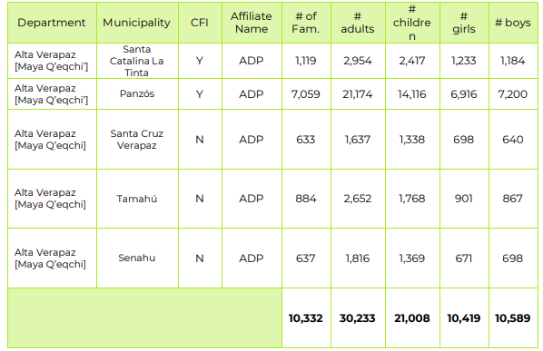
Initially the plan prioritized 631 families; however it is not possible to reach families in the municipality of Cuilco in Huehuetenango as the partner Tierra Nueva could not establish a working collaboration partnership with a peer organization. Therefore, the number of families being assisted dropped down to 505.
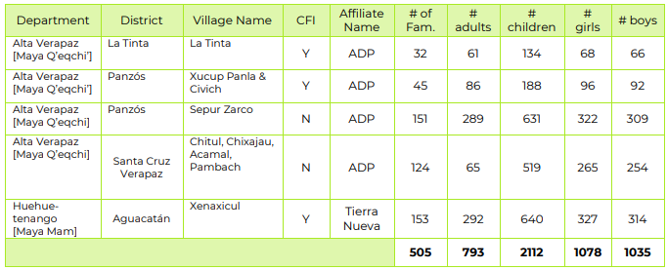
These families have received food baskets, health kits, WASH kits, and shelter kits as planned. Total investment made is as follows

What is the current progress of implementation vs. the established response plan?
1. We will be receiving, for every Monday of each week, updating of member reports,
2. And the Country humanitarian team- Health Cluster, Guillermo Leverman, Protection Officer, will be updating us when the meetings are held.

There are 2 response plans: the first to address the emergency due to the effects of COVID 19 and the second to address the emergency caused by the passage of storms Eta and Iota.
In the case of the COVID response plan, the funds are under development and the funds to cover the prioritized families with a second installment.
In the case of the response plan by ETA-IOTA, it is under development with the performance of diagnoses for psychosocial care, the delivery of shelter and hygiene kits and the necessary funds for its implementation are been seeked.
The response will focus on the communities where there is already programmatic intervention. However, due to the magnitude of the damage and the weakness of the state response, depending on the availability of funds, it is proposed to serve other communities within the area as implementing partners.

02/10/2021
During January
- Tierra Nueva supported the rehabilitation of a school in the community of Xenaxicul in Aguacatán, Huehuetenango. $1640 were invested to support 700 children which will attend to classes in safer conditions.
- ADP: 43 families from Cantihá, Xucup Panla and Chivich from the municipalities of Santa Catalina la Tinta and Panzós in the Polochic vasin of the department of Alta Verapaz, received a voucher exchangeable for food with local providers. $1,634 were invested to support 262 persons.
- ADP: 228 families received 2 matresses, 2 sheets and 2 mosquito nets. A total of $ 17,633 were invested and 1,367 persons in total were supported.

03/09/2021
During February:
From February 8 to 11, a field visit was carried out to monitor and evaluate the current situation of the affected areas of the municipalities of Panzos, Santa Catarina La Tinta, Santa Cruz Verapaz, San Cristóbal Verapaz and San Pedro Carchá, department of Alta Verapaz, due to the Effects of Tropical Storms Eta and Iota served by Childfund and ADP with humanitarian aid.
This visit was carried out jointly with the organization "All hands and hearts" and the possibility of a joint intervention was raised. Currently, there is a NSP to meet the needs of 454 of 3 communities in Ata Verapaz with the provision of hygiene kits and prevention of the contagion of COVID as well as filters to have safe water for family consumption. This fund will be executing since March.

Who are we partnering or collaborating with to provide our response?
The situation is under analysis evaluating the possible options.
ChildFund participates in two cluster of the Humanitarian Country Team: Health and Protection clusters. Next date of Health cluster meeting is on March 24th.
The participation on the Health Cluster meetings has overseen by Guillermo Leverman, OP protection specialist and Jairo Hernández, program officer.
There has been participation in the protection and health clusters, and in the Cash Working Group to explore ways of coordination. As soon as we have a clearer understanding of the resources available and how are we going to invest them, we will be able to participate in the inter-cluster response plan.
During the last health cluster meeting on March 31, the Ministry of Health recognized a “small crisis” due to the lack of personal protection kits for the health professionals and others attending the emergency. The main problem is the impossibility to find providers for the resources at a national level.
We continue participating in the Health cluster, protection cluster and Child protection subcluster to coordinate the possibility for alliances.
At a local level, the local partners have made coordination with local health authorities, municipalities and other NGOs for food kits and broadcast of radio messages.
Coordination have been made with United Way for the delivery of food kits. Currently 1188 kits have been delivered and a 1-to-1 delivery is in development. ChildFund will purchase one kit and United Way will donate one.
Isabel Gutiérrez de Bosch Foundation: A donation of Q15,420.00 (US $ 1,976.00) was made to support the implementation of the communications strategy of the humanitarian response in Guatemala, and another donation together with the Alliance for Nutrition for 250 boxes of food, with a value of Q250.00 each, which in total equals Q62,500.00 (US $ 8,012.00). The Isabel Gutiérrez de Bosch Foundation, together with PROSAME, supported the design of materials for radio theater focused on early childhood.
Lego Foundation: The request for financing was made for a total value of US $ 500,000.00 of which US $ 141,918.00 is destined to cash transfers to support 3,547 heads of household. The request was approved by and its implementation is from July to December 2020. This project is under development, radio theaters and storybooks are under design and the coordination for the implementation and monitoring is under process.
United Way: A donation of 1,188 boxes from the “Cajas de amor” (Love boxes) campaign was delivered the same number of families in late June. In July a donation of 250 additional boxes were donated by Isabel Gutierrez de Bosh foundation. And under the 1 x 1 donation system the delivery of was coordinated, making a total of 2,004 more boxes, half financed by United Way (1002) and the other half plus the costs of transportation and delivery was funded by ChildFund.
Response to Eta-Iota:
Participation and coordination in the health cluster, protection cluster, and child protection subcluster and the Humanitarian Team has been maintained.
A coordination has been created with the Isabel Gutiérrez de Bosh Foundation for the use in some shelters in Alta Verapaz of communication products (radio plays) created to promote the prevention of contagion, the development of activities related to child development and the importance of play and recreation. There is an interest of this foundation to finance the support of psychosocial care in shelters.
Next steps
1. Local partners and their staff inform and guide families, through leaders and guide mothers (local volunteers), about actions of protection.
2. Make continuous reports about families in the communities.
3. Follow-up of cases, if any.
4. We are determining with the local partners what could be our contribution to the situation, especially with the sponsorship resources.
5. We are analyzing the creation and/or socialization of communication products for the communities regarding the COVID-19 and the link to protection issues.
6. Definition of strategies in a mid and long term to implement the programs without putting on risk the health of collaborators of local partners and participants.
7. There is an ongoing negotiation with a major financial service provider through mobile transactions (Tigo money).
8. It will conclude with the first delivery of vouchers to prioritized families this week.
9. Sign agreements with Tigo money to support the families that have access to that service, continue with the vouchers and bags of supplies.
10. The local partners will continue with the delivery of vouchers, cash transfers and food kits. The local partners will be moving gradually to the cash transfer modality, specifically using Tigo money services.
11. During the 3rd week of June cash transfers will begin with Tigo money.
12. The process with Tigo money is taking longer than expected and we are diversifying the possibilities to deliver cash transfers through other financial providers. For this reason and because of the experience we have had with two local partners (Renacimiento and Tierra Nueva), all local partners have been asked to screen families lacking support (and who receive DFC) in the different priorities to determine the best form of delivery. That is, how many missing families (by priority) can the money be delivered through (and not conditioned by this order):
- Transfer of funds from account to account (at no cost) Banrural, another bank or other-
- Transfer of funds by national remittance (with a cost of GTQ5 approx) in Banrural, another bank or another
- Transfer of funds through cooperatives that are close to the service areas - according to research, each cooperative has its own ways of working, so it is necessary for you to address them on site.
- Families that cannot be served by these means will be using the transfer of funds by TIGO for when this system is ready.
- Families that will be delivered directly, but with the above options, it would be expected to be a minimum number.
For the October period, additional funds were available through a NSP (21EM06) with a value of US $ 25,000 to serve the prioritized families in the most vulnerable group and conclude the support to all prioritized families. With these funds, the local partners were able to serve the following number of families: Tierra Nueva 283, CDRO 57 and Renacimiento 292. In total, 632 families served through the NSP with vouchers and food bags.
During January, with the support from United Way and Target, 236 families (1,210 people) received a box with food and hygiene kits.

3.b.1. Stop COVID-19 from infecting children and families
ChildFund’s Global Response Plan
To help children and families protect themselves from COVID-19, we are installing community, handwashing stands; educating communities about symptoms, hygiene measures and where to get tested or treatment; and distributing soap, hand sanitizer, gloves and masks to families and frontline, health workers. For children who are being treated for COVID-19 or are subject to quarantine measures, we are creating child-friendly spaces with age-appropriate toys and reading matter.

An institutional communication plan has been defined and the design of materials related to the prevention of contagion and the self-care of families for the prevention of violence is in process.
Local partners have maintained telephone communication with families and created key messages that they carry during this emergency period.
In the delivery of vouchers redeemable for food, personal protection equipment was delivered to the families at the time of going to local businesses to make the exchange of the voucher.
248 families received hygiene supplies as part of bags of food and supplies delivered in their communities.
925 families received hygiene supplies during March and April.
25 different messages were provided to the families through phone calls, whatsapp, loudspeakers.
During May, 17,873 persons were reached with 35 messages related to prevent infections. These messages were provided to the families through phone calls, sms, whatsapp, loudspeakers and written materials.
During June, 21,332 persons were reached and 127 messages were designed and delivered by the local partners, and 1188 kits of hygiene supplies were delivered to the same amount of families.
During July
- 2,818 families received hygiene kits.
- 15 Community Protection Mechanisms, in the same number of communities, have developed Covid-19 prevention campaigns and guidelines for the care of cases of children violated in their rights, especially in issues of violence and health.
- 27 different messages were designed and delivered by local partners to 9,512 families.
During the month of August:
2709 families received hygiene kits.
227 communication products were addressed to 27,135 people on hygiene and contagion prevention with various remote modalities created by local partners themselves in local languages.
The project "playful parenting at home despite covid" began to be implemented with key messages about home parenting and all messages included issues of contagion prevention.
During September:
200 families received hygiene kits.
52 communication products were addressed to 30,176 persons on hygiene and contagion prevention with various remote modalities created by local partners in local languages.
In October, 55 communication products were delivered by different means to families and the importance of maintaining bioprotection measures in communities was reinforced through audio messages transmitted at mobile fairs. In most communities, the population, in general, does not take action assuming that there are no cases within the community. Reinforcing prevention messages was key during the month through mobile activities with little or no contact with the population.
During the mobile activities, 299 kits for the prevention of contagion such as masks, alcohol gel were delivered.
During November 40 different key messages were delivered to the families regarding covid prevention.
Eta-Iota response:
150 masks were delivered in an emergency way in three shelters in Alta Verapaz.
185 families received a hygiene kit for the prevention of contagion containing soap, bleach, and masks.

02/10/2021
236 families received a hygiene kit in Central Highlands.
123 personas received masks by ADP local partner, in the communities affected by ETA-IOTA .
210 face masks where delivered in the K’iche’ area (CDRO local partner) during the mobile community fair.

04/09/2021
Programmatic actions based on the models of programs with distance modalities have been resumed, in most cases. In some cases, when the context allows local members to maintain the protocol for the prevention of contagion by covid, face-to-face activities are carried out. In both cases, it is used to reinforce messages about the measures to be taken to prevent contagion, especially at a time when measures have generally been relaxed and in many rural areas the measures of use of masks and distancing are no longer being applied.

3.b.2. Ensure that children get food they need
ChildFund’s Global Response Plan
To ensure that the most vulnerable families can keep food on the table, pay rent and cover other basic needs, we are providing cash for those families most needing this support, such as those who have lost their income because of COVID-19, child or elder-headed households, and/or households affected by disability or chronic illness. Where possible, we are distributing food and basic household items directly, carefully abiding by COVID-19 protection measures
Local partners have delivered vouchers redeemable for food and hygiene supplies to prevent the spread of the virus. Voucher redemption has been done through small local providers so that families do not have to leave their communities to obtain them. Families have received some personal protective equipment such as face masks to use on visits to local stores. Currently, vouchers, worth US $ 38, have been delivered to 569 families, the equivalent of approximately 2,845 people.
Local partners have delivered vouchers redeemable for food and hygiene supplies to prevent the spread of the virus. Voucher redemption has been done through small local providers so that families do not have to leave their communities to obtain them. Families have received some personal protective equipment such as face masks to use on visits to local stores. In the communities where no local supplier was able to deliver the number of products, other suppliers were found and bags containing food and hygiene supplies equivalent to 38 US$ were delivered directly to the communities on strategic points with specific schedules to avoid concentrations. DFCs were delivered in cash when they were available and condtions were favorable, 300 families received DFCs in cash.
Currently, vouchers, worth US $ 38, have been delivered to 569 families, the equivalent of approximately 2,845 people. 375 families received bags with food and hygiene kits. 300 families received DFCs in cash.
L3.b.2.1. Cash Transfers and vouchers
-Is your CO planning or implementing cash transfers as part of COVID19 response?
- If so, brief description of progress to date.

The 12,873 families were identified to receive cash transfers. They are organized in three groups according their necessities based on criteria defined among Guatemala and Honduras country offices. The group #1 (the one with the most vulnerable conditions) consists of 5,522 families. The second group consists of 3,754 and the third group of 3,597 families.
With the sponsorship funds from March to June local partners will have the capacity to aid 3,255 families of the first group. Additional funds will be required to aid the rest of the 2,267 families of the first group and the other two groups. In total 9,618 families will require additional funds to be attended.

All LPs submitted the emergency plan response. We are checking consistency and availability of funds before the approval.

We expect to start the cash transfer early next week.

Food voucher delivery started on April 14 with a local partner and all local members are expected to complete all deliveries by April 24. It will serve 839 families with an average of 5 each average members for a sum of 4195 members, who are in the group with the greatest need, delivering vouchers that can be exchanged in small stores in their communities for products equivalent to $ 38.

Now, 569 families have been supported with an average of 5 members per family.

Now (April 29) 1244 families have been supported with an average of 5 members per family.

On May 5, 1,382 families have been supported. 375 families received kits with food. 512 received vouchers exchanged in small local stores, 495 received cash transfers.

Currently, local partners are preparing a 2nd delivery of vouchers, food kits and cash transfers.

Local partners will be supporting, by May 22: 325 families with food kits, 239 families with cash transfers delivered directly to the families or through banking transactions and 320 families with vouchers. 884 families in total.
Through a coordination with United Way, 790 boxes containing food and hygiene supplies with the value of Q200 or US$ 26.32 will be delivered during the present week.

A review of the families to be aid with cash transfer (in all the modalities) has given an updated amount of 12,386 families. It is expected to support 8,361 families by the end of June and 4,025 families will be attended in the beginning of next fiscal year.

The sign of agreements with Tigo money are in the final phase and accounts on the transferece system of cash through this financial service. On the month of June we will begin to use this system. Unfortunately, this will be a mechanism that won’t include all the families, due to conditions of access and proximity to places where they could use this mechanism.
On the coming months we will use three mechanisms:
Cash transfer (with a local financial system like Tigo Money or Banrural) depending on the access conditions in the communities to these services.
Direct delivery of cash or vouchers: If, in or nearby the community, there is no financial systems a very well-organized groups will be arranged to make a direct delivery of cash will be done. Or, in coordination with medium local suppliers, vouchers will be delivered to the families, taking all the measures to guarantee the accountability.
Food boxes delivery: This modality will be implemented only where no large or medium providers or financial system services will be available.
938 additional boxes containing food and hygiene supplies from United Way will be delivered this week

From June 1st to 9th, 1188 boxes containing food and hygiene supplies from United Way were delivered to the same amount of families in the department of Huehuetenango through one local partner.

From April to the date, 3407 families have been supported. 2023 with food kits, 925 hygiene supplies, 869 with vouchers and 547 received cash.

From June 1 to 9:
- 1188 families received boxes containing food and hygiene supplies.
- 46 vouchers were delivered.
- 369 families received cash transfers.

The total amount of families supported to the date (06/26/2020) is: 4357. Approximately 21,785 persons.

The total amount of families supported to the date (06/30/2020) is: 4482. Approximately 22,410 persons.

During June:
1188 families received boxes of food and hygiene supplies were delivered.
186 families received vouchers.
1086 families received cash transfers.

To the end of June, a total of 4679 families have been supported, approximately 23,415 persons.

During July 2,819 families received food and hygiene kits with an individual value of $33,
54 families received cash transfers, and 2 families received vouchers.
A total of 2875 families.
In the period of July, an alliance was made with the United Fund for the donation of “love boxes” with a value of US $ 32 with the modality of 1 to 1.
2,004 boxes were delivered in total, half financed by United Way and the other half, plus the cost of transportation and delivery to the communities was funded by ChildFund.
250 boxes containing food and hygiene supplies were delivered on the second week of July by one local partner. This was a donation from Isabel Gutiérrez de Bosh Foundation.
565 food and hygiene kits were delivered by one local partner with one local supplier with the individual value of $32.
Training for the use of Tigo Money was delivered to local partners and now they will begin with the use of this financial provider.
Tigo Money: The respective processes were started, on the part of the local partners, for the creation of virtual pockets to carry out cash transfers in the areas where there are families within the prioritized groups and which is feasible due to the existence of the service. Contracts and letters of intent were signed and during the month of July the staff of local members were trained in the use of the Tigo money platform, local members are preparing information on the population that will receive transfers using this method. in cash and will start with a pilot with one of them in August.

In August:

681 families received cash transfers. In this period began with the delivery of a small pilot with Tigo money and a larger one with a system bank in the form of national remittances.
860 families received vouchers redeemable for food.
4766 families received a food kit.

During september:

1413 families received food kits.
795 families received cash transfers. 442 of them were made by electronic bank deposits and 60 through Tigo money.

In the September period, the management of complementary funds for US $ 6,606.08 was registered through the management with the United Fund to support the delivery of 205 food kits and hygiene supplies.

With the support of the LEGO Foundation, through the “playful parenting at home despite covid” project, US $ 56,750 in vouchers and food bags were delivered in September to serve 1,435 families. This adds up to a total of 3103 families supported in the months of August and September with $ 120,821 delivered.

In total, in the September period, funds from other sources were used for a value of approximately US $ 64,281.

In October:
433 families received cash deliveries through bank transfers, Tigo money, and direct cash deliveries.
210 families received vouchers.
822 families received food baskets
With an NSP, US$ 25,000 additional were delivered in form of baskets and vouchers to these families.

In November:

381 families received food baskets. 185 of them received a food of basket and hygiene kit due to the Iota and Eta storms. 100 families received food in shelters for one day, approximately $3.8 per person.
1249 families received cash transfers

01/12/2021
124 families from 4 communities of Santa Cruz Verapaz were supported with the following humanitarian aid: 2 mattresses, 2 blankets, 2 mosquito nets. This Kit has a cost of Q 600.00 for a total of Q 74,400.00 ($ 9590.10).
In December, 178 families received a food kit, a contagion prevention kit and a shelter kit in Aguacatán, Huehuetenango as part of the ETA-IOTA service provided by the local partner Tierra Nuevaf.
37 families received a COVID prevention and protection kit in Panzós by the local partner ADP.
360 families received masks in the department of Sacatepéquez through a community DF.
100 children received masks as part of psychosocial care in Chitul, Santa Cruz Verapaz.

04/09/2021

37 families received vouchers exchangeable for food by 1 local member who has identified cases of lack of resources for food consumption.

The project aimed at strengthening livelihoods has begun, the participation of 360 families from communities affected by the crisis generated by COVID and by the passage of storms is projected. 3 local partners are in the process of hiring specialized personnel to serve these families and the purchase of supplies to start the implementation of comprehensive food and seed production systems in April.

Cash transfers executed
Beneficiaries |  |  | Amount transferred (US$) | Transfer mechanism (i.e. mobile money, banking system other financial service provider etc,
Total | Gender (if available)
 | Female | Male
2845 |  |  | 21,622 | Vouchers para la entrega de alimentos e insumos de limpieza con pequeños proveedores locales
6220 |  |  | 47,272 | 569 families received vouchers exchangeable for food and hygiene supplies in small local stores.  317 families received bags with food and hygiene supplies.  300 families received cash from DFCs.
6,910 |  |  | 54,552 | 375 families received food kits  512 families received vouchers  300 families received support in cash
4420 |  |  | 24,752 | 239 will receive cash during this week  320 will receive vouchers (178 already have)  325 will receive food kits during this week.
7920 |  |  | 45,545 | 239 will receive cash during this week  320 will receive vouchers  325 will receive food kits during this week.  790 families will receive a box of food and hygiene supplies with a value of $26.32 from United Way
16,723 |  |  | 115,590.16 | 1188 families received a box containing food and hygiene supplies.
19,110 |  |  | 126,512
21,785 |  |  | 151,690 | ChildFund funds (aprox US$38 per family)  1430 families have received cash transfers.  936 families have received food vouchers  835 families have received food kits  United Way funds (aprox US$ 26.32 per family)  1188 families
22,410 |  |  | 156,440 | ChildFund funds (aprox US$38 per family)  1555 families have received cash transfers.  936 families have received food vouchers  835 families have received food kits  United Way funds (aprox US$ 32 per family)  1188 families
23,415 | 12412 | 11004 | $234,419.25 | The amount transferred where updated with the information related to dfs delivered (in some cases higher than the $38 defined as a standard) and the financial support of other institutions and local donors.  Prior to this, the report of the amount trasnsfered was calculated on base of the amount of $38 for each family.
39132 | 20441 | 18692 | $ 329,417.51 | From April to July:  4006 families received a box of food and hygene kits, with the aproximate value of US$ 33 (including transportation cost) in coordination with United Way  836 families received a bag of food with a value of US$ 38  4931 families received a hygiene kit.  1028 families received a voucher exchangable for food and other esential supplies.  1718 families received cash transfers.

August
Beneficiaries |  |  |  | Transfer Amount (US$) | Transfer Amount (Qtz.) | Transfer mechanism
Total families | Total Persons | Gender
 |  | Female | Male
4766 | 25302 | 14218 | 11083 | $ 134,507.13 | 1,040,369.85 GTQ | In kind
681 | 4508 | 2559 | 1950 | $ 35,488.70 | 222,155.26 GTQ | Cash transfer
860 | 3435 | 2061 | 1374 | $ 26,731.00 | 257,654.44 GTQ | vouchers

Accumulative April – August 2020:
Beneficiaries |  |  |  | Transfer Amount (US$) | Transfer mechanisms
Total families  s | Total persons | gender
 |  | Female | Male
9616 | 51190 | 27806 | 23383 | 314496 | En especie
2359 | 13126 | 7153 | 5975 | 122908 | En efectivo
1886 | 8059 | 4317 | 3741 | 81740 | Vales

SEPTIEMBRE
 | Beneficiarios |  |  |  | Monto de Transferencia (US$) | Monto de Transferencia (Qtz.) | Mecanismo de transferencia (Transferencia de efectivo vale y en especie) | %
 | Total Familias | Total Personas | Sexo
 |  |  | Femenino | Masculino
5 socias locales | 1413 | 7570 | 3870 | 3700 | $ 54,578.68 | 423,309.76 GTQ | En especie | 53
 | 795 | 3623 | 1958 | 1665 | $ 15,156.25 | 231,549.87 GTQ | En efectivo | 29
 | 476 | 2380 | 1326 | 1054 | $ 18,379.58 | 142,800.00 GTQ | Vales | 18

Accumulative April – September 2020

 | Beneficiaries |  |  |  | Monto de Transferencia (US$) | Monto de Transferencia (Qtz.) | Mecanismo de transferencia (Transferencia de efectivo vale y en especie) | %
 | Total Familias | Total Personas | Sexo
 |  |  | Femenino | Masculino
5 socias locales | 11029 | 58760 | 31677 | 27082 | $ 369,075.06 | 2,904,436.63 GTQ | En especie | 60
 | 3154 | 16749 | 9111 | 7640 | $ 138,063.95 | 1,123,364.34 GTQ | En efectivo | 23
 | 2362 | 10439 | 5643 | 4796 | $ 100,119.97 | 811,533.15 GTQ | Vales | 17

October
 | Beneficiaries |  |  |  | Transfer amount (US$) | Transfer amount GTQ | Transfer mechanism | % | average
 | Total families | Total persons | Gender
 |  |  | Femenine | Masculine
todas las socias locales | 822 | 4953 | 2730 | 2211 | 31490 | 243,890.55 GTQ | En especie | 54 | 38
 | 443 | 2425 | 1382 | 1033 | 18529 | 142,832.83 GTQ | En efectivo | 32 | 42
 | 210 | 1050 | 630 | 420 | 8404 | 65,300.00 GTQ | Vales | 14 | 40

Accumulative April-October

 | Beneficiaries |  |  |  | Transfer amount (US$) | Transfer amount GTQ | Transfer mechanism | % | average
 | Total families | Total persons | Gender
 |  |  | Femenine | Masculine
4 socias locales | 11851 | 63713 | 34406 | 29294 | $ 400,564.88 | 3,148,327.18 GTQ | En especie | 3,148,327.18 GTQ | 60
 | 3489 | 19174 | 10493 | 8673 | $ 169,508.88 | 1,230,582.85 GTQ | En efectivo | 1,230,582.85 GTQ | 23
 | 2572 | 11489 | 6273 | 5216 | $ 108,524.09 | 876,833.15 GTQ | Vales | 876,833.15 GTQ | 17

November
 | Beneficiaries |  |  |  | Transfer amount (US$) | Transfer amount (Qtz.) | Transfer mechanism | % | Average november
 | Total Famili | Total Personas | Sexo
 |  |  | Femenino | Masculino
todas las socias locales | 381 | 2058 | 1191 | 867 | $ 11,302.46 | 87,752.25 GTQ | En especie | 14 | 30
 | 1249 | 6545 | 3605 | 2711 | $ 61,651.83 | 477,775.55 GTQ | En efectivo | 79 | 49
 | 130 | 722 | 394 | 328 | $ 5,156.51 | 40,200.00 GTQ | Vales | 7 | 40

Accumulative from April to November
SOCIA LOCAL | Beneficiarios |  |  |  | Monto de Transferencia (US$) | Monto de Transferencia (Qtz.) | Mecanismo de transferencia | %
 | Total Familias | Total Personas | Sexo
 |  |  | Femenino | Masculino
4 socias locales | 12232 | 65771 | 35597 | 30161 | $ 411,867.34 | 3,236,079.43 GTQ | En especie | 55
 | 4738 | 25719 | 14098 | 11384 | $ 231,160.71 | 1,708,358.40 GTQ | En efectivo | 29
 | 2702 | 12211 | 6667 | 5544 | $ 113,680.60 | 917,033.15 GTQ | Vales | 16

December

 | Beneficiaries |  |  |  | Transfer amount (US$) | Transfer amount GTQ | Transfer mechanism | % | average
 | Total families | Total persons | Gender
 |  |  | Female | Male
All local partners | 1905 | 10412 | 5160 | 5252 | $ 84,100.24 | 652,515.05 GTQ | In kind | 48 | 40
 | 970 | 5450 | 3036 | 2414 | $ 48,495.86 | 376,579.34 GTQ | Cash | 33 | 50
 | 561 | 4292 | 2352 | 1940 | $ 28,692.43 | 222,697.23 GTQ | Voucher | 19 | 51

Accumulative April to December
 | Beneficiaries |  |  |  | Transfer amount (US$) | Transfer amount GTQ | Transfer mechanism | %
 | Total families | Total persons | Gender
 |  |  | Female | Male
All local partners | 14137 | 76183 | 40758 | 35412 | 495968 | 3888594 | En especie | 55
 | 5708 | 31169 | 17134 | 13798 | 279657 | 2084938 | En efectivo | 29
 | 3263 | 16503 | 9019 | 7484 | 142373 | 1139730 | Vales | 16
TOTAL | 23108 | 123855 | 66911 | 56694 | 917997 | 7113263 | 0 | 100
Renacimiento | 2454 | 14232 | 7210 | 7010 | 105557 | 814619 | En especie | 50.87
 | 1935 | 11217 | 3877 | 3612 | 101951 | 786884 | transferencia en efectivo | 49.13
 | 0 | 0 | 0 | 0 | 0 | 0 | vales | 0.00
Tierra Nueva | 2782 | 13910 | 7330 | 5689 | 94943 | 731561 | En especie | 45.38
 | 1690 | 8011 | 4491 | 3285 | 80098 | 616860 | Transferencia en Efectivo | 38.26
 | 467 | 1829 | 949 | 880 | 34464 | 263828 | vales | 16.36
ADP | 2245 | 11225 | 6289 | 4316 | 44274 | 397153 | En especie | 30.96
 | 953 | 4765 | 2215 | 1540 | 45341 | 329717 | transferencia en efectivo | 25.70
 | 1902 | 9510 | 5010 | 3985 | 73313 | 555951 | Voucher | 43.34
PIES / CDRO | 2405 | 14841 | 8029 | 6812 | 83381 | 643481 | en especie | 54.33
 | 1130 | 6311 | 3074 | 2523 | 45621 | 351478 | transferencia en efectivo | 29.67
 | 458 | 3777 | 0 | 0 | 24426 | 189497 | vales | 16.00
CDRO - LEGO | 2356 | 12641 | 4172 | 3981 | 90720 | 703808 | en especie | 100.00
 | 0 | 0 | 0 | 0 | 0 |  | vales | 0.00
ADP - LEGO | 0 | 0 | 0 | 0 | 0 | 0 | en especie | 0.00
 | 436 | 2252 | 1149 | 1103 | 16815 | 130454 | vales | 100.00
ACODIHUE-LEGO | 1429 | 7145 | 1948 | 1872 | 59058 | 458172 | en especie | 100.00
 | 0 | 0 | 0 | 0 | 0 | 0 | vale | 0.00
Renacimiento - LEGO | 466 | 2189 | 1120 | 937 | 18035 | 139800 | en especie | 100.00
 | 0 | 0 | 0 | 0 | 0 | 0 | vale | 0.00

The "Playful Parenting Despite COVID" project has benefited a total of 4,687 families through vouchers and food bags, with a total of $ 184,628 invested.

JANUARY
 | Beneficiarios |  |  |  | Amount $ | Amount GTQ | Transfer mechanism
 | Total Familias | Total Personas | Gender
 |  |  | Female | Male
COVID RESPONSE | 248 | 1338 | 716 | 622 | $ 7,971.43 | 62,005.76 GTQ | En especie
 | 1482 | 8197 | 4586 | 3611 | $ 72,540.58 | 564,112.97 GTQ | En efectivo
 | 174 | 870 | 522 | 348 | $ 6,718.47 | 52,200.00 GTQ | Vales
ETA-IOTA RESPONSE | 394 | 2248 | 1202 | 1046 | $ 19,523.81 | 151,700.00 GTQ | food kits, shelter kits, hygiene kits
TOTAL | 2298 | 12653 | 7026 | 5627 | $ 106,754.29 | 830,018.73 GTQ

APRIL 2020 TO JANUARY 2021 ACCUMULATIVE COVID RESPONSE
Beneficiaries |  |  |  | Amount (US$) | Amount (Qtz.) | Transfer mechanism | % | promedio
Total families | Total Persons | gender
 |  | Female | Male
14920 | 79476 | 44840 | 29178 | 541535 | 4509322 | En especie | 55 | $ 36.30
7190 | 38501 | 21279 | 16985 | 273011 | 2649051 | En efectivo | 32 | $ 37.97
3887 | 20416 | 11093 | 18878 | 166628 | 1061476 | Vales | 13 | $ 42.87

ETA-IOTA RESPONSE JANUARY
LP | Description | Deptartment | Municipio | comunidad | families | Unit cost $ | Total cost $ | Direct beneficiaries
ADP | Food vouchers | Alta Verapaz | La Tinta | Cantihá | 29 | 38 | 1102 | 167
ADP | Shelter kits (matresses, sheets, mosquito nets) | Alta Verapaz | La Tinta | Cantihá | 32 | 77 | 2475 | 192
ADP | Food vouchers | Alta Verapaz | Panzós | Xucup | 11 | 38 | 418 | 77
ADP | Food vouchers | Alta Verapaz | Panzós | Chivich | 3 | 38 | 114 | 18
ADP | Shelter kits (matresses, sheets, mosquito nets) | Alta Verapaz | Panzós | El remolino | 45 | 77 | 3480 | 270
ADP | Shelter kits (matresses, sheets, mosquito nets) | Alta Verapaz | Panzós | Rancho la esperanza | 106 | 77 | 8198 | 636
ADP | Shelter kits (matresses, sheets, mosquito nets) | Alta Verapaz | Panzós | Xucup | 30 | 77 | 2320 | 180
ADP | Shelter kits (matresses, sheets, mosquito nets) | Alta Verapaz | Panzós | Chivich | 15 | 77 | 1160 | 89
Tierra Nueva | School rehabilitation | Huehuetenango | Aguacatán | Xenaxicul | 1 | 1639.60 | 1640 | 700

February
 | Beneficiaries |  |  |  | Amount (US$) | Amount (Qtz.) | Transfer mechanism | %
 | Total Families | Total Persons | Gender
 |  |  | Female | Male
All local partners(COVID) | 41 | 284 | 153 | 131 | 1003 | 7783 | Food kits from DFCs, as a sponsor request | 2
 | 802 | 5152 | 2820 | 2334 | 38279 | 296078 | Cash = DFCs | 94
 | 38 | 190 | 114 | 76 | 1481 | 11400 | Vouchers | 4
 | 881 | 5626 | 3087 | 2541 | $ 40,763.18 | 315,261.50 GTQ |  | 100

MARCH:
Beneficiaries |  |  |  | Amount (US$) | Amount (Qtz.) | Transfer mechanism | %
Total Families | Total Perso | Gender
 |  | Female | Male
37 | 185 | 111 | 74 | $1,439.54 | Q11,100.00 | Vouchers (COVID 19 ) | 100

3.b.2.2. Other responses in relation to objective 3.b.2.

3.b.3. Keep children safe from violence: physically and emotionally
ChildFund’s Global Response Plan
We are supporting community-based child protection systems that identify, respond to and refer cases of abuse, neglect, violence or exploitation. We are also providing virtual, online psychological first aid and counseling, and supporting temporary shelters for children who live on the street, providing hygiene supplies, food and other basics. We are also arranging safe and appropriate care for children who are separated from their caregivers due to treatment or prevention measures.
An institutional communication plan has been designed that has as one of its objectives to sensitize families about violence prevention, the importance of recreational activities and psychological self-care. A radio theater series focused on infants and children is currently in the production process.
The radio theater series is currently in the production process, the provider has been selected and hiring is in process.
Local partners have started to develop communication strategies to reach 18,000 families through phone calls, radio messages, and social media. Coordination with community-based protection mechanisms has enabled coordination to be entered into communities for the delivery of cash transfers, food kits, and hygiene supplies
14,541 persons were reached with the communication strategy implemented by local partners through phone calls and social media. As part of this communications information to denounce to national authorities in cases of abuse of violence detected in coordination with the community-based protection mechanisms and other local volunteers. 136 of these CBPM are active in the communities and in coordination with the local partner staff.
During April, 26 messages on childcare and violence prevention were sent to the families. 6 messages delivered on recreative activities and 11 messages about selfcare.
Radio theater episodes, focused on ECD, are now broadcasting at a national level with one of the most listened radios (Emisoras Unidas, https://emisorasunidas.com/radio-en-linea/). It is expected to reach 180,000 families in general and 12,000 families within our target population. They are being broadcast in 5 national languages.
During May, 69 messages on childcare and violence prevention were sent to the families. 5 messages delivered on recreative activities and 4 messages about selfcare.
The administrative process and the contents are designed to implement a strategy to send information to 10,000 families through an automatic sms and voice messages. This will begin with LS3 population and is set to start on June 13.
Coordination is under development to broadcast radio theater episodes in local radios, through 5 local partners.
The Jugando Contigo Team has met the LEGO Foundation project manager. The team is working in elaborating messages to be broadcasting by community radios in local languages. Other partners will also participate in this effort.
Local partners have begun to create learning materials, made by the staff to continue the program model implementation. 18 products (infographics, videos, audios and reading materials) were delivered to the families through phone calls, whatsapp and community loudspeakers.
Local partners have designed 156 different educative materials (songs, videos, infographics, reading materials) and 1 micro web site to continue with the program implementation of the year according to the contents defined in the program models for year 2. This will work as pilots to program implementation for alternative implementation in the new context of COVID19.
During May, 21 different communication products were used to continue delivering programmatic content based on the models. These materials were designed and delivered to the participants in our programs through the local partners’ staff.
The transmission of a radio theater episodes, focused on ECD, began through the ChildFund Guatemala Facebook channel.
Launch of the text message campaign for adolescents and young people, which has already started mass SMS sending for 6,100 adolescents and young people.
During June:
137 different key messages on Child protection and prevention of violence were delivered to the families.
50 different key messages on the importance of recreational activities for education.
40 key messages on self-care and emotional care were delivered.
All these messages are the sum of all the communication products designed and delivered by the local partners. The messages were designed or translated to the local languages according to each region.
At a national level 5,868 adolescents and youth received automatic SMS with 5 different messages regarding emotional self-care, prevention of violence and recreational activities.
Text messages are currently being sent in Spanish to 5,868 AJs and 9,253 parents.
Automatic calls with audio messages are expected for 7,057 AJ and 9,253 parents which will be sent in different languages: Mam, K'iche, Kaqchikel , Q'eqchi (mayan languages) and Spanish.
Socialization of the Project "Playful breeding at home in Guatemala, despite COVID-19" was made with all local partners. Efforts to coordinate the communication activities will be made to attend
A total of 21,224 person were attended through telephone calls and messages or communication products in July. In July 160 communication messages / products were sent: 73 on child protection and violence prevention; 16 on emotional self-care; 27 on hygiene and protection from contagion, 30 on recreational and educational activities; and 14 on other programmatic models.
As an effort from OP: 7,050 adolescents and young people received 10 text messages and 10 calls with information on violence prevention, where to go to report violence against children and advice for mental health. 9,250 fathers and mothers received 4 text messages and 4 voice messages with information for the protection of children during quarantine and the proper use of financial resources. 15 Community Protection Mechanisms, in the same number of communities, have developed Covid-19 prevention campaigns and guidelines for the care of cases of children violated in their rights, especially in issues of violence and health. 5 chapters of a radio theater linked to child protection and development were designed and reproduced in 5 languages: Spanish, Mam, K'iche ', Q'eqchi' and Kaqchiquel. 25 more chapters are in the process of being designed to be reproduced on national and local radio stations.
The design of 25 new episodes of radio theater and storybooks on 5 different languages on ECD is under development. The coordination with local partners to broadcast the episodes in local radios has been made. This is being coordinated by the project: “learning throug play in home despite of Covid-19" funded by Lego Foundation.
Mobile fairs and virtual fairs were held as part of the programmatic implementation. The mobile fairs were called "Caravan of protection and joy", they were carried out with extreme measures of bioprotection and little or no contact with the population, relying on the dissemination of the message through mobile sound units
The virtual fairs were carried out as a first trial to carry out massive activities remotely and were carried out by 2 local partners, mainly with the adolescent population and young people of the programs I love myself and PACTO.
22,500 people received key messages related to 4 main themes: a) prevention of contagion, b) protection, childcare and prevention of violence; c) recreational activities for education; d) emotional self-care.
During the October period, 10 episodes were broadcast in Spanish and translated into 4 Mayan languages on radios: Emisoras Unidas Tacaná (San Marcos) 98.3FM, Emisoras Unidas Imperial (Alta and Baja Verapaz) 91.1FM, Emisoras Unidas Patrolling Information (national) , Kebuena Occidente 95.1FM and Kebuena Quiché 103.5 FM
The download links of the radio drama spots that have been produced from 6 to 20 are shared in all languages (Spanish, Kaqchikel, K'iche ', Mam and Q'eqchi').
Spots in Spanish https://bit.ly/RadioTeatroEspCFGT
Spots in kaqchikel https://bit.ly/RadioTeatroKakCFGT
Spots in k'iche 'https://bit.ly/RadioTeatroKicCFGT
Spots on mam https://bit.ly/RadioTeatroMamCFGT
Spots in q'eqchi 'https://bit.ly/RadioTeatroQeqCFGT
All spots (radio drama episodes): https://drive.google.com/drive/folders/1MbuoWCRM-4DYLWj7LtboV0NnblkgJtVr?usp=sharing
It began to send text messages on health, nutrition and development of infants, in coordination with the Ministry of Public Health, the early childhood table. 5,485 families will be served with 55 messages for a period of 3 months. It started at the end of September. During the month of October, 152,569 text messages were sent on health issues, stimulation and promotion of listening to radio plays.

During August the following messages were delivered in the respective formats
Subject | Audio mess | songs | infographics | lectura | Reading mat | Text mesages | Radio program | Meetings | Radio spots | video | Grand Total
Importance of recreation and play | 5 |  | 3 | 1 | 3 | 4 | 4 |  | 6 | 1 | 27
Emotional self care | 8 |  | 1 | 1 | 3 | 8 | 1 | 1 | 5 | 3 | 31
Higiene y prevención del contagio | 6 | 1 | 4 | 4 | 2 | 21 | 2 | 1 | 14 | 18 | 73
Programatic models | 9 |  | 6 | 5 | 2 | 11 |  |  | 2 | 7 | 42
Violence prevention | 18 | 3 | 8 | 8 | 3 | 16 |  | 1 | 12 | 13 | 82
Grand Total | 46 | 4 | 22 | 19 | 13 | 60 | 7 | 3 | 39 | 42 | 255

In September, the production of 10 new radio drama episodes was concluded and their transmission began through the two commercial stations with the greatest coverage in the intervention areas. The first 5 radio plays were broadcast through local radios coordinated by the local partners. The episodes can be downloaded in spanish following this link: https://bit.ly/RadioTeatroEspCFGT

Row Labels | audio | canción | infografía | lectura | llamada | mensaje texto | programa radial | reunión | Spot radial | video | Videollamada | Grand Total
ACODIHUE LEGO |  |  |  |  |  | 12 |  |  | 15 |  |  | 27
ADP | 1 |  | 3 | 10 | 17 | 12 |  |  | 8 | 3 | 1 | 55
ADP LEGO |  |  |  |  |  | 1 |  |  | 5 |  |  | 6
CDRO | 5 |  |  |  | 5 | 2 |  | 2 | 5 | 1 |  | 20
FIGB Renacimiento |  |  | 4 |  |  | 3 |  |  | 4 |  |  | 11
Renacimiento | 2 |  | 9 | 4 | 5 | 12 | 2 |  | 15 | 5 |  | 54
Tierra Nueva | 20 | 8 | 8 | 7 |  | 20 |  |  | 10 | 7 |  | 80
Grand Total | 28 | 8 | 24 | 21 | 27 | 62 | 2 | 2 | 62 | 16 | 1 | 253

Infants, children, youth enrolled | 13,966
Infants, children, youth community, not enrolled | 1,610
Caregivers sponsorship | 7,623
caregivers LEGO emergency | 3,103
Infants and children with less than 7 years old LEGO emergency | 3,181
Local authorities | 519
Teachers | 174
Total de personas atendidas | 30,176

During September:
84 messages were delivered on child protection and violence prevention.
50 messages were delivered on the importance of recreative activities
20 messages were delivered on emotional self-care.
47 messages were delivered on program models according to the content implementation map.

During October:
LPs | audio | canción | infografía | juego | lectura | llamada | mensaje texto | programa radial | reunión | Spot radial | video | Grand Total
ADP | 19 |  | 10 |  | 7 | 3 | 10 |  | 1 | 8 | 1 | 59
CDRO | 12 |  |  |  | 2 | 2 | 2 |  |  | 6 |  | 24
OP - Crianza ludica |  |  |  |  |  |  | 41 |  |  | 10 |  | 51
Renacimiento | 1 | 3 | 1 | 1 |  |  | 1 | 4 |  | 3 | 4 | 18
Tierra Nueva | 19 | 4 | 22 |  | 1 |  | 26 |  |  |  | 13 | 85
Grand Total | 51 | 7 | 33 | 1 | 10 | 5 | 80 | 4 | 1 | 17 | 18 | 237

During November:
27 messages were delivered on emotional self care.
50 messages on the importance of play and recreational activities.
3 messages on protection mechanisms.
19 messages on prevention of violence.
Many of the issues related to the emergency have been worked on from the contents raised in the program models, managing to continue with the implementation with alternative modalities and at the same time, addressing issues related to the emergency.
During December:
- 19 messages were delivered on emotional selfcare.
- 70 messages on the importance of play and recreational activities.
- 51 messages on protection mechanisms and violence prevention.
- In the month of December, the delivery of storybooks designed and printed from the project Crianza Lúdica despite COVID began. 4722 books were delivered to a total of 2361 families (2 different books for each family).

On January:
During the month of January, programmatic implementation continued through alternative modalities based on programmatic models. These activities were linked to the importance of emotional self-care, the importance of educational activities and violence prevention mechanisms, from the sessions defined in the programmatic models.
The LEGO “play with me” project has continued the coordination in communities to advance with the implementation of activities on field.

On February:
During the month of January, programmatic implementation continued through alternative modalities based on programmatic models. These activities were linked to the importance of emotional self-care, the importance of educational activities and violence prevention mechanisms, from the sessions defined in the programmatic models. During this month, mobile community activities with caravans were carried out, under a bioprotection protocol, which provide information related to child protection, prevention of coronavirus contagion and other topics related to programmatic models.

04/09/2021
The programmatic implementation of year 3 of the program models is maintained where protection, violence prevention and emotional care are cross-cutting themes. In some cases, face-to-face workshops have been resumed in open spaces and with a strict bioprotection protocol, this has allowed mothers, fathers, caregivers and community leaders to have a safe space to discuss issues related to upbringing and protection

3.b.5. Other responses

The emergency response plan is complemented by a document containing the risk analysis and mitigation measures for these risks. This as part of the actions of Safeguard. It was carried out with the support of personnel from various ChildFund areas in Guatemala and Honduras. The link is attached. Available in Spanish.
https://childfundintl-my.sharepoint.com/:w:/r/personal/gleverman_childfund_org/Documents/Emergencia%20COVID_19/Safeguarding%20para%20plan%20de%20emergencia%2005%2013%202020.docx?d=w8f426c763060417684c33a15bbcedf22&csf=1&web=1&e=RYknFl

This plan has been shared with local partners for the use during the emergency response plans implementation.

Below Sections for Internal Use Only

Part 4: Office and Staff Status
Office Status (Open/Closed) | Number of Staff: 33 (CO 11 – GRANTS 15 – GSS 2 - Multi-country 1-  International staff 2 - Regional Office Staff 2
 | Diagnosed with COVID19 | Diseased from COVID19 | Working from Office | Working from Home | On Special Leave
Closed | 1 | 0 | 0 | All Staff | 0
Notes:
- Any cases of staff diseased need to be reported immediately to RD and GHR.
- Special leave as per COVID19 Administrative Guidelines.
Number of staff/partner organization staff completed WHO COVID online training https://www.who.int/emergencies/diseases/novel-coronavirus-2019/training/online-training.
In process - (Looking for the training course in Spanish for staff)
- 25% of staff have completed the course. (April 7)
- Other online training related to COVID19 was shared with the staff.
- A communication tree was created to provide and receive information from personnel during the COVID19 emergency.
May 12 :
- There was a meeting with all the OP and Grant staff about work from home.
- UN Security Personnel were invited to provide us with information.
- Security measures are maintained, with office closings
May 18 :
- Meeting with UN Security personnel to define new training dates with the personnel.
- Sending updated security information
May 25
- Biosecurity information review
June 1:
- Preparation of security protocol for return to offices
June 10
- Preparation documents for Training (Information Booklet)
June 15
- Training of sponsorship personnel for biosecurity measures. (June 12 )
- Preparation meeting with all staff to present biosecurity measures (visit offices)
- June 22
- Meeting with all staff on biosecurity measures for office visits and field work
June 29
- Training and education committee on occupational health and safety.
- Preparation of Occupational Health and Safety Plan.
- Review and approval of the Internal Staff Regulations.
- Personnel diagnosed with COVID 19 have returned to work and are in good health.
July 06:
- Nothing to report.
Staff-assisted courses
- Global Giving "Free Webinar! Coronavirus and Nonprofit Grants: Tactics and Strategies to Help You Adapt".
- ECDAN "La primera infancia y el COVID-19 - Respuestas a la emergencia (Early Childhood and COVID-19: Responses to the Emergency in Latin America)"
- Charityhowto: Coronavirus and Nonprofit Grants: Tactics and Strategies to Help You Adapt
- GoFundMe Charity: How Nonprofits Can Use Crowdfunding to Raise More Money During the COVID-19 Crisis.
- CaLP: E-transfer Procurement Learning and Good Practices
- CaLP: Genero y COVID-19 en America Latina: Recomendaciones para actores humanitarios
- Obligaciones fiscales en Organiaciones no Lucrativas
- Leadership in times of change

Part 5 Human Resources

Which visitors are there in the country? Please include names, functions, contact information and arrival/departure dates for both IO and RO staff (note: due to the travel ban, this will apply only once the ban has been lifted)

Any gaps in staffing/need for deployment from other COs or Global Teams?

Are there any other major HR issues?
Name: Henrietta Teh - Intern at Toronto University of Canada
(Agreement between the University of Toronto and ChildFund's CONFIO Project)
Henrietta Teh is a student intern from the University of Toronto who is carrying out her internship with the PICMCA/CONFIO project and team to provide support in project management, communications and knowledge management tasks. There has been a signed agreement with the PICMCA/CONFIO project and the University of Toronto regarding her internship.
Due to the COVI-19 pandemic, the University of Toronto has advised and taken actions to bring all their students and interns in countries of placement back to Canada and for them to continue their internships remotely. On Sunday the 15th of March, Henrietta Teh was notified that she had a flight for Tuesday the 17th of March. So, the ChildFund team drove her from Quetzaltenango on Monday to Guatemala City. But, on Monday night the government in Guatemala announced that they were going to close the borders till the end of the month due to the country's lockdown measures. Her flight was cancelled. So, she is waiting in Guatemala City for the soonest flight possible either commercial or a repatriation flight to Canada under the university's advice.
Henrietta was evacuated from Guatemala to Canada on Sunday, March 29.
Nothing to report
Nothing to report (April 14)
Nothing to report (April 22)
Nothing to report (May 12)
Nothing to report (May 18)
Nothing to report (May 25)
Nothing to report (June 1)
Nothing to report (June 10)
(June 15) A positive case of COVID 19
June 22 The person identify with COVID is in recovery and in good condition
July 06: nothing to report.
August 10: Guatemala’s staff and their families are in good health.
January 12: Nothing to report.

Part 6 Safety & Security

Are police and other services functioning in the normal manner?
Yes

Are the courts still operating?
Yes through specific time

Are there reports of looting or increased criminality?
No

Have military personal being deployed to patrol towns or cities?
No, only the police during the curfew hours

Confirm the safety of staff and their families in the affected area.
Staff has reported to be safe and secure

Have Safety and security risks/mitigation plans been updated to current environment?
No yet

Recommendations around any upcoming travel planned for staff or donors (note: Only once global travel ban has been lifted)
All upcoming travels for staff and donors are suspended. All borders are closed. In addition, the Government has suspended all the labor activities with some exceptions until 31 March.
During the current week additional restrictions in the movement are in place. It’s prohibited to move among departments, all recreational trips are suspended. The curfew is maintained form 4pm to 4am.
For the week of April 13^{th.}, the restrictions remain the same. In addition, the use of mask is compulsory in public spaces. The travels are still suspended until April 19th.
For the week of April 20^{th.}, the restrictions remain the same. In addition, the curfew is from 6pm to 4 am.
For the week of April 27^{th.}, the restrictions remain the same. In addition, the curfew is from 6pm to 4 am.
For the week of May 05^{th.}, the restrictions remain the same. In addition, the curfew is from 6pm to 4 am.
For the week of May 18., the restrictions remain the same, except the curfew is from 5pm to 5 am.
For the week of June ., the restrictions remain the same, except the curfew is from 5pm to 5 am.

Part 7 Grants

List all active grants:
Grant Job Code | Grant Name | Donor | Status of Implementation (Normal/Reduced/Suspended) | Any specific guidance received from donor? (Yes/No)
12-0354 | CONFIO | GAC | Suspended * | Do not know
24-085 | Juega Conmigo | LEGO Foundation | Suspended | Yes
  - CONFIO staff are working in reports, and elaboration of training materials. All the field work has been suspended.

Provide any additional narrative on how the COVID19 crisis affects implementation of your major grants.

The regional manager of CONFIO Grant is in contact with the prime (Children Believe) and will get information soon.

LEGO Foundation has contacted Bizuwork Negussie the guidance received from Andrea Arriaga of LEGO Foundation is as follow:
“For now, regarding COVID-19 and the LF guidance, let me start by saying that the wellbeing, health, and safety of your team, the partners you’re working with, and the families and workers that are being reached by this project are our top concerns. We are all in the midst of an unprecedented situation right now and recognize that in all likelihood a number of the efforts that our partners are undertaking around the world are going to be deeply impacted by this health emergency. As a funder it is our intention to approach this reality with flexibility, patience, and understanding.
Knowing that shifts in planned activities and deliverables are likely, a request that we have of you at this time is that you document and communicate known shifts as openly as you’re able to right now and as we continue to move forward. Because we are still in the midst of a constantly changing situation, it may be difficult to form and enact mitigation plans at this point, but it will be valuable to have a record of activities/deliverables that are being impacted by the crisis. This will be especially helpful once we’ve moved past this moment and are able to assess the overall impact on the project. We can then work with you to develop a responsive and responsible mitigation strategy accordingly.”
A concept note has been prepared for the Lego Foundation in the amount of $ 500,000 to serve 7,000 children between the ages of 0 and 5 from approximately 300 families.
The answers to final questions were sent after the concept note were submitted and the founding request is ongoing.
Twilio Foundation: A new request was presented in response to the Impact Fund, in the amount of US $ 150,000.00 to operate a helpline for people who were prioritized in eight municipalities in the department of Sololá and are incorporated in the response. At the end of August the donor responded denying the application without further explanation.
Cummins Foundation: An application has been submitted to the Cummins Foundation to support 977 women from Chimaltenango and Sololá, the figure was adjusted to US $ 63.00 per capita. We are waiting to know the final number of women that this foundation could support.
Coca Cola Foundation: A request for cash transfers was sent to support 569 women from Alta and Baja Verapaz combining the transfers with a livelihood endowment. The per capita cost was calculated at US $ 169.89. Thus far the donor has not responded to this unsolicited application.
A new emergency response plan is in place to support affected people by two tropical storms, ETA and IOTA. The total fund request in such plan es US$414,787.

Part 8 Funding
Provide information about potential sources of funding, including grant donors, subsidy, Emergency Action Fund, Alliance members, GIK, etc., for these emergency response efforts using the chart below:
Donor | Program | Amount (USD) | Requested? (Y/N) | Confirmed? (Y/N)
Sponsorship | Cash transfer mechanism | 114,852 | Y | Y
PEF | Prevention, protection and self-care | 50,000 | Y | Y
Fundación Gutierrez | IEC radio messages for the ECD program | 7,000 | N | Y
Local Grants * | COVID-19 appeal | 112,296 | N | N
Local Corporates (cash or in kind)* | COVID-19 appeal | 286,812 | Y | N
Corporates via IO  Coca Cola | COVID-19 aooeal | 96,670 | Y | Lost
Corporates via IO  Cummins | COVID 19 appeal | 61,368 | Y | Lost
Foundation via/Lego Foundation | COVID-19 appeal | 526,541 | Y | Y
Instituttional donor via IO/USAID NPI | COVID-19 appeal | 1,200,000 | Y | N
Tropical Storms ETA & IOTA emergency appeal |  | 414,787 | Y | N
*Early next week a local fundraising appeal to local and corporates will be launched through social networks: Facebook, Instagram...

A funding request was submitted before the Lego Foundation for a total value of US $ 500,000, of which US $ 141,918 is destined to cash transfers to support 3,547 heads of household. The project will deliver three results: 1) 3,547 caregivers and 7,095 infants [0 to 5 years old] receive educational materials to stimulate play and relieve toxic stress caused by the home quarantine imposed as a containment measure of COVID-19; also, 180,000 homes in communities where the COVID-19 response plan is implemented, they have access to audible materials and text messages related to stimulating play in infants; 2) 3,547 heads of household receive a monetary transfer of approximately Q300; and 3) 3,587 heads of households receive text messages via cell phone regarding the health protocol to prevent COVID-19 infection and 180,000 households have access to these same messages through radio spots. In addition, the project includes an evaluation component to obtain lessons learned that will later be shared with different audiences [MSPAS, MINEDUC, local partners, the Joining Forces Alliance, the Global Alliance for Early Childhood Development, the Isabel Gutiérrez de Bosch Foundation and the donor]. As of June 30th, this concept note was approved by the donor and the award agreement is now sign.
A new funding opportunity was identified of continually researching grants makers platforms in support of third-world countries’ response to COVID-19. The US-based corporate Twilio, a communication software developer and remote digital service provider, launched a global call within its Social Corporate Partnership scheme. Twilio Foundation openned its Two (2) million Impact Fund [https://www.twilio.org/impact-fund/] to specifically support communications needs surrounding COVID-19. NGOs and social enterprises in third world countries operating toll-free crisis call centers were invited to submit proposals; Child Fund in conjunction with another INGO, IsraAid, prepared and submitted an application to this Twilio Impact Fund. There are 6507 people of 8 municipalites in Solola proposed to be supported with professional psychosocial counseling. Unfortunately, this proposal was rejected by the donor
In continue implementing the response plan, two new concept notes are being prepared. The first concept note on cash transfer will target 8,727 women and its total ask is US$745,959. The second concept note will target 9,507 women; the total ask is US$ 484,667. These interventions complete each other as some of the women receiving cash transfers [food and hygiene kits] also receive a one-off endowment of either seeds to grow vegetables or livestock [chicken or sheep]. Both proposals are aimed at US-based corporate foundations. Two new asks for cash transfer are being negotiated with two US-based foundations; these are Coca Cola and Cummins . Both proposals were denied
Another funding source in matters of mental health for those affected by COVID-19 is being evaluated in terms of both opportunity to team up with Children Believe and a local youth organization. The final decision involves the RO.After thoughroug consideration this opportunity was dismissed because of time constraints.
A new funding opportunity was launched by USAID via the New Partnership Initiative and for community leaders to directly respond to COVID-19. This is a global US$20.0 million call; CFI prioritized five countries for this opportunity, these being Bolivia, Ecuador, Honduras, Guatemala and Kenya. The concept note was submitted on Sep 21st . The decision is still pending
Until august 7 $2,300 of individual donations has been received through the social media campaing.
An in-kind donation of food items will be donated to 1188 families by United Way during the current week. The value of the donation is for US$ 38,076.
Now we are working on a 1:1 alliance in which we buy one food box and United way donate one to ChildFund. This is a good oportunity because we can optimize the budget.
In this week of July 1, we are working on signing an agreement and monitoring the delivery of the first request. ChildFund will make an investment to acquire 1,800 boxes through the United Fund donation campaign to receive a total of 3,600 boxes. All the boxes delivered in July.
We are working on a new order of aproximately 500 boxes for august.
Funding needs has been identified according to the update of the families defined by LP. In total, taking in account the funds from the first quarter of fiscal year 2021, and looking forward to aid all the families 2 times, a remaining of 13,651 families need to be funded. A fundraising strategy for those families will include virtual forums in the communities and at a national or regional levels, educative materials design and reproduction, radio production, communicative resources (data for the cellphones of the families) and a component for economic recovery with food security actions. All these aditional to funds for cash transfers.
10/Sep
Until september 10, US$4,266.75 of individual donations has been received through the social media campaing.
A new negotiation was made with United Way with the 1:1 alliance in which 1182 boxes of food were acquired, of which 591 were donated. The amount of this new in kind donation is US$ 18,942
This are the results of the local fundaising until sep 10,
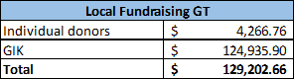
9/oct
Until october 9, US$6,450.09 of individual donations has been received through the social media campaing and with local alliances.
This are the results of the local fundaising until octuber 9
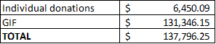
This are the results of the local fundaising until dic 9
Individual Donors | $7,180.99
GIF | $132,076.31
Total | $139,248.30

This are the results of local fundraisinf until feb 10
Individual Donors | $ 7,376.50
GIK | $ 139,631.41
Total | $ 147,007.91

This are the results of local fundraisinf until april 10
Individual Donors | $ 7588.04
GIK | $ 139,631.04
Total | $ 147,219.45

Budget
- Outline how we will use this funding with a rough topline budget.
- As recommended by the Funding Policy, we will be allocating 25% of the sponsorship funds to carry out the information process on radio stations, for hygiene measures, and safeguarding protection, and we are in dialogue with the Partners, for support measures for communities and families
- Local partners are creating a new budget to attend the main necessities, depending on each context.

Part 9 Media/Communications

List of media who will be or have been contacted with press releases.
The list of possible contacts in press, Tv and radio, in case of press releases:
Press media | Name | Position | E-mail | Phone Number
elPeriódico | Julia Corado | Manager | jcorado@elperiodico.com.gt
 | Luisa Paredes | Web editor | lparedes@elperiodico.com.gt
 | Lucy Chay | Editor in chief | lchay@elperiodico.com.gt
Prensa Libre/ Guatevisión | Antonio Barrios | Journalist | abarrios@prensalibre.com.gt
 | Andrea Orozco | Journalist | aorozco@prensalibre.com.gt
 | Ana Lucía Ola | Journalist | aola@prensalibre.com.gt | 3016-8433
La Hora | Douglas Gámez | Editor | d.gamez@lahora.com.gt
 | Cristina Vélix | Journalist |  | 5410-8721
Nuestro diario | Mario Ramos | Editor | m.ramos@nuestrodiario.com
Plublinews | Omar Solís | Journalist |  | 3053-2185
República Gt | Winther Flores | Journalist |  | 4758-7226
 | Henry Pocasangre | Journalist |  | 5690-4152
Sonora | Raul Morales | Journalist |  | 5510-6808
 | María solares | Receptionist | maria.soalrez@sonora.com.gt
La red | Fernando Andrino | Journalist |  | 7770-7185
Emisoras Unidas | Adrián Soto | Journalist |  | 5150-4346
 | Oscar Canel | Journalist |  | 5981-1081
 | Karla Marroquín | Journalist |  | 5741-6027
Canales Nacionales | Beatriz Rivera | Editor | beatrizderivera@canal3.com.gt
 |  |  | beatriz.ramirez@canal3.com.gt
 | Luisa Velásquez (Canal 3) | Journalist |  | 4399-0866
 | Daniel Collin (TN23) | Journalist |  | 5762-8092
 | Magaly Alvarado (Canal 7) | Journalist |  | 3020-5992
 | Axel Cardona | Journalist |  | 5536-6813
TV Azteca | Jessica García | Journalist |  | 4152-2842
 | Alejandro Castillo | Journalist |  | 4868-4937
Radio Punto | Lourdes Arana | Journalist |  | 5860-6619
 | Francisco Quiñonez | Journalist |  | 4151-4841
Canal Antigua | Sergio Osegueda | Journalist |  | 5651-7898
 | Juan Diego Zebadua | Journalist |  | 4770-0062
As an observation, as ChildFund we have not had a press release by ourselves. We usually have these actions as Joining Forces.

List of emergency CO spokespeople, including name, location, contact information, and languages spoken.
Name | Location | Mail | Languages
Rodrigo Bustos (CD) | Guatemala CO | rbustos@childfund.org | English and Spanish
Mónica Mazariegos | Guatemala CO | mmazariegos@childfund.org | English and Spanish

Plans for collecting photos/videos/stories, e.g., should an outside photographer be hired?
Due to the government measures, we are not allowed to travel to the communities to get in touch with the partners and the families and continue with the photos and stories collection. So, we will work with the backup material we have, as photographies, to share in our social media platforms. This includes the programs photos.
We plan to use free animation pictures from Canvas, to inform. In the communication plan we are going to publish about coronavirus context in the country, childcare through the pandemic, emergency response, material for local fund raising and continue with the ChildFund institutional media resources.
Also, we are going to evaluate the resources from the international office, to adapt them to Guatemalan context.
Local partners had been collecting photos and some videos during the emergency response in the communities. These photos are being send to CO. Advocacy and communications specialist with the social network specialist, filter the photos based in the rights-based approached communication and distribute the materials in the media bank, social networks, and colleagues of the office who need the materials.
Local partners have received guidelines to produce photos and videos according to a rights-based approach. The results are significantly better from the photos and videos produce during days before.

Key points for messaging and visibility, particularly any host-government sensibilities that must be considered.
  - National Information about COVID 19
    - Share national information from the decisions of the government
    - Prevention and hygiene measures
  - Organizational information
    - Regular post
    - Child protection posts during the pandemic
    - Emergency response actions information:
  - Guatemalan and Honduras CO are working together in a communication plan during the emergency for both countries. This communication plan will be implemented in 3 phases, the first one is focus in the dissemination of critical information, specially focus in the prevention of violence, because there is enough information about the prevention of Covid 19. These will be via spots in communities' radios in 4 languages: Kakchikel, Kekchi, Kiche and Spanish.
The massage for LS1 and LS2 are already been produce by the Grow with me team. During this week massage for LS3 has been designed. We are working in the testing of the massage with adolescents and youth, and with a psychology group to assure the massage are ok. We also are defining reporting routes to produce graphic materials and share with LS3 groups. All these actions are contained in the communication plan for the response to Covid 19.
  - The plan has been approved by the SMT and the implementation of it will start immediately for Guatemala CO.
  - The implementation of the plan is been executed. During last week, messages have been developed and now the efforts are to finish TDR and open the announcement to receive proposals for the production of the messages and digital design of inphografics and other media resources.
  - The office is focus in hiring the technical support to develop the voice and text messages that will be sent to adolescents and youth´s cellphones that participate in LS3 programs. These messages will be following by digital resources produce for WhatsApp that will be send to them to support the information provided in the calls and SMS.
  - June 15: the hiring process is done. During this week the products are being developed.
  - During week of June 15, the SMS were sent to adolescent and youth. These provided information about identification, prevention or denounce way for violence against them. At the end of the process, more than 6000 SMS will be send to young people in our programs and communities.
  - Communication campaign was launch on radios and social media:
    - Link to our Facebook page:
    - https://www.facebook.com/ChildFundGt/videos/694680137767913/

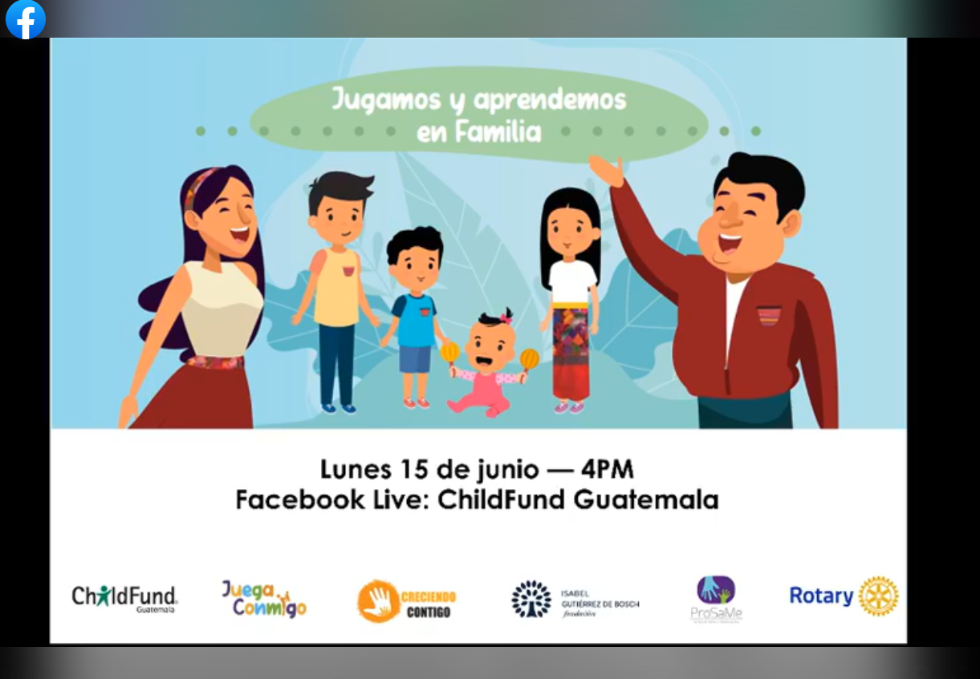

  - Digital education materials for youth and adolescents are approved to send and publish in social media.

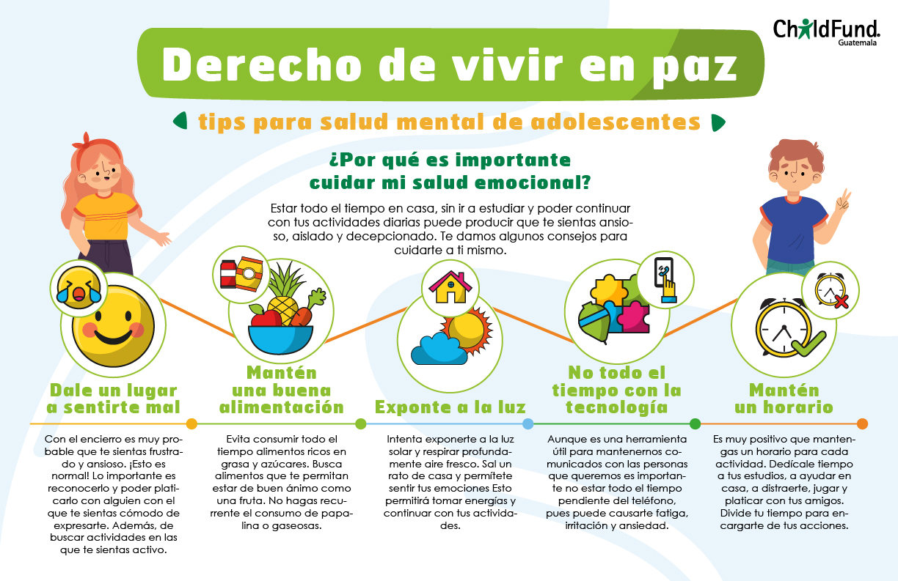

  - Digital report of the intervention during May is approved. The purpose of this material is for external audience, such as individual and corporate donors, international donors, guatemalan report of humanitarian response in country by INGO’s and international agencies, etc.

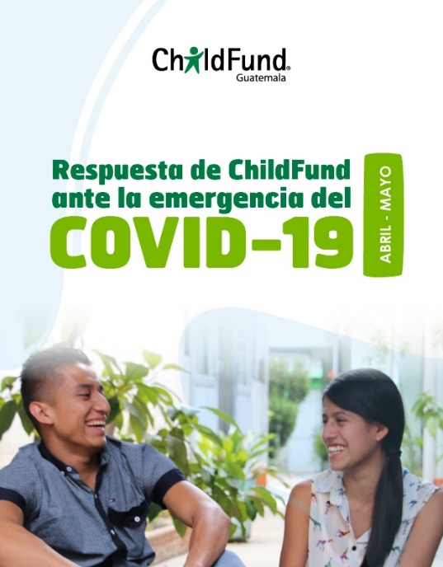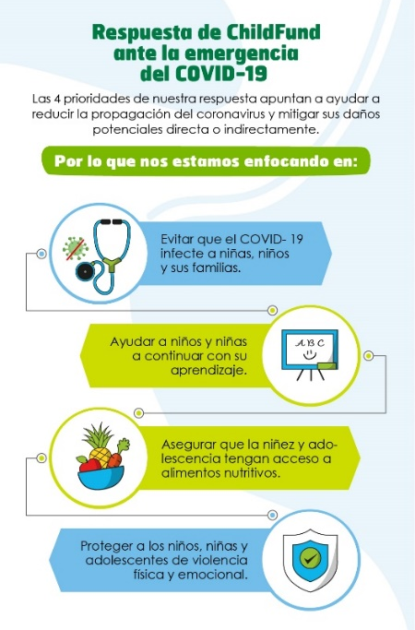

- Audios for automatic call are being developed during this week. These calls will reinforce the information about prevention of violence and mental/emotional health for LS3 audience and parents or relative as head of families.
- Report of the emergency response during June is publish.
- Automatic calls in different language has been done to adolescent, youth and parents. These calls are about prevention of Covid 19, mental health during the pandemic and prevention of violence against children.
- Report of the emergency response during July is published.
- Report of the emergency response during August is published.
- Report of the emergency response during September is published.
- Nothing to report during November 2020.
- Nothing to report during December 2020.
- Nothing to report during January 2020. - 02.10.2021
- Nothing to report during February 2020. - 02.10.2021
- Nothing to report during March 2020. - 03.10.2021
- Nothing to report during April 2020. - 04.09.2021

Marketing post:
  - Local fundraising campaign started April 20.
Instagram: https://www.instagram.com/p/B_6QCqnl0rm/?utm_source=ig_web_copy_link
Facebook: https://www.facebook.com/photo?fbid=1993810180763844&set=a.710972449047630

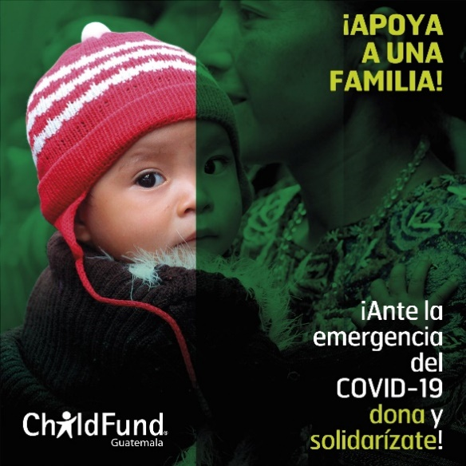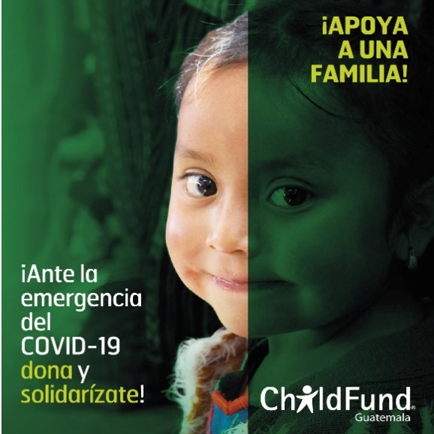

Until July 1, 21 influencers and 21 mass media have shared our campaign or make an interview as this one: https://www.guatevision.com/nacionales/childfund-invita-a-ser-parte-de-una-campana-de-ayuda-a-familias-vulnerables

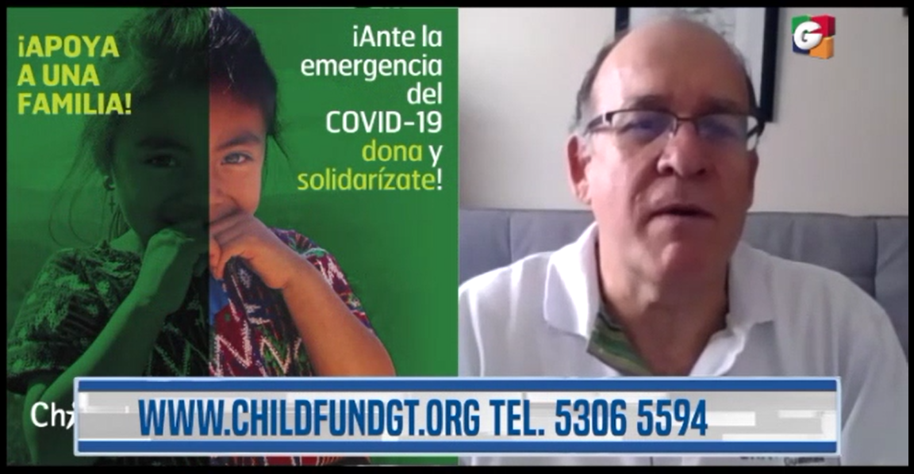
Another example of the interview in mass media.
https://elperiodico.com.gt/nacion/2020/06/04/queremos-ayudar-a-13-mil-familias-en-vulnerabilidad-en-el-altiplano-occidental-del-pais2/

https://dca.gob.gt/noticias-guatemala-diario-centro-america/familias-de-ocho-departamentos-reciben-alimentos-y-kits-de-higiene/

https://www.guatemala.com/noticias/sociedad/childfund-guatemala-dona-viveres-mas-2-mil-familias-escasos-recursos-durante-covid-19.html?fbclid=IwAR01boRWz2OoIHc3O0OpxvNbE9YuoF2uR42OtxrrSjU4BSNIX-BQyEbZsDc

By the end of june, a forum will be coordinated where the Director of the Guatemala office and one of our most important corporate donors will participate, so that we can generate more interest with the media. Talking about long-term actions related to the emergency.
This press conference will be held on july 2 in conjunction with World Bank, PAHO and Isabel Guiettez Foundation.
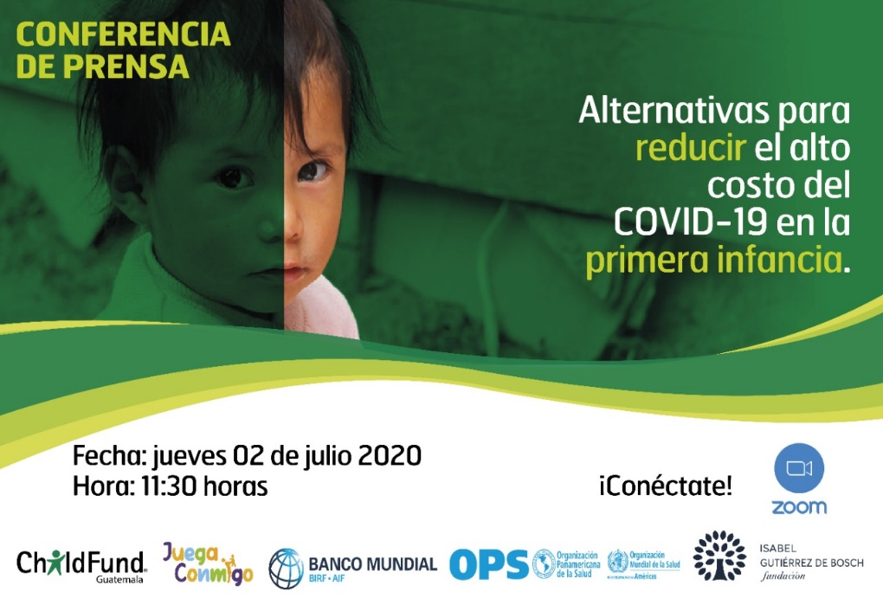
These are some of the press conference publications.
https://www.perspectiva.gt/empresa/alternativas-para-desarrollo-infantil-durante-el-covid-19/
https://elperiodico.com.gt/nacion/2020/07/02/ninez-guatemalteca-se-encuentran-en-riesgo-de-no-ser-productiva-en-su-edad-adulta-2/
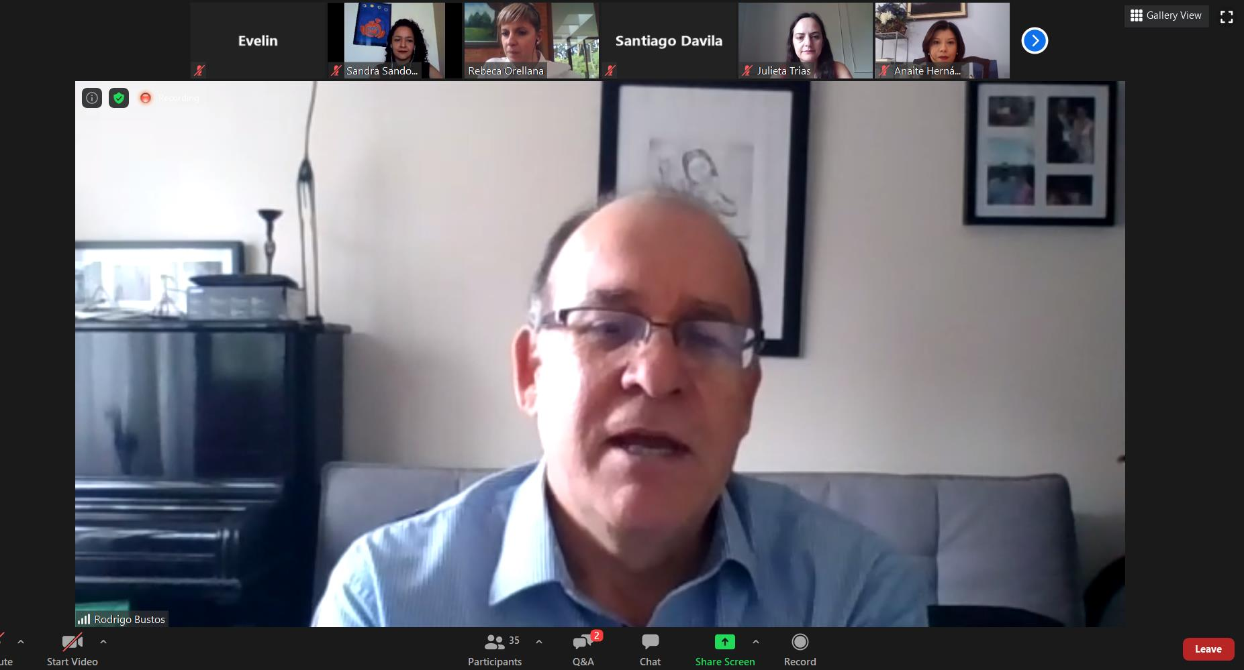
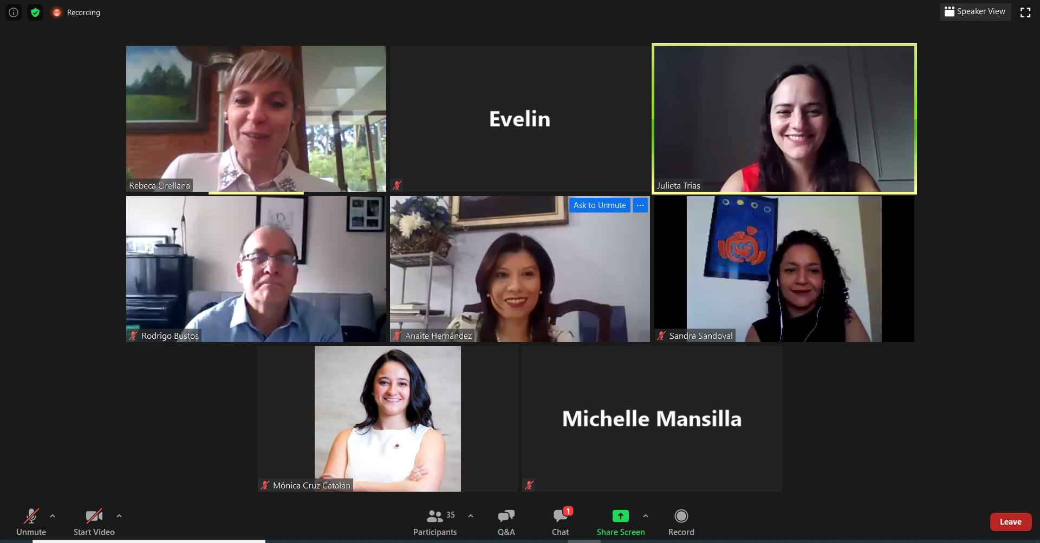
We are working in alliances with organizations and companies for in kind donations.

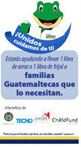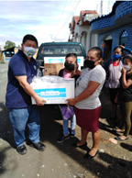

During the week of July 6 to 10, we started a new alliance with the HUGO app, a delivery application where the option of giving donations through this app is being given.
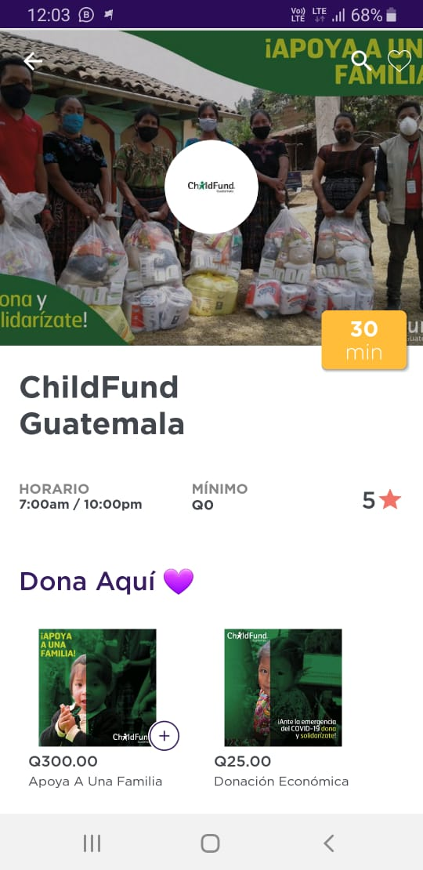

In July, an alliance was started with a supermarket to donate food bags. The alliance remains in effect for August
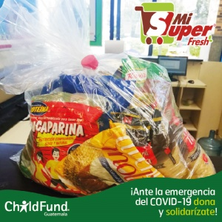
In august, 3 members of the team of Guatemala had the opportunity of participated in the program “Dreaming in Family” in Guatevision, one of the most popular local TV channel, on prime time for an entired week (august 17/21). From this activity we promote our brand and we get visibility in a national and international audience.

A zoom meeting was held with 8 new influencers (mothers / women) so that they can help us communicate the campaign.
In September we started a new initiative, this time with the participation of 16 influencers who will do a kind of challenge, nominating each other in a chain so that they all join and support a family. In this activity they tell their audience about the work that childfund does and also invite them to donate.
They are the influencers who helped us with this initiative
In October we are planning some online fundraising events. The first will be a training session with influencer Pamela Sosa.

In celebration of Children's Day on October 1, we made an alliance with the delivery company Hugo App. This initiative gave us a lot of brand exposure and a donation of $ 1,800
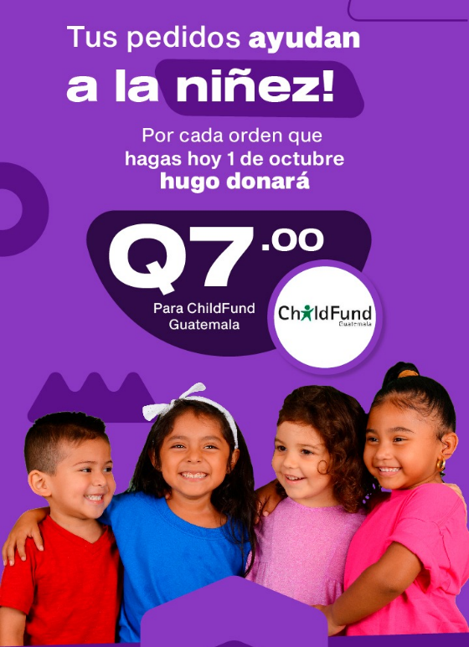
We are working on a new image on social networks to make it more dynamic and invite people to donate
A new alliance was made with Fundacion Azteca, with which we will be able to collect funds together.

In November we received a donation of Fundacion 13 Aguas of 72 food bag.
During December, 11 post about de emergency were posted on social media.

Last week we received a donation of United Way Guatemala of 236 food bags that where delivered to our partner Renacimiento.

Support needed or requested from IO, GSS or Global Teams – whether onsite or remote.
We need from P&P particularly form Business Development to consult with Children Believe and LEGO Foundation if there will be time extension of the CONFIO and Jugando Contigo Grants.

ANEXO: Photographs December 2020
December:
Renacimiento:
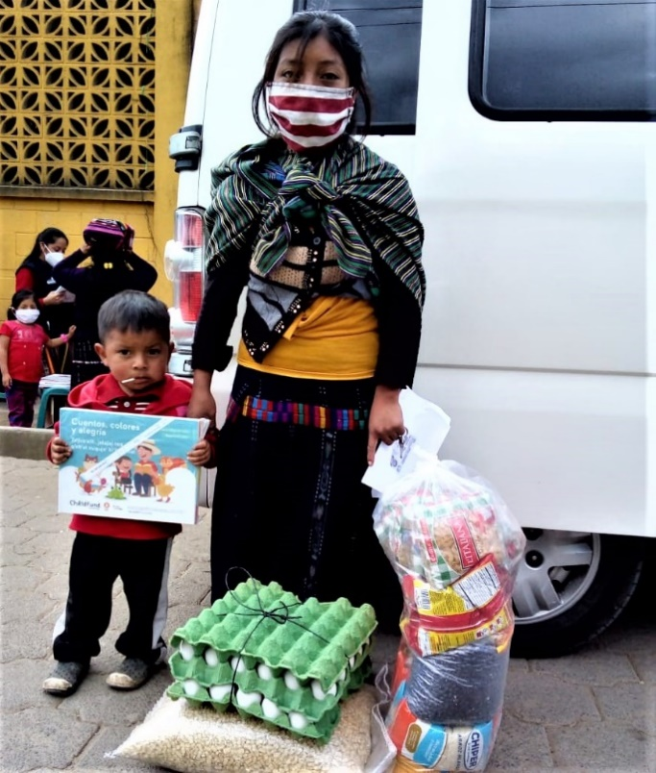
Delivery of food bags in Tzucubal Ixtahuacán Sololá
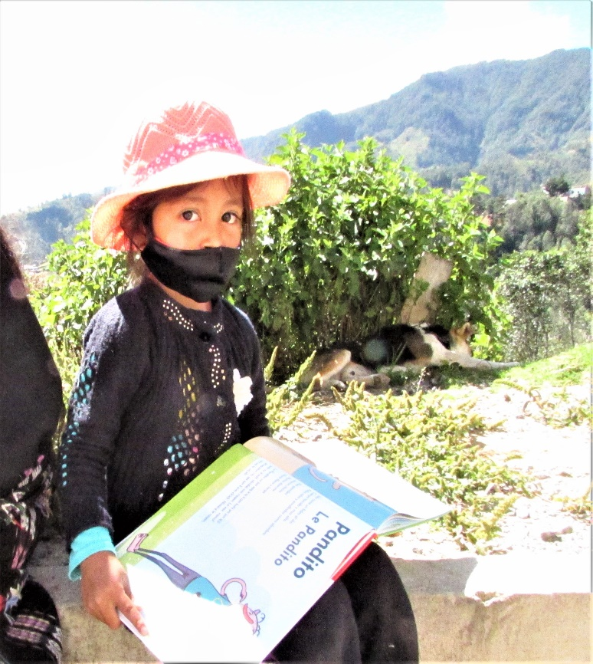
Delivery of books and infographics on DRR _ Chajuab_ Nahualá Sololá
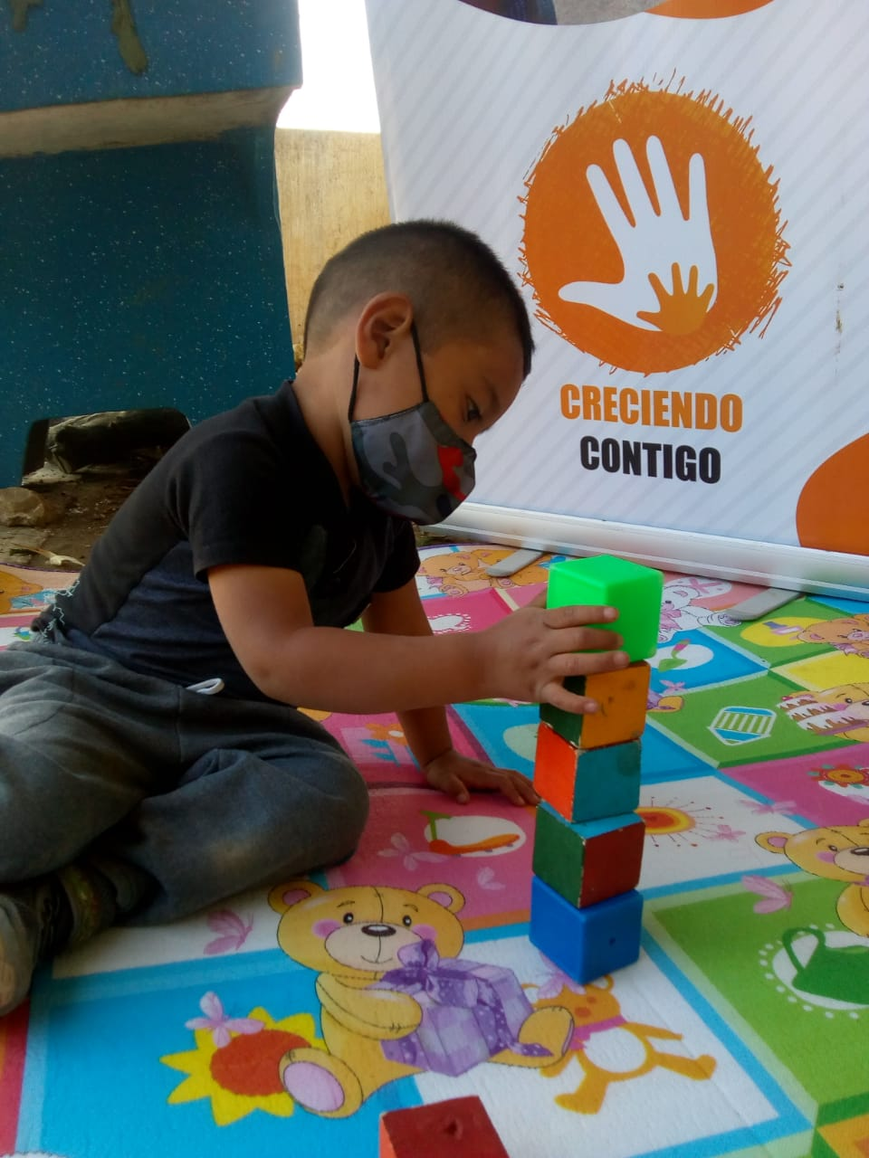
Child from CC in the evaluation of the development scale in San JuanComalapa Chimaltenango

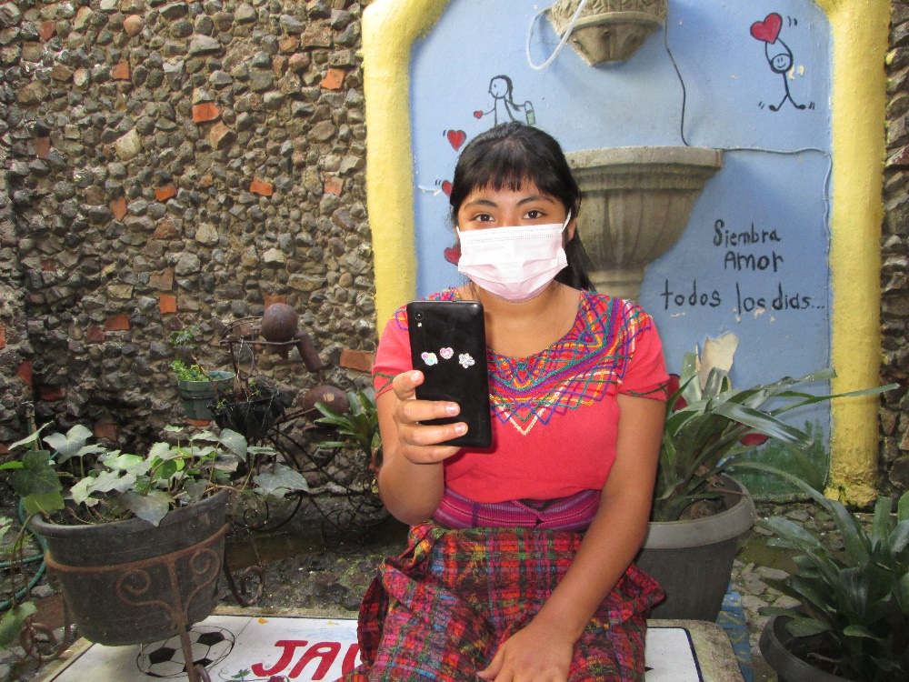
Teenager is receiving the Virtual Workshop on the topic "It's your decision" "Live your identity"
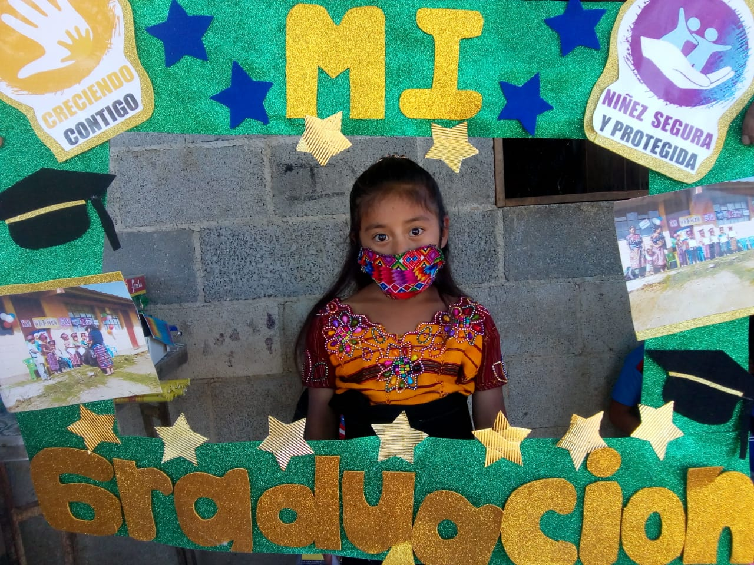
Girl makes her successful transition from the “Growing with You” Program Model to the “Safe and Secure Childhood” Program
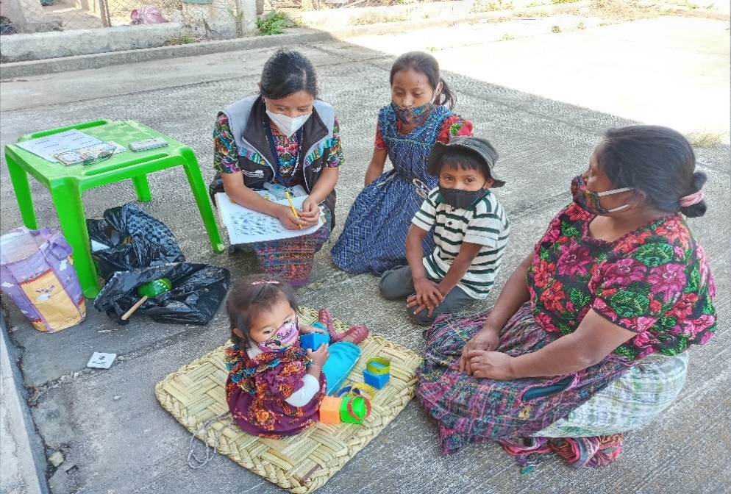
Evaluation with the kite tool (development scale) in Xejaví of the municipality of Tecpán

TIERRA NUEVA
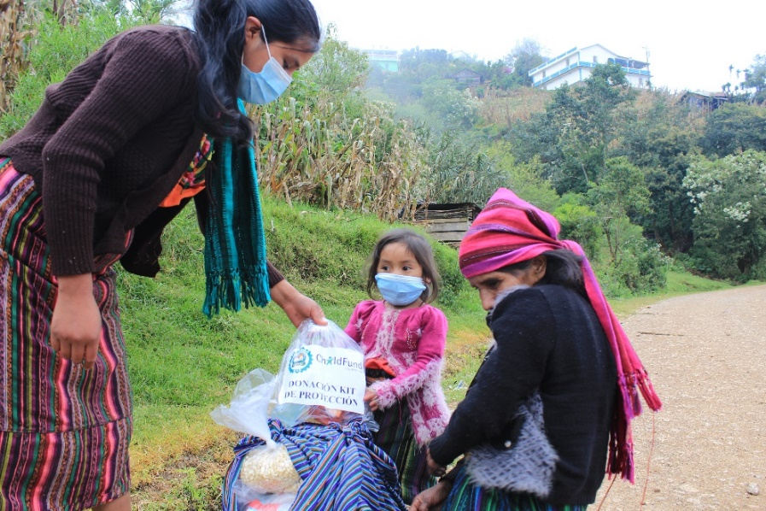

After the storms the calm arrives, today Dolores, mother and grandmother receive a feeding kit, a kit of coats and protection, Dolores is an orphan of a father he died when he was 1 years old, despite his limitations in his development communication and motor skills. She is happy, Dolores is very attached to her grandmother, she says that before participating in the activities carried out at the school Dolores was a very reserved girl and cried about everything, today she is an active girl, she plays with her cousins and expresses what you feel. "These are the changes that I have seen in her, I am grateful because I have seen the change in her, the activities have helped her, we are always worried because many families damaged their homes, thank God ours was not much."
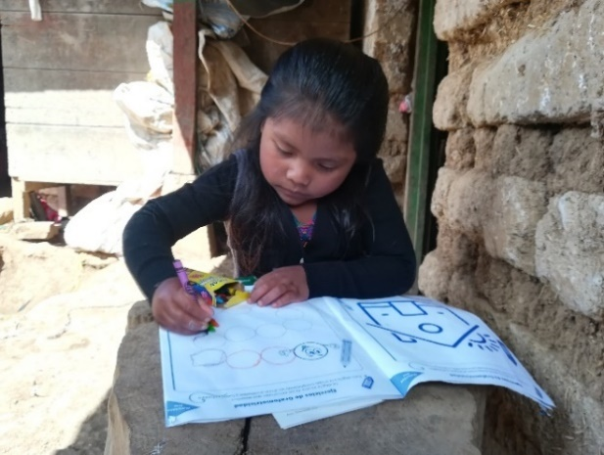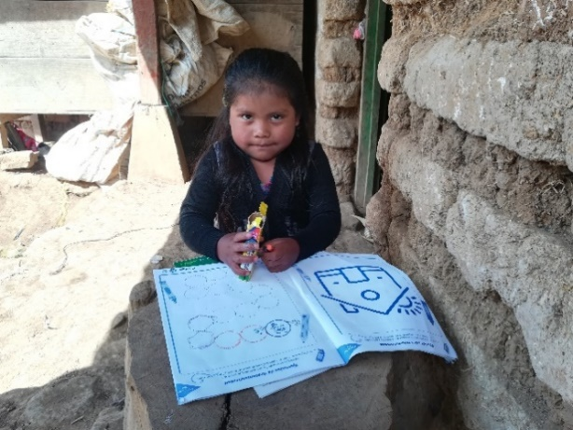
The photograph shows Zuly Arely, 4 years old, where she performs with great dedication the exercises in her notebook that was given by the Tierra Nueva staff. She lives in a very humble house and receives a lot of affection from her parents and siblings.

ADP

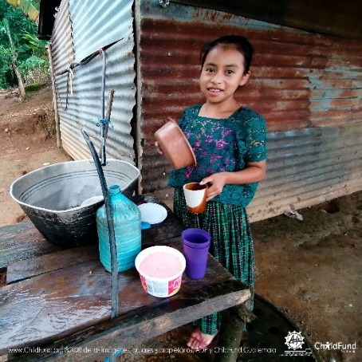
Quimberly is a very smiling and friendly girl, and she is also growing up healthy next to her parents. Quimberly is adapting to the radical changes that the pandemic (COVID 19) has caused, such as the use of masks, constant hand washing, among others.
She is currently in fourth grade, she also hopes to graduate as a teacher to help the children of her community. Quimberly participates in the programmatic model Me Quiero Me Cuido. She likes to support
her mother with chores around the house.

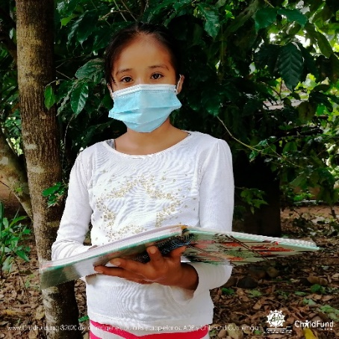
Sindy is a happy girl and likes to read, due to the passage of hurricane ETA and IOTA is currently living in a shelter in a community close to hers, always very attentive to the correct practice and use of the mask and thus avoid getting the COVID 19.

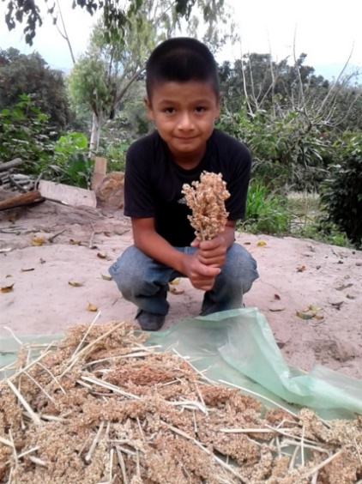
Rodolfo is a very happy boy, he likes to help his mother in the drying of maicillo, with this he feeds his corral animals. He lives in a community full of beautiful landscapes and has fun going out to play soccer with his brothers.
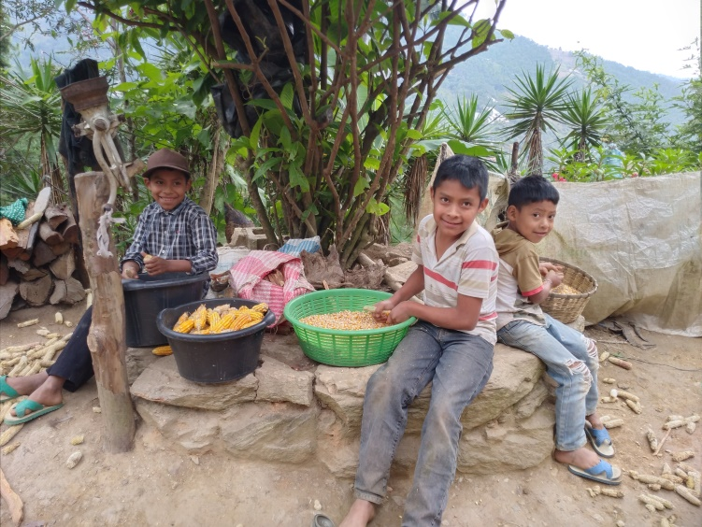
Abner lives in a community with his brothers and family, they take advantage of their free time to learn and support with some jobs at home appropriate to their ages.

PHOTOS DELIVERY OF HUMANITARIAN AID TO COMMUNITIES OF SANTA CRUZ VERAPAZ
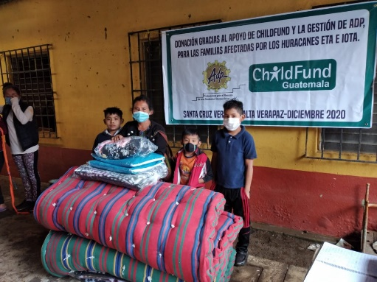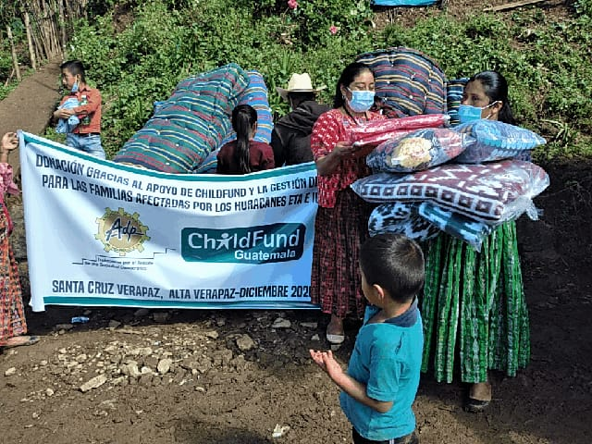
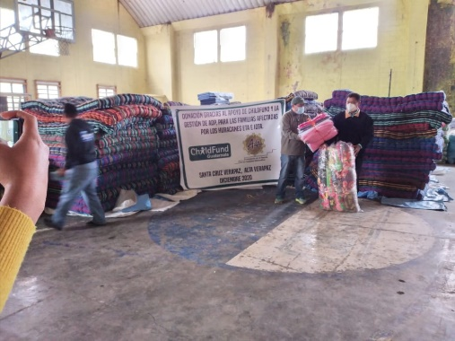
PHOTOS OF THE ARRIVAL AND HOSTING IN THE MUNICIPALITY OF PANZÓS, ALTA VERAPAZ., SIGNATURE OF KNOWLEDGE OF RECEIVED BY THE MUNICIPAL MAYOR
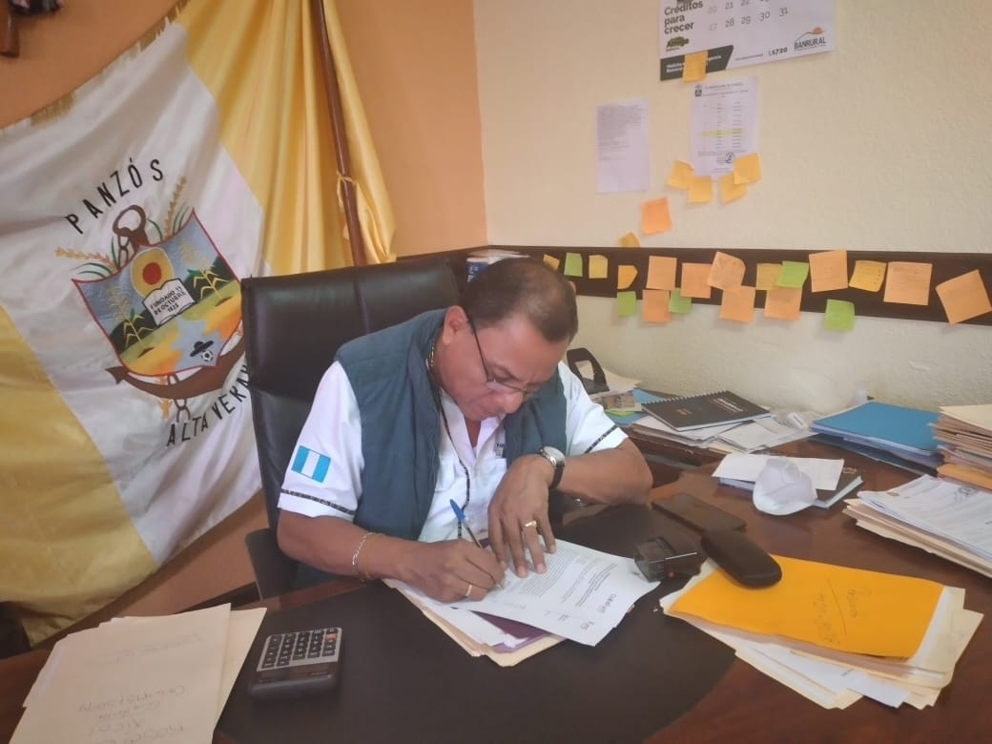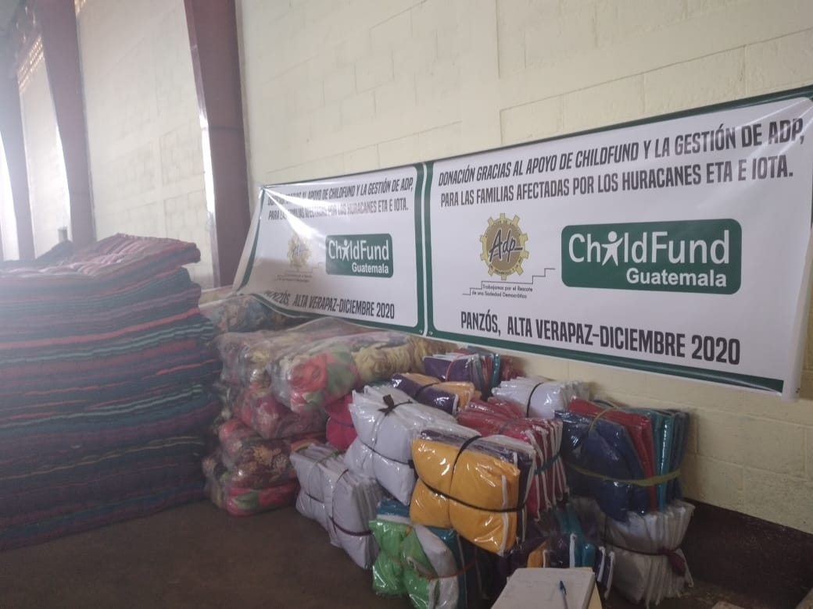

PHOTOS OF PSYCHOSOCIAL HELP TO 140 CHILDREN OF THE CHITUL DE SANTA CRUZ VERAPAZ COMMUNITY
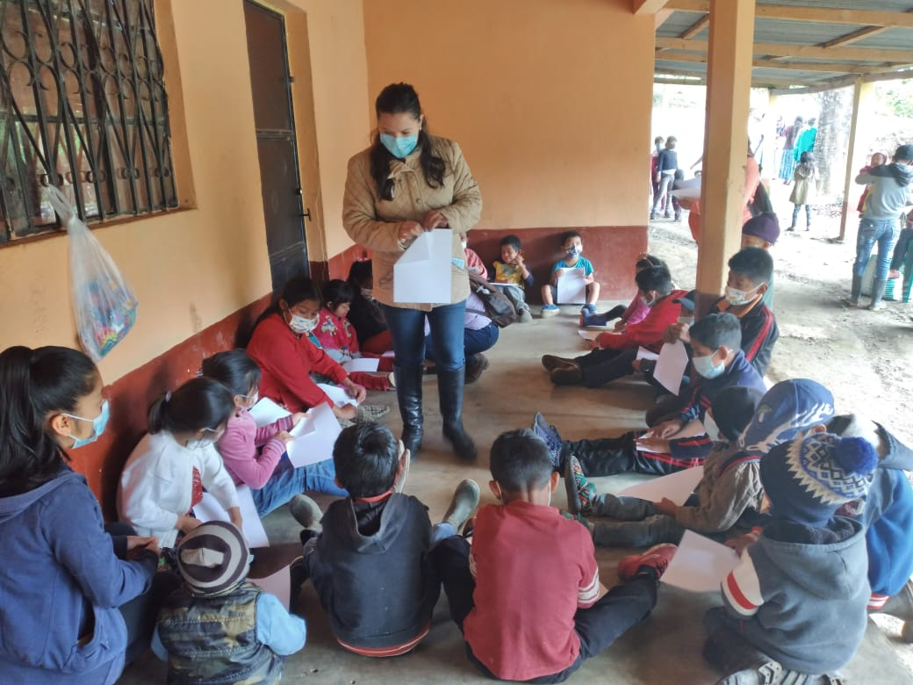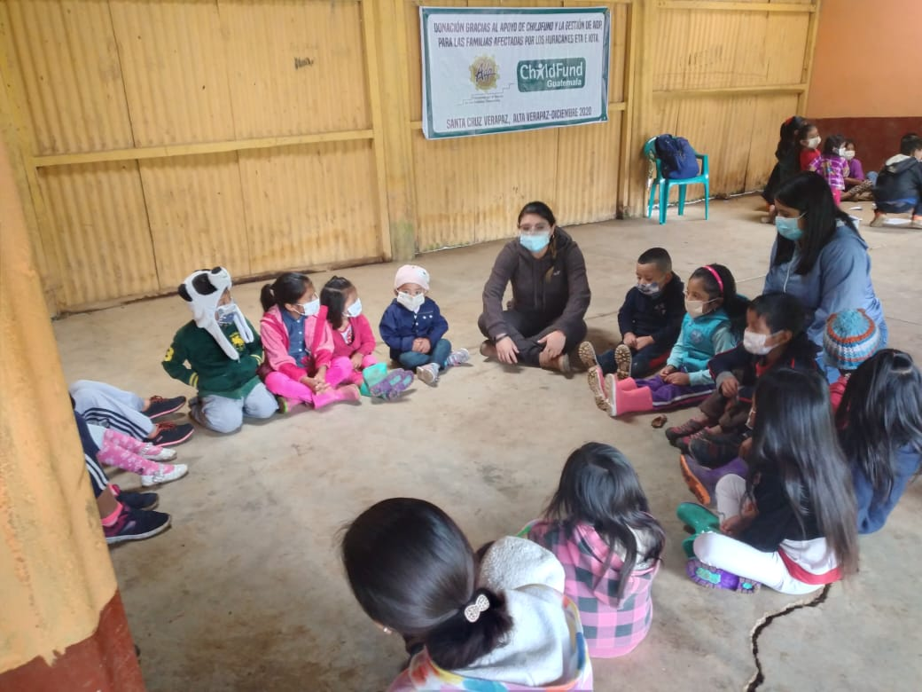
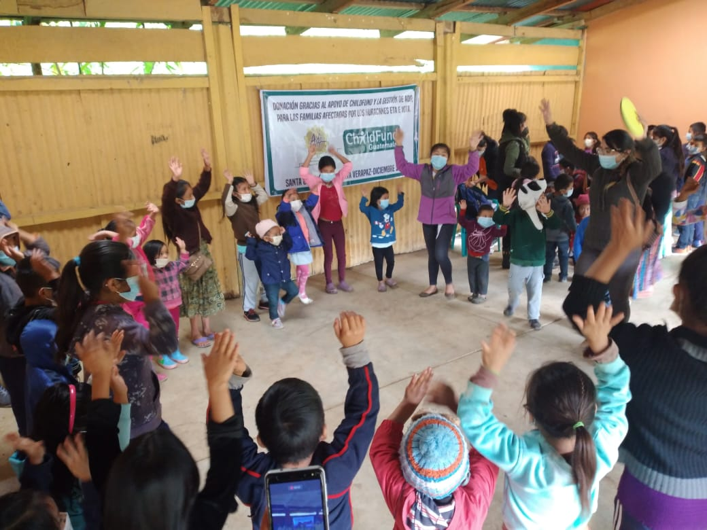

CDRO
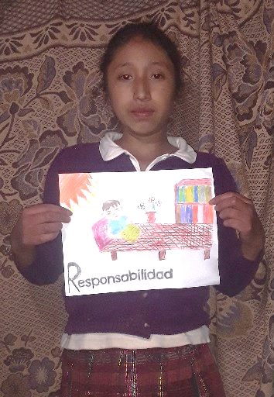
Juana Silvia, the municipality of Totonicapán, participates in the program Me Quiero, Me Cuido, shows one of the tasks carried out in the virtual workshop

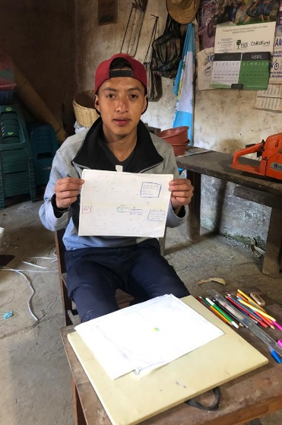
Orlando Tzunún, from the municipality of Totonicapán, participates in the Pacto program.
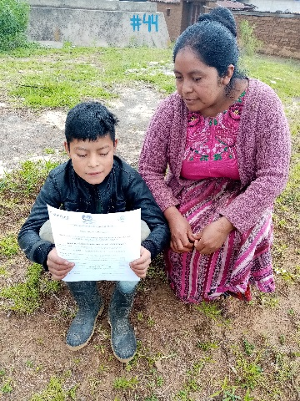
Nelson from the municipality of Santa María Chiquimula, is happy reading his worksheet, which with the support of his mother carried out the task described there for his self-study

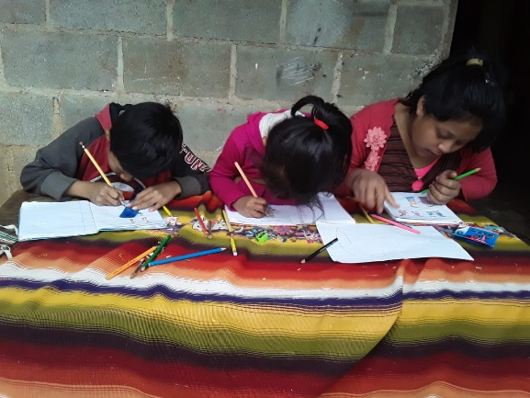
Girls from the municipality of Chichicastenango in the department of Quiche, actively participated in the remote session of the NSP model
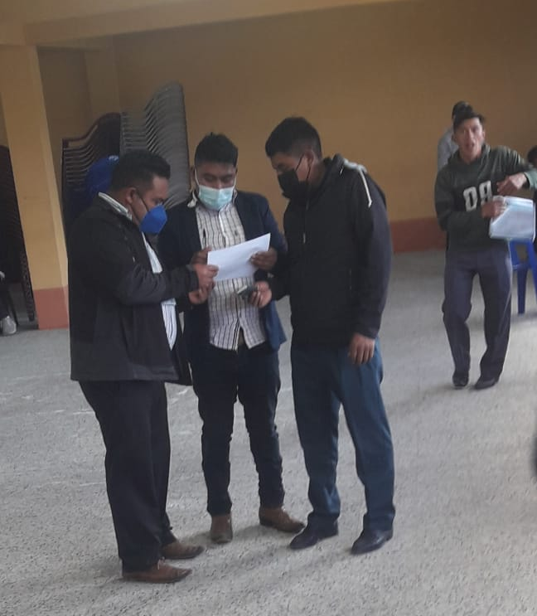
Workshop held with leaders in Casa Blanca in the municipality of Santa María Chiquimula

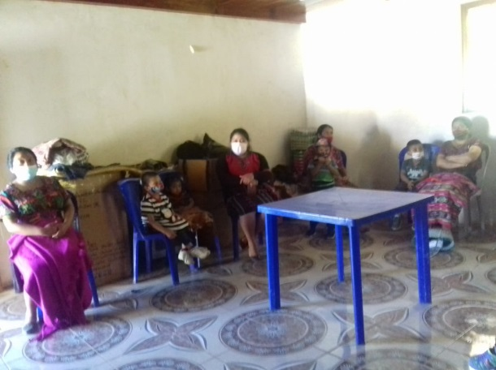
Workshop held with caregiver mothers in Chulumal Primero in the municipality of Chichicastenango del Quiche.

Playful parenting despite COVID

Story book delivery
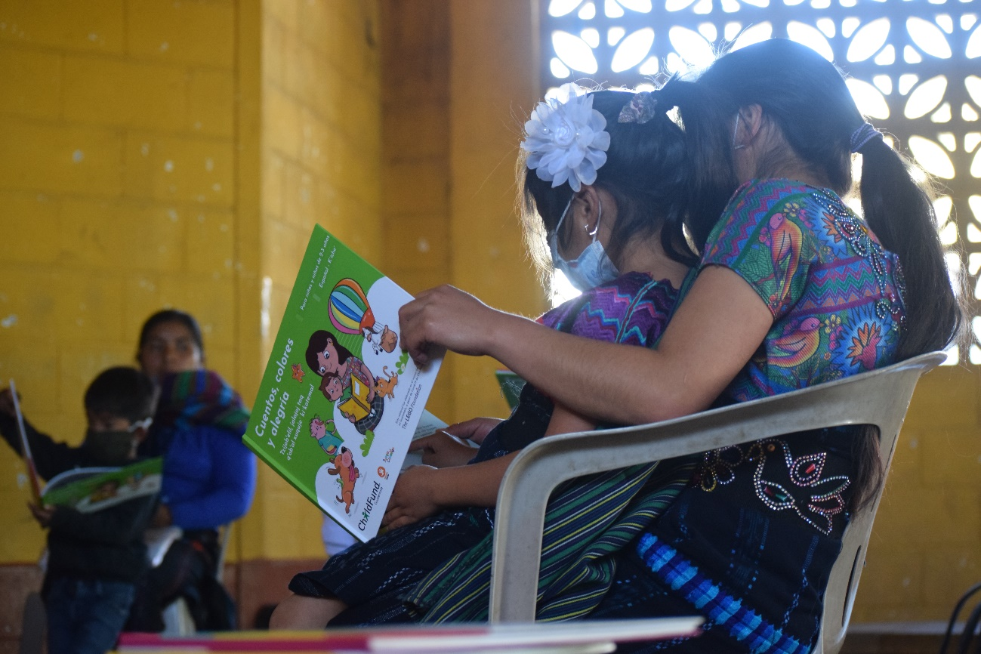
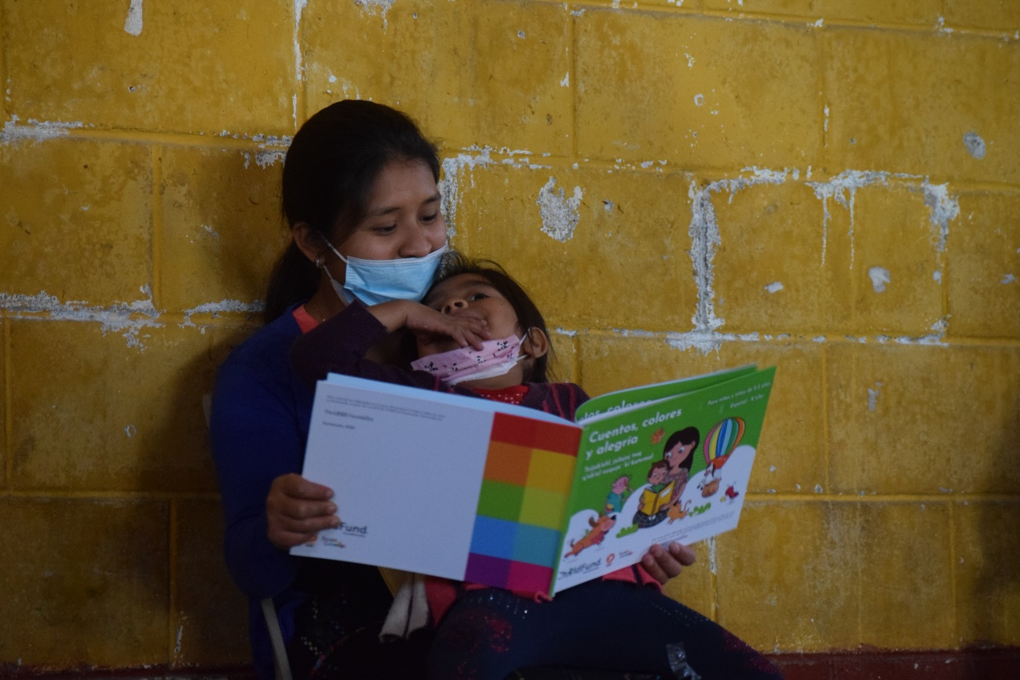
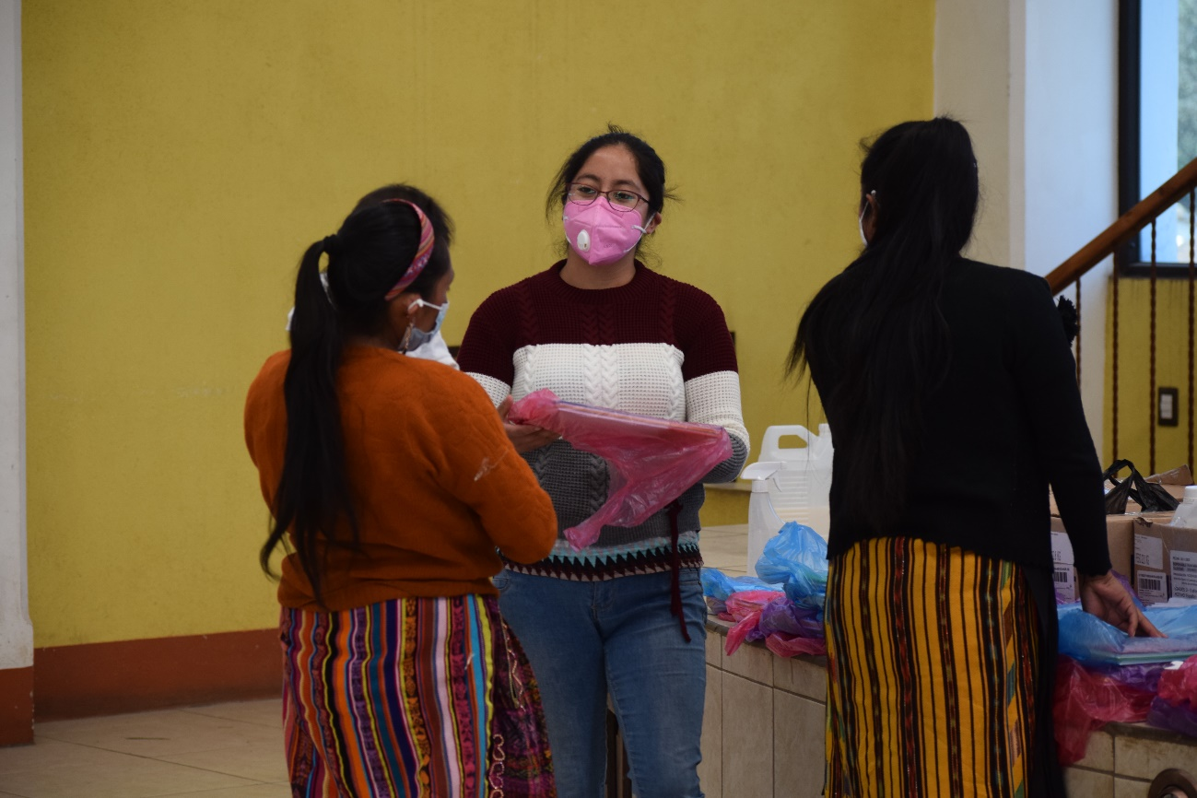
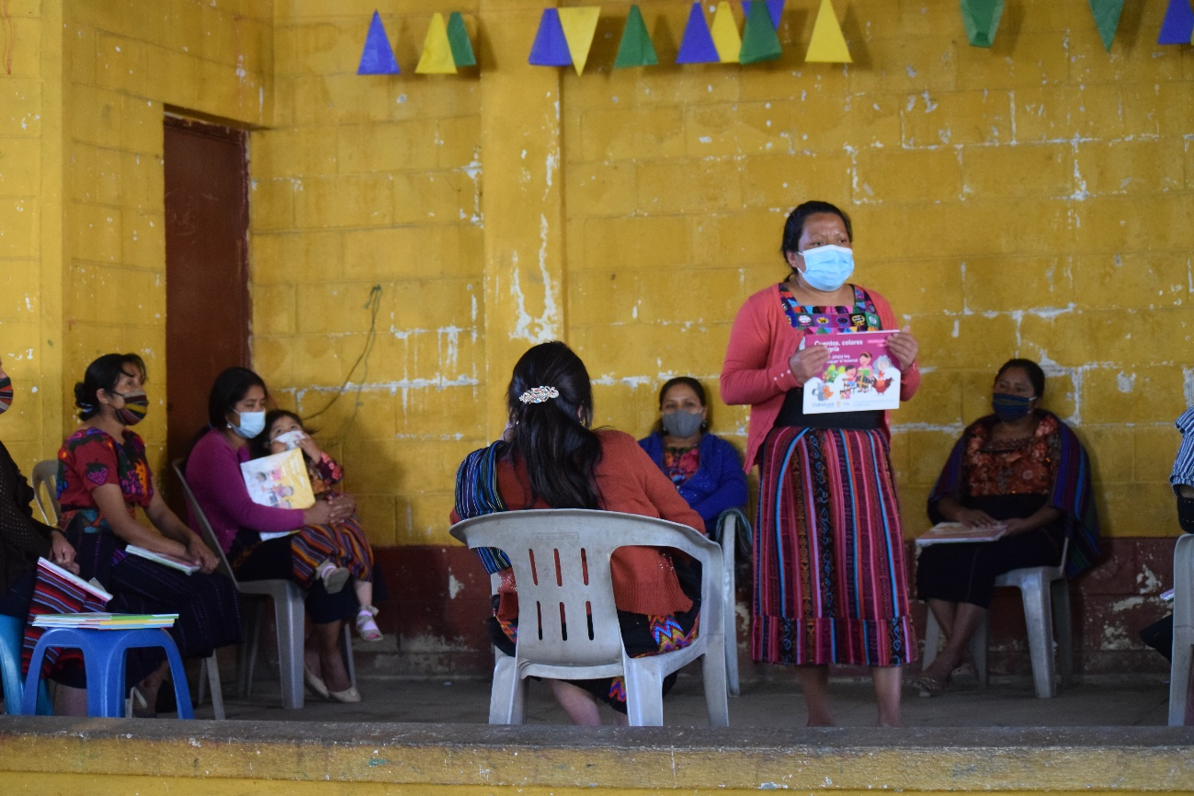
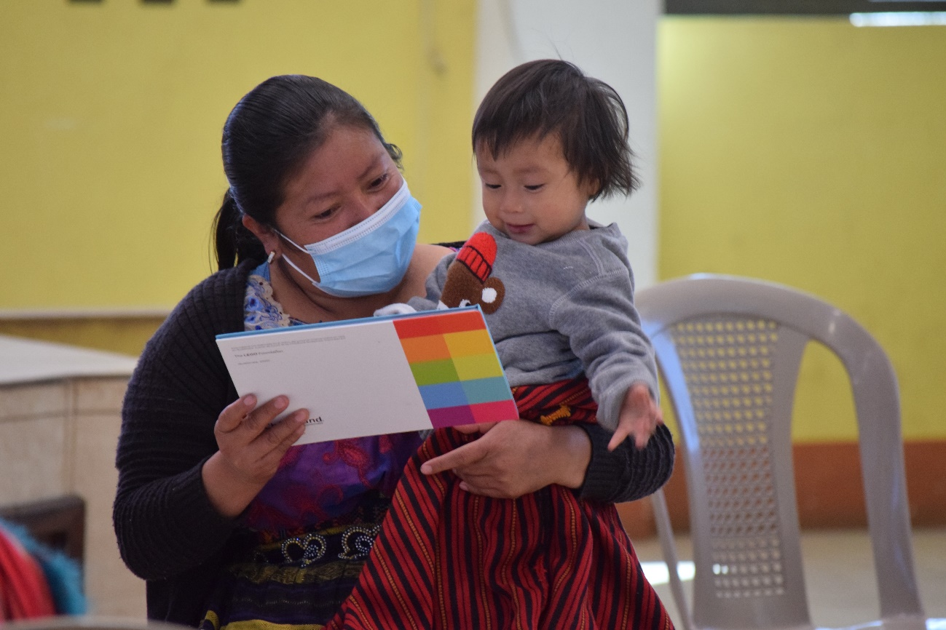

January 2021

CDRO:
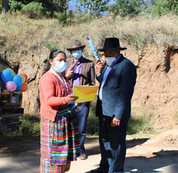
Community leaders and community authorities from the community of Xecococh, Santa Maria Chiquimula, actively participated in the 8th. mobile fair, disseminating information on child protection.

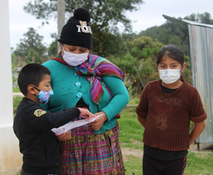
Fabian Cristian and his family have participated in the 8th. Community fair, who currently participates in the Safe and Protected Childhood program, is still learning to read and write, with the mother's help she is reading and understanding the central theme of the 8th. Fair.

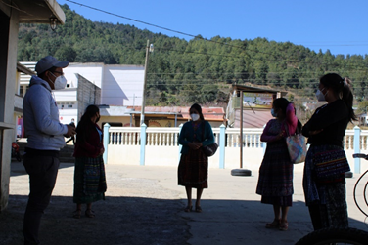
Ladies enrolled in the Pacto Totonicapán model, actively participated in the 8th. Mobile fair, with biosecurity practices anticipating covid-19 (social distancing, correct use of the mask and application of gel)
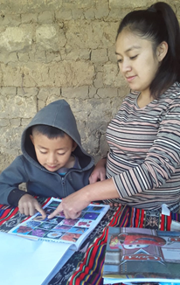
In the alternative modalities, the mothers of families play an important role, since they recognize the importance of developing communication and language skills, as indicated in session 17 Development Module. The child Willlian Mateo, with the support of his mother, participated in the program session.

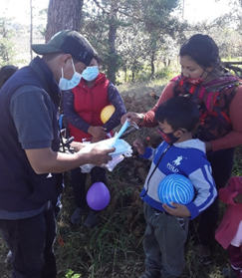
During the tour of the 8th. The fair continued to guide families in the prevention of covid19, and masks were also donated. Image taken in the community of Chulumal

ADP

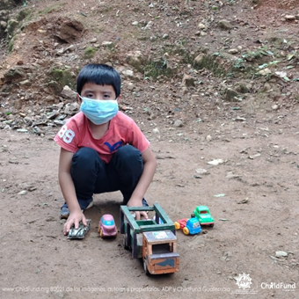
Heber, 8 years old, is a boy who has fun playing carts with his cousins, to protect himself from the Covid-19 pandemic, he no longer invites his friends, because of the pandemic he had to isolate himself from them to protect and protect himself Although they have not started classes yet, he is very excited to return to school and thus share and live in harmony with the other children, his parents support him to fulfill his dreams, because when he grows up he yearns to be a teacher.

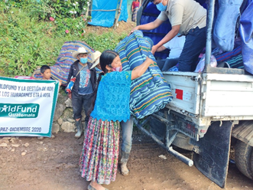
Shelter kits delivered.

RENACIMIENTO

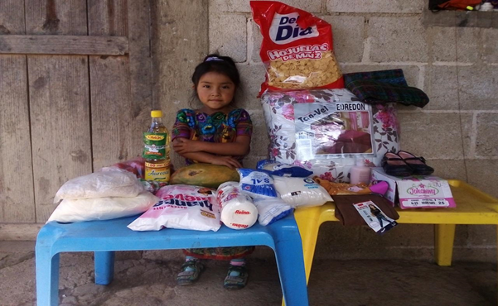

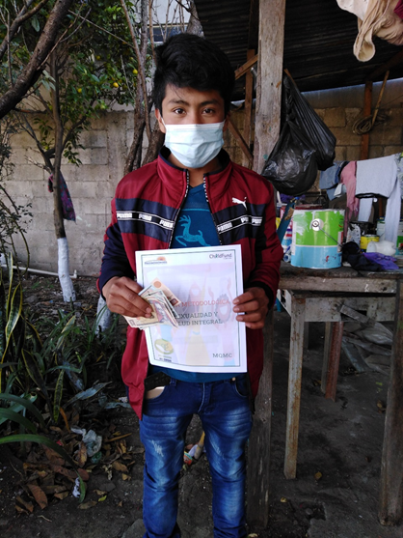

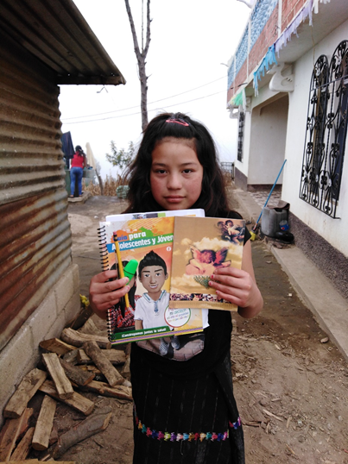
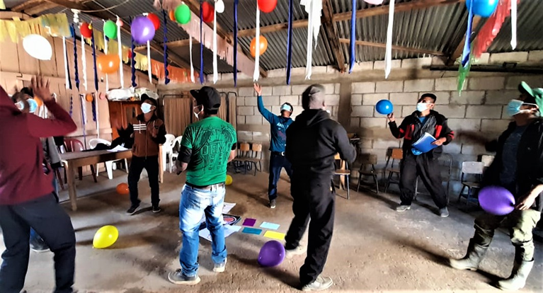
Session with male fathers parental involvement in early childhood development in Sololá

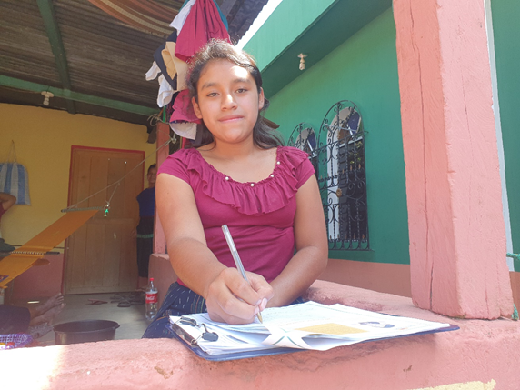
Aldea Xojola_working MQMC self-study guide exercises

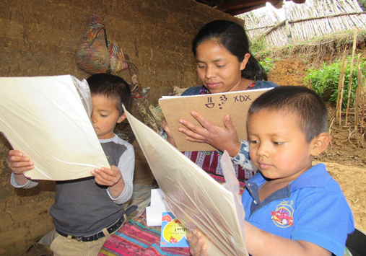
Trabajando los ejercicios de Creciendo Contigo en Patzún

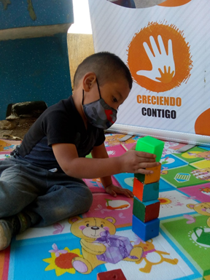

Development scale test application in Patzún.

FEBRUARY

Renacimiento (Central Highlands)

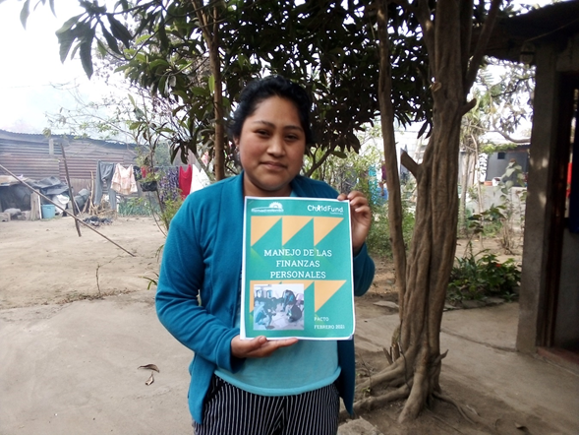
Young woman receiving printed material for her participation in the PACTO program activity

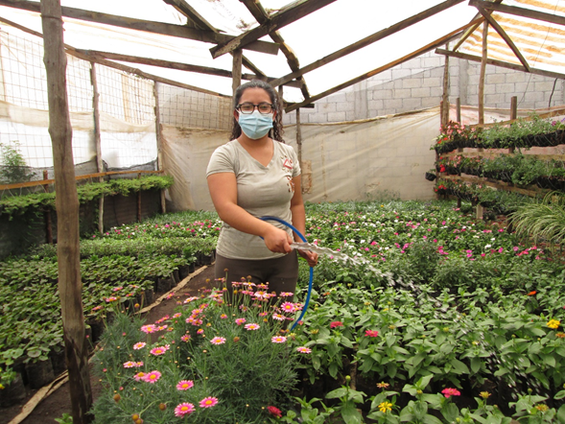
Young woman collaborating on homework generation homework

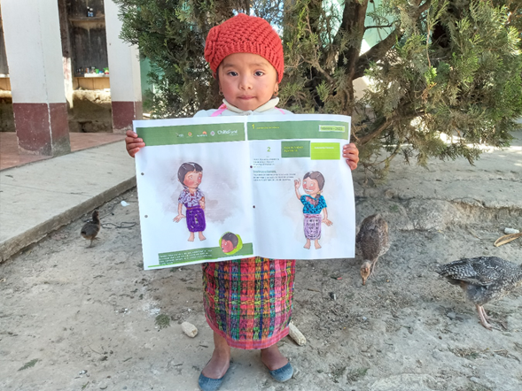
Showing your work in your booklet of “growing with you” program

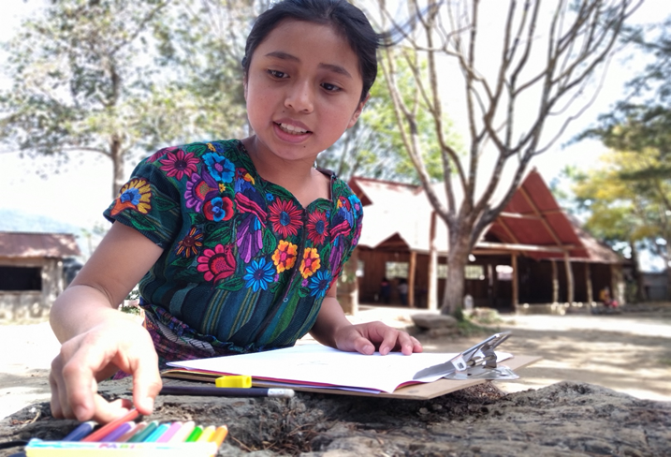
Carrying out your Safe and Protected Childhood activity in San Juan Comalapa

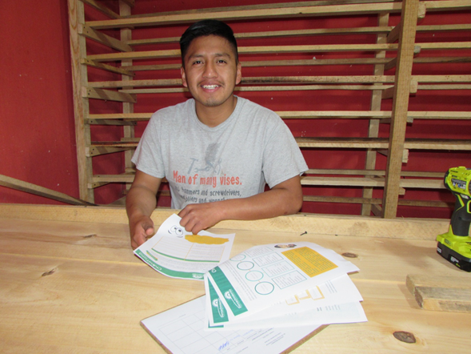
Performing the exercises of the printed material of the PACTO Program in San Juan Comalapa

CDRO (K’iche’ area)
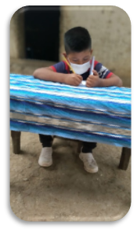Cristobal performing his tasks from the Safe and Protected Childhood programmatic session, received through radio programming, is observed taking notes for the subsequent task.

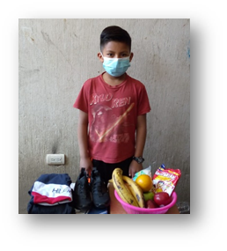Selvin is a child who received DF, he and his family are happy and shared photographs showing their interest in eating healthy, since with the gift they bought nutritious food.

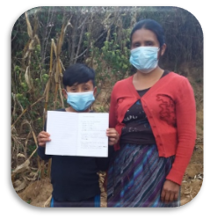Marcos, shows his homework with his mother, which was later sent as a product of the programmatic session through radio transmission, with the support of his mother

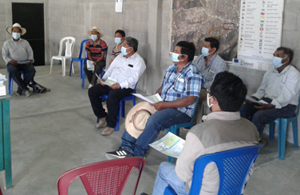
In Paquix community, male parents actively participated in a programmatic session in person, to contribute to the development of their skills and knowledge, for the care and development of childhood.

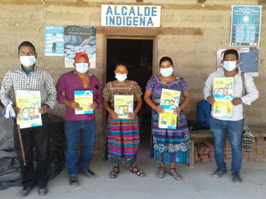Leaders integrated into the Protection Mechanism, committed to improving their capacities to be able to contribute to actions for the protection of children at the community level, motivating the participation of women in the spaces for participation.

ADP
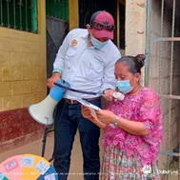
Doña Luisa is the mother of two children, who participate in the programmatic model I love myself, I take care of myself, she together with her children learns about sexuality and integral health, in the photo doña Luisa is observed playing with the questioning roulette that was one of the tools used at the community fair. She shares her knowledge acquired during the tele-workshops with other mothers, since she has been a guide mother for more than 5 years.

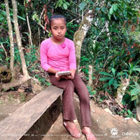
Evelin, 10 years old, lives with her mother with whom she shares and lives in harmony, she likes to read and write, she also loves to paint, she is a smiling and friendly girl. The use of the Tablet for communication with her sponsor has impressed him and she catches his attention, because she wants to learn more about using technology as a communication tool.

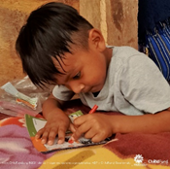
Oliver, is a 5-year-old boy, participates in the programmatic model Growing With You, currently attends the pre-primary level in the school of his community. He performs tasks from home for the detected cases of Covid-19 in the country of Guatemala. In the photo we happily observe Oliver coloring the material contained in the ChildFund Passport Kit.

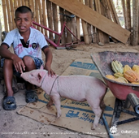
Walter Bernabé, 10 years old, participates in the Safe and Protected Childhood program model, wants to continue studying to graduate as a teacher when he grows up, together with his grandparents he is dedicated to raising pigs, which they then sell in their community market. His grandparents have supported him to get ahead in his studies. He feeds the poultry and pigs. This year he is in fourth grade of primary school, with all the security measures to avoid contagion of covid-19

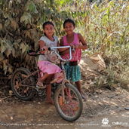
10-year-old Kimberly and 9-year-old Merlyn; They are cousins, they go out together and cycle around the house in their free time, to be able to recreate, always with the accompaniment of their parents. The girls participate in the Safe and Protected Childhood program, currently the two go to school in the same fourth grade with all the protection measures due to the covid-19 pandemic. The community where they live is very beautiful surrounded by trees and rivers.

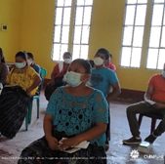
Jertrudis, is a 19-year-old lady who participates in the PACTO programmatic model, she has been a very active lady, since she puts into practice the knowledge she obtains in the workshops she has participated in. She wants to be an agent of change in her community and support other people to get ahead

Tierra Nueva

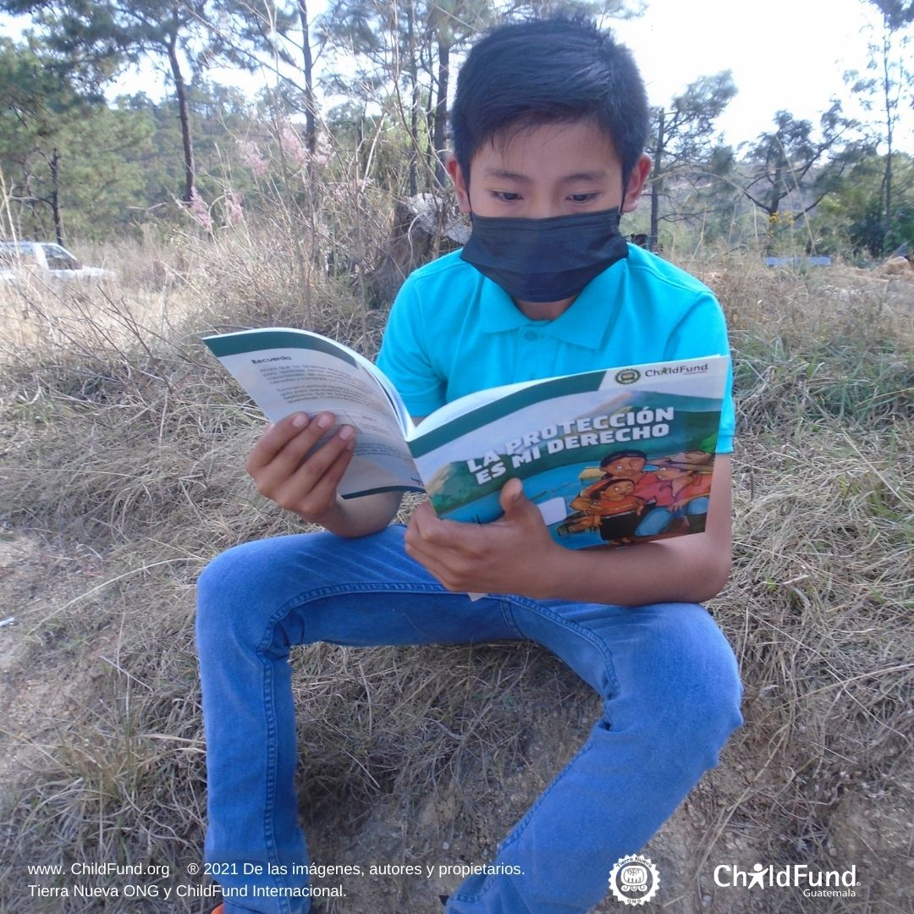

Julio, 12 years old, is a very sociable, friendly and charismatic child, he likes to do his homework that is sent to him from school, he also likes to read and learn many things, with the educational materials he receives from the Tierra Nueva Organization, he has been learning to know about their rights and improve their reading and writing habits. He says: "I have understood that as children we have rights to study, we must also respect each other and not hurt ourselves."

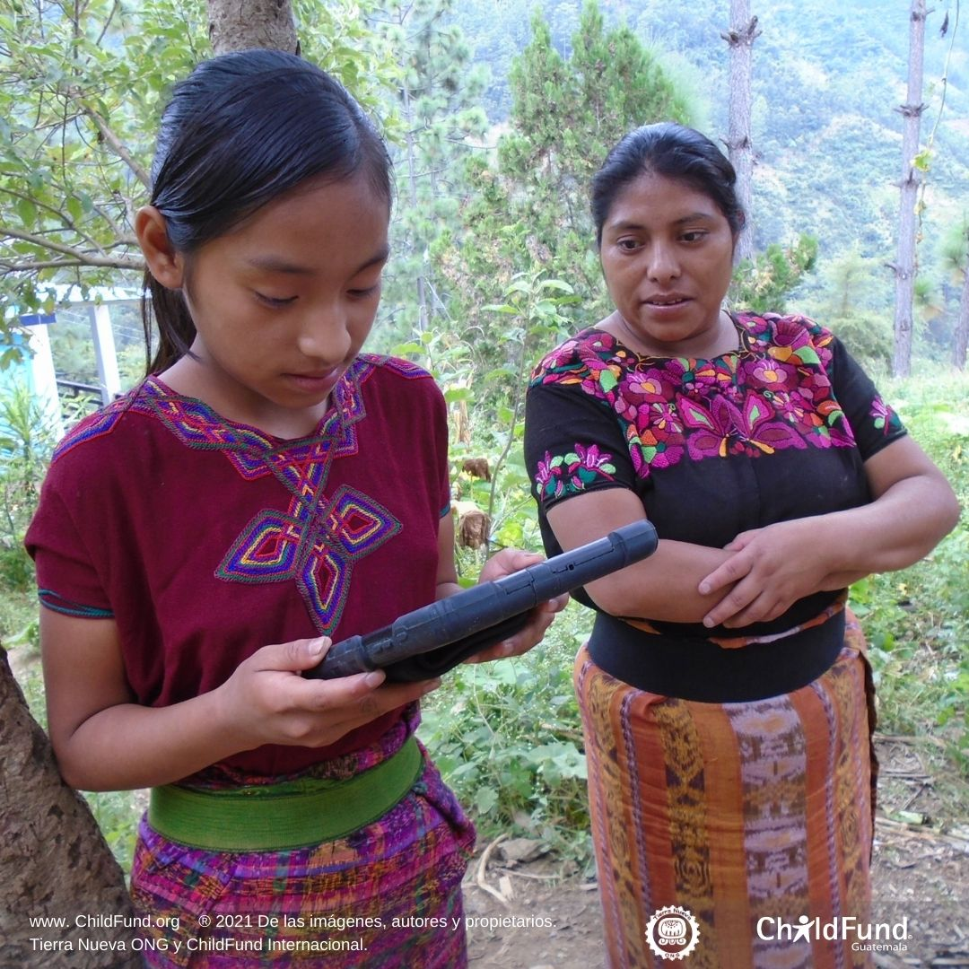
Llelsi is 12 years old, she likes to study and that is why this year she is finishing her primary level studies and wants to be a teacher in the future; she is the second of four siblings. Llelsi likes to care for and feed the chickens they have at home. She has been visited by the Tierra Nueva team since her sponsor has sent her a letter and she is responding through the Tablet. She tells us:
"My mother's effort has allowed us to move forward, we have received support from Tierra Nueva in this emergency"
"I like to use the Tablet since I can draw, take pictures and share them with my sponsor so that he knows about the activities that he carried out together with my family"

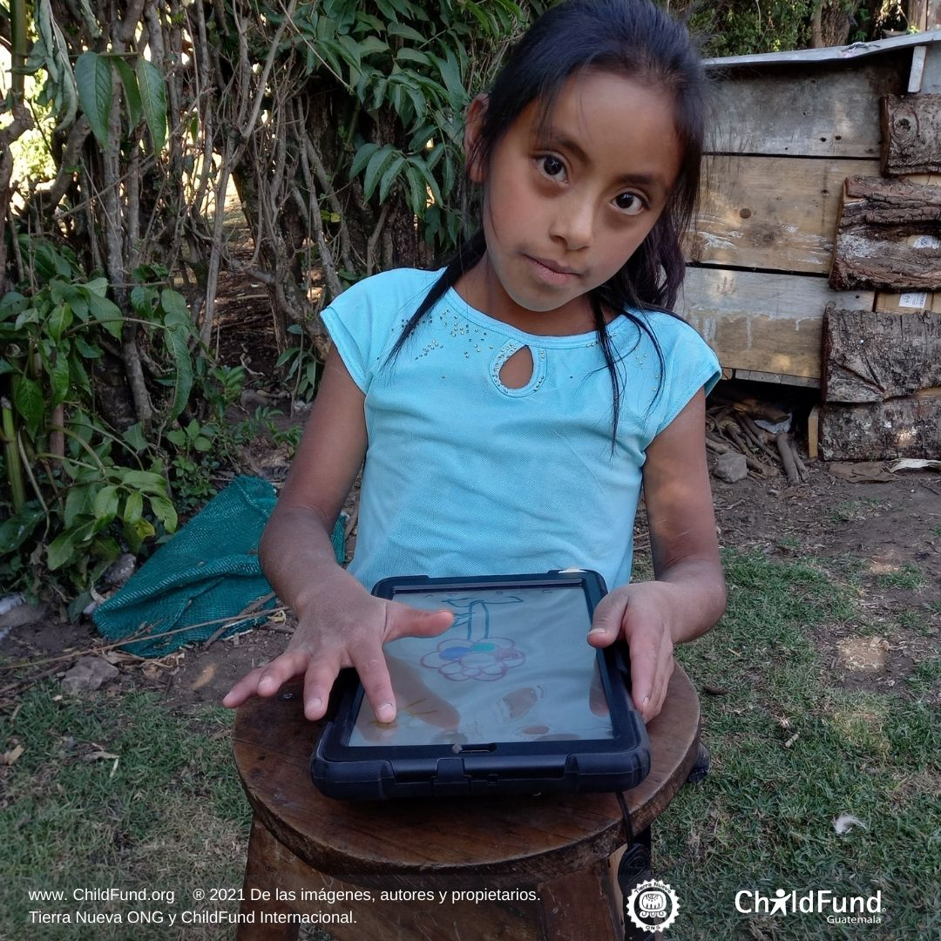
Alejandra is an 8-year-old girl who likes to learn and when the organization's team comes to visit her due to a communication from her sponsor, she loves to draw on the tablet, taking her time to elaborate it with great care.
She tells us: "I feel excited to be able to write a letter to my sponsor, it is a very nice experience since I do it on a large phone (Tablet)"

ADP: Q’eqchi area
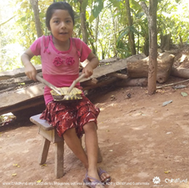
Ingrid Esmeralda Marisol, 8 years old, participates in the programmatic Model Me quiero Me Cuido where she has learned about her sexual and reproductive rights, Ingrid in her free time enjoys the joy of singing and playing her native instrument. She is currently studying at her community school where she is learning to read and write.
I like to play my native instrument (a turtle shell) to play it with my brothers at the end of the year “posadas”.

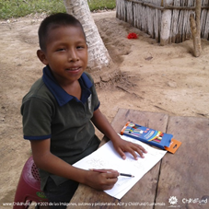
Esvin is an outgoing and cheerful child, participates in the Safe and Protected Childhood program, and likes to do the worksheets provided to reinforce his knowledge. He lives with his mother and two brothers in a humble home and the attention and affection of his mother are not lacking. He is currently in the fourth grade and attends school once a week due to the security measures of the establishment, Esvin uses a mask to protect himself. Esvin comments that he is very happy to participate in the program because he learns to read and write, he likes to do the worksheets that are given as reinforcement of the themes of the programmatic model.

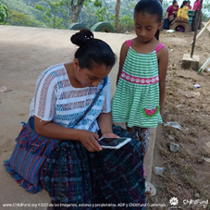
During the visit to Gloria, she was found at the school in her community, along with her mother who accompanies her on the way to school, Gloria is 7 years old, a very curious girl with wishes to learn for this reason her mother supports her so that little by little she learns. During the time that Gloria has participated in the activities of the Safe and Protected Childhood model, she has learned to live in harmony with her family. Gloria says “I am very happy to belong to the CHILFUND family”. Gloria states "That she is interested in learning more about the use of technology"
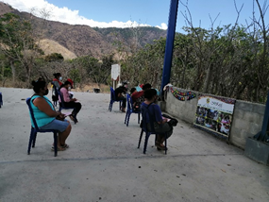
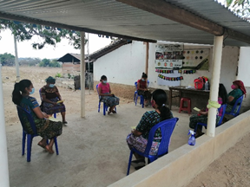
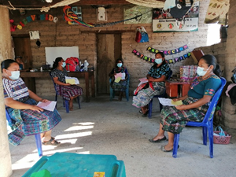
Face-to-face workshops taking into account protection care to prevent contagion, the workshop was given to objective mothers with the theme of protection, a rights approach, the role and responsibility of the caregiver in the protection of children within their family and the community, and fine motor skills.

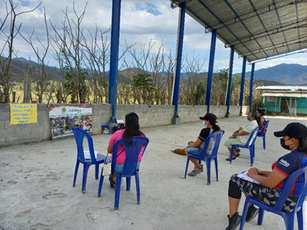
Face-to-face workshop with mothers on the topic: I know the Steps to protect my sons and daughters, the mothers met the community and institutional actors that protect children and youth and identify the route of complaint against any violation of the rights of the childhood.

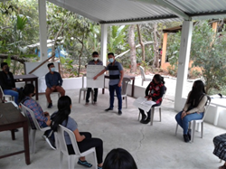
AJ participates in face-to-face workshops practicing biosecurity measures to avoid contagion. During the workshops they recognize the importance of practicing different forms of communication with their family in relation to their interests and emotions on issues of sexuality.

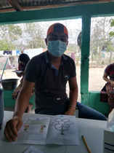
Young men and women identify skills to promote a possible entrepreneurship.

RENACIMIENTO (Central Highlands)
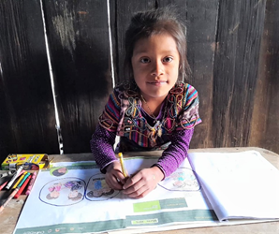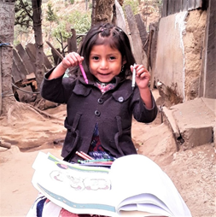
Session follow-up: Development in Growing With You in communities of Sololá

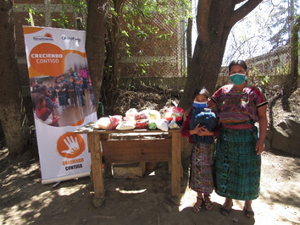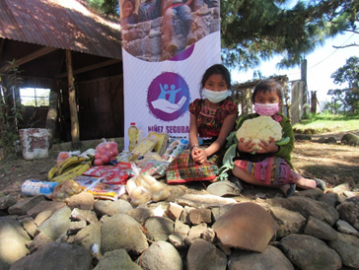
A family received DFC and decided to use it to buy food

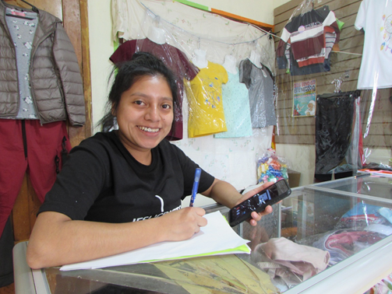
In his own business and receiving his virtual workshops as well as answering the learning guides in Comalapa.

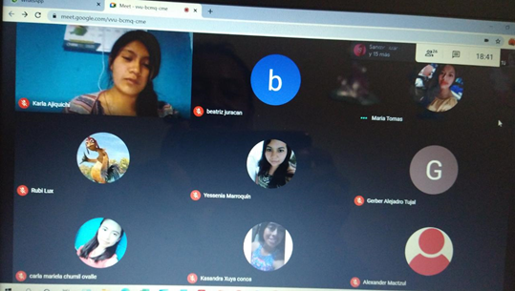
Virtual workshop with AJ addressed topics on: skills to promote entrepreneurship

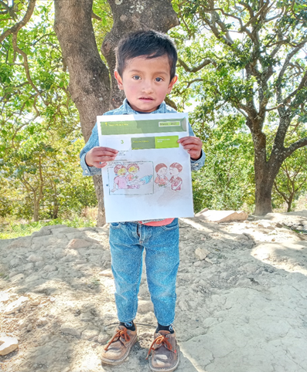
Work on children's booklets with the theme Courtesy and Social Treatment in one community of Chimaltenango

CDRO (K’iche’ area)

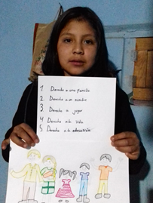
Olivia from the NSP program presents her shared task done via WhatsApp to the technical team, she is excited to finish and successfully present her task after the development of the session.
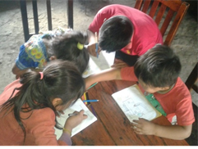
Carmen, her sister and brother from the NSP programmatic model carry out their tasks since their father supports them at the time of the session. The father lends them his cell phone and supports his children in their tasks, the lack of cell phones of each one makes them meet and carry out their tasks in a comprehensive way.

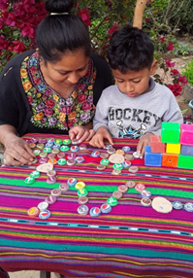
Olivia is a mother who supports her son in the games for the development of the session and to develop gross motor skills with her son, she is aware that supporting and guiding her son will learn and have better opportunities.
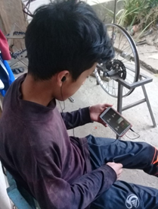
Despite the current situation that does not allow face-to-face activities, Aníbal makes the effort to connect in his virtual session, from his homework he sets aside time for learning because he considers it important
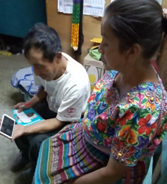
In the session of parents of families, Don Benigno and his wife actively participate using the zoom platform from the cell phone in their home, despite their daily activities they have made space for the sessions and perform tasks.
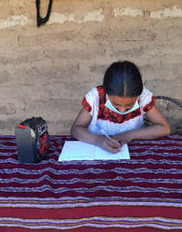
Keyly is from a family with few resources and the telephone and internet signal is very low where she lives, so through radio transmission, she sets aside her time, performs her tasks and does not miss important sessions.

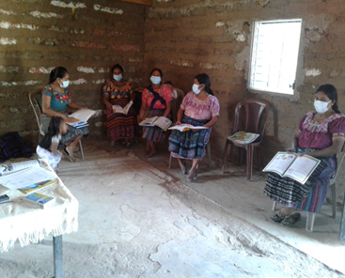
The participation of women in the protection mechanisms based on a community of El Quiché, with the objective of promoting a culture of denunciation since it is very important in the most retired communities, it is achieved through participation and being entities protectors in your community.

There is 1 case in Antigua Guatemala, Sacatepéquez. This is not a case of a Sponsored or enrolled child.

