ChildFund International
Humanitarian Situation Report Template

Humanitarian Situation Report 022
COVID-19 – Guinea
March 10, 2021
Point of Contact – Sekou Touré SSFP +224 622 35 12 08 stoure@childfund.org
From February 11, 2021 to March 10, 2021

FOR UPDATES, PLEASE HIGHLIGHT UPDATED SECTIONS IN RED

Part 1: The Overall Situation
COUNTRY
Total Number of COVID-19 Cases Reported | Number of Deaths | Number of Cases Recuperated
17 010 | 98 | 15 261
SOURCE: https://www.arcgis.com/apps/opsdashboard/index.html#/bda7594740fd40299423467b48e9ecf6

ChildFund-supported areas (Provide only if you have reliable data on this. You can report on a consolidated basis or by program state/region/province/etc. if you have this detail.)
Geographical area (country or state/region/province | Total Number of COVID19 Cases Reported | Number of Deaths | Number of Cases Recuperated
Labe | 266 | 1 | 152
Telimele | 1 | 0 | 1
Faranah | 1 | 0 | 1
Kindia | 310 | 14 | 276
Dabola | 5 | 0 | 2
Mamou | 92 | 3 | 81
SOURCE: National Ministry of Health or other reliable source

- Any relevant background information about areas affected.
Labe, Telimele and Faranah are the Global Fund TB/HIV and Malaria implementation areas. ChildFund has one project staff in Labe and SSRs in Telimele and Faranah.
Kindia, one of our sponsorship prefectures has recorded three hundred and ten (310) confirmed cases with fourteen (14) death cases and two hundred seventy-six (276) recovered.
Mamou, one of program areas has recorded ninety-two (92) cases, eighty-one (81) recovered and three (03) death cases.
Labe, one of program areas has recorded two hundred sixty-six (266) confirmed cases with one (1) death case and one hundred fifty-two (152) recovered.
The contact persons are under monitoring by the prefectural COVID 19 Task Force based in Kindia, Labe and Mamou regions.
We continue monitoring the situation in those areas.

- Host government posture: Have they declared a state of emergency and/or requested outside assistance? Which nationwide measures has the government taken, e.g., limitation on meetings, internal travel, school closures etc.
- The government declared the state of emergency on the 26 of March, has extends it again for one month since October 16.
- Due to the invrease of confirmed cases during the month of February, access to public places have been restricted and barrier measures reinforced like the compulsory of wearing a face mask and social distancing.
- Suspension of flights except cargos.
- Suspension of visa delivery in all Guinea embassies.
- After all the exams have been done, the Government has now opened school for specially the intermediate classes from September 1st to October 15.
- The initially declared curfew has been reviewed to be from 12:00pm to 04:00am only in the capital city (Conakry, Coyah and Dubreka) and suspended in all other provinces.
- Transport traffic between Conakry and other cities is now opened.
- All territorial borders are opened except three for political reasons (Senegal, sierra Leone and Bissau Guinea) was declared momentarily closed.
- The Big Market “Madina” will be opened from 6:00 AM to 6:00 PM.

- What responses has the government put into place to address the health crisis and/or the economic impact?
- The development of a national emergency response
- Three COVID-19 care medical centers activated and functional in Conakry and all the other regions in the country (Boke, Kindia, Mamou, Labe, Kankan, Faranah, N’Zerekore, Siguiri).
- Two national coordination taskforces (strategic lead by the President and operational lead by the National Health Security Agency) setup and functional.
- The Prime Minister announced on April 6, 2020, the economic contingency plan and committed to respect their commitments.
- The Government has initiated public places (ministry buildings and Conakry biggest Market Madina) disinfection.

- What travel restrictions has the government put in place for travelers entering the country?
- Suspension of flights except cargos.
- Suspension of visa delivery in all Guinea embassies.
- The initially declared curfew has been reviewed to be from 12:00pm to 04:00am only in the capital city (Conakry, Coyah and Dubreka) and suspended in all other provinces.
- Transport traffic between Conakry and other cities is suspended except for goods. In the president address on April 13, this measure has been reinforced.
- All territorial borders are closed except for goods.

Part 2: The Situation in Areas Where ChildFund Works

Partner Organization (Use Salesforce identifying code/name.) | # of Enrolled and Sponsored Children |  | COVID19 Cases Reported in ChildFund Communities (Y/N/Unknown) Provide number if available. | Number of Enrolled Children Reported with COVID19 (If available.) | Number of enrolled children diseased as result of COVID19
 | Sponsored | Enrolled
FMK | 2 190 | 4 243 | Y 310 cases | 0 | 0
FDD | 1 842 | 3 766 | Y 5 cases | 0 | 0

Child deaths: List any sponsored child (with Partner organization and child ID from salesforce) diseased as a result of COVID19. (Note: These need to be reported immediately following the regular sponsorship protocols.)
Partner Organization (Use Salesforce identifying code/name.) | What is the status of the program/sponsorship processes (operational/suspended)?
 | Program Implementation | CVS | M&E  Level 2 | Enrollment /Disaffiliation | Sponsorship Communication | DFC
FMK | Operational | Operational |  | Suspended | Operational | Operational
FDD | Operational | Operational |  | Suspended | Operational | Operational
Note: As a global measure, all sponsor visits have been suspended.
- What issues are children in these areas facing (food shortages, safety concerns, schools closure, etc.)? schools closure. School opened in December 1, 2020
- Child protection risks caused or exacerbated by crisis situation. High risk of child contamination, food shortage/hunger
Part 3: ChildFund’s Response
3.a. Overall
- Who is or will be leading/managing the response? Country Manager
- How is ChildFund linked with humanitarian coordination structures, i.e., in which clusters or working groups do we participate? The most recent/next meeting and who is representing ChildFund? Donor meetings we have attended, or missions that we are aware of related to the response?
- Participation in Coordination structures and meetings/INGOs network
- ChildFund linked with Community Health National Direction (DNSCMT) will be participating in “Community Health thematic group set up by the National Agency for health security lead of the response in Guinea. We contribute to develop a roadmap for the community response which has been submitted this week
- The most recent/next meeting are:
- Guinea INGOs network meeting: Country Manager
- Participation in Global Fund Grant contribution on COVID 19 national response meetings (with PNLP & CRS for Malaria and Plan International for TB/HIV) on weekly basis.
- ChildFiund’s Global Fund Malaria project community response to COVID-19 in 7 prefectures is approved by the PR (CRS) is under implementation. The main activities are community awareness through home visits with hand washing demonstration and radios campaign, sanitizers, masks for project and community health volunteers
- Child Protection cluster called CANEPE and COLTE/CDE: Guinea Child protection specialist is participating on the weekly basis
- Education cluster under UNICEF leadership: Guinea Education specialist is representing ChildFund in the weekly basis
3.b. Program Response
Please organize your program response report as per the 4 objectives included in our global response plan. You can add an additional category if you have response activities planned or executed that do not align with these objectives. For each objective use the questions below to guide your report.
- What kind of response activities or interventions have been executed? What support items are needed or have been collected/distributed?
- What is the current progress of implementation vs. the established response plan?
- Who are we partnering or collaborating with to provide our response?
- What kind of response activities are you still planning for the coming period?
3.b.1. Stop COVID-19 from infecting children and families
ChildFund’s Global Response Plan
To help children and families protect themselves from COVID-19, we are installing community, handwashing stands; educating communities about symptoms, hygiene measures and where to get tested or treatment; and distributing soap, hand sanitizer, gloves and masks to families and frontline, health workers. For children who are being treated for COVID-19 or are subject to quarantine measures, we are creating child-friendly spaces with age-appropriate toys and reading matter.

- What kind of response activities or interventions have been executed? What support items are needed or have been collected/distributed?
What kind of response activities or interventions have been executed? | What support items are needed or have been collected/distributed?
Distribution of COVID 19 prevention kits (Gel, soap, bucket, mask gloves, posters, agent training) and sensitization through home visits in Malaria Project zone (Kindia, Telimele, Mamou, Pita, Faranah, Dalaba and Dabola) | Masks and Soap to 2,193 community health workers/volunteers/traditional communicators  Sanitizers (Hydro alcohol gels to 53 LPs frontline staff  Posters electronic version received from CRS, reproduced at LPs level, and distributed and fixed in public areas (mayor office, health centers, etc..)  The Chimio Prevention campaign is under implementation. The second is running from August 5 to 15, 2020. For this second phase
In the response of COVID 19 Guinea has received Hygiene kits for baby and pregnancy women. During November the GIK has been distributed to 150 newborns babies and pregnant women at Dabola prefectural hospital
26 community educational center from the Dabola sponsorship area with 2,301 pupils including 1,071 girls, supervised by 45 educators including 14 women benefited hand washing kits to prevent COVI -19 in learning environment
Communication on preventive messages through radios and distribution of hygiene kits to health structures | Kindia and Dabola areas  Hand Washing facilities to Health Centers in Kindia and Dabola  Additional hand washing kits distributed in 60 sub health centers (Health post) in Kindia and 40 sub health centers in Telimele (Funded Global funds)  Hydro alcohol gel to LPs frontline staff (Animators and Community Mobilisers)  Mask and Gloves to all LPs frontline staff  Masks and glovers distributed to Voice Now groups and Club of young girls’ leaders: 34 Voice Now members and 45 Club of Young girls’ leaders’ members are involved in the IEC/awareness campaign and peer education.  Distribution of 109 hand washing kits to 109 vulnerable households is ongoing in Dabola sponsorship area  188 bactigel tubs donated to Mamou Health District Direction  Two radio programs carried out on preventive measures against COVID 19 in Dabola with an estimate of 39,160 people reached by emission
Continue community, youth, adolescents, and children sensitization on COVID 19 prevention measures | Radios broadcasts (iterative sessions) have been organized in two local radios in Dabola led by children parliament, the social affairs representative and LP Manager during the celebration of international children right day. These broadcasts reached 39,160 including 4,425 children.  80 awareness-raising sessions were carried out by 80 VLS groups reaching 2,400 people, mainly women  During February 2021, 1750 members (1625 women and 125 men) of 65 VSL groups in the 9 communities of Kindia were sensitized on preventive measures against COVDI - 19 especially during their meetings and at home
Preparation of school re-open at primary school and ECD center | Donation of Hand washing kits including soap to 47 schools in Dabola program areas. 5,733 schools’ pupils including 2,230 girls are reached.  Radio broadcast have been organized by the club of Youth girls’ leaders and the platform youths to sensitize parents and peers on barrier measures at school (in and outside classroom).
During November 2020, the LP in Kindia FMK has distributed in twenty (20) schools, hygiene kits composed by hand washing facilities, Soap, Mask. In Guinea, official school re-opened on December 1, 2020.
1,600 mask have been distributed to 800 schools pupils, 20 handwashing facilities have been donated to twenty school including 20 package of 960 pieces of soap.
During February 2021, 26 community educational center from the Dabola sponsorship area with 2,301 pupils including 1,071 girls, supervised by 45 educators including 14 women benefited hand washing kits to prevent COVI -19 in learning environment

- What is the current progress of implementation vs. the established response plan?

Response plan | Progress
Distribution of COVID 19 prevention kits (Gel, soap, bucket, mask gloves, posters, agent training) and sensitization through home visits in Malaria Project zone (Kindia, Telimele, Mamou, Pita, Faranah, Dalaba and Dabola) | On progress  Training/Orientation of community volunteers on COVID 19 sensitization process  Procurement of Masks and sanitizers for LPs staff and community volunteers
Communication on preventive messages through radios and distribution of hygiene kits to health structures | 41,827 home visits are done for 258, 648 persons reached in ChildFund programmatic area of which 31,403 in Malaria Project zone including sponsorship area where 215,046 persons are reached and 43, 602 persons reached in TB/HIV project zone with 10,424 home visits.  910 educational talks for 22,358 community leaders of which 8,313 persons in Malaria project area and 14,045 persons in TB/HIV zone.  In Malaria Project zone, with Seasonal malaria chemotherapy, 339,525 children age of 3 to 59 months are benefited a preventive treatment of Malaria  awareness-raising sessions carried out by 80 VLS groups
Transfer of funds to vulnerable families of enrolled children (Cash Transfer /Vouchers). Note: Activity will be implemented when final version is identified and target vulnerable families identified  Distribution of masks and soap to village sponsor committees and community association members to make demonstrations during home visits  Participation to coordination meetings at national particularly in Education, Child protection and Community health clusters. At District level ChildFund is represented by LPs through Global Funds project supervisors and animators | Community Households identification has been led by Village association members with support from Community Mobilizers  Villages committee in charge of vulnerable households’ identification have been set up (1 head of village representative, 1 woman and 1 youth representative).  The households’ identification sessions including home visit to the beneficiaries for data collection and information on the objective of the Cash transfer is done. In total 1,571 most vulnerable households are identified based on the preset criteria and Cash transfer paid:  - The first Cash Transfer covered 971 most vulnerable households and 860 enrolled children have reached including 471 girls most vulnerable enrolled children families benefited from this first Cash Transfer payment. In total 7,507 people have been reached (4,020 women and 3,487 men)  - The second Cash Transfer of US$25,000 covered 430 most vulnerable households, reached 3,217 people (1,697 Female and 1,520 Male) and 646 enrolled children including 347 girls.  - The third Cash Transfer of US$9,290.43 covered 169 most vulnerable households, reached 1,251 people (672 Female and 579 Male) and 102 enrolled children including 51 girls

- Who are we partnering or collaborating with to provide our response?
Partners: Global Fund, CRS, Global Fund Malaria Project Sub-Sub Recipients (6 local NGOs), ChildFund two traditional LPs in Kinida and Dabola and local radios, health district
- What kind of response activities are you still planning for the coming period?

- Home visits continue implementing by 2,193 Community Health volunteers, Volunteers, community professional health workers
- Radio campaign, radio broadcasts in all rural radios in our program areas (synchronization)
- Monitoring of home visits and hand washing demonstrations process
- Cash transfer received from households monitoring in progress by local associations members and LPs community mobilizers

3.b.2. Ensure that children get food they need
ChildFund’s Global Response Plan
To ensure that the most vulnerable families can keep food on the table, pay rent and cover other basic needs, we are providing cash for those families most needing this support, such as those who have lost their income because of COVID-19, child or elder-headed households, and/or households affected by disability or chronic illness. Where possible, we are distributing food and basic household items directly, carefully abiding by COVID-19 protection measures

3.b.2. 1. Cash Transfers and vouchers
-Is your CO planning or implementing cash transfers or vouchers as part of COVID19 response?
- Guinea Country Office has cash transfer infrastructures in place and has good experience on mobile payment through Orange money.
- For COVID 19 response, the Cash Transfer budget is finalized per LPs and PEF saving budget.
- Criteria of vulnerable families is finalized in relation with LPs and villages selection committee set up and identified most vulnerable enrolled and other households during a public session in each village
- 971 beneficiaries’ families are identified, and Cash Transfer payment done on May 26, 2020
- Seventeen confirmed case are notified in one our sponsorship areas (Kindia). However, the cash transfer started, and the affected households and enrolled children families will benefit this week and next week.
- 430 other vulnerable households have been plaid through orange money cash Transfer
- Rejected numbers are being corrected with Orange agencies in the prefectures of Dabola and Kindia
- 430 most vulnerable households have been paid through orange money. Each family member received US$53.16 and the total transferred is US$23,630.35. Monitoring process is ongoing to ensure fund is using in the interest of the entire members of the family.
- The third Cash Transfer reached 169 vulnerable households including 1,251 people (672 Female and 579 Male) and 102 enrolled children including 51 girls.

- If so, brief description of progress to date.
- LPs AOPs have been adjusted and certain activities have been postponed to free budget to support cash transfer to affected and/or most vulnerable households and enrolled children families.
- Criteria to be used to identify the enrolled children families and most vulnerable families affected by COVID 19 restrictions are finalized by the LPs with the support of ChildFund Guinea program team.
- The beneficiary’s villages and vulnerable households are identified by village committees set up and based on beneficiaries’ criteria already validated with Social affairs, villages associations members and LPs board members.
- Orientation of LPs staff on Cash transfer process
- Communication with prefecture coordination committees on Cash transfer initiative
- Village committee in charge of beneficiary’s identification is set up in each of the new beneficiary villages. The identification of the 430 news households’ beneficiaries of the NSP is done.
- LPs community mobilizers and the Village Sponsorship committee will make a follow up to confirm the receipt of the cash and ensure the beneficiaries are using funds for the entire family profit.
- Guinea benefited US$25,000 NSP for Cash Transfer. 430 households have been identified with 3,217 beneficiaries including 1,697 women. 646 enrolled children are reached including 347 girls. The payment will be done by Friday 12 June 2020.
- Guinea Country office has an allocation of US$9,290.43 for Cash Transfer to vulnerable households affected by COVID-19. 168 households benefited the cash Transfer in Kindia and Dabola prefecture. This third Cash Transfer reached 1,251 people (672 Female and 579 Male) and 102 enrolled children including 51 girls.
- In term of Cash Transfer monitoring strategy, 16 community mobilisers are oriented to collect survey data on Cash transfer Beneficiaries trough CommCare application. The data collect process is ongoing and will end this September 2020
- During November 2020, the program team in relation with LPs board members, have decided to meet the Cash Transfer beneficiaries to have their appreciation on the Cash Transfer and confirm the evidence of receiving the funds. This monitoring campaign has been carried out in the two sponsorship Program areas Kindia and Dabola. In Kindia Program area, 90% of Cash Transfer beneficiaries have been visited and in Dabola, four communities out of 7 have been visited.

Cash transfers or vouchers executed
Beneficiaries |  |  | Amount transferred (US$) | Transfer mechanism (i.e. mobile money, banking system other financial service provider etc,
Total | Gender (if available)
People | Female | Male | Amount US$
11,975 | 6,389 | 5,586 | 85,310.13 | Mobile money (Orange Money). 1,570 vulnerable households covered

- The first Cash Transfer covered 971 most vulnerable households and 860 enrolled children have reached including 471 girls most vulnerable enrolled children families benefited from this first Cash Transfer payment. In total 7,507 people have been reached (4,020 women and 3,487 men)
- The second Cash Transfer covered 430 most vulnerable households, reached 3,217 people (1,697 Female and 1,520 Male) and 646 enrolled children including 347 girls.
- The third Cash Transfer covered 169 most vulnerable households, reached 1,251 people (672 Female and 579 Male) and 102 enrolled children including 51 girls.
- 16 community mobilisers are oriented to collect survey data on Cash transfer Beneficiaries trough CommCare application. The data collect process is ongoing and will end this September 2020
3.b.2.2. Other responses in relation to objective 3.b.2.
3.b.3. Keep children safe from Violence: physically and emotionally
ChildFund’s Global Response Plan
We are supporting community-based child protection systems that identify, respond to and refer cases of abuse, neglect, violence or exploitation. We are also providing virtual, online psychological first aid and counseling, and supporting temporary shelters for children who live on the street, providing hygiene supplies, food and other basics. We are also arranging safe and appropriate care for children who are separated from their caregivers due to treatment or prevention measures.

- What kind of response activities or interventions have been executed? What support items are needed or have been collected/distributed?
What kind of response activities or interventions have been executed? | What support items are needed or have been collected/distributed?
Radio campaign with clear messages on how to keep children safe from violence and emotional. | Posters
Community sensitization during home visits carried out by LPs frontline staff | Soap for hand washing demonstration  Mask and gloves for key LPs staff and community volunteers involved  Synchronized radios messages are done through 2 radios stations in Dabola on COVID 19 prevention

- What is the current progress of implementation vs. the established response plan?
During COVID response, no intervention is planned
Response plan | Progress
Radio campaign with clear messages on how to keep children safe from violence and emotional. | Started the first week of April 2020  - Public interview led jointly by Voice Now and clubs of Young girls Leaders on community knowledge and practice about COVID-19 prevention measures  - 3 replayed radio broadcasts are led by the Voice Now and Club of Young girls’ Leaders on Child protection in COVID-19 in Kindia and Dabola  - 1 Radios reportage on community practices in COVID 19 context
Community sensitization during home visits carried out by LPs frontline staff | 41,827 home visits are done for 258, 648 persons reached in ChildFund programmatic area of which 31,403 in Malaria Project zone including sponsorship area where 215,046 persons are reached and 43, 602 persons reached in TB/HIV project zone by 1,0424 home visits.  910 educational talks for 22,358 community leaders of which 8,313 persons in Malaria project area and 14,045 persons in TB/HIV zone.  In Malaria Project zone, with Seasonal malaria chemotherapy, 339,525 children age of 3 to 59 months are benefited a preventive treatment of Malaria

- Who are we partnering or collaborating with to provide our response?
Global Fund, CRS, Global Fund Malaria Project Sub-Sub Recipients (6 local NGOs), ChildFund two traditional LPs in Kinida and Dabola and local radios, health district
The Cash transfer implementation is only in our sponsorship areas to focus on the enrolled families
- What kind of response activities are you still planning for the coming period?
- Radio campaign with clear messages on how to keep children safe from violence and emotional
- Community sensitization during home visits carried out by LPs frontline staff
- The Voice Now groups (2 In Kindia and 1 Dabola) and Club of Young Girls leaders (2 in Kindia and Dabola) are engaged in the following activities:
* Sensitization by peers through Radio broadcast and door to door (home visits)
* Children and Youth engagement through social medias (Whatsap and Facebook groups)
- The voice-now group is actively participating in radio broadcast for sensitization and educating on COVID19 barrier measures and on child right (child right on education, protection against FGM, child Marriage).
3.b.4. Help children continue to do their job: Learning
ChildFund’s Global Response Plan
While schools remain closed, we are supporting children’s learning through activities and tutoring sessions online or by radio. For students without reliable internet access, we are distributing home learning kits with materials and guides for their use.
- What kind of response activities or interventions have been executed? What support items are needed or have been collected/distributed?
What kind of response activities or interventions have been executed? | What support items are needed or have been collected/distributed?
Radio campaign with clear messages on how to keep children and youth safe from violence and emotional. | Masks and bactigels distributed to radios staff where the Voice Now members and the Club of young girls’ leaders are leading the radio broadcast sessions
Peers sensitization during home visits carried out by Voice Now groups and two clubs of young girls in Kindia and Dabola | Masks and gloves distributed to Voice Now groups and Club of young girls’ leaders: 34 Voice Now members and 45 Club of Young girls’ leaders’ members are involved in the IEC/awareness campaign and peer education  The youth groups gather at Voice Now initiative are involve in COVID 19 sensitization trough radios sessions in Dabola and Kindia  42 new-born kits were distributed to 42 households in 16 communities of Kindia

- What is the current progress of implementation vs. the established response plan?
- No specific interventions are planned
Response plan | Progress
Radio campaign with clear messages on how to keep children safe from violence and emotional. | - The Voice Now groups members and the young girts leaders’ members have been inducted on COVID 19 prevention and key messages  - The sensitization messages led by the youth groups by are registered in the local rural radios  - 34 members of Voice Now and 45 members of clubs of young girls’ Leaders are oriented and trained on COVID-19 prevention and on community awareness technique in COVID 19 context.
Community sensitization during home visits carried out by LPs frontline staff | Peer sensitization and awareness is undergoing since May 18, 2020  - Orientation of the ASCs of Kindia on the community health strategy and COVID - 19 for the integration of COVID 19 activities in the existing package of community health project.  - Door to door sensitization have been undertaken by the club of young girls’ leaders in sewing, hairdressing, vehicle repair centers.  - Media caravan led by Voice Now and Club of Young girls’ leaders went in several villages to communicate on COVID-19 prevention measures

- Who are we partnering or collaborating with to provide our response?
Partnership with FMK and FDD our traditional LPs

- What kind of response activities are you still planning for the coming period?
- Peer awareness and sensitization through door to door and home visits
- Direct radio campaign led by the Voice Now groups and the Club of Young girls’ leaders of Kinda and Dabola
- Door to door sensitization will continue by the club of young girls’ leaders in sewing, hairdressing, vehicle repair centers to ensure they reach as much as possible their peers (youth working in various professional centers)
3.b.5. Other responses
Below Sections for Internal Use Only
Part 4: Office and Staff Status
Office Status (Open/Closed) | Number of Staff:
 | Diagnosed with COVID19 | Diseased from COVID19 | Working from Office | Working from Home | On Special Leave
Opened | 2 | 0 | 36 (10-4 approach) | 36 (10-4 approach) | 0
Note:
- The 10 – 4 approach is being applied, the staff is divided in two groups and coming alternatively to the office.
- A new recruited staff has been tested positive has been admitted in the treatment center and after eight (8) days of treatment, he has been tested negative and declared free of COVID-19 in June 2020.
- During this period of reporting one staff from TB/VIH project was infected by COVID-19 virus but has recuperated after treatment.
- All the fourteen potential contact staffs who were in quarantine have been tested negative to COVID-19 in June 2020 `
- 2 vacant positions (PSD, and Admin Assistant). The PSD and the Administrative assistant are recruited
- With the Chimoio-Prevention of Malaria campaign the second phased, all the field staff and the Coordination team are mobilized for the supervision. 14 program staffs including 2 drivers are involved in the campaign.
- Guinea office applied earlier in September the 10-4 approach. The Country Office and Mamou field office are working alternatively based on 10-4 approach directives. 33 staff are working alternatively from home and office
Notes:
- Any cases of staff diseased need to be reported immediately to RD and GHR.
- Special leave as per COVID19 Administrative Guidelines.
Number of staff/partner organization staff completed WHO COVID online training https://www.who.int/emergencies/diseases/novel-coronavirus-2019/training/online-training.
Part 5 Human Resources
- Which visitors are there in the country ? Please include names, functions, contact information and arrival/departure dates for both IO and RO staff (note: due to the travel ban, this will apply only once the ban has been lifted) No visitor present in the country
- Any gaps in staffing/need for deployment from other COs or Global Teams? No
- Are there any other major HR issues? Not yet
Part 6 Safety & Security
- Are police and other services functioning in the normal manner? Yes
- Are the courts still operating? No, courts are suspended except some specific case. Courts are operating
- Are there reports of looting or increased criminality? Yes
- Have military personal being deployed to patrol towns or cities? Yes,
- Confirm the safety of staff and their families in the affected area. Staff and families are safe
- Have Safety and security risks/mitigation plans been updated to current environment? On going
- Recommendations around any upcoming travel planned for staff or donors (note: Only once global travel ban has been lifted) No recommendation
Part 7 Grants
List all active grants:
Grant Job Code | Grant Name | Donor | Status of Implementation (Normal/Reduced/Suspended) | Any specific guidance received from donor? (Yes/No)
99-0245D | GIN-TUBERCULOSE COMMUNAUTAIRE -VIH PREVENTION GIN-C-PLAN-2018 | Global Fund | Normal | Yes : After two weeks of observations, the project activities continue as planned despites restrictions of movement from Conakry. All the project staff are based in the field
99-0238D | GIN-Strengthening Malaria Control Services in the Republic of Guinea-2018-CRS | Global Fund | Normal | Yes : Project activities are under implementation as planned despites restrictions of movement from Conakry.

Provide any additional narrative on how the COVID19 crisis affects implementation of your major grants.
The consortium leads (CRS and Plan International) are under COVID-19 further impact assessment
Part 8 Funding
Provide information about potential sources of funding, including grant donors, subsidy, Emergency Action Fund, Alliance members, GIK, etc., for these emergency response efforts using the chart below:
Donor | Program | Amount (USD) | Requested? (Y/N) | Confirmed? (Y/N)
N/A | N/A | N/A | N | N

- Budget
  - Outline how we will use this funding with a rough topline budget.

Part 9 Media/Communications
  - List of media who will be or have been contacted with press releases. Local radio stations in Dabola, Mamou and Kindia
  - List of emergency CO spokespeople, including name, location, contact information, and languages spoken.
Country Office:
Drissa Dabone, Country Manager, Conakry, ddabone@childfund.org, +224 622 35 12 15, French & English
Sekou Toure, SS Focal Point, Conakry, stoure@childfund.org, +224 622 35 12 08, French & English
Bangaly Diane, Field Office Coordinator, Mamou, bdiane@childfund.org, +224 628 57 46 87, French
  - Plans for collecting photos/videos/stories, e.g., should an outside photographer be hired? No, Community mobilizers and communication specialist will collect photos and stories
  - Key points for messaging and visibility, particularly any host-government sensibilities that must be considered. No

- Support needed or requested from IO, GSS or Global Teams – whether onsite or remote.
- Technical orientation/support and guidance
- NSP Funding to support government and LPs efforts
- Contingency plan and budget approval
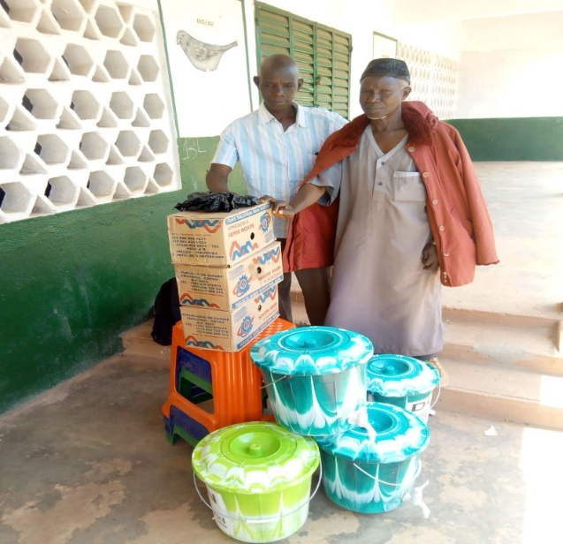
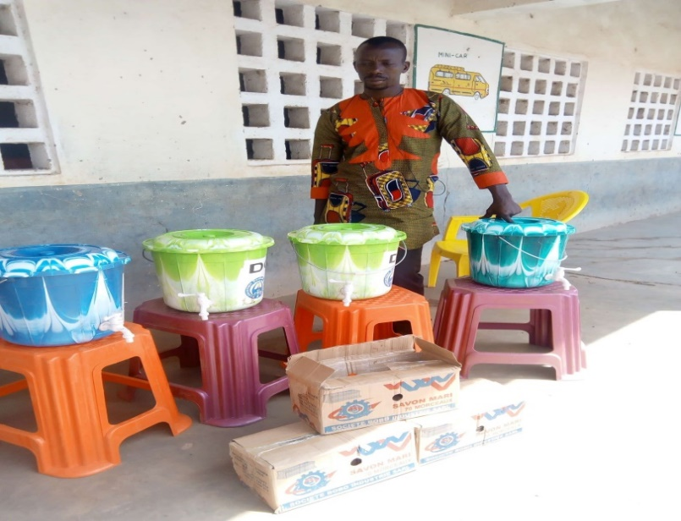
Distribution of hands Washing kits in community educational centers

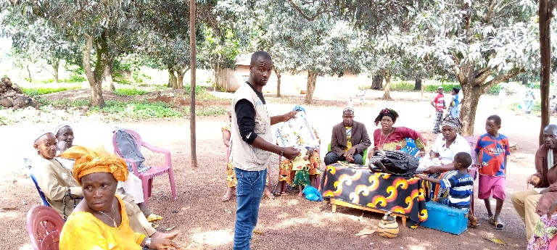
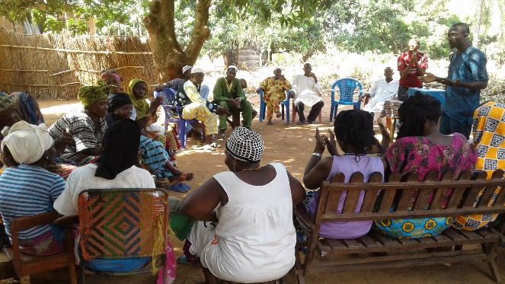
sensitization of VSL members on strengthening preventive measures against COVID-19

