ChildFund International
Humanitarian Situation Report Template

Humanitarian Situation Report [20]
COVID-19 – [Kenya]
10th March 2021
Point of Contact – Chege Ngugi, Country Director
10th February 2021 to 9th March 2021

Part 1: The Overall Situation
COUNTRY
Since 13 March 2020 when the first case was confirmed in Kenya, a total of 106,470 (Male 67,424 and Female 39,046) confirmed cases and 1,863 have died giving a case fatality rate of 1.7% have been line-listed. Of these, 105,136 cases (99%) were local transmissions. Out of the 106,470 cases, 47,092 (44%) are from Nairobi County followed by Mombasa County with 9,254 (9%). The total number of recoveries and discharges for COVID-19 is 86,860 (health Facilities 22,065, and Home-Based Care 64,795) (Kenya Ministry of Health Covid-19 Situation report of 2nd March 2021)
Total Number of COVID-19 Cases Reported | Number of Deaths | Number of Cases Recuperated
106,470 | 1,863 | 86,860
SOURCE: https://www.arcgis.com/apps/opsdashboard/index.html#/bda7594740fd40299423467b48e9ecf6

- ChildFund-supported areas (Provide only if you have reliable data on this. You can report on a consolidated basis or by program state/region/province/etc. if you have this detail.)
 | Geographical area (county) | Total Number of COVID-19 Cases Reported | Number of Deaths | Number of Cases recovered
 | Nairobi | 47,092 | Not Known | NK
 | Mombasa | 9,254 | NK | NK
 | Kiambu | 6,747 | NK | NK
 | Nakuru | 4,973 | NK | NK
 | Kajiado | 3,281 | NK | NK
 | Uasin Gishu | 3,094 | NK | NK
 | Busia | 2,969 | NK | NK
 | Kilifi | 2,801 | NK | NK
 | Machakos | 2,602 | NK | NK
 | Kisumu | 2,266 | NK | NK
 | Kericho | 1,593 | NK | NK
 | Meru | 1,290 | NK | NK
 | Nyeri | 1,161 | NK | NK
 | Laikipia | 1,086 | NK | NK
 | Kakamega | 1,048 | NK | NK
 | Kisii | 1,026 | NK | NK
 | Turkana | 1,014 | NK | NK
 | Bungoma | 993 | NK | NK
 | Migori | 947 | NK | NK
 | Murang'a | 864 | NK | NK
 | Trans Nzoia | 798 | NK | NK
 | Kitui | 757 | NK | NK
 | Garissa | 735 | NK | NK
 | Taita Taveta | 665 | NK | NK
 | Embu | 650 | NK | NK
 | Siaya | 578 | NK | NK
 | Kirinyaga | 518 | NK | NK
 | Makueni | 512 | NK | NK
 | Nandi | 500 | NK | NK
 | Narok | 488 | NK | NK
 | Kwale | 445 | NK | NK
 | Nyandarua | 398 | NK | NK
 | Bomet | 397 | NK | NK
 | Homa bay | 373 | NK | NK
 | Nyamira | 350 | NK | NK
 | Baringo | 330 | NK | NK
 | Lamu | 315 | NK | NK
 | Isiolo | 266 | NK | NK
 | Tharaka | 194 | NK | NK
 | Samburu | 191 | NK | NK
 | Vihiga | 176 | NK | NK
 | West Pokot | 171 | NK | NK
 | Marsabit | 148 | NK | NK
 | Elgeyo Marakwet | 117 | NK | NK
 | Mandera | 108 | NK | NK
 | Tana River | 104 | NK | NK
 | Wajir | 85 | NK | NK
 | SOURCE: National Ministry of Health or other reliable source

Any relevant background information about areas affected.
As of 2nd March 2021 Nairobi, and Mombasa Counties have the highest attack rates of COVID-19 at 1,071 and 765.8 per 100,000 population respectively when compared to 223.8/100,000 for the whole country and need enhanced interventions. Besides, the COVID-19 outbreak has so far spread to 100% of the counties in the country. Risk communication, laboratory testing, and contact tracing have been identified as key challenges.
All the 26 counties in which ChildFund Kenya operates are affected.

Host government posture: Have they declared a state of emergency and/or requested outside assistance? Which nationwide measures has the government taken, e.g., limitation on meetings, internal travel, school closures etc.
The government has provided several directives the first being on 13th March 2020 when the first case was reported in the country. The latest announcements that were made on 2nd January 2021 by the President included:
- Extension of the nationwide curfew up to 12th March 2021.
- The nationwide curfew will continue to be enforced between 10.00 pm and 04.00 am daily.
- The general directions governing religious gatherings shall remain unchanged, but any indoor religious gathering other than for the purpose of a wedding or funeral, shall be conducted in accordance with the guidelines issued by the Inter Faith Council and with all other applicable Ministry of Health guidelines and protocols remaining in force.
- All forms of public events and gatherings which may act as ‘super spreader’ events for COVID-19, including political and roadside gatherings/meetings, shall remain suspended.
- Funerals/burials and weddings to be conducted with prior approval and with the number of persons being capped at a maximum of 150 persons, and only if the venue can accommodate that number of persons while adhering to all applicable guidelines and protocols.
- Prohibition of all overnight vigils or events of any kind.
- All isolation facilities in the Country shall continue to be maintained at a high state of preparedness through continuous capacity building of healthcare workers, provision of adequate Personal Protective Equipment (PPE) for healthcare workers, and the continuous implementation of Infection Prevention and Control measures.
- The County Governments to enhance investment in piped and portable oxygen capacity in all isolation and critical care treatment facilities for the management of severe Covid-19 cases.
- With the re-opening of learning institutions on the 4th of January 2021, all schools shall ensure that they have adequate handwashing stations corresponding to their student population, in line with the guidelines issued by the Ministry of Health and the Ministry of Education; schools experiencing water problems must ensure that there is adequate availability of hand sanitizers for both the students and the teachers.
- All non-essential visits to schools by parents and guardians are prohibited and should only be allowed in exceptional circumstances – in fidelity with the guidelines issued by the Ministry of Education; with all visitors to schools being registered in the school records and being subject to all infection prevention protocols.
- All Teachers and Students shall wear appropriate facemasks when in the school premises or within school transport, in addition to strictly applying hand-hygiene and physical spacing.
- All extra-curricular activities such as sports, drama, music, and prize giving days, involving more than one school remain prohibited for the next 90 days; and all exchange visits between schools shall remain prohibited for the same period.
- The Principal/Headteacher of every school shall maintain a register of all sick pupils/students or teachers, and immediately inform the County Health Department of all instances of moderate to severe illness; and
- The County Health Departments to carry out routine surveillance for COVID-19 and other public health problems in all schools, including random sampling of pupils, teachers, and ancillary staff.

What responses has the government put into place to address the health crisis and/or the economic impact?
- Response efforts continue to be coordinated through a whole government and multiagency approach following Executive Order No. 2 of 2020 issued by His Excellency the President on 28th February 2020.
- The Diagnostic capacity in the Country has been scaled up. A total of forty-three (43) public and private laboratories in thirteen (13) counties (Nairobi, Kisumu, Mombasa, Kilifi, Wajir, Kericho, Uasin Gishu, Machakos, Busia, Nakuru, Kajiado, Trans Nzoia, and Mandera) are currently conducting confirmatory tests for COVID19.
- The National Emergency Response Committee and the Kenya National Immunization Technical Advisory Group endorsed the introduction of the COVID-19 vaccine in Kenya. To be done in the context of the National Routine Vaccines and Immunization Program.
- COVID-19 Vaccine Technical working group has been gazetted.
- A National COVID-19 Deployment and Vaccination Plan, 2021 Deployment - draft plan has been developed.
- On 4th March 2021 Health Cabinet Secretary Senator (CS) Mutahi Kagwe received a consignment of 1.02 million doses of AstraZeneca Covid-19 Vaccines at the Jomo Kenyatta International Airport. The CS said the vaccination exercise will be carried out on a priority basis starting with the more than 400,000 health workers countrywide followed by teachers, security officers and persons with underlying issues.
- President Uhuru Kenyatta has cautioned Kenyans including the media against peddling falsehoods on Covid-19 national vaccination exercise.

- What travel restrictions has the government put in place for travelers entering the country?
The latest travel directives are:
- All Passengers in public and private vehicles must wear masks and always maintain hand hygiene while within the motor vehicle.
- All public service vehicles shall observe a strict 60% maximum carrying capacity limit.
- Local Air Travel within Kenya resumed on Wednesday, 15th July 2020, in strict conformity with all applicable guidelines and protocols from both the Ministry of Health and civil aviation authorities.
- International Air Travel into and out of Kenya resumed on 1st August 2020, in strict conformity with all protocols from the Ministry of Health, local and international civil aviation authorities, and any additional requirements applicable at the ports of departure, arrival or transit.
Part 2: The Situation in Areas Where ChildFund Works

Partner Organization (Use Salesforce identifying code/name.) | # of Enrolled and Sponsored Children |  | COVID-19 Cases Reported in ChildFund Communities (Y/N/Unknown) Provide number if available. | Number of Enrolled Children Reported with COVID19 (If available.) | Number of enrolled children deceased as result of COVID19
 | Sponsored | Enrolled
1450001 (Eastern Community Development Program) | 4152 | 5247 | Unknown | No | No
1450002 (Nairobi Metropolitan Program) | 3530 | 4438 | Unknown | No | No
1450003 (Lake region Development Program | 3213 | 4311 | Unknown | No | No
1450004 (Emali Dedicated Program Area) | 2671 | 3606 | Unknown | No | No
1450005 (Pioneer Child Development Program) | 3421 | 3884 | Unknown | No | No
1450006 (Kisumu Development Program) | 3590 | 5282 | Unknown | No | No
1450008 (Central Rift Community Development Program) | 3602 | 4667 | Unknown | No | No
1450009 (Nawiri Child Development Programme) | 2169 | 3323 | Unknown | No | No
1450010 (Samburu Children’s Programme) | 2866 | 3979 | Unknown | No | No
1450011 (Childrise Development Programme) | 2033 | 2844 | Unknown | No | No
1450012 (Ewangan Child Development Programme) | 1988 | 3217 | Unknown | No | No
1450013 (Mt. Kilimanjaro Child Development Programme | 1968 | 3188 | Unknown | No | No
1450014 (Frontiers Children Development programme) | 1228 | 2180 | Unknown | No | No

Child deaths: List any sponsored child (with Partner organization and child ID from salesforce) diseased as a result of COVID-19. (Note: These need to be reported immediately following the regular sponsorship protocols.)
None.
Partner Organization (Use Salesforce identifying code/name.) | What is the status of the program/sponsorship processes (operational/suspended)?
 | Program Implementation | CVS | M&E  Level 2 | Enrollment /Disaffiliation | Sponsorship Communication | DFC
1450001 (Eastern Community Development Program) | Operational | Operational | Operational | Operational | Operational | Operational
1450002 (Metropolitan Childcare Organization) | Operational | Operational | Operational | Operational | Operational | Operational
1450003 (Lake region Development Program | Operational | Operational | Operational | Operational | Operational | Operational
1450004 (Emali Dedicated Program Area) | Operational | Operational | Operational | Operational | Operational | Operational
1450005 (Pioneer Child Development Program) | Operational | Operational | Operational | Operational | Operational | Operational
1450006 (Kisumu Development Program) | Operational | Operational | Operational | Operational | Operational | Operational
1450008 (Central Rift Community Development Program) | Operational | Operational | Operational | Operational | Operational | Operational
1450009 (Nawiri Child Development Programme) | Operational | Operational | Operational | Operational | Operational | Operational
1450010 (Samburu Children’s Programme) | Operational | Operational | Operational | Operational | Operational | Operational
1450011 (Childrise Development Programme) | Operational | Operational | Operational | Operational | Operational | Operational
1450012 (Ewangan Child Development Programme) | Operational | Operational | Operational | Operational | Operational | Operational
1450013 (Mt. Kilimanjaro Child Development Programme | Operational | Operational | Operational | Operational | Operational | Operational
1450014 (Frontiers Children Development programme) | Operational | Operational | Operational | Operational | Operational | Operational

Note: As a global measure, all sponsor visits have been suspended.
What issues are children in these areas facing (food shortages, safety concerns, schools’ closure, etc.)? As the country has reopened schools for in-person learning after the COVID-19 pandemic peaked in late July – early August 2020, the Government developed a COVID-19 surveillance system that will ensure students and staff keep safe.
It shall involve the proactive collection of data from all schools and teaching institutions through the administration of a standardized tool by teachers to identify suspect COVID-19 cases for public health action.
Child protection risks caused or exacerbated by crisis.
Reports of increased teenage pregnancies, SGBV especially FGM, early marriages and domestic violence continue to be reported by the media and some government agencies.
There have been reports of many children not reporting back to schools as had been expected due to a number factors such teenage pregnancies, lack of school fees, being employed and/or engagement in income generating activities to eke a living
Part 3: ChildFund’s Response
3.a. Overall
Who is or will be leading/managing the response? Country Director, supported by the Senior Management Team (SMT)

How is ChildFund linked with humanitarian coordination structures, i.e., in which clusters or working groups do we participate? The most recent/next meeting and who is representing ChildFund? Donor meetings we have attended, or missions that we are aware of related to the response?
ChildFund Kenya continues to participate and attend most of the coordination committees and groups of child focused NGO, including national and County government COVID-19 coordination forums. Some of the meetings/forums we are participating are:
- UN led meetings on ongoing response efforts.
- INGOs humanitarian forum on intervention and coordination of response
- COVID Response Subgroups on Informal Settlements; People Living with Disability, ASALs/Pastoralists, Youth and Children, M&E Surveillance and Research and Gender
- Kenya Humanitarian Partnership Team (KHPT) composed of UN, Government, INGOs and donors such as USAID.
- Private Sector driven COVID-19 Response initiative- Pamoja Imara
3.b. Program Response
Please organize your program response report as per the 4 objectives included in our global response plan. You can add an additional category if you have response activities planned or executed that do not align with these objectives. For each objective use the questions below to guide your report.
What kind of response activities or interventions have been executed? What support items are needed or have been collected/distributed?
-Detailed below in section 3.b
What is the current progress of implementation vs. the established response plan?
All the 12 LPs and the Nairobi Metropolitan Programme (direct implementation by the CO) are implementing response activities.

Who are we partnering or collaborating with to provide our response?
Collaborators and partners in the COVID-19 Response include:
- All the 12 Local Partners
- County governments in the 26 counties
- National Government ministries and departments specifically Ministry of Health, Ministry of Labour and Social Protection, National Council for Children etc
- NGOs affiliates – Joint Forces Alliance, Girls not Brides
- CSO Forums – COVID-19 Community Engagement Working Groups
- Private Sector Corporates – Coca Cola, Dow Chemicals, and Proctor and Gamble

What kind of response activities are you still planning for the coming period?
- Cash Transfers
- WASH – Sanitizers, Soap, Water storage facilities, handwashing stations and vessels
- Awareness and sensitization
- Child Protection activities – Community Based Child Protection Mechanism supports, Child Friendly spaces
- Direct food distribution and other protective items.
3.b.1. Stop COVID-19 from infecting children and families.
ChildFund’s Global Response Plan
To help children and families protect themselves from COVID-19, we are installing community, handwashing stands; educating communities about symptoms, hygiene measures and where to get tested or treatment; and distributing soap, hand sanitizer, gloves, and masks to families and frontline, health workers.
- In Machakos and Kitui Counties, the LP through the WASH projected (funded by Procter & Gamble) engaged 20 Community Health Extension Workers (CHEWs) and 80 Community Health Volunteers (CHVs) in conducting health education in 23 primary schools on Covid-19 virus reaching 1765 pupils (boys 870 and girls 895). The 300 Community Health Volunteers (CHVs) carried out sensitization for 12,000 households on the importance of personal hygiene as well as prevention of Covid -19 virus. Over 28,000 children in the schools and 32,000 community members were reached. Further Community Dialogue Days were conducted where a total of 303 community members were reached.
- In Kajiado County, the LP, Ewangan Children Development Programme provided handwashing vessels and soap to one school, Naningoi Girls boarding primary School benefiting a total of 320 girls and 12 teachers.
- In Nairobi County, ChildFund through its Nairobi Metropolitan Programme (NMP) distributed a total of 238 mask to 96 households in Mukuru informal settlement.
- In Nyeri south, Kieni East and Buuri Sub Counties, 27 Community volunteers and 10 CBCPM data collectors were supported with hand sanitizers and facemasks. This enabled them to interact with the caregivers and children during data collection and letters processing activities. An additional 52 HHs with children under 5yrs were supported with handwashing vessels under the covid-19 prevention emergency programme.
- In Homabay County, the LP, Lake Region Development Programme (LRDP) supported 13 Schools with 3,138 children; boys – 1600 and girls – 1,538 and 135 teachers with hand washing vessels, further hygiene and sanitation sensitization was carried out in a total of 20 primary schools with a population of 4,222 children; 2054 boys and 2168 girls and 208 teachers.
3.b.2. Ensure that children get food they need.
ChildFund’s Global Response Plan
To ensure that the most vulnerable families can keep food on the table, pay rent and cover other basic needs, we are providing cash for those families most needing this support, such as those who have lost their income because of COVID-19, child or elder-headed households, and/or households affected by disability or chronic illness. Where possible, we are distributing food and basic household items directly, carefully abiding by COVID-19 protection measures.
The LP in Machakos County, Eastern Community Development Programme (ECDP) facilitated 28 Community Based Trainers (CBTs) to carry out follow ups to 71 groups on saving and loan activities for livelihood interventions. This is enabling the members to sustain their livelihoods during these hard times occasioned by Covid-19.
Emali Dedicated Children’s Agency (EDCA) supported 2 (1male, 1female) CHVs to conduct post monitoring evaluation of 41 caregivers (15male, 26 female) and 164 children (81boys and 83 girls) who had been supported with food basket in Kajiado County.
In Nairobi County, ChildFund through its Nairobi Metropolitan Programme (NMP) provided food supplements 850 HHs with children under 5 in Mukuru and Kasarani.
In Nyeri County, the LP, Pioneer Child Development Programme issued 17 dam liners and 15 drip kits and trained 32 caregivers to improve their farm productivity, additionally, 150 families were provided with chicken as seed capital to improve the nutritional status of their children as well as improving the HH income to cater for basic needs during the Covid-19 pandemic.
In Marsabit County the LP, Nawiri CDP supported 200 Pregnant and Lactation Women with food rations each benefitting from 25Kgs of Maize, 11.25 Kgs of beans and 1.5 litres of fortified cooking oil.
In Nakuru County, ChildFund Kenya through its Local Partner, Central Rift CDP supported 80 enrolled households with cash transfer of KES 3,000.00 each. This will go a long way in benefiting additional 354 household members to access nutritious food.
3.b.2. 1. Cash Transfers and vouchers
Is your CO planning or implementing cash transfers or vouchers as part of COVID19 response? Yes
- In February one of the Local Partners undertook cash transfers
Cash transfers or vouchers executed.
Cash transfer to 80 households was executed in Nakuru County in the month February.
3.b.2.2. Other responses in relation to objective 3.b.2.
None
3.b.3. Keep children safe from Violence: physically and emotionally.
ChildFund’s Global Response Plan
We are supporting community-based child protection systems that identify, respond to and refer cases of abuse, neglect, violence or exploitation. We are also providing virtual, online psychological first aid and counseling, and supporting temporary shelters for children who live on the street, providing hygiene supplies, food and other basics. We are also arranging safe and appropriate care for children who are separated from their caregivers due to treatment or prevention measures.
- In Machakos and Kitui Counties, the LP, Eastern Community Development Programme worked with the Child Welfare Protection Committees to sensitize caregivers on child Protection. The sensitization meetings were undertaken at zonal levels by the 42 Child Welfare Protection Committee Members.
- In Narok and Kajiado Counties, LP- Ewangan CDP continued with the monitoring of vulnerable children in the community through the local administration to ensure they resume learning and their safety from child protection risk.
- In Isiolo County, the LP, Nawiri in partnership with the county government developed an integrated child development action plan which guides children activities within the county. This Action plan will inform operations of development partners in the county.
- In Samburu County, the LP, SCP facilitated the child protection technical working group meeting on planning for zero tolerance to FGM campaign 60 people (Male 40, Female 20) participated.
3.b.4. Help children continue to do their job: Learning
ChildFund’s Global Response Plan
With the reopening of schools, we are supporting children to access learning in safe environment and continue to access learning program at home through various activities including provision of hygiene and sanitation items in schools, learning materials, provision of school fees and solar powered radios for use at home.

In Machakos and Kitui Counties, 32,000 caregivers were sensitized on parenting including children upholding good morals and discipline and addressing the social effects of the pandemic on the children and negative peer influence after staying out of school for quite long time.
In Kajiado County, EDCA supported 6 youth (4females, 2male) to access e-learning at EDCA’s Youth resource centre. The youth were able to access the internet, access school notes to enable them keep up with their schoolwork, professional online writing for online writers and brighter Monday for those looking for jobs.
EDCA also supported 60 children (27male,33female) in Secondary School with school fees after their families were affected by covid-19. Another 11 children (6male, 5 female) with special needs were also supported with fees and learning materials to attend schools in various institutions for children with special needs.
LP-Pioneer distributed covid-19 IEC materials, posters to 18 primary schools in Naromoru this benefited a total of 226 teachers and 2140 pupils.

3.b.5. Other responses

Below Sections for Internal Use Only
Part 4: Office and Staff Status
Office Status (Open/Closed) | Number of Staff:
 | Diagnosed with COVID-19 | Diseased from COVID-19 | Working from Office | Working from Home | On Special Leave
Open and adopted the rotational work arrangement- 10-4 Approach | None | None | 10-4 Approach adopted | 10-4 Approach adopted | None

Notes:
- Any cases of staff diseased need to be reported immediately to RD and GHR.
- Special leave as per COVID-19 Administrative Guidelines.
Number of staff/partner organization staff completed WHO COVID online training https://www.who.int/emergencies/diseases/novel-coronavirus-2019/training/online-training.
The confirmed number of staff who have completed the course is 96% of total staff. This is verified by the certificates received by the HRD.
Part 5 Human Resources
Which visitors are there in the country? Please include names, functions, contact information and arrival/departure dates for both IO and RO staff (note: due to the travel ban, this will apply only once the ban has been lifted)
None
Any gaps in staffing/need for deployment from other COs or Global Teams? No
Are there any other major HR issues? No.
Part 6 Safety & Security
Are police and other services functioning in the normal manner?
Yes.
Are the courts still operating?
Courts have resumed normal operations (in-person hearings) especially on bail cases; however, only a small number of persons are allowed in the courtroom. This is to ensure compliance with the government directive on social gathering.
Are there reports of looting or increased criminality?
Criminality has continued to increase across the country with armed crime and home invasions targeting residences dominating in the high – end estates. Low-income settlements have also been affected with assailants largely targeting pedestrians. An upsurge in cybercrimes since the onset of the Covid -19 linked to the formalization of online centric frameworks e.g., Mobile banking, and online transactions have also been reported across the country.
On 7th March, six suspects were arrested over cybercrimes in Kasarani, Nairobi County.
On 5th March, an individual snatched a firearm from a traffic police officer near the Kisumu Bus Terminus in Kisumu County killing three people and injuring several others.
On 2nd March, two armed criminals were arrested after targeting civilians in robberies, Ridgeways, Kiambu Road.
On 2nd March, suspected criminal was killed in police shooting, Mariguini area in Kiambu County.
On 20th February, commuters were robbed their belongings at bus terminus by assailants armed with bladed weapons in Thika Bus Terminus, Kiambu County.
On 19th February, two suspects were arrested by police at two residences located along Wanyee Road and Gitanga Road after they allegedly defrauded an Australian national of KES 6. 4 million
(USD 58 397) in a fake gold scam.
On 11th February, MPesa vendor was shot dead and another injured following armed robbery in Kaloleni, Mombasa County.
On 11th February, police shot dead an armed assailant in Umoja Phase - 3 while two others escaped on board a boda boda (motorcycle taxi).
Have military personal being deployed to patrol towns or cities?
No.
Confirm the safety of staff and their families in the affected area.
Staff and their families are safe.
Have safety and security risks/mitigation plans been updated to current environment?
Yes. The CO has in place the Covid -19 Contingency plan aimed at addressing the main aspects of dealing with Covid -19 at the organization level. It includes preventive, protective and containment measures that lower chances for transmission of Covid -19 amongst staff and subordinates at the workplace.
The CO has adopted 10 – 4 approach where staff have been placed into two working groups. Each group works from the office for four working days and then from home for six subsequence working days. The purpose of this is to significantly reduce the level of exposure to staff by ensuring only minimal number is present in the office.
The CO Covid -19 Contingency plan is reviewed on quarterly basis with the current one running until June 2021.

Recommendations around any upcoming travel planned for staff or donors (note: Only once global travel ban has been lifted)
Despite the government opening international commercial flights in the country since August 2020, CF International global travel ban is still on unless on emergency assignment or mission where a staff must fill in “travel request form” and gets approvals from the Country Director, and travel clearance from the Global Safety and Security Director.
It is also important to note that, as of 11th January, the Ministry of Health (MoH) announced that all individuals arriving or departing Kenya must present a negative PCR based COVID -19 test certificate conducted within 96 hours prior to travel that has been digitally verified through the Africa Centres for Disease Control and Prevention (Africa CDC) Trusted Travel (TT) Initiative. The revised test requirements ensure that travelers present testing samples to authorized laboratories that will in turn issue valid COVID 19 test results and TT codes that can be further corroborated by airline operators and port health authorities.
On 7th March, Kenya Civil Aviation Authority (KCAA) issued 14-day mandatory quarantine to travelers for six states that is, Brunei, Czech Republic, Kuwait, Spain, Switzerland, and Thailand at own cost upon arrival into the country effective from 8th March 2021.

Part 7 Grants
List all active grants:

Grant Job Code | Grant Name | Donor | Status of Implementation (Normal/Reduced/Suspended) | Any specific guidance received from donor? (Yes/No)
12-0414 | KEN-Nanny III- Youth Entrepreneurial and Livelihood Development -2018-BMZ | ChildFund Germany | Reduced | NO – Sent communication to donor awaiting response
12-0412 | KEN-Tharaka Nithi-Child protection project-2018 | ChildFund Korea | Reduced | Donor approved reprogramming for COVID response
25-039 | KEN-Early Childhood Development-2018 | Conrad N Hilton Foundation | Most activities suspended, reduced in activities | Received Micro-grant for USD 5,000, responding towards COVID 19
12-0429 | Nanny 3 -Ken | ChildFund Deutschland | Reduced | NO – Communicated to donor awaiting response.
25-055D | KEN-Safe Drinking Water Phase II-2019 | Procter and Gamble | Reduced | NO - Sent communication to IO donor focal person awaiting response. Approval received to reprogram and extra funding to be received to reach an additional 3,000HHs not originally in the project. – Through the donor IO allocated additional funds to respond to COVID, updated below.
12-0375 | KEN-MFAT-ADED Project -ChildFund New Zealand | ChildFund New Zealand | Reduced | NO – communicated to ChildFund New Zealand donor focal person.

Provide any additional narrative on how the COVID-19 crisis affects implementation of your major grants.

Part 8 Funding
Provide information about potential sources of funding, including grant donors, subsidy, Emergency Action Fund, Alliance members, GIK, etc., for these emergency response efforts using the chart below:
Donor | Program | Amount (USD) | Requested? (Y/N) | Confirmed? (Y/N)
TALA | WASH (COVID-19) | 0 | Y | Y – Donor withdrew this funding, and it will no longer be available.
ChildFund Korea | EMERGENCY (COVID_19) | 104,900 | Y | Y
IO (Philanthropy) | WASH (COVID-19) | 4,471 | Y | Y
Subsidy | WASH (COVID-19) | 20,000 | Y | Y
Conrad N Hilton | Child Protection (COVID-19) | 5,000 | Y | Y
Coca-Cola Bottlers Africa | WASH -COVID-19 | 6,300 | Y | Y (In Kind – Handwashing stands)
IO Philanthropy team | WASH-COVID-19 | 1,000 | Y | Y
IO Philanthropy team | WASH-COVID-19 | 10,000 reviewed downward to $9,752.50 | Y | Y
Standard Chartered Bank | Livelihood and  Learning -COVID-19 | USD 234,334  USD 247,258 | Y | Y—Not successful.  A new proposal submitted for phase II. – Feedback received and Standard Chartered will not be in a position to fund second submission
Emergency Response to COVID – 19 in Kenya | COVID -19 response | USD 642,199 | Y | Y – Funded and implementation started on 24 August 2020.
Emergency COVID Response – Procter & Gamble | COVID -19 Response | USD 26,874 | Y | Y
Post COVID-19 Support to Communities | COVID 19 Response | USD 1,426,914 | Y | New proposal submitted to KOICA  Feedback received from donor and not shortlisted to proceed to the next stage.
COVID-19 Response in Mukuru Informal Settlements -  IO Emergency Fund | COVID 19 Response | UDS 25,000 | Y | Y  Received funding from IO EAF funds
Tuchanuke OCP (Let’s Wise Up – Online Child Protection) Google Africa Online Safety Fund | Online Sexual Exploitation – Increased due to opened up technology and COVID pandemic leading to access to online services. | USD 65,000 | Y | N – awaiting modification of the proposal – Application request was $100,000, donor has confirmed an available funding of $65,000

Part 9 Media/Communications
  - List of media who will be or have been contacted with press releases.
  - List of emergency CO spokespeople, including name, location, contact information, and languages spoken. Chege Ngugi, Country Director

  - Plans for collecting photos/videos/stories, e.g., should an outside photographer be hired? There is need to document the life of one of some of our sponsored families as they maneuver the tough COVID-19 times especially caregivers and the children in informal settlements in Nairobi.

  - Publications
None
- Filming
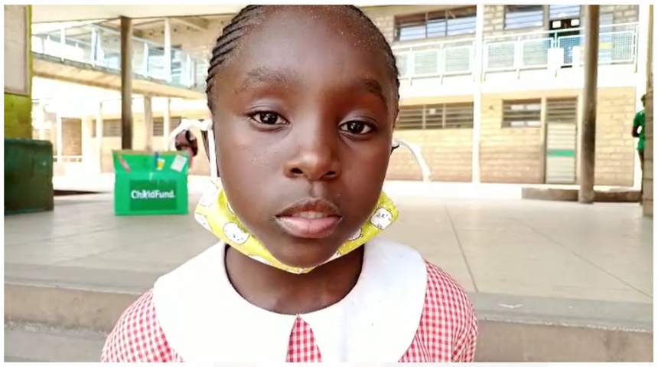
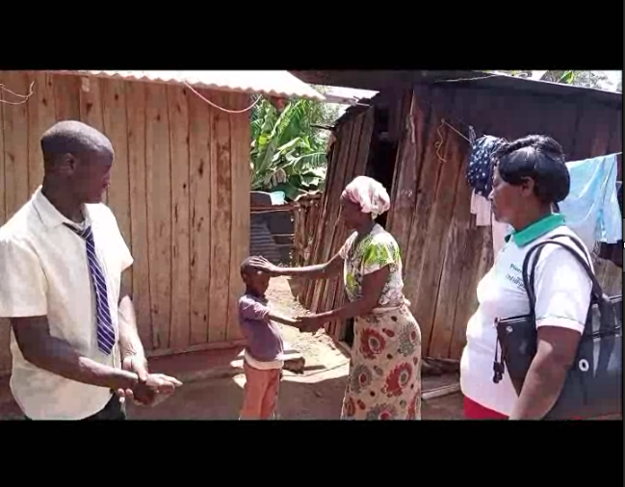
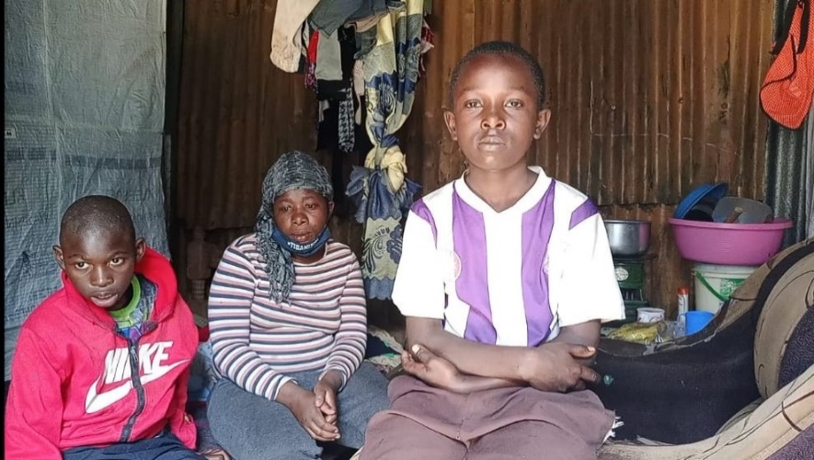
The CO conducted video interview of children formerly interviewed for TV by SBS a Korean TV station when the ChildFund Korea team visited in 2018. The children were interviewed in Nyeri and Nairobi counties. We also conducted interview for children who received face masks at Mukuru Pri. School.

  - Media engagements:
- To commemorate the International Day of Zero Tolerance for Female Genital Mutilation 2021the Comms Specialist published an OPED on how survivors of FGM can become champions against it .
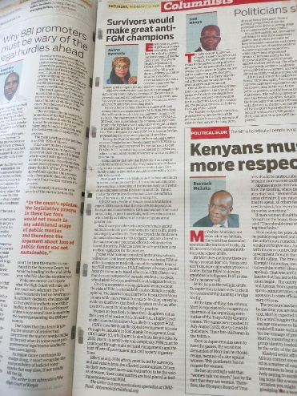
https://www.standardmedia.co.ke/opinion/article/2001403203/survivors-would-make-great-anti-fgm-champions

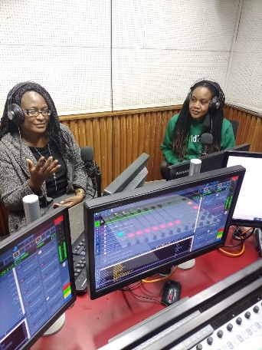
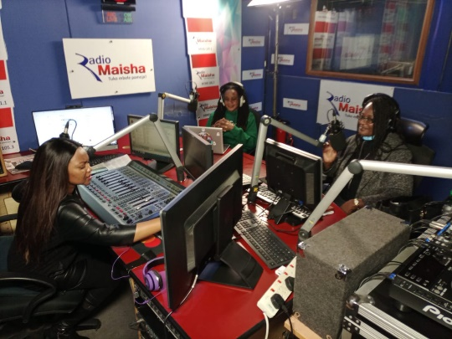
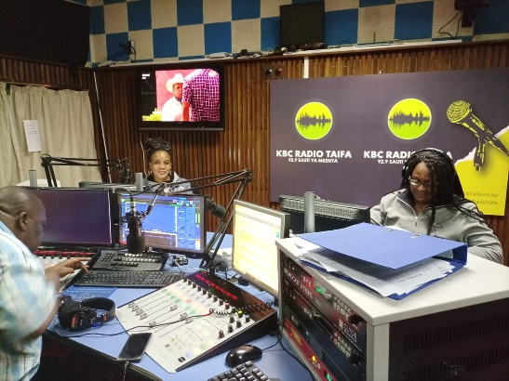
- The Child Protection and Advocacy Manager with support of the Comms Specialist also took part in radio programs on KBC English, Radio Taifa and Radio Jambo to sensitize the public on the risks/dangers of FGM and deter them from practicing this outlawed practice.

- Masimba Press release:
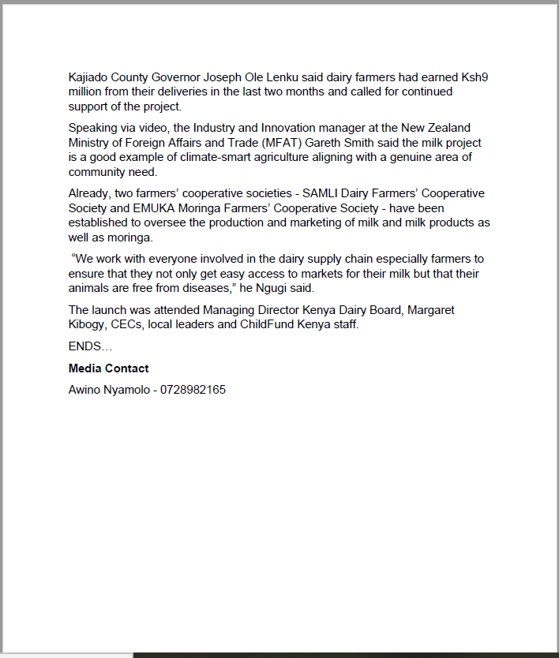

- Masimba media coverage:
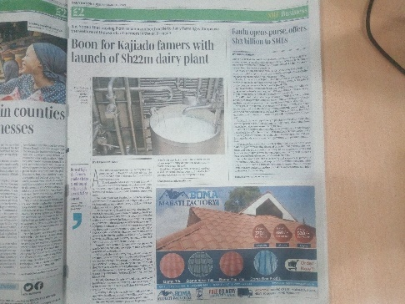
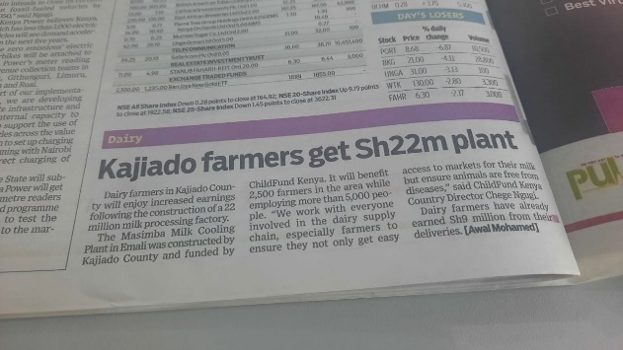
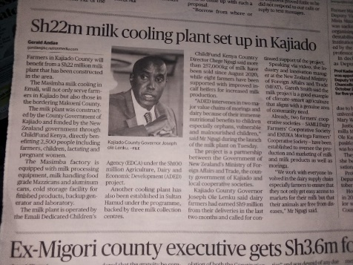
Newspapers
Daily Nation
The Standard
Business Daily
- 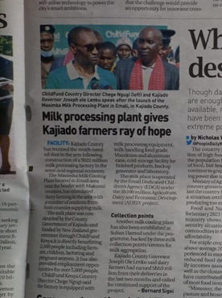
- People Daily
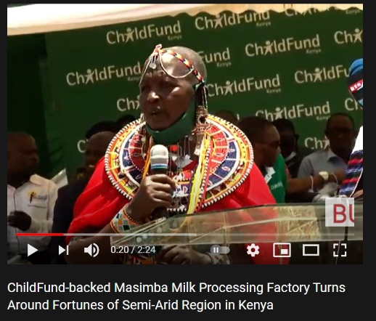
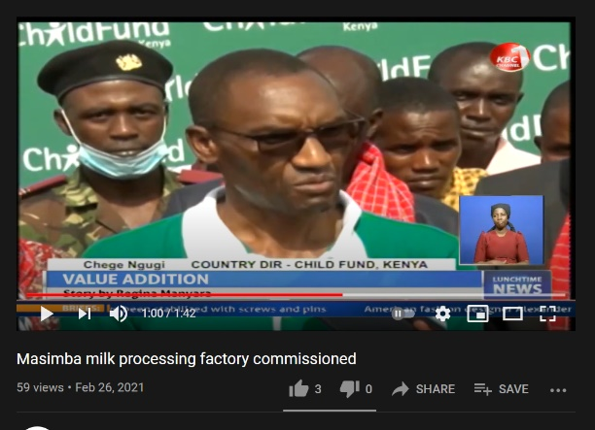
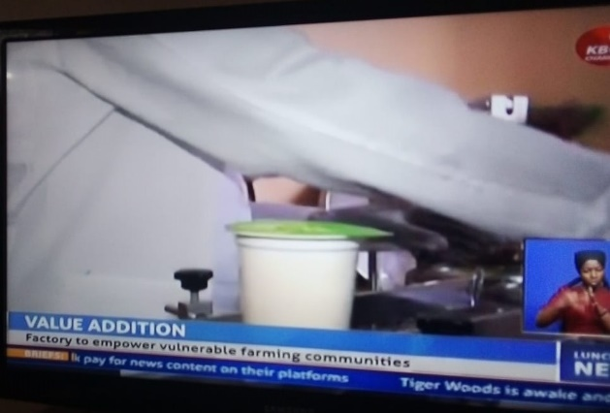
- Masimba TV coverage:
Business Today TV Kenya
KBC TV
Citizen TV

Masimba online links:
- https://www.youtube.com/watch?v=tRKd-QnjgfI&feature=emb_imp_woyt
- https://businesstoday.co.ke/masimba-milk-processing-plant-changes-fortunes-of-semi-arid-region/
- https://youtu.be/JFaEy4D2IT8
- https://businesstimes.co.ke/milk-processing-plant-changes-fortunes-for-semi-arid-region/
- https://biznakenya.com/milk-processing/

- Key points for messaging and visibility, particularly any host-government sensibilities that must be considered.
None in the reporting period
- Support needed or requested from IO, GSS or Global Teams – whether onsite or remote.
None at this stage

