ChildFund International
Humanitarian Situation Report Template
Humanitarian Situation Report [1]
COVID-19 – [MEXICO]
[March 9th, 2021]
[Point of Contact – Morgane Bellion, Program Manager/CO S&S Focal Point]

FOR UPDATES, PLEASE HIGHLIGHT UPDATED SECTIONS IN RED

Part 1: The Overall Situation
COUNTRY
Total Number of COVID-19 Cases Reported | Number of Deaths | Number of Cases Recuperated
2,130,477 | 190,923 | 1,675,996
SOURCE: https://coronavirus.gob.mx/ and Secretary of State, March 8th .

Mexico Federal government makes a formal announcement every day at 7:00 pm to share the official update of the situation of Covid-19 spread in the country. Unless another date is mentioned, all the information shared in this report is updated to this day (March 8th)
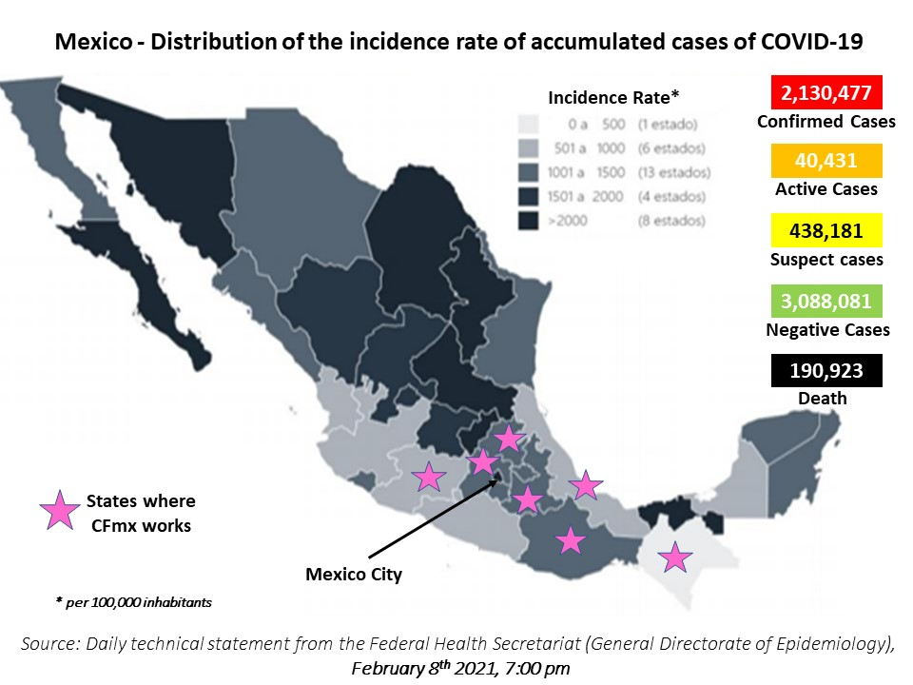

ChildFund-supported areas
Geographical area (city or State) |  | ChildFund presence | Total of Confirmed Cases | Total of Active Cases | Suspect cases | Number of Deaths | Number of Cases Recuperated
Mexico City |  | Country Office staff | 571,315 | 16,073 | U | 36,549 | U
Chiapas |  | 1 LP | 10,101 | 89 | U | 1,348 | U
Estado de México |  | 2 LPs | 221,759 | 4,596 | U | 21,764 | U
Hidalgo |  | 7 LPs, Confio grant | 35,166 | 545 | U | 5,534 | U
Michoacán |  | 2 LPs, ArcelorMittal grant | 43,743 | 398 | U | 4,563 | U
Oaxaca |  | 3 LPs, Confio grant | 41,665 | 753 | U | 2,898 | U
Puebla |  | 3 LPs, Walmart grant | 72,904 | 1,539 | U | 9,256 | U
Veracruz |  | 1 LP | 55,852 | 602 | U | 8,159 | U
 | SOURCE: National Secretary of Health, https://coronavirus.gob.mx/

Since our last SitRep (February 9th) the trend at State level in our areas of intervention, has been the following:
Variation from Feb. 7th to March 8th
 | Feb. 7th | March 8th | Accumulated | Active | Death
Ciudad de México |  |  | 14% | -38% | 19%
Estado de México |  |  | 11% | -37% | 14%
Veracruz |  |  | 7% | -42% | 12%
Puebla |  |  | 14% | -18% | 23%
Michoacán |  |  | 6% | -45% | 19%
Oaxaca |  |  | 14% | 16% | 14%
Chiapas |  |  | 5% | -59% | 5%
Hidalgo |  |  | 7% | -34% | 14%
National total |  |  | 10% | -47% | 15%

As mentioned before, those figures are to be taken with caution as they only show the officially registered cases and depend on the facility to access to test. We will share in the next sections more specific information about the recent trends at LP’s level.

Background information | The coronavirus pandemic continues its expansion in Mexico and the rest of the world in its second wave of infections, with a renewal of containment measures to cut the chain of transmission, at a time when many regions present their highest figures since the beginning of the crisis.
The production of vaccines allows for a ray of hope, in Mexico Pfizer laboratory has already formally requested the Mexican authorities to receive approval for use. In that sense, the health authorities presented this Tuesday (Dec. 8th) the vaccination plan against Covid-19 so that, once the use of the vaccines is approved, a massive campaign will begin.
The plan consists in several phases to target priority groups established by age and condition, the first group being conformed by health personnel working directly to attend the pandemic, with 125,000 Pfizer/BioNTech vaccines available between December and February. The next groups will be based on age ranges, starting in February with population above 60 years old, and ending between June 2021 and March 2022 with the population under 40 years old. The National Autonomous University of Mexico UNAM) launched a call to its students and academics from Medicine, Nursing and Dentistry careers to be part of the vaccination campaign within the university campus, as the institution already contemplates the possibility of actively participating in the massive vaccination and seeks to advance the training process.
Based on the current figures, Mexico ranks thirteenth in the world in the number of infections and third with the most deaths from the pandemic, behind the United States and Brazil, according to the US Johns Hopkins University. Mexico City and the State of Mexico have the highest number of estimated active cases of Covid-19; while Campeche State has the lowest figure. The capital of the country has the highest incidence rate of active and accumulated cases, with 178 and 6 thousand 365 confirmed infections per 100 thousand inhabitants.
According to data from the Ministry of Health, collected by the UNAM, about 45.25 percent of the people who have died from coronavirus in Mexico had hypertension, the comorbidity mostly found among deaths with covid-19.
Regarding the details of the vaccination plan, the Director General of the National Center for Preventive Programs and Disease Control, Ruy López Ridaura, reported that, at the nationwide cut-off at 5pm this Tuesday, March 8th, that 202,701 doses of the vaccine has been applied to adults over 60 years old - this figure has not broken the record of more than 300 thousand injections against the SARS-CoV-2 virus applied in one day. Thus, since December 24th, 2020, when the first dose of the Pfizer-BioNTech vaccine was applied, a cumulative 3,100,868 doses have been applied, and with the implementation of the national vaccination plan, the graph has had a constant rise.
To date, 73% of the health sector staff have received the complete immunization scheme. On the other hand, 99% of the teaching staff in the state of Campeche are in the same condition – CFMX does not work in this State but as it is the first to consider a return to presential education, there is a focus on its vaccination strategy. At the same time, 1,670,263 adults over 60 years old have received at least one dose of any of the four approved and used vaccines. However, due to their recent application, none of them have received full immunization. Since the beginning of the national vaccination strategy, a total of 3,100,868 doses have been applied.
The percentage of hospital occupancy due to COVID-19 cases at the national level has decreased in the last weeks, and the rates are currently the following: 26% occupancy in general hospital beds, and 30% occupancy in beds with ventilators. Once more Mexico City tops the list nationwide for bed occupancy with ventilators with 53%.

Government posture and measures to address the health crisis and economic impact |
The official “traffic light system” by regions according to risk level is still in place:
Red = only essential tasks are allowed,
Orange = more non-essential work activities can be carried out at a reduced level, social activities in open space with reduced participants
Yellow = all work activities can operate without restrictions, lower restrictions for open public space and restricted opening of closed public space (churches, museums, cinemas ...)
Green = all restrictions lifted, but public health measures still apply. School activities are reactivated.
This system considers 5 categories of analysis and measures: public health measures | economic activities (essential and non-essential work categories) | social activities in open and closed public spaces | vulnerable population | education
Essential health measures will apply throughout all of the phases.

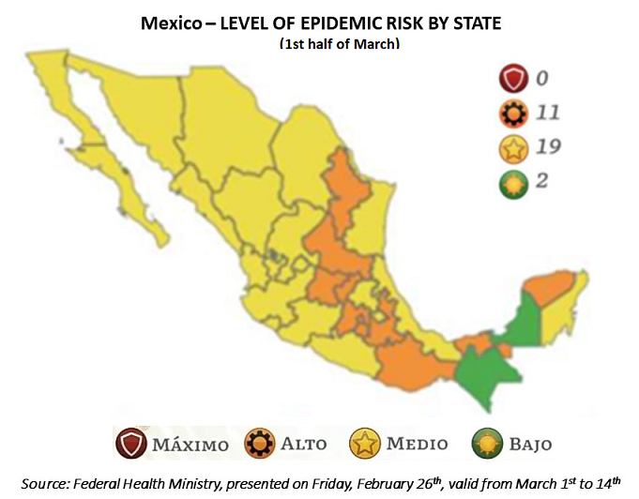
Red level implies the highest risk of virus transmission, while orange is the second-highest risk level. Under federal guidelines, states in red should only allow essential businesses to operate, such as those related to food, security, communications, public utilities, manufacturing, mining, construction, and critical health services. Residents are encouraged to remain inside their homes, except to perform essential tasks, and to wear protective face coverings whenever in public.

In the tables above and below, each State or each local partner is figured in the color corresponding to their State’s scale.

State of Emergency or requested outside assistance | not at this time.
Travel restrictions | no mandatory procedures but for now, the official recommendation is to stay home as long as possible to avoid flare-ups. Based on a common agreement, the governments of the USA and of Mexico have extended the border closure to non-essential travels until March 21st. This measure has been applied since the end of March 2020 and has been reconducted monthly so far.
Mexico is one of the few countries in the world that has not implemented restrictive measures to enter the country. So far, the only requirement is to fill out a health form.

Part 2: The Situation in Areas Where ChildFund Works

(Based on national information and information shared by the LPs, each LP is colored in the corresponding level of the “traffic light” risk scale for the current week)
Partner Organization |  | International Sponsorship |  | Local Sponsorship |  | Total enrolled | COVID19 Cases Reported in ChildFund Communities (Y/N/Unknown) if available. | Number of Enrolled Children Reported with COVID19 (If available.) | Number of enrolled children diseased as result of COVID19
# | Local Partner | Sponsored | Enrolled | Sponsored | Enrolled
1 | La Casa de los Niños de Tezonapa A.C. |  |  | 840 | 1092 | 1193 | N | n/a | n/a
1751 | Niños Unidos de Tetitla I.A.P. | 177 | 285 | 87 | 133 | 418 | N | n/a | n/a
1765 | Centro Infantil Jonacapa A.C. | 236 | 268 | 76 | 95 | 363 | N | n/a | n/a
2005 | Centro de Promoción Ocumicho A.C. | 695 | 786 | 41 | 69 | 855 | N | n/a | n/a
2068 | Yohualichan A.C. | 1289 | 1426 | 344 | 417 | 1843 | N | n/a | n/a
2165 | Centro Infantil Huextetitla A.C. | 338 | 544 |  |  | 544 | N | n/a | n/a
2516 | Desarrollo Infantil Taxadhó A.C. | 352 | 427 | 183 | 280 | 707 | N | n/a | n/a
2517 | Niños de Santa Fe A.C. | 1297 | 1452 | 79 | 104 | 1556 | N | n/a | n/a
2518 | Hñahñú Batsi de San Andres Daboxtha A.C. | 406 | 485 | 251 | 286 | 771 | N | n/a | n/a
2520 | Niños Totonacos A.C. | 2479 | 2811 | 356 | 432 | 3243 | N | n/a | n/a
2522 | Niños de Bobashi I.A.P | 816 | 945 | 504 | 589 | 1534 | N | n/a | n/a
2523 | Apoyo Infantil Hñahñú A.C. | 378 | 445 | 124 | 129 | 574 | N | n/a | 1
2839 | Niños Unidos de Ixtlahuaca A.C. | 482 | 590 |  |  | 590 | N | n/a | n/a
2842 | Sakubel K'inal A.C. | 433 | 497 | 118 | 166 | 663 | N | n/a | n/a
2843 | Hñahñú Batsi Ri Xudi A.C. | 360 | 478 | 109 | 165 | 643 | N | n/a | n/a
2924 | Org. de Apoyo y Beneficios Saucitlán A.C. | 1147 | 1329 | 79 | 116 | 1445 | N | n/a | n/a
3848 | Centro Tepelmeme A.C. | 208 | 349 |  |  | 349 | N | n/a | n/a
4285 | Niños de Magdalena Teitipac A.C. | 175 | 266 | 96 | 140 | 406 | N | n/a | n/a
9262 | Niños Acatecos A.C. | 1214 | 1446 |  |  | 1446 | N | n/a | n/a

Since the last SitRep we received updates from 1 LP reporting suspect and confirmed cases of Covid-19 in enrolled family:
LP | LP # | family | locality | notification date | situation
Niños de Santa Fe | 2517 | Arteaga Gómez | Puerto del Obispo | February 22nd 2021 | The parents have Covid-19, the family is quarantined and under medical vigilance. There are 2 enrolled children, David (child # 125037228) and Romina (child #125042612)
 |  | Cruz Guzman | Puerto del Obispo |  | Enrolled child is Monserrath (child # 125048943), her brother presented symptoms of Covid -19, therefore they are in quarantine and are being monitored.
 |  | Mendiola Garfias | La Mariel |  | Enrolled child is Lesly (child # 845068684), her mother presented symptoms of Covid -19, therefore they are in quarantine and are being monitored.
 |  | García Tellez | La Mariel |  | Enrolled child is Brayan (child # 845841952), his grandmother presented symptoms of Covid -19, therefore they are in quarantine and are being monitored.

Update about the situation in the States where CFMX works and their position vis a vis “new normal”: (data from the 1st week of March)

State | Governor | Update / State Government stance
Mexico City | Claudia Sheinbaum Pardo | The Head of Government announced the start of the first day of the Vaccination Plan for adults over 60 years of age in three municipalities: Cuajimalpa, Milpa Alta and Magdalena Contreras, after supervising different points where they were presented incidents. On Sunday, February 28th, the Ministry of Health (SSA) reported that the Undersecretary of Prevention and Health Promotion, Hugo López-Gatell, had been hospitalized since Wednesday, February 24 for coronavirus and with a favorable evolution. 92% of older adults foreseen in 6 municipalities have been vaccinated. Sheinbaum indicated that, so far, in total 92 percent of older adults have been vaccinated against the coronavirus that were planned in Tláhuac, Milpa Alta, Magdalena Contreras, Iztacalco, Cuajimalpa and Xochimilco. Mexico City remains on an orange traffic light due to covid-19 from March 8 to 14, reported Eduardo Clark, general director of the Digital Agency for Public Innovation (ADIP).
Chiapas | Rutilio Escandón Cadenas | Governor Rutilio Escandón Cadenas reported that the immunization process against COVID-19 in the older adult population of Chiapas is progressing successfully and will continue in this way until all municipalities are covered. Because in Chiapas 65.7 % of the population over 20 years old suffers from problems of overweight and obesity, the State Secretariat of Health invites the population to follow the recommendations for weight control and join the Mutual Help Groups (GAM) that are in the different medical units of the 10 health districts. All this within the framework of World Obesity Day, which is celebrated on March 4th. The federal Ministry of Health announced that Chiapas will remain on a green light for two more weeks, from March 1 to 14. In this sense, the Chiapas Ministry of Health urges the population not to lower their guard in the application of personal protection measures and join the new challenge #YoSalvoLaSemanaSanta, to contain the spread of the virus and allow people to enjoy the easter holiday.
Edo. Mex. | Alfredo del Mazo Maza | Ernesto Nemer Álvarez, head of the Ministry of Government, reported this Saturday that, as of Monday, March 1, cinemas, theaters, cultural centers and gyms will be able to open with a maximum capacity of 30 percent and with a closing time until 9 PM. • The state government asked the mayors of the 125 municipalities of the entity to know and disseminate among their population the agreed provisions after extending the orange color of the epidemiological traffic light for two more weeks due to the Covid 19 coronavirus pandemic.
Hidalgo | Omar Fayad Meneses | The vaccination day against COVID-19 began to protect the elderly in the state of Hidalgo. The municipality of Jaltocán was the first in the state of Hidalgo to begin with the vaccination of hundreds of older adults who were previously notified about the vaccination and had gathered in the vaccination module hours before. For the first time since the federal Secretary of Health implemented the epidemic risk traffic light for the covid-19 pandemic, Hidalgo will turn yellow, that is, at the medium level of the alert for the new coronavirus. However, the State Health Secretariat reported that 33 municipalities in the state will maintain the red alert color for COVID-19 infections.
Michoacán | Silvano Aureoles Conejo | The members of the State Health Safety Committee of Michoacán agreed on new rules for the standardization "without risk of Covid-19 contagion" of opining hours in commercial establishments throughout the entity. The CESSM determined that starting this weekend, shopping malls, restaurants (without bars), churches, clubs and gyms will be able to normalize their schedules. The numbers of infections and deaths reported this Thursday reflect a slowdown in the growth of the epidemic in the state, since the first weeks of February there were more than 300 infections and up to 50 deaths per day, higher figures compared to cases reported in the first days of March. So far, 37,806 adults over 60 have received the first dose of the coronavirus vaccine in the State.
Oaxaca | Alejandro Murat Hinojosa | Medical personnel began at the end of February the vaccination against Covid 19 of adults over 60 years of age in the Central Valley of Oaxaca, in the municipalities of Tlacolula de Matamoros and San Antonio de la Cal (which are within the intervention area of one of our LPs). Oaxaca is now at yellow traffic light and will be able to return to activities, except for schools, mentioned Alejandro Murat. The governor also said that 203 municipalities in the state are on a green traffic light. Community organization and union is the best health measure that so far favors health and life in San Miguel Villa Talea de Castro, the second Oaxacan municipality of Zapotec origin that remains Covid-19-free one year after the pandemic in Mexico. There have been no deaths from Covid-19 or active cases, according to the National Council for Political Evaluation of Social Development (Coneval). San Francisco del Mar is the other coronavirus-free municipality.
Puebla | Miguel Barbosa Huerta | The state government makes available to the Federation about 700 medical units, including hospitals and health centers, to carry out vaccination against Covid-19. This was reported by Governor Miguel Barbosa Huerta, in a virtual press conference, in which he expressed his support and desire to help coordinate immunization. Puebla enlists a strategy to prevent a third wave of covid-19 infections during Holy Week, which begins with establishing communication between the General Coordination of Civil Protection of the State (Cgpce) with temples and vacation centers. The Secretary of Health, José Antonio Martínez García, will hold a meeting with the rectors of private universities in order to start planning for the massive application of the vaccine.
Veracruz | Cuitláhuac García Jiménez | The governor announced that the second phase of the National Vaccination Plan against COVID-19 will begin very soon in the large cities of the state, it will take place over seven days and in alphabetical order, that is, starting with first letter of the paternal surname of the beneficiaries. This week Veracruz turned to the yellow color of the epidemiological traffic light—, Cuitláhuac García Jiménez, reported that the entity has not been able to reduce coronavirus infections in recent weeks. He pointed out that more than 700 cases are confirmed daily, and this figure has not been reduced despite the measures implemented.

At local level, we have kept doing our weekly analysis of cases and death in the municipalities where we work with our Local Partners or with Grants / special projects. Between February 7th and March 8th, the general increase of cases in our intervention area was + 8% (back to the pre-holidays trend) and in particular in the municipalities the evolution was the following:
LP# | State | Municipality | Cases confirmed on Feb. 7th | Cases confirmed on March 8th | Increase since last month | Death
2522 | México | Acambay | 391 | 440 | 13% | 37
9262 | Puebla | Acatlán | 261 | 313 | 20% | 37
1765 / 2839 | Hidalgo | Alfajayucan | 72 | 80 | 11% | 19
2522 | México | Atlacomulco | 1,296 | 1,380 | 6% | 107
2520 | Puebla | Ayotoxco de Guerrero | 18 | 20 | 11% | 6
2518 / 2523 | Hidalgo | Cardonal | 80 | 84 | 5% | 24
2520 | Puebla | Caxhuacan | 4 | 4 | - | 1
2005 | Michoacán | Charapan | 30 | 31 | 3% | 6
9262 | Puebla | Chila | 13 | 13 | - | 2
3848 | Oaxaca | Concepción Buenavista | 7 | 7 | new cases | -
2068 / 2520 | Puebla | Cuetzalan del Progreso | 48 | 54 | 13% | 16
9262 | Puebla | Guadalupe | 35 | 44 | 26% | -
2924 | Oaxaca | Huajuapan de León | 1,315 | 1,648 | 25% | 81
2520 | Puebla | Huehuetla | 17 | 19 | 12% | 6
2520 | Puebla | Hueytamalco | 45 | 57 | 27% | 16
1765 | Hidalgo | Huichapan | 490 | 535 | 9% | 68
2516 / 2843 | Hidalgo | Ixmiquilpan | 592 | 620 | 5% | 121
2520 | Puebla | Ixtepec | 10 | 10 | - | 2
2520 | Puebla | Jonotla | 5 | 7 | 40% | 2
ARCEMX | Michoacán | Lázaro Cárdenas | 5,763 | 5,892 | 2% | 402
2005 | Michoacán | Los Reyes | 291 | 329 | 13% | 57
4285 | Oaxaca | Magdalena Teitipac | 3 | 3 | - | 3
25-078D | Chiapas | Mazatán | 28 | 30 | 7% | 5
2520 | Puebla | Olintla | 8 | 8 | - | 1
2517 | Michoacán | Quiroga | 198 | 209 | 6% | 17
4285 | Oaxaca | San Agustín de las Juntas | 172 | 215 | 25% | 9
4285 | Oaxaca | San Antonio de la Cal | 551 | 626 | 14% | 47
2165 | Hidalgo | San Felipe Orizatlán | 73 | 75 | 3% | 23
2924 | Oaxaca | San Jerónimo Silacayoapilla | 4 | 7 | 75% | 1
4285 | Oaxaca | San Jerónimo Tlacochahuaya | 60 | 69 | 15% | 5
2924 | Oaxaca | San José Ayuquila | 2 | 6 | 200% | -
2522 | México | San José del Rincón | 221 | 235 | 6% | 27
2924 | Oaxaca | San Miguel Amatitlan | 8 | 8 | - | 1
3848 | Oaxaca | San Miguel Tequixtepec | 5 | 5 | - | 1
9262 | Puebla | San Pablo Anicano | 9 | 12 | 33% | -
9262 | Puebla | San Pedro Yeloixtlahuaca | 22 | 22 | - | 3
2516 | Hidalgo | San Salvador | 236 | 258 | 9% | 67
1 | Puebla | San Sebastián Tlacotepec | 4 | 4 | - | -
2924 | Oaxaca | Santiago Ayuquililla | 7 | 13 | 86% | 1
2516 | Hidalgo | Santiago de Anaya | 97 | 106 | 9% | 23
3848 | Oaxaca | Santiago Tepetlapa | 2 | 2 | - | -
2924 | Oaxaca | Santo Domingo Tonalá | 16 | 21 | 31% | 1
2005 | Michoacán | Tangancícuaro | 176 | 183 | 4% | 16
25-078D | Chiapas | Tapachula | 1,512 | 1,615 | 7% | 239
2839 | Hidalgo | Tasquillo | 50 | 61 | 22% | 20
1765 | Hidalgo | Tecozautla | 143 | 156 | 9% | 28
2522 | México | Temascalcingo | 291 | 316 | 9% | 35
3848 | Oaxaca | Tepelmeme Villa de Morelos | 16 | 16 | - | 2
9262 | Puebla | Tepexi de Rodríguez | 97 | 115 | 19% | 13
1 | Veracruz | Tezonapa | 60 | 60 | - | 15
2842 | Chiapas | Tila | 17 | 18 | 6% | 5
3848 | Oaxaca | Tlacotepec Plumas | 2 | 2 | - | 1
2520 | Puebla | Tlatlauquitepec | 149 | 164 | 10% | 48
2517 | Michoacán | Tuxpan | 134 | 141 | 5% | 15
2520 | Puebla | Tuzamapan de Galeana | 6 | 7 | 17% | 2
4285 | Oaxaca | Villa de Zaachila | 765 | 827 | 8% | 48
2842 | Chiapas | Yajalón | 32 | 32 | - | 3
2520 | Puebla | Zaragoza | 54 | 61 | 13% | 11
2517 | Michoacán | Zitácuaro | 1,421 | 1,516 | 7% | 209
2520 | Puebla | Zoquiapan | 1 | 1 | - | -
 |  | TOTAL | 17,435 | 18,812 | 8% | 1,955

Child deaths: List any sponsored child (with Partner organization and child ID from salesforce) diseased as a result of COVID19. (Note: These need to be reported immediately following the regular sponsorship protocols.)
None since the one reported in May.

Partner Organization (Use Salesforce identifying code/name.) |  | What is the status of the program/sponsorship processes (operational/suspended)?
 |  | Program Implementation | CVS | M&E Level 2 | Enrollment /Disaffiliation | Sponsorship Communication | DFC
1 | La Casa de los Niños de Tezonapa A.C. | Program sessions, events, training are suspended. LPs are working on awareness raising and communication activities + administrative and sponsorship activities. All staff are working from home | postponed to Q 3/Q4 FY21. We will plan the virtual training during February. |  | Enrollments / RAM will be suspended begin in some LP. Departures have some delays with some LPs. Identifying new departures and additional monitoring. | Limited as LP staff work from home and with delays recovering children letters. Translations in progress and up to date. In our local Sponsorship we carried out our Christmas Catalogue along with our LP´s. | The DFCs are being delivered in the form of a generic letter to avoid exposing children and with all hygiene and safe distance measures. Due to the change of the fiscal law our DFC´s delivery process will be slower.
1751 | Niños Unidos de Tetitla I.A.P.
1765 | Centro Infantil Jonacapa A.C.
2005 | Centro de Promoción Ocumicho A.C.
2068 | Yohualichan A.C.
2165 | Centro Infantil Huextetitla A.C.
2516 | Desarrollo Infantil Taxadhó A.C.
2517 | Niños de Santa Fe A.C.
2518 | Hñahñú Batsi de San Andres Daboxtha A.C.
2520 | Niños Totonacos A.C.
2522 | Niños de Bobashi I.A.P
2523 | Apoyo Infantil Hñahñú A.C.
2839 | Niños Unidos de Ixtlahuaca A.C.
2842 | Sakubel Ki´nal A.C.
2843 | Hñahñú Batsi Ri Xudi A.C.
2924 | Organización de Apoyo y Beneficios Saucitlán A.C.
3848 | Centro Tepelmeme A.C.
4285 | Niños de Magdalena Teitipac A.C.
9262 | Niños Acatecos A.C.

Note: As a global measure, all sponsor visits have been suspended.

- What issues are children in these areas facing (food shortages, safety concerns, schools’ closure, etc.)?
- As anticipated, the beginning of the school year in virtual modalities has caused difficulties for families, first in terms of access (there are TV and radio options but for families with several children at “homeschool” it can be challenging to manage the different schedules), and also in terms of cost (for internet to send homework, or to transfer to a place with internet access) and of course for children due to lower quality of teaching, lack of social contact necessary for their development and wellbeing, etc.
- Possible increase of school dropout due to connectivity and learning challenges, and to send children to work to compensate families’ loss of income (see point on child labor)
- Increase in parents/caregiver’s unemployment or income drop due to the mitigation measures.
- Families’ attitude towards the “social distancing” varies, between incredulity, anxiety, and partial respect to the recommendations.
- Mothers and in general parents/caregivers feeling overwhelmed by having their children at all time at home.
- Increase of mobility within the country, and lack of precautionary measures to check the health status.
- Increase of domestic violence.
- Increase of child labor.

- Child protection risks caused or exacerbated by crisis situation.
- School dropout, lack of proper activities (educational or recreational), with intellectual and psychosocial consequences.
- Increased risk of domestic physical or emotional violence. (see comments above)
- Increased risk of sexual abuse due to overcrowding living conditions
- Increased risk of child labor (as children are not currently going to school, and possible impact of the contingency on families’ livelihoods) see example above.
- Increase risk of been contaminated as culturally children -specially girls- and women are ill caregivers.

Part 3: ChildFund’s Response

3.a. Overall
- Who is or will be leading/managing the response?
SMT + LP Specialist, Communications, Advocacy and Corporate Fundraising Specialist.

- How is ChildFund linked with humanitarian coordination structures, i.e., in which clusters or working groups do we participate? The most recent/next meeting and who is representing ChildFund? Donor meetings we have attended, or missions that we are aware of related to the response?
Currently we are linked in working groups with OCHA, the CALP network, and Joining Forces strategy at national level. Most recurrent meetings are with the national CALP group as we are now contacting possible providers for future cash-based interventions and are about to receive the proposals of several providers.
3.b. Program Response
Please organize your program response report as per the 4 objectives included in our global response plan. You can add an additional category if you have response activities planned or executed that do not align with these objectives. For each objective use the questions below to guide your report.
- What kind of response activities or interventions have been executed? What support items are needed or have been collected/distributed?
- What is the current progress of implementation vs. the established response plan?
- Who are we partnering or collaborating with to provide our response?
- What kind of response activities are you still planning for the coming period?
According to our LP’s monthly reports, in the month of February we had accumulated 11,872 young people over 15 years old and adults receiving direct information through 975 Whatsapp groups, SMS groups phone calls or Facebook groups.

3.b.1. Stop COVID-19 from infecting children and families
ChildFund’s Global Response Plan
To help children and families protect themselves from COVID-19, we are installing community, handwashing stands; educating communities about symptoms, hygiene measures and where to get tested or treatment; and distributing soap, hand sanitizer, gloves and masks to families and frontline, health workers. For children who are being treated for COVID-19 or are subject to quarantine measures, we are creating child-friendly spaces with age-appropriate toys and reading matter.

So far we have implemented a communication campaign for social media and for our LPs to disseminate preventive messages (how to recognize symptoms, hygiene measures to limit spreading, emergency contacts for suspected cases, etc.). Those have been disseminated by the LPs through different channels: posters, videos, puppet shows, radio, speakerphone, whatsapp and SMS groups… We will continue this strategy of the “weekly information package” until the end of Q1.
In February, the number of participants in the diffusion groups through whatsapp, SMS, facebook… has reached a total of 11,872 youth over 15 years old, caregivers, facilitators, teachers, local authorities’ members, CBCPM members.
Hygiene and prevention messages disseminated through… | Infographics | 23
 | Webinar | 0
 | Radio spots | 1
 | Speaker message | 5
 | Videos | 2
 | Other (posters or tarps) | 22
 | Total | 53

In the groups referring to hygiene messages, prevention of contagion, the following contents were shared: Videos of preventive measures for COVID-19, "do not lower your guard", tips to overcome fear and prevent it from COVID-19, infographics with the risk level status and traffic lights system, myths and realities about COVID-19, infographics on proper use of face masks, use of antibacterial gel, keep a healthy distance, correct hand washing.
LP # 2005 Ocumicho: Placement of tarps on prevention and care to cut the chain of COVID-19 infections. LP # 1765 Jonacapa: infographic with continuity of preventive measures against COVID-19, LP # 3848 Tepelmeme: Infographics on "How to improve your health by consuming healthy food and avoid sugary products and junk food”. LP # 2520 Niños Totonacos: radio spot focused on the vaccination campaign against covid-19

3.b.2. Ensure that children get food they need
ChildFund’s Global Response Plan
To ensure that the most vulnerable families can keep food on the table, pay rent and cover other basic needs, we are providing cash for those families most needing this support, such as those who have lost their income because of COVID-19, child or elder-headed households, and/or households affected by disability or chronic illness. Where possible, we are distributing food and basic household items directly, carefully abiding by COVID-19 protection measures

3.b.2. 1. Cash Transfers and vouchers
This intervention ended in January 2021, currently the implementing LPs are conducting the 2nd phase of results evaluation, as agreed with the global M&E team.

Detail of Cash transfer accumulated direct beneficiaries (=members of the 1,716 families selected in groups 1, 2 3, 4, 5 and 6)
groups 1+2+3+4+5+6 | women | men | Total
Children from 0 to 5 years old | 600 | 634 | 1,234
Children from 6 to 14 years old | 1053 | 1010 | 2,063
Youth from 15 to 24 years old | 693 | 626 | 1,319
Adultos from 25 to 64 years old | 1721 | 1111 | 2,832
Senior adults from 65 years old and up | 272 | 193 | 465
Total | 4,339 | 3,574 | 7,913

3.b.2.2. Other responses in relation to objective 3.b.2.
On another hand, some LPs have secured additional support through external partnerships to enhance families’ food security, distributing food pantries to 51 new families during this month.

3.b.3. Keep children safe from Violence : physically and emotionally
ChildFund’s Global Response Plan
We are supporting community-based child protection systems that identify, respond to and refer cases of abuse, neglect, violence or exploitation. We are also providing virtual, online psychological first aid and counseling, and supporting temporary shelters for children who live on the street, providing hygiene supplies, food and other basics. We are also arranging safe and appropriate care for children who are separated from their caregivers due to treatment or prevention measures.
Aligned to what was mentioned in 3.b.1, we are sending each week an “information package” to the LPs, including recommendations for activities and violence prevention, with tips about positive parenting, to be disseminated at community level. In addition, the LPs are working in coordination with the activated CBCPM and local authorities to detect and refer any case of abuse, neglect, violence, or exploitation.
During February:
Violence prevention messages disseminated through… | Infographics | 23
 | Webinars | 1
 | Radio Spots | 35
 | Speaker messages | 19
 | Videos | 2
 | Other (posters, flyers or tarps) | 18
 | Total | 98

Emotional and selfcare messages disseminated through… | Infographics | 35
 | Webinars | 0
 | Radio spots | 1
 | Speaker messages | 6
 | Videos | 12
 | Other (posters, flyers or tarps) | 1
 | Total | 55

More details about Child Protection activities are available in the monthly report shared at regional level.
In the groups referring to protection messages, information continues to be provided through infographics, videos, on violence prevention, prevention of gender violence, prevention of child abuse, positive parenting, children rights, local legislation to ensure children rights, …
In February, the LPs continued the diffusion of our Growing without Violence program through radio, based on an adaptation of the modules that was designed at CO level with the support of an external provider for the adaptation of scripts and recordings.

3.b.4. Help children continue to do their job: Learning
ChildFund’s Global Response Plan
While schools remain closed, we are supporting children’s learning through activities and tutoring sessions online or by radio. For students without reliable internet access, we are distributing home learning kits with materials and guides for their use.

Aligned to what was mentioned in 3.b.1, we are sending each week an “information package” to the LPs, including recommendations for recreational and educational activities.
During February:
Messages with content of recreational and educational activities… | Infographics | 68
 | Webinars | 0
 | Radio Spots | 17
 | Speaker messages | 8
 | Videos | 9
 | Other (posters, flyers or tarps) | 4
 | Total | 106

Activities are shared according to each Life Stage: Infographics, stories, drawing activities, physical activity, video of technological skills, and other activities to promote the development of capacities and abilities in children and youth.

3.b.5. Other responses
n/a

- For sitreps submitted after ChildFund response has been initiated, what is the current progress of implementation vs. the established response plan? n/a

Below Sections for Internal Use Only
Part 4: Office and Staff Status
Office Status (Open/Closed) | Number of Staff :
 | Diagnosed with COVID19 | Diseased from COVID19 | Working from Office | Working from Home | On Special Leave
CO Office and Core Structure (closed since Friday, March 27th ) | 2 | 0 | 0 | 26 | 0
GSS staff members (always work remotely | 0 | 0 | 0 | 3 | 0
Grants contracted staff members (only 3 normally work from CO) | 0 | 0 | 0 | 17 | 0

Notes:
- Any cases of staff diseased need to be reported immediately to RD and GHR.
- Special leave as per COVID19 Administrative Guidelines.
Number of staff/partner organization staff completed WHO COVID online training https://www.who.int/emergencies/diseases/novel-coronavirus-2019/training/online-training.

Part 5 Human Resources
- Which visitors are there in the country? Please include names, functions, contact information and arrival/departure dates for both IO and RO staff (note: due to the travel ban, this will apply only once the ban has been lifted)
None

- Any gaps in staffing/need for deployment from other COs or Global Teams?
Not for the moment

- Are there any other major HR issues?
Not for the moment
Since Monday May 18th, the office has launched an external Personalized Comprehensive Support service to contribute to staff’s psychological, emotional, and physical well-being. After a group kick-off meeting, the service is available for individual support through Whatsapp request. Service is still available for all staff.
Monthly updates are provided through Internal Communications Mexico, regarding the local COVID situation.

Part 6 Safety & Security
- Are police and other services functioning in the normal manner? Yes

- Are the courts still operating? Yes

- Are there reports of looting or increased criminality? Not during this period in our areas of intervention or at national level.

In some area, mostly rural, there is still animosity towards public health services or sanitization campaigns, which have been wrongly interpreted in some places as intents of the government to spread contagion.

- Have military personal being deployed to patrol towns or cities? No, but according to the usual emergency procedure in the country, the army and the marine are essential actors when the government declares the state of emergency (plan DN-III)

- Confirm the safety of staff and their families in the affected area. Until now no incidents have been reported by CO staff members nor LP staff members.

- Have Safety and security risks/mitigation plans been updated to current environment? Not at the moment.

- Recommendations around any upcoming travel planned for staff or donors (note: Only once global travel ban has been lifted) local travel can be authorized under specific conditions, including the precedence and destination States not being at red traffic light alert level, staff involved agreeing on travelling and following the prevention measures, including maintaining home isolation 10 days prior and after the travel, etc.

Part 7 Grants
List all active grants:
Grant Job Code | Grant Name | Donor | Status of Implementation (Normal/Reduced/Suspended) | Any specific guidance received from donor? (Yes/No)
ARCEMX (Local corporate contribution) | Cultivando Futuros | ArcelorMittal | Reduced | Activities are adjusted and updates are shared on a weekly basis with the donor, last exchange with the donor was on March. 5th, project AOPB for 2021 has been approved.
12-0354D | CONFIO | Government of Canada | Reduced | Several adjustment plans have been shared with CONFIO regional leadership team, we are also conducting monthly meetings with all involved CO staff members and LPs.
25-080D | Educación Sexual Integral “Mi Cuerpo y yo” | Fundación Río Arronte | Reduced | Yes / Last call was on Jan. 26th.
12-088D | Proyecto para el bienestar de la niñez totonaca | Fundación Walmart | Reduced | Yes / We submitted the quarterly report at the end of January and sent a follow up email about the audit process (no observations so far)

Provide any additional narrative on how the COVID19 crisis affects implementation of your major grants.
In all the cases, we have suspended all program sessions and group activities. The administrative activities, individual follow up or farm/orchard supervision visits are still being done. According to the situation in each project area, some activities are conducted (such as family follow up, online activities and communication) but all large-scale activities remain suspended (such as group trainings, nutritional monitoring…).

Part 8 Funding
Provide information about potential sources of funding, including grant donors, subsidy, Emergency Action Fund, Alliance members, GIK, etc., for these emergency response efforts using the chart below:
(no updates this month)
Donor | Program | Amount (USD – 23.01 MXN) | Requested? (Y/N) | Confirmed? (Y/N)
Digital Fundraising Campaign COVID-19. | Campaign that will contribute to the cash transfer strategy that will support the well-being and food security of families. | The funds raised by Individual Donors YTD are $ 5,557.86 USD. | Y/This campaign was launched on April 15th without scheduled date to finalize it. | Y/ A total of 117 donors have been acquired.
Rotoplas | Contribute to the implementation of the health and hygiene action with the installation of sanitary stations | Not yet | Y/ Rotoplas, is available to donate in kind. The proposal of in-kind donation of supplies such as water tanks, biodigester, etc. is under development. | Not yet
Nestlé México . | Internal digital campaign with employees (many of which are current sponsors) to raise funds for the health and hygiene action/ food security of the ChidlFund Mexico action plan | The campaign procurement goal is  $ 21,729 | Y / Yes, the procurement goal, timeline, axes, and procurement channels, have already been defined together with the donor. | Y / The donor will confirm the amount collected and we will begin the administrative process for receiving the donation.
BASF | Internal digital campaign with employees to raise funds for the health and hygiene action of the ChidlFund Mexico action plan. We are also under conversations for in kind donations of hands sanitizer for the communities where we operate and hospitals or health systems close to them. | $934.11 | Y/The proposal was sent to the donor considering necessary supplies for the hygiene kits. | Y/ We received 5,800 tons of sanitizer and delivered them to health centers.
VESTA Management | The proposal will contribute to the development of community infrastructure and sustainable economic models for families in affected communities. | $ 9,000 | The proposal is under development to begin negotiations with the donor. | Not Yet
Huella Sustentable | The proposal will contribute to covering the basic needs of families and will allow the implementation of the cash transfer strategy. | $ 6,500 | Y/A general proposal was sent to the donor. They are analyzing what specific food security action they will support so that we can send a concrete economic proposal. | Not Yet
PYMO | The proposal will contribute to the implementation of cash transfer | To confirm | Y/ The proposal was sent to the donor. | Y/ We started the cause marketing campaign in August and closed in September. For every product purchased, PYMO will donate 25% to ChildFund.
Helvex | The proposal will contribute to the development of community infrastructure and sustainable economic models for families in affected communities. | In-kind and Volunteering work. | The proposal is under development to begin negotiations with the donor. | Not yet
IEnova Foundation | The proposal will contribute to covering the basic needs of families and will allow the implementation of the cash transfer strategy. | $133,116.92 | Y/A general proposal was sent to the donor. | Y/ The donor tells us that there is a probability of receiving the donation in March 2021.
HASBRO | The proposal will contribute to covering the basic needs of families and will allow the implementation of the cash transfer strategy. We will also include a proposal to request toys for families. | Cash donation  36,011 + inkind. | Y/ The proposal was sent to the donor. | Y/ In-kind donation was accepted, we will receive the donation in October
Regional FRO campaign | The regional MKT team and FR have concluded all Procurement processes to hire new vendor providers for: Web Builder/FR platform | TMK |Digital agency |Content | New individual donors  Mama a mama campaign | The Set up activities with the new vendor providers are been planned to pe executed in October 2020. | The strategy of acquire new leads to be converted in regular donors, will start during November 2020.
P&G | The proposal will contribute to the implementation of the health and hygiene axis, through the delivery of supplies for hygiene kits. | 162,420  (Exchange rate 1 USD - 22.5 MXN)  New In Kind donation for a total of $ 5,270 USD | Y/The proposal was sent to the donor considering necessary supplies for the hygiene kits. | Y/ in addition to the donation received in June, this October we received another in-kind donation of supplies for the delivery of hygiene kits for 2202 families in Puebla.
EATON | A workplace giving campaign was carried out during the month of July and the company will make a match of the total collected. In addition, there is the possibility of presenting a specific proposal to the Board and receiving a corporate donation. | To confirm | Y/ The proposal was sent to the donor. | Y/ We developed a workplace giving campaign and as a second phase, we are waiting for the EATON Board to approve a cash donation for ChildFund Mexico.
Odyssey | We sent a general proposal on the COVID care plan. | $9,788. 13 USD | Y/ We received the donation. | Y/ The donation will be used for the cash transfer strategy.
Autocinema Santa Fe | We present the general proposal and the COVID care plan. | $3,000 USD, (to be confirmed with the donor) | Y/ the proposal was sent to the donor | Y/ We are waiting for the confirmation of the date, time and name of the film that will be donated to ChildFund.
P&G (NSP) | Delivery of educational support kits for LS 2 | $ 26,872 | Y/The proposal was sent to the donor. | Y/ We have received the donation
IO (NSP) | This donation will contribute to the delivery of 88 educational kits and delivery of 88 financial transfers for families | $25000 | Y/The proposal was sent to the donor. | Y/ We have received the donation.

- Budget
  - Outline how we will use this funding with a rough topline budget.

Part 9 Media/Communications
(no updates this month)
List of media who will be or have been contacted with press releases.
  - Since the beginning of the pandemic we had the support of our pro-bono Media Agency Insight Comunicación. During July-August we didn’t have media impacts.
We keep sharing in our social media, testimonies, and stories of COVID cash transfers.
We keep producing the infographics for weekly activities.

  - Internal communications: HR and Communication team are sending organizational mailings Fridays, every 15 days, to all CO staff members to check-in and share tips and recommendations to handle the situation.

  - List of emergency CO spokespeople, including name, location, contact information, and languages spoken.
Sonia Bozzi, México, sbozzi@childfund.org , Spanish and English
Morgane Bellion, Mexico mbellion@childfund.org , Spanish, English, and French
Yil Felipe, Mexico, yfelipe@childfund.org Spanish and English

  - Plans for collecting photos/videos/stories, e.g., should an outside photographer be hired?
  - We have started to collect testimonials and photos from LPs and are using them in our social media content and reports.

  - Key points for messaging and visibility, particularly any host-government sensibilities that must be considered.
  - We keep publishing Joining Forces press releases.

  - Support needed or requested from IO, GSS or Global Teams – whether onsite or remote.
Sharing the info in English and attaching the editable files of the materials

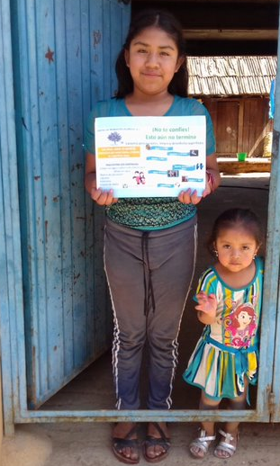
LP # 2005 Centro de Promoción Ocumicho delivering flyers to remind about preventive measures

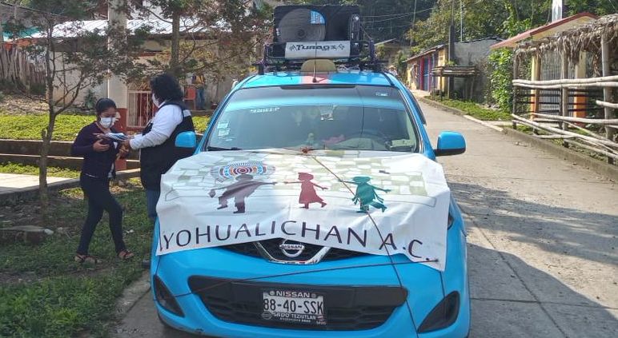
LP #2068 Yohualichan A.C sharing prevention and self care messages in remote communities

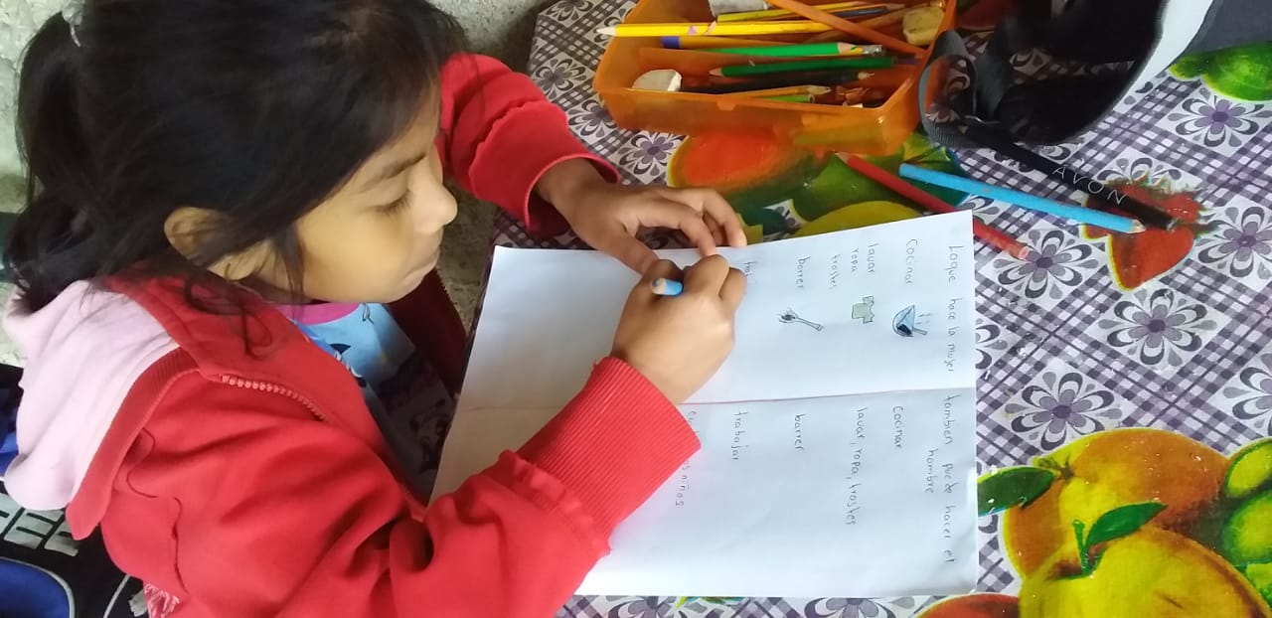
Alma Delia, 8 years old, enrolled to LP # 2165 Centro Infantil Huextetitla A.C., performing a LS2 activity on gender roles, from “My Body and I” program ↓

