ChildFund International
Humanitarian Situation Report Template

Humanitarian Situation Report [#23]
COVID-19 – [Zambia]
[February 10 2021]
[Simba Machingaidze – CD, +260 977 173 992]
[11th January 2020 – 10th February 2021]

FOR UPDATES, PLEASE HIGHLIGHT UPDATED SECTIONS IN RED

Part 1: The Overall Situation
COUNTRY: Zambia
Total Number of COVID-19 Cases Reported | Number of Deaths | Number of Cases Recuperated
65,573 | 901 | 58,875
SOURCE: https://www.arcgis.com/apps/opsdashboard/index.html#/bda7594740fd40299423467b48e9ecf6

ChildFund-supported areas (Provide only if you have reliable data on this. You can report on a consolidated basis or by program state/region/province/etc. if you have this detail.)
Geographical area (country or state/region/province | Total Number of COVID19 Cases Reported | Number of Deaths | Number of Cases Recuperated
Lusaka Province | 666 | 32 | 574
Copperbelt Province | 190 | 07 | 70
Central Province | 38 | 00 | 36
Muchinga Province | 652 | 00 | 621
North Western Province | 21 | 00 | 08
Northern Province | 06 | 00 | 05
Luapula Province | 17 | 00 | 10
Eastern Province | 12 | 00 | 07
Southern Province | 11 | 00 | 11
Western Province | 19 | 03 | 06
SOURCE: Minster of Health Press Statements and Zambia National Public Health Institute COVID-19 Situational Reports.
NOTE
Kindly note that the Ministry of Health seems to have stopped sharing the latest case load, deaths and recovery break down per province since July 2020.
- Any relevant background information about areas affected.
The Zambian government confirmed the outbreak of COVID-19 in Zambian on 18th March 2020 with two confirmed cases. Zambia is now experiencing a second wave of COVID-19 from December 2020. The case load has sharply increased to 65,573 as at 10th February 2021 with 901 deaths, 5,410 active cases and 58,875 recoveries. January 2021 saw the highest spike in both COVID-19 cases and deaths this far. Zambia recorded 33,493 case with 375 deaths in January 2021 alone. This trend has continued into February 2021. Between 1st and 10th February 2021, the country has recorded 11,356 cases with 138 deaths. The fatality rate stands at 1.4 percent with 17 percent positivity rate while the recovery rate is at 86.5 percent.

- Host government posture: Have they declared a state of emergency and/or requested outside assistance? Which nationwide measures has the government taken, e.g., limitation on meetings, internal travel, school closures etc.
The Zambian government has not declared a COVID-19 State of Emergency. However, the government closed all schools, colleges and Universities as of 20th March 2020. The government has banned all types of gatherings. Be it workshops, weddings, funerals or any event that may pull people together.

On 11th September 2020, the Zambian President addressing the nation when he opened the fifth session of the Twelfth National Assembly and announced the following:
- Bars, night clubs and taverns were partially opened to operate on Fridays, Saturday and Sundays.
- Schools were fully opened for all grades. That is all nonexamination classes are now fully open. The President also fully opened all Universities, Colleges and skills training centers.

On 8th May 2020, the president addressed the nation and he announced the following:
- Schools opened for examinations classes on 1st June 2020 (Grades 7, 9 and 12)
- Restaurants were reverted to their normal operations while observing public health regulations
- Casinos, Gyms and Cinemas were reopened subject to public health regulations observance.
- Tour operation areas including the Victoria Falls have been opened to the public.
- All bars and night clubs remain closed.
During the period under review, the government announced 8th June 2020 as the re-opening date of all Universities, Collages and skills training Institutions for the final year students.
- What responses has the government put into place to address the health crisis and/or the economic impact?

Muchinga Province has remained the COVID-19 epicenter with 652 cases. The consolation however is that the province has posted low cases (7) in the last seven days from 24th June to 1st July 2020. However, Lusaka and Copperbelt Provinces have seen a steady increase in cases.

Western Province has also recoded two new cases in the last seven days. The increase in the geographical spread and case load implies that Zambia will remain in the emergency response mode for some time to come. Zambia seems not to have reached the peak yet.

- The Nakonde boarder with Tanzania which was closed was opened and the Nakonde total lockdown lifted on Friday 22nd May 2020. Effective 2nd June 2020, the boarder point started operating 24 hours until all traffic backlog for cargo and passengers is cleared.
- The country has now equipped Chipata General Hospital in Eastern Province with the capacity to test COVID-19. This brings the total test centers to five with Ndola Teaching Hospital on the Copperbelt, University Teaching Hospital and University of Zambia Veterinary School in Lusaka and Chinsali General Hospital in Muchinga Province. The government is determined to equip all provincial Hospitals with capabilities to test for COVID-19.
- All the boarder points are open including Nakonde. To date the government has argued that closing the boarders will negatively impact the economy and the people given that Zambia is a landlocked country. However, all those entering the country are being tested and quarantined until results come out. Those found positive are taken to health facilities and those testing negative are left to proceed with their journeys. This is to avoid overwhelming the quarantine facilities.
- The government has made it mandatory for all to wear face masks on public transport and shopping malls.
- Government has also suspended Customs Duties and Value Added Tax on medical supplies used in the fight against COVID-19 in order to expedite the provision of medical-related devices needed to support the fight against COVID-19 for the initial 6 months.
Response to Economic Impact
- Government has set up an Epidemic Preparedness Fund under the Ministry of Health amounting to K57 million;
ii. Cabinet has approved a COVID-19 Contingency and Response Plan with a budget of K659 million under the Disaster Management and Mitigation Unit.
iii. To support the easing of liquidity in the face of the adverse effects of COVID-19, Government will release K2.5 billion to reduce domestic arrears owed to domestic suppliers of goods and services, reduce outstanding arrears to pensioners under Public Service Pension Fund and retirees under Ministry of Justice and reduce outstanding third-party arrears and other employee related commitments. In addition, K140 million will be released to pay local contractors in the road sector.
iv. The Bank of Zambia has approved and released K10 Billion line of credit to banks that may face liquidity challenges. Small and medium scale enterprises will be prioritized for this line of credit by banks.
v. The President addressed the nation on 25th June 2020 and in his address, he indicated that government has approved a K30 million Youth Empowerment fund targeting artists countrywide.
vi. The president also informed the nation that government has issued a COVID-19 Bond amounting to K8 Billion as a stimulus package to enhance economic activity in the country.
vii. The president also re-opened all the International Airports in the country to boost the tourism sector.
In order to provide tax relief to businesses, Government has:
i. Suspend excise duty on imported ethanol for use in alcohol-based sanitizers and other medicine related activities subject to guidelines to be issued by ZRA
ii. Remove provisions of SI 90 relating to claim of VAT on imported spare parts, lubricants and stationery to ease pressure on companies;
- Waived tax penalties and interest on outstanding tax liabilities resulting from the impact of COVID-19.

- What travel restrictions has the government put in place for travelers entering the country?
Government has suspended all none-essential foreign travel. Travelers entering the country without symptoms should be quarantined for at least 14 days at their own cost.
The government has also commenced mandatory quarantining of all truck drivers entering Zambia for 14 days before they can continue with their journeys either transiting or in-country.
Part 2: The Situation in Areas Where ChildFund Works

Partner Organization (Use Salesforce identifying code/name.) | # of Enrolled and Sponsored Children |  | COVID19 Cases Reported in ChildFund Communities (Y/N/Unknown) Provide number if available. | Number of Enrolled Children Reported with COVID19 (If available.) | Number of enrolled children diseased as result of COVID19
 | Sponsored | Enrolled
Chibombo Child Development Agency | 2,963 | 4,071 | 00 | 00 | 00
Chongwe Child Development Agency | 3,717 | 5,852 | 00 | 00 | 00
Kafue Child Development Agency | 3,821 | 5,498 | 26 | 00 | 00
Luangwa Child Development agency | 3,486 | 6,311 | 00 | 00 | 00
Lusaka Child Development Agency | 1,388 | 2,120 | YES | 00 | 00
Mumbwa Child Development Agency | 3,210 | 4,154 | 00 | 00 | 00

NOTE
YES: There are 26 COVID-19 cases with 1 death reported in Kafue District as at 16th June 2020. It should also be noted that Kafue Child Development Agency also operates in Chilanga District which has also recorded 31 COVID-19 cases as at 8th June 2020.
Kafue District was on 15th and 16th April 2020 put on lockdown for disinfection of all public places such markets, health centers, shops and offices. The lockdown has since been lifted and people are going about their businesses normally.
The organization followed up the recovery status of the 37-year-old female of Shikoswe who is mother to three of our enrolled children. The patient has fully recovered from COVID 19 and has since been discharged. She returned home on 29/04/20 and has since been reunited with the family.
The number of cases in Chaisa and Jack localities in Lusaka District are not yet known.
Child deaths: List any sponsored child (with Partner organization and child ID from salesforce) diseased as a result of COVID19. (Note: These need to be reported immediately following the regular sponsorship protocols.)

Partner Organization (Use Salesforce identifying code/name.) | What is the status of the program/sponsorship processes (operational/suspended)?
 | Program Implementation | CVS | M&E  Level 2 | Enrollment /Disaffiliation | Sponsorship Communication | DFC
Chibombo | Operation | Operation | Operational | Operational | Operational | Operational
Chongwe | Operation | Operation | Operational | Operational | Operational | Operational
Kafue | Operational | Operation | Operational | Operational | Operational | Operational
Luangwa | Operation | Operation | Operational | Operational | Operational | Operational
Lusaka | Operation | Operation | Operational | Operational | Operational | Operational
Mumbwa | Operation | Operation | Operational | Operational | Operational | Operational
Note: As a global measure, all sponsor visits have been suspended.
- What issues are children in these areas facing (food shortages, safety concerns, school closure, etc.)?
All schools were closed as of March 20, 2020. However, the President on 8th May 2020 announced the reopening of schools for examination classes only as of 1st June 2020.

- Child protection risks caused or exacerbated by crisis situation.
- Most children are worried of the risk of contracting COVID 19
- While most children have received information and massages on COVID-19, on what it is, how it is transmitted and how one can prevent him/herself from contracting the disease. However, children from disadvantaged families report that they do not have soap to use for washing their hands, neither have they seen hand sanitizers in their lives. This implies supporting vulnerable households with such supplies for the prevention of COVID-19.
Part 3: ChildFund’s Response
3.a. Overall
- Who is or will be leading/managing the response?
The CD with support from the COVID 19 Task Force that has been put in place. While Country Office is connecting with stakeholders at the Country level. LPs are leading the response at the community level.

- How is ChildFund linked with humanitarian coordination structures, i.e., in which clusters or working groups do we participate? The most recent/next meeting and who is representing ChildFund? Donor meetings we have attended, or missions that we are aware of related to the response?
ChildFund is part of the National Education Working Group. The working group is composed of all INGOs and Local NGOs working in the Education sub-sector such as Save The Children, Plan International, World Vision. The platform also includes UN agencies such as UNICEF, WHO, WFP, UNESCO and other agencies such as USAID. These meeting are attended by the Education Technical Manager. The next meeting will be on Wednesday 1st July 2020.

ChildFund has also joined the Cash Working group chaired by the Ministry of Community Development and Social Welfare. Other members include the World Bank, WFP, UNICEF, DFID, Red Cross and Plan International. ChildFund and the other members are still waiting for the signing of a communique which will signify the commencement of the cash transfer intervention in response to COVID-19. Informal inquiries at the Ministry of Community Development have indicated that not all players had submitted the cash transfer information requested by the Ministry. This could partly explain the delay in the communique. The National Social Protection working Group, which ChildFund is part of, will be holding its meeting on Friday 3rd July 2020 and the Cash transfer intervention will be discussed. ChildFund hopes that the Ministry of Community Development will, during this meeting indicate when the Communique might be signed.
The National Social Protection Working Group Meeting was held on 19th June 2020. Unfortunately, official from Ministry of Community Development and Social Welfare were held up with other engagements and did not participate in the meeting. As such, all partners are waiting for the Ministry to communicate on the way forward. As such, ChildFund and other partners are still on hold.

3.b. Program Response
Please organize your program response report as per the 4 objectives included in our global response plan. You can add an additional category if you have response activities planned or executed that do not align with these objectives. For each objective use the questions below to guide your report.
- What kind of response activities or interventions have been executed? What support items are needed or have been collected/distributed?
- What is the current progress of implementation vs. the established response plan?
- Who are we partnering or collaborating with to provide our response?
- What kind of response activities are you still planning for the coming period?
3.b.1. Stop COVID-19 from infecting children and families
ChildFund’s Global Response Plan
To help children and families protect themselves from COVID-19, we are installing community, handwashing stands; educating communities about symptoms, hygiene measures and where to get tested or treatment; and distributing soap, hand sanitizer, gloves and masks to families and frontline, health workers. For children who are being treated for COVID-19 or are subject to quarantine measures, we are creating child-friendly spaces with age-appropriate toys and reading matter.

ChildFund through its six Local Partners in collaboration with Ministry of Health and Zambia National Information Services has continued conducting sensitization activities on prevention of COVID 19 through mobile vehicle campaigns, posters, flyer and community radio stations. More than 3 million people have been reached in 10 District and 31 communities in which Childfund operates.
Child Fund has also continued supporting 101 health facilities with hand washing facilities, soap, hand sanitizers, face masks, infra-red thermometers, including beds and blankets for quarantine centers. ChildFund has also provided hand washing facilities and soap in all community centers.
At district and community level, ChildFund is working with District Disaster Management and Mitigation committees chaired by the District Commissioner, Ministry of Health, Ministry of Information, Ministry of Chiefs and Traditional affairs including Civic and traditional Leaders in all the 31 communities where we are working.

The CO will continue supporting health and community facilities with WASH consumables especially soap for the next three months to promote good hygiene.
The CO through Luangwa Child Development Agency has commenced supporting mass screening and testing for COVID 19 in Luangwa District. As at Tuesday 19th May 2020, 101 community members and medical personnel were swabbed and samples sent to Lusaka for testing. ChildFund will continued providing fuel for the mobile screening and testing teams.
The CO has also been continuously supporting the community sensitization in all the 31 communities in which we operate.
The CO has also continued supporting District Councils in the disinfection of public places like markets, health centers and shops by supplying disinfection chemicals and materials.
On 1st May 2020, ChildFund CO donated 100 beds to Chawama Quarantine Center at Chawama level 1 hospital, 4,610 face masks, 4,050 soap bars and 2,200 hand sanitizers.

During the period under review, ChildFund worked with the District Health Office (DHO) in all the ten districts where ChildFund is operational to conduct community sensitization on Child Health Week which is running from 22nd to 26th June 2020. This was to ensure that all children aged 0-5 years are taken to the nearest Health Centers for Growth Monitoring and Health Promotion as well as Vaccination against childhood preventable illnesses. It is anticipated that all the under five children in all the ten districts will be vaccinated against childhood preventable diseases. In addition, all DHOs in conjunction with the Zambia National Information Services have continued sensitizing the community on COVID-19 using mobile Public Announcer System.

ChildFund has continued sensitizing community members on COVID-19 through Community Radio Stations.
- Childfund has continued supporting boarder entry screening at the harbor in Luangwa District. In the past seven days, a total of 121 people from Mozambique and Zimbabwe were screened and sensitized on the importance of adhering to the prescribed health guideline on COVID-19 prevention.
- Zambia is still in the response mode and ChildFund has continued supporting the COVID-19 response. During the period under review, 71 handwashing buckets were distributed to health centers, schools and community centers in Chibombo, Chongwe, Lusaka and Rufunsa districts.
- One (1) defunct borehole was repaired in Chibombo district benefiting 100 households. This was meant to ensure that community members have access to clean and safe water in the face of COVID-19 pandemic.
- ChildFund Zambia through its Local partners also provided the following assorted medical supplies, PPEs and Infection Prevention and Control (IPC) materials to Health Centers, Schools, markets, and households in Chibombo, Chisamba, Mumbwa, Shibuyunji, Lusaka, Chilanga, Kafue, Chongwe, Rufunsa and Luangwa districts
- 6,545 liquid soaps
- 1,917 face masks
- 768 tablets of bathing Soaps
- 200 packet of washing soap
- 164 hand sanitizers
- 100 litres Disinfectants
- 100 cases of toilet paper
- 50 rolls of paper towels
- 40 Surgical gowns
- 40 Medical caps
- 25 (2.5 liters) methylated spirit
- 42 infrared thermometers
- 13 Bp machines
- 5 Boxes of surgical masks
- 2 ICU beds
- 10 buckets of chlorine
- 1 duo function suction machine
- 1 oxygen concentrator

ChildFund has also continued with community awareness sensitizations on COVID-19 (signs, symptoms, prevention and response) using mobile public address systems and community radio stations in all our ten operational districts. During the period under review, ChildFund distributes 155 handwashing buckets to health centers, schools and community association offices in Chongwe, Rufunsa, Lusaka and Chibombo districts. 12 Handwashing Drums were also distributed in Chongwe and Rufunsa districts. In addition, 40,455 water purification sachets were distributed to 8,945 households in Kafue, Mumbwa, Lusaka and Chibombo districts.

ChildFund reached 682,200 people with information on signs and symptoms, prevention and response to COVID-19 in Chibombo, Chongwe, Mumbwa, Shibuyunji, Luangwa, Lusaka, Runfunsa and Chisamba districts. During the sensitization activities, 40, 00 brochures were also distributed through Community Volunteers in Kafue, Chongwe, and Rufunsa Districts. In addition, 42 Radio adverts were carried out to support community sensitization as a complement to the mobile sensitizations conducted in conjunction with Ministry of Health and Zambian Information Services. ChildFund also trained 400 Community Supporters in childcare and stimulation in Chibombo and Chisamba Districts.

The Country Office through its Local Partners supported all the ten District Health Offices with fuel for the Child Health week that ran from 23rd to 28th November 2020. During the Child Health week, all the under five children received their routine vaccinations, Vitamin A supplement, TB screening, and vaccination against measles rubbela.
In Luangwa District all the 11 out station centers where the Child Health Week activities were held received Infra-red thermometers for screening those brining children. The Community Volunteers were also supported with face masks to enable them to adhere to COVID-19 guidelines as they were helping community mobilization for the Child Health week.

ChildFund has also continue supporting families and communities accessing clean and safe water. The distribution of P&G water purifier sachets has continued. In Luangwa District, a total of 29,280 sachets were distributed to 244 families in Mandombe and Chikondwelelo communities.
Childfund working through its Local Partners has continued with its heightened community sensitization activities in partnership with the Ministry of Health and Zambia Information Services in all the ten Districts. ChildFund has continued using the mobile public address systems and Community Radio Stations to sensitize community members. Beyond key messages of What COVID-19 is, its symptoms, how it is transmitted, how to prevent contracting the virus and the need to seek immediate medical attention in an event that one suspects contracting the virus. ChildFund is encouraging all community members:
- Not to be reckless with one’s life but placing a high value on one’s life
- Not to develop a casual attitude toward COVID-19 because the disease has been around for a year now but to be on guard and observe all the preventive measures as guided by the Ministry of Health.

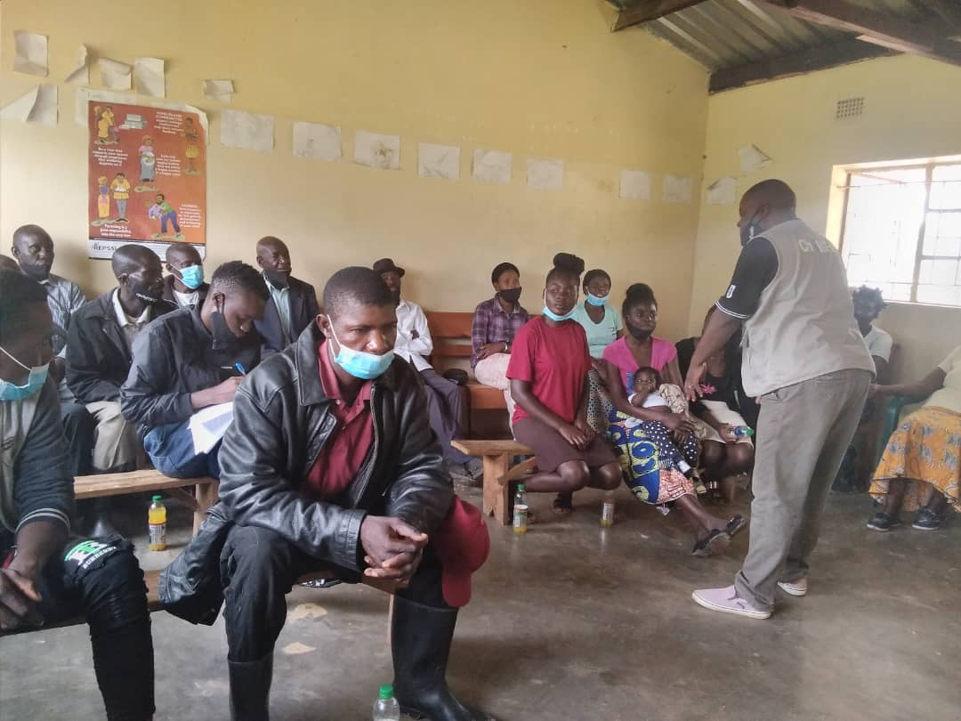
Figure 1: Community Leaders’ COVID-19 Sensitization in progress in Chibombo District.

3.b.2. Ensure that children get food they need
ChildFund’s Global Response Plan
To ensure that the most vulnerable families can keep food on the table, pay rent and cover other basic needs, we are providing cash for those families most needing this support, such as those who have lost their income because of COVID-19, child or elder-headed households, and/or households affected by disability or chronic illness. Where possible, we are distributing food and basic household items directly, carefully abiding by COVID-19 protection measures

3.b.2. 1. Cash Transfers and vouchers
-Is your CO planning or implementing cash transfers or vouchers as part of COVID19 response?
- If so, brief description of progress to date.
The meeting to agree on the cash transfer value finally took place on 1st and 2nd June 2020. The meeting agreed to put the transfer value at K400.00. During the meeting, the Disaster Management and Mitigation Unit (DMMU) defined the priority Districts were the cash transfer should be implemented immediately. In Lusaka and Central Provinces where ChildFund operates, the priority districts included: - Lusaka Province: (Lusaka, Kafue and Chilundu), Central Province: (Mkushi, Serenje, Chitambo and Kapirimposhi). Lusaka and Kafue Districts were given to WFP while ChildFund was given Chilanga and Luangwa Districts. While Chilanga and Luangwa Districts are not appearing on the DMMU Priority list, Childfund argued that Chilanga District actually had more COVID-19 cases compared to Kafue District. In addition, Luangwa District shares boarders with Zimbabwe and Mozambique and is likely to experience COVID-19 cases. It was therefore agreed that ChildFund will initially start the cash transfer in Chilanga and Luangwa Districts. Other districts of interest to ChildFund may come on board if such districts start registering COVID-19 cases and DMMU includes them on its priority list.
In addition, all households to receive cash transfer have already been selected by the Ministry of Community Development. As such, government directed that all implementing Agencies will pick up the lists from Ministry of Community Development starting from Tuesday 9th June 2020 after signing of a communique by all implementing Agencies with the Ministry of Community Development. Thereafter Agencies can start the disbursement from Wednesday 10th June 2020 going forward. It should be noted here that Agencies can only recruit new households (expanding horizontally) after exhausting the beneficiaries on the lists provided by government. The implication for our enrolled families is that only those households that are appearing on the Social Cash Transfer lists will benefit in the initial stages. However, the picture will become clearer after the first round of disbursement.
ChildFund also convened a consultative meeting on the subject with Plan International and Red Cross on Tuesday 16th June 2020. That consultative meeting agreed to engage the Ministry of Community Development to see if the organizations can access the beneficiary lists for verification while waiting for the communique to be signed so as to pave the way for disbursements to proceed once the signing is done.
The last National Social Protection Working Group Meeting was held on 19th June 2020. Unfortunately, officials from Ministry of Community Development and Social Welfare were held up with other engagements and did not participate in the meeting. As such, all partners are waiting for the Ministry to communicate on the way forward and ChildFund together with other partners are still on hold.
In the past seven days, ChildFund through its Local Partner with support from the Disaster Management and Migration Unit (DMMU) distributed 5,600 bags of mealie meal to vulnerable households in Chongwe District.

The Ministry of Community Development has not yet indicated when the Communique to signify the commencement of the Cash Transfer intervention will be made. However, the National Social Protection working group, to which ChildFund is a part, will hold its next meeting on 3rd July 2020. It is being hoped that the Ministry of Community Development will, during this meeting, give an indication of when the communique may be signed.
The National Cash Working Group met on 3rd July 2020 as scheduled. The meeting agreed to start the cash transfer interventions without further delay as a lot of time has been lost and it was becoming difficult to continue holding on to monies. Organizations like ChildFund and Plan International have been holding on to these monies meant for this purpose since April 2020. The meeting reconfirmed the transfer value at K400.00 per household. The meeting also agreed that the caseloads for priority districts be shared with partners immediately and this was done on 3rd July 2020 itself. ChildFund was provided with the case loads for Luangwa and Chilanga Districts. The meeting further agreed that Data Management meeting would be held on 8th July 2020 and another National Cash Technical Working Group meeting will be held on 10th July 2020 while the signing of the communique was tentatively schedule for 16th July 2020 to signify the commencement of the cash transfer intervention.
On 28th July 2020, the Zambian government through the Ministry of Community Development officially launched the COVID-19 Emergency Cash Transfer programme as part of the social protection intervention. ChildFund has been allocated Chilanga and Luangwa Districts for cash transfer intervention. Chilanga has 2,250 households to benefit from the cash transfer while Luangwa has 2,105 households. This gives ChildFund a total of 4,355 households in the two districts to benefit from the cash transfer intervention. The transfer value of K400.00 (US$21.98) has been upheld and this intervention will run for six (6) months. ChildFund has commenced the verification of all the case loads in the two districts. The verification exercise is addressing the physical presence of the household, the National Registration Card numbers and the phone numbers. For those without phones, ChildFund will buy sim cards so that all households can receive their monies through mobile money service providers (The family member will go with a sim card to the service provider and then use the service provider’s hand set to access the massage on receipt of money and withdraw). This will reduce on contacts with community members and improve accountability.
ChildFund was scheduled to conduct a cash transfer to 2,075 verified households in Luangwa District on 7th September 2020. However, Luangwa District is holding a by-election on the 17th September 2020 and the Emergency Cash Transfer Project is being mixed-up with the on-going by-election campaigns. This development has touched on the safety and security of the staff. To mitigate the risk and ensure the safety and security of the LCDA staff, the activity has been suspended until the by-election is over on 17th September 2020. As such, the transfer will be made in the week beginning 21st September 2020.
ChildFund launched the cash transfer in Luangwa District on 28th September 2020 and 2,075 beneficiaries received K800.00 (US$39.83) each. This money was for two months (July and August 2020). The Emergency Cash Transfer is supposed to run for six months (July – December 2020). What was discussed and agreed with UNICEF initially was that Childfund was to pay for the first two months (July and August 2020) and thereafter UNICEF was to pay for the remaining four months (September – December 2020). However, on 28th September 2020, UNICEF indicated to ChildFund that Luangwa is not among the priority Districts agreed with its donors and therefore could no longer guarantee its earlier commitment. The implication of this turn around on the part of UNICEF is that ChidFund has to look for K3,455,775.04 (US$172,057.51) in order to meet the six-month commitment to the beneficiaries so that the remaining four months (September – December 2020) can also be paid.
Following the UNICEF turn around on paying the remaining four months in Luangwa District, the Country Office managed to raise US$92,545.84 from ChildFund Germany (US$44,206) and ChildFund New Zealand (US$48,339.84). This means that ChildFund Zambia was able to pay the 2,075 families the Emergency Social Cash Transfer for two additional months (September and October). However, before the payment was effected, the key stakeholders that will include the 2,075 households, District government officials and the traditional leaders will be engaged and sensitized that ChildFund will be unable to pay for the last two months of the project (November and December) due to financial resource constraints.
ChildFund effected the September and October 2020 payment to the 2,075 households on 21st December 2020.
ChildFund disbursed the Emergency Social Cash Transfer in Luangwa District to 2,075 beneficiaries. The transfer was for two months (September and October 2020). Each beneficiary received ZMW 820. The ZMW 20 was for the withdrawal charge the cash from the mobile money service provider. The beneficiaries comprosed of 1,465 women and 610 men.
Cash transfers or vouchers executed
Beneficiaries |  |  | Amount transferred (US$) | Transfer mechanism (i.e. mobile money, banking system, other financial service provider etc,
Total | Gender (if available)
 | Female | Male
2,075 | 1,465 | 610 | 80,792.97 | Mobile Money

3.b.2.2. Other responses in relation to objective 3.b.2.
The Country office has continued supporting rural households with livestock that include cows, goats and chickens. The country office is also supporting community members with drilling of bore holes to ensure availability of clean and safe water for hygiene purposes and domestic consumption. In the month of May 2020, ChildFund through Chongwe Child Development Agency is empowering 207 vulnerable households with goats. Each household is receiving 3 she goats and 1 he goat.
Childfund through its Local Partners in Chibombo and Kafue Districts distributed food parcels to 808 households. The food parcels comprised of 3 x 25Kg bag of mealier meal, 10Kg dry beans, 10Kg of Soya chunks, 5Kg of dry Kapenta, 10Lts cooking Oil, 2Kg Salt and 2Kg Sugar.
During the month of January 2021, ChildFund through its local partner in Kafue and Chilanga Districts supported 250 families with food parcels. The food parcel included a 25Kg bag of mealie meal, 5Kg of Beans and 2.5Kg of soya chucks.
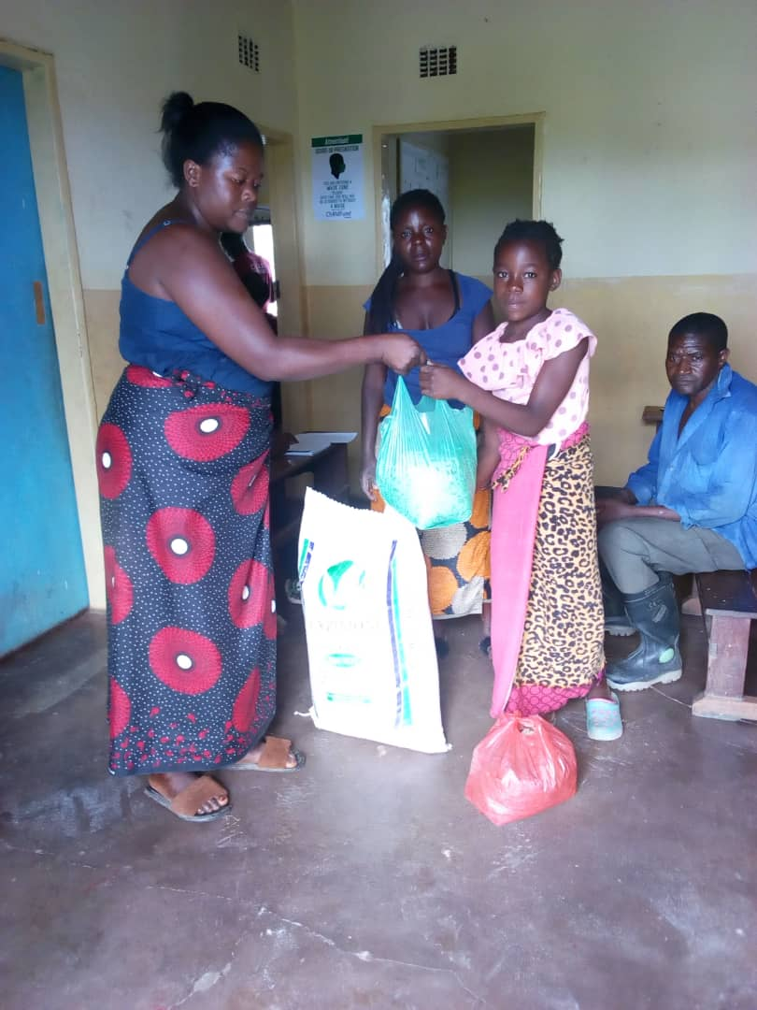
Figure 2:Rosemary from Chawama Community Receiving her Food Parcel in Kafue District.

3.b.3. Keep children safe from Violence: physically and emotionally
ChildFund’s Global Response Plan
We are supporting community-based child protection systems that identify, respond to and refer cases of abuse, neglect, violence or exploitation. We are also providing virtual, online psychological first aid and counseling, and supporting temporary shelters for children who live on the street, providing hygiene supplies, food and other basics. We are also arranging safe and appropriate care for children who are separated from their caregivers due to treatment or prevention measures.
ChildFund is working with LPs to strengthen existing community and district level child support structures. Circles of support from the district and community structures have been kept active with communication lines open for any case of abuse to be reported quickly. The CO is support community child protection advocates to ensure that abuse and violence against children continues to be monitored and reported. Sponsored community radio programmes on COVID-19 also includes sensitization of community members especially care givers on upholding of children’s rights. Child friendly materials on hand washing, parenting during COVID-19 period and What children can do to stop the spread of COVID-19 have been distributed in all the 31 communities where Childfund works.
ChildFund has continued supporting traditional leadership in sensitizing communities against child Marriages during the COVID-19 period when schools are closed.
ChildFund through LPs has continued providing airtime and stationery to the Child Protection Committee members in all the 31 communities to enable them continue operating smoothly and be able to report any child protection issues to the organization and other stakeholders such as the Social Welfare Department and the Victim Support Unit of the Zambia Police. On Tuesday, 16th June 2020 Zambia joined the rest of the African Union member states in commemorating the Day of the African Child. ChildFund Zambia joined hands with its Lusaka based Local Partner, Lusaka Child Development Agency and donated various COVID-19 hygiene materials and food items to Lusaka Central Correctional Facility, Juvenile section. The donation benefited forty-five (45) juveniles who are currently incarcerated at the facility. The donation included the following items worth $1055.00 :
- Bathing soap- 768 tablets
- Liquid hand soap- 50 bottlesWashing soap- 200 packets
- Toilet tissue-100 rolls
- Hand Sanitizers- 24 bottles
- Sugar- 40kgs
- Toothbrushes- 60
- Toothpaste- 60
- Body Lotion- 54 bottles
- Vaseline-6 bottles X 500g
- Glycerine- 24 bottles
- Face towels-50
- Cooking oil- 15 liters
- Buns- 12 trays
- Eggs- 10 trays
- Sausage- 15kgs
- Soya pieces- 8 kgs
- Baby Porridge- 12 packets
- Baby powder- 6 packets
- Sanitary pads- 80 packs
- Slippers- 40 pairs

In July 2020 One case of child marriage was reported in Chibombo District where a girl eloped. The case was reported and promptly responded to by the Child Protection Committee in the area. The girl has since been returned to her home and the two families have been counselled and warned against promoting child marriage by the state.

In the month of August 2020, ChildFud responded to a case of defilement involving a 3 years 6 months old girl child in Kafue District. The Community Based Child Protection Committee members apprehended the perpetrator and handed him over to the Police. The Perpetrator is currently in Police custody and appearing before the courts of law.

ChildFund has continued supporting the Community Based Child Protection Committees and District Child Protection Committees so that there is swift response to any Child Protection case that may be reported during the COVID-19 pandemic period.

3.b.4. Help children continue to do their job: Learning
ChildFund’s Global Response Plan
While schools remain closed, we are supporting children’s learning through activities and tutoring sessions online or by radio. For students without reliable internet access, we are distributing home learning kits with materials and guides for their use.
While schools remain closed, ChildFund has developed Concept notes to source for funds to support children’s learning. For ECE to grade 7, plans are underway to procure radios for them to tune in to the lessons aired on radio. For Grades 8-9, plans are underway to procure smart phones for them to access the e-Learning Portal. For those in very rural areas, Country office through Local Partners will support the printing of learning Modules so that they can have access to hard copies. For ECD, we are working on radio scripts which will have key messages on playing and communication, that will be put on SD Cards for the caregivers with children, 0 to 3 years old to ensure that they continue stimulating children to attain their developmental milestones.
Schools re-opened on 1st June 2020 for Examination classes only – Grades 7, 9 and 12. ChildFund supported 141 schools in ten districts with 277 hand washing facilities, 547 boxes of soap, 104 boxes of hand sanitizers, 56 infra-red thermometers for the school that could not manage to buy on their own, 100 paper towels, 224 packs of disinfectants, 250 copies if ICE materials on COVID-19 prevention in schools, 5,520 face masks, 125 face shields for teachers and 2,640 liters of fuel for the DEBS offices to distribute the materials to schools in their respective jurisdictions. All the 141 school that ChildFund supports reopened successfully and ChildFud will continue supporting the school children with COVID-19 prevention activities.
ChildFund Zambia handed over assorted play equipment, toys and other educational materials valued at ZMW 50,000 to Children’s COVID isolation facilities at the University Teaching Hospital and Levy Mwanawasa hospital. Once COVID is over, the toys will be put in children’s play corners so that children can be stimulated while they wait to receive the routine services such as GMP+.

For now, the toys and reading materials will be used to stimulate children to learn and play which is a key development factor and also help them feel less anxious about being admitted in the COVID centers without familiar faces around them.
ChildFund through its Local partners has continued supporting schools with hand washing facilities, infra-red thermometers and face masks. During the past week, we supported 14 schools with 24 hand washing facilities, 14 thermometers and 2,400 face masks.
During the past seven (7) days, ChildFund supported District Health Offices in the ten districts of our operations to go round schools and sensitize the schools children on what COVID-19 is, symptoms and how to avoid contracting the disease and the need to develop early medical seeking behavior if any one suspects contracting the disease.
ChildFund has continued supporting schools with soap, Hand sanitizers and face masks. In the week starting 29th June 2020, Country will distribute 5,000 face masks and 77 Infra-red thermometers to schools that have reported a short fall in face masks for school children and thermometers.
ChildFund Zambia has continued supporting schools through its Local Partners. During the period under review, 25 schools were supported with teaching and learning materials in Chibombo and Luangwa Districts. Nine (9) schools in Chongwe district were supported with stationery benefitting 865 children in examination classes while 587 non-examination pupils in Mumbwa District have been supported with learning materials to enhance the home- based learning activities.

ChildFund has continued supporting schools with soap and hand sanitizers and face masks. Chongwe Child Development Agency supported 14 schools with hand washing facilities, soap, hand sanitizers and face masks.

Figure 3: Distributing Face Masks to school Children at Chainda Primary School in Chongwe District.
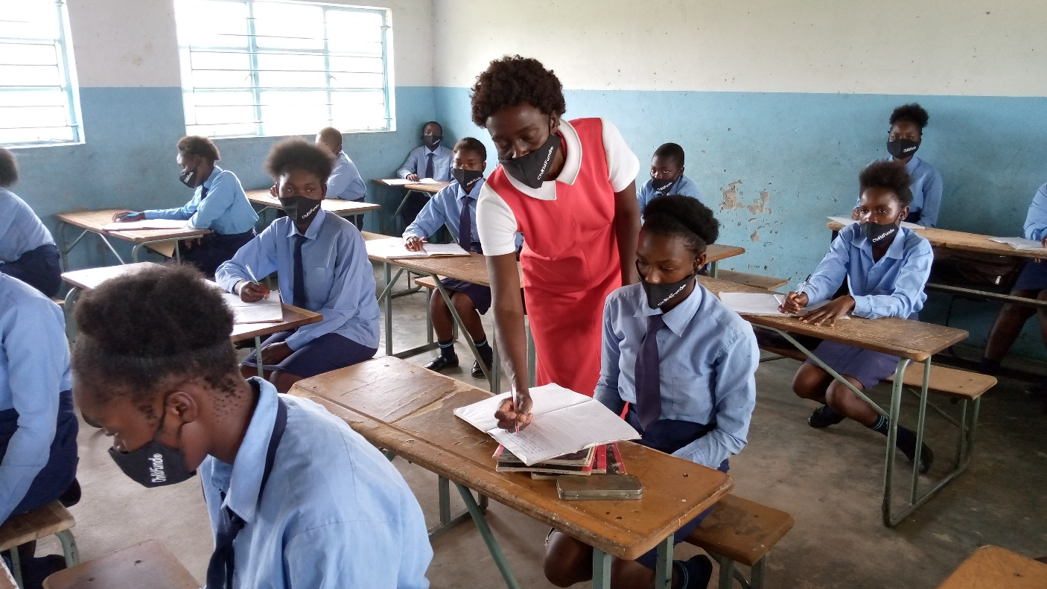
Figure 4: Observing Social Distancing in classroom at Chainda Secondary School in Chongwe District

Below Sections for Internal Use Only
Part 4: Office and Staff Status
Office Status (Open/Closed) | Number of Staff:
 | Diagnosed with COVID19 | Diseased from COVID19 | Working from Office | Working from Home | On Special Leave
Open.  However, all Staff members are encouraged to work from home | 02 | 02 | 10 | 27 | 00

Notes:
- Any cases of staff diseased need to be reported immediately to RD and GHR.
- Special leave as per COVID19 Administrative Guidelines.
Number of staff/partner organization staff completed WHO COVID online training https://www.who.int/emergencies/diseases/novel-coronavirus-2019/training/online-training.
Part 5 Human Resources
- Which visitors are there in the country? Please include names, functions, contact information and arrival/departure dates for both IO and RO staff (note: due to the travel ban, this will apply only once the ban has been lifted)
None
- Any gaps in staffing/need for deployment from other COs or Global Teams?
None for now
- Are there any other major HR issues?
None for now
Part 6 Safety & Security
- Are police and other services functioning in the normal manner?
Yes
- Are the courts still operating?
Yes
- Are there reports of looting or increased criminality?
No
- Have military personal being deployed to patrol towns or cities?
The Police and Military personnel deployed to Kafue last week for 3 days have returned to their respective stations. The situation is back to normal.
- Confirm the safety of staff and their families in the affected area.
All the staff members are safe up to the reporting date.
- Have Safety and security risks/mitigation plans been updated to current environment?
Yes
- Recommendations around any upcoming travel planned for staff or donors (note: Only once global travel ban has been lifted)
- No unnecessary field travels. Only travels sanctioned by the Department Lead.
Part 7 Grants
List all active grants:
Grant Job Code | Grant Name | Donor | Status of Implementation (Normal/Reduced/Suspended) | Any specific guidance received from donor? (Yes/No)
12-0383D | Cfger-Cfs3-Zam |  | Normal | No
2-0357D | Ire- Kakonge prjct- Zam | Irish embassy | Normal | No
25-040D | Hilton- Multi Co Ecd- Zam | Conrad Hilton Foundation | Normal | Yes
25-054D | Gcf/Pg-Safe H20 P2- Zam | P & G | Normal | No
3-0375D | Unicef- Cbiedcd P2- Zam | UNICEF | Normal | No
99-0243D | Chaz- Ftec- Zam | CHAz (Church Association of Zambia) | Normal | No

Government has suspended gatherings until further notice, and some of our grants have activities that require Community gatherings. Such activities have been put on hold – thereby affecting the implementation of such grants.

Part 8 Funding
Provide information about potential sources of funding, including grant donors, subsidy, Emergency Action Fund, Alliance members, GIK, etc., for these emergency response efforts using the chart below:

Donor | Program | Amount (USD) | Requested? (Y/N) | Confirmed? (Y/N)
CHILDFUND | PEF | US$5,000 | Y | Y
CONRALD HILTON | ECD | US$3,000 | Y | N
CHILDFUND | SUBSIDY | US$15,000 | N | N
UNICEF | WASH | US$9296.50 | Y | N
UNICEF | EDUCATION | US$519,327.50 | Y | N
UNICEF | EMERGENCY CASH TRANSFER | US$2,000,000.00 | Y | N
CHILDFUND IO | LIVELIHOOD/WASH | US$457,518 | Y | N

- Budget
- Outline how we will use this funding with a rough topline budget.
The main interventions are being planned around community sensitization materials, printing and distribution of IEC materials, Public address announcements through the Zambia News & Information services.
Other planned activities are to create community response mechanism that will link the affected individuals in the communities to health centers for immediate assistance
The Country office is working on raising US$457,518 to support the continued production of IEC materials, on COVID-19 and Child Protection, WASH supplies, cash transfer to 6,000 most vulnerable households, soaps and hand sanitizers, glove, faces masks and Personal Protection equipment.
The Country office submitted a WASH Concept Note to UNICEF on 9th April 2020 (UN Flash) for possible funding as part of COVID-19 response worth US$9,296.50.
The Country Office has also submitted another concept note worth US$519,327.50 to UNICEF (UN Flash) to support the enhance the continue of learning among 30,000 (20, 000 Primary School learners and 10,000 Secondary school learners) during the COVID period.
The Country Office further submitted a concept note worth US$2,00,000.00 to UNICEF (UN Flash Appeal) to support COVID-19 Urban and Rural Emergency Cash Transfer for six months (June – December 2020).

Part 9 Media/Communications
  - List of media who will be or have been contacted with press releases.

    - Zambia National Broadcasting Co-operation, Zambia Daily Mail, Times of Zambia, One Love Radio, NGO news.
    - The Program Director is featuring on the Zambia National Broadcasting Corporation giving highlights about the ChildFund COVID response plan. The same highlight is being aired on radio 4 and will run for the next one month. This update is being aired during the national COVID updates on Mondays and Fridays.
    - ChildFund has also come up with a one-month series on one love radio being aired three times of a week. During the live radio programs staff are giving updates on COVID covering the different sectors across the children’s life stages.
    - The Regional Director featured on the same Program to give an overview of ChildFund at global and the Africa Region.

  - List of emergency CO spokespeople, including name, location, contact information, and languages spoken.

    - Simba Machingaidze -The Country Director (0977173992)- Lusaka- English
    - Harriet Chewe- Human Resource Manager (0977760715)- Lusaka- English
    - Priscilla Chama- Communications Manager (0977450009) – Lusaka- English
    - Godwin Nsofu-Partnership Portfolio Specialist (0966748729)-Lusaka- English

  - Plans for collecting photos/videos/stories, e.g., should an outside photographer be hired?

    - We are planning to collect these from our LPs that are doing sensitizations as regards the preventive measures. No plan to hire outside photographer. We will take photos internally.
    - Due to restrictions in movements and in order not to put our enrolled children at risk, LP staff have been requested to work with district staff from the Zambia News and Information Services to take short videos and photos during the dissemination of information on hygiene and sanitation. These then will be submitted to the Country Office for reviews and dissemination.

  - Key points for messaging and visibility, particularly any host-government sensibilities that must be considered.

    - For now, Government has produced IEC materials and translated them in different languages for use during the sensitizations. We will reproduce these when the need arises. We will focus on the press releases and other programs on community radio stations. We will follow MOH guidelines on messaging.
    - We are still using IEC materials produced by the Ministry of Health as we were given enough to go round our six local partners.

  - Support needed or requested from IO, GSS or Global Teams – whether onsite or remote.
    - None for now

