ChildFund International
Humanitarian Situation Report Template

Humanitarian Situation Report [#23]
COVID-19 – US Program
Feburary 10, 2020
Julia Campbell, Program Sponsorship Manager, jcampbell@childfund.org
January 10, 2020 – February 10, 2021

FOR UPDATES, PLEASE HIGHLIGHT UPDATED SECTIONS IN RED

Part 1: The Overall Situation
COUNTRY
Total Number of COVID-19 Cases Reported | Number of Deaths | Number of Cases Recuperated
27,239,037 (up 4.8 million from last month) | 469,833 (up 94 K) | 5,985,047 (no new data)
SOURCE: https://www.arcgis.com/apps/opsdashboard/index.html#/bda7594740fd40299423467b48e9ecf6
The US reached a one-day record of new infections (50,000) on July 1.
ChildFund-supported areas (Provide only if you have reliable data on this. You can report on a consolidated basis or by program state/region/province/etc. if you have this detail.)
Geographical area (country or state/region/province | Total Number of COVID19 Cases Reported | Number of Deaths | Number of Cases Recuperated
Richmond, VA (City of Richmond, Henrico & Chesterfield Counties) | 54,625 (up 14.8 K from last month) | 717 | No data for counties
Jackson, MS (Hinds/Rankin Cos) | 30,406 (up 5 K) | 620 | No data counties
Rio Grande Valley, TX (Hidalgo & Cameron Counties) | 105,913 (up 19.6 K) | 3912 | No data for counties
Totals for US Program target areas: | 190,944 (up 45.7K) | 5249 (up 712)
SOURCE: National Ministry of Health or other reliable source
https://www.arcgis.com/apps/opsdashboard/index.html#/bda7594740fd40299423467b48e9ecf6
MS Department of Health - https://msdh.ms.gov/msdhsite/_static/14,21882,420,873.html
TX Dept of State Health Services - https://txdshs.maps.arcgis.com/apps/opsdashboard/index.html#/ed483ecd702b4298ab01e8b9cafc8b83

- Any relevant background information about areas affected.
In a recently released Childhood Report from Save the Children, U.S. counties are ranked on how well they protect and provide for children – based on Child Poverty rates and 6 other indicators: Infant Deaths, Child Hunger, High School Dropouts, Teen Pregnancy, Child Homicides & Suicides, and COVID-19* (*Vulnerability scores reflect the degree of vulnerability to stresses on human health caused by outbreaks like COVID-19.)
Area | Child Poverty Rate | COVID 19 Score  0 (lowest vulnerability) to 1 (highest vulnerability) | Overall child well-being ranking of County (out of 2,617 US counties)
Richmond Area  (city, Henrico & Chesterfield Counties) | 34.5%  12.6%  9.9% | .77  .26  .18 | 2308  268  176
Jackson, MS (HINDS county) | 30.4% | .87 | 2362
Rio Grande Valley (Hidalgo & Cameron County) | 40.4%  40.2% | .98  .98 | 1851  1852
- Host government posture: Have they declared a state of emergency and/or requested outside assistance? Which nationwide measures has the government taken, e.g., limitation on meetings, internal travel, school closures etc.
President-elect Biden’s top priority once he is sworn in is to “tackle the pandemic”. He has named a COVID-19 Transition Advisory Board to provide a blueprint for doing that – including a mask mandate, ramping up testing, contact tracers.
Governors have declared State of Emergency in each of ChildFund’s 3 targeted states. All federal and state assessments (standardized testing) have been suspended for the 2019-2020 school year. “Grab and go” breakfasts and lunches are available to anyone 18 yrs and under in all targeted areas at selected school (and community sites) throughout the school closures. All ChildFund US target areas are currently under “Stay at Home” orders. Schools are closed for remainder of the school year for all ChildFund US target areas.
Mississippi and Texas have some of the highest rates in the US, setting multiple daily records of confirmed cases

RGV, TX: As of March 23, in target counties, all non-essential businesses ordered closed until April 10th. Curfew in place between 2000 – 0500. Schools are closed until further notice (last day of school is May 29). The statewide “stay at home” order expands closure of nonessential businesses until at least April 30.
First phase of the plan to “Open Texas” went into effect on May 1. Under Phase I, certain services and activities are allowed to open with limited occupancy, and DSHS released minimum standard health protocols for businesses and individuals. The Governor also announced statewide testing and contact tracing initiatives to identify and test Texans who contract COVID-19 and mitigate further spread of the virus. (See more in section 3.b.1 regarding activation of AmeriCorps members to conduct contact tracing). On May 26, TX governor announced additional services and activities that can open under phase II. (TX is among states with fewest restrictions/limitations in place at this stage of the pandemic). On June 17, the Hidalgo County Emergency Management Director signed an order Wednesday requiring all Hidalgo County businesses to mandate the use of facial coverings by all employees and customers due to the growing number of infections. Record-setting levels of new cases of the coronavirus and related hospitalizations have Texas officials. Every person in Texas shall wear a face covering over the nose and mouth when
inside a commercial entity or other building or space open to the public, or when in an outdoor public space, wherever it is not feasible to maintain six feet of social distancing. Record # of cases confirmed (3000) week of June 28 for target area and continue to escalate, RGV counties (target area) has re-instituted strict “Stay at Home” measures impacting program delivery, and where Hidalgo county hospitals are at capacity.

Hidalgo County school districts (where the majority of our children/families are) will start out virtually for at least the first six weeks, but most likely not until January. Minimal hybrid instruction (some virtual/some in person by parent choice) is in place in schools. Some schools extended winter break an additional week.

Richmond, VA - Non-essential retail businesses that cannot limit their operations to 10 patrons or less with adequate social distancing must close. All VA schools are closed for the remainder of the school year. VA statewide Stay at Home order is effective until June 10. RPS has officially announced that they will remain completely virtual for the second semester beginning on February 8, 2021.
On May 9 Governor Northam released “Forward Virginia” plan to safely and gradually ease public health restrictions while containing the spread of COVID-19. The Phase One guidelines will be implemented when the data meets the public health criteria outlined by the Commonwealth. Virginia governor announces face-covering requirement in public indoor settings, effective May 29th and also extended Virginia’s state of emergency declaration. Richmond will move into the second phase of the state’s gradual reopening on June 12, a week behind most of the rest of the state. Restaurants/bars indoor dining at 50% capacity, gyms at 30% capacity. Some recreation/entertainment venues to reopen. Social gatherings restricted to 50, social distancing of 6 feet to continue. Virginia will not move into phase 3 of re-opening as expected the week of June 15 sue to the continual climb of confirmed COVID-19 cases and deaths in VA. Phase Three of the Forward Virginia reopening plan now scheduled to go into effect July 1. Richmond rates are decreasing and there have been no deaths in the past 2 weeks. Richmond area schools have all started the year virtually for at least first 6-9 weeks.

Jackson, MS: Civil Emergency declared for Jackson, MS through March 31 – non-essential city government offices closed. Gatherings of 10 or more people are prohibited. Bars have been ordered to close and restaurants may only operate as take-out, drive-through, or delivery service only. Schools are closed through at least April 10. However, on March 25 the MS Governor overrode individual municipality “stay at home” for non-essential services orders. While MS has still not declared a statewide stay at home, the governor allows local county/city orders to take precedence. The city of Jackson’s “stay at home” order is in effect until April 17 (includes school closures). On April 1, the MS Gov declared a Stay at Home order.
Mississippi governor delays reopening state after COVID spike. The Mayor of Jackson, MS eases restrictions on businesses, urging continued vigilance amid COVID-19 threat as the MS governor issues Safe Return Order, effective June 1 which allows all businesses and non-profits to open subject to certain limitations to minimize person to person interactions and associated risks. MS has fully reopened following Gov. Reeve’s “Safe Return” order on June 1, allowing all travel and business to resume in the state (including summer school). June 8 recorded MS’s highest # of cases. Gov. Tate Reeves ordered a statewide mask mandate on August 4th and Jackson area schools will be all-virtual for the entire fall semester of the 2020-2021 school year. Jackson area hospitals (which normally serve communities throughout the state have been at full capacity for weeks. As of January, Jackson public schools are operating under a hybrid basis, per parent options.

- What responses has the government put into place to address the health crisis and/or the economic impact?
- Various federal stimulus packages are currently being considered/debated in the US Congress, including a package worth $1.8 trillion to ease the impact of coronavirus which includes loans for small businesses to cover expenses/pay employees for up to 8 weeks, payments of $1,200/adult and $500/child, support to hospitals for Covid-19 expenses. In addition to this federal response, various actions are being taken in ChildFund target areas including suspension of housing evictions, elimination of Medicaid copay requirements and extending tax deadlines. Congress passed the 2 trillion Coronavirus Aid, Relief, and Economic Security (CARES) Act, provides a 2 trillion package of economic, health and education supports, including provisions for 501(c)3 organizations (non-profits) and specific provisions that provide flexibility for US Program as an AmeriCorps grantee (federal grant). Congress is considering next legislative steps, including an interim bill and a second CARES Act.
- “UNITE Act” calls for increased AmeriCorps recruitment and increased compensation, offers priority consideration to unemployed veterans, others unemployed due to the coronavirus. The Pandemic Response and Opportunity Through National Service Act, introduced by Sen. Coons (D) would fund 750,000 national service (AmeriCorps, Peace Corps, etc) positions over a three-year period, prioritizing funding for activities directly related to response and recovery, such as: Public health services, Emergency logistics, Workforce and reemployment services, Education support and Services that combat nutrition insecurity. Both the Senate and House version of this Act have been introduced!
  - Senate Bill: S.3624 - Led by Senator Coons (DE)
  - House Bill: H.R. 6702 - Led by Rep. David Price (NC) & Rep. Doris Matsui (CA)
  - Senate Bill S.3964 – The CORPS ACT (Cultivating Opportunity and Response to the Pandemic through Service (CORPS) Act) has been introduced. The bi-partisan CORPS Act would double the number of AmeriCorps positions available this year to 150,000 and provide a total of 600,000 service opportunities nationwide over the next three years to unemployed youth and others looking to assist their communities. These positions could support a variety of response and recovery efforts based on community needs, including expanding food pantry capacity, mentoring and tutoring at-risk students, bridging health inequities by expanding access to COVID-19 screening and testing, and more.
- The President signed an executive order limiting immigration to the U.S. for the next 60 days.
- The US Senate passed a $484 billion coronavirus aid package on Tuesday for additional support tsmall businesses, including additional help for hospitals and virus testing. House expected to vote April 23. The
- President signed Congress' latest coronavirus economic relief package, which includes additional aid to small businesses and hospitals and includes funding for testing.
- Families First Coronavirus Response Act - USDA to provide more than $1 billion in food benefits through the Pandemic Electronic Benefit Transfer (P-EBT) program to families with children who have temporarily lost access to free or discounted school meals due to COVID-19-related school closures. P-EBT provides a one-time benefit of @$285 per child, which can be used in the same way as SNAP food benefits to pay for groceries. 47 states currently approved to deliver P-EBT including Virginia, Texas and Mississippi. For non-SNAP recipients school districts have provided link for families to apply. Families have been appreciative of our Community Mobilizers who are assisting families in filling out the applications. However, even though any child who attends a school in our TX target area is eligible for this benefit (regardless of citizenship status), and it will not impact other government assistance, some families are still hesitant to take the chance of applying.
- On Dec 22, Congress approved a $900 billion package which extends some parts of the CARES Act (passed in March) and includes $600 stimulus checks for individual citizens, targeted aid for small businesses, and funding to buy and distribute vaccines. In a change from the last round, payments will not be denied to citizens married to someone without a social security number, allowing some spouses of undocumented immigrants to claim the benefit this time around.
- President Biden $1.9 trillion American Rescue Plan includes stimulus checks ($1400), unemployment support, minimum wage hike, COVID vaccine program, aid for schools to re-open safely, child-tax credit, rental assistance and extension of a moratorium on evictions, foreclosrues until September. The House hopes to bring it to a vote on Feb 22.

- What travel restrictions has the government put in place for travelers entering the country?
Foreign nationals who have visited one of the following countries in the past 14 days may not enter the United States: China, Iran, European Schengen area (Austria, Belgium, Czech Republic, Denmark, Estonia, Finland, France, Germany, Greece, Hungary, Iceland, Italy, Latvia, Liechtenstein, Lithuania, Luxembourg, Malta, Netherlands, Norway, Poland, Portugal, Slovakia, Slovenia, Spain, Sweden, Switzerland, Monaco, San Marino, Vatican City), United Kingdom (England, Scotland, Wales, Northern Ireland), Republic of Ireland. While there is currently no ban on international travel for American citizens, lawful permanent residents, families will be allowed to enter the US but only through one of 13 airports if they have been in one of the above countries in the past 14 days. https://www.cdc.gov/coronavirus/2019-ncov/travelers/travel-in-the-us.html The US borders with Canada and Mexico are temporarily closed to nonessential travel. Mexico has closed ports of entry along Texas border due to the high rate of COVID in the US (and in response to Texas re-opening status), banning the entry of residents and care Americans beginning Wednesday May 27th. US
US Program is of course abiding by ChildFund International’s ban on international travel and USP has suspended all domestic travel for our staff until further notice. Officials in Texas order air travelers arriving from several locations within the US to self-quarantine for 14 days.

Part 2: The Situation in Areas Where ChildFund Works
Partner Organization (Use Salesforce identifying code/name.)  Texas is only area with enrolled/ sponsored children | # of Enrolled and Sponsored Children |  | COVID19 Cases Reported in ChildFund Communities (Y/N/Unknown) Provide number if available. | Number of Enrolled Children Reported with COVID19 (If available.) | Number of enrolled children diseased as result of COVID19
 | Sponsored | Enrolled
Texas Area  LP- CIS Hidalgo Co | 2043 | 2886 | 2 staff members | 1 | None reported
CIS Richmond | NA | NA | None reported | None reported | None reported
Operation Shoestring (MS) | NA | NA | OS staff family member | None reported | None reported

Child deaths: List any sponsored child (with Partner organization and child ID from salesforce) diseased as a result of COVID19. (Note: These need to be reported immediately following the regular sponsorship protocols.)
Partner Organization (Use Salesforce identifying code/name.) | What is the status of the program/sponsorship processes (operational/suspended)?
 | Program Implementation | CVS | M&E  Level 2 | Enrollment /Disaffiliation | Sponsorship Communication | DFC
Partner 1 | Alternative program services | QTR 2 data collection through CPRs for participation, presence, education & health status | Delayed until FY22 | Preparing for enrollments in new schools  Departures from one community planned QTR 4 | Sending photos of TYL from kids that have been collected. | Deliver DFC e-gift cards
Partner 2 | Alternative program services | NA |  | NA | NA | NA
Partner 3 | Alternative program services | NA |  | NA | NA | NA
Note: As a global measure, all sponsor visits have been suspended.
- What issues are children in these areas facing (food shortages, safety concerns, school closure, etc.)?
- Child protection risks caused or exacerbated by crisis situation.
Food insecurity, the digital divide and educational inequity, child protection concerns, economic disparity and fear and anxiety due to immigration/citizenship status are issues that our target population experiences under normal circumstances. We are concerned that the coronavirus pandemic will only exacerbate these issues.
- Many families within the US depend on the daily free breakfasts and lunches their children receive while attending school. While all target schools are providing “grab and go” breakfasts and lunches during school closures, families must come to a designated site in order to participate. However, transportation is not provided which will result in many of the most vulnerable going hungry.
- During school closures, many schools are offering virtual instruction through various methods. However, many of our families do not have access to internet or home computers (or insufficient where there are multiple children in the home). Families are less likely to have children’s books in the home, so less likely for children to read.
- Additionally, we know that violence in the home will most likely increase, with families quarantined and cooped up in often small, substandard living conditions under heightened stress and anxiety.
- We anticipate that the economic impact on target population will take a toll as a large % of the population are engaged in seasonal, self-employment, are undocumented or not part of the work force and won’t even benefit from government stimulus measures.
- Healthcare – We are concerned that families of undocumented immigration status will be reluctant to seek appropriate healthcare (including Covid-19 symptoms) when needed out of fear of detection by ICE.
- Mississippi is experiencing the highest rates of hospitalization due to COVID (1 out of 3 confirmed persons are hospitalized).
- While the data on the racial disparity in COVID-19 remains limited, early data is indicating a disproportionately high rate of COVID infections and death among people of color (especially black Americans) due to: a) higher rates of underlying medical conditions such as asthma, diabetes, etc. b) Many hold low-wage/essential jobs, (food service, public transit, health care), requiring interaction with the public. c) mistrust of the medical/healthcare system.
- Although not directly related to COVID, the turmoil and upheaval throughout US communities in response to the police killing of a Black man, does exemplify a systemic problem that our communities face that has increased the stress and trauma families are dealing with on top of the stressors of life during COVID 19. What the world witnessed in that 9 minute video of George Floyd, basically narrating his own death, and the outrage displayed through protests and rallies, provides a glimpse into the life experience of so many Black Americans.
- Of particular concern is migrants who have come to the US to seek asylum and are currently being detained in detention centers or awaiting in migrant camps on the Mexico side of the southern US border.
Part 3: ChildFund’s Response
3.a. Overall
- Who is or will be leading/managing the response?
Julia Campbell will provide oversight for the USP response, reviewing updated information, status and requests from ChildFund and external stakeholders to continually inform the USP response and update our staff and LPs on evolving directives, guidance, opportunities to support effectiveness and efficiency.
  - Richmond: Local Partner - CIS of Richmond is working in collaboration and response to emergency leadership planning facilitated by the City of Richmond and County of Henrico and includes the health director and superintendents.
  - Jackson, MS: Local Partner - Operation Shoestring is working to ensure that children and youth and their families have access to nutrition and learning resources while schools are closed. OS has applied for a Payroll protection grant/loan through the CARES Act, to help them keep their part-time staff on board.
  - RGV Texas: Our ChildFund team under the direct supervision of Santiago Baldazo is leading ChildFund’s response in the RGV. (The ChildFund team is responsible for implementing all of our sponsorship activities and much of our programming – with support from our LP CIS)
- Planned, desired or ongoing response – inside or outside current operational areas.
We will focus our response on our current operational areas but may be able to expand our scope in Texas through collaboration with our TX AmeriCorps network.
- Who are we partnering or collaborating with to provide our response?
In addition to our Local Partners in each of our areas, our Texas team is directly coordinating with schools, county officials and will continue to reach out to appropriate resource partners (mental health providers, area food banks, etc.). We also are coordinating statewide with other Texas AmeriCorps programs through OneStar Foundation, our grantor and TX state AmeriCorps Commission.
- How is ChildFund linked with humanitarian coordination structures, i.e., in which clusters or working groups do we participate? The most recent/next meeting and who is representing ChildFund? Donor meetings we have attended, or missions that we are aware of related to the response?
3.b. Program Response
Please organize your program response report as per the 4 objectives included in our global response plan. You can add an additional category if you have response activities planned or executed that do not align with these objectives. For each objective use the questions below to guide your report.
- What kind of response activities or interventions have been executed? What support items are needed or have been collected/distributed?
- What is the current progress of implementation vs. the established response plan?
- Who are we partnering or collaborating with to provide our response?
- What kind of response activities are you still planning for the coming period?
3.b.1. Stop COVID-19 from infecting children and families
ChildFund’s Global Response Plan
To help children and families protect themselves from COVID-19, we are installing community, handwashing stands; educating communities about symptoms, hygiene measures and where to get tested or treatment; and distributing soap, hand sanitizer, gloves and masks to families and frontline, health workers. For children who are being treated for COVID-19 or are subject to quarantine measures, we are creating child-friendly spaces with age-appropriate toys and reading matter.

ChildFund Community Mobilizers , AmeriCorps members and Local Partners are texting, calling families to stay connected and check in with them to see how they are doing, provide tips on helping children manage stress and stay safe, give encouragement. Video tips and demonstrations on washing hands and physical distancing are shared via LP social media. Printed child-friendly tip sheets are being delivered along with learning packets. (see under 3.b.4) CIS is conducting weekly supply drives for diapers/baby wipes, cleaning products, paper towels and toilet paper, (as well as Children’s Books).
Our AmeriCorps grant requires us to make AmeriCorps members available to support disaster response and/or recovery efforts as needed by the State of Texas. On May 6, OneStar notified us that they are activating all available AmeriCorps members that can reasonably respond to participate in contact tracing activities with the Texas Department of State Health Services (DSHS). ChildFund AmeriCorps members will be certified to serve a minimum of 8 hours/week as contact tracers, calling persons who have been diagnosed with COVID-19, gather their contacts and proceed to call those contacts warning them of potential exposure and connect them with public health information and services including testing. This will fortify efforts to control the pandemic in Texas. Our members will also be able to continue supporting ChildFund’s COVID 19 response activities along with the contact tracing. Minimum hours/wk have been adjusted to 15, due to logistic issues on the part of DSHS, which excludes some of our members from serving as contact tracers.
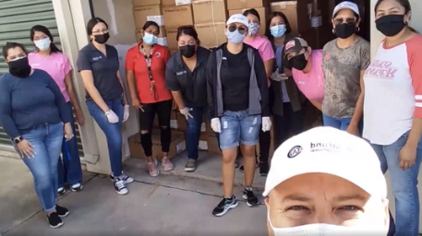
Our Texas team recently received a shipment of 150,000 masks through ChildFund’s GIK program to be distributed to children and families in the RGV and in partnership with local schools. Over 6300 of these masks have been distributed to date.
As more testing sites open, our staff are notifying families through regular contact calls and via Facebook of the options and requirements.
Texas Team unloading GIK Mask Donation
3.b.2. Ensure that children get food they need
ChildFund’s Global Response Plan
To ensure that the most vulnerable families can keep food on the table, pay rent and cover other basic needs, we are providing cash for those families most needing this support, such as those who have lost their income because of COVID-19, child or elder-headed households, and/or households affected by disability or chronic illness. Where possible, we are distributing food and basic household items directly, carefully abiding by COVID-19 protection measures
2/3 of target families have indicated a need for food support.
Local Partners in Mississippi and Richmond area are collaborating with schools and other groups to ensure that their most vulnerable families have access to food – through school curbside deliveries, take-away evening meals and through deliveries of food packets directly to homes and grocery shopping for at-risk families who cannot go to the store, LPs plan on ramping up distribution of food packets throughout summer. Texas team will promote and encourage families to participate in USDA Summer Food Service Program (free meals for any children 18 yrs and under), available at various sites throughout the RGV.
Our staff are ensuring families are aware of the various free food distributions being offered by local food bank, churches, civic organizations, government offices and as schools start back virtually, the lunch/breakfast (and sometimes dinner) curbside meal deliveries provided by local school districts. In November, food baskets were distributed to over 50 families
3.b.2. 1. Cash Transfers and vouchers
-Is your CO planning or implementing cash transfers or vouchers as part of COVID19 response?
As COVID rates continue to rise in Texas, impacting our families economical wellbeing and we have an existing method of getting cash (DFC’s) safely into the hands of families via Wal-Mart e-gift cards, we are doing family assessments to assess extenuating situations that we can address through cash transfers. We are working through some of the challenges/glitches with e-gift cards before exploring this as an option for cash advances.
- If so, brief description of progress to date.

Cash transfers or vouchers executed
Beneficiaries |  |  | Amount transferred (US$) | Transfer mechanism (i.e. mobile money, banking system other financial service provider etc,
Total | Gender (if available)
 | Female | Male

3.b.2.2. Other responses in relation to objective 3.b.2.
Based on a Family Needs Assessment collected on TX families indicating extraordinary needs, the additional June subsidy allocated to Texas (due to savings in donor acquisitions) will go towards household utilities, lot payments, groceries, clothing and home school supplies.
Operation Shoestring distributed financial support (@$500/family) for families participating in their virtual summer program.
USP received funding from the COVID emergency fund to distribute cash vouchers through our LP in Mississippi (Operation Shoestring) and also in our Texas area. Distributions in MS will begin in February.
3.b.3. Keep children safe from Violence: physically and emotionally
ChildFund’s Global Response Plan
We are supporting community-based child protection systems that identify, respond to and refer cases of abuse, neglect, violence or exploitation. We are also providing virtual, online psychological first aid and counseling, and supporting temporary shelters for children who live on the street, providing hygiene supplies, food and other basics. We are also arranging safe and appropriate care for children who are separated from their caregivers due to treatment or prevention measures.
Key findings from staff check-ins: families are abiding by stay-at-home orders and many are spending time interacting with their children. The biggest stressors seem to be fear of the coronavirus (el virus), lack of access to PPEs and struggling/frustration with home school instruction. Staff have indicated that calls with parents are often lengthy as there is a need for someone to hear them out. This regular outreach to families has been critical and cannot be underestimated as they provide an opportunity for staff to identify and mitigate major stressors among our youth and parents, providing a vital connection, a listening ear and referrals* to appropriate local resources. *(staff have vetted, checked eligibility, and give guidance on how to access)
“During the past two weeks of service I had the opportunity to interact with the community through phone calls. …I was able take a glance at some of the families’ lives through their stories. One lady talked to me about her family and how they all were affected by COVID. Another lady talked to me about a rare condition her child has and how they cope with it. Some of their stories were sad and left me feeling a bit helpless. However, some parents just wanted someone to listen to their stories and being able to do that gave me a sense of accomplishment. In the end what I enjoyed the most was hearing the kids’ stories about their likes and personalities.” Jose, AmeriCorps Member
We are also providing psychosocial support through our online “Dream Corner” activities where we intentionally build children’s resiliency through storytelling for children who have had difficult things happen to or around them. By using books and stories, children take journeys alongside relatable characters which make them feel less alone and help them find ways of working through difficult situations and imagine new possibilities for themselves. These “safe spaces” needed more than ever during this COVID environment, so we are adapting our programming to virtual and at-home Dream Corners to help children navigate their way through this very scary time (see more under 3.b.4)
The current protests and upheaval taking place across US communities due to the killing of yet another Black man by the police, raises additional stress and trauma for children and families, especially for Black communities. In MS, our LP is stepping up engagement with youth Ambassadors, meeting virtually twice a week to help them navigate through this very distressing and fretful time. The ambassadors are planning how they can take action as a group in response to the issue of police brutality (including a recent local incidence of a Black man killed by police), while acknowledging that unfortunately these recent incidents are “nothing new - it happens all the time”.
3.b.4. Help children continue to do their job: Learning
ChildFund’s Global Response Plan
While schools remain closed, we are supporting children’s learning through activities and tutoring sessions online or by radio. For students without reliable internet access, we are distributing home learning kits with materials and guides for their use.
Schools often provide a “safety net” * for so many of our vulnerable children -- USP’s traditional programs (Youth Ambassadors and Dream Corners) normally take place during school and after-school programs, providing dedicated safe spaces for children and youth and trusted relationships with adults to work through adverse experiences which otherwise would undermine their educational performance.

- ChildFund staff, AmeriCorps members and LPs are supporting distance learning through online options such as home learning modules, mini lessons, storytime sessions and virtual sessions:
  - TX: Reimagining our Dream Corners for the places in which children and youth are now spending much of their time: at home, and online.
    - SEL Unit Plans: AmeriCorps members are pairing up (virtually) and reviewing selected SEL children’s books to develop unit plans (discussions questions, arts activities, music, games, supplies list, etc.) with a “remote learning” lens based on those books. Unit plans will be incorporate into upcoming (summer or beyond) remote programming.
    - Creating storytime videos readings and demonstrations of activities that accompany featured books (“Whimsy’s Heavy Things”, “After the Fall”, Dreamers, etc.) that focus on themes of managing anxiety, fear, loneliness, etc. for kids/families to read and do together at home (like make a kite, listing your “heavy things” and things their grateful for or hope for) and go out and fly it together. Some of our partner schools will also include these readings/activity demonstrations on their Facebook pages. Staff are editing the videos and content will be available beginning week of April 27. Staff are notifying and encouraging families to sign up or follow Facebook group and send invites of new video postings to every family that is not part of Facebook group.
    - AmeriCorps members who are creating the video presentations (storytelling & connection activities) have created Dream Corners at their homes that will provide a nice setting for videos. Content for the various Storytelling Units (video reading, demonstration of connection activities, Just Ask Us! survey) have been developed and are being edited for Facebook postings (“closed group”).

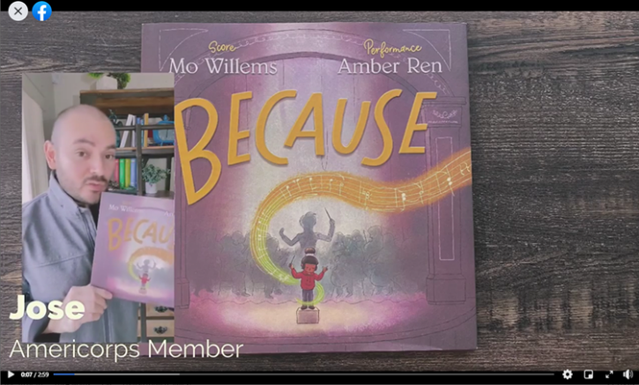
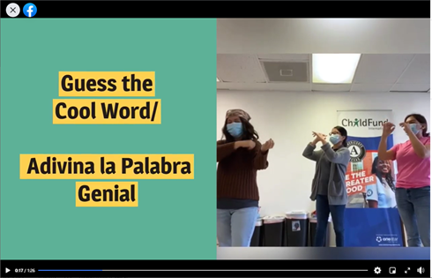
    - As schools re-open virtually, districts are providing tablets and laptops to students who do not have them (most of our families). However, the availability is not automatic, and it is mainly those who reach out to let districts know they are in need. ChildFund staff are getting out the word, through regular community mobilizer check-in calls and Facebook and encouraging families to speak up and be proactive. In addition, most school districts are also providing access to internet via ‘Drive-up Wifi locations and school-buses traveling within communities.
    - Scan this QR Code to access current online program content on developed and posted on Facebookn in the past month (De) based on children’s books: >>>

    - Texas team is implementing “No Pressure Zone” activities throughout our target communities, which include distribution of Unit activity kits and books and collecting finished activity products from participating children. We also celebrate those children who have birthdays – so meaningful to the children who are unable to gather with friends or classmates.
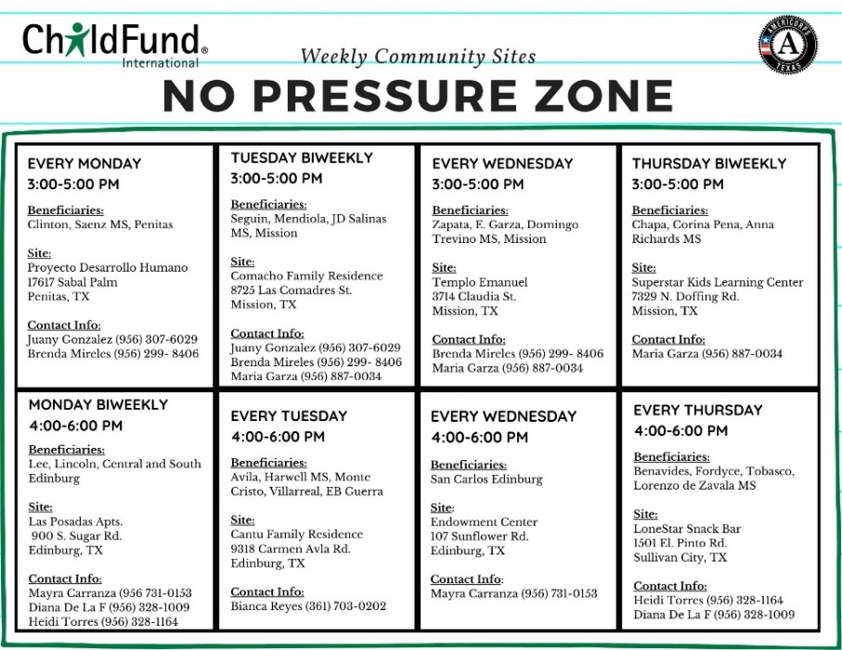

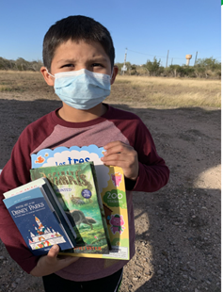
No Pressure Zone Activity Packets Distribution

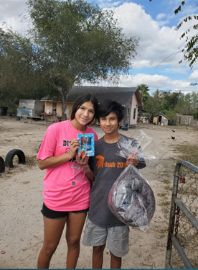
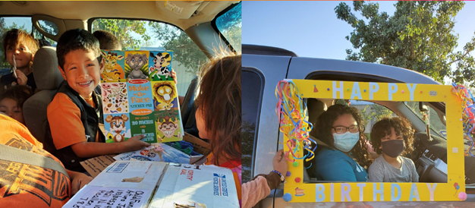
Home Visits - checking in, delivery of program packets, sponsor correspondence/gifts, basic needs
Celebrating Birthdays Safely
Connecting Curbside - Happy Faces
To further develop COVID 19 “Learning” initiatives, AmeriCorps COVID 19 Planning Grant team (includes “Design Sprints” were launched June 22 to reimagine our Dream Corners methodology (currently being facilitated by AmeriCorps members) for the places in which children and youth are now spending much of their time: at home, and online. The Design Gym consultant firm is facilitating this process. Texas team members participated in an “Empathy Research” Training Session conducted in preparation of Community Mobilizers conducting 1-on-1 Empathy Research interviews with children, youth, and parents to contribute towards the development of a new Dream Corner protype. The team participated in “design sprint” ideation sessions to develop new ideas, opportunities and protypes for virtual and “at home” Dream Corners. The team participated in a Rapid Prototyping Session to build prototypes for Online & At Home “Dream Corners” resulting in over 300 raw ideas which were synthesized and prioritized into 8 concepts. The team divided into teams to further develop prototypes for each concept. (see below photo) Community Mobilizers received training and conducted User-feedback sessions on the prototypes with children, youth and parents who were interviewed during the Empathy Research Interviews. The entire team participated in a Prototype Refinement & Roadmap Planning Session to inform next steps on rolling out prototypes and engaging partners in support. The RGV Expression and Mobile Truck prototypes are being further developed and incorporated into fall “No Pressure Zone” programming.

  - Mississippi: Facebook live events support academic instruction, using Barksdale Reading, Scholastic’s home learning modules and other resources. Youth Ambassador virtual gatherings: Interns maintain weekly contact with Ambassadors through GroupMe and other social media platforms, assessing their needs, well-being and challenges as they transition to remote learning during the school closures. Ambassadors continue working on service-learning projects to share youth experience by researching impacts of Corvid 19 on youth, poverty, and their future. Summer programming includes:
    - Adaptable activities designed to be flexibly implemented through multiple modalities (in-person community “festivals”, Family Fun “Nights”, Facebook Live and other interactive virtual facilitation, digital delivery, or sent in take-home packets) - designed primarily to support social and emotional well being
    - Virtual service projects/challenges for youth;
    - Ambassadors are designing and conducting the summer virtual program activities for middle school students.
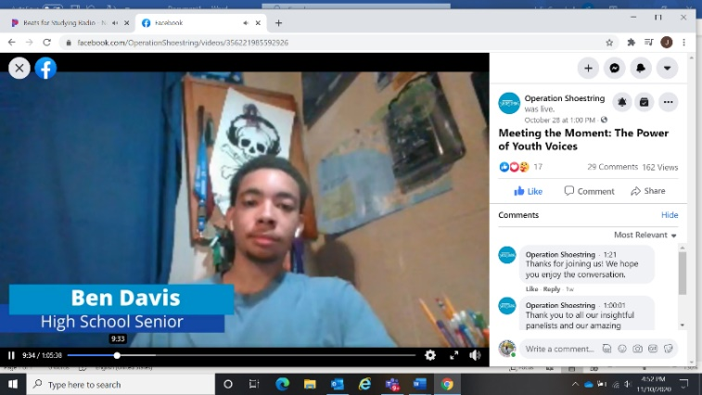
    - Summer camper youth participated in Zoom rallies where they were able to check in with their friends, let off a little steam, and participate in social-emotional learning opportunities like learning to cope with stress, “All About Me” Graffiti Walls, making connections with other and dealing with “big” changes.
    - Operation Shoestring’s Conversation on Community: The Power of Youth Voices featured perspectives on how youth are navigating the current turbulent time.
Youth Ambassador serving as panelist in Conversation on Community
    - ChildFund is partnering with Operation Shoestring in conducting a “design sprint” to respond to the extraordinary circumstances (COVID, racial injustice, etc.) that have impacted children, families they serve and the way they conduct programming and operations.
    - Richmond: Local partners (CIS) are building resiliency through virtual social-emotional learning and mindfulness tools. CIS Site Managers have provided focused support to high school seniors to ensure they “cross the finish line” and graduate.
  - Richmond Public Schools is eligible for CARES ACT funding and some will be allocated towards addressing children’s trauma due to COVID, etc. LP CIS Richmond is part of the TILT (Trauma Informed Leadership Team) and will focus on strengthening students SEL through parent enagement efforts, which has been a part of ChildFund’s partnership with them.
  - CIS Richmond & Chesterfield County staff are making sure that RPS students have everything they need to start this school year virtually.
  - Approximately 2/3 of US Program target families in all areas, lack internet access, (for those who do, access through cell phones but coverage is spotty), so our distance learning approach includes both online virtual options and distribution of printed materials through learning packets in all areas.
  - Making sure that children have books at home during this time out of school, as we know reading is one of the best ways for children to not “fall behind” and it’s a great activity for families to do together. Books and “school” supplies are distributed through learning packets, curbside lunches.
  - Distributions at 10 community sites began June 22 and include “Drive-through” deliveries of activity supplies, books, stress relievers and a 30-Day challenge- based on a packet of activities (COVID-19 tips and messages, fun activities, mindfulness exercises, etc.) for families. Despite the 95 degree temps, and COVID cases reaching record highs in Texas, turn-out has been larger than expected, children are so excited to see the Community mobilizers, AmeriCorps members and parents are very appreciative. Mask wear is approximately around 80%, and the team emphasized the importance of wearing a mask. Each week, teams of 5-6 staff will rotate to various community sites 4 days a week to continue the distributions. Participating families will be recognized for completion of ties. Community distributions have been suspended As of July 1 for the next couple of weeks due to the skyrocketing of COVID 19 new cases each day and orders from local officials to “stay at home” unless necessary. Curbside drop-offs at family’s homes will take place in the meantime.
  - Decisions on school openings in the fall have not been decided in any of our target school districts, which will greatly impact how we implement our school-based programming in each target area.
  - Although high school seniors are missing out on traditional graduation activities, Texas team is recognizing and celebrating this important milestone for our graduating seniors, including an online graduates’ photo album and celebration parade as well as a “graduate gift kit”. Community mobilizers have collected photos of graduates as well as their baby pictures
3.b.5. Other responses
Below Sections for Internal Use Only
Part 4: Office and Staff Status
Office Status (Open/Closed) | Number of Staff: (includes ChildFund employees, contract staff and AmeriCorps members
 | Diagnosed with COVID19 | Diseased from COVID19 | Working from Office | Working from Home | On Special Leave
TX Office on staggered opening by teams. Community sites staffed by those able (i.e. don’t have children at home, per-existing conditions, etc.) During December, community site visits have been suspended due to increased COVID rates. | 1 | 0 | 6 at any one time | Remaining 24 | 0
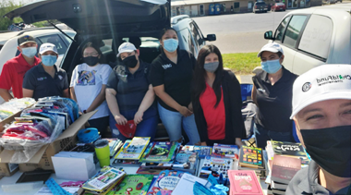
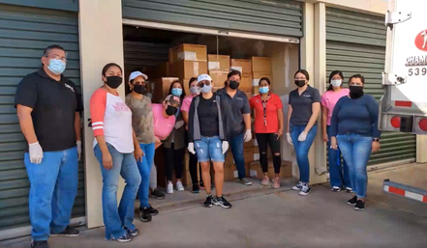
Texas team at Community Site
This is how we do it!
Operation Shoestring has begun a limited return to office, but programming continues to be remote and virtual.
CIS Richmond staff working remotely, all programming currently virtual

- Working with HR on guidelines for phasing in the opening of TX office. Carmen Dryer is providing guidance and support in our Return to Office plans (working from office and working in the community). She has developed two schedules around the theory of 4/10 which are being considered for applicability and practicality. A guidance manual has been finalized that support staff’s and member’s return to the office and includes such topics as: social distancing, use of personal protective equipment (PPE), use of common areas (e.g., break rooms, restrooms), rotating team schedule, visitor controls and staff restrictions/accommodations. ChildFund Texas Area Office began partial return to office June 8 with continuous monitoring and assessing of health and safety protocols and compliance by each team member of these requirements and procedures.
Notes: Any cases of staff diseased need to be reported immediately to RD and GHR. Special leave as per COVID19 Administrative Guidelines.

Number of staff/partner organization staff completed WHO COVID online training https://www.who.int/emergencies/diseases/novel-coronavirus-2019/training/online-training.
None at this time – Staff have registered and participates in online COVID trainings from other sources.
SCAN Self-Care webinar, “Trauma-Informed in the Age of Coronavirus” national screening - All US Program staff participated
OneStar “Managing Self Care and Preventing Burnout During COVID 19”
Childsavers Virtual Brown Bag – Trauma-informed Resources for Educators
“Youth Communications”- Reframing our Perspective (helping youth get through the collective trauma)
“Reopening School: A Panel Discussion with Education Leaders” – Webinar
OneStar Summer Webinar Series: Challenges Facing Education Focused AmeriCorps Programs
PBS KIDS Virtual Professional Learning Week on Social & Emotional Learning Strategies
Disaster Ready - Good Shelter Distributions
Meeting the Moment during turbulent times – Youth Voices (Operation Shoestring Conversation on Community webinar)

Part 5 Human Resources
- Which visitors are there in the country? Please include names, functions, contact information and arrival/departure dates for both IO and RO staff (note: due to the travel ban, this will apply only once the ban has been lifted)
- Any gaps in staffing/need for deployment from other COs or Global Teams?
- Are there any other major HR issues?
Part 6 Safety & Security
- Are police and other services functioning in the normal manner?
Police in the Rio Grande Valley have set up check points throughout communities, stopping people and asking where they are going. Fines up to $1000 for those violating the Stay at Home order.
- Are the courts still operating? Varies from state to state and by type of court proceedings – specifics.
- Are there reports of looting or increased criminality? Not at this time (although some reports of price gouging). Crime is actually down as people stay home.
- Have military personal being deployed to patrol towns or cities? No
- Confirm the safety of staff and their families in the affected area. We are holding weekly Team Check-ins via Microsoft TEAMS to ensure all team members are safe and engaged in service. These check-ins also include “self-care” resources and exercises.
- Have Safety and security risks/mitigation plans been updated to current environment?
Following OneStar AmeriCorps Risk Management Guidelines
- Recommendations around any upcoming travel planned for staff or donors (note: Only once global travel ban has been lifted) No plans for travel of donors or staff through the next few months.
Part 7 Grants
List all active grants:
Grant Job Code | Grant Name | Donor | Status of Implementation (Normal/Reduced/Suspended) | Any specific guidance received from donor? (Yes/No)
98-012 | OneStar AmeriCorps | OneStar | Grant period started Sept. 1. Proposed school-based activities currently in virtual and community-based implementation. | YES

Provide any additional narrative on how the COVID19 crisis affects implementation of your major grants.
OneStar is providing ongoing guidance and support as we continue to implement our AmeriCorps grant. Key changes to implementation include: (see attached AmeriCorps TX Coronavirus Guidance)
- Development of alternative service opportunities for AmeriCorps members
- Development of Teleservice policy
- Provision of AmeriCorps member living allowances
- Flexibility in expenditure of grant funds towards Covid-19 program response
- Waiver of penalty’s for AmeriCorps members not fulfilling target service hours
Part 8 Funding
Provide information about potential sources of funding, including grant donors, subsidy, Emergency Action Fund, Alliance members, GIK, etc., for these emergency response efforts using the chart below:
Donor | Program | Amount (USD) | Requested? (Y/N) | Confirmed? (Y/N)
FirstBook | TX Bookmobile | $1000 | Y | Y
OneStar AmeriCorps | TX programs | Allowed to re-direct % of grant funds (TBD) towards Covid-19 response. | Y | Y
OneStar AmeriCorps | Covid-19 Response Planning Grant | $61,607 | Y | Y
Center for Disaster Philanthropy | US COVID Response | Undetermined | N (Initial call w/ Directors of Strategic Initiatives & Major Initiatives) | N
Porticus Foundation | Support for US projects – Education | Undetermined | N | N
OneStar Foundation AmeriCorps  (2nd yr grant) | TX SEL programming | $282,420 | Y | Y
?? GIK | TX Area Program | $750,000 (value) | Y | Y

- Budget
  - Outline how we will use this funding with a rough topline budget.
- FirstBook: Funding is in the form of a “Gift Certificate” for purchase of books from First Book’s Book Bank. Must be spent by April 30th. 2800 books purchased for distribution to children in TX.
- OneStar: We submitted a budget reallocation shortly before COVID situation. We continue to follow that budget, with allowance for adjustments to support COVID related responses such as purchase of tablets and accessories for members to be able to effectively work remotely.
Part 9 Media/Communications
  - List of media who will be or have been contacted with press releases.
  - List of emergency CO spokespeople, including name, location, contact information, and languages spoken. Julia Campbell (English) is primary USP CO spokesperson, with Santiago Baldazo as secondary contact (focused on TX and Spanish language media requests). We have a couple of AmeriCorps members with COMMS skills we may want to prepare for AmeriCorps media opps.
  - Plans for collecting photos/videos/stories, e.g., should an outside photographer be hired?
  - Key points for messaging and visibility, particularly any host-government sensibilities that must be considered.
  - Support needed or requested from IO, GSS or Global Teams – whether onsite or remote.
- US Program Staff received “Teams” training on March 26
- Requested support from Shelby French for team “self-care moments” during upcoming team meetings.
- Collaborating with Digital team on potential postings for ChildFund broader audience based on our SEL Storytelling

https://l.facebook.com/l.php?u=https%3A%2F%2Fwww.savethechildren.org%2Fus%2Fabout-us%2Fresource-library%2Fus-childhood-report%3Ffbclid%3DIwAR3V02AXYDmflR1LXQcaWezYL8b0186FFTByR8c_XxNklfw7ufNN7f59ro4&h=AT2xr5Y0ujCMWjSVxXhC_59PUXRsQ2UwKT8BUh0p3B4y2Xw_5K5JruszJ8wEIadIjCzOcLDJv4_nToqxOOe-XZWqhjAUxmf2zmcHfOPt8bOd_G8-4BnCpac81sFiHIPI2r6kj3_uPpMwSkvJscc
Sponsors: Senators Chris Coons (D-DE), Roger Wicker (R-MS), Cory Booker (D-NJ), Lindsey Graham (R-SC), Jack Reed (D-RI), Marco Rubio (R-FL), Tammy Duckworth (D-IL), Cindy Hyde-Smith (R-MS), Kamala Harris (D-CA), Bill Cassidy (R-LA), Tammy Baldwin (D-WI), John Cornyn (R-TX), Angus King (I-ME) and Susan Collins (R-ME)

