ChildFund International
Humanitarian Situation Report
Humanitarian Situation Report [22]
COVID-19 – [Uganda]
[10st January 2021]
[Point of Contact – Moses Otai, Country Director, +256 792666620]
[Date Range: [1st to 31st December 2020]
FOR UPDATES, PLEASE HIGHLIGHT UPDATED SECTIONS IN RED
Part 1: The Overall Situation
COUNTRY
Total Number of COVID-19 Cases Reported | Number of Deaths | Number of Cases Recuperated
37,554 | 301 | 12,720
SOURCE: https://www.arcgis.com/apps/opsdashboard/index.html#/bda7594740fd40299423467b48e9ecf6

ChildFund-supported areas (Provide only if you have reliable data on this. You can report on a consolidated basis or by program state/region/province/etc. if you have this detail.)
Geographical area (country or state/region/province | Total Number of COVID19 Cases Reported | Number of Deaths | Number of Cases Recuperated
Kampala | 11767 | 106 | 461
Kiryandongo | 315 | 03 | 137
Acholi | 699 | 02 | unknown
Mbale | 65 | 02 | 32
Jinja | 35 | 01 | 16
Soroti | 36 | unknown | unknown
CECE | 23
SOURCE: Partner SitRep

1 Local partner(LACCODEF) staff died due to COVID-19 in November 2020.
Any relevant background information about areas affected
- Of the 971 cases, 53 are Ugandans, 2 are Chinese the majority of whom had recent travel history to Dubai, and other high-risk countries. 24 of those had no travel history but had links with a confirmed cases Only 2 had no link to a confirmed case; 1 case is a boarder trader in Adjumani, and another is an 8 months baby in Iganga whose father had a recent travel history to Kisumu-Kenya. Two cases are Chinese nationals who were part of the group of six re arrested when they were attempting to cross to DR Congo and had escaped from the quarantine center. The last 23 cases have been of foreign long-distance cargo truck drivers tested at the border points.
(13 from Kenya and 10 from Tanzania).
- The most recent were 11 cases of children from an evangelical city church called Watoto who travelled back from the UK and Canada on a musical tour.
- Over 400 cases tested in the past two days turned out negative, giving some reprieve to the country
- The government has decided to search for all travelers who entered the country between March 7th-22nd to have them tested and partially the reason for lockdown of the country.
- The majority of new confirmed cases are Truck drivers from Kenya and Tanzania. To address this importation of infections, government has instituted mandatory testing before entry by truck drivers. Unlike previously when samples would be secured from divers for testing while they continued with the journey. Drivers will now have to wait for results before they can continue with the journey .Only Truck drivers who test negative will be allowed I or out of the country.
- So far, 01 case from our sponsored child # 149023800/00008 in Buwenge Community in Jinja who tested positive and is now receiving treatment in Entebbe COVID-19 treatment facility since Monday 18th May 2020. The IP communicated with the treatment center and his condition is not in danger. The IP also sent him 30USD for personal effects as the Government is handling all the other related costs. The case is a senior four leaver who during vacation, got a temporary employment as a heavy truck turn boy on Uganda-Kenya route via Malaba. While the IP was in the process of enrolling him on vocational training to pursue his dream course of mechanics FY20/21. He last interacted with his family and community staff in February 2020 when he came to acknowledge for DFC. We will continue assessing other needs and provide timely support to him and his family.
- The health worker attached to him reports that he is positively responding to treatment since he indicates that headache, dizziness, and sneezing has stopped.
- The sponsored child who tested positive with COVID19 was reported (by the health workers treating him) to have recovered. The health worker attached to him indicated on the 15th June 2020 that the boy would be taken back home in Buwenge on the 16th June 2020 by MOH from Entebbe treatment facility.
- The child who recovered now is at home in a good health condition. He sounds confident that the counseling and psychosocial support he received while at Entebbe RRH was adequate for him to cope with life while in the community. The LP (JIACOFE) staff are in touch offering psychosocial support on phone and reminding him to observe MOH guidelines of staying home for more 14 days, keeping social distance, washing hands regularly with soap, wearing face masks and sanitizing. The District Health Officer advised the LP not to reach the child’s home not until the surveillance team interprets the discharge documents and conducts community sensitization. They have not acted but we are still following up. The child appreciates the care, love and support extended to him by JIACOFE and ChildFund during the hard time at Hospital. He also appreciates the cash transfer extended to his family at a time he could not support them.

- The evolving trend of confirmed community COVID-19 cases is worrying as the risk of surge is high even when the government is working around the clock to contain the pandemic.
- With the rise of confirmed community cases and registering deaths, the country’s risk is high with need for heightened vigilance by staff and the program participants.
- There is increase in community cases with a rise in deaths and therefore the need for continued vigilance in following the MOH guidelines.
- In Jinja area, 4 people, including a “Boda boda” cyclist from Nkombe and Malongo (Mayuge district) tested positive with Covid19. They are being managed at Jinja isolation and treatment center, since the Mayuge, centers have been closed due to lack of funds.
- In Kampala area, a total of 768 people tested positive for COVID-19. These are from the divisions of Rubaga, Makindye and Kira. There is no death registered yet. All are community cases and are currently being treated in the referral centers around Kampala. There are so far no cases from enrolled families.
- In Kiryandongo District the number so far registered is 117, out of whom 86 (30 Ugandan nationals and 56 Southern Sudanese) emerged in the past two weeks. 2 deaths have been registered. No cases from enrolled families.
- Cases from Mbale area are on the increase, having registered 9 patients and 2 deaths from Mbale district, 7 patients and no death from Sironko district . All the patients are said to be in steady progress but are yet to recover. There are no cases from enrolled families.
- In Soroti, the quarantine centre has been closed after the Nursing school opening for classes. It has been confirmed that COVID19 pandemic in Soroti has reached phase 4.There are currently 30 positive cases being attended using home based care approach.Only 6 cases are being isolated within the hospital facility
- 35 people in Kamuli tested positive with Covid19. These were 28 medical staff at Kamuli general Hospital and 7 local government officials. Currently Kamuli, general hospital is closed and therefore not operating. All the 35 patients were advised to isolate and self-quarantine themselves at their respective homes and follow instructions from health practitioners.
- After the resumption of Soroti Nursing school, Soroti district opened a new treatment centre. There 120 positive cases, they discharged 82, 31 are active, out of these, 7 people died while undergoing treatment.
- In Kampala, one of the children lost a parent to Covid-19 in Mbuya community
Host government posture: Have they declared a state of emergency and/or requested outside assistance? No declaration of the state of emergency yet and government is open to any response efforts.
- The Government has taken additional firm measure of a 14day lockdown with a curfew implemented from 7:00pm to 6:30am.
- Government allows only essential services to continue
- For two last days there was testing of suspected persons with no positive cases which is a good sign that the measures instituted by Government including 14 days countrywide local may be working positively.
- The private sector has come in to support government and donated cash and items (particularly medical supplies and equipment) worth $540k.
- It is likely that Government will be announcing a phased lifting of the lockdown but with still stringent prevention and control measures in place.
Which nationwide measures has the government taken, e.g., limitation on meetings, internal travel, school closures etc.
- International Boarders closed including the international airport and all international passenger flights banned except Cargo flights that are allowed with certain conditions such as quarantining of the crew in designated facilities/hotels.
- All schools, tertiary institutions and universities closed for 32 days effective Friday 20th, March 2020.
- The Government is emphasizing prevention (Social distancing, Handwashing, avoid coughing/sneezing in public, reporting suspected cases). Set up hotlines and mobile centers for picking up samples for testing.
- The Government banned all activities that require mass gathering like, religious gatherings, political gatherings, concerts, parties, bars, funeral ceremonies, marriage ceremonies.
- Government has activated country wide isolation centers
- Government is allowing in only cargo transportation country wide.
- Government has banned public transport, and nonfood markets, closed shopping malls and arcades
- Government on Monday the 30th March issued more guidelines suspending all forms of transport including private cars except for emergency response, declared a nationwide curfew from 7:00 pm-6:30 am effective 31st March 2020. All these will run for 14 days.
- The Government extended the countrywide lockdown and curfew for the next 21 days elapsing on the 5th May 2020 to try and contain the pandemic.
Government made pronouncements on the 18th May to relax a number of measures I the next two weeks. The areas to be relaxed will include; Final year students will be allowed to return to school, general merchandize shops to operate, public transport to open with carriers operating at half capacity, private cars to operate at maximum of 3 persons per car including the driver.
However, the public and private transport will remain prohibited in the 40-boarder districts to reduce the risk of infiltration from the neighboring countries.
Government plans to distribute high quality masks to all Ugandans aged 6 years and above within two weeks to help reduce the risks as the lockdown measures are being relaxed.
The Government is yet to start mass distribution of masks.
Public transport lockdown was lifted effective 4th June but they are to carry half their usual capacity.
- The nationwide curfew has been adjusted to start from 9.00pm to 5.30Am
- Boda-boda(motorcycle transport was allowed to carry one passenger but with strict adherence to the standard operating procedure; use of helmet, sanitizers and masks.
- Border districts remain under lockdown with no movement of both public and private vehicles except for emergency purposes with mandatory clearance from district authorities.
- Boarder districts are still under lockdown
- Schools continue to be closed with a lot of talk by central government about the possibility of a phased reopening beginning late September. Consequently, learning continues to be challenging because of limited learning materials developed and provided by government and limited access to learning via radio and TV platforms for rural children.
- Travel restrictions on boarder districts have been lifted
- Government has made pronouncement on re-opening of schools and institutions only for candidate classes and final year students, with strict SOPs effective October 15th 2020.
- Places of worship were opened for individual prayers and confession with priests or counseling with necessary SOPs, prayers and fellowships should not exceed 70 people. Night prayers and trans night prayers were prohibited. Sunday school children not allowed to operate.
- Places of worship are now permitted to have upto 200 worshipers with use of masks and social distancing.
- Open air activities of sports were opened provided there are no spectators, and the players are tested for COVID – 19 at least 72 hours before engagement in tournaments. This test expires in 14 days, so the sportsmen will have to repeat the tests fortnightly.
- Air travels into the country were opened, especially for tourists and Ugandans returning home, provided they tested negative 72 hours before arrival in Uganda and tourists do not mix with Ugandans.
- Campaigns in the national general elections have kicked off. Candidates are allowed to have meetings with a maximum of 200 people with observance of social distancing and use of masks.
- The country will hold general elections in January 2021 and campaigns for the different elective positions including; the president, members of parliament and local government leaders is ongoing. While the COVID 19 control SOPs discourage gatherings, there has been widespread violation of the SOPs as large gatherings are seen during the campaign meetings of the candidates across the country. This has led to the rise in new cases and the numbers are expected to surge as we conclude the elections in January.
What responses has the government put into place to address the health crisis and/or the economic impact?
- It is reported that government is planning to borrow from the World Bank and has so far presented a loan request of about $90m to Parliament for approval.
- Government is engaging the private sector to produce needed essential items such as sanitizers and has committed to waive taxes on these items.
- Surveillance teams have been set up country wide.
- Isolation centers are being established and so far, three are operational. Also 900 beds have been prepared at the newly refurbished national referral hospital.
- Government led by the president is providing updates and carrying out awareness on the pandemic using multiple media channels and routine briefings
- Weekly mass markets have been closed.
- Public and private transport banned with exception of only vehicles that offer essential services (Health and Security)
- Task forces have been put place in the local governments manned by the District Health office and security. Nationally there is a task force led by the Prime Minister and the Minister for Health
- Government intends to identify the very poor and provide them with dry food rations.
- Government launched the distribution of food rations targeting the vulnerable households whose livelihoods were eroded by the lockdown. Over 2000 families have so far benefited in Kampala capital city slum settlements.
- Ministry of education has issued preliminary guidance that schools may be reported on April 27th and tertiary institutions on May 2nd if the situation normalizes. Second and third terms were extended to allow for coverage of the syllabus and parents will not be charged additional fees when schools resume or face any fees increments. This is however dependent on the evolving situation and containment efforts.
- Parliament of Uganda passed a supplementary budget, realigning quarter four budgets to focus on COVID response. Ministry of Health is requesting for a supplementary budget of $110m to respond to the pandemic.
- USAID realigned $15m from its Maternal and Child health projects to support government in responding to Covid19.
- Government has instituted mandatory testing of all truck drivers entering the country and restricting their stop over locations for easy tracking and following up.
- Government is now proposing to have asymptomatic cases managed from their homes due to congestion in the designated COVID-19 referral points. This may worsen the incident of community cases.
- All schools and institutions re-opening for candidates/finalist students have been issued with stringent SOPs, with emphasis on testing, social distancing, hand washing and use of masks.
- The schools opened and are still operating with final year students only. There have been no major incidents since reporting early October.
What travel restrictions has the government put in place for travelers entering the country?
- No international travel for passengers. No entry and exit except for those negotiated by the UN and individual embassies but also those must only come with empty plans to evacuate their passengers.
- The major airport has resumed operations, under strict SOPs. All passengers must be tested for COVID-19 at least 72 hours before travelling. All planes and luggage must be disinfected prior to boarding and upon exit of passengers. Travel so far limited t tourists and Ugandan nationals returning home.
Part 2: The Situation in Areas Where ChildFund Works
Partner Organization (Use Salesforce identifying code/name.) | # of Enrolled and Sponsored Children |  | COVID19 Cases Reported in ChildFund Communities (Y/N/Unknown) Provide number if available. | Number of Enrolled Children Reported with COVID19 (If available.) | Number of enrolled children diseased as result of COVID19
 | Sponsored | Enrolled
1490007  ACFP | 1808 | 2344 | N | N | N
1490003  BUACOFE | 2713 | 3001 | N | N | N
1490006  CECE | 2882 | 3364 | N | N | N
1490001  JIACOFE | 3439 | 4145 | N | N | N
1490005  KAFOC | 1780 | 2209 | N | N | N
1490002  MAFOC | 3273 | 4039 | N | N | N
1490004  PfCW | 2796 | 3457 | N | N | N
1490009  MACDEF | 2698 | 3175 | N | N | N
1490008  LACCODEF | 2820 | 3503 | N | N | N

Child deaths: List any sponsored child (with Partner organization and child ID from salesforce) diseased as a result of COVID19. (Note: These need to be reported immediately following the regular sponsorship protocols.)
Partner Organization (Use Salesforce identifying code/name.) | What is the status of the program/sponsorship processes (operational/suspended)?
 | Program Implementation | CVS | M&E  Level 2 | Enrollment /Disaffiliation | Sponsorship Communication | DFC
1490007  ACFP | Contingency planning | Halted | Halted | Enrolments halted  /Departures will continue virtually  Enrolments and departures are now resumed but operating with caution and following of MOH SOPs | All new correspondences that require interaction children are on hold. Others will continue virtually  IPs have resumed working with children to respond to any pending correspondence with caution and following MOH SOPs | The Country Office will not be able to deliver DFCs effective April  This has partially resumed we are working with IPs to ensure all the pending correspondence are cleared.  We are sending to IPs DFC for April and May
1490003  BUACOFE | Contingency planning | Halted | Halted | As above | As above | As above
1490006  CECE | Contingency planning | Halted | Halted | As above | As above | As above
1490001  JIACOFE | Contingency planning | Halted | Halted | As above | As above | As above
1490005  KAFOC | Contingency planning | Halted | Halted | As above | As above | As above
1490002  MAFOC | Contingency planning | Halted | Halted | As above | As above | As above
1490004  PfCW | Contingency planning | Halted | Halted | As above | As above | As above
1490009  MACDEF | Contingency planning | Halted | Halted | As above | As above | As above
1490008  LACCODEF | Contingency planning | Halted | Halted | As above | As above | As above
Note: As a global measure, all sponsor visits have been suspended.
What issues are children in these areas facing (food shortages, safety concerns, schools closure, etc.)?
- Children are home because of school closure with very minimal reading and learning taking place at home
- Children in urban areas are facing food shortage. Caregivers are already rationing food in order to sustain the 14 days restriction on movements. This situation is bound to worsen given the 21 days extension of the lockdown by government.
- Safety concerns are being raised for the young adolescents and youth who escape from their homes to join their peers
- High likelihood of violence in low income households that survive on hand to mouth.
- Likelihood of children not resuming school timely due to the economic hit on parents.
- Learning from home by rural school age children who have no access to instructional and learning materials.
- Due to heavy rains in the country, a number of households especially those who live along the shores of lake victoria and other low lying areas have been affected by the floods and water logging eg in the villages of Namundiri, Maduwa and Sitengo in Busia and in Katakwi and Amuria districts. The situation is bound to worsen as the rains peak by June 2020.
- Feedback from all over the country through child protection platforms and the media all report increased VAC cases so our children are at increased risk of abuse.
- Many children still do not have enough study materials. A few that have access are not able to make adequate use of them due to lack or very limited teacher support. Most homes do not have adult supporters who can aid in studies. Many parents especially in the rural areas are illiterate and busy with farming and other household chores.
- IPs s are reproting increasing cases of defilement and teenage pregnancies due to idleness, despair and poverty in the families as a result of the restrictions which were brought by COVID19. A case in a point was a defilement case of 14-years old girl by a 54 years old man in Lumino in Busia district. Together with the family members, the case was reported under to police and the culprit was arrested although on a sad note, it was later reported that that the culprit escaped from the cell after breaking through the ceiling board. The IP will follow-up through the office of Child and Family Protection Unit to have the culprit apprehended.
- Rampant cases of domestic violence among due to long stay at home by both husbands and wives. Quarrels and fights stimulated by failure by either party to fulfil their cardinal roles accordingly
- Although we facilitated radio lessons during this period, it only targeted the category of children in grades four to seven. In one of the radio talk shows, a student of advanced level called to express the need for the education program to cover his category of learners as well.

Child protection risks caused or exacerbated by crisis situation.
- Likelihood of violence against children, neglect due to loss of livelihoods especially for urban poor as well as increase in SGBV cases.
- Police is reporting an increase in domestic violence which exposes children to harms.
- Likelihood of heightened mental distress and stress for children, youths, and care givers
- Children in institutional care likely to suffer more with no clear guidance from Government
- In Busia Child labour where children are engaged in petty business and heavy casual work in order to supplement on their parents’ contributions. Many youths especially the females are forced in house maid work in order to enable their parents and siblings meet their family needs.
- High levels of teenage pregnancies and early / forced marriage due to family constraints to meet their needs.
- Increased cases of emotional violence, anxiety, and uncertainty especially among those who have not returned to school, expectant and those who were unable to meet the school requirements.
- In Busia, the introduction of night fundraisings for funerals commonly known as “Disco Matanga” is continuing to expose children to abuse in the communities of Busia district.
- Child exploitation and child labour around the areas of Majanji where children were left practicing mining with no one caring.

Part 3: ChildFund’s Response
3.a. Overall
- Who is or will be leading/managing the response?
- How is ChildFund linked with humanitarian coordination structures, i.e., in which clusters or working groups do we participate? The most recent/next meeting and who is representing ChildFund? Donor meetings we have attended, or missions that we are aware of related to the response?
Who is or will be leading/managing the response?
The Country Director oversees the national response
Planned, desired or ongoing response – inside or outside current operational areas.
The desired response will likely be both in operational and non-operational areas.
Partners have been supported to re-draft Contingency plans to redirect the budget to the critical needs of the households such as hygiene, cash transfers for basics as well as health needs and protection needs of the children. The partner plans have been submitted to redirect and adapt programming. Implementation started.
An E- learning platform was developed by UNICEF and NITA Uganda and approved by the National Curriculum development center. It is called the KOLIBRI E- Learning platform that helps children to keep studying and learning during the COVID 19 pandemic. The content is in Science and Mathematics for secondary school learners and inclusive Education for primary level section. A link has been provided to enable parents and learners to access the materials. The CO has been shared with IP managers to see how it can be accessed to our children and youth in secondary schools as well as those with disabilities. However, it is likely to mostly benefit those with smart phones and who can afford the cost of internet data.
Government released the second batch of home study materials and Implementing partners are helping with distribution to ensure that children continue learning while at home.
Through the 9 Implementing partners ChildFund is engaging with District level response task forces and support the awareness campaign through radio talk shows.
The Country office is procuring handwashing facilities to be distributed to households, health facilities in one Kampala where one of the Partner operates.
- BUACOFE through her partnership with other stakeholders, encouraged the police during the service providers’ meeting to liaise with the office of district resident commissioner and village local council to ensure that such gathering are prohibited.
- The OC Majanji was encouraged during the service providers’ meeting to follow up on the mining field in Dadira and ensure it is closed since it was attracting children
- Printing and distribution of 305 IEC materials sensitizing the communities on child protection

How is ChildFund linked with humanitarian coordination structures, i.e., in which clusters or working groups do we participate? The most recent/next meeting and who is representing ChildFund? Donor meetings we have attended, or missions that we are aware of related to the response?
ChildFund is participating in webinars hosted by the IASC, UNHCR and UNICEF and the CP Sub working Group. A technical Note on Child Protection in Humanitarian action by the IASC has been shared and ChildFund is referring to it. The CP Specialist has been participating in these meetings
ChildFund has also contributed to the Business Continuity Plans consolidated by UNHCR highlighting awareness creation as our focus area in response to COVID-19

3.b. Program Response
Please organize your program response report as per the 4 objectives included in our global response plan. You can add an additional category if you have response activities planned or executed that do not align with these objectives. For each objective use the questions below to guide your report.
What kind of response activities or interventions have been executed? What support items are needed or have been collected/distributed?
- Support local partners complete their contingency and adapt program interventions to support households and work with government.
- CO plans to redirect some of the PEF budget to support partner response plans
- Concept notes
- The CO is redirecting up to 370,000USD for COVID response (prevention and control measures and cash transfers for enrolled families.
- Cash transfers, Awareness messages, Hand washing facilities are being considered as first line for most vulnerable households.
- IPs conducted distribution of IEC materials bearing COVID 19 messages of both English and local language to enrolled families, partners, police, Health centers, VHTs, PEC/Home visitors, community office and Board.
- IPs continued with community sensitizations on COVID 19 prevention and control using volunteers
- The distribution of learning materials to aid children to continue with home based learning
- Distribution of sanitizers to community staff and mobilizers
- Extended Alert support to enrolled children to access medical attention ranging from treatment, operation and payment of medical bills.
- Supported flood affected Victims with cash transfers Lango, Busia, Kampala and Soroti. The flooding has had the biggest negative impact in terms of destroying gardens of families besides displacing some of them. The tragedy still continues in some locations and many families livelihood is greatly affected. As a result, The support to the affected households helped to address the immediate food needs.
- Supported families with cash to buy planting materials suitable to their needs, they were supported by the extension workers to decide on the kind of planting materials for second season. This was undertaken in a bid to mitigate the effects of floods and water logging as well as address nutritional needs of children in the affected communities like Teso and elgon sub regions.
- ACFP printed and distributed Learning materials to 4,602 enrolled children and their siblings (2283 boys, 2319 girls)
- ACFP has also completed construction of 2 houses for enrolled families that were displaced during the floods in Agago district. One more house is not completed due to interruptions by the family relations of the beneficiary. ACFP intervened and mediated the misunderstanding between our beneficiary and the relatives over passage to the beneficiaries construction site and the house is due to be completed in September.
- CECE distributed 2,166 posters (518 for life stage one and 1648 for Life stage two), with information, Education and Communication messages) to the households and major communal sites within the districts of Wakiso, Luwero and Kyankwanzi.

- Families affected by the floods in Busia received conditional cash transfers for buying planting items (bean seeds and maize seeds). Health workers were facilitated to conduct orientation of VHTs on how to sensitize the enrolled families about the messages printed on IEC materials on COVID-19. A total of 4,147 families were reached for these sensitizations.

- BUACOFE supported radio lessons to ensure children continue learning from home since schools are still closed. Approximately 1,108 children benefited from these lessons.
- BUACOFE also responded to VAC cases by procuring mattresses and blankets for juveniles held in cells. These were distributed to the CFPU departed at Busia police station.
- BUACOFE Supported radio lessons for learners of grade four to seven and issued Conditional cash transfer to 810 families (67 non enrolled and 743 enrolled)

- KAFOC commissioned a WASH project, being implemented in 150 schools and markets in the divisions of Kampala City and its suburbs, with funding from Standard Chartered bank.
- LACCODEF:Provided 10 health facilities with hand washing facilities, megaphones and sanitizers. The IP also procured and distributed work supplies to Village Health Teams (VHTs) in 8 communities in districts of Dokolo, Kole and Kwania. The items included gumboots, sanitizers, umbrellas, reusable masks and megaphones. With this initiative, the VHTs are now better placed and well equipped to conduct door to door sensitization on COVID-19, parenting and any other health related activities within the communities.

- PfCW Supported 17 health centres in the 6 districts with a total of 37 handwashing facilities and 17 megaphones for among others health awareness raising and community mobilsation .
- PfCW trained family groups for cash infusion and is awaiting cash support in November 2020.

- BUACOFE received an NSP for Fruit and vegetables to distribute to enrolled families. Therefore, a total number of 171 households were given; - pawpaw’s, mangoes, egg plants, oranges, cow peas and collards for planting so as to ensure food security.
- BUACOFE supported life threatening cases of which (07) were medical intervention and (1) house construction.
- In BUACOFE, a total of 49 children were given monetary gifts from their sponsors and most families used their Funds to meet their household needs.
- In KAFOC IGA packs were distributed to 21 households in 3 communities of Bbiina, Nakulabye and Mbuya to empower them regain economic freedom amidst covid 19.
Communities are continuing to distribute 2 bars of soap and 5 liter jerrycan to each of the enrolled children to encourage the households to maintain the SOP of washing hands regularly to prevent transmission of covid 19. Kireka Community used the project gift to provide 2.5kgs of maize flour and 1kg of sugar to each of the 45 families that had been badly hit by covid 19 as identified by the PEC. 7 health emergencies like typhoid, respiratory issues among children and youth were reported and supported to access diagnosis and treatment from qualified personnel.

- BUACOFE in the month of November supported alert cases and these were isolated in nature. They were health, house burnt, and educational. Under health they were (2), for house burnt (1) and under education where children were supported with registration fees they were (11). All these were supported financially.
- 47 sponsored children received financial gifts from their sponsors. The finances helped families to acquire some of the basic needs required.
- In a bid to improve household incomes, the organization supported training of 23 TOTs in MEDs who will train selected VSLA groups in IGAs like making shampoo, herbal Jelly, wax candles, shoe polish, making of both liquid & bar soaps among others.
- In a bid to help in identification and reporting issues affecting youth in the communities on reproductive health, 8 youth were trained as facilitators of voice now and these will facilitate in collecting out issues affecting youth in the communities.
- Printing of 574 copies of self study books for learners of grades four to six. However, these had not been distributed during the reporting period.
- A total of 14 children of life threatening conditions were supported financially. 2 were for health, 1 for house burnt and 11 with education.

- KAFOC supported 7 parents received IGAs
50learners whose materials were reviewed by teachers received them back.
21 Parents supported with IGAs
27 Education Alerts for both UCE and UACE. Included 2 Female and 4Male responded to
26 beneficiaries received soap and jerrycans
7 members i.e.2 Male and 5Female participated in Voice Now physical engagement
Conducted family visits and reached 102 households, 67 were male and 35 female
3 health alerts were supported
- In Busia; a total of 223 children received gifts from their sponsors and these were used to acquire household basic needs and purchase of IGAs for future use
- A radio talk show to sensitize the general public on child protection was conducted
- 305 IEC materials on child protection were printed and distributed in the communities
- Sensitization of households i.e. door to door on GBV was also conducted with support of CPC members.
- One radio talk show was conducted to sensitize the community on covid19 and the preventive measures. The sensitization was on the creation of village task forces where the task force mobilized and sensitized people about the village task forces.
- 223 children received monetary gifts from their sponsors and they used the funds to buy basic needs
- A radio talk on child protection was conducted
- 7 children with alert 13 children were supported and received UNEB registration fees. this will enable them to sit for the final exams.
- 19 VSLA groups were trained on MEDs and these will start using the skills to improve on their household incomes.
- 562 copies of learning materials were distributed among 562 learners

What is the current progress of implementation vs. the established response plan?
- Yes, Uganda is planning to implement cash transfers.
If so, brief description of progress to date.
- Communication and guidance have been developed and shared with the local partners to prepare for execution of the cash transfers
- Partners are being supported to redraft Contingency plans to redirect the budget to the critical needs of the households such as hygiene, cash transfers for basics as well as health needs and protection needs of the children.
- The partner plans have been submitted to redirect and adapt programming. Implementation starts later the week of 9th April.
- Request for subsidy and PEF funds has been submitted to treasury and expect funds by Wednesday 8th.April 2020
- Sponsorship correspondences are flowing normally.
- Grants are being implemented, though at a slower pace. The CO as negotiated for no cost extension for awards, with tapering schedules, but with unaccomplished scope of work.
- Ips have continued with emergency work to cover the three objectives of stopping COVID-19, Putting food to the table and preventing violence against children.
- Education materials are being printed and distributed to children and reinforced with radio education programs.
- Other essential projects such as provision of safe drinking water to children and their communities are being implemented on case by case basis.
- Quarter one implementation by 9 local partners averaged at 72%. There have also been delays in Government developing additional learning materials for children to continue learning from home. The COVID 19 control measures/SOPs have slowed down iimplementation as Partners have to engage participants in small groups to reduce the risk of COVID spread,

Who are we partnering or collaborating with to provide our response?
- Nine (9) local partners namely:
- Acholi Child and Family Programme (ACFP)
- Masindi Child Development Federation (MACDEF)
- Lango Child and Community Development Federation (LACCODEF)
- Community Efforts for Child Empowerment (CECE)
- Kampala Area Federation of Communities (KAFOC)
- Jinja Area Communities Federation (JIACOFE)
- Partners for Children Worldwide (PfCW)
- Mbale Area Federation of Communities (MAFOC)
- Busia Area Communities Federation (BUACOFE)
- Joining Forces coalition for a press statement and advocacy with the Ministry of Gender.
- Vision Group for messaging through its online and social media channels including print
- Followed up with UNICEF for possibility of a response, Followed up with Standard Chartered Bank for a possible Concept Note
- ChildFund is participating in webinars hosted by the IASC, UNHCR and UNICEF and the CP Sub working Group. A technical Note on Child Protection in Humanitarian action by the IASC has been shared and ChildFund is making reference to it. The CP Specialist has been participating in these meetings
- ChildFund has also contributed to the Business Continuity Plans consolidated by UNHCR highlighting awareness creation as our focus area in response to COVID-19
- The Ministry of Gender Labour and Social Development finalized and shared their Emergency Response Plan and requested Partners to align their response plans to that guidance
- The Ministry of Gender also re-opened the Uganda Child Help line with a Toll-free line 116 to enable reporting of child abuse cases also calling on partner support
- Joining Forces Initiative in-country to develop a joint statement with Advocacy Asks to Government and donors on COVID-19 Response
- The National Child Protection Working Group held its first webinar to guide partners on COVID-19 Response
- Most important for communities will be access to basic hygiene and handwashing kits including soap
- Right now, most engagements are at the level of government and missions as well as WHO however, we have requested to join MOH partner coordination meetings
- Invited to join MOH sub-group partners meetings but will only be possible once we get a waiver for a vehicle to move which we are pursuing
- Standard Chartered Bank

What kind of response activities are you still planning for the coming period?
- More cash transfers for the most vulnerable households
- Recovery interventions focusing on strengthening household economic resilience.
- Resource mobilization through proposal writing
- To Support Families/Children Infected with Covid 19.
- Distribute Covid 19 Messages to All Stakeholders
- Distribute Cash Transfer and micro grants to Vulnerable Families
- Print and Distribute additional learning materials to all school going enrolled children.
- To Support Violence Against Children cases
- To Carry Out Family Visitations
- Provide supported schools with hand washing facilities
- Alert response for enrolled children in candidate classes, who cannot meet the cost of registration for their final examinations.

3.b.1. Stop COVID-19 from infecting children and familie
ChildFund’s Global Response Plan
To help children and families protect themselves from COVID-19, we are installing community, handwashing stands; educating communities about symptoms, hygiene measures and where to get tested or treatment; and distributing soap, hand sanitizer, gloves and masks to families and frontline, health workers. For children who are being treated for COVID-19 or are subject to quarantine measures, we are creating child-friendly spaces with age-appropriate toys and reading matter.

- Through the 9 Implementing partners ChildFund is engaging with District level response task forces and support the awareness campaign through radio talk shows.
- The Country office is procuring handwashing facilities to be distributed to households, health facilities in one Kampala where one of the Partner operates.
- Awareness messages for parents, youths and young children on COVID-19 and how parents can support children and keep them engaged have been developed and are being disseminated through child protection working groups and IPs including one of the leading dailies. Messaging through upcountry media stations has been shared with the local partners to engage the radio stations in their respective locations supported by the Communications Officer.
- CO came up with an additional poster specific to caregivers for engaging toddlers in play during the lockdown period and beyond.
- The households are also using part of the cash transfers provided by the CO to buy soap for handwashing.
- The CO is circulating government awareness messages and keeping our audiences informed about COVID19 through our social media platforms: Twitter and Facebook
- The CO developed informationals messages based on MOH guidelines that have been designed and shared as e-posters with all our stakeholders.
- We have also had the same posters translated into Bari and Arabic for printing and distribution in Moyo where there are settlements with South Sudan refugees
- CO has developed informational SMS to be translated into respective local languages by IPs and shared with enrolled families
- In a bid to ensure patients and health workers are protected from COVID transmission, the CO though 9 implementing partners procured and distributed to 93 health centers personal protective equipment(PPEs) such as Aprons, pair of gumboots, heavy duty gloves, examination gloves, surgical gloves, masks, pieces of eye shield, and hand sanitizers among others.
- The procurement process for washing facilities and megaphones for community awareness creation is ongoing.
- Megaphones and hand washing facilities for community awareness creation were procured distributed to community Health volunteers.

CECE procured an assortment of personal protective equipment worth 16,500,000 and distributed to 14 health centers across the districts of Kyankwanzi and Luwero. The items were handed over to the respective RDCs offices in the said districts then distributed to the benefiting health facilities. Below is a summary of the items distributed
DISTRIBUTION LIST FOR MEDICAL PROTECTIVE GEARS TO HEALTH FACILITIES
S.No | HEALTH FACILITY | ITEM DESCRIPTION | QUANTITY ALLOCATED
1 | Kiyuni HC III | Temperature gun | 2
 |  | Hand senitizers(5 litre) | 2
 |  | Masks | 10
 |  | Hand Dispensers | 3
 |  | Mega phones | 5
2 | Ntwetwe IV | Temperature gun | 1
 |  | Masks | 10
 |  | Hand senitizers(5 litre) | 1
 |  | Hand Dispensers | 2
 |  | Mega phones | 3
3 | Kikolimbo HC II | Temperature gun | 1
 |  | Masks | 10
 |  | Hand senitizers(5 litre) | 2
 |  | Hand Dispensers | 2
 |  | Mega phones | 4
4 | Masodde HC II | Temperature gun | 1
 |  | Masks | 8
 |  | Hand senitizers(5 litre) | 1
 |  | Hand Dispensers | 1
 |  | Mega phones | 0
5 | Bukwiri HC11 | Temperature gun | 1
 |  | Masks | 8
 |  | Hand senitizers(5 litre) | 1
 |  | Hand Dispensers | 1
 |  | Mega phones | 1
6 | Kisaala HC II | Temperature gun | 1
 |  | Masks | 5
 |  | Hand senitizers(5 litre) | 1
 |  | Hand Dispensers | 2
 |  | Mega phones | 3
7 | Butemba HC III | Temperature gun | 1
 |  | Hand Dispensers | 1
 |  | Masks | 8
 |  | Hand senitizers(5 litre) | 2
 |  | Mega phones | 3
8 | Byerima HCII | Temperature gun | 1
 |  | Hand senitizers(5 litre) | 1
 |  | Mega phones | 2
 |  | Hand Dispensers | 2
 |  | Masks | 10
9 | Kikubya HCII | Temperature gun | 1
 |  | Hand senitizers(5 litre) | 1
 |  | Masks
 |  | Hand Dispensers | 1
 |  | Mega phones | 1
10 | Sirimula HC II | Temperature gun | 2
 |  | Hand Dispensers | 1
 |  | Hand senitizers(5 litre) | 2
 |  | Masks | 10
 |  | Mega phones | 3
11 | Mujjunza HCII | Temperature gun | 1
 |  | Hand Dispensers | 1
 |  | Hand senitizers(5 litre) | 1
 |  | Masks | 8
 |  | Mega phones | 2
12 | Kyankwanzi HCIII | Temperature gun | 1
 |  | Hand senitizers(5 litre) | 1
 |  | Hand Dispensers | 1
 |  | Masks | 8
 |  | Mega phones | 4
13 | Kigombe HCII | Temperature gun | 1
 |  | Masks | 3
 |  | Hand senitizers(5 litre) | 2
 |  | Hand Dispensers | 1
 |  | Mega phones | 2
14 | Kasana HC IV | Temperature gun | 1
 |  | Masks | 10
 |  | Hand senitizers(5 litre) | 4
 |  | Hand Dispensers | 5
 |  | Mega phones | 6

LACCODEF in the month of November distributed IEC parenting posters to 3311 (M=1733, F=1578) enrolled children to raise awareness on COVID-19 prevention, response as well as good parenting practices during the pandemic. The 40 trained Village Health Teams across the eight communities conducted the activity through door to door sensitization and delivery. With these items in place, the children behavior towards adherence to the SOPs will improve and this will in turn reduce on the spread of COVID-19 within the communities.
- In Kampala, Covid 19 response items that include 150 infrared temperature guns, 150 hand washing facilities which is pedal operated as required by the SOPs, 450 jerry cans of liquid soap and assorted learning were procured and distributed to 114 schools and 36 markets. These were to ensure that the learners in schools and the users of the markets practice the SOPs as advised. All together the project has reached out to 89,632 beneficiaries directly and indirectly. 14, 649 adults (6,635M, 8,005F) were reached with the project in both schools and markets and markets alone took the biggest share with (5,365M, 6461F) making a total of 11,826 market vendors benefiting directly from the project.

3.b.2. Ensure that children get food they need
ChildFund’s Global Response Plan
To ensure that the most vulnerable families can keep food on the table, pay rent and cover other basic needs, we are providing cash for those families most needing this support, such as those who have lost their income because of COVID-19, child or elder-headed households, and/or households affected by disability or chronic illness. Where possible, we are distributing food and basic household items directly, carefully abiding by COVID-19 protection measures
The enrolled households that were supported with cash transfers used part of these funds to buy basic needs and food items. The funds paid out were used by parents to purchase basic needs like food salt, suger and soap. Shakira Erumbi an enrolled child in Buyengo community in Busia district had this to say” my uncle who was a bread winner in the family was arrested and is in prison. During this lockdown we had started begging from neighbors to eat however when my Antie received money from ChildFund we purchased soap, and food and she gave me the balance to buy sanitary pads to use this month. I am grateful to Buyengo community and ChildFund, they helped us when we had no person to help.

Additional cash transfers will be provided to the most vulnerable households in the coming months. The CO office provided criteria to IPs for determining the HHs to receive additional cash transfers. IPs have submitted data and the CO is processing the next release for distribution to the most vulnerable households. Of the 29,126 enrolled families,12822(44%) met the criteria for receiving additional cash transfers.
In response to the effects COVID-19 prevention and control measures instituted by government such as total lockdown for months leading some families to lose their livelihoods and are currently just beginning to recover from the losses, to enhance food security for the very vulnerable households, the CO through implementing partners supported with the provision of planting materials to households. Some partners are still undertaking the process of procuring planting materials for distribution. For instance, BUACOFE distributed cash transfers to 153 families i.e. 86 enrolled and 67 non enrolled to enable them buy planting materials following the destruction of crops resulting from floods. They were all from Buhenye community. More 657 enrolled families in Busia received un conditional cash transfers to buy basic needs for their families
LACCODEF supported 7 struggling caregiver’s groups with micro grants to start up micro enterprise for income generation. Each caregiver was given UGX 140,000= as start-up capital for the enterprises identified.
LACCODEF and MAFOC also supported 206 (M=147, F=59) enrolled floods and COVID affected households with improved seeds of 8 kg of beans and 6kg of maize to be able to cultivate food.

BUACOFE procured and distributed vegetable and fruit seedlings to 171 enrolled families which were struggling to meet their family needs in Buhasaba and Buyengo communities.

CECE supported, 71 (F-53, M-18) caregivers from Gayaza, Kinabwe and Wakiso communities were each supported with a micro grant of 500,000Ush to boost their businesses. The selected households for support came up with business plans which were reviewed for feasibility and budget alignment. The beneficiary households made 10% community contribution towards the seed grant/ capital and this was to enhance ownership for the support received. The community contribution will be used to reach more beneficiaries. With this boost, we have seen them register additional profit. Businesses were ranging from vegetable selling, second hand cloth vending, fabrics for tailors and sewing machines. The selection of these beneficiaries was based on the results of the vulnerability household assessment.

LACCODEF during the month of October supported a total 154 enrolled families with micro grants to regain their livelihoods which had been affected by COVID. These families in their caregiver groups. Each received UGX 140,000 to start up micro enterprises of their choice ranging from selling vegetables, fruits, seeds at the road side and local trading centres. This is aimed at helping families generate regular income and become more resilient in the face of emergencies like COVID. A total of 101 males and 53 female household heads were supported.
ACFP in the month of November2020 supported 30 groups with micro grants to enable them recover from the effects of the lockdown that slowed down businesses and local trade. A total of 1,250,000/= was given to each group basing on the request received at office from the group. Initiatives varying from produce buying and selling, quarrying, poultry and goat rearing have been undertaken by the groups. A total of 616 females and 218 males have been reached through the grants
CECE in November supported 55 (F-40, M-15) caregivers from Gayaza, Masodde Kinabwe and Kiyuni communities with a micro grant support worth 500,000/= to boost their business. The selected households for support came up with business plans which were reviewed for feasibility and budget alignment. The beneficiary households made 10% community contribution towards the seed grant/ capital and this was to enhance ownership for the support received. The community contribution will be used to reach more beneficiaries. With this boost, we have seen them register additional profit. Businesses were ranging from vegetable selling, second hand cloth vending, fabrics for tailors and sewing machines. The selection of these beneficiaries was based on the results for vulnerability house hold assessment.

60(F-38, M-22) care givers were from Masodde and Kinabwe communities were supported with one in kind goat worth 300,000/= to boost their livelihoods in their homes. The selected households for support were trained for two days in the recommended practices for rearing goats. The beneficiary households will Passover the young ones to other beneficiaries and this will increase on the number of beneficiaries reached i

JIACOFE supported care givers and 1 youth group to reach 169 children with micro grants. 139 from Buwenge and Kamuli communities and 30 members from Buwenge youth group. They comprised of (94 male & 75 female). The support to these families was geared towards boosting their income generating projects in to be able to support enrolled children and youths.

LACCODEF supported sub-county extension workers of Dokolo and Kwania to provideextension services to 206 (M=147, F=59) floods affected households who received seeds for planting in quarter one. This was done in Amuda, Acenlworo, Adita and Apyen-nyang to monitor the progress of the crops planted and provide technical support in terms of pest identification, weeding and post-harvest handling. According to the report, most of the crops are doing well and the harvest will help the households to be food secure and meet their basic needs.
In November, 8 struggling caregiver’s groups (M=93, F=95) from Acori and Amuda communities were also supported with micro grants to improve on their household income through business skills initiatives. These groups were trained by the TOTs last FY on MEDS and Income Generating Activities. Each caregiver was given 140,000= as start-up capital for the enterprises identified. We believe that the profits realized will help to meet their basic needs and stabilize the households economically.

PfCW reached 797 households with micro grants mainly in the communities of Kidetok, Amuria and Katakwi communities. The others will be reached in the second half of the year
Overall 40,000,000 million were given out to 797 households during the month.
- In December 2020, ACFP supported 30 groups with micro grants to enable them recover from the effects of the lockdown that slowed down businesses and local trade. A total of 1,250,000/= was given to each group basing on the request received at office from the group. Initiatives ranging from produce buying and selling, quarrying, poultry keeping and goat rearing have been undertaken by the groups. A total of 616 females and 218 males have been reached through the grants.

- In CECE, 08 (F-5, M-3) caregivers from Butemba community were supported with a micro grant support worth 500,000/= to boost their business. The selected households for support came up with business plans which were reviewed for feasibility and budget alignment. The beneficiary households made 10% community contribution towards the seed grant/capital and this was to enhance ownership for the support received. The community contribution will be used to reach more beneficiaries. With this boost, we have seen them register additional profit. Businesses were ranging from vegetable selling, secondhand cloth vending, fabrics for tailors and sewing machines. The selection of these beneficiaries was based on the results of household vulnerability assessment.

- In JIACOFE households taking care of 128 children and youths (71 male & 57 female) from Imanyiro, Buwaaya, Buwuda and Kamuli communities were supported with Micro-grants. Support to these families was aimed at boosting their income generating projects for increased incomes and wellbeing of the enrolled children and youths. Below is the beneficiary breakdown.

- In KAFOC, 6 parents supported with IGAs to boost their household incomes in Nakulabye community.
- In LACCODEF during December, a total of 109 caregivers (51 males and 58 females) from Dokolo community were supported with micro grants to start-up micro business enterprises. Each caregiver received at total of UGX 140,000. This is aimed at ensuring that the enrolled households engage in small business ventures like vegetable selling to raise income and meet their basic needs.

- MACDEF distributed 16,000,000 to 40 households as microgrants to boost their livelihods.

3.b.2. 1. Cash Transfers and vouchers
-Is your CO planning or implementing cash transfers or vouchers as part of COVID19 response?
- If so, brief description of progress to date.

The CO released to 9 local partners 132,238USD targeting 12,822(44%of enrolled families) who met the criteria for additional cash transfer support. The household will use the funds to meet the basic household needs. Each family will receive about 10USD, being a top up to the 13USD they previously received from ChildFund.
Cash transfers or vouchers executed
ChildFund’s Global Response Plan
We are supporting community-based child protection systems that identify, respond to and refer cases of abuse, neglect, violence or exploitation. We are also providing virtual, online psychological first aid and counseling, and supporting temporary shelters for children who live on the street, providing hygiene supplies, food and other basics. We are also arranging safe and appropriate care for children who are separated from their caregivers due to treatment or prevention measures.

- We have developed posters with messages on parenting and children engagement during this period. These have been shared widely through the staff and through our online platforms
- Developing messages on child protection to disseminate through the same channels
- We are working on translating the same messages into local languages for dissemination via Radio stations in the communities of operation. The messages focus child protection, youth participation and positive parenting in the face of stress caused by the COVID19 pandemic.
- Spot messages are being aired on local radio stations e.g. Rupiny Radio in Gulu, Mighty Fire in Kitgum and Wang-OO in Agago on parenting and child protection
- Through SMS, parents have been encouraged to report all cases of child abuse and neglect to the police for management
- Through IPs we are providing psychosocial support and counselling to enrolled children and families on phone.
- Running bulk SMS through caregivers/children’s phones on strengthening child protection and promotion of child friendly play at home.

Cash transfer targeting all (29,126) enrolled households funded in April
Beneficiaries |  |  | Amount transferred (US$) |  | Transfer mechanism (i.e. mobile money, banking system other financial service provider etc.,
Total | Gender (if available)
 | Female | Male
28,023 | 14,483 | 13540 | 474,528.78 |  | Mobile Money and cash
Top up Cash transfers to most vulnerable households (targeting 12,822 which is 44%of enrolled hhs) funded in May. These are part of the households that received CTs previously as reported above. These are receiving top ups given their high vulnerabilities.
13,541 | 6,960 | 6,581 | 139,500.21 |  | Mobile money and Cash
CTs for Flood affected households funded in June.
These were part of the 927 targeted families that affected by floods who were targeted with additional cash transfers to meet urgent needs such as food and shelter.
925 | 438 | 487 | 14 492 |  | Mobile money
CTs provided to households in October 2020 (Kampala, CECE, LACCODEF and MAFOC)
827 | 413 | 414 | 28,277
CTs provided to households in November 2020
2,369 | 1,416 | 953 | 54,164 |  | Mobile money and cash
CTs provided to households in December 2020
1,566 | 904 | 662 | 37,239 |  | Mobile money and cash

3.b.2.2. Other responses in relation to objective 3.b.2.
3.b.3. Keep children safe from Violence: physically and emotionally.
ChildFund’s Global Response Plan
We are supporting community-based child protection systems that identify, respond to and refer cases of abuse, neglect, violence or exploitation. We are also providing virtual, online psychological first aid and counseling, and supporting temporary shelters for children who live on the street, providing hygiene supplies, food and other basics. We are also arranging safe and appropriate care for children who are separated from their caregivers due to treatment or prevention measures.

We have sent bulk SMS (messages) to 3420 enrolled families as a sensitization mechanism urging parents to keep their families and children safe by washing hands with soap and running water; Reporting any suspected cases of child abuse/violence to police; and knowing the whereabouts of your children at any one point during this COVID19 Period to safeguard them from criminals. This specific protection messages falls under this objective of keeping children safe from violence
IPs conducted follow up of child survivors of violence.. LACCODEF for example facilitated Officers from the Child and Family Protection unit of police and Probation Officers to follow up a total of 18 cases (male 7 and females) 11.
Spot messages on parenting and child protection were aired on BABA and Busoga one radio stations. The activity targeted all enrolled children and their households and was aimed at creating awareness on parenting and child protection during COVID19 pandemic period
Parenting IEC materials were distributed to life stage 1 and 2 households across the 6 communities of JIACOFE. This intended to create awareness on proper parenting during COVID19 pandemic period
LACCODEF:
- Conducted radio talk show, spot messages on good parenting skills Over 2,000 caregivers were reached and we believe that this will translate into better parenting practices and reduced cases of Violence Against Children within the communities Male=1,135 Female=865.
- Facilitated online training in life skills including ASRH through Radio Talk Show by the Senior Community Development Officer and Health Worker from Dokolo Health centre IV targeting the youth. An estimated number of 1,640 youth and adults were reached based on the multiple calls and messages received from listeners M=907, F=733.

- Facilitated linkages and referrals of VAC cases to access justice, in which a 14 year old girl who was defiled by a 40yrs old man in Acori community was supported to seek medical services while the district Probation Officer and CDO were facilitated with fuel and SDA to make follow-ups on the case. The Survivors’ case is still at the police as the search of the perpetrator who is still on the run goes on.
- Facilitated linkages and referrals for children with health-related special needs, in which 3 Alert cases (two health related and an accident)
- In the month of October 2020, 2 radio talk shows for one hour each on parenting practices were conducted on divine FM and radio Unity. These talk shows targeted parents in Kwania and Kole districts with messages on how to parent children 0 – 5 years, 6 – 14 years and 15 – 24 years during children’s stay at home period. They were facilitated by District Community Development Officers and Health In-charges from the two districts with a LACCODEF program staff. Its estimated that close to 2000 people from the two districts listened to the talk shows.
- LACCODEF in the month of October, supported 4(3F and 1M) VAC survivors. The cases included sexual harassment, child neglect and physical abuse. The survivors were supported with transport to access justice, treatment, and provision of basic needs like food and clothing.

- In the month of November, LACCODEF facilitated 8 coordination meetings across all her communities where the participants included; child protection stakeholders. The aim of this meeting was to share achievements on child protection activities conducted; challenges faced and come up with action plans on unresolved issues with a long-term goal of strengthening child advocacy. This forum was also used to present upcoming issues from the CPC meeting that required the attention of other stakeholders like the CDO, Police, health departments so that they are resolved at their level. The meetings were attended by different child protection stakeholders including the Health workers, parish chiefs, LCIII representatives, Child Protection Committees (CPCs) representatives, religious leaders, cultural leaders, teachers from the schools concerned with addressing child protection concerns in their school among others. 145 participants took part in these meetings. (M=97, F=48).
Facilitated linkages and referrals of VAC cases to access justice.
- LACCODEF supported 9 VAC cases during the month and all these were from Telela community. One isolated case was of a 2yr old girl who had been abused and abandoned by her parents and whose care had been taken up by a good Samaritan. This child together with the caretaker were supported with basic necessities of life like clothes, food stuff and sundries. Then LACCODEF was also able to support the CDO in conducting case follow up on VAC cases of neglected children that were within their jurisdiction. Eight cases were handled where these children were helped in accessing justice as well as being relocated to safer places where they can leave happily. In total, 9 VAC cases were identified, reported on and responded to (M=3 F=6)
- Facilitated linkages and referrals for children with health-related special needs.
LACCODEF responded to two major Alert cases within the month and these were Elizabeth Adongo, case number 00067 from Acenlworo community and Acen Brenda case# 00560 of Telela community. LACCODEF availed a vehicle which transported Elizabeth who was anemic and her father from Lira to Gulu Regional Referral Hospital where she was admitted for 3 days. She underwent treatment and blood transfusion which saved her life. She was supported with UGX: 385,000 as medical support. Brenda’s case was even more critical as she has a cancerous eye that needed to be operated from Mulago. Upon receiving this case, LACCODEF supported to transport the child to Mulago and met all the medical bills. A total of 900,000 was used to support the child restore her sight (M=00 F=02)
- Provided emotional support and facilitate referals for GBV survivors.
In the month of November Telela community supported the SCDO of Kole district in following up GBV cases and providing emotional support to the survivors of the same. Due to Covid-19, cases of GBV have been on the rise. In these particular cases, there were incidents of physical fights among spouses. Five households were visited (F=3 and M=2.
- Facilitated quarterly CPC meetings; district, sub county / parish.
In order to strengthen systems for CBCPM but also come up with mechanisms to strengthen the referral pathways, LACCODEF facilitated CPC meetings with Child Protection Committees across her 8 communities in November month. The aim of these meetings was to share achievements on child protection activities conducted, challenges faced but also come up with action plans on unresolved issues especially during this Covid-19 period with a long-term goal of strengthening child advocacy. Through this meeting, the CPCs were able to share cases handled and those referred pending follow up and support. 116 CPCs were reached (M=78, F=38).

PfCW facilitated one radio talk show on positive parenting to address GBV and VACs among members of the community.
- BUACOFE facilitated a radio talk show to sensitize communities on child protection.
- Printed and distributed 305 IEC materials on child protection.

3.b.4. Help children continue to do their job: Learning
ChildFund’s Global Response Plan
While schools remain closed, we are supporting children’s learning through activities and tutoring sessions online or by radio. For students without reliable internet access, we are distributing home learning kits with materials and guides for their use.
- An E- learning platform was developed by UNICEF and NITA Uganda and approved by the National Curriculum development center. It is called the KOLIBRI E- Learning platform that helps children to keep studying and learning during the COVID 19 pandemic. The content is in Science and Mathematics for secondary school learners and inclusive Education for primary level section.
- A link has been provided to enable parents and learners to access the materials.
- The CO has shared with IP managers to support extend access to the learning materials through the local leadership to our children and youth in secondary schools as well as those with disabilities. These materials is based on the guidance below from the ministry of education.
- The Ministry of Education and sports has issued new guidelines regarding Learning for children and youth during the lock down.
- The Ministry of Education and Sports encourages schools and institutions of learning to use media learning and self-study materials until such a time when advised otherwise.
- The Ministry of Education and Sports has secured airtime on selected radios and TVs across the country, to be used by teachers to deliver lessons. A timetable to assist teachers in presenting lessons on radio and TVs has been provided.
- Print versions of the lessons have been prepared to specifically target learners who may not have access to radio and TV. The teaching and learning during this period will focus on literacy, numeracy and life skills for pre-primary and primary schools and problem solving and confidence building for the Ordinary and Advanced levels. To assist teachers in lesson preparation and presentation, the competences/ key concepts have been identified in each subject for primary, Ordinary and Advanced levels. For all levels focus is on Term One work and prior knowledge that informs it in the core subjects/themes only.
- The implementing partners have been asked to reach out to the District Education officers, Resident District Representatives, and Chief Administrative officers to discuss how we can support in printing and delivering of the Instructional and learning materials to the communities.
- The CO is working on the modalities to work with IPs and district local governments to support the printing and distribution of learning materials to the communities. These materials were developed by the Ministry of Education and Sports in conjunction with the National Curriculum Development Center targeting all classes from Primary 1 to Senior 6.
- Lessons for different classes are also aired on different radio stations throughout the country. The CO role is to mobilize parents to provide time for children to learn.
- According to the presidential address to the Nation on COVID -19 on the 4th of May, schools will remain closed for the next two weeks or so, as government continues to assess the situation.
- Some learning materials from different schools and government have been shared with some learners(those that access to smart phones) especially in the urban areas through whatsApp to ensure that children continue learning while at home. We also encourage those who have access to radios and televisions to tune in whenever the lessons are broadcasted on several media stations.
- We are currently facilitating the Mbale district education department teams that are teaching on the radios.

- The CO released 27,800 USD to the 9 Local partners for reproducing and distributing learning materials development by the Ministry of Education for children to do self study from home.
- The CO working with LPs has distributed learning materials to 23,263 (11,610M and 11,653F) of the 25,259 targeted children across the program areas so far. The purpose of this activity is to promote children’s continuous learning from home as a result of schools remaining closed due to COVID 19. The materials have been distributed to pupils from grade one to Seven, and secondary level. This activity has helped to complement the government’s program of providing children learning materials to promote their learning from home and yet the materials have been not enough. The children who have received their materials so far have a lot of excitement about the materials and many have pledged to use the materials rightly. The distribution process is still continuing to other enrolled children not yet reached. In a bid to strengthen children’s learning from home further, bulk messages targeting parents on how they can engage their children, provide time, materials and conducive environment for children’s learning while at home have been sent parents. These bulk messages and other media engagements have re-emphasized the critical role that parents have to play to promote effective children’s learning from home.
- Additional Learning materials targeting 14,435 children were distributed to 8266 (4085M and 4181F) children by end of August and more are being procured and will be distributed in the month of Sept 2020.
- Teachers across in some communities supported by ChildFund were also engaged by implementing partners to guide primary school learners on how to use the home study materials across the six communities.
- MAFOC local partner distributed learning materials to 1997 (972M and 1025F) pupils during the monthof October.This will enable children continue with the learning from home program.

- ACFP printed and distributed Learning materials to 4,602 enrolled children and their siblings (2283 boys, 2319 girls)
- During the month of October 2020, LACCODEF printed and distributed the ECD parents’ guide to enable ECD children learn from home. The ECD caregivers have been at the forefront of distributing and guiding the parents on how to use the learning guide. The ECD caregivers have also supported in practically using the guide with children at home through door to door approach. A total of 1100 caregivers have received and been taken through the ECD guides for continuous support of ECD children to learn from home. 1100 ECD children have been supported with this approach (Male 539 and female 569).
- JIACOFE supported 08 enrolled children, 01 male and 07 females with funds to register for their O’ level UNEB examinations. The 08 children were at home while their fellow candidates reported back to school because their caregivers could not afford registration fees which were urgently needed. Support provided helped these children to register, keep in school, and they will be able to sit for their end of O’ level examinations.
- In a bid to improve learning from home during the school lockdown, LACCODEF distributed reading materials to 693 (M=382, F=311) enrolled upper primary pupils in all the eight communities. This was done by the community volunteers who delivered the materials at household level. With these materials in place, the learners will have enough time to revise and when schools reopen, their performance will not be affected.

- PfCW distributed learning materials to 1324 (623M and 701F) life stage 2 and 3 learners
 | Gender
ECD Centre | Male | Female
Ayer ECD | 57 | 47
Tetugu ECD | 32 | 42
Angwecibange ECD | 83 | 97
Apyennynag ECD | 48 | 50
Wigweng ECD | 28 | 33
Apwori ECD | 40 | 64
Goi ECD | 82 | 93
Teilwa ECD | 19 | 14
Ilong ECD | 53 | 30
Apire ECD | 59 | 43
Abakuli | 38 | 48
 | 539 | 561

PfCW is ready for Second phase issue of learning materials contextualized for PfCW supported children and will distribute in November 2020

PfCW is renovating two changing rooms for teenage and adolescent girls in Aakum and Akani primary schools in Katakwi and Kaberamaido districts respectively.
- In Busia, printed and distributed 719 copies of self-study materials for learners of grades four to six. The materials are targeting 719 enrolled children in primary 1 to 3 and senior 1 to 3 &5.

- In CECE, to support children to continue learning while at home, a total of 960 copies of learning materials for primary six were procured within the month for Masodde community. The total cost for the learning materials was 9,504,000/=. The distribution of the learning materials will be done in the first week of January 2021 and plans are under way to support other children in other communities and in other classes.

- In JIACOFE Distribution of children’s learning materials to 648 enrolled children in Primary 4-6 is ongoing. The aim of the intervention is to ensure that children continue studying from home while schools are still closed due to Covid19 pandemic. Children are happy that they have continued to access study materials while at home. Distribution of learning materials will be completed this month of January 2021. Disaggregated beneficiary data will be shared in next month’s Sitrep in February 2021.

- In a bid to improve learning from home during the school lockdown, LACCODEF distributed reading materials to 693 (M=382, F=311) enrolled upper primary pupils in all the eight communities. This was done by the community volunteers who delivered the materials at household level. With these materials in place, the learners will have enough time to revise and when schools reopen, their performance will not be affected..

- MACDEF distributed learning materials reaching 560 learners for 2nd & 3rd Terms for P5,P6, S3 &S5

3.b.5. Other responses
Below Sections for Internal Use Only
Part 4: Office and Staff Status
Office Status (Open/Closed) | Number of Staff: 48
 | Diagnosed with COVID19 | Diseased from COVID19 | Working from Office | Working from Home | On Special Leave
Open | 01 | 0 | 23 | 23 | 02

One staff tested positive, accessed treatment and has since recovered from COVID19.
The CO is starting the return to office process. Guidelines for return including standard operating procedures and staff schedule were shared with all staff. Management will continue guiding the gradual process to ensure staff safety as we return to office.
Notes:
- Any cases of staff diseased need to be reported immediately to RD and GHR.
- Special leave as per COVID19 Administrative Guidelines.
Number of staff/partner organization staff completed WHO COVID online training https://www.who.int/emergencies/diseases/novel-coronavirus-2019/training/online-training.

Part 5 Human Resources
Which visitors are there in the country? Please include names, functions, contact information and arrival/departure dates for both IO and RO staff (note: due to the travel ban, this will apply only once the ban has been lifted)
- None
Any gaps in staffing/need for deployment from other COs or Global Teams?
- No
Are there any other major HR issues?
- No, however we requested 3 drivers to take leave as well as two admin support staff who cannot work from home by the nature of their work.
- The country office participates in the weekly webinars for HR managers organized by the HR Managers Association of Uganda. Key topics for sharing include;
-Mental health issues, stress due to loss of dear ones- Recommended Response is through online Counselling.
-Morale of staff - Regular communication one on one, Team sessions, open communication channels, on-line meetings.
-Motivation - On line meetings, Wats up groups, on-line Team building events, on-line quiz, give room to listen to what is going on in people's minds.
-Leave - Encourage staff to apply for leave.
- The Country office is using the weekly staff meetings as well as the team social media platforms to rollout the above recommended strategies and the results are positive as the team is actively engaged and in high spirits despite the challenging times.
Part 6 Safety & Security
Are police and other services functioning in the normal manner?
Yes
Are the courts still operating?
Yes, via video link and restricted number
Only receiving new cases but not adjudicating
Are there reports of looting or increased criminality?
No
Have military personal been deployed to patrol towns or cities?
Yes, effective 31st March 2020 there is a countrywide curfew from 7:00pm
Confirm the safety of staff and their families in the affected area.
Staff are safe and working from home and others on annual leave.
Have Safety and security risks/mitigation plans been updated to current environment?
Partially
Recommendations around any upcoming travel planned for staff or donors (note: Only once global travel ban has been lifted)
Postpone all travels for now.
Part 7 Grants
List all active grants:
Grant Job code | Grant Name | Donor | Status of Implementation (Normal/Reduced/Suspended) | Any specific guidance received from donor? (Yes/No)
12-0379D | Busia ECD | ChildFund Korea | Reduced | No
12-0380D | Busia MNCH | ChildFund Korea | Reduced | No
12-0384D | Kitgum ECP | ChildFund Korea | Reduced | No
12-0411D | Kitgum Household Resilience | ChildFund Korea | Reduced | Yes
12-0442D | Moyo BREPs /Refugee Response | ChildFund Korea | Suspended for one month | No
25-052D | P & G Safe Water, Kiboga | P & G | Reduced | No
99-0261D | Protecting children to avoid violence during COVID-19 | Wakiso &Kampala districts | Reduced | No

Provide any additional narrative on how the COVID19 crisis affects implementation of your major grants.

- There will be slowdown in implementation because of the activities that require group trainings, group or mass meetings. Focus now will be on only individualized activities and offsite activities
Part 8 Funding
Provide information about potential sources of funding, including grant donors, subsidy, Emergency Action Fund, Alliance members, GIK, etc., for these emergency response efforts using the chart below:
Donor | Program | Amount (USD) | Requested? (Y/N) | Confirmed? (Y/N)
Stanchart Bank | Community Resilience and recovery | 35,000 | Y | Y
EU -DEVCO | Child Protection | 542,578 | Y | Y
UNICEF | Child protection
ChildFund Korea | COVID-19 Emergency response | 76,000 | Y | Y

- Budget
  - Outline how we will use this funding with a rough topline budget.
  - The Stanchart small grant will address IECs and hand washing facilities in Kampala and Wakiso districts.
  - The 76,000 USD for COVID-19 Emergency response will be used to procure personal protective equipment for health workers in 94 health facilities across ChildFund Program communities. These PPEs include medical masks, examination gloves, and sanitizers, Chlorine based disinfectants, face shields and aprons.
The EU-DEVCO is a 3-year project expected to comment in mid July 2020 to child protection work in the context of COVID-19 in Kampala and Wakiso districts.
Part 9 Media/Communications
  - Plans for collecting photos/videos/stories, e.g., should an outside photographer be hired?
  - Key points for messaging and visibility, particularly any host-government sensibilities that must be considered.
List of media who will be or have been contacted with press releases
- A press release has been shared with various media houses both in print and online: They include: The New Vision, Daily Monitor, The Observer, Soft Power News, Chimp Reports, NTV Digital team, The East African, Sanyu FM, Radio One, Capital FM and CBS FM.
- The same press release has also been shared on our social media platforms: Facebook & Twitter.
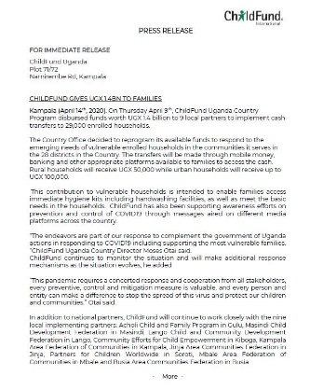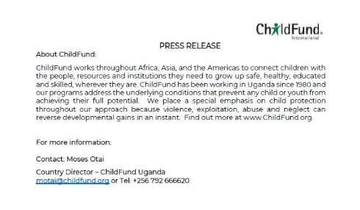

- Vision Group and Nation Media group contacted for any press releases
- A press release developed and shared with Vision Group, Nation Media, Observer, Soft Power News once the Country Office finalizes the planned response together with the IPs
- We have developed posters with messages on parenting and children engagement during this period. These have been shared widely through the staff and through our online platforms
- Developing messages on child protection to disseminate through the same channels
- We are working on translating the same messages into local languages for dissemination via Radio stations in the communities of operation
- We received a ton of coverage for the CO’s response from the press release shared with various media channels Here are a few links:
The Independent: https://www.independent.co.ug/child-fund-reprograms-budget-to-hand-out-cash-to-households/
Uganda Radio Network: https://ugandaradionetwork.net/story/child-fund-reprograms-budget-to-hand-out-cash-to-households#_
Soft Power News: https://www.softpower.ug/childfund-uganda-gives-vulnerable-households-cash-support-worth-shs-1-4bn/
- We also had an opinion article from the Africa Regional Director Published: Corona Virus puts Children living in poverty at greater risk: https://www.softpower.ug/opinion-coronavirus-puts-children-living-in-poverty-at-greater-risk/
- We had an opinion article from the Country Director published in one of the leading print media houses, The Observer: We must keep our children resilient and safe during epidemics . https://observer.ug/viewpoint/64635-we-must-keep-our-children-resilient-and-safe-during-epidemics
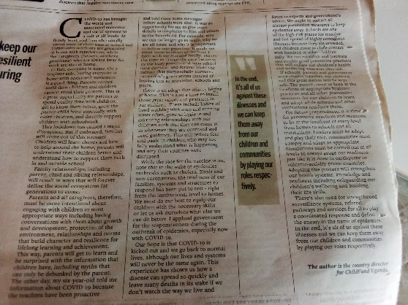

- We engaged two radio stations in West Nile (Nile FM & Aulogo) to air messages in Bari and Arabic on COVID19 prevention, parenting, youth participation, children engagement and protection for a month. These messages are targeting South Sudanese Refugees and host communities in West Nile where CO has projects. Nile FM started airing messages on 4th and Aulogo FM will do the same by Friday 8th May 2020.
- Aulogo FM to start airing spot messages similarly to Nile FM in Bari and Arabic on 13th May 2020 for a month
- TV Engagement: Spot awareness messages on COVID19 prevention, parenting and child protection started airing on NTV Morning Prime show (Mwasuze Mutya) on 11th May 2020 They will be airing until 10th June 2020.https://m.facebook.com/story.php?story_fbid=572408056745560&id=558148007652271
Spot message airing in Video at: 55:04 to 55:50
The CO Communication Officer wrote an article tilted “Sheltering the family unit through the COVID-19 pandemic” in the national daily New Vision.
https://www.newvision.co.ug/new_vision/news/1518876/sheltering-family-unit-covid-19-pandemic
An opinion piece by the Country Director highlighting the challenges facing children in continuity of learning during school closure and how they can potentially be addressed was published by the New Vision: “Children in villages dig as their counterparts study during lockdown” https://www.newvision.co.ug/new_vision/news/1519395/children-villages-dig-counterparts-study-lockdown
ARD Victor Koyi: Enforce hygiene when schools reopen: https://www.newvision.co.ug/news/1520797/enforce-hygiene-schools-reopen
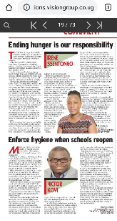
On 18th June 2020, ChildFund Uganda alongside 5 other INGOs under the umbrella of Joining Forces coalition held a children led engagement with stakeholders from Ministries of: Health, Education and Sports, Gender Labour and Social Development and Uganda Police. Two children from LP Kampala Area Federation of Communities represented ChildFund.
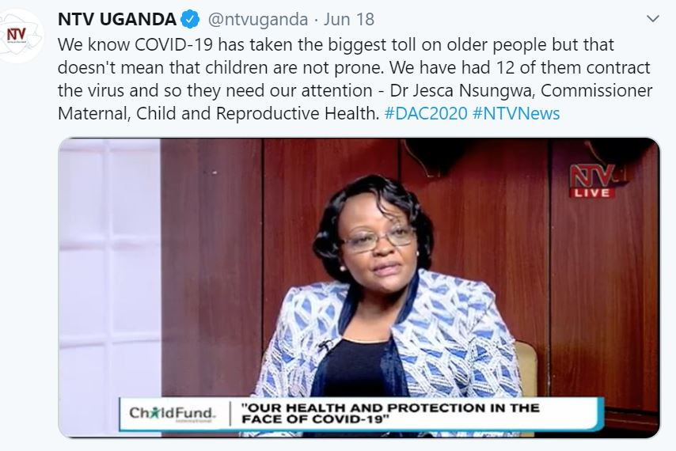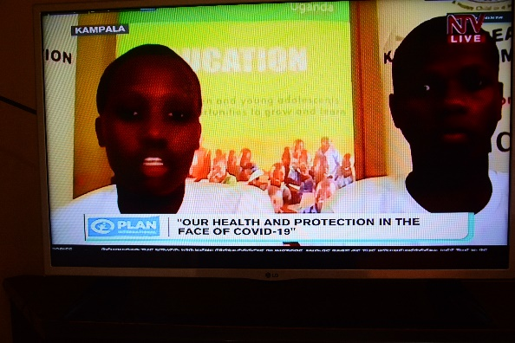
Child Protection Specialist Dorah wrote an article about Day of the African 2020 theme on ensuring a child Friendly Justice system that was carried by the New Vision.
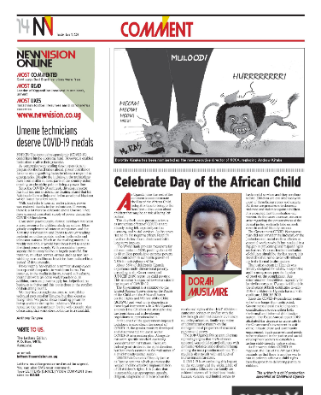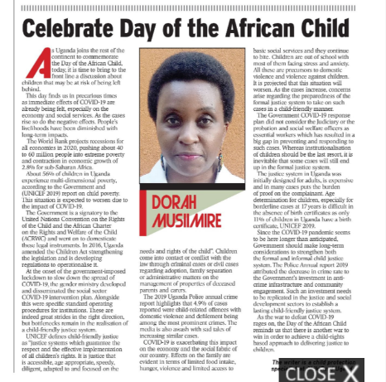
Press Release: ChildFund releases over UGX 100 million for distribution of reading materials
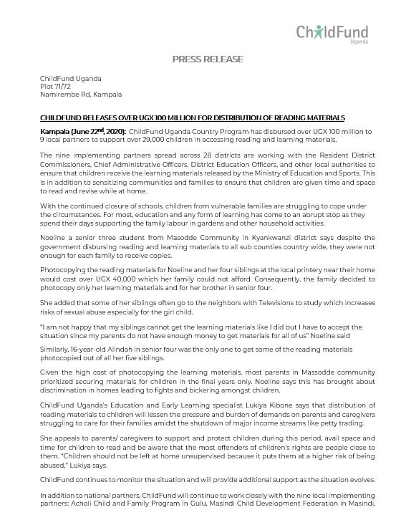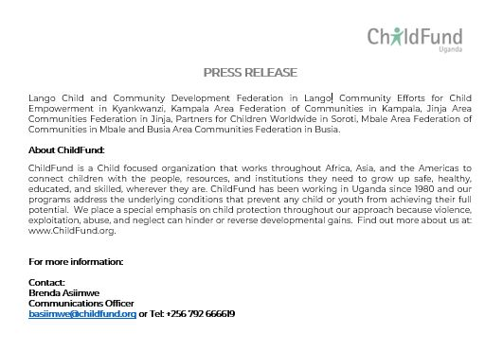
The Press Release has been published by over 5 news outlets. https://www.softpower.ug/childfund-releases-over-shs-100m-for-distribution-of-reading-materials-for-learners/
https://www.pmldaily.com/news/education/2020/06/childfund-supports-homeschooling-with-ugx-100m.html
https://www.education.co.ug/2020/06/22/childfund-learning-materials/
On June 25th the CD Moses Otai, was hosted on NTV, Uganda’s biggest broadcaster. He shared the Country Office response to COVID19 and sustainable measures being put in place to ensure that families and children are able to thrive despite the socio-economic effects of the pandemic. The recording of the interview can be accessed here: https://drive.google.com/file/d/1QHBWJCEI3NFRaCax-mdQGbZ4MkOAw3Li/view?usp=sharing
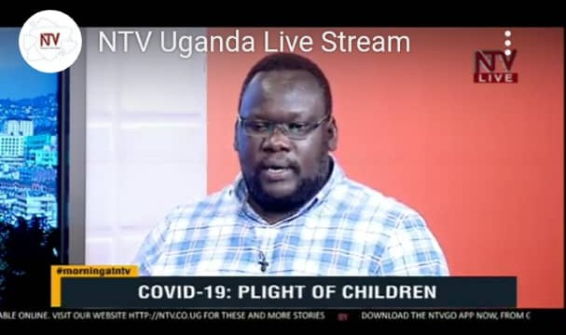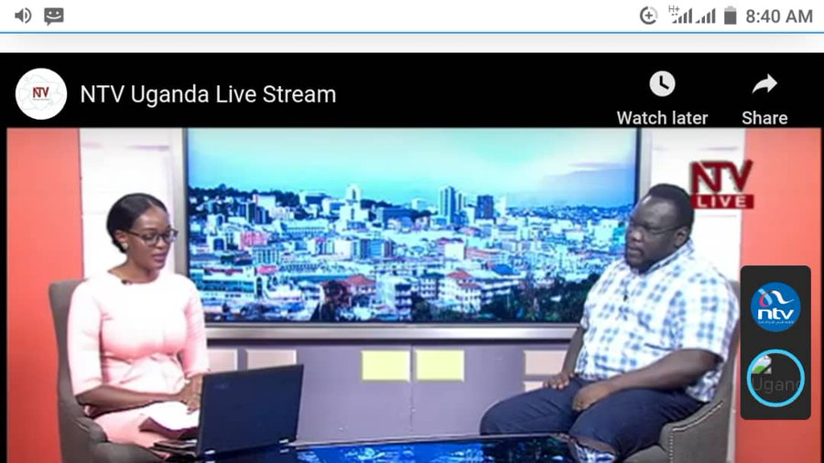
The Country Office held a successful a press conference that was covered by over 10 media houses comprising of Radio, Television, print and online news platforms. This provided a ton of coverage for the release of PPEs worth UGX 220 million to over 90 health facilities. The briefing was officiated by an official from Ministry of Health
- https://www.newvision.co.ug/news/1522784/covid-19-94-health-facilities-protective-equipment-worth-sh-220m
- https://www.softpower.ug/covid-94-health-facilities-in-29-districts-receive-ppe-worth-shs-220m-from-childfund/
- https://chimpreports.com/covid-19-94-health-centers-receive-ppes-worth-shs-220m-from-childfund/
- https://smlnews.ug/2020/07/15/moh-receives-ppe-worth-over-220m-shs-from-childfund-uganda/
- Baba TV story at 15:46 -18:11 :https://www.facebook.com/babatelevision/videos/590836791509238/?app=fbl
- Record TV story at 17:56 – 20:19: https://www.facebook.com/recordtvuganda/videos/1016314635453759/
- http://pressug.com/childfund-uganda-has-supported-94-health-facilities-with-ppes/
- Social Media influencer Facebook live: https://www.facebook.com/solomon.grace.169/videos/1918021508332632/?app=fbl
https://www.facebook.com/solomon.grace.169/videos/1918030611665055/?app=fbl
Radio feature
- Sanyu FM News bulletin
- Radio One News bulletin
- Mama FM News bulletin
- Capital Radio News bulletin
- KFM News bulletin
- CBS FM
- Bukedde Radio

The CO had one opinion piece published by one of the mainstream media houses, The weekly Observer
Francis Oundo a Senior Social Worker wrote an elaborate piece on the status of Child Care Institutions/orphanages: https://observer.ug/viewpoint/65856-children-need-family-environment-not-childcare-homes
Our Child Protection Specialist Dorah Musiimire contributed to an article published by New Vision on ending of violence against children: https://www.newvision.co.ug/news/1523090/end-violence-children-covid-19
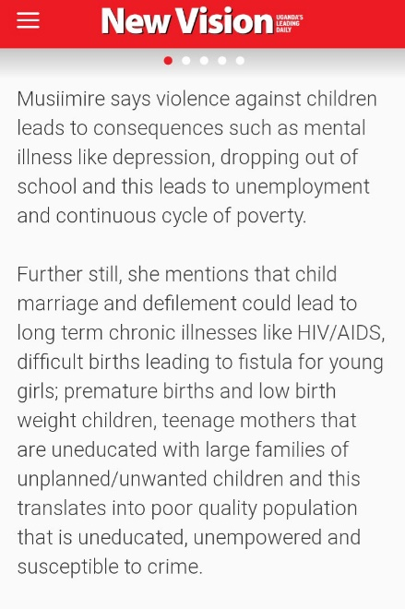
Dorah Musiimire also contributed the Straight Talk Newspaper July edition meant for children living in Karamoja region. Straight Talk promotes communication for social Change through print, radio and face to face interventions for adolescents and adults in the lives of adolescents such as teachers and parents.
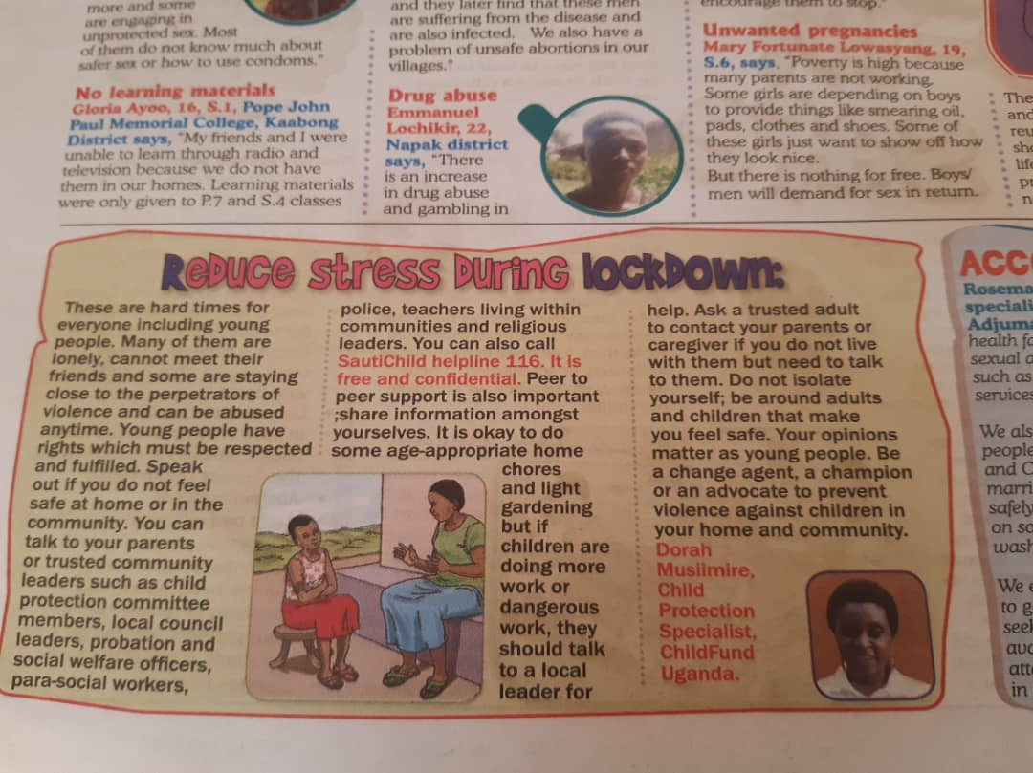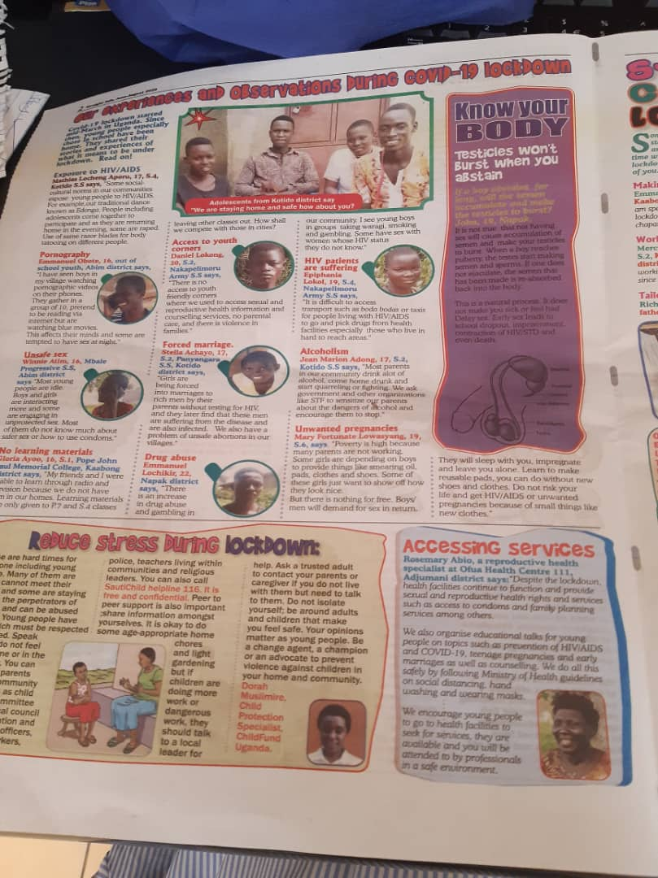

The CO had two opinion pieces published in two of the mainstream media houses, The New Vision and Daily Monitor
- Oped by Youth Development Specialist Jenner on IYD2020: https://www.newvision.co.ug/news/1524596/improving-youth-engagement-uganda
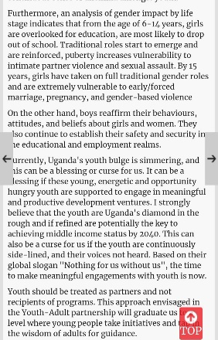
- ARD Oped in Daily Monitor: https://www.monitor.co.ug/OpEd/Commentary/Cash-transfer-best-way-help-the-vulnerable/689364-5611614-bucpjfz/index.html
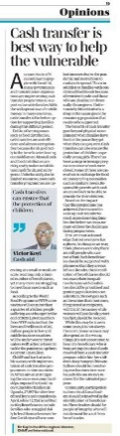
- Our Education Specialist Lukiya Kibone was featured in a radio interview by one of the prominent radio stations in Kampala (Radio One). Lukiya was speaking about how COVID19 has affected CO programming, especially in education
- CO engaged an external Videography Company (Incredible media) to film and document the progress and updates from children and their families in Busia that were supported in 2017. This was upon the request of ChildFund Korea.
Opinion piece by CD Moses was published by Daily monitor: Men’s leadership essential in stemming teenage pregnancy: https://www.monitor.co.ug/uganda/oped/commentary/men-s-leadership-essential-in-stemming-teenage-pregnancy-2727680
Children’s Dialogue event in Kitgum: Upland TV Feature on Facebook: https://www.facebook.com/114259726969221/posts/183288910066302/
- https://www.facebook.com/114259726969221/posts/183282396733620/
- Jackson Omona, the LC5 Kitgum District https://fb.watch/1Kyee-hQn8/
- Hon: Okin PP Ojara, Chua West Member of Parliament: https://fb.watch/1KykrFo9_W/
- NBS Story: 24:18/28:08 https://www.youtube.com/watch?v=QQFViljictU
- 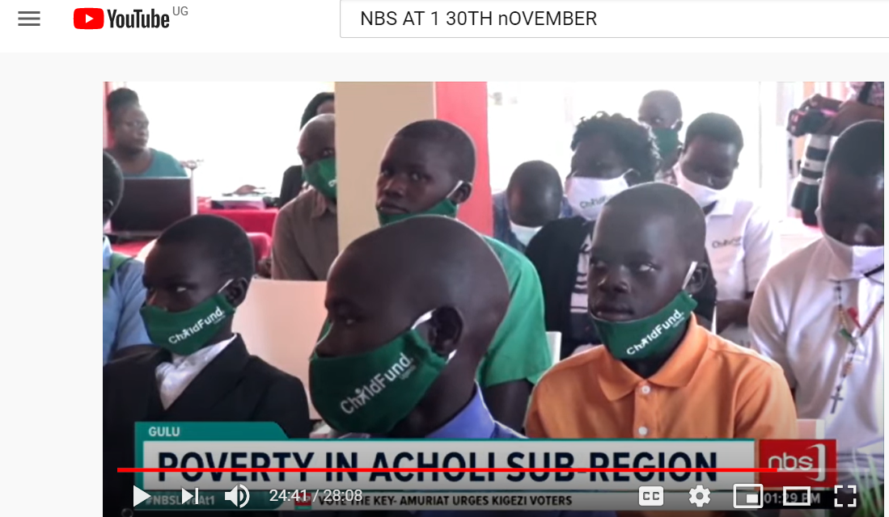
Oped by ARD: http://edge.ug/2020/11/13/incorporate-outdoor-learning-in-schools/
- https://businessfocus.co.ug/opinion-incorporate-outdoor-learning-in-schools/
- https://thebrinknews.com/incorporate-outdoor-learning-in-schools-victor-koyi/
- http://edge.ug/2020/11/13/incorporate-outdoor-learning-in-schools/
- https://news24.co.ug/incorporate-outdoor-learning-in-schools/
Oped by the CD: https://thebrinknews.com/minding-childrens-wellbeing-during-this-extended-homestay-period-moses-otai/
- https://eagle.co.ug/2020/11/23/minding-childrens-wellbeing-during-this-extended-homestay-period.html
- https://www.busiweek.com/minding-childrens-wellbeing-during-this-extended-homestay-period/
- http://edge.ug/2020/11/21/minding-childrens-wellbeing-during-this-extended-homestay-period/
CO participated in a National virtual Learning event on Child wellbeing organized by Ministry of Gender Labour and Social Development on 25th& 26th November
- http://edge.ug/2020/11/27/depression-suicide-in-children-rising-in-covid19-era-mangen/
- http://edge.ug/2020/11/26/covid19-worsened-violence-against-children-says-youth-minister-nakiwala/
- Children Prone To Online Abuse Due To Ongoing Schools Lockdown -Child Protection Specialists https://smlnews.ug/2020/11/27/children-prone-to-online-abuse-due-to-ongoing-schools-lockdown-child-protection-specialists/
- New Vision: https://editions.visiongroup.co.ug/html5/reader/production/default.aspx?pubname=&pubid=6d9458b3-cd0b-49f7-88e3-23edd4fabb2b
- Eagle: https://eagle.co.ug/2020/11/27/covid-19-cso-calls-for-strengthening-of-child-protection-in-uganda.html

- Schools And Markets Supported To Fight COVID-19 https://smlnews.ug/2020/12/03/schools-and-markets-supported-to-fight-covid-19/

- http://edge.ug/2020/12/03/childfund-kafoc-donate-shs120m-worth-of-covid19-items-to-schools-markets/
- http://edge.ug/2020/12/04/rdc-kawonawo-backs-childfund-kafoc-wash-project/
- https://eagle.co.ug/2020/12/03/covid-19-childfund-donates-washing-facilitates-temperature-guns-to-114-upe-schools-and-36-communal-markets.html
- https://www.newvision.co.ug/news/1534464/upe-schools-markets-receive-covid-19-items-worth-sh120m
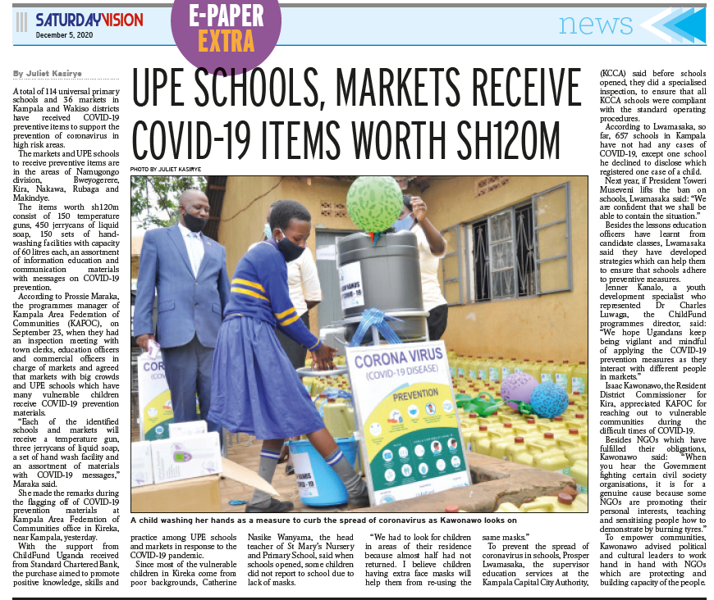
- https://eagle.co.ug/2020/12/03/covid-19-childfund-donates-washing-facilitates-temperature-guns-to-114-upe-schools-and-36-communal-markets.html
- Radios: Radio one, Capital Radio, Sanyu FM and Bukedde Radio. Use link to access audios
- UBC: Learning event on Child Well-being featuring ChildFund Uganda staff : https://youtu.be/N51ukg_mMwY
- Daily Monitor: ALL CHILDREN SHOULD BELONG TO A FAMILY: https://www.monitor.co.ug/resource/blob/3223780/3732a46a14df3abec5fd355f613c42ae/childhood-data.pdf
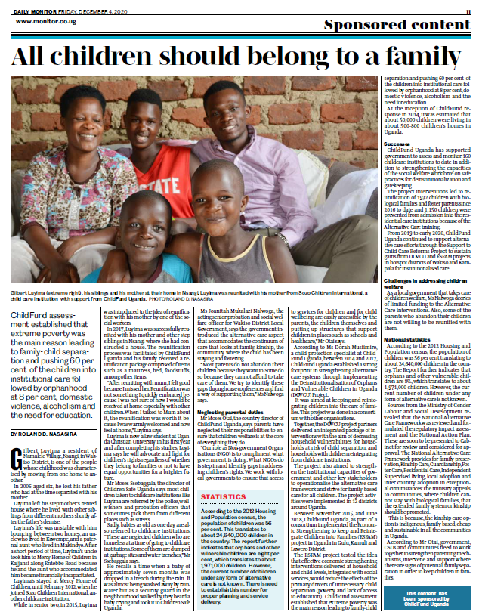

List of emergency CO spokespeople, including name, location, contact information, and languages spoken
Moses Otai + 256792 666620, based in Kampala, Uganda.
Email: motai@childfund.org

Skype: motai@childfund.org
Plans for collecting photos/videos/stories, e.g., should an outside photographer be hired?
- No outsider will be allowed in country. In case of any need for content collection, the Communications officer will handle depending on the situation if not under total lockdown.
- Working with IPs to take pictures of the materials CO will be donating to communities and families before dispatching them.
- IPs will reach out to recipients of these items for quotes and statements via phone calls. This information will be collated by the Communications Officer and shared with IO
- We have uploaded pictures/videos that we have received from the IPs so far to the media bank and notified IO.

Key points for messaging and visibility, particularly any host-government sensibilities that must be considered
- Any messaging that is contradicting government or WHO position on COVID 19 response
- Criticism of government efforts
- The CO is circulating government awareness messages and keeping our audiences informed about COVID19 through our social media platforms: Twitter and Facebook
- Developed information messages based on MOH guidelines that we are designing to be shared as e-posters with all our stakeholders
- The CO is circulating government awareness messages and keeping our audiences informed about COVID19 through our social media platforms: Twitter and Facebook
- The CO developed informationals messages based on MOH guidelines that have been designed and shared as e-posters with all our stakeholders.
- We have also had the same posters translated into Bari and Arabic for printing and distribution in Moyo where there are settlements with South Sudan refugees
- CO has developed informational SMS to be translated into respective local languages by IPs and to be shared with enrolled families.
- Additionally, CO engaged two Radio stations in Moyo and Adjumani districts: Nile FM and Aulogo FM to disseminate the translated material through spot messages, jingles and DJ mentions to increase awareness in the Refugee Settlement.
Support needed or requested from IO, GSS or Global Teams – whether onsite or remote.
- Fundraising once the concept notes are ready
- Support with preparation of a concept note on Alternative Care for Children to Unicef.

Some shots from the field for interventions made during the reporting period.

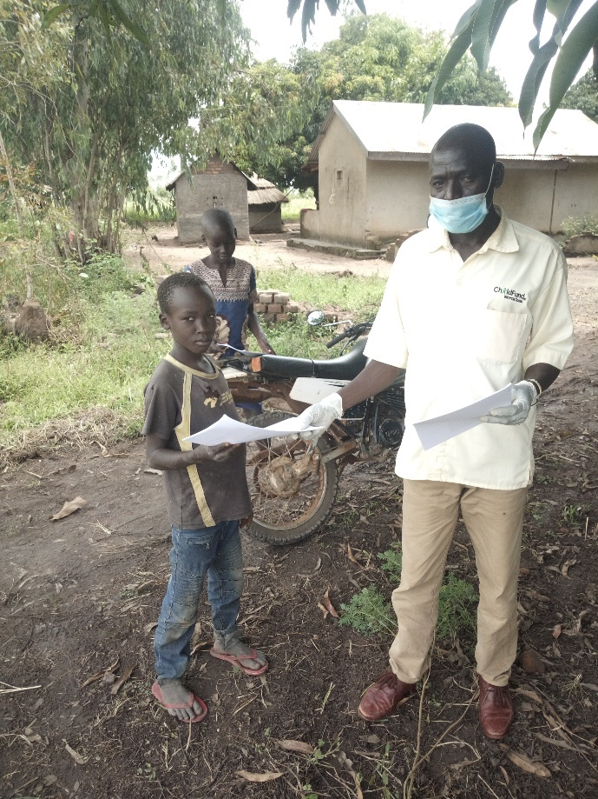
Above: A pupil received reading materials from community staff in Patongo community

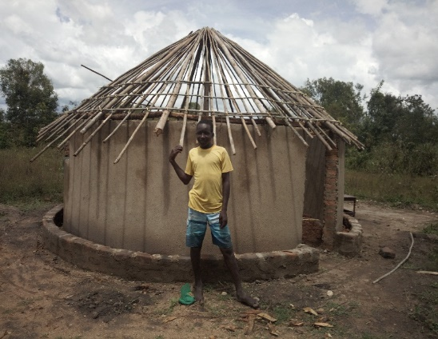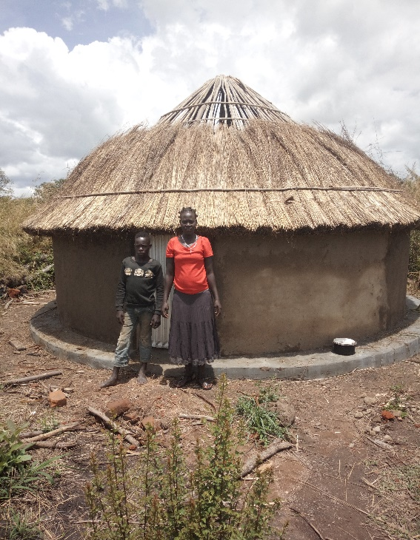
Above: Progress on reconstruction of houses for people displaced by floods in Acholi region in Northern Uganda.
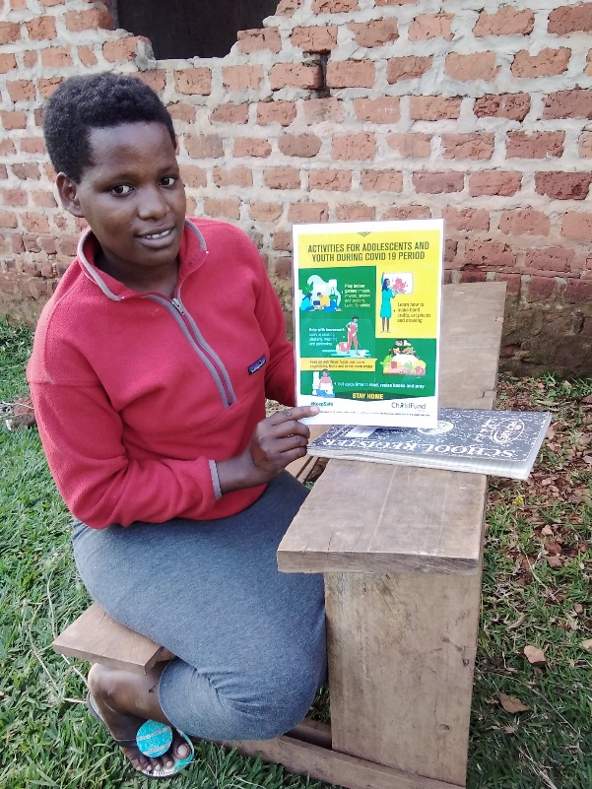
Above: A youth displays COVID-19 IEC poster in Masodde-Kyankwanzi district

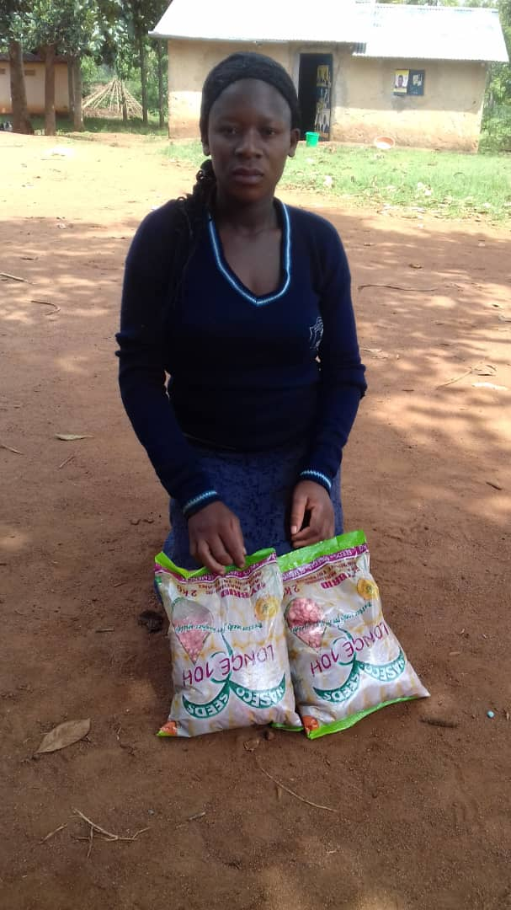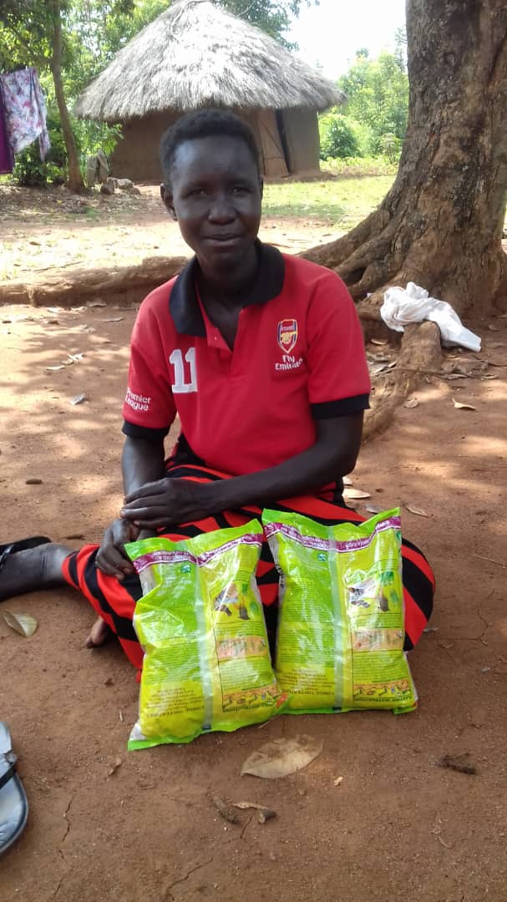
Above: Beneficiaries of conditional cash transfer to buy planting materials in Busia

