ChildFund International
Humanitarian Situation Report

Humanitarian Situation Report # 21
COVID-19 – Sierra Leone
December 10, 2020
James Pimundu, National Director jpimundu@ChildFund.org +23279876811
November 11 2020-December 10 2020

Part 1: The Overall Situation
COUNTRY
The first case of COVID-19 was detected in Sierra Leone on the evening of March 30, 2020. Two days later on Wednesday, April 1 2020, a second case of the virus was confirmed in the country. COVID-19 cases are rising exponentially in Sierra Leone. Epidemiological data and other evidence indicate that there is community transmission of #COVID-19 in #SierraLeone. Sierra Leone on May 24 2020 recorded 100 new infections of COCID-19, record number over 24-hours and more than double its highest daily jump since the index case was confirmed in the country on 31 March 2020. Sixty-seven of them are from among 85 Sierra Leoneans repatriated on Friday from Kuwait where they had been working, mostly domestic workers.
There is huge concern over people not adhering to prevention imperatives across the capital, Freetown. The police over the last weekends raided a bar across the Lumley Beach area where a lot of people were jampacked in a bar living a normal life as though coronavirus wasn’t in the country already. The same is happening in other areas in the country.
The country had begun registering zero cases couple of weeks ago. Meanwhile, in the week of 6-10 December 2020, the country started recording between two to three cases. However, the country is still in a state of emergency
Due to the reduction in the number of confirmed daily cases of COVID-19 in the country, it is very likely that citizens may not adhere to COVID-19 prevention measures during the festive period, thus increasing the chances and possibilities of a secod wave of the virus.
The Police have issued a statement reminding citizens that COVID-19 is still around and admonishing all to follow all regulations pertaining to the pandemic especially those that have not been lifted by the government.

The government of Sierra Leone has relaxed restrictions on all sporting and athletic activities in the country, to enable the National Teams’ (Leone Stars) prepare for international competition.
See related link: https://panafricanvisions.com/2020/09/sierra-leone-sports-ban-on-sporting-activities-partially-lifted/
Congregational proceedings in Churches and Mosques now go beyond 90 minutes. NACOVAC has advised congregational worship can go up to 180 minutes.

In October 2020, government of Sierra Leone relaxed the initial curfew order which restricted movements of citizenry for a month, while authorities continue to monitor the country’s COVID-19 situation very closely. Prior to the government relaxing the restrictions, there was public outcry by mainly business owners whose businesses were affected by the curfew.
In another development, the NACOVERC has reduced 60% of its COVID-19 workforce.

Cases keep fluctuating. The country on September 5 2020, recorded 11 cases; recorded 1 on September 7 and 9 on September 8 2020. In July, the government announced it was opening schools to enable students take public examination. The West Africa Senior School Certificate Examination (WASSCE) ended successfully.
President Julius Maada Bio, ordered the Attorney General and Minister of Justice to fully implement the recommendations of the Commissions of Inquiry’s White Paper which is looking into allegations of corruption by former President Earnest Bai Koroma and Ministers and civil servants who served in his government. See related link: https://statehouse.gov.sl/wp-content/uploads/2020/09/Statement-By-His-Excellency-Dr-Julius-Maada-Bio-President-of-the-Republic-of-Sierra-Leone-at-the-Formal-Presentation-of-Report-of-the-Commissions-of-Inquiry-and-Government-White-Paper-%E2%80%93-24-Sept-2020.pdf

Furthermore, the Anti-Corruption Commission (ACC) is also investigating the former president on some serious corruption allegations, separate from what is recommended in the White paper. Supporters of the former president made a protest without respect for COVID-19 rules such as social distancing among others.
President Julius Maada Bio has also relieved those civil servants whose names were listed in the white paper and were still serving during his regime.
Government of Sierra Leone launched new education project. See related link: https://statehouse.gov.sl/sierra-leones-president-julius-maada-bio-launches-education-project-signs-us-66-million-education-multi-donor-trust-fund/
First Girls School launched in Port Loko District. See related link: https://statehouse.gov.sl/sierra-leones-president-julius-maada-bio-launches-first-girls-school-in-port-loko-emphasises-the-nexus-between-education-and-development/

President Bio on Tuesday, June 23 2020, held a press conference that aimed at updating the general public on COVID-19, as well as making some adjustments to the initial restrictions. See related link:https://statehouse.gov.sl/wp-content/uploads/2020/06/Statement-by-His-Excellency-Dr-Julius-Maada-Bio-President-of-the-Republic-of-Sierra-Leone-at-the-Fourth-Press-Conference-on-Covid-19.-Freetown-State-House-23-June-2020.pdf
A total of 16 Cuban doctors flew into the country a few weeks ago to help contain the pandemic. They were all placed under quarantine. They have met with President Bio following their completion of quarantine. See related link:
https://www.facebook.com/TheBioPresidency/posts/646420795968970?notif_id=1596553691738938&notif_t=page_highlights&ref=notif
Sexual penetration on minors is growing at an alarming rate amid COVID-19, for which Sierra Leone’s President Julius Maada Bio has launched a Sexual Offences Model Court as part of the First lady’s Hands off Our Girls Campaign Initiative. See related link: https://statehouse.gov.sl/sierra-leones-president-julius-maada-bio-launches-sexual-offences-model-court-praises-hands-off-our-girls-campaign/
Additionally, the First Lady has engaged the District-level Family Support Unit Coordinators nationwide as part of continued effort to stop violence against children, especially girls who being violated at an alarming rate. See related link: https://snradio.net/first-lady-engages-district-coordinators-at-the-family-support-units-nationwide/
The government released a guide on COVID-19 test for passengers departing the country See related link: https://snradio.net/additional-guide-on-covid-19-test-for-departing-passengers/

As cases increase nationwide, the government is increasing the treatment beds in all treatment centers, starting with the 34 Military hospital in Freetown. Fifteen out of the country’s 16 districts have recorded at least a case of the virus. Karene, the only COVID-19 free district now, is closer to the Bombali district that had recorded cases of the virus. Although there is inter-district lockdown, many believe the district is still not safe, as people with government approved passes go in and out of the district. There are two main characteristics of the cases from Sierra Leone:
- Majority of the cases are asymptomatic.
- Community transmission given the hike in cases
Government has relaxed some of the restrictions including the lifting of the indefinite inter-district lockdown and shifting the time for night curfew from 9p.m-6a.m to 11p.m – 6a.m. However, there is strict enforcement on the wearing of facemasks in all public places and transportation vehicle.
It is rumored that the Government is still considering lifting the ban on inter-District travels. This has left a lot of tongues wagging, as people (mostly traders-market women) cannot wait to see it happen.
There is ongoing high-level engagements among key authorities in the Ministry of Transport and Aviation (MTA); the Sierra Leone AirPort authority (SLAA); Ministry of Health and Sanitation (MoHS); National COVID-19 Emergency Center (NACOVERC) and the Presidential Task Force on effective preparation of the country’s airport ahead of the rumored resumption of flights. Key among the discussions is centered on the safety of passengers that will be going out and coming into the country and the prevention of reoccurrence of COVID cases.
Schools have resumed for students that will be taking public examinations. The Ministry of Basic Education and Secondary education (MBSSE) in consultation with the West Africa Examination Council (WAEC) has released the followed dates for the pending public exams:
- National Primary School Examinations (NPSE) -Monday 3rd August 2020 @ 9a.m
- Basic Education Certificate Examination (BECE) – commencing 14th September 2020 and lasts for 10 days
- West African Senior School Certificate Examination (WASSCE) – From 11th August 2020 to 7th September 2020. Source: www.mbsse.gov.sl

President Bio engaged development partners, including members of the diplomatic corps and Civil Society organizations in the country, and called for continued support in fighting the pandemic in the country. See related links: https://statehouse.gov.sl/sierra-leones-president-julius-maada-bio-engages-civil-society-leaders-on-covid-19-and-other-development-issues/
https://statehouse.gov.sl/sierra-leones-president-julius-maada-bio-continues-engagement-with-development-partners-on-covid-19-response/
President Bio engaged religious leaders to discuss opening places of worship across the country. One key action point for religious leaders was to come up with a plan for adhering to all protocols, if Churches and Mosques were to reopen. During the debate on the Speech delivered by the President in the State Opening of Parliament, some members of Parliament intensified the call for the opening of places of worship (churches and Mosques).

Doctors treating coronavirus patients in Sierra Leone have launched a strike over unpaid bonuses among other grievances. The strike on Thursday marked an escalation in a row between doctors and the government over what doctors say is a misuse of funds for the coronavirus response in the country and a lack of protection and compensation for health workers. https://www.aljazeera.com/news/2020/07/sierra-leone-doctors-treating-covid-19-patients-launch-strike-200703054749666.html#.
Frontline COVID-19 health care workers threatened to down their tools on Monday, June 1 2020, if their risk allowances were not paid to them. But the government of Sierra Leone is in negotiations with them.
The government extended an initial 14-day partial lockdown until further notice. The Directorate of Science, Technology, and Innovation (DSTI) in collaboration with the Ministry of Health and Sanitation (MoHS), Ministry of Information and Communications (MIC), and Niche Solutions created the Electronic Pass (E-PASS) Management System (http://www.epass.eoc.gov.sl) as part of an integrated ICT response to COVID-19. The electronic issuance of passes will now make it easier and faster for the EOC to process requests and authorize the movement of essential goods, and service providers during the COVID lockdown and curfew in a transparent and auditable process. http://www.thepatrioticvanguard.com/sierra-leone-s-covid-19-lock-down-and-curfew-e-pass
One of the presidential guards tested positive, for which President Julius Maada Bio was on self-isolation, starting Tuesday, April 21, 2020. President Julius Maada Bio wrapped up his self-isolation after one of his presidential guards tested positive for COVID-19. Information reaching citizens from State House confirms the President and his family members are tested negative for the virus. https://www.africanews.com/2020/05/04/virus-free-sierra-leone-records-covid-19-scuffles-over-quarantine-at-airport// In another development, President Bio has appointed the Deputy Minister of Foreign Affairs, Solomon Jamiru as the official spokesperson for COVID-19.
The country completed the second phase of a 3-day lock-down which started on Sunday, May 3, 2020, and spanned through Tuesday, May 5 2020. Government, through the Bank of Sierra Leone, instructed that all Banks be opened on the weekends leading to the lockdown to enable citizens to access their monies for preparing for the 3-day lockdown. Yet, many people observed the lockdown with mixed feelings. There are grumblings around the government not informing citizens early of a potential lockdown.
Some of the major challenges associated with the lockdown are that most of the Sierra Leonean population relies on daily wages possibly after the sale of their products, or days job, to survive. As such, they are grappling with food shortages and water crises. Shortages of water, especially in Freetown, has left many tongues wagging. Water is crucial to practicing good hygiene, and ultimately, fighting the pandemic.
There are also challenges in procuring Infection, Prevention and Control materials. There is, for instance, a spike in the trade of veronica buckets. There is, at least, a 20 percent hike in the cost of buckets and hand sanitizers. Pharmacies ran out of standard surgical protection. At the Ola During children’s hospital, sick children have been turned away since the 100-strong staff went into self-isolation, following a doctor testing positive.
There is heightened sensitization by government officials and Civil Society Organisations (CSOs) across the country. CSOs are doing nationwide monitoring of government’s actions with regards fighting the pandemic.
President Bio has in a press conference with journalists, informed the nation that 100% of contacts of cases (those who encountered infected persons) have been identified, and 75% of those that came very close to these contacts have also been identified. Meanwhile, a 14 day inter-district lockdown has been imposed starting from Sunday 12th April 2020 to curtail the spread of the disease across the country. This is since been extended indefinitely.
There is heightened fear by Sierra Leoneans to visit hospitals and health centers across the country, for which the government has sensitized there are separate beds for persons infected with the virus.
Total Number of COVID-19 Cases Reported | Number of Deaths | Number of Cases Recuperated
2, 435 | 74 | 1,847
SOURCE: https://snradio.net/sierra-leone-registered-1-new-confirmed-cases-1-new-death-and-2-new-recoveries-from-coronavirus/

ChildFund-supported areas (Provide only if you have reliable data on this. You can report on a consolidated basis or by program state/region/province/etc. if you have this detail.)
Geographical area (country or state/region/province | Total Number of COVID19 Cases Reported | Number of Deaths | Number of Cases Recuperated
Northern West Region
Northern East Region
Eastern Region
Southern Region
Western Area Rural
Western Area Urban
SOURCE: National Ministry of Health or other reliable source:
https://snradio.net/sierra-leone-registered-2-new-confirmed-cases-0-new-death-and-1-new-recoveries-from-coronavirus-3/

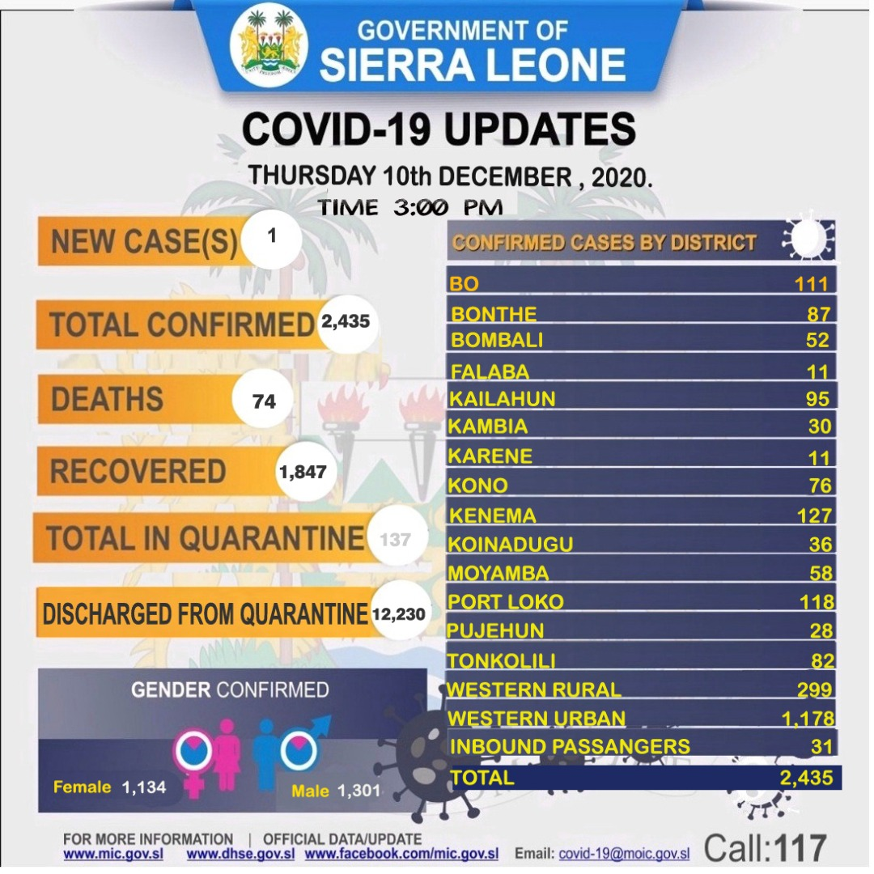

- Any relevant background information about areas affected.
Western Area (Sierra Leone’s capital city) is Sierra Leone’s COVID-19 hotspot, haven recorded 81 cases of the novel virus.
- Host government posture: Have they declared a state of emergency and/or requested outside assistance? Which nationwide measures has the government taken, e.g., limitation on meetings, internal travel, school closures etc.
- Sierra Leone is still in a State of Emergency. Government is still calling on donor and development partners to fill in the gaps by giving their expertise and human, financial and material resources in the fight against the pandemic.
The United Arab Emirates sent an aid plane containing seven metric tons of medical supplies to Sierra Leone to bolster the country’s efforts to curb the spread of COVID-19.
- https://reliefweb.int/report/sierra-leone/uae-sends-medical-aid-sierra-leone-fight-against-covid-19

- Sierra Leone is among 25 countries with immediate debt relief from the International Monetary Fund (IMF). See related link: https://www.imf.org/en/News/Articles/2020/04/13/pr20151-imf-executive-board-approves-immediate-debt-relief-for-25-countries. Also, quite recently, the World Bank Group approved a $7.5 million grants for COVID-19 response in Sierra Leone. This, many people believe, will cushion some of the burden on government and is expected to reduce the hardship in so far as the Sierra Leone economy is concerned.
- The World Bank Group has approved a $ 100 million grants for Sierra Leone. See related link: https://www.worldbank.org/en/news/press-release/2020/06/17/sierra-leone-world-bank-approves-100-million-to-support-economic-resilience#:~:text=WASHINGTON%2C%20June%2017%2C%202020%20%E2%80%93,growth%20and%20building%20economic%20resilience.
- The OPEC Fund for International Development (OFID) approved $243 million in funding to support developing countries across the globe. It also noted that it is already aiding developing countries in responding to the coronavirus pandemic. Sierra Leone stands to benefit $ 20 million to assist Freetown WASH and Aquatic Environment Revamping. See related link: https://www.oilandgasmiddleeast.com/products-services/36767-opec-fund-approved-243-million-to-support-developing-countries

- What responses has the government put into place to address the health crisis and/or the economic impact?
- #SierraLeone’s President Julius Maada Bio hands over Le4 Billion to support the #tourism and hospitality sectors for the revenues and jobs they lost since the #COVID_19 pandemic in March this year. See related link

- Sierra Leone’s Public National Emergency Operation Center (PNEOC) is still very functional, as Government together with its partners has paid keen attention to thorough disease surveillance, epidemiology, social mobilization and logistics
- 137 people are currently being quarantined
- 12,230 released from quarantine

- There is an alteration in the official working hours (8:00 AM -5:00 PM now 9:00 AM-4:00 PM) for government agencies. 8:00 AM -5:00 PM
- Social Mobilization nationwide

- COVID-19 keeps worsening the economic situation in Sierra Leone. Every day comes with new challenges, as government institutes new measures. The recent partial lockdown by the government is affecting businesses. Freetown, for instance, relies on produce from the provinces. With this new measure, business/market women suffer the most, as they are the ones most engaged in producing and selling crops. The transport sector is also affected if passengers are not there to carry from one place to another. Big businesses are still very constrained. Government revenue generation is now snail-paced, compared to how things were before COVID-19.
- What travel restrictions has the government put in place for travelers entering the country?
- The air, land and seaports are closed in Sierra Leone, except for essential items for fight against the virus. Soldiers are manning the borders with Guinea and Liberia.
Part 2: The Situation in Areas Where ChildFund Works

Partner Organization (Use Salesforce identifying code/name.) | # of Enrolled and Sponsored Children |  | COVID19 Cases Reported in ChildFund Communities (Y/N/Unknown) Provide number if available. | Number of Enrolled Children Reported with COVID19 (If available.) | Number of enrolled children diseased as result of COVID19
 | Sponsored | Enrolled
Partner 1  4251/ N’domakeh | 2, 599 | 4,017 | 0 | No available information | No available information
Partner 2  4103/  Munafa M’patie | 4, 310 | 6,112 | 0 | No available information | No available information
Partner 3  4104/  Daindemben | 4, 030 | 6, 441 | 0 | No available information | No available information

Child deaths: List any sponsored child (with Partner organization and child ID from salesforce) diseased as a result of COVID19. (Note: These need to be reported immediately following the regular sponsorship protocols.) At the moment, none of our enrolled children has been infected.
Partner Organization (Use Salesforce identifying code/name.) | What is the status of the program/sponsorship processes (operational/suspended)?
 | Program Implementation | CVS | M&E  Level 2 | Enrollment /Disaffiliation | Sponsorship Communication | DFC
Partner 1  N’domakeh-  4251 | Operational | On hold | Operational | Operational | Enrollment Operational | operational
Partner 2  Munafa M’patie- 4103 | Operational | On hold | Operational | Operational | Enrollment Operational | operational
Partner 3  Daindemben-  4104 | Operational | On hold | Operational | Operational | Enrollment Operational | Operational
Note: As a global measure, all sponsor visits have been suspended.
- What issues are children in these areas facing (food shortages, safety concerns, school closures, etc.)? Food shortages, safety concerns, schools closure, high prices of food, transportation constraints, Child protection risks caused or exacerbated by crisis situation, limited access to Child Protection Services and increased psychosocial distress among caregivers, child abuse, neglect, teenage pregnancy,
Part 3: ChildFund’s Response
3.a. Overall
- Who is or will be leading/managing the response? Who is or will be leading/managing the response? Victor Kamara, Programs and Sponsorship Director

- How is ChildFund linked with humanitarian coordination structures, i.e., in which clusters or working groups do we participate? The most recent/next meeting and who is representing ChildFund? ChildFund is currently active in two main government preparedness clusters (Child Protection and Health) which are leading the government’s efforts in preparedness for any potential outbreak of the covid19 disease in Sierra Leone. The Country Director and SMT have appointed Victor Kamara (Programs and Sponsorship Director) to represent ChildFund at all coordination forums and provide an update to SMT on the outcome of all meetings and engagements. The most recent virtual meeting attended was on the 5th May 2020 with the Ministry of Agriculture and Forestry to discuss the need for a large scale food security assessment to determine the impact of COVID-19 on the food security situation of the country.
Meanwhile, the Country Director, on the other hand, leads donor engagement on same, as and when an opportunity arises. Currently, the donor community is focused on support government to compliment gaps within the national COVID-19 response budget. Meanwhile, ChildFund Sierra Leone is tracking and in constant touch with key donors for any potential opportunity that may arise.

3.b. Program Response
Please organize your program response report as per the 4 objectives included in our global response plan. You can add an additional category if you have response activities planned or executed that do not align with these objectives. For each objective use the questions below to guide your report.
- What kind of response activities or interventions have been executed? Medical supplies and IPC materials What support items are needed or have been collected/distributed?
- The donated items include assorted essential drugs and other relevant medical supplies (hand gloves, respiratory and normal masks among others). The donation by ChildFund came a day after a second case of COVID-19 was announced. Health officials at MoHS say ChildFund was the first International Non-governmental Organisation to make such donations to the fight against the virus in Sierra Leone. Some of the items donated by ChildFund such as: the N95 respiratory mask, is in short supply in the international market, for which the MoHS staff were so appreciative. As of Sunday, April5 2020, 6 cases had been recorded in the country.

ChildFund, on September 3 2020, donated 3,667 multi-disciplinary textbooks worth $ 960, 336.62 to the Ministry of Basic and Senior Secondary Education (MBSSE), in support of the government’s Free Quality Education drive, and in fulfillment of one of the organisation’s programing approaches— ‘Educated and Confident Children’. The textbooks donated by ChildFund (some of which include algebra 1& 2, Mathematics, History, Reading and Writing Workshop, Geography, Economics, Civic Education Chemistry and Physics), cater for pupils in the Sciences, Arts, and Commercial streams. This is a big boost as schools prepare to reopen starting September 2020.
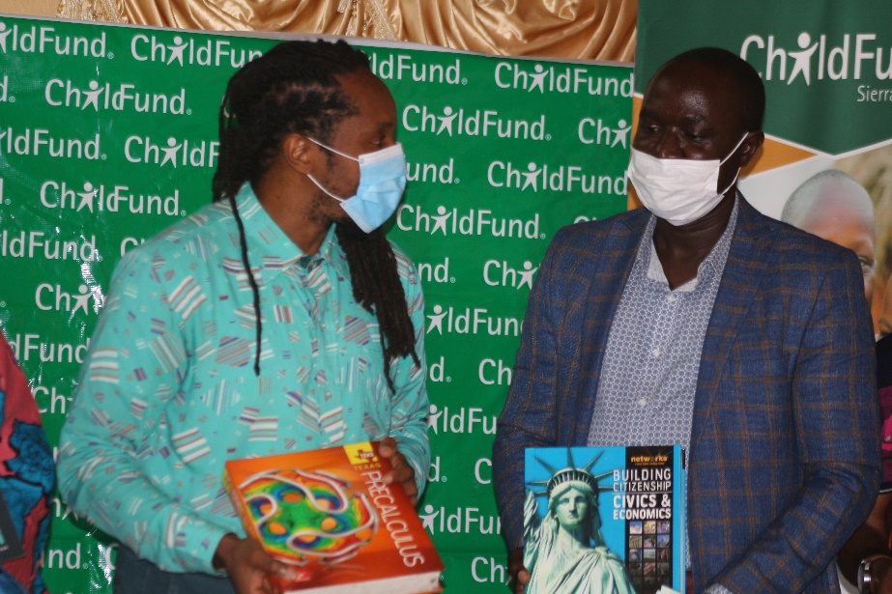
Caption: Minister of Education, Dr. Moinina Sengeh, left expressing his gratitude
to James Pimundu, ChildFund’s Country Director and his organization for the donation
The CO also donated medical equipment to the Ola During children’s hospital in Freetown
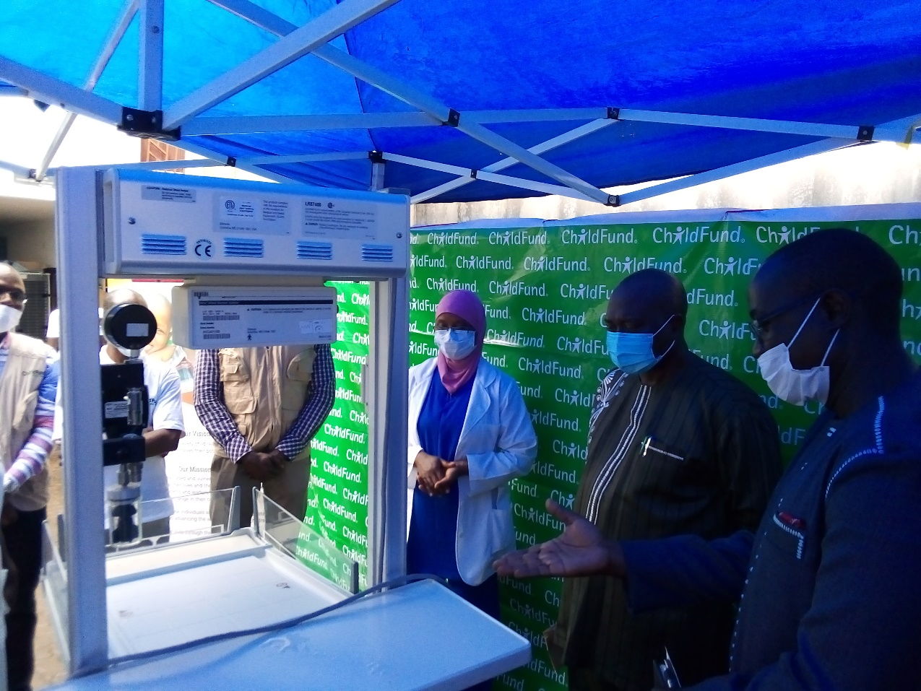
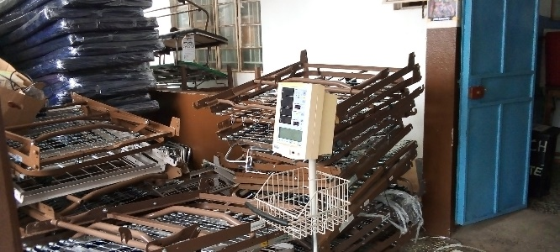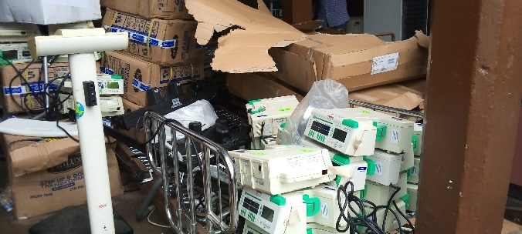
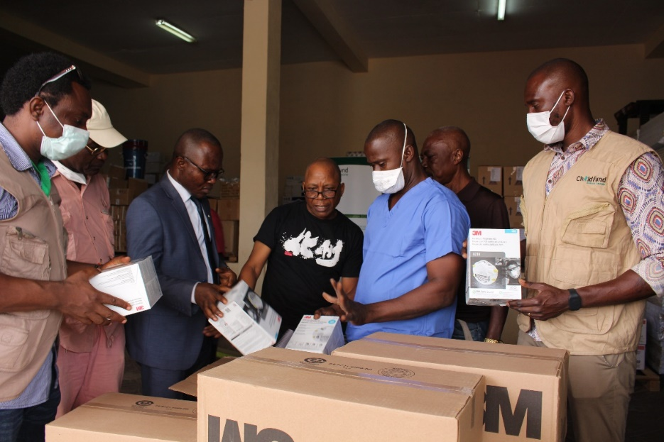
Photo caption: Donation of essential medical supplies to MoHS

- Infection Prevention and Control (IPC)materials (veronica buckets, handwash) donated by ChildFund are currently being used by children in the various communities targeted within the organisation’s operational areas in the Koinadugu, Bombali and Kailahun districts.
- ChildFund Sierra Leone has developed a comprehensive COVID-19 plan with complimentary proposal and budget for potential donors. The key areas of proposed response intervention include Direct Cash transfers to vulnerable households, Education support to pupils through the provision of solar-powered radios to follow ongoing radio learning programs, community awareness through IEC materials, IPC materials and support to coordination efforts by Ministries Departments and Agencies.
- The LPs have submitted their COVID-19 Response plan.

Photo caption: Donation of second wave of essential medical supplies to MoHS

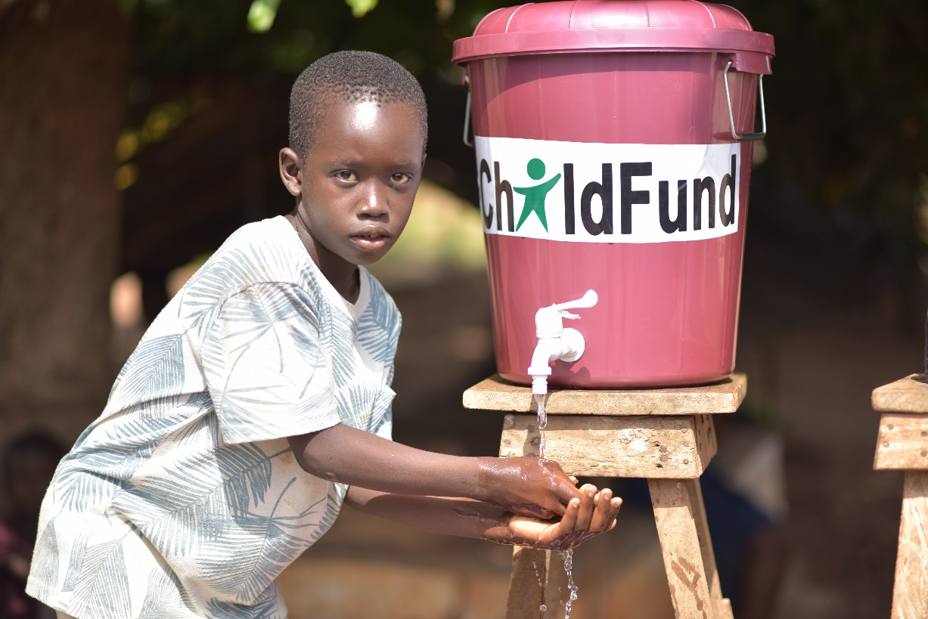
Photo caption: Veronica buckets donated by ChildFund being utilized

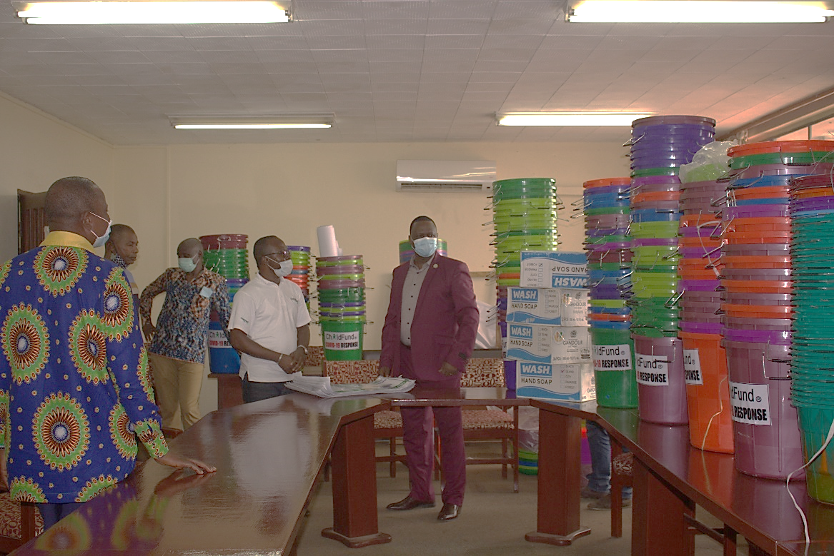
ChildFund on May 13 2020 donated 360 veronica buckets and wash and 100 IEC (COVID-19) poster to the Ministry of Trade and Industry for use by Market Women in Freetown.
Caption: Donation of IPC materials to the Ministry of Trade and Industry for use by
market women

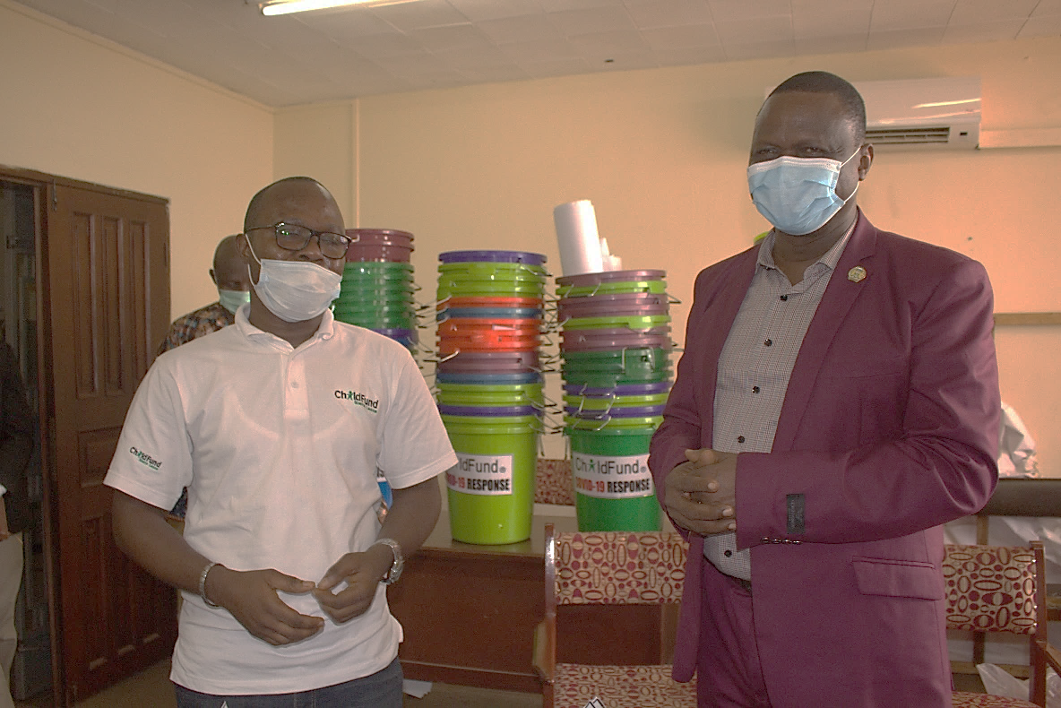

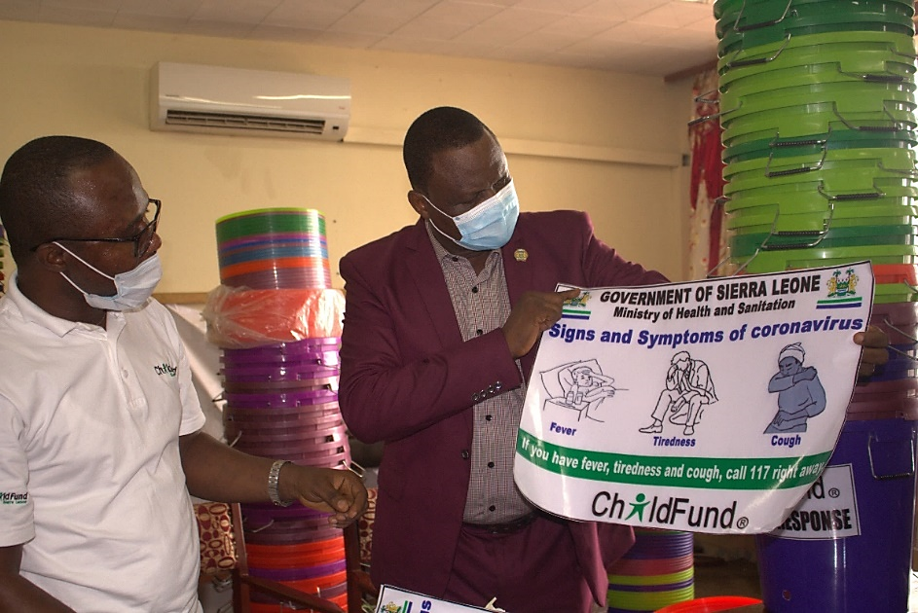
Caption: IEC Material donated to the Ministry of Trade and Industry

- What is the current progress of implementation vs. the established response plan?
- For sitreps submitted after ChildFund response has been initiated, what is the current progress of implementation vs. the established response plan?
3.a. Cash Transfers

Cash transfers have commenced in the LPs; beneficiaries have started receiving cash through APEX Bank to Community Banking System, a new approach for transferring cash to vulnerable groups. Previously, mobile companies were used for the said transaction.
Caption: Anita, physically challenged woman with five mouths to feed,
is a beneficiary of cash transfer from ChildFund in Sierra Leone
Some beneficiaries of the cash transfer have begun investing in petty trading. See related photo below:
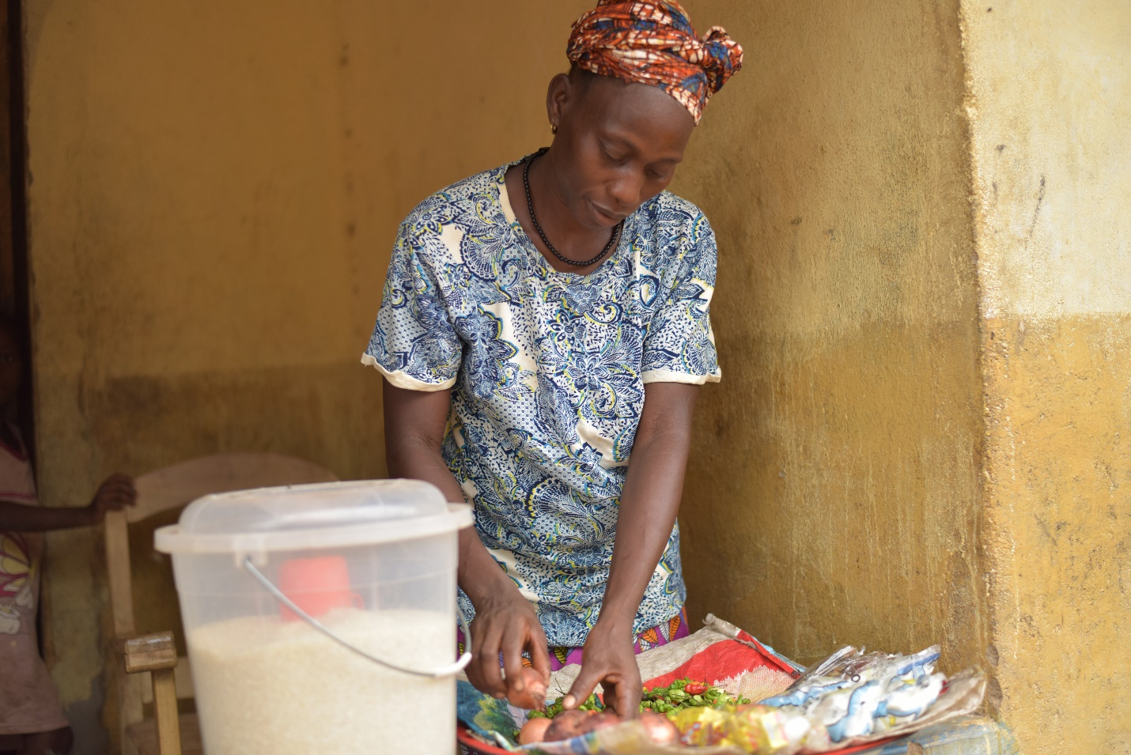
Caption: Mariama Mansaray, beneficiary of the cash transfer with her just set up petty trade
The CO is also preparing for the final tranche payment of the Cash Transfer for this quarter (April-June2020) to the intended beneficiaries.

Discussions have been held with LPs to understand lessons learned from previous cash transfer initiative during the 2015 Ebola response. The unconditional cash transfer is made to the most vulnerable children in our operational areas for an initial period of 3 months.

The timeline is being reviewed based on emerging trends in the COVID-19 response.
Previously, mobile money was used but proved to be ineffective since the service providers lacked the relevant infrastructure to reach remote communities with payments. This led to the cancellation of the contract. Unfortunately, the same service providers and infrastructure are the only available mobile money options in the country that has wider coverage and reach.

Together with the LPs, we have decided to explore the possibility of moving on with community banks this time. Apex bank which coordinates the activities of all community banks have been engaged and a formal MoU has been signed on the 12th May 2020. LPS are currently engaged in beneficiary selection for the cash transfer which was delayed due to the 3-day nationwide lockdown. Cash transfer funds were being transferred into the Apex Bank Account on the 14th May 2020.
Who are we partnering or collaborating with to provide our response? Government of Sierra Leone and our Local Partners

- What kind of response activities are you still planning for the coming period? IPC materials to vulnerable communities, cash transfers, community sensitization.
3.b.1. Stop COVID-19 from infecting children and families
ChildFund’s Global Response Plan
To help children and families protect themselves from COVID-19, we are installing community, handwashing stands; educating communities about symptoms, hygiene measures and where to get tested or treatment; and distributing soap, hand sanitizer, gloves and masks to families and frontline, health workers. For children who are being treated for COVID-19 or are subject to quarantine measures, we are creating child-friendly spaces with age-appropriate toys and reading matter.

To help children and families protect themselves from COVID-19, we are installing community, handwashing buckets; educating communities about symptoms, hygiene measures and where to get tested or treatment; and distributing soap to families and masks and gloves government for frontline, health workers
3.b.2. Ensure that children get food they need
ChildFund’s Global Response Plan
To ensure that the most vulnerable families can keep food on the table, pay rent and cover other basic needs, we are providing cash for those families most needing this support, such as those who have lost their income because of COVID-19, child or elder-headed households, and/or households affected by disability or chronic illness. Where possible, we are distributing food and basic household items directly, carefully abiding by COVID-19 protection measures
3.b.2. 1. Cash Transfers and vouchers
-Is your CO planning or implementing cash transfers or vouchers as part of COVID19 response? Yes
- If so, brief description of progress to date. Cash transfers has been approved for implementation. Disbursement of funds to beneficiaries is expected to commence by 20th May 2020.

Cash transfers or vouchers executed
Beneficiaries |  |  | Amount transferred (US$) | Transfer mechanism (i.e. mobile money, banking system other financial service provider etc,
Total | Gender (if available)
 | Female | Male
6,456 | 4,849 | 1,607 | 195,876.37 | Banking System
3250 | 2130 | 1120 | 96,128.140 | Banking System
1,211 | 826 | 385 | 35,999.73 | Banking System

3.b.2.2. Other responses in relation to objective 3.b.2.
3.b.3. Keep children safe from Violence : physically and emotionally
ChildFund’s Global Response Plan
We are supporting community-based child protection systems that identify, respond to and refer cases of abuse, neglect, violence or exploitation. We are also providing virtual, online psychological first aid and counseling, and supporting temporary shelters for children who live on the street, providing hygiene supplies, food and other basics. We are also arranging safe and appropriate care for children who are separated from their caregivers due to treatment or prevention measures.
We are supporting children and communities with hand washing materials to ensure proper hygiene practices as prescribed by the government and WHO. Additionally, we are in close contact with community CP structures to identify, respond and refer cases of abuse, neglect, exploitation and all forms of violence against children in our operational areas. Added to that, under the EU-funded SGBV prevention grant, ChildFund in partnership with Development Initiative Programme (DIP) and in collaboration with the Ministry of Gender and Children’s’ Affairs (MoGCA) and the Family Support Unit (FSU) of the Sierra Leone Police completed a staggered 6 days Capacity Building training of CSOs, Media Houses and other District Leaders on SGBV Case Management, Referral Network and ethical reporting and documentation in Portloko and Kambia Districts in the North-West region of Sierra Leone. A total of 82 male adults, 22 female adults, 6 boys and 10 girls were trained.
3.b.4. Help children continue to do their job: Learning
ChildFund’s Global Response Plan
While schools remain closed, we are supporting children’s learning through activities and tutoring sessions online or by radio. For students without reliable internet access, we are distributing home learning kits with materials and guides for their use.
A total of 430 children from the Koinadugu, Bombali, Kailahun and Falaba Districts, have benefitted from the multi-purpose solar radio sets distributed by ChildFund, through its Local Partners, Daindemben Federation, Munafa M’Patie Federation and N’domakeh Federation to pupils, including those taking public examinations soon. The radio sets were provided by ChildFund Korea, through the Integrated COVID-19 Emergency Assistance to Support Most Vulnerable Families project in Sierra Leone. Pre-recorded lessons in on SD cards and IEC materials were also provided to the children. See related photos below: Community volunteers and teachers followed up on the pupils on the use of the radio and provided special assistance to some pupils related to the radio teaching programs. Added to that, ChildFund through the local partners supported some schools with handing washing kits to be used by students who have resume classes ahead of their public examinations.
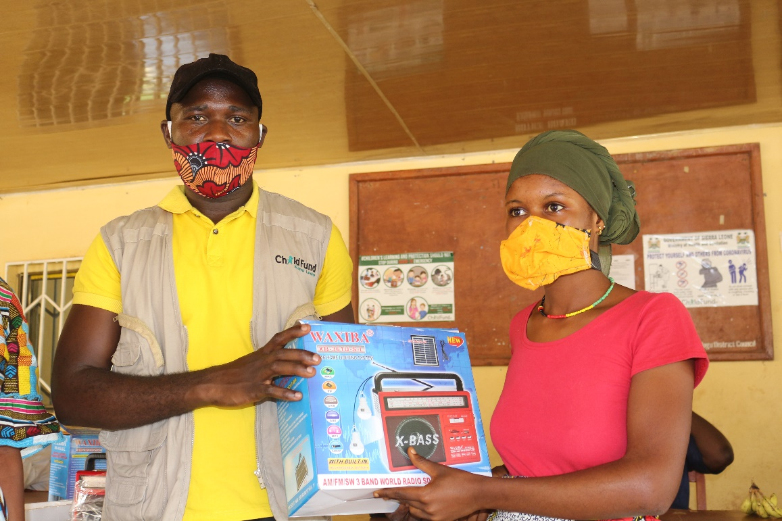
Caption: Bando Marrah, ChildProtection Specialist, and the Korean Project
Lead distributing radios to children in Koinadugu

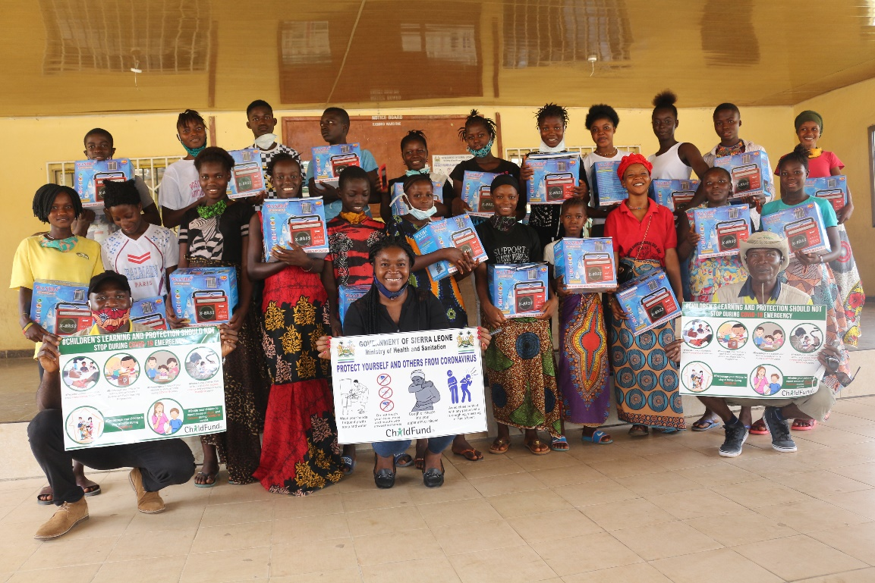
Caption: cross-section of children (with ChildFund and LP staff) posed with their radios and IEC materials in Koinadugu
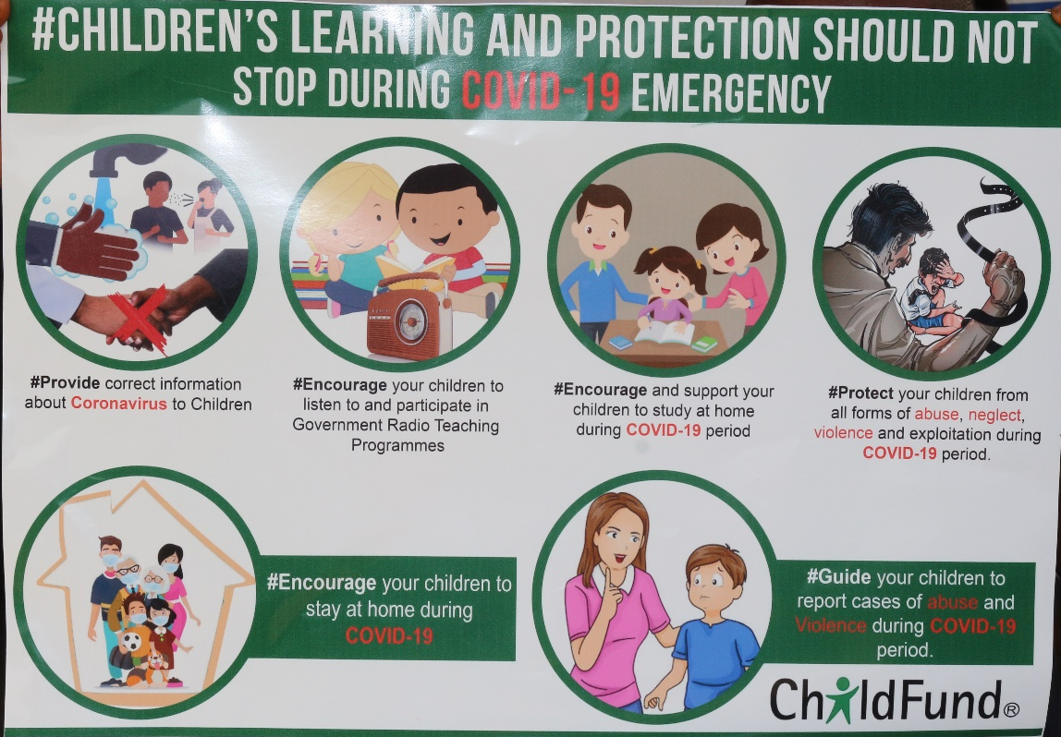
Sample of the IEC with integrated messages provide to students and community members during the distribution of solar powered radios in 4 districts
3.b.5. Other responses

Below Sections for Internal Use Only

Part 4: Office and Staff Status
Office Status (Open/Closed) | Number of Staff:
 | Diagnosed with COVID19 | Diseased from COVID19 | Working from Office | Working from Home | On Special Leave
Open | 0 | 0 | All | 0 | 0

Notes:
- Any cases of staff diseased need to be reported immediately to RD and GHR.
- Special leave as per COVID19 Administrative Guidelines.
Number of staff/partner organization staff completed WHO COVID online training https://www.who.int/emergencies/diseases/novel-coronavirus-2019/training/online-training.
Part 5 Human Resources
- Which visitors are there in the country? Please include names, functions, contact information and arrival/departure dates for both IO and RO staff (note: due to the travel ban, this will apply only once the ban has been lifted) No visitors in-country
- Any gaps in staffing/need for deployment from other COs or Global Teams?
- Are there any other major HR issues? No major HR issues

Part 6 Safety & Security
- Are police and other services functioning in the normal manner? Yes
- Are the courts still operating? There has been some changes to court arrangements.
One remand centre inmate tested positive for covid-19 and the inmate is now labeled as case 90. There is an alteration to normal court schedules. See bullets below:
- All inmates at the Freetown male re-integration centre hereinafter called “the isolation and observation unit” at special court be transferred to the male correctional centre at Pademba road;
- All inmates at the remand section at Pademba Road and the correctional hospital are now with immediate effect relocated
- To “the isolation and observation unit” at special court as a quarantine measure; inmates from the correctional hospital will be transferred/treated separately from the other inmates.
- The church building at Pademba Road will be temporarily used as a medical referral centre for inmates at the male correctional centre.
- The current remand centre at Pademba Road is being fumigated and it is currently out of use.
- As a result of the above, it is hereby announced that with immediate effect, there is the cessation of all court activities in the magistrate courts nationwide for one month effective Tuesday, 28th April 2020 to prevent movement of possibly infected persons from police stations to court and court to prisons.

- Are there reports of looting or increased criminality? No
- Have military personal being deployed to patrol towns or cities? Yes, and to man the borders with Guinea and Liberia. Checkpoints are being mounted by military and police personnel on highways, to enforce/enhance hand washing before entering and exiting major district headquarters and the capital city, Freetown.

- Confirm the safety of staff and their families in the affected area.
All ChildFund staff are safe in the affected areas. In keeping with the government’s lockdown measures, all our staff are asked to stay in their districts of operations. Before the lockdown measures, ChildFund staff observed a two-day work-from-home simulation that ended on Friday, April 3 2020. Staff are been encouraged to observe all measures in line with government and WHO regulations to keep themselves and families safe

- Have Safety and security risks/mitigation plans been updated to current environment? Yes
- Recommendations around any upcoming travel planned for staff or donors (note: Only once global travel ban has been lifted)
Part 7 Grants
List all active grants:
Grant Job Code | Grant Name | Donor | Status of Implementation (Normal/Reduced/Suspended) | Any specific guidance received from donor? (Yes/No)
OXFAM/EULOT2 -99-0256D | BAFS LOT 2 - Crops | EU | Reduced | No
OXFAM/EULOT2 -99-0257D | BAFS LOT 3 - Livestock | EU | Reduced | No
DIP/SGBV-990254D | SGBV Prevention and Response for women and Girls | EU | Reduced | No
P&G -25-04D | School and Community Health Support | Procter and Gamble | Normal | No
N/A | After Filming Support | ChildFund Korea | Normal | No
Grant Job Code | Grant Name | Donor | Status of Implementation (Normal/Reduced/Suspended) | Any specific guidance received from donor? (Yes/No)
OXFAM/EULOT2 -99-0256D | BAFS LOT 2 - Crops | EU | Reduced | No
OXFAM/EULOT2 -99-0257D | BAFS LOT 3 - Livestock | EU | Reduced | No
DIP/SGBV-990254D | SGBV Prevention and Response for women and Girls | EU | Reduced | No
CFK | Integrated COVID-19 Emergency Assistance to Support Most Vulnerable Families | ChildFund Korea | Normal | Yes

Provide any additional narrative on how the COVID19 crisis affects implementation of your major grants. As it stands now, everything (including our operation) rest with what government suggests. Citizens envisage continued lockdowns. State of emergency is still very active. Business is not as usual. The country’s concentration is on COVID-19

Part 8 Funding
Provide information about potential sources of funding, including grant donors, subsidy, Emergency Action Fund, Alliance members, GIK, etc., for these emergency response efforts using the chart below:
Donor | Program | Amount (USD) | Requested? (Y/N) | Confirmed? (Y/N)
Alliance Members  (Childfund Korea) | Preparedness and response activities | 76,000 | Yes | Yes
Emergency Action Fund | Response Activities | 25,000 | Yes | Yes
P&G | Response Activities | 26,872.08 | Yes | Yes
Alliance Members  (Childfund Korea) | Response activities | 80,000.07 | Yes | Yes

- Budget
  - Outline how we will use this funding with a rough topline budget.
- An unconditional cash transfer to 2,076 HHs of families of vulnerable enrolled children- $61,713.82
- Service fee to the bank for payment of cash transfer to beneficiaries - $3,808.04
- Radio support to vulnerable pupils to follow ongoing radio teaching program-$3,878.79
- Support community sensitization and prevention activities on COVID-19- $29,335.84
- Support project monitoring and local travels- $4,600.97
- Support staff salary, benefits and admin cost- $28,537.63
Part 9 Media/Communications
  - List of media who will be or have been contacted with press releases.
- Regional Director’s ‘’Coronavirus puts children in poverty at greater risk’’ Opinion Editorial on two dailies in Sierra Leone

The CO contacted three media houses (African Young Voices Television, Sierra Leone Broadcasting Corporation SLBC and Society for Radio Democracy on Frequency Modulation 98.1), to cover donation of textbooks to the Ministry of Education. Click on link below:
- https://childfundintl.sharepoint.com/:f:/s/programs/AfricaWest/SierraLeone/EpT2bhGeiA5Mu-zgD5yjw6MB6iNK8xGVFuAjW34RL21G2w?e=M00K4g
- The CO also did a comprehensive Press Release on the organisation’s COVID-19 response in Sierra Leone. The Press Release in question was published in two of the most widely-read dailies (Awareness Times and Awoko News) in the country. See related link:
- https://childfundintl.sharepoint.com/:f:/s/programs/AfricaWest/SierraLeone/EtztPKxHPGtPpatIzl_lbvUB_TZrgYk9NPqvszzRLbNY6Q?e=bbDPaT

Cash Transfer-Africa Young Voices (AYV) TV Coverage:
AYV TV covered the cash transfer in three districts in Sierra Leone. See related link: https://childfundintl.sharepoint.com/:v:/r/sites/programs/AfricaWest/SierraLeone/Shared%20Documents/COVID-19%20Response/COVID-19%20Media%20Coverage/Television%20News%20Coverage/AYV%20TV%20News-%20Cash%20Transfer%20to%20vulnerable%20households.mp4?csf=1&web=1&e=JEzpxq

Africa Young Voices AYV Newspaper:

- -Donation of Medical and pharmaceuticals: AYV News
- http://www.ayvnewspaper.com/index.php/2020/04/20/corona-virus-puts-children-living-in-poverty-at-greater-risk/
- ChildFund had one media mention on Africa Young Voices (AYV) Television— the most widely watched television in Sierra Leone that also has wider national and international online presence and coverage. See related link: https://childfundintl.sharepoint.com/:v:/s/programs/AfricaWest/SierraLeone/Ea_1onTTPulGuKZrxFXoBDMBKn9rIIEiYfhsRuMkyn-1Aw?e=zadaEA
- Social media is also being updated on a regular basis and has been effective in communicating our interventions and also helping viewers with helpful tips for staying safe during the pandemic.
- -Also, in order to engage Sierra Leoneans during lockdown, an article (capturing donation to the ministry of health) was developed, designed and disseminated via whatsapp and got a wider reach. The article in question (with photo folder) has been uploaded to Sierra Leone’s page on Sharepoint. See related link: https://childfundintl.sharepoint.com/:b:/s/programs/AfricaWest/SierraLeone/Ea9LL7CDTxZIh7cToXfY-dIB7nBJ1mqNuLvciAgK5Cit9A?e=dg0LeA

  - List of emergency CO spokespeople, including name, location, contact information, and languages spoken.
- The Main Spokesperson for Country office is James Pimundu – Country Director / jpimundu@ChildFund.org 220 437 8078/79| +23279876811|English

In his absence: Victor Kamara – Programs and Sponsorship Director |vkamara@childfund.org +23276847759| English

- Plans for collecting photos/videos/stories, e.g., should an outside photographer be hired? Photos and short videos of ChildFund’s donation of essential medical items were captured in-house and some have been used for Social Media updates and on articles.

  - Key points for messaging and visibility, particularly any host-government sensibilities that must be considered. Messages and guideline must be in compliance with the government’s standard operating procedures (SOPs)
  - Politically suggestive comments must be avoided by all ChildFund staff. Sensitive information, facts and figures on COVID-19 must be sourced from the government of Sierra Leone’s site and confirmed before releasing

- Support needed or requested from IO, GSS or Global Teams – whether onsite or remote.
The CO requires continued IO guidance on COVID 19 preparedness and response efforts in line with ChildFund’s policies and procedures.

