ChildFund International
Humanitarian Situation Report Template

Humanitarian Situation Report [# 20]
COVID-19 – [Philippines]
[December 10, 2020]
[Point of Contact – Federico Diaz Albertini, Country Director]
November 10-December 10, 2020

FOR UPDATES, PLEASE HIGHLIGHT UPDATED SECTIONS IN RED

Part 1: The Overall Situation
Philippines
In the Philippines, since the lockdown in March 16, the Covid 19 cases in the country has been rising steadily and has currently 442,785 positive cases (previous report 399,749) with 8,670deaths (previous report 7,661) report and 408,790 recovered cases (previous report 361,919).
Total Number of COVID-19 Cases Reported | Number of Deaths | Number of Cases Recovered
442,785 | 8,670 | 408,790
SOURCE: https://www.doh.gov.ph/2019-nCoV ( December 10, 2020)

Of the confirmed cases by 55% are male, with the most affected age group 20-29 years (26.4%) followed by 30-39 years (23.8%). 48% of cases reported from National Capital Region (NCR), followed by CALABARZON (18%), Central Visayas (6.1%), and Central Luzon (5.9%). Largest increase in new cases from NCR.
Out of 8,418 confirmed deaths, 60% are male, with the most affected age group aged over 70 (34.7%) followed by 60-69 years (27.3%) 43% of deaths reported from NCR, followed by Central Visayas (16%), CALABARZON (12%), and Western Visayas (6.3%). Largest increase in new deaths from NCR.
Department of Health (DOH) and WHO emphasizing the need for compliance to, and proper implementation of, national guidelines at LGU level.

98.2% of health facilities daily reporting to DOH’s DataCollectApp showing 35 % occupancy rate of ward, ICU and isolation beds for COVID19 patients nationally. In NCR, out of161 health facilities, 37.3% of dedicated COVID-19 beds are occupied. In CALABARZON, 216 health facilities report 40% occupancy rate of dedicated COVID-19 beds. Currently 141 laboratories using RT-PCR are accredited for COVID-19 testing, as well as 43 laboratories using GeneXpert.

Metro Manila will remain under General Community Quarantine (GCQ) until the end of the year in an effort to limit the spread of the COVID-19 virus. This was the recommendation of the InterAgency Task Force and supported by local chief executives of the metropolis. Also included under GCQ status until 31 December 2020 are Batangas, Iloilo City, Tacloban City, Lanao del Sur, Iligan City, Davao City and Daval del Norte. The rest of the country will remain under Modified General Community Quarantine (MGCQ). The government is renewing its appeal to the public to continue observing the minimum health standards such as wearing of mask, frequent washing of hands, observing safe physical distancing especially during this holiday season. The Department of Interior and Local Government (DILG) officials have cautioned against rushing to resume face-to-face classes, as some lawmakers advocated for localized and limited face-to-face sessions to ease the burden on parents who are not equipped to teach their children at home. The resumption of face-to-face classes would mean millions of students converging in schools – a situation that would be very hard to manage. The PHILIPPINES SITUATION IN NUMBERS WHO Philippines CORONAVIRUS DISEASE (COVID-19) Situation Report 64 1 December 2020 2 President has said he will not allow face-to-face classes until after a vaccine against COVID19 is available.

TY Rolly (international name: GONI), a super typhoon at its peak, killed at least 16 people as it caused flooding and landslides, destroyed houses, and toppled power lines in the hardesthit areas where hundreds of thousands fled their homes over the weekend. Six power plants in Luzon went on emergency shutdown to avoid typhoon damage and disconnection from the power grid, while 3 others are undergoing restoration. The entire Bicol region is still without power.

At national level, the Philippines remains in Stage 2, localised community transmission with some geographic areas showing higher transmission intensity and indications of wide spread community transmission. There is ongoing evidence of an increasing trend in the number of cases and higher transmission in Region 3 and Region 4A, and a decreasing trend in the NCR. At national level, the bed occupancy rate for COVID-19 allocated beds is currently at 35% occupancy, with variation between Regions. Additional beds are being allocated for COVID-19 cases, as per the direction of the government. In the past weeks there seem to have been a decrease in daily reported cases, deaths and recoveries by as much as 25%. Recently DOH has changed the reporting of recovered cases based on the national criteria. Mild and asymptomatic cases are tagged as recovered 14 days after onset or specimen collection. Additional data validation and harmonisation efforts are ongoing. The government is responding across sectors, including through enhanced community engagement, targeted isolation and quarantine measures, expansion of contact tracing and continuous increase in laboratory capacity.

The table below shows almost all program areas of our partners are in Modified General Community Quarantine except for Metro Manila partner that is under General Community Quarantine based on the latest category of quarantines defined by the national government. One program area of the partner is under strict Enhanced Community Quarantine guidelines due to rising Covid 19 cases. The table below also shows the number of Covid cases that are either Positive, Person Under Investigation (PUI) or Person Under Monitoring (PUM)

(As of December 10, 2020)
Partners (Name, Province, Region, Municipalities, Cities) | Quarantine Category |  |  |  | Cases in covered Mun/Cities
 | MGCQ | GCQ | MECQ | ECQ | Positive Case | PUI | PUM
1.SPUP
Apayao Province, Northern Luzon
1. Luna | 1 |  |  |  | 2 | 5 | 55
2.Flora | 1 |  |  |  | 0 | 2 | 27
2. GEMS
National Capital Region
1. Pasay |  | 1 |  |  | 3887 | 769 | 93
2. Manila |  | 1 |  |  | 4,753 | 736 | 285
3. T. Martires |  | 1 |  |  | 443 | 130 | 87
3. REINA
Northern Quezon Province, Southern Luzon Region
1.Infanta | 1 |  |  |  | 143 | 0 | 5
2.Nakar |  |  |  | 1 | 44 | 0 | 0
3. Real | 1 |  |  |  | 79 | 60 | 8
4. FACE
Bicol Region
1.Pili (Camarines Sur province) | 1 |  |  |  | 57 | 0 | 170
2.Sorogon City (Sorsogon province) | 1 |  |  |  | 42 | 68 | 519
3.Irosin (Sorsogon province) |  | 1 |  |  | 3 | 21 | 138
4. Bulan (Sorsogon province) | 1 |  |  |  | 7 | 23 | 205
5.Matnog (Sorsogon province) | 1 |  |  |  | 6 | 0 | 112

5. CHILD Initiative
Western Visayas Region
1.Roxas (Capiz province) | 1 |  |  |  | 34 | 5 | 408
2.San Joaquin (Iloilo province) | 1 |  |  |  | 88 | 18 | 10
3. Bacolod (Negros Occidental province) |  | 1 |  |  | 5446 |  | 230
6. KKKK
Northern Mindanao Region
1.Cagayan De Oro (Misamis Oriental) | 1 |  |  |  | 2458 | 15234 | 3
7. Hauman-BREATH
Central Mindanao Region
1.Midsayap (North Cotabato province) | 1 |  |  |  | 0 | 5 | 287
2.Aleosan (North Cotabato) | 1 |  |  |  | 0 | 0 | 0
3.Cotabato City | 1 |  |  |  | 99 | 81 | 0
4. Upi (Maguindanao province) | 1 |  |  |  | 8 | 10 | 0
5.South Upi (Maguindanao province) | 1 |  |  |  | 0 | 0 | 0
6.Tupi (South Cotabato province) | 1 |  |  |  | 0 | 0 | 0
8. ZnFEPA
Zamboanga Del Norte Province, Zamboanga Peninsula Region
1.Dipolog | 1 |  |  |  | 10 | 27 | 294
2.Dapitan | 1 |  |  |  | 17 | 9 | 554
3. Pres.MAR | 1 |  |  |  | 0 | 1 | 64
4.Katipunan | 1 |  |  |  | 0 | 0 | 57
5. Manukan | 1 |  |  |  | 0 | 0 | 53
6.Sindangan | 1 |  |  |  | 0 | 1 | 138

9. XAES
Zamboanga Del Sur Province, Zamboanga Peninsula Region
1.L.Postigo | 1 |  |  |  | 0 | 0 | 28
2.Gutalac | 1 |  |  |  | 0 | 0 | 9
10. KPPA
Zamboanga Del Sur Province, Zamboanga Peninsula Region
1.Pagadian | 1 |  |  |  | 585
2.Zamboanga City | 1 |  |  |  | 3,074 | 4,201 | 1,724
11. IFI
Basilan Province, Bangsamoro Autonomus Region of Muslim Mindanao
1.Isabela | 1 |  |  |  | 9 | 102 | 0
2.Lamitan | 1 |  |  |  | 2 | 21 | 0
3.Sumisip | 1 |  |  |  | 0 | 0 | 0
4.Maluso | 1 |  |  |  | 4 | 1 | 0
5. Tipo tipo | 1 |  |  |  | 0 | 0 | 0
6. Tuburan | 1 |  |  |  | 0 | 0 | 0
7.Lantawan | 1 |  |  |  | 0 | 0 | 0
12. VSDFI
Bangsamoro Autonomus Region of Muslim Mindanao
1.Jolo (Sulu province) | 1 |  |  |  | 110
2.Patikul (Sulu province) | 1 |  |  |  | 6
3.Tawi-tawi province |  |  |  | 1 | 114
Total | 36 | 5 | 0 | 1 | 21,530 | 21,530 | 5,563
Previous Report Totals | 37 | 5 | 2 | 1 | 19,454 | 20,569 | 6,621

As of December 10, there are 21,530 positive cases in the program areas and majority of them are still in Metro Manila program areas (9,083) or in the National Capital Region. 21,530 individuals that are PUI’s while 5,563 were recorded are in the PUM list in scattered in almost all program areas. Based on the table above, positive cases in almost all program areas have increased. Most of these cases are local transmission already.
The table below shows that there are 2,067 positive cases of Covid 19 directly affecting the covered communities of our partners (1,974 cases last month) which is significant increase from previous month. If you observe from the table above and below positive cases of Covid 19 are increasing in covered municipalities and communities in seven partners (REINA, FACE, CHILD Ini, KKKK, Znfepa, KPPA, VSDFI). Most of these new cases are local transmission. Despite the rising positive cases in the rural areas the government will not be declaring any strict quarantine implementation as the government think the economy cannot afford another major lockdown as it might totally destroy the local economies.
Five enrolled child family member that tested positive for Covid 19 and three enrolled child tested positive. all family members who tested positive have been provided intervention by the government and where put into quarantine facilities. All of them where just experiencing asymptomatic symptoms except for the enrolled who developed moderate symptoms but was immediately treated and is now out of danger. Local partners concerned provided needed intervention and support to these families.

However, based on the feedback by the local partners though Covid 19 is not really spreading in their program areas but the impact of the strict quarantine restriction implementation is really affecting the communities they are serving.
On livelihood, partners shared that many head of households lost their jobs and opportunities for livelihood activities becomes limited. Family members that lost their jobs in the cities have returned to the provinces and are engaging back to farming. Farmers have struggle marketing their products outside their villages. Families are resorting to backyard gardening as additional source of food. the agricultural produce are being sold cheap whereas prices of other necessities are high. What other farmers are doing is that some of their produce (rice, corn, vegetables) are not being sold but use this as household consumption. Some families engage themselves to online business and others.
On Education, school opended last October 5 and the department of education started implementing the blended learning approach a mix of modular and online lessons. So far there have been a lot of complained from parents, students and teachers themselves on the challenges particularly on teaching students using the modular approach as most of the parents are struggling to teach their children in their respective homes. Internet connection remains a major challenge in this remote teaching approach.
On businesses, sales of goods went down because people opted to buy only the necessities and also supplies are low. Non-essential commodity businesses are really affected. Prices of essential commodities went high as well affecting greatly the poor families.
On health services, the partners shared commonly that people in the rural areas are afraid to go to the health centers for check-up because they are afraid to be infected with the virus and afraid of experiencing discrimination if suspected of having Covid.
Part 2: The Situation in Areas Where ChildFund Works

Parent Account | Community Name | Community ID | # of Enrolled and Sponsored Children |  | COVID19 Cases Reported in ChildFund Communities (Y/N/Unknown) Provide number if available. | Number of Enrolled Children Reported with COVID19 (If available.) | Number of enrolled children diseased as result of COVID19
 |  |  | Sponsored | Enrolled
Community Hope and Initiative for Lasting Development, Inc. CHILDInitiative | Western Visayas Area | 3960 | 1549 | 1949 | 17 | 0 | 0
Federation of Associations for Communities and Children Empowerment, Inc. (Bicol Area) | Bicol Area | 1852 | 1952 | 2449 | 22 | 1 | 0
GEMS Heart Outreach Dev't, Inc. | Bukas Kamay | 1854 | 680 | 1447 | 1,753 | 0 | 0
Halad Uma Alang Sa Nasud (Human) Association, Inc | Bila-an | 3812 | 444 | 653 | 0 | 0 | 0
Halad Uma Alang Sa Nasud (Human) Association, Inc | Tiruray | 3811 | 457 | 675 | 0 | 0 | 0
Halad Uma Alang Sa Nasud (Human) Association, Inc | Reconciliation | 3924 | 528 | 666 | 0 | 0 | 0
Halad Uma Alang Sa Nasud (Human) Association, Inc | Ha Uman | 1139 | 2167 | 2757 | 0 | 0 | 0
Isabela Foundation, Inc. | Inspiracion delos Pobres | 1841 | 421 | 704 | 5 | 0 | 0
Isabela Foundation, Inc. | Maluso | 1837 | 456 | 708 | 0 | 0 | 0
Isabela Foundation, Inc. | Punuhkubong | 1836 | 287 | 450 | 0 | 0 | 0
KALAMBU AN PROJECT Parents Association, INC. | Holy Rosary | 3815 | 247 | 295 | 107 | 0 | 0
KALAMBU AN PROJECT Parents Association, INC. | Kalambu-an | 1834 | 348 | 573 | 0 | 0 | 0
REINA Federation of Parents Associations, Inc (REINA Area) | REINA Area | 4235 | 2506 | 3140 | 47 | 2 | 0
SPUP Commu nity Development Center Foundation, Inc. | ChildProTECT | 4296 | 739 | 1315 | 0 | 0 | 0
Vicariate Social Development Foundation, Inc | Kalimayahan Family Life Center | 1853 | 546 | 842 | 110 | 0 | 0
Vicariate Social Development Foundation, Inc | Tawi-Tawi Family Center | 3931 | 526 | 964 | 6 | 0 | 0
Xavier Agricultural Extension Service Foundation Inc. | CREATE CD | 4289 | 1264 | 1799 | 0 | 0 | 0
Xavier Science Foundation, Inc. | Kabtangan Sa Katilingban Sa Ilang | 4037 | 729 | 1175 | 0 | 0 | 0
Zamboanga del Norte Federation of Parents Association, Inc. | Zamboanga del Norte Area | 1847 | 2564 | 3090 | 0 | 0 | 0
Total |  |  | 18,410 | 25,651 | 2,067  (previous 1,964) | 3 | 0

Parent Organization | Community Name | Community ID | What is the status of the program/sponsorship processes (operational/suspended)?
 |  |  | Program Implementation | CVS | M&E  Level 2 | Enrollment /Disaffiliation | Sponsorship Communication | DFC
Community Hope and Initiative for Lasting Development, Inc. CHILDInitiative | Western Visayas Area | 3960 | Family Disaster Resiliency Program | Suspended | Suspended | Suspended | Fully operational | Fully Operational
Federation of Associations for Communities and Children Empowerment, Inc. (Bicol Area) | Bicol Area | 1852 | Family Disaster Resiliency Program | Suspended | Suspended | Suspended | Fully operational | Fully Operational
GEMS Heart Outreach Dev't, Inc. | Bukas Kamay | 1854 | Family Disaster Resiliency Program | Suspended | Suspended | Suspended | Fully operational | Fully Operational
Halad Uma Alang Sa Nasud (Human) Association, Inc | Bila-an | 3812 | Family Disaster Resiliency Program | Suspended | Suspended | Suspended | Fully operational | Fully Operational
Halad Uma Alang Sa Nasud (Human) Association, Inc | Tiruray | 3811 | Family Disaster Resiliency Program | Suspended | Suspended | Suspended | Fully operational | Fully Operational
Halad Uma Alang Sa Nasud (Human) Association, Inc | Reconciliation | 3924 | Family Disaster Resiliency Program | Suspended | Suspended | Suspended | Fully operational | Fully Operational
Halad Uma Alang Sa Nasud (Human) Association, Inc | Ha Uman | 1139 | Family Disaster Resiliency Program | Suspended | Suspended | Suspended | Fully operational | Fully Operational
Isabela Foundation, Inc. | Inspiracion delos Pobres | 1841 | Family Disaster Resiliency Program | Suspended | Suspended | Suspended | Fully operational | Fully Operational
Isabela Foundation, Inc. | Maluso | 1837 | Family Disaster Resiliency Program | Suspended | Suspended | Suspended | Fully operational | Fully Operational
Isabela Foundation, Inc. | Punuhkubong | 1836 | Family Disaster Resiliency Program | Suspended | Suspended | Suspended | Fully operational | Fully Operational
KALAMBU AN PROJECT Parents Association, INC. | Holy Rosary | 3815 | Family Disaster Resiliency Program | Suspended | Suspended | Suspended | Fully operational | Fully Operational
KALAMBU AN PROJECT Parents Association, INC. | Kalambu-an | 1834 | Family Disaster Resiliency Program | Suspended | Suspended | Suspended | Fully operational | Fully Operational
REINA Federation of Parents Associations, Inc (REINA Area) | REINA Area | 4235 | Family Disaster Resiliency Program | Suspended | Suspended | Suspended | Fully operational | Fully Operational
SPUP Commu nity Development Center Foundation, Inc. | ChildProTECT | 4296 | Family Disaster Resiliency Program | Suspended | Suspended | Suspended | Fully operational | Fully Operational
Vicariate Social Development Foundation, Inc | Kalimayahan Family Life Center | 1853 | Family Disaster Resiliency Program | Suspended | Suspended | Suspended | Fully operational | Fully Operational
Vicariate Social Development Foundation, Inc | Tawi-Tawi Family Center | 3931 | Family Disaster Resiliency Program | Suspended | Suspended | Suspended | Fully operational | Fully Operational
Xavier Agricultural Extension Service Foundation Inc. | CREATE CD | 4289 | Family Disaster Resiliency Program | Suspended | Suspended | Suspended | Fully operational | Fully Operational
Xavier Science Foundation, Inc. | Kabtangan Sa Katilingban Sa Ilang | 4037 | Family Disaster Resiliency Program | Suspended | Suspended | Suspended | Fully operational | Fully Operational
Zamboanga del Norte Federation of Parents Association, Inc. | Zamboanga del Norte Area | 1847 | Family Disaster Resiliency Program | Suspended | Suspended | Suspended | Fully operational | Fully Operational

Part 3: ChildFund’s Response

3.a. Overall
ChildFund CO has ended as of the moment its Covid 19 relief response interventions from its partners as of the moment and currently implementing Family Disaster Resilience program. This is an initial intervention in supporting the program areas in adapting to “new normal”, preparing the partners in possible double disasters happening as the country is entering the typhoon season, and most of the program areas are high risk to impacts of hydro meteorological hazards aside from the other hazards. The CO has provided initial guidelines in the implementation of the Family Disaster Resilience program. This program includes home-based activities and PFA interventions in the communities of partners.
The CO continues to be in close coordination with the Philippine International NGO Network (PINGON), participates actively with the National Child Protection Working Group (NCPWG) and Mindanao Humanitarian Team on updating and coordination remote meetings in discussions in addressing Covid 19 humanitarian issues in the Philippines.
The CO just concluded its program models assessment to its local partners. The purpose of the assessment is to generate data from partners on how the existing program models can adjust/adapt in the context of the new normal of program implementation under Covid 19 emergency.
All loca partners have just finished their 1st quarter implementation of Family Disaster Resiliency program and will continue to implement the program until end of 2nd quarter.
The CO will start drafting adjustment to the program models being implemented integrating the result and analysis of the program assessment.

3.b. Program Response
- Ensure that children get food they need
The CO fully implemented its Cash transfer Program intervention since June 30. Currently no intervention related to food security being implemented but are providing support activities for families on food resilience under the Family Disaster Resiliency program. Family participants are implementing backyard gardening to ensure food always in their table and as part of emergency readiness.
BUILDCA2P Child labor project are currently finalizing their food pack distribution plan in their four program areas. 920 facemasks and face shields distributed already to village patrols, village leaders, health workers and nutrition volunteers in 8 villages from four municipalities in two provinces.
As of end of August, the BUILDCA2P Child labor project distributed food packages to 3,300 households of Child Laborers in the provinces of Bukidnon, Davao del Norte and North Cotabato.

- Keep children safe from Violence: physically and emotionally

To ensure support in community-based child protection systems that identify, respond to and refer cases of abuse, neglect, violence or exploitation. The CO will implement capacity building of partners to implement Mental Health and Psychosocial Support (MHPSS) to their covered program areas.
The CO is closely monitoring the implementation of local partners of their MHPSS activities that is integrated in their regular program intervention. CO will provide technical support as needed.
Currently the CO MHPSS team of facilitators will conduct an MHPSS training to the BUILDCA2P project partners. This intervention forms part of BUILDCA2P Covid 19 response.
Most the local partners are continuously conducting MHPSS related sessions in their respective communities in particular providing needed PSS/PFA sessions to parents and service providers.
Local partners REINA Federation in Quezon province and FACE Inc in Camarines Sur province conducted PSS/PFA sessions to around 900 children and adults in their respective program areas as an immediate response intervention brought about the successive typhoons that hit their program areas last November (Goni and Vamco)

- Help children continue to do their job: Learning

All HFAK activities have ended since July but text information blast continuously provided to covered communities of partners. In particular, provided information related OSEC and referral information to families.
The BOAT school project from PALLADIUM has recently started last September. This is implemented in the island province of Tawi-tawi in the Municipalities of Pandami and Siasi. Implementation is on-going and is not affected by the Covid 19 cases as currently not positive cases has been reported in the island municipalities.

Below Sections for Internal Use Only

Part 4: Office and Staff Status
Members of the health and wellness committee of the CO have finalized the return from work preparation of the CO for selected staff. But with recent spike of Covid 19 cases in the country particularly in Metro Manila, the CMT has pushed back on the plans of selected going to office to work particularly with Metro Manila reverting back to MECQ were no public transport is available. CMT will further study and observe the situation before arriving deciding again on back-to-office schedule.
Last August 20, the health and wellness committee have conducted another online “Kumustahan” to check on the staff overall wellness and conditions.
Back-to-office schedule remains on hold as Covid 19 cases continue to affect Metro Manila. With public transportation continues to be very limited and other work sectors are back to work, it is making public transport very congested which makes staff anxious to go back to office.
Last October 26, the health and wellness committee conducted an online session on Anger Management. This is to support and orient staff who are experiencing these kind of emotions in these times of quarantine

Part 5 Human Resources
N/A
Part 6 Safety & Security
All domestic flights are now available but only up to 50% capacity and traveler need to secure travel passes from their respective covid 19 Task-force unit before travelling to their destination. The travel is inclusive already of a medical certificate to clear that you have no Covid 19 virus. There is a national standard guidelines on travelling from one province to another but the implementation and interpretation is depended on the local government units as Covid 19 situation are varies from every area that is why there are provinces, municipalities and cities that are strictly implementing quarantine and movement protocols while other are more relax.
Immediately after ST Goni made impact the health department issued an advisory that humanitarian responders do not need to undergo PCR test (swab test). Responders may be deployed under the conditions that they have no symptoms and recent exposure to a COVID-19 case and have been cleared by a medical doctor.
The advisory also added that Upon deployment, responders will be adhere to established Infection Prevention and Control protocols and will be in appropriate Personal Protective Equipment (face mask, Face shield and gloves). Deploying agency/unit will be responsible to the over-all safety and welfare of the responder. Coordination with relevant health authorities in the area of deployment should likewise be observed.
The CO sent a Four-person team to provide support the local partner FACE in Pili, Camarines sur and REINA Federation in Quezon province in the implementation of their response. The team was led by the DRM specialist, Communication specialist, Program Portfolio officer which is the MHPSS expert on the team and a driver. Before the team left Metro Manila they first seek a travel pass from the Police designated by the Covid 19 Inter Agency Task Force and requested acceptance certificate from the respective local government unit that will receive them.

Part 7 Grants
List all active grants:
Grant Job Code | Grant Name | Donor | Status of Implementation (Normal/Reduced/Suspended) | Any specific guidance received from donor? (Yes/No)
 | ECD IP | ChildFund Korea | Has finished implementing realigned budget approved by donor related to Covid 19 response. | Yes
 | USDOL BUILDCA2P | USDOL | Suspended; currently implementing Covid 19 relief response in their program areas. | Yes

As of July, the BUILDCA2P project has started implementing their Covid 19 response to their covered program areas in close coordination and partnership with Department of Labor, respective partner local government units and their 4 local partner organizations.

Part 8 Funding
No current funding received as of the moment related to Covid 19 response. Partners are implementing Family Disaster Resiliency program using subsidy funds.

- Overall Funding landscape in the Philippines:
- Individual Fundraising
- Crowdsourcing platforms and online fundraising events (i.e. concerts and pay per view webinars) are emerging
- Public solicitation is directed to healthcare professionals & national hospitals (i.e. PPEs, masks, meals for health workers)

- Private Sector
- Funds from CSR reached $163M
- Purchase of PPEs, ventilators, test kits and meals for health workers and policemen
- Gift checks to buy groceries and essentials
- Metro Manila primary recipient of CSR for COVID-19
- Major CSR funding are consolidated to either the national hospitals, the Department of Welfare and Development, Philippine Disaster Resilience Foundation (a local NGO), or catholic organizations (Caritas etc.)

- Multilateral Institutions
- No COVID-19 related call for proposals to date from international missions & UN agencies
II. Updates on resource mobilization efforts:
No latest update as of the moment related to Covid 19

Part 9 Media/Communications
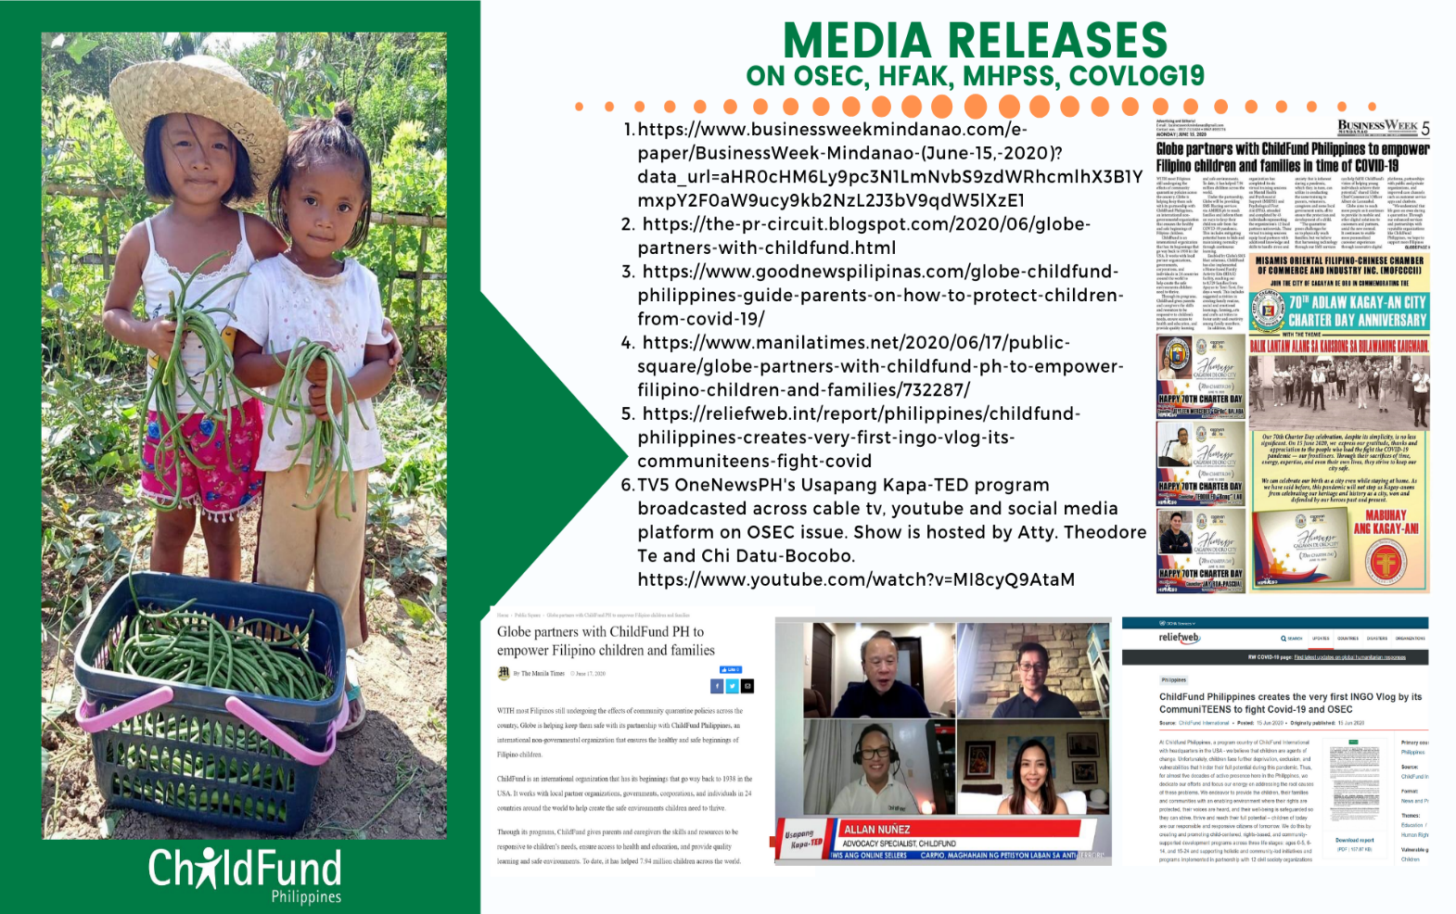
Below are the latest list of materials developed related to Covid 19 shared publicly;

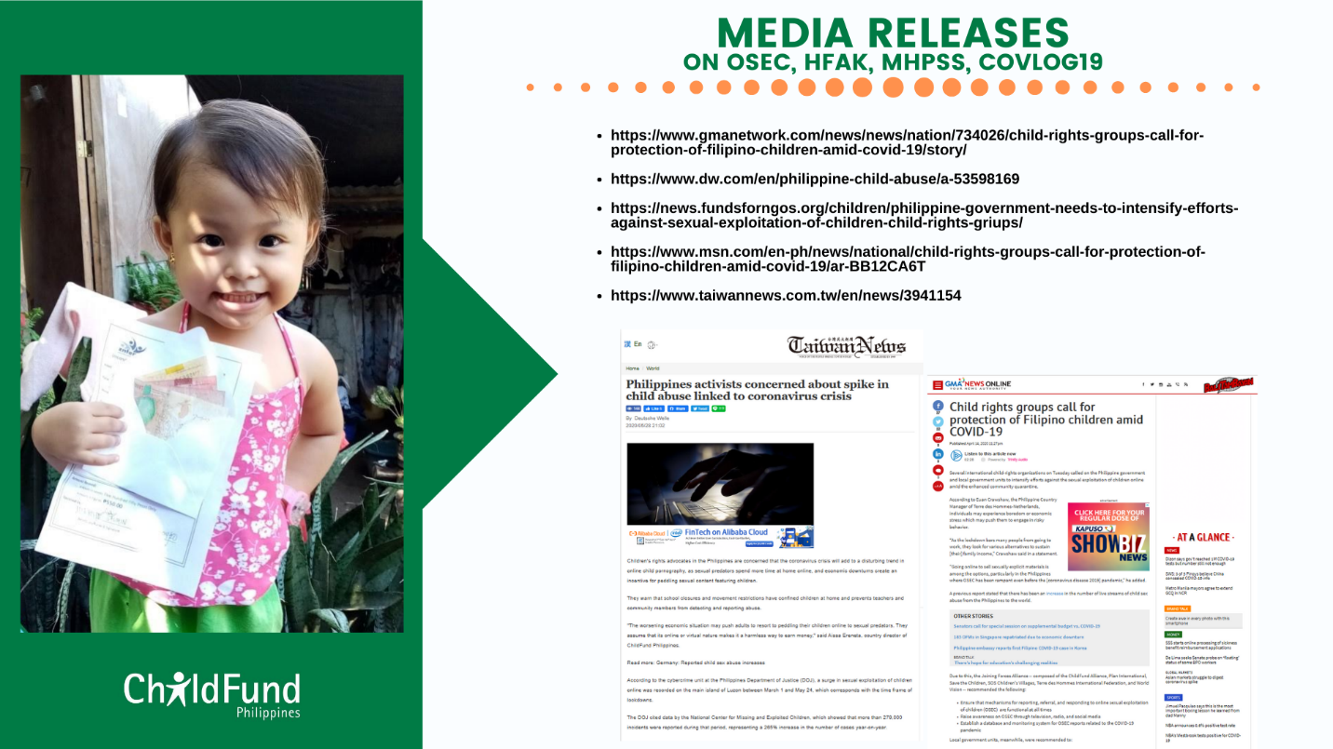

Local Partners update as of September 9, 2020
Modified General Community Quarantine-refers to the transition phase between GCQ and New Normal. When the following temporary measures are relaxed and becomes less necessary; limiting movement and transportation, the regulation of operating industries and presence and presence of uniformed personnel to enforce community quarantine protocols
PUI- Fever and / or cough + a travel history in the past 14 days to areas with issued travel restrictions especially areas with Cases of COVID 19+ A History of Exposure to COVID 19.
PUM- a travel history in the past 14 days to areas with issued travel restrictions especially areas with Cases of COVID 19+ A History of Exposure to COVID 19
https://reliefweb.int/sites/reliefweb.int/files/resources/20201102%20Flash%20Update%20no.2%20on%20Typhoon%20Goni.Rolly_final.pdf?utm_source=OCHA+Philippines+SitRep+list&utm_campaign=dec5a5ecc5-EMAIL_CAMPAIGN_2019_03_26_12_31_COPY_01&utm_medium=email&utm_term=0_2172bc068e-dec5a5ecc5-179831857

