ChildFund International
Humanitarian Situation Report Template
Humanitarian Situation Report [1]
COVID-19 – [MEXICO]
[December 9th, 2020]
[Point of Contact – Morgane Bellion, Program Manager/CO S&S Focal Point]

FOR UPDATES, PLEASE HIGHLIGHT UPDATED SECTIONS IN RED

Part 1: The Overall Situation
COUNTRY
Total Number of COVID-19 Cases Reported | Number of Deaths | Number of Cases Recuperated
1,193,225 | 110,874 | 881,050
SOURCE: https://coronavirus.gob.mx/ and Secretary of State, December 8th .

Mexico Federal government makes a formal announcement every day at 7:00 pm to share the official update of the situation of Covid-19 spread in the country. Unless another date is mentioned, all of the information shared in this report is updated to this day (December 9th)
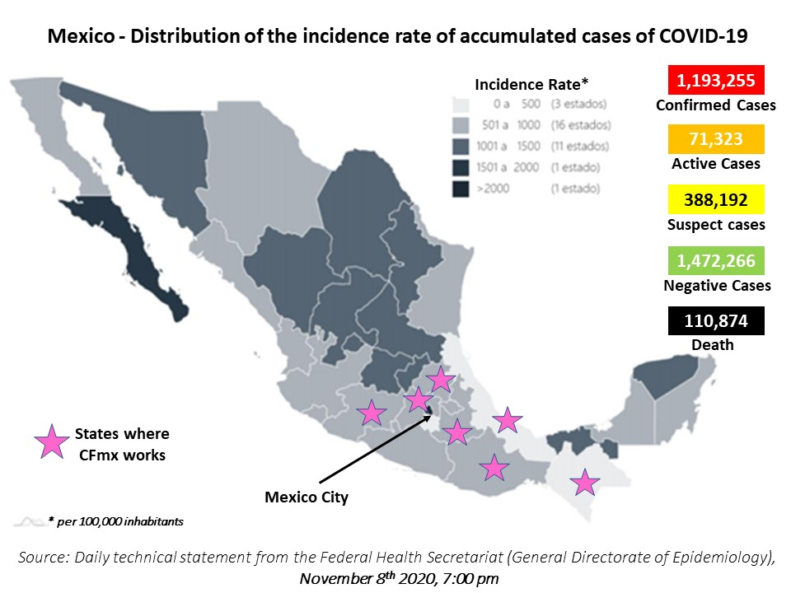

ChildFund-supported areas
Geographical area (city or State) |  | ChildFund presence | Total of Confirmed Cases | Total of Active Cases | Suspect cases | Number of Deaths | Number of Cases Recuperated
Mexico City |  | Country Office staff | 239,006 | 25,942 | U | 18,390 | U
Chiapas |  | 1 LP, Herdez grant | 7,858 | 176 | U | 1,090 | U
Estado de México |  | 2 LPs | 119,071 | 6,358 | U | 12,389 | U
Hidalgo |  | 7 LPs, Confio grant | 20,254 | 1,211 | U | 2,843 | U
Michoacán |  | 2 LPs, ArcelorMittal grant | 29,527 | 1,031 | U | 2,372 | U
Oaxaca |  | 3 LPs, Confio grant | 25,354 | 1,005 | U | 1,903 | U
Puebla |  | 3 LPs, Walmart grant | 41,206 | 1,764 | U | 5,281 | U
Veracruz |  | 1 LP | 40,716 | 748 | U | 5,864 | U
 | SOURCE: National Secretary of Health, https://coronavirus.gob.mx/

Variation from Nov. 9th to Dec. 8th
State | Accumulated | Active | Death
Mexico City | 40 % | 481 % | 18 %
Chiapas | 4 % | 577 % | 0 %
Estado de México | 18 % | 110 % | 13 %
Hidalgo | 22 % | 93 % | 19 %
Michoacán | 13 % | 103 % | 15 %
Oaxaca | 15 % | 103 % | 12 %
Puebla | 12 % | 148 % | 8 %
Veracruz | 7 % | 56 % | 18 %
National TOTAL | 23 % | 152 % | 17 %
Since our last SitRep (Nov. 9^{h}) the trend at State level in our areas of intervention, has been the following:

As mentioned before, those figures are to be taken with caution as they only show the officially registered cases and access to test is still complicated (due to their low diffusion and high price, and also fear of people to go to the hospital or health center even if the show symptoms). We will share in the next sections more specific information about the recent trends at LP’s level.

Background information | The coronavirus pandemic continues its expansion in Mexico and the rest of the world in its second wave of infections, with a renewal of containment measures to cut the chain of transmission, at a time when many regions present their highest figures since the beginning of the crisis.
The production of vaccines allows for a ray of hope, in Mexico Pfizer laboratory has already formally requested the Mexican authorities to receive approval for use. In that sense, the health authorities presented this Tuesday (Dec. 8th) the vaccination plan against Covid-19 so that, once the use of the vaccines is approved, a massive campaign will begin.
The plan consists in several phases to target priority groups established by age and condition, the first group being conformed by health personnel working directly to attend the pandemic, with 125,000 Pfizer/BioNTech vaccines available between December and February. The next groups will be based on age ranges, starting in February with population above 60 years old, and ending between June 2021 and March 2022 with the population under 40 years old. The National Autonomous University of Mexico UNAM) launched a call to its students and academics from Medicine, Nursing and Dentistry careers to be part of the vaccination campaign within the university campus, as the institution already contemplates the possibility of actively participating in the massive vaccination, and seeks to advance the training process.
Also on December 8th, the Secretary of Public Education (SEP), Esteban Moctezuma, announced that, on a voluntary basis, States that are on a yellow or green risk level will be able to return to face-to-face pedagogical and socio-emotional counseling activities as of January 2021. This return to classes will be through the opening of “Community Learning Centers”, which will guarantee a gradual and safe return of children and adolescents to schools, and will be installed according to local will. He added that for the attendance of the students, their caregivers will be asked to write a responsive letter in which they state that, under their own responsibility, they have an interest in participating.
Esteban Moctezuma commented that the states of Chiapas, Campeche and Veracruz, which are on a green traffic light, should start face-to-face classes from January 2021, at the decision of their local authorities, following the measures established by the federal health and educational authorities. He assured that the return will mitigate socio-emotional problems faced by some of the students due to preventive isolation.

Government posture and measures to address the health crisis and economic impact |
The official “traffic light system” by regions according to risk level is still in place:
Red = only essential tasks are allowed,
Orange = more non-essential work activities can be carried out at a reduced level, social activities in open space with reduced participants
Yellow = all work activities can operate without restrictions, lower restrictions for open public space and restricted opening of closed public space (churches, museums, cinemas ...)
Green = all restrictions lifted, but public health measures still apply. School activities are reactivated.
This system considers 5 categories of analysis and measures: public health measures | economic activities (essential and non-essential work categories) | social activities in open and closed public spaces | vulnerable population | education
Essential health measures will apply throughout all of the phases.

Red level implies the highest risk of virus transmission, while orange is the second-highest risk level. Under federal guidelines, states in red should only allow essential businesses to operate, such as those related to food, security, communications, public utilities, manufacturing, mining, construction, and critical health services. Residents are encouraged to remain inside their homes, except to perform essential tasks, and to wear protective face coverings whenever in public.

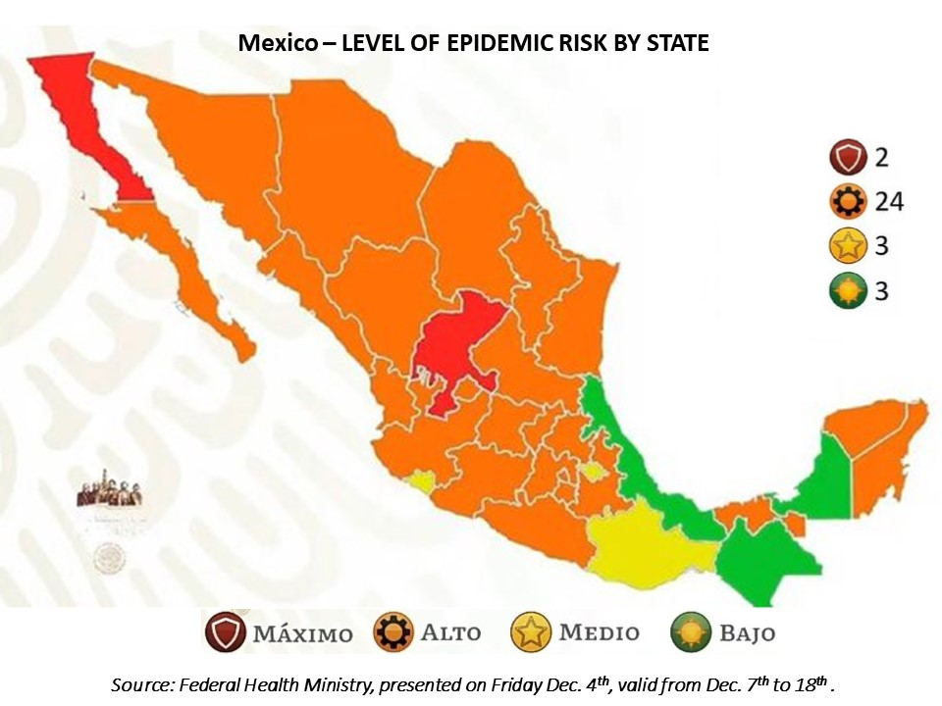

In general updates:
During the last weeks there have been constant updates to the alert level for each State. A couple of days ago, other 2 States went back to the red level (maximal prevention measures - Baja California and Zacatecas), while Veracruz is the newest entity that has managed to turn green, according to Ricardo Cortés Alcalá, general director of Health Promotion (Campeche has maintained this level for 2 months and Chiapas achieved it in mid-november).
However, Cortés Alcalá, also assured that States such as Mexico City, Hidalgo Aguascalientes, Nuevo León, Coahuila, Sonora, Durango, Guanajuato, Querétaro and the State of Mexico are at greater risk of going to the level maximum this week.
In Mexico City for instance, the increase of cases and hospitalization has been significant and constant in the last weeks, as we can see with data shared page 2, and the local government increased the points to deliver rapid tests for Covid-19 from 200 to 230 between kiosks (33), macro kiosks (50), hospitals of the Ministry of Health (30) and health centers (117).
The President Andrés Manuel López Obrador called on the population to redouble efforts to prevent coronavirus infections at a time when the number of cases and deaths from Covid-19 is increasing in the world. Through a decalogue, the president urged the population not to hold parties during this time, as well as to avoid going out on the streets if there is no real need to do so. Paradoxically he also mentionned that the use of facemask was not essential, giving mixed signals to his fellow citizens.
Finally, the Federal Government has announced a new measure, through institute for social welfare (IMSS), consisting in financial support for relatives Covid-19 deceased. This money will be provided for funeral expenses, which will be an amount of $ 11,460 mexican pesos (around $ 575 USD as per today’s exchange rate). It was reported that this payment will be available until the end of the pandemic.
In the tables above and below, each State or each local partner is figured in the color corresponding to their State’s scale.
State of Emergency or requested outside assistance | not at this time.
Travel restrictions | no mandatory procedures but for now, the official recommendation is to stay home as long as possible to avoid flare-ups. Based on a common agreement, the governments of the USA and of Mexico have extended the border closure to non-essential travels until December 21st. This measure has been applied since the endo of March and has been reconducted monthly so far.

Part 2: The Situation in Areas Where ChildFund Works

(Based on national information and information shared by the LPs, each LP is colored in the corresponding level of the “traffic light” risk scale for the current week)
Partner Organization |  | International Sponsorship |  | Local Sponsorship |  | Total enrolled | COVID19 Cases Reported in ChildFund Communities (Y/N/Unknown) Provide number if available. | Number of Enrolled Children Reported with COVID19 (If available) | Number of enrolled children diseased as result of COVID19
# | Local Partner | Sponsored | Enrolled | Sponsored | Enrolled
1 | La Casa de los Niños de Tezonapa A.C. |  |  | 838 | 1193 | 1193 | N | n/a | n/a
1751 | Niños Unidos de Tetitla I.A.P. | 184 | 285 | 87 | 134 | 419 | N | n/a | n/a
1765 | Centro Infantil Jonacapa A.C. | 238 | 273 | 70 | 105 | 378 | N | n/a | n/a
2005 | Centro de Promoción Ocumicho A.C. | 697 | 789 | 40 | 72 | 861 | N | n/a | n/a
2068 | Yohualichan A.C. | 1299 | 1450 | 341 | 431 | 1881 | N | n/a | n/a
2165 | Centro Infantil Huextetitla A.C. | 351 | 544 |  |  | 544 | N | n/a | n/a
2516 | Desarrollo Infantil Taxadhó A.C. | 352 | 420 | 181 | 283 | 703 | N | n/a | n/a
2517 | Niños de Santa Fe A.C. | 1291 | 1466 | 79 | 107 | 1573 | N | n/a | n/a
2518 | Hñahñú Batsi de San Andres Daboxtha A.C. | 410 | 474 | 249 | 301 | 775 | N | n/a | n/a
2520 | Niños Totonacos A.C. | 2476 | 2858 | 337 | 436 | 3294 | N | n/a | n/a
2522 | Niños de Bobashi I.A.P | 805 | 909 | 505 | 599 | 1508 | N | n/a | n/a
2523 | Apoyo Infantil Hñahñú A.C. | 374 | 452 | 128 | 147 | 599 | N | n/a | 1
2839 | Niños Unidos de Ixtlahuaca A.C. | 495 | 593 |  |  | 593 | N | n/a | n/a
2842 | Sakubel K'inal A.C. | 439 | 499 | 117 | 167 | 666 | N | n/a | n/a
2843 | Hñahñú Batsi Ri Xudi A.C. | 362 | 468 | 108 | 172 | 640 | N | n/a | n/a
2924 | Organización de Apoyo y Beneficios Saucitlán A.C. | 1182 | 1361 | 81 | 118 | 1479 | N | n/a | n/a
3848 | Centro Tepelmeme A.C. | 209 | 354 |  |  | 354 | N | n/a | n/a
4285 | Niños de Magdalena Teitipac A.C. | 150 | 238 | 98 | 141 | 379 | N | n/a | n/a
9262 | Niños Acatecos A.C. | 1210 | 1431 |  |  | 1431 | N | n/a | n/a

During this last month, we didn’t receive any report of suspect or confirmed cases within the area of intervention of our LPs.

Update about the situation in the States where CFMX works and their position vis a vis “new normal”: (data from the 1st week of December)
State | Governor | Update / State Government stance
Mexico City | Claudia Sheinbaum Pardo | The mayor Claudia Sheinbaum reported this Saturday (dec. 5th) that the city is at a time of high contagion and that "only with citizen participation" can we move forward. During her message she called on citizens to avoid leaving their homes and postpone meetings with family and friends during the Christmas season.  "I do not want to fail to mention that we are in the city at a time of high contagion, critical, it is time to stay at home, go out for what is necessary and, above all, postpone parties with family and friends for another time.". She highlighted the acquisition of one million antigen tests and the strengthening of systems for tracking coronavirus cases. She also mentioned that the government is working on the design of the vaccination plan for the inhabitants of the capital, so that it is ready by the time the vaccines arrive in Mexico.
Chiapas | Rutilio Escandón Cadenas | During the launch of the “House by House Brigades: Winter Season” campaign in the municipality of Tuxtla Gutiérrez, Governor Rutilio Escandón highlighted that from December 1 to January 31, 2021, the State would be intensifying tours with the purpose of reducing the transmission of coronavirus and mitigating the epidemiological impact, for which he recognized the health personnel for carrying out this strategy with total commitment. In this framework, the president invited the population to join the “I Save Christmas” Campaign, through the use of face mask, and stated that, although Chiapas remains green in the Epidemiological Risk Traffic Light, it is necessary not to trust and continue with the care to combat COVID-19.
Edo. Mex. | Alfredo del Mazo Maza | The governor of the State of Mexico, Alfredo del Mazo Maza, reiterated the call to the population to extreme sanitary measures during December and avoid attending meetings to avoid the spread of Covid-19, since infections have increased in recent days. “As we have all seen, the rate of growth of infections is on the rise and that implies that we continue to be very responsible in managing the pandemic. The actions that we carry out over the next few days and weeks will be fundamental so as not to regress what we have already achieved, I would like here again to invite everyone to become aware of how important it is to continue maintaining preventive measures. "
Hidalgo | Omar Fayad Meneses | The Ministry of Health reported that, for the seventh consecutive fortnight, Hidalgo will keep the orange color of the epidemiological risk traffic light on, which will be in force from December 07 to 19, which means that there is still a high risk of contagion by COVID-19. The head of the Hidalgo Health Secretariat (SSH) Efraín Benítez Herrera explained that hospital occupancy is at 40 percent, however, he invited the population to strengthen biosecurity measures to avoid saturation. Regarding the vaccine against the Influenza virus, Benítez Herrera pointed out that the approval of the request to receive a first delivery of doses one month before the start of the season, allowed to cover the population at risk, health and safety personnel.
Michoacán | Silvano Aureoles Conejo | Stopping mobility and the economic reopening stand out among the most energetic measures if infections and deaths from Covid-19 do not stop in Michoacán, mainly in 15 municipalities, said Silvano Aureoles Conejo.  In a message to the Michoacanos, Aureoles Conejo addressed mainly those who live in the municipalities of Morelia, La Piedad, Lázaro Cárdenas, Zitácuaro, Uruapan, Zamora, Pátzcuaro, Hidalgo, Maravatío, Apatzingán, Zacapu, Tarímbaro, Tacámbaro , Sahuayo, Los Reyes, which register a higher risk. "We have to be very firm with sanitary measures from today, because if we do not act now, we may have, due to the circumstances of the season, major complications," he argued.
Oaxaca | Alejandro Murat Hinojosa | Due to the pandemic, Governor Alejandro Murat, decided to suspend all ecclesiastical and liturgical activities that are celebrated in the month of December, including the anniversaries of the Virgin of Juquila, La Soledad and Guadalupe. The Secretary of Health, Donato Casas Escamilla, reported that, together with the governor, Alejandro Murat and the State Committee for Health Safety (CESS), the suspension of all ecclesiastical activities corresponding to the month of December was agreed. The official invited Oaxacan families and visitors at this time of year to maintain the faith from their homes, "soon this health emergency will pass and we will be able to resume our traditions, today is the time to take care of all of us, so I ask you, pilgrim, stay home ", he said
Puebla | Miguel Barbosa Huerta | Given the increase in the number of COVID-19 infections, primarily in the capital of Puebla and neighboring municipalities, Puebla went again from yellow to orange at the state epidemiological traffic light, reported Governor Miguel Barbosa Huerta. He considered that, among the factors in the increase, the street sells have generated greater mobility and greater risk of contagion of said virus. In this sense, he announced that, from his attributions, the State Government will take measures on this issue. He also called on the Puebla City Council to regulate, through dialogue and in accordance with the law, this type of commerce.
Veracruz | Cuitláhuac García Jiménez | The federal government, through an official letter, the director of Medical Attention of the Veracruz Health Secretariat, Dr. Alejandro Rey del Ángel Aguilar, reported that in the second week of December they expect the arrival of the Pfizer vaccine to the State of Veracruz. According to what was stated by the state official, it is a first phase, which will be given priority to immunize first and second level health personnel, starting with hospitals with 60 beds and more, involved in direct care to patients with COVID 19. The scheme consists of two doses (0-21 days) and requests the support of the hospitals directors to make health personnel aware of the importance of said vaccination. It was also announced that the entity has managed to pass to the green traffic light.

At local level, we have kept doing our weekly analysis of cases and death in the municipalities where we work with our Local Partners or with Grants / special projects. Between November 9th and December 7th, the evolution was the following. In general, the weekly variations have been at their lower point – this is not the case throughout the country, as seen above with the State data.

LP# | State | Municipality | Cases confirmed on Nov. 9th | Confirmed cases this week | Increase since last month | Death
ARCEMX | Michoacán | Lázaro Cárdenas | 4,944 | 5,131 | 4% | 307
25-078D | Chiapas | Tapachula | 1,260 | 1,277 | 1% | 201
2522 | México | Atlacomulco | 1,028 | 1,083 | 5% | 78
2924 | Oaxaca | Huajuapan de León | 785 | 876 | 12% | 61
2517 | Michoacán | Zitácuaro | 693 | 803 | 16% | 90
4285 | Oaxaca | Villa de Zaachila | 478 | 555 | 16% | 30
4285 | Oaxaca | San Antonio de la Cal | 357 | 401 | 12% | 40
2516 / 2843 | Hidalgo | Ixmiquilpan | 321 | 416 | 30% | 73
2522 | México | Acambay | 270 | 294 | 9% | 20
2522 | México | Temascalcingo | 233 | 239 | 3% | 23
2005 | Michoacán | Los Reyes | 197 | 207 | 5% | 30
1765 | Hidalgo | Huichapan | 162 | 222 | 37% | 20
9262 | Puebla | Acatlán | 147 | 160 | 9% | 24
2522 | México | San José del Rincón | 143 | 152 | 6% | 16
2516 | Hidalgo | San Salvador | 130 | 149 | 15% | 36
2517 | Michoacán | Quiroga | 115 | 138 | 20% | 7
4285 | Oaxaca | San Agustín de las Juntas | 101 | 111 | 10% | 8
2005 | Michoacán | Tangancícuaro | 99 | 104 | 5% | 8
2520 | Puebla | Tlatlauquitepec | 86 | 99 | 15% | 24
9262 | Puebla | Tepexi de Rodríguez | 64 | 68 | 6% | 6
2517 | Michoacán | Tuxpan | 64 | 70 | 9% | 7
2516 | Hidalgo | Santiago de Anaya | 53 | 57 | 8% | 16
1 | Veracruz | Tezonapa | 53 | 53 | - | 10
2165 | Hidalgo | San Felipe Orizatlán | 51 | 57 | 12% | 18
1765 | Hidalgo | Tecozautla | 47 | 65 | 38% | 7
2518 / 2523 | Hidalgo | Cardonal | 42 | 56 | 33% | 15
2068 / 2520 | Puebla | Cuetzalan del Progreso | 37 | 39 | 5% | 12
1765 / 2839 | Hidalgo | Alfajayucan | 34 | 44 | 29% | 6
2520 | Puebla | Hueytamalco | 33 | 35 | 6% | 13
2842 | Chiapas | Yajalón | 29 | 29 | - | 3
2005 | Michoacán | Charapan | 28 | 28 | - | 5
25-078D | Chiapas | Mazatán | 25 | 25 | - | 4
2520 | Puebla | Zaragoza | 25 | 32 | 28% | 5
4285 | Oaxaca | San Jerónimo Tlacochahuaya | 20 | 38 | 90% | 1
2520 | Puebla | Ayotoxco de Guerrero | 16 | 16 | - | 5
2839 | Hidalgo | Tasquillo | 16 | 22 | 38% | 2
2842 | Chiapas | Tila | 16 | 16 | - | 5
3848 | Oaxaca | Tepelmeme Villa de Morelos | 13 | 14 | 8% | 2
2520 | Puebla | Huehuetla | 12 | 12 | - | 2
2520 | Puebla | Ixtepec | 10 | 10 | - | 2
9262 | Puebla | Guadalupe | 8 | 9 | 13% | -
9262 | Puebla | San Pedro Yeloixtlahuaca | 7 | 8 | 14% | 2
9262 | Puebla | Chila | 6 | 6 | - | 1
2924 | Oaxaca | Santo Domingo Tonalá | 6 | 7 | 17% | 1
2520 | Puebla | Jonotla | 4 | 4 | - | 1
2520 | Puebla | Olintla | 4 | 4 | - | -
9262 | Puebla | San Pablo Anicano | 4 | 6 | 50% | -
4285 | Oaxaca | Magdalena Teitipac | 3 | 3 | - | 3
3848 | Oaxaca | San Miguel Tequixtepec | 3 | 3 | - | 1
1 | Puebla | San Sebastián Tlacotepec | 3 | 3 | - | -
2924 | Oaxaca | Santiago Ayuquililla | 3 | 4 | 33% | -
2520 | Puebla | Tuzamapan de Galeana | 3 | 4 | 33% | 1
2924 | Oaxaca | San Jerónimo Silacayoapilla | 2 | 2 | - | 1
2520 | Puebla | Caxhuacan | 1 | 2 | 100% | -
2924 | Oaxaca | San Miguel Amatitlan | 1 | 3 | 200% | 1
2520 | Puebla | Zoquiapan | 1 | 1 | - | -
3848 | Oaxaca | Tlacotepec Plumas | - | 1 | new case | 1
 |  | TOTAL | 12,296 | 13,273 | 8% | 1,255

Child deaths: List any sponsored child (with Partner organization and child ID from salesforce) diseased as a result of COVID19. (Note: These need to be reported immediately following the regular sponsorship protocols.)
None since the one reported in May.
Partner Organization (Use Salesforce identifying code/name.) |  | What is the status of the program/sponsorship processes (operational/suspended)?
 |  | Program Implementation | CVS | M&E Level 2 | Enrollment /Disaffiliation | Sponsorship Communication | DFC
1 | La Casa de los Niños de Tezonapa A.C. | Program sessions, events, training are suspended. LPs are working on awareness raising and communication activities + administrative and sponsorship activities. All staff are working from home | postponed to Q 3/Q4 FY21 |  | Enrollments / RAM will be suspended until Q3. Departures have some delays with some LPs. Identifying new departures and additional monitoring. | Limited as LP staff work from home and with delays recovering children letters. Translations in progress and up to date. In our local Sponsorship we carried out our first massive process with Christmas cards, finding that the LPs spend twice as much time in being able to make the visits without being able to finish on time. | The DFCs are being delivered in the form of a generic letter to avoid exposing children and with all hygiene and safe distance measures.
1751 | Niños Unidos de Tetitla I.A.P.
1765 | Centro Infantil Jonacapa A.C.
2005 | Centro de Promoción Ocumicho A.C.
2068 | Yohualichan A.C.
2165 | Centro Infantil Huextetitla A.C.
2516 | Desarrollo Infantil Taxadhó A.C.
2517 | Niños de Santa Fe A.C.
2518 | Hñahñú Batsi de San Andres Daboxtha A.C.
2520 | Niños Totonacos A.C.
2522 | Niños de Bobashi I.A.P
2523 | Apoyo Infantil Hñahñú A.C.
2839 | Niños Unidos de Ixtlahuaca A.C.
2842 | Sakubel Ki´nal A.C.
2843 | Hñahñú Batsi Ri Xudi A.C.
2924 | Organización de Apoyo y Beneficios Saucitlán A.C.
3848 | Centro Tepelmeme A.C.
4285 | Niños de Magdalena Teitipac A.C.
9262 | Niños Acatecos A.C.

Note: As a global measure, all sponsor visits have been suspended.
- What issues are children in these areas facing (food shortages, safety concerns, schools’ closure, etc.)?
- As anticipated, the beginning of the school year in virtual modalities has caused difficulties for families, first in terms of access (there are TV and radio options but for families with several children at “homeschool” it can be challenging to manage the different schedules), and also in terms of cost (for internet to send homework, or to transfer to a place with internet access) and of course for children due to lower quality of teaching, lack of social contact necessary for their development and wellbeing, etc.
- Possible increase of school dropout due to connectivity and learning challenges, and to send children to work to compensate families’ loss of income (see point on child labor)
- Increase in parents/caregiver’s unemployment or income drop due to the mitigation measures.
- Families’ attitude towards the “social distancing” varies, between incredulity, anxiety, and partial respect to the recommendations
- Mothers and in general parents/caregivers feeling overwhelmed by having their children at all time at home
- Increase of mobility within the country, and lack of precautionary measures to check the health status
- Increase of domestic violence.
- Increase of child labor.
- Child protection risks caused or exacerbated by crisis situation.
- School dropout, lack of proper activities (educational or recreational), with intellectual and psychosocial consequences.
- Increased risk of domestic physical or emotional violence. (see comments above)
- Increased risk of sexual abuse due to overcrowding living conditions
- Increased risk of child labor (as children are not currently going to school, and possible impact of the contingency on families’ livelihoods) see example above
- Increase risk of been contaminated as culturally children -specially girls- and women are ill caregivers

Part 3: ChildFund’s Response

3.a. Overall
- Who is or will be leading/managing the response?
SMT + LP Specialist, Communications, Advocacy and Corporate Fundraising Specialist.

- How is ChildFund linked with humanitarian coordination structures, i.e., in which clusters or working groups do we participate? The most recent/next meeting and who is representing ChildFund? Donor meetings we have attended, or missions that we are aware of related to the response?
Currently we are linked in working groups with OCHA, the CALP network, and Joining Forces strategy at national level. Most recurrent meetings are with the national CALP group as we are now contacting possible providers for future cash-based interventions and are about to receive the proposals of several providers.

3.b. Program Response
Please organize your program response report as per the 4 objectives included in our global response plan. You can add an additional category if you have response activities planned or executed that do not align with these objectives. For each objective use the questions below to guide your report.
- What kind of response activities or interventions have been executed? What support items are needed or have been collected/distributed?
- What is the current progress of implementation vs. the established response plan?
- Who are we partnering or collaborating with to provide our response?
- What kind of response activities are you still planning for the coming period?
According to our LP’s November monthly reports, in the month of November we had accumulated 14,480 young people over 15 years old and adults receiving direct information through 757 Whatsapp groups, SMS groups phone calls or Facebook groups.

3.b.1. Stop COVID-19 from infecting children and families
ChildFund’s Global Response Plan
To help children and families protect themselves from COVID-19, we are installing community, handwashing stands; educating communities about symptoms, hygiene measures and where to get tested or treatment; and distributing soap, hand sanitizer, gloves and masks to families and frontline, health workers. For children who are being treated for COVID-19 or are subject to quarantine measures, we are creating child-friendly spaces with age-appropriate toys and reading matter.

So far we have implemented a communication campaign for social media and for our LPs to disseminate preventive messages (how to recognize symptoms, hygiene measures to limit spreading, emergency contacts for suspected cases, etc.). Those have been disseminated by the LPs through different channels: posters, videos, puppet shows, radio, speakerphone, whatsapp and SMS groups… We will continue this strategy of the “weekly information package” until the end of Q1.
In November, the number of participants in the diffusion groups through whatsapp, SMS, facebook… has reached a total of 14,480 youth over 15 years old, caregivers, facilitators, teachers, local authorities’ members, CBCPM members.
Hygiene and prevention messages disseminated through… | Infographics | 131
 | Webinar | 0
 | Radio spots | 10
 | Speaker message | 9
 | Videos | 1
 | Other (posters or tarps) | 9
 | Total | 160

In the groups referring to hygiene messages, prevention of contagion, the following contents were shared: Videos of preventive measures for COVID-19, "do not lower your guard", tips to overcome fear and prevent it from COVID-19, infographics with the risk level status and traffic lights system, myths and realities about COVID-19, infographics on proper use of face masks, use of antibacterial gel, keep a healthy distance, correct hand washing.
In addition, the LPs organized in-kind donation of personal protection materials and hygiene products to 1,887 more families; and continued to support local clinics, health centers and other institutions (this months of November, no new health center was benefitted, but 23 clinics previously supported received additional donations of 2,180 hygiene products such as facemasks, facial protection, and cleaning materials)
The details are available in the monthly report shared at regional level.

3.b.2. Ensure that children get food they need
ChildFund’s Global Response Plan
To ensure that the most vulnerable families can keep food on the table, pay rent and cover other basic needs, we are providing cash for those families most needing this support, such as those who have lost their income because of COVID-19, child or elder-headed households, and/or households affected by disability or chronic illness. Where possible, we are distributing food and basic household items directly, carefully abiding by COVID-19 protection measures

3.b.2. 1. Cash Transfers and vouchers
This month we were able to incorporate a new group (6th group) of 88 families that will start receiving the support in November, thanks to the assignation of a NSP.
Since the launch of this temporary program, a total of 1,716 families have been incorporated and in the month of November, there were 481 families active in the program.

Cash transfers or vouchers executed, referring to November data (not accumulating previous months data)
Beneficiaries |  |  | Amount transferred (US$) | Transfer mechanism (i.e. mobile money, banking system other financial service provider etc,
Total | Gender (if available)
 | Female | Male | Total per family = $ 1,600 pesos = $ 71 USD approx..
481 families | See details in following table |  | Total of $ 804,500 MXP = $ 40,474 USD approx. (including PPE and transportation budget for the logistics) | Direct delivery

Detail of Cash transfer accumulated direct beneficiaries (=members of the 1,716 families selected in groups 1, 2 3, 4, 5 and 6)
groups 1+2+3+4+5+6 | women | men | Total
Children from 0 to 5 years old | 600 | 634 | 1,234
Children from 6 to 14 years old | 1053 | 1010 | 2,063
Youth from 15 to 24 years old | 693 | 626 | 1,319
Adultos from 25 to 64 years old | 1721 | 1111 | 2,832
Senior adults from 65 years old and up | 272 | 193 | 465
Total | 4,339 | 3,574 | 7,913

3.b.2.2. Other responses in relation to objective 3.b.2.
At the end of June, we sent additional resources to 6 LPs for them to extend their family orchards activities in order to incorporate more families, giving priority to the families that are currently in the temporal cash transfer program. In July, 212 families have been included in this project, and in August 220 more families received materials and training to implement their orchard (total = 432 orchards installed n July/august period). In September, the orchards ascend to 530 (+98 individual orchards launched in September)
One LP started a pilot for backyard poultry, with 28 families. We will monitor the results to see if it is feasible to replicate with other LPs, considering the specific needs in terms of follow up, veterinary services, etc. that this kind of project requires and that not all LPs have such installed capacities. A new group of families has been benefitted in September (+ 29 families)
On another hand, some LPs have secured additional support through external partnerships to enhance families’ food security, distributing food pantries to 406 new families during this month.

3.b.3. Keep children safe from Violence : physically and emotionally
ChildFund’s Global Response Plan
We are supporting community-based child protection systems that identify, respond to and refer cases of abuse, neglect, violence or exploitation. We are also providing virtual, online psychological first aid and counseling, and supporting temporary shelters for children who live on the street, providing hygiene supplies, food and other basics. We are also arranging safe and appropriate care for children who are separated from their caregivers due to treatment or prevention measures.
Aligned to what was mentioned in 3.b.1, we are sending each week an “information package” to the LPs, including recommendations for activities and violence prevention, with tips about positive parenting, to be disseminated at community level. In addition, the LPs are working in coordination with the activated CBCPM and local authorities to detect and refer any case of abuse, neglect, violence, or exploitation.
During November:
Violence prevention messages disseminated through… | Infographics | 54
 | Webinars | 2
 | Radio Spots | 9
 | Speaker messages | 11
 | Videos | 4
 | Other (posters, flyers or tarps) | 3
 | Total | 83

Emotional and selfcare messages disseminated through… | Infographics | 26
 | Webinars | 2
 | Radio spots | 3
 | Speaker messages | 7
 | Videos | 4
 | Other (posters, flyers or tarps) | 1
 | Total | 43

More details about Child Protection activities are available in the monthly report shared at regional level.
In the groups referring to protection messages, information continues to be provided through infographics, videos, on violence prevention, prevention of gender violence, prevention of child abuse, positive parenting, children rights, local legislation to ensure children rights, …
LP Niños de Bobashi launched a campaign for the world day for prevention of sexual abuse against children and adolescents to remember that it is a common duty to provide them with the protection and tools to reduce the risk (ABC of prevention, attention numbers, dissemination of rights and empowerment for children and adolescents). LP Saucitlan launched a Child Sexual Abuse prevention workshop and a “Let's talk about sexuality” workshop with NN. LP Proyecto para los niños Acatecos worked on infographics of Sexually Transmitted Infections and options of contraceptive methods.

3.b.4. Help children continue to do their job: Learning
ChildFund’s Global Response Plan
While schools remain closed, we are supporting children’s learning through activities and tutoring sessions online or by radio. For students without reliable internet access, we are distributing home learning kits with materials and guides for their use.

Aligned to what was mentioned in 3.b.1, we are sending each week an “information package” to the LPs, including recommendations for recreational and educational activities.
During November:
Messages with content of recreational and educational activities… | Infographics | 117
 | Webinars | 0
 | Radio Spots | 4
 | Speaker messages | 3
 | Videos | 13
 | Other (posters, flyers or tarps) | 3
 | Total | 140

Activities are shared according to each Life Stage: Infographics, stories, drawing activities, physical activity, video of technological skills, and other activities to promote the development of capacities and abilities in children and youth.
For instance, LP Centro Tepelmeme focused this month on motor skills for LS1, creative and cognitive activities for families, and sent an educational video to prevent respiratory diseases for the winter season. LP Niños de Santa Fe focused on promoting reading habits.
In addition, during October, the LPs distributed “learning kits” to 236 additional children; and 400 calendars for 2021 with preventive recommendations against Covid-19.

3.b.5. Other responses
n/a

- For sitreps submitted after ChildFund response has been initiated, what is the current progress of implementation vs. the established response plan? n/a

Below Sections for Internal Use Only
Part 4: Office and Staff Status
Office Status (Open/Closed) | Number of Staff :
 | Diagnosed with COVID19 | Diseased from COVID19 | Working from Office | Working from Home | On Special Leave
CO Office and Core Structure (closed since Friday, March 27th ) | 1 | 0 | 0 | 25 | 0
GSS staff members (always work remotely | 0 | 0 | 0 | 3 | 0
Grants contracted staff members (only 3 normally work from CO) | 0 | 0 | 0 | 24 | 0

Notes:
- Any cases of staff diseased need to be reported immediately to RD and GHR.
- Special leave as per COVID19 Administrative Guidelines.
Number of staff/partner organization staff completed WHO COVID online training https://www.who.int/emergencies/diseases/novel-coronavirus-2019/training/online-training.

Part 5 Human Resources
- Which visitors are there in the country? Please include names, functions, contact information and arrival/departure dates for both IO and RO staff (note: due to the travel ban, this will apply only once the ban has been lifted)
None

- Any gaps in staffing/need for deployment from other COs or Global Teams?
Not for the moment

- Are there any other major HR issues?
Not for the moment
Since Monday May 18th, the office has launched an external Personalized Comprehensive Support service to contribute to staff’s psychological, emotional, and physical well-being. After a group kick-off meeting, the service is available for individual support through Whatsapp request. Service is still available for all staff.
Monthly updates are provided through Internal Communications Mexico, regarding the local COVID situation.

Part 6 Safety & Security
- Are police and other services functioning in the normal manner? Yes

- Are the courts still operating? Yes

- Are there reports of looting or increased criminality? Not during this period in our areas of intervention or at national level.

In some area, mostly rural, there is still animosity towards public health services or sanitization campaigns, which have been wrongly interpreted in some places as intents of the government to spread contagion.

- Have military personal being deployed to patrol towns or cities? No, but according to the usual emergency procedure in the country, the army and the marine are essential actors when the government declares the state of emergency (plan DN-III)

- Confirm the safety of staff and their families in the affected area. Until now no incidents have been reported by CO staff members nor LP staff members.

- Have Safety and security risks/mitigation plans been updated to current environment? Not at the moment.

- Recommendations around any upcoming travel planned for staff or donors (note: Only once global travel ban has been lifted) n/a

Part 7 Grants
List all active grants:
Grant Job Code | Grant Name | Donor | Status of Implementation (Normal/Reduced/Suspended) | Any specific guidance received from donor? (Yes/No)
ARCEMX (Local corporate contribution) | Cultivando Futuros | ArcelorMittal | Reduced | Activities are adjusted and updates are shared on a weekly basis with the donor, last call with the donor was on Friday Dec. 4th.
12-0354D | CONFIO | Government of Canada | Reduced | Several adjustment plans have been shared with CONFIO regional leadership team, we are also conducting monthly meetings with all involved CO staff members and LPs.
25-078D | Saber Nutrir | Herdez | Reduced | Yes / We have monthly calls with the donor (last one was on Dec 9th ) and weekly email exchanges. We are currently adjusting the budget for the 2021 project according to the donor’s feedback..
25-080D | Educación Sexual Integral “Mi Cuerpo y yo” | Fundación Río Arronte | Reduced | Yes / Last contact was in the 1st week of November as we asked for authorization to print additional materials for teenage pregnancies awareness.
12-088D | Proyecto para el bienestar de la niñez totonaca | Fundación Walmart | Reduced | Yes / Currently the donor is auditing the project as part of their normal grants follow up procedures.

Provide any additional narrative on how the COVID19 crisis affects implementation of your major grants.
In all the cases, we have suspended all program sessions and group activities. The administrative activities, individual follow up or farm/orchard supervision visits are still being done. According to the situation in each project area, some activities are conducted (such as family follow up, online activities and communication) but all large-scale activities remain suspended (such as group trainings, nutritional monitoring…). Project 25-078D is located in Chiapas where the risk alert level is in green since mid-November and is piloting small group activities with children, with all the prevention measures required.

Part 8 Funding
Provide information about potential sources of funding, including grant donors, subsidy, Emergency Action Fund, Alliance members, GIK, etc., for these emergency response efforts using the chart below:

Donor | Program | Amount (USD – 23.01 MXN) | Requested? (Y/N) | Confirmed? (Y/N)
Digital Fundraising Campaign COVID-19. | Campaign that will contribute to the cash transfer strategy that will support the well-being and food security of families. | The funds raised by Individual Donors YTD are $ 5,557.86 USD. | Y/This campaign was launched on April 15th without scheduled date to finalize it. | Y/ A total of 117 donors have been acquired.
Rotoplas | Contribute to the implementation of the health and hygiene action with the installation of sanitary stations | Not yet | Y/ Rotoplas, is available to donate in kind. The proposal of in-kind donation of supplies such as water tanks, biodigester, etc. is under development. | Not yet
Nestlé México . | Internal digital campaign with employees (many of which are current sponsors) to raise funds for the health and hygiene action/ food security of the ChidlFund Mexico action plan | The campaign procurement goal is  $ 21,729 | Y / Yes, the procurement goal, timeline, axes, and procurement channels, have already been defined together with the donor. | Y / The donor will confirm the amount collected and we will begin the administrative process for receiving the donation.
BASF | Internal digital campaign with employees to raise funds for the health and hygiene action of the ChidlFund Mexico action plan. We are also under conversations for in kind donations of hands sanitizer for the communities where we operate and hospitals or health systems close to them. | $934.11 | Y/The proposal was sent to the donor considering necessary supplies for the hygiene kits. | Y/ We received 5,800 tons of sanitizer and delivered them to health centers.
VESTA Management | The proposal will contribute to the development of community infrastructure and sustainable economic models for families in affected communities. | $ 9,000 | The proposal is under development to begin negotiations with the donor. | Not Yet
Huella Sustentable | The proposal will contribute to covering the basic needs of families and will allow the implementation of the cash transfer strategy. | $ 6,500 | Y/A general proposal was sent to the donor. They are analyzing what specific food security action they will support so that we can send a concrete economic proposal. | Not Yet
PYMO | The proposal will contribute to the implementation of cash transfer | To confirm | Y/ The proposal was sent to the donor. | Y/ We started the cause marketing campaign in August and closed in September. For every product purchased, PYMO will donate 25% to ChildFund.
Helvex | The proposal will contribute to the development of community infrastructure and sustainable economic models for families in affected communities. | In-kind and Volunteering work. | The proposal is under development to begin negotiations with the donor. | Not yet
IEnova Foundation | The proposal will contribute to covering the basic needs of families and will allow the implementation of the cash transfer strategy. | $133,116.92 | Y/A general proposal was sent to the donor. | Y/ The donor tells us that there is a probability of receiving the donation in March 2021.
HASBRO | The proposal will contribute to covering the basic needs of families and will allow the implementation of the cash transfer strategy. We will also include a proposal to request toys for families. | Cash donation  36,011 + inkind. | Y/ The proposal was sent to the donor. | Y/ In-kind donation was accepted, we will receive the donation in October
Regional FRO campaign | The regional MKT team and FR have concluded all Procurement processes to hire new vendor providers for: Web Builder/FR platform | TMK |Digital agency |Content | New individual donors  Mama a mama campaign | The Set up activities with the new vendor providers are been planned to pe executed in October 2020. | The strategy of acquire new leads to be converted in regular donors, will start during november 2020.
P&G | The proposal will contribute to the implementation of the health and hygiene axis, through the delivery of supplies for hygiene kits. | 162,420  (Exchange rate 1 USD - 22.5 MXN)  New In Kind donation for a total of $ 5,270 USD | Y/The proposal was sent to the donor considering necessary supplies for the hygiene kits. | Y/ in addition to the donation received in June, this October we received another in-kind donation of supplies for the delivery of hygiene kits for 2202 families in Puebla.
EATON | A workplace giving campaign was carried out during the month of July and the company will make a match of the total collected. In addition, there is the possibility of presenting a specific proposal to the Board and receiving a corporate donation. | To confirm | Y/ The proposal was sent to the donor. | Y/ We developed a workplace giving campaign and as a second phase, we are waiting for the EATON Board to approve a cash donation for ChildFund Mexico.
Odyssey | We sent a general proposal on the COVID care plan. | $9,788. 13 USD | Y/ We received the donation. | Y/ The donation will be used for the cash transfer strategy.
Autocinema Santa Fe | We present the general proposal and the COVID care plan. | $3,000 USD, (to be confirmed with the donor) | Y/ the proposal was sent to the donor | Y/ We are waiting for the confirmation of the date, time and name of the film that will be donated to ChildFund.
P&G (NSP) | Delivery of educational support kits for LS 2 | $26,872 | Y/The proposal was sent to the donor. | Y/ We have received the donation
IO (NSP) | This donation will contribute to the delivery of 88 educational kits and delivery of 88 financial transfers for families | $25000 | Y/The proposal was sent to the donor. | Y/ We have received the donation.

- Budget
  - Outline how we will use this funding with a rough topline budget.

Part 9 Media/Communications
List of media who will be or have been contacted with press releases.
  - Since the beginning of the pandemic we had the support of our pro-bono Media Agency Insight Comunicación. During July-August we didn’t have media impacts.
We keep sharing in our social media, testimonies, and stories of COVID cash transfers.
We keep producing the infographics for weekly activities.

  - Internal communications: HR and Communication team are sending organizational mailings Fridays, every 15 days, to all CO staff members to check-in and share tips and recommendations to handle the situation.

  - List of emergency CO spokespeople, including name, location, contact information, and languages spoken.
Sonia Bozzi, México, sbozzi@childfund.org , Spanish and English
Morgane Bellion, Mexico mbellion@childfund.org , Spanish, English and French
Yil Felipe, Mexico, yfelipe@childfund.org Spanish and English

  - Plans for collecting photos/videos/stories, e.g., should an outside photographer be hired?
  - We have started to collect testimonials and photos from LPs and are using them in our social media content and reports.

  - Key points for messaging and visibility, particularly any host-government sensibilities that must be considered.
  - We keep publishing Joining Forces press releases

  - Support needed or requested from IO, GSS or Global Teams – whether onsite or remote.
Sharing the info in English and attaching the editable files of the materials
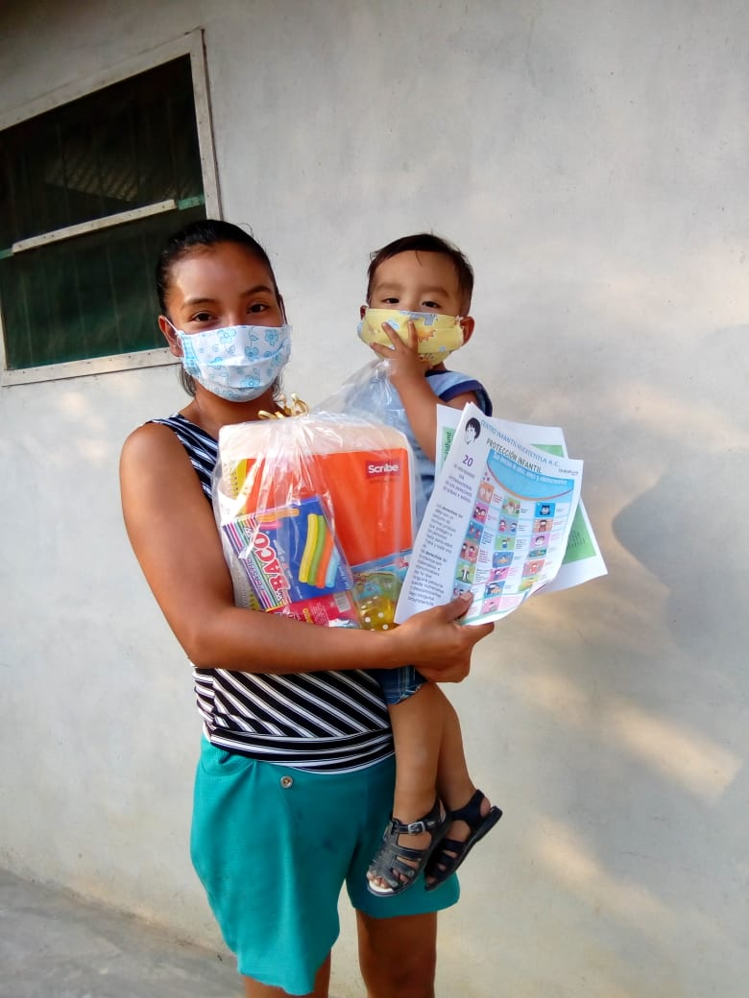
Delivery of educational kits in LP 2165 Centro Infantil Huextetitla AC

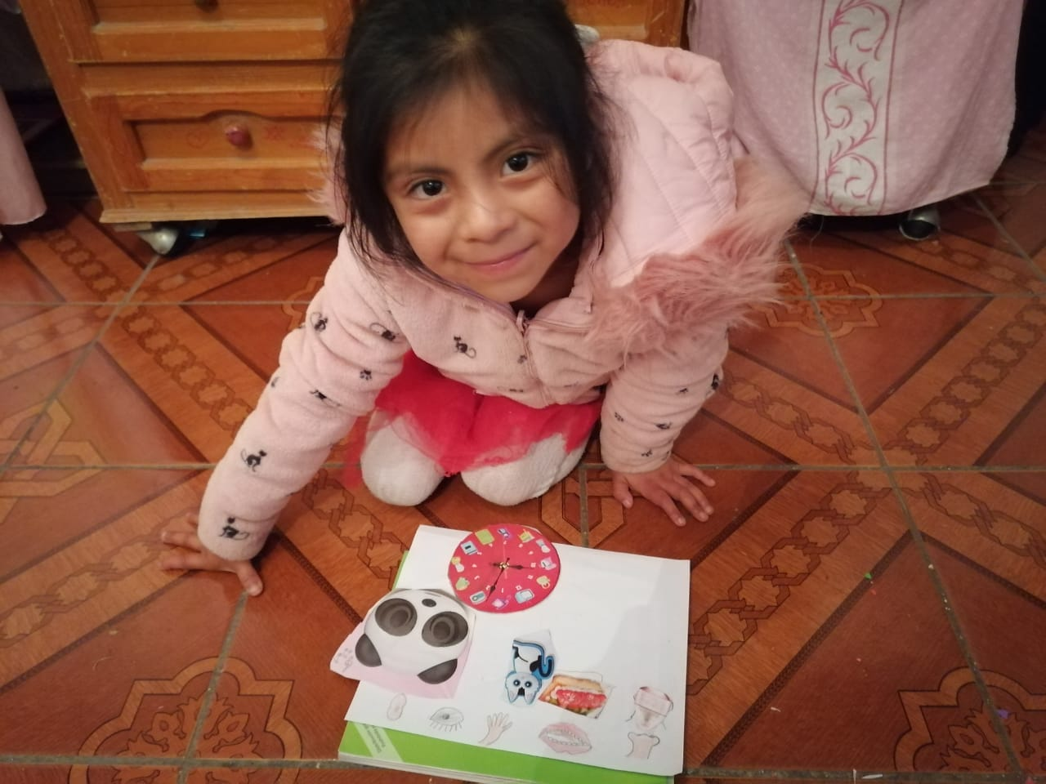
Maydelin, enrolled to LP 2522 Niños de Bobashi, shows her sensorial activity “I feel, I smell, I see, I listen, I touch”

