ChildFund International
Humanitarian Situation Report Template

Humanitarian Situation Report [18]
COVID-19 – [Kenya]
10th December 2020
Point of Contact – Chege Ngugi, Country Director
10th December 2020 to 9th January 2021

Part 1: The Overall Situation
COUNTRY
Total Number of COVID-19 Cases Reported | Number of Deaths | Number of Cases Recuperated
89,100 | 1,545 | 69,839
SOURCE: https://www.arcgis.com/apps/opsdashboard/index.html#/bda7594740fd40299423467b48e9ecf6
- ChildFund-supported areas (Provide only if you have reliable data on this. You can report on a consolidated basis or by program state/region/province/etc. if you have this detail.)
 | Geographical area (county) | Total Number of COVID-19 Cases Reported | Number of Deaths | Number of Cases recovered
 | Nairobi | 38067 | Not Known | NK
 | Mombasa | 8009 | NK | NK
 | Kiambu | 5839 | NK | NK
 | Nakuru | 4308 | NK | NK
 | Kajiado | 2988 | NK | NK
 | Uasin Gishu | 2746 | NK | NK
 | Busia | 2492 | NK | NK
 | Machakos | 2344 | NK | NK
 | Kilifi | 2160 | NK | NK
 | Kisumu | 2018 | NK | NK
 | Kericho | 1469 | NK | NK
 | Kisii | 957 | NK | NK
 | Laikipia | 947 | NK | NK
 | Meru | 946 | NK | NK
 | Nyeri | 942 | NK | NK
 | Kakamega | 913 | NK | NK
 | Turkana | 872 | NK | NK
 | Migori | 805 | NK | NK
 | Trans Nzoia | 760 | NK | NK
 | Bungoma | 737 | NK | NK
 | Garissa | 663 | NK | NK
 | Murang'a | 620 | NK | NK
 | Kitui | 615 | NK | NK
 | Embu | 508 | NK | NK
 | Siaya | 477 | NK | NK
 | Nandi | 441 | NK | NK
 | Narok | 437 | NK | NK
 | Taita Taveta | 438 | NK | NK
 | Kirinyaga | 411 | NK | NK
 | Bomet | 382 | NK | NK
 | Nyandarua | 356 | NK | NK
 | Makueni | 342 | NK | NK
 | Kwale | 311 | NK | NK
 | Nyamira | 295 | NK | NK
 | Homabay | 274 | NK | NK
 | Baringo | 266 | NK | NK
 | Lamu | 221 | NK | NK
 | Isiolo | 205 | NK | NK
 | Tharaka Nithi | 173 | NK | NK
 | West Pokot | 166 | NK | NK
 | Vihiga | 148 | NK | NK
 | Samburu | 137 | NK | NK
 | Marsabit | 116 | NK | NK
 | Elgeyo Marakwet | 106 | NK | NK
 | Mandera | 100 | NK | NK
 | Tana River | 94 | NK | NK
 | Wajir | 83 | NK | NK
 | SOURCE: National Ministry of Health or other reliable source

- Any relevant background information about areas affected.
- As on 9th December 2020, 47 out of 47 counties have reported cases. Nairobi City and Mombasa Counties have the highest attack rates of COVID-19 at 869.2 and 664.7 per 100,000 population respectively when compared to 187.3/100,000 for the whole country and need enhanced interventions. Besides, the COVID-19 outbreak has so far spread to 100% of the counties in the country. Risk communication, laboratory testing, and contact tracing have been identified as key challenge.
- All the 26 counties in which ChildFund Kenya operates are affected.
- Host government posture: Have they declared a state of emergency and/or requested outside assistance? Which nationwide measures has the government taken, e.g., limitation on meetings, internal travel, school closures etc.
The government has provided several directives the first being on 13th March 2020 when the first case was reported in the country. The latest announcements that were made on 4th November 2020 by the President included:
- Extension of the nationwide curfew up to 3rd January 2021.
- Variation of curfew hours from between 11:00 pm and 4:00 am to 10:00 pm and 04:00 am effective 4th November 2020.
- As consequence of the variation of the 10:00 pm curfew, all bars, restaurants, and other establishments open to the public must now close by 9:00 pm.
- Pioneer Competency Based Curriculum (CBC) class and the Kenya Certificate of Primary Education (KCPE) and Kenya Certificate of Secondary Education (KCSE) candidates will continue with their learning and examination preparations under heightened health safety measures; with all other basic learning classes resuming in-person learning in January 2021.
- All political gatherings and rallies were suspended for a period of 60 days with immediate effect. Anyone wishing to hold such meetings should do so in town halls and must observe all COVID protocols, including limiting the attendees to one-third seating capacity of the hall.
- To enforce compliance at both the National and County levels, the President directed that the Ministry of Interior constitutes a Special Enforcement Unit made up of the National Police Service, National Government Administration Officers and supplemented by the County Government inspectorate units to jointly enforce compliance to COVID Protocols.
- Where there is an upsurge of COVID-19 cases in a specific County, the National Government will consult with the affected county to issue localized lockdowns and movement restrictions as may be necessary to stem the spread of the disease.
- County governments and other relevant government agencies will enhance and strictly enforce all public health social measures including hand washing, social distancing, and mandatory wearing of masks in public places.
- To enhance civic responsibility, the National and County Governments have resolved that going forward, services will not be rendered to anyone who does not abide by the Ministry of Health protocols. In that regard, the president called on the private sector to join the Government in the public sensitization campaign dubbed, “No mask, No service”.
- What responses has the government put into place to address the health crisis and/or the economic impact?
- On 4th November 2020, the President chaired the Sixth Extraordinary Session of the National and County governments Summit whose agenda focused on COVID-19 and the decision to de-escalate COVID measures on 27th September 2020. They interrogated the performance during the last 38 days of de-escalation and explored what we could have done better.
- The National Treasury has maintained the tax relief on VAT, PAYE and Resident income tax at 14%, 25% and 25% respectively until January 2021.
- National Treasury to consider maintaining 100% tax relief for persons earning gross monthly income of less that Kshs. 24,000 (USD 240)

- What travel restrictions has the government put in place for travelers entering the country?
The latest travel directives are:
- All passengers in public vehicles must wear a facemask.
- Local Air Travel within Kenya resumed on Wednesday, 15th July 2020, in strict conformity with all applicable guidelines and protocols from both the Ministry of Health and civil aviation authorities.
- International Air Travel into and out of Kenya resumed on 1st August 2020, in strict conformity with all protocols from the Ministry of Health, local and international civil aviation authorities, and any additional requirements applicable at the ports of departure, arrival or transit.

Part 2: The Situation in Areas Where ChildFund Works
Partner Organization (Use Salesforce identifying code/name.) | # of Enrolled and Sponsored Children |  | COVID19 Cases Reported in ChildFund Communities (Y/N/Unknown) Provide number if available. | Number of Enrolled Children Reported with COVID19 (If available.) | Number of enrolled children deceased as result of COVID19
 | Sponsored | Enrolled
1450001 (Eastern Community Development Program) | 4206 | 5419 | Unknown | No | No
1450002 (Nairobi Metropolitan Program) | 3654 | 4966 | Unknown | No | No
1450003 (Lake region Development Program | 3242 | 4397 | Unknown | No | No
1450004 (Emali Dedicated Program Area) | 2847 | 3423 | Unknown | No | No
1450005 (Pioneer Child Development Program) | 3447 | 3929 | Unknown | No | No
1450006 (Kisumu Development Program) | 3590 | 5363 | Unknown | No | No
1450008 (Central Rift Community Development Program) | 3634 | 4646 | Unknown | No | No
1450009 (Nawiri Child Development Programme) | 2188 | 3193 | Unknown | No | No
1450010 (Samburu Children’s Programme) | 2882 | 4079 | Unknown | No | No
1450011 (Childrise Development Programme) | 2016 | 2760 | Unknown | No | No
1450012 (Ewangan Child Development Programme) | 1996 | 3230 | Unknown | No | No
1450013 (Mt. Kilimanjaro Child Development Programme | 1979 | 2688 | Unknown | No | No
1450014 (Frontiers Children Development programme) | 1094 | 2100 | Unknown | No | No

Child deaths: List any sponsored child (with Partner organization and child ID from salesforce) diseased as a result of COVID-19. (Note: These need to be reported immediately following the regular sponsorship protocols.)
None.
Partner Organization (Use Salesforce identifying code/name.) | What is the status of the program/sponsorship processes (operational/suspended)?
 | Program Implementation | CVS | M&E  Level 2 | Enrollment /Disaffiliation | Sponsorship Communication | DFC
1450001 (Eastern Community Development Program) | Operational (scaled down) | Suspended | N/A | Operational | Operational | Operational
1450002 (Metropolitan Childcare Organization) | Operational (scaled down) | Suspended | N/A | Operational | Operational | Operational
1450003 (Lake region Development Program | Operational (scaled down) | Suspended | N/A | Operational | Operational | Operational
1450004 (Emali Dedicated Program Area) | Operational (scaled down) | Suspended | N/A | Operational (scaled down) | Operational | Operational
1450005 (Pioneer Child Development Program) | Operational (scaled down) | Suspended | N/A | Operational | Operational | Operational
1450006 (Kisumu Development Program) | Operational (scaled down) | Suspended | N/A | Operational | Operational | Operational
1450008 (Central Rift Community Development Program) | Operational (scaled down) | Suspended | N/A | Operational | Operational | Operational
1450009 (Nawiri Child Development Programme) | Operational (scaled down) | Suspended | N/A | Operational | Operational | Operational
1450010 (Samburu Children’s Programme) | Operational (scaled down) | Suspended | N/A | Operational | Operational | Operational
1450011 (Childrise Development Programme) | Operational (scaled down) | Suspended | N/A | Operational | Operational | Operational
1450012 (Ewangan Child Development Programme) | Operational (scaled down) | Suspended | N/A | Operational | Operational | Operational
1450013 (Mt. Kilimanjaro Child Development Programme | Operational (scaled down) | Suspended | N/A | Operational | Operational | Operational
1450014 (Frontiers Children Development programme) | Operational (scaled down) | Suspended | N/A | Operational (scaled down) | Operational | Operational

Note: As a global measure, all sponsor visits have been suspended.
- What issues are children in these areas facing (food shortages, safety concerns, schools’ closure, etc.)?
- The phased reopening of schools has allowed Pioneer Competency Based Curriculum class and the Kenya Certificate of Primary Education (KCPE) and Kenya Certificate of Secondary Education (KCSE) candidates to continue with their learning and examination preparations.
- Children in all other basic learning classes remain at home with hope of resuming in-person learning in January 2021.

- Child protection risks caused or exacerbated by crisis situation.
- Reports of increased teenage pregnancies, SGBV especially FGM, early marriages and domestic violence continue to be reported by the media and some government agencies.
Part 3: ChildFund’s Response
3.a. Overall
- Who is or will be leading/managing the response? Country Director, supported by the Senior Management Team (SMT)

- How is ChildFund linked with humanitarian coordination structures, i.e., in which clusters or working groups do we participate? The most recent/next meeting and who is representing ChildFund? Donor meetings we have attended, or missions that we are aware of related to the response?
ChildFund Kenya continues to participate and attend most of the coordination committees and groups of child focused NGO, including national and County government COVID-19 coordination forums. Some of the meetings/forums we are participating are:
- UN meeting called to explore the role NGOs in the response and support.
- INGOs humanitarian forum to explore areas of intervention and coordination
- COVID Response Subgroups on Informal Settlements; People Living with Disability, ASALs/Pastoralists, Youth and Children, M&E Surveillance and Research and Gender
- Kenya Humanitarian Partnership Team (KHPT) composed of UN, INGOs and donors such as USAID
- Private Sector driven COVID-19 Response initiative- Pamoja Imara

3.b. Program Response
Please organize your program response report as per the 4 objectives included in our global response plan. You can add an additional category if you have response activities planned or executed that do not align with these objectives. For each objective use the questions below to guide your report.
- What kind of response activities or interventions have been executed? What support items are needed or have been collected/distributed?
-Detailed below in section 3.b

- What is the current progress of implementation vs. the established response plan?
All the 12 LPs and the newly created Nairobi Metropolitan Programme are implementing response activities.

- Who are we partnering or collaborating with to provide our response?
Collaborators and partners include in the COVID-19 Response include:
- All the 12 Local Partners
- Country governments in the 26 counties
- National Government ministries specifically Ministry of Health, National Council for Children; Ministry of Social Protection
- NGOs affiliates – Joint Forces Alliance, Girls not Brides
- CSO Forums – COVID-19 Community Engagement Working Groups
- Private Sector Corporates – Coca Cola, Dow Chemicals, and proctor and gamble

- What kind of response activities are you still planning for the coming period?
- Cash Transfers
- WASH – Sanitizers, Soap, Water storage facilities, handwashing stations and vessels
- Awareness and sensitization
- Child Protection activities – Community Based Child Protection Mechanism supports, Child Friendly spaces
- Direct food distribution.
3.b.1. Stop COVID-19 from infecting children and families
ChildFund’s Global Response Plan
To help children and families protect themselves from COVID-19, we are installing community, handwashing stands; educating communities about symptoms, hygiene measures and where to get tested or treatment; and distributing soap, hand sanitizer, gloves and masks to families and frontline, health workers. For children who are being treated for COVID-19 or are subject to quarantine measures, we are creating child-friendly spaces with age-appropriate toys and reading matter.

- In Nyeri, the LP supported 127 HHs supported with hand washing water dispensers.
- In Machakos and Kitui, the LP continued to engage 450 Community Health Volunteers to sensitize the community members on the importance of observing the Covid-19 prevention measures. In addition, 300 CHVs under the Procter & Gamble project have continued to share prevention messages during their home visits in partnership with the Ministry of Health personnel in Machakos and Kitui Counties. Further, 27 CHVs in Machakos and Kitui Counties continued to spearhead the prevention efforts against the spread of Covid-19 reaching over 4,000 community members in November.
3.b.2. Ensure that children get food they need
ChildFund’s Global Response Plan
To ensure that the most vulnerable families can keep food on the table, pay rent and cover other basic needs, we are providing cash for those families most needing this support, such as those who have lost their income because of COVID-19, child or elder-headed households, and/or households affected by disability or chronic illness. Where possible, we are distributing food and basic household items directly, carefully abiding by COVID-19 protection measures
- In Murang’a, Kiambu and Migori counties, ChildFund completed 1st round of direct food distribution to 5,000 households through KOICA grant. The food baskets consist of 10kg maize flour, 6 kgs beans, 5 kgs rice and 3 litres cooking oil equivalent of 28 USD per HH. For HHs with under 5 years children, ChildFund is additionally distributing complementary food baskets consisting of 2 litres of Milk, 2 kgs Soya fortified flour, 1kg porridge millet flour and 300 mgs Plumpy nuts equivalent of 14 USD per HH.
- In Isiolo, the LP bought 85 Galah goats for 42 enrolled vulnerable families to increase household food security to strengthen their livelihood. The LP also issued 20 dam liners and 15 drip kits to enrolled families so that they can improve on their farm productivity by harvesting and conserving water for farming. Additionally, 220 families were assisted with chicken and 400 with Avocado seedlings as seed capital to ensure that children have enough proteins & HHs have an improved HH income to cater for basic COVID-19 requirements and other family needs.
3.b.2. 1. Cash Transfers and vouchers
-Is your CO planning or implementing cash transfers or vouchers as part of COVID19 response? Yes
- In November,666 HHs were supported with cash transfer of USD 16,650. The beneficiaries were from Machakos and Kitui sub-counties.

Cash transfers or vouchers executed
Beneficiaries |  |  | Amount transferred (US$) | Transfer mechanism (i.e., mobile money, banking system other financial service provider etc.
Total | Gender (if population available)
Households | Female | Male
666 | 1,698 | 1,632 | 16,650 | Mobile money-MPESA
* The Average HH size in Kenya is 5.
*USD = 100 KES
3.b.2.2. Other responses in relation to objective 3.b.2.
None
3.b.3. Keep children safe from Violence: physically and emotionally
ChildFund’s Global Response Plan
We are supporting community-based child protection systems that identify, respond to and refer cases of abuse, neglect, violence or exploitation. We are also providing virtual, online psychological first aid and counseling, and supporting temporary shelters for children who live on the street, providing hygiene supplies, food and other basics. We are also arranging safe and appropriate care for children who are separated from their caregivers due to treatment or prevention measures.

- In Marsabit, the LP in collaboration with the County Government Department of Gender, culture, Tourism, and social service trained more than 200 girls on fight against Female Genital Mutilation (FGM) and early marriage.
- In Machakos and Kitui, the LP continued to work hand in hand with 42 Child Welfare Protection Committee (CWPCs) members who have been instrumental in sensitizing the children and the community on Child Protection, Gender Based Violence as well the steps they should take to protect themselves as well as ensuring that the community takes an active role in spearheading child protection. In November, over 4,300 children were reached through the sensitizations.

3.b.4. Help children continue to do their job: Learning
ChildFund’s Global Response Plan
While schools remain closed, we are supporting children’s learning through activities and tutoring sessions online or by radio. For students without reliable internet access, we are distributing home learning kits with materials and guides for their use.
- The second wave of COVID-19 and the increasing cases (and death rate) are more than alarming, certainly given the counties relatively weak health system. The pandemic has been one of the biggest disruptions to education the world has ever known affecting more than 90% of the world student’s population.
- In Marsabit, the LP distributed 115 Solar Radios with lights to families to support children continue learning. The LP also distributed hand washing water dispensers to 4 schools with a population of 1432 children (687 male / 745).
- In Central Rift, 660 enrolled children were supported with Solar Radio to help them access radio learning programs.
3.b.5. Other responses
- LPs are routinely sharing information with parents, care givers and children on how to access learning through the media as provided by the Ministry of Education and other stakeholders.

Below Sections for Internal Use Only
Part 4: Office and Staff Status
Office Status (Open/Closed) | Number of Staff:
 | Diagnosed with COVID-19 | Diseased from COVID-19 | Working from Office | Working from Home | On Special Leave
Open and adopted the rotational work arrangement- 10-4 Approach | None | None | 10-4 Approach adopted | 10-4 Approach adopted | None

Notes:
- Any cases of staff diseased need to be reported immediately to RD and GHR.
- Special leave as per COVID19 Administrative Guidelines.
Number of staff/partner organization staff completed WHO COVID online training https://www.who.int/emergencies/diseases/novel-coronavirus-2019/training/online-training.
The confirmed number of staff who have completed the course is 96% of total staff. This is verified by the certificates received by the HRD.
Part 5 Human Resources
- Which visitors are there in the country? Please include names, functions, contact information and arrival/departure dates for both IO and RO staff (note: due to the travel ban, this will apply only once the ban has been lifted)
None
- Any gaps in staffing/need for deployment from other COs or Global Teams? No
- Are there any other major HR issues? No other apart from the diagnosed cases reported.
- Part 6 Safety & Security
- Are police and other services functioning in the normal manner?
- Yes. However, enforcement operations by security personnel have intensified across the country following a directive by the Inspector General of police due to the surge of positive cases. Those caught floating Covid -19 preventive and containment measures are arrested and aligned in courts. For instance, on 5th December, up to 100 public service vehicle (PSV) operators were arrested in Athi River, Machakos County, during a coronavirus disease (COVID -19) compliance exercise, as the operators were flouting relevant government protocols.
- Are the courts still operating?
- Operations are both in-person and virtual. Of note, several courts have experienced closure for at least two weeks following reports of positive cases by their staff members.
- Are there reports of looting or increased criminality?
- Organized and opportunistic criminal activity continued to mark the overall threat environment across the country, particularly in Nairobi with several incidents of burglary reported in various estates. In addition, the disappearances of teenagers from their homes have recently been on the rise, as criminals continue to devise new ways to target victims. On 21st November, a police operation led to the arrest of 44 minors aged between 14 and 17 years from a private residence in Mountain View, Westlands, where assorted narcotics and alcohol was seized. The increased targeting of minors in recent times has been partly attributed to the continued closure of schools due to the coronavirus disease (COVID -19) pandemic, with criminal organizations taking advantage of the disruption of school activities.
- Have military personal being deployed to patrol towns or cities?
- No.
- Confirm the safety of staff and their families in the affected area.
- Staff and their families are safe.
- Have safety and security risks/mitigation plans been updated to current environment?
- Yes. The CO has the Covid -19 Contingency plan in place aimed at addressing the main aspects of dealing with Covid -19 at the organization level. It includes preventive, protective and containment measures that lower chances for transmission of Covid -19 amongst staff and subordinates at the workplace.
- The CO has adopted 10 – 4 approach where staff have been placed into two working groups. Each group works from the office for four working days and then from home for six subsequence working days. The purpose of this is to significantly reduce the level of exposure to staff by ensuring only minimal number is present in the office.
- The CO Covid -19 Contingency plan is reviewed on quarterly basis.
- Recommendations around any upcoming travel planned for staff or donors (note: Only once global travel ban has been lifted)
- International commercial flights are operational since 1st August but with strict restrictions where only Covid -19 low risk countries are allowed in the country. Passengers are required to provide coronavirus disease (COVID -19) clearance certificates derived from negative test results not more than 48hrs old conducted prior to departure.
- Kenya is currently experiencing high positivity rate of above 10% therefore travel by either staff or donor is not recommended.

Part 7 Grants

List all active grants:

Grant Job Code | Grant Name | Donor | Status of Implementation (Normal/Reduced/Suspended) | Any specific guidance received from donor? (Yes/No)
12-0414 | KEN-Nanny III- Youth Entrepreneurial and Livelihood Development -2018-BMZ | ChildFund Germany | Reduced | NO – Sent communication to donor awaiting response
12-0412 | KEN-Tharaka Nithi-Child protection project-2018 | ChildFund Korea | Reduced | Donor approved reprogramming for COVID response
12-0420 | Ken-Disaster Risk Reduction, Child Protection and Climate Resilience in Marsabit County-2018- | ChildFund Korea | Normal | No - Sent communication to donor awaiting response. No reprograming required, the project brought forward activities planned for later quarters forward.
25-039 | KEN-Early Childhood Development-2018 | Conrad N Hilton Foundation | Most activities suspended, reduced in activities | Received Micro-grant for USD 5,000, responding towards COVID 19
12-0429 | Nanny 3 -Ken | ChildFund Deutschland | Reduced | NO – Communicated to donor awaiting response.
25-055D | KEN-Safe Drinking Water Phase II-2019 | Procter and Gamble | Reduced | NO - Sent communication to IO donor focal person awaiting response. Approval received to reprogram and extra funding to be received to reach an additional 3,000HHs not originally in the project. – Through the donor IO allocated additional funds to respond to COVID, updated below.
12-0375 | KEN-MFAT-ADED Project -ChildFund New Zealand | ChildFund New Zealand | Reduced | NO – communicated to ChildFund New Zealand donor focal person.

Provide any additional narrative on how the COVID-19 crisis affects implementation of your major grants.

Part 8 Funding
Provide information about potential sources of funding, including grant donors, subsidy, Emergency Action Fund, Alliance members, GIK, etc., for these emergency response efforts using the chart below:
Donor | Program | Amount (USD) | Requested? (Y/N) | Confirmed? (Y/N)
TALA | WASH (COVID-19) | 0 | Y | Y – Donor withdrew this funding, and it will no longer be available.
ChildFund Korea | EMERGENCY (COVID_19) | 104,900 | Y | Y
IO (Philanthropy) | WASH (COVID-19) | 4,471 | Y | Y
Subsidy | WASH (COVID-19) | 20,000 | Y | Y
Conrad N Hilton | Child Protection (COVID-19) | 5,000 | Y | Y
Coca-Cola Bottlers Africa | WASH -COVID-19 | 6,300 | Y | Y (In Kind – Handwashing stands)
IO Philanthropy team | WASH-COVID-19 | 1,000 | Y | Y
IO Philanthropy team | WASH-COVID-19 | 10,000 reviewed downward to $9,752.50 | Y | Y
Standard Chartered Bank | Livelihood and  Learning -COVID-19 | USD 234,334  USD 247,258 | Y | Y—Not successful.  A new proposal submitted for phase II. – Feedback received and Standard Chartered will not be in a position to fund second submission
Emergency Response to COVID – 19 in Kenya | COVID -19 response | USD 642,199 | Y | Y – Funded and implementation started on 24 August 2020.
Emergency COVID Response – Procter & Gamble | COVID -19 Response | USD 26,874 | Y | Y
Post COVID-19 Support to Communities | COVID 19 Response | USD 1,426,914 | Y | New proposal submitted to KOICA  Feedback received from donor and not shortlisted to proceed to the next stage.
COVID-19 Response in Mukuru Informal Settlements -  IO Emergency Fund | COVID 19 Response | UDS 25,000 | Y | Y  Received funding from IO EAF funds

Part 9 Media/Communications
  - List of media who will be or have been contacted with press releases.
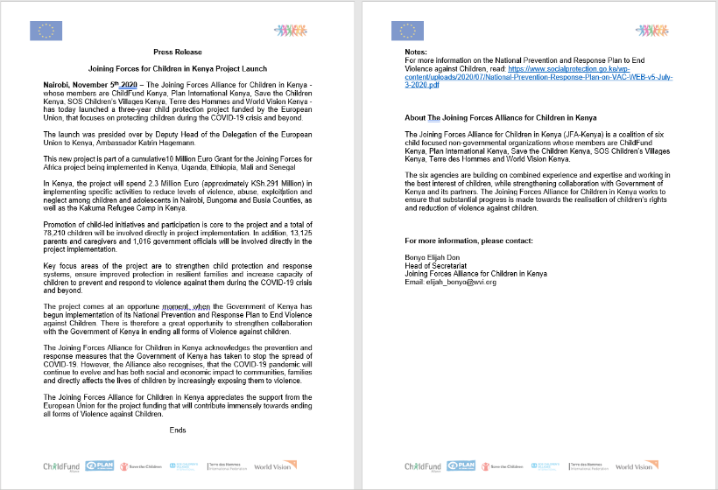
- ChildFund under the Joining Forces Alliance sent the press release below on the JFA launch to the journalists/media houses attached.

  - List of emergency CO spokespeople, including name, location, contact information, and languages spoken. Chege Ngugi, Country Director

  - Plans for collecting photos/videos/stories, e.g., should an outside photographer be hired? There is need to document the life of one of some of our sponsored families as they maneuver the tough COVID-19 times especially caregivers and the children in informal settlements in Nairobi.
-We were involved in filming and photography of children and families supported through food distribution, masks, sanitizers and solar radios in Kiambu and Murang’a counties just outside Nairobi.
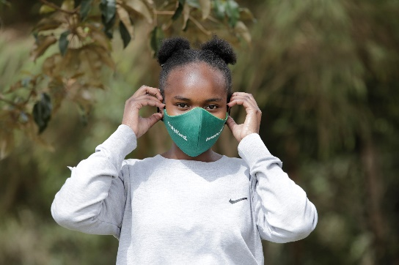
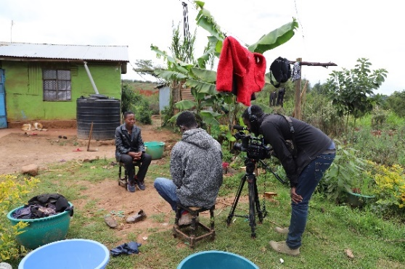
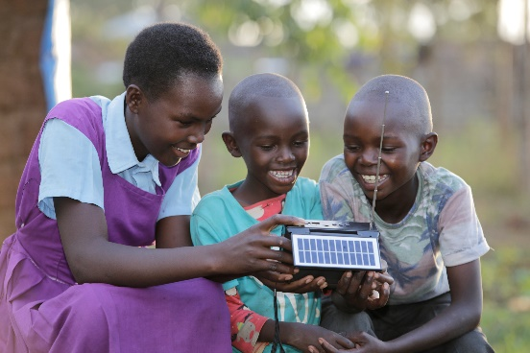

  - Media engagements:
NTV: Kenya CD, Chege Ngugi, took part in a one-hour TV interview on one of the country’s leading TV stations on November 20 to commemorate World Children’s Day. He discussed the status of child rights in the wake of COVID-19 and ChildFund’s ongoing COVID-19 response interventions. See link below: https://youtu.be/KuwR7mf9-o0
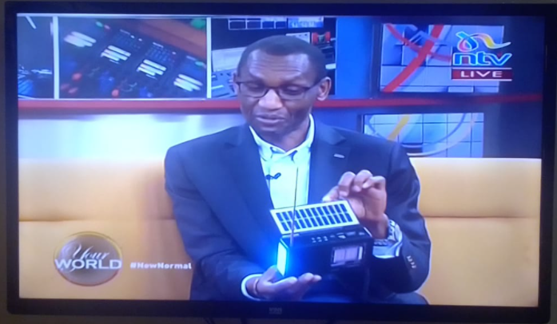

Ene FM, Serian FM, Mayian FM: ChildFund-sponsored children participated in radio programs on 3 radio stations to discuss recommendations from children’s engagement foras organized ahead of World Children’s Day. The recommendations highlighted COVID-19 guidelines on reopening schools, online education, violence against children during the lockdown period and the role of children in the fight against COVID-19.
- Key points for messaging and visibility, particularly any host-government sensibilities that must be considered.
ChildFund took part in the launch of JOFA in Kenya on Nov. 5th 2020. JFA is a three-year child protection project funded by the European Union, that focuses on protecting children during the COVID-19 crisis and beyond.The launch was presided over by Deputy Head of the Delegation of the European Union to Kenya, Ambassador Katrin Hagemann.
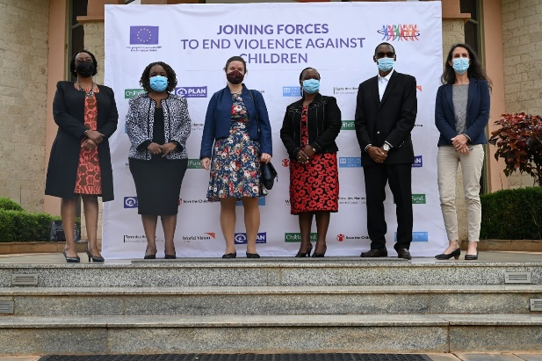
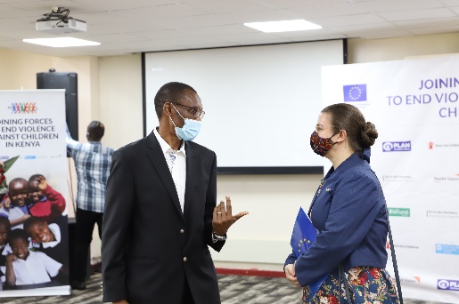

- Support needed or requested from IO, GSS or Global Teams – whether onsite or remote.
None at this stage

